1. 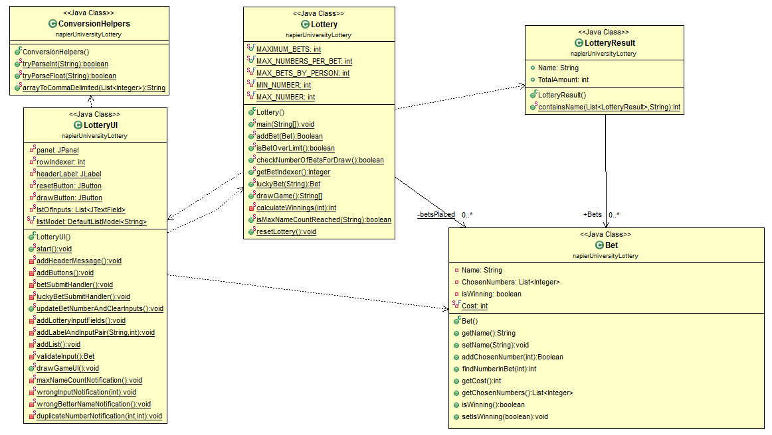Class Diagram
2. Description of classes:

* **Bet** class:

It contains all the relevant information for bets and has four private fields:

* + Name
  + ChosenNumbers
  + IsWinning
  + Cost

A bet is always associated with a person so the **Name** field (String object) will contain the user placing the bet. All numbers will be added to the **ChosenNumbers** field (List of integers) with the help of ‘setter’ functions that will expose adding capability publicly to other classes**,** namely **addChosenNumber(int** number) will add a parsed number from the input if the number of betting numbers haven’t exceeded the maximum amount allowed.  
