Crystal plasticity finite element modelling

Introduction
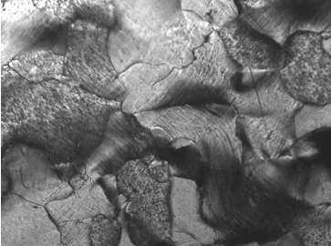
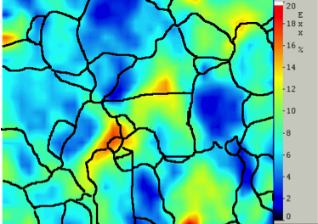
Nearly all metals used in engineering applications are polycrystalline. The elastic and plastic anisotropy of the grains in the polycrystalline leads to incompatibilities between grains during deformation so that deformation at the microstructural scale is heterogeneous [1]. This can be observed experimentally using surface mapping techniques such as digital image correlation (DIC). Figure 1 shows the evelotion of local strains during the deformation of ferritic steel [ref]. As a result, the local stress and strain within each grain is different from the mean stresses and strains in the polycrystalline aggregate. To date, the two most successful computational approaches for calculating stresses in strains at the grain level are elasto-plastic self-consistent modelling [2] and crystal plasticity finite element modelling (CPFEM) [3], the latter being used in the work reported here. The CPFEM implementation used here is discussed in detail in [4] for the 2-D case and has been shown to predict both the texture evolution in steel [5] and the magnitude of diffraction intergranular strains measured during tensile deformation [6].
100 µm
Figure 1: Strain map (right) between first and final (left) images of the sequence obtained during in-situ testing of a large grained ferritic steel. The average strain in grain B is 12% whereas in the neighbouring grain A it is only 4%.

In CPFEM, the microstructure is represented by an FE mesh where each grain is represented by one or more elements. A typical meshed volume is shown in Figure 2. The volume modelled must contain enough grains, with different orientations, that it is representative of the bulk material being modelled. This representative volume element (RVE) must exhibit the same mechanical properties as the bulk material. In this RVE, both the elastic deformation and plastic deformation of each grain is anisotropic. For cubic symmetry, the elastic anisotropy can be defined by three independent compliance moduli measured from single crystal experiments. Plastic anisotropy, on the other hand, has origin in the crystallographic nature of slip, which is assumed to be only mechanism of plastic deformation. At low to moderate temperatures, dislocation movement is restricted to certain crystallographic planes and directions. Each set of compatible plane and direction makes up a slip system. In ferritic steel, which has a body centred cubic (bcc) crystal structure, there is good evidence that, at the single crystal level, the active slip systems are the {112}<111> and {011}<111>, which make up a total of 24 slip systems. These slip systems are indicated in Figure 3.

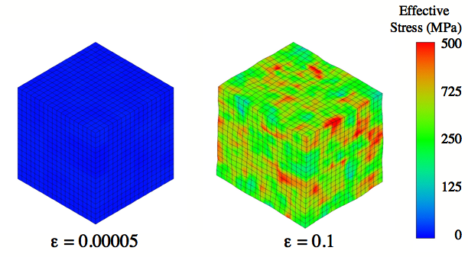
Effective Stress (MPa)

0

200

400

600

800

1000

1200

Figure 2: Typical meshed volume used in CPFEM calculation. In this particular simulation, each grain is represented by a hexahedral element. The colours represent the value of effective stress calculated at each integration point during the uniaxial deformation of ferritic steel at 0.05 % strain and at 10% strain.

Although all of the grains making up the RVE have the same 24 possible slip systems, only a subset of these slip systems is active during deformation. As a consequence, although the slip resistance is the same for every slip system, the stress and strain at each integration point depend on the particular combination of active slip systems and on the magnitude of slip on each of them. The determination of the active slip systems and their magnitude is primarily a function of the crystallographic orientation with respect to the overall imposed deformation. The slip plane and direction determine how the applied normal stress and strain are resolved into shear stresses and strains at the level of each grain. For each slip system, this relationship is given by the Schmidt factor and the contribution of each of the active slip systems is added up to give the stress and strain at each integration point. As consequence some grains will have orientations that are “soft”, i.e. they start deforming plastically at lower applied stresses, whilst others will have “hard” orientations.

Individual grain orientation is the biggest factor in determining the active slip systems, their magnitude and hence the stress and strain in a particular grain. However, the overall equilibrium imposed by the FE formulation introduces another factor in the form of constraint imposed by neighbouring grains. A grain with a “soft” orientation will deform more when surrounded by other “soft” grains and less when surrounded by grains with “hard” orientations. This means that two grains in the RVE with the same orientation will not necessarily have the same stress and strain.

In summary, CPFEM predicts a distribution of stresses in the modelled RVE by taking into account the crystallographic nature of metal deformation in a FEM framework. In the implementation used here, this stress distribution can be thought of having three origins: single crystal elastic anisotropy, grain orientation and neighbourhood constraint.

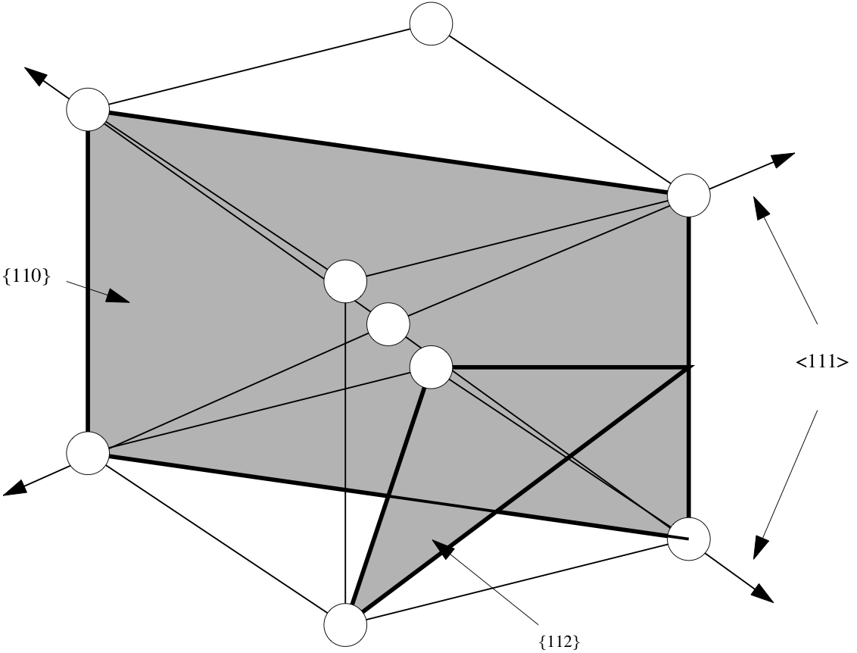

Figure 3: Active slip systems in bcc steel. Slip planes are {110} and {112}, with slip direction <111>, making a total of 24 slip systems.

Implementation details

The CPFEM implementation used here is discussed in detail in [4] for the 2-D case. It follows the usual trial stress methodology often employed by elasto-viscoplastic FE simulations whereby equilibrium is solved for using an implicit formalism, that is, at the end of each time step. A small strain formulation is employed, which makes the usual strain decomposition particularly straightforward. The main steps of the implementation are shown in Error: Reference source not found.

Step1-Trial stress calculation: The prescribed strain increment is applied to all the elements in the volume. This strain is used to calculate stress using the usual elasticity equations. Whereas in conventional FE analysis the material is considered to be elastically isotropic, in CPFEM the (usually anisotropic) single crystal compliance tensor is used to calculate a trial stress.

Step 2 – Determination of slip system activity: One fundamental difference between CPFEM and a conventional elasto-plastic FE calculation is the way in which the plastic strain increment is calculated. Instead of employing a yield surface defined by yield criterion, a two level iteration procedure is used. At the first level the trial stress calculated in step 1 is used to determine the slip increments using the slip directions and plane normals. These are provided as input in the coordinate system of the crystal (or grain) and must be transformed into to the sample coordinate system at each integration point. This transformation is determined by the crystallographic orientation at each integration point defined during meshing.

Step 3 – Plastic strain increment: Once slip activity has been determined, the plastic strain increment can be calculated by summing the slip strain at each active slip system. The plastic strain increment can then be subtracted from the total strain to give a new elastic strain increment that is converted into a new trial stress. Steps 2 and 3 are then repeated until the preset convergence criterion has been met.

Step 4: Once the iteration in steps 2 and 3 is complete, the total strain increments and the strain values are used, together with the Jacobian, to solve for overall equilibrium. A non-linear implicit (forward) integration method is used to solve for overall equilibrium. The spin matrix is used to calculate the rate of lattice spin, which in turn is used to reorient the crystal. This calculation gives new values of stress and strain, which are now different at every integration point. These are then used as the starting point for a new iteration, starting at Step 1.

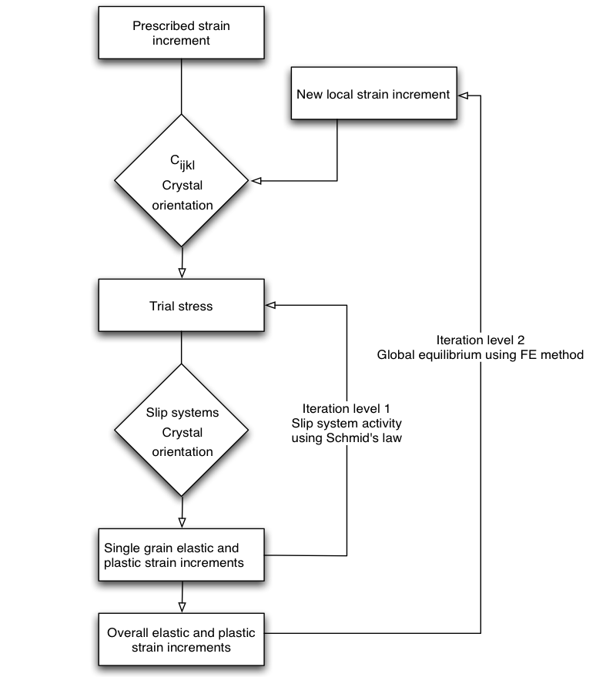
Figure 4: Flowchart outlining the main calculation steps in the CPFEM implementation used in this work.

Hardening model

In crystal plasticity, the change in flow stress caused be plastic deformation (work hardening) is calculated for each slip system individually. In the implementation used, plastic deformation is assumed to occur by slip, which is assumed rate sensitive according to:

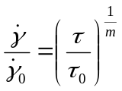 (6)
where is the slip rate, 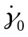 is a nominal reference slip rate, τ is the resolved shear stress and τ₀ the instantaneous slip resistance in any given slip system. The rate sensitivity, m, has a small positive value (typically 0.02) for all systems. Slip hardening behaviour is modelled using a modified Voce type law, which describes a power law decay of the hardening rate from an initial to a final rate. It is given by:

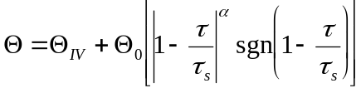 (7)
where Θ₀ is the initial hardening rate, Θ_{IV} is stage IV or final hardening rate, τ is the resolved shear stress and τ_{s} a saturation slip resistance. Since dislocations on each slip system can interact with those on other systems, the hardening on each slip system should also depend on the amount of slip on interacting slip systems. This effect, termed latent hardening, is accounted for in the model. Here, the simplest form of latent hardening is assumed, that is slip on a particular slip system causes equal amounts of hardening on itself and all other interacting slip sytems.

Model inputs
The following information is required for a CPFE simulation:
- a discrete number of orientations representative of the crystallographic texture of the material
- the single crystal compliance tensor
- initial slip resistance for every slip system
- slip hardening parameters (equation 7)

The orientations in 1 can be obtained either by sampling at random an orientation correlation function calculated from an X-ray texture measurement or by sampling a discrete orientation dataset produced by electron back scattered diffraction, for example.
The single crystal compliance tensor can be determined experimentally by either ultrasonic measurements on single crystals or via in-situ loading diffraction experiments on polycrystalline material. These experiments are costly and difficult to perform and the values determined in this way often differ only slightly from those in the literature. Therefore compliance values are usually obtained from previous published work.
Although values for the initial slip resistance and slip hardening parameters are, effectively, single crystal parameters, in practice they cannot be obtained from test on single crystals. This is because the slip resistance and hardening behaviour is affected by the presence of grain boundaries in the polycrystal, with the Hall-Petch effect being probably the best known example. Instead these parameters are usually obtained through a calibration procedure, which is outlined in detail in section 3.2.

[1] R.W.K. Honeycombe, The Plastic Deformation of Metals, 2nd edition (1984), Edward Arnold.
[2] R. Hill, “Continuum micro-mechanics of elastoplastic polycrystals”, Mechanics of Physics and Solids, 1965, 13, 89-101.
[3] R. Asaro, A. Needleman, “Texture development and strain hardening in rate dependent polycrystals”. Acta Metall. 33 (6), 1985, 923–953.
[4] P. Bate. Modelling deformation microstructure with the crystal plasticity finite-element method. Phil. Trans. R. Soc. Lond., Vol. 357, pp. 1589–1601, 1999.
[5] P. S. Bate and J. Q. da Fonseca. Texture development in the cold rolling of if steel. Mat. Sci. Eng. A, Vol. 380, pp. 365–377, 2004.
[6] J. Q. da Fonseca, E. C. Oliver, P. S. Bate, and P. J. Withers, “Evolution of intergranular stresses during in situ straining of if steel with different grain sizes”, Mat. Sci. Eng. A, Vol. 437, pp. 26–32, 2006.

