
MINISTRY OF EDUCATION, CULTURE AND RESEARCH
OF THE REPUBLIC OF MOLDOVA
Technical University of Moldova
Faculty of Computers, Informatics and Microelectronics
Department of Software Engineering and Automation

Report
on laboratory work no. 4
Operating Systems
Topic: The xv6 Shell from the Outside

Done by:
st. gr. FAF-242, Gabriela Bîtca

Checked by:
Reițman Patricia, asistent universitar

Chișinău - 2026

PURPOSE OF THE WORK
The purpose of this laboratory work is to understand what a shell really does, by comparing the xv6 shell (user/sh.c, 499 lines) with bash. First, I updated my sleep program from Lab 2 so that it builds on the current version of xv6. Then I ran the same commands in both shells and found out by experiment which features a shell must have and which ones bash adds on top. I wrote a small program, args, which prints the arguments it receives, for both xv6 and Linux, to find out who expands * and who removes the quotes. Finally, I read the source code of the xv6 shell to explain the differences I observed.
The work was done in Ubuntu running in a Parallels virtual machine on my MacBook Air M4. Before starting, I checked with bash os2026-setup.sh --check that xv6 builds and boots. The deliverables are this report, user/sleep.c, user/args.c, args_linux.c and the Makefile with my UPROGS lines.

1 PART 1: FIX SLEEP FOR THE CURRENT XV6

1.1 Commands and output
In August 2025 the xv6 authors renamed the system call sleep() to pause(). In Lab 2 I worked on macOS with an older version of xv6, from before the rename, but the course setup script downloaded the newest version into ~/xv6-riscv in Ubuntu. First I checked which name this tree uses.
Figure 1.1 - The grep result in user.h
The grep found only int pause(int); on line 25 of user/user.h, so this tree uses the new name and sleep() no longer exists. I copied my user/sleep.c from Lab 2 into this tree, changed the call sleep(atoi(argv[1])) to pause(atoi(argv[1])), and added $U/_sleep\ to the UPROGS list in the Makefile (line 135, right after $U/_echo\).
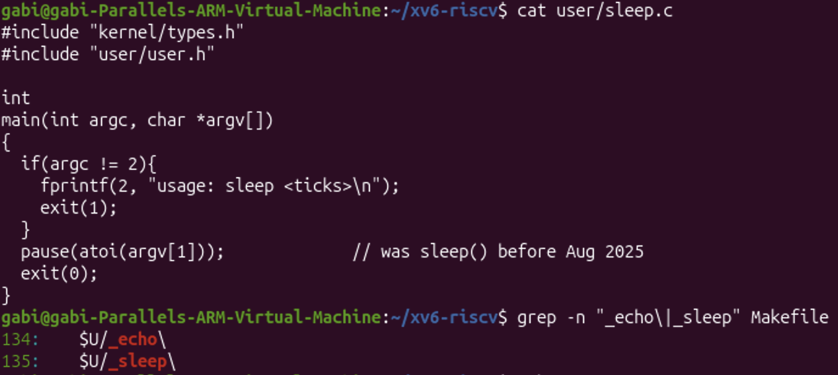
Figure 1.2 - The updated sleep.c
Then I rebuilt xv6 with make qemu and tested the program with and without an argument.
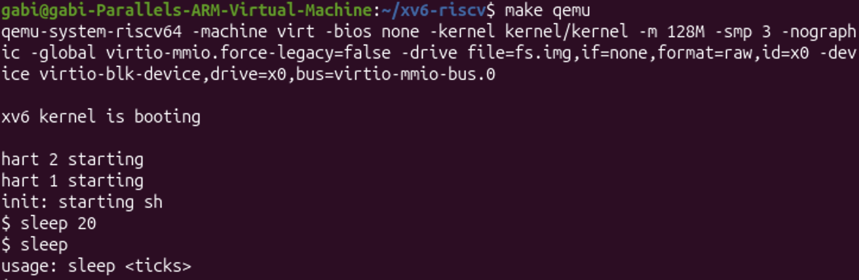
Figure 1.3 - sleep running in xv6, with and without an argument

1.2 Observations
Only the name of the system call changed; its job is the same. pause(n) asks the kernel to put the process to sleep for n clock ticks, so sleep 20 paused for about 2 seconds before the prompt came back, while sleep without an argument printed the usage message and exited with code 1. A user program depends on the exact list of system calls declared in user/user.h: when the kernel interface changes, the programs that use it must be updated too.
The first time I booted xv6, sleep printed "exec sleep failed" (Figure 1.4), because I had not yet added $U/_sleep\ to UPROGS. The Makefile only compiles the programs listed in UPROGS and copies them into the xv6 file system image (fs.img), so the shell could not find a program named sleep. After adding the line and rebuilding, the program worked.
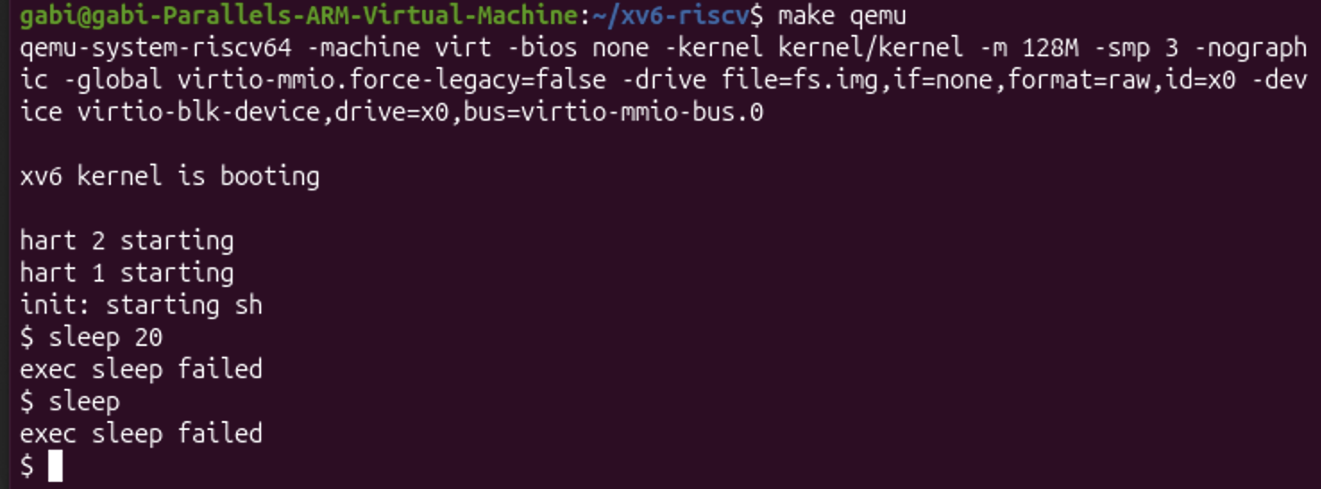
Figure 1.4 - exec sleep failed before sleep was added to UPROGS

2 PART 2: BASH VERSUS THE XV6 SHELL

2.1 Commands and output
I ran the same commands twice: once in bash, in an empty test folder ~/shtest that contains a file named README, and once at the xv6 $ prompt.
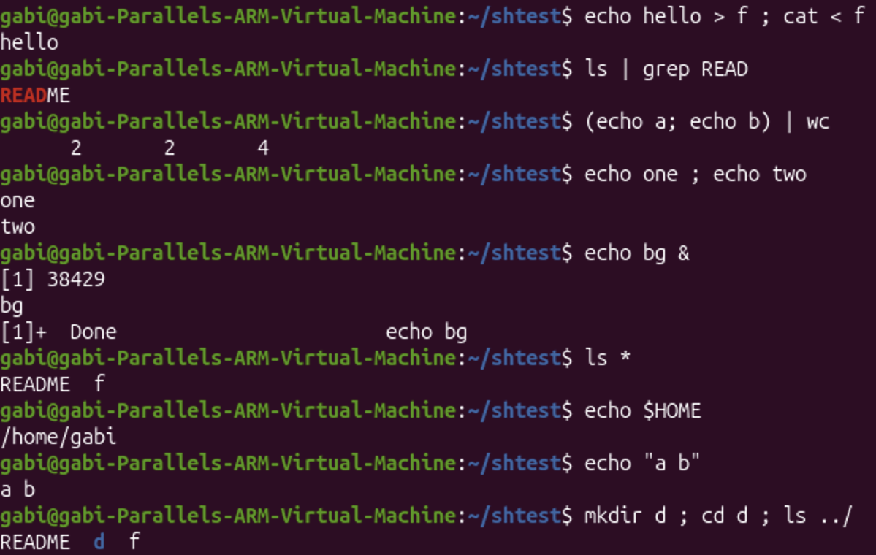
Figure 2.1 - The commands run in bash
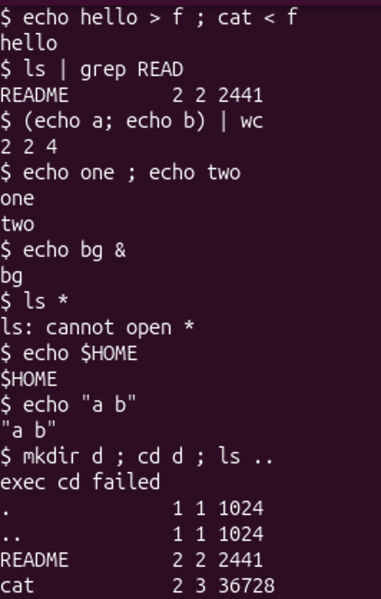
Figure 2.2 - The same commands run in xv6 (the listing of / is shortened)
Then, in xv6, I entered the folder d with a separate cd d command and tried to run ls from inside it.
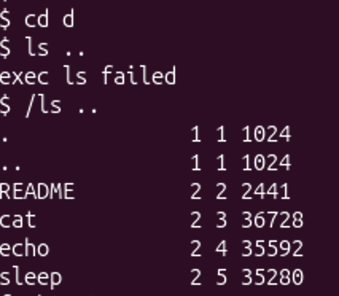
Figure 2.3 - ls failing after cd d, and the working alternative (shortened)
Table 2.1 - bash versus the xv6 shell
Command | Tests | bash | xv6
echo hello > f ; cat < f | redirection | hello | hello (works the same)
ls | grep READ | pipe | README | README 2 2 2441 (works; xv6 ls also prints type, inode and size)
(echo a; echo b) | wc | grouping, list | 2 2 4 | 2 2 4 (works the same)
echo one ; echo two | sequence | one, two | one, two (works the same)
echo bg & | background | [1] 38429, bg, [1]+ Done | bg (runs in the background, but there is no job number and no "Done" message)
ls * | globbing | README f | ls: cannot open * (no globbing)
echo $HOME | variables | /home/gabi | $HOME (no variables)
echo "a b" | quotes | a b | "a b" (quotes are not removed)
mkdir d ; cd d ; ls .. | PATH | README d f | exec cd failed, then the listing of /; after a separate cd d, ls .. gives exec ls failed and only /ls .. works
arrow up, Tab, Ctrl+R | history, completion | all work | not supported: the keys only print raw characters

2.2 Observations
The basic mechanisms work the same in both shells: redirection with > and <, pipes, grouping with parentheses, sequences with ; and running a command in the background with &. They are all built from a few system calls (fork, exec, pipe, open, close), which xv6 has. The differences appear in everything that bash does to the command line before running a command: xv6 does not expand *, does not replace $HOME, and passes the quotes to the program as ordinary characters.
Two details about cd surprised me. In the line mkdir d ; cd d ; ls .. the xv6 shell printed "exec cd failed": it only treats cd as a built-in command when the line starts with cd (with a space), so inside a ; list it tried to run a program called cd, which does not exist, and the shell stayed in /. For the same reason a bare cd without an argument also failed. Only cd d typed on its own line really moved the shell into d. Also, during my first attempt even echo failed with "exec echo failed" in the root folder; deleting the old disk image (rm -f fs.img) and rebuilding it with make qemu fixed it, because fs.img keeps all changes between boots.

2.3 Answers
(1) List the features both shells have, and the ones only bash has. Both shells have: running programs with arguments, input and output redirection (<, >), pipes (|), sequences (;), grouping with parentheses, background execution (&) and the built-in cd. Only bash has: globbing (*), variables ($HOME), quote removal, a PATH that is searched for programs, job control (job numbers, jobs, "Done" messages), command history (arrow up, Ctrl+R) and Tab completion.
(2) In xv6, ls stops working after cd d. Why? Find a way to run ls from inside d anyway. All xv6 programs live in the root directory /, and the xv6 shell has no PATH: it calls exec with exactly the name I typed, so the kernel looks for the file ls in the current directory. Inside d there is no file ls, so exec fails ("exec ls failed"). The fix is to give the path to the program: /ls .. works from inside d (../ls .. would work too).
(3) Which missing feature would you miss most in daily work, and which would be easiest to add? I would miss the command history and Tab completion the most, because they save a lot of typing, together with globbing. The easiest feature to add would be a simple PATH: if exec fails, the shell could try again with / in front of the name, which is only a few lines in runcmd() in sh.c.

3 PART 3: WHO EXPANDS *? A PROGRAM THAT PRINTS ITS ARGV

3.1 Commands and output
I wrote the program user/args.c for xv6. It prints argc, the number of arguments, and then every element of argv between square brackets, so that spaces and quotes inside an argument are visible. I added $U/_args\ to UPROGS in the Makefile, just like sleep in Part 1.
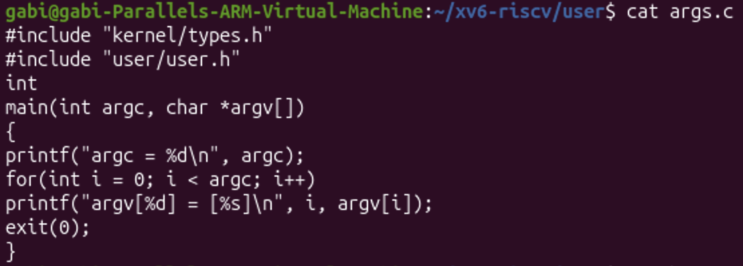
Figure 3.1 - args.c
I also wrote the same program for Linux as args_linux.c: it includes <stdio.h> instead of the two xv6 headers and returns 0 instead of calling exit(0). I compiled it with gcc -o args args_linux.c; gcc printed nothing, which means it compiled without errors (Figure 3.4).
Then I ran the same four lines in both shells: in xv6 as args ..., and in bash as ./args ... inside ~/xv6-riscv/user, a folder with many .c files.
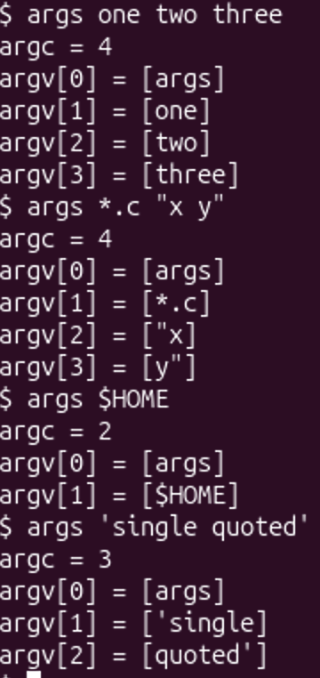
Figure 3.2 - args output in xv6
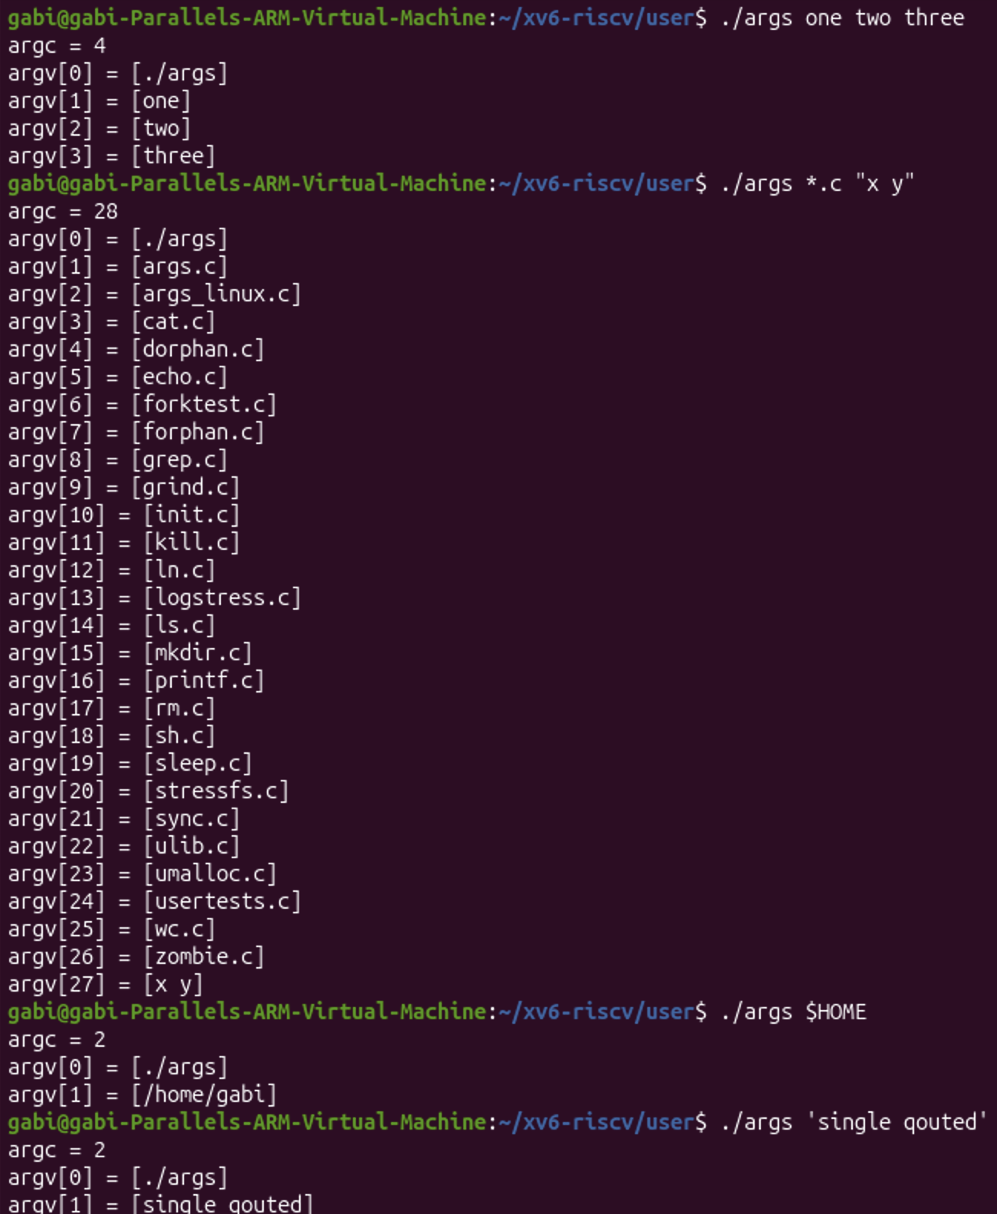
Figure 3.3 - args_linux output in bash
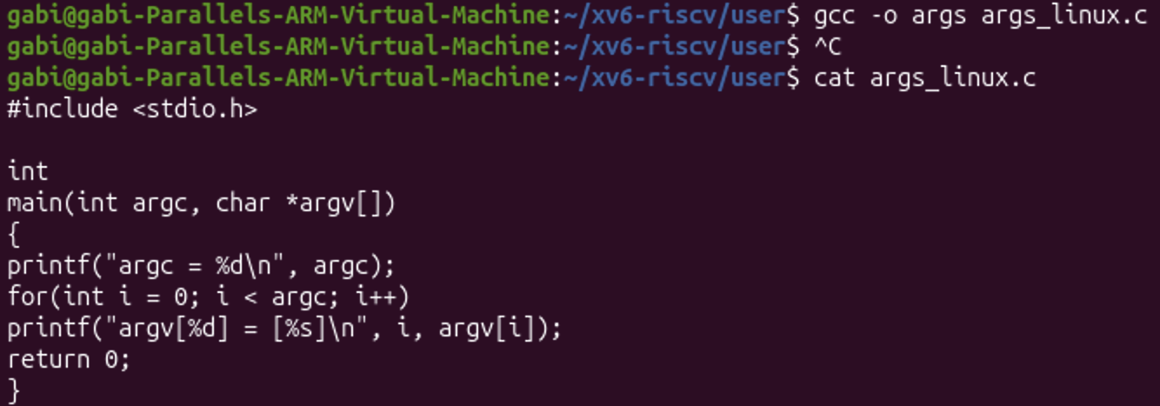
Figure 3.4 - args_linux.c and its compilation with gcc

3.2 Observations
The two programs are the same, but they received very different arguments for the same command line. In bash *.c became 26 file names and $HOME became /home/gabi, while in xv6 both reached the program unchanged. With quotes it was the opposite: bash removed them and kept x y and single qouted as one argument each, while xv6 kept the quote characters and split the text at the space, so 'single quoted' became two arguments, ['single] and [quoted'].

3.3 Answers
(1) Paste both outputs for args *.c "x y". How many arguments did each program receive? In xv6 the output was argc = 4: argv[0] = [args], argv[1] = [*.c], argv[2] = ["x], argv[3] = [y"] (Figure 3.2). In bash the output was argc = 28: argv[0] = [./args], then argv[1] to argv[26] were the 26 .c files in the folder (args.c, args_linux.c, cat.c, ..., zombie.c), and argv[27] = [x y] (Figure 3.3). So the xv6 program received 3 arguments after its name, while the Linux program received 27.
(2) So who turns *.c into file names and removes the quotes: the program, the kernel, or the shell? The shell. The two programs have the same code and simply print what they receive, and the kernel only passes the argument list unchanged from exec to the new process. The difference comes only from the shell that built the argument list: bash expands *.c into file names, replaces $HOME and removes the quotes before calling exec, while the xv6 shell does none of this, so the program receives the text exactly as it was typed, only split at the spaces.
(3) What happened to the extra spaces in one two three? They disappeared. Both shells split the command line into words at whitespace, and any number of spaces or tabs between two words counts as one separator, so the program received exactly three arguments, one, two and three, with argc = 4, and never saw the spaces. Spaces are only kept inside an argument when they are quoted, and only in bash (argv[27] = [x y]).

4 PART 4: READ THE SHELL

4.1 Commands and output
Inside ~/xv6-riscv I looked at the source code of the xv6 shell. wc -l user/sh.c showed that the whole shell has only 499 lines. Then I searched for the kinds of commands, the place where each kind is run, and the code that handles cd.
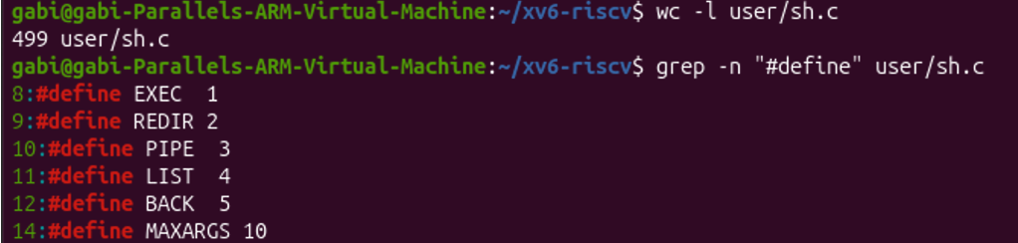
Figure 4.1 - The command kinds defined in sh.c
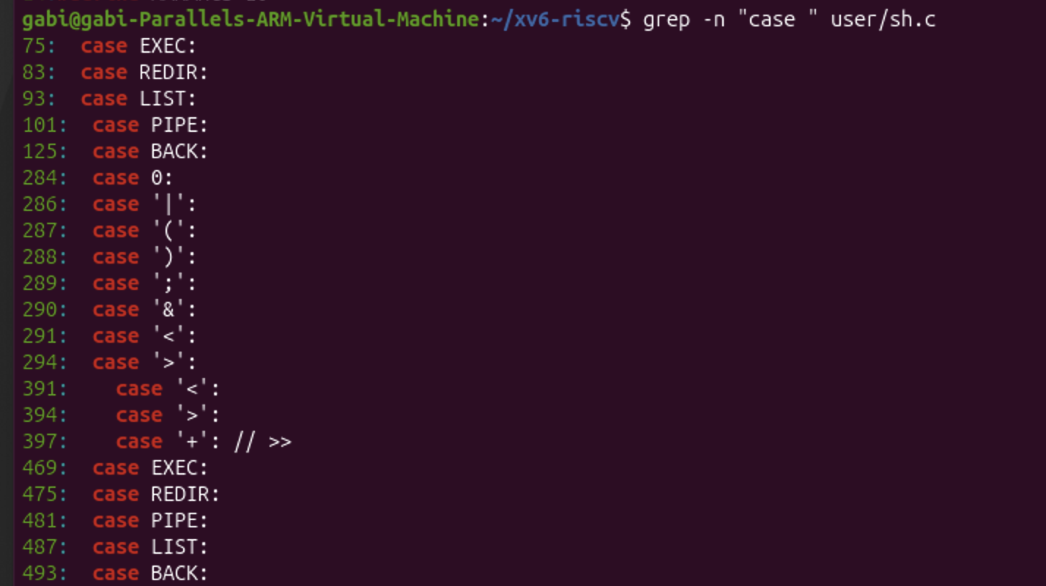
Figure 4.2 - Where each kind is run
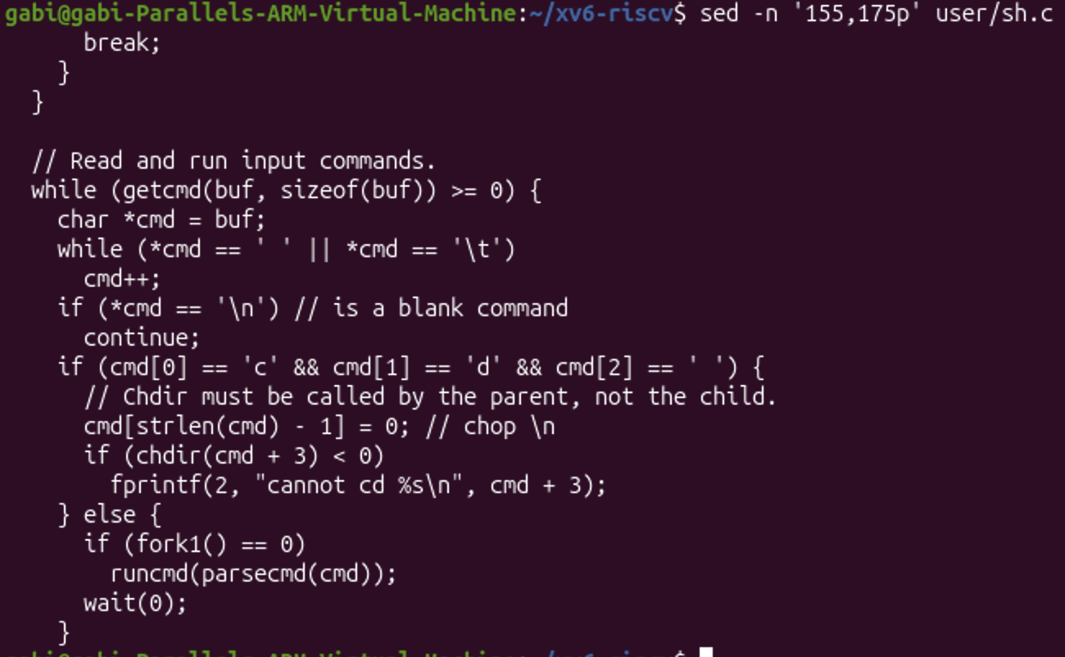
Figure 4.3 - The code that handles cd
Finally, I searched for any code that handles * or $, and read the function gettoken(), which splits the command line into tokens.
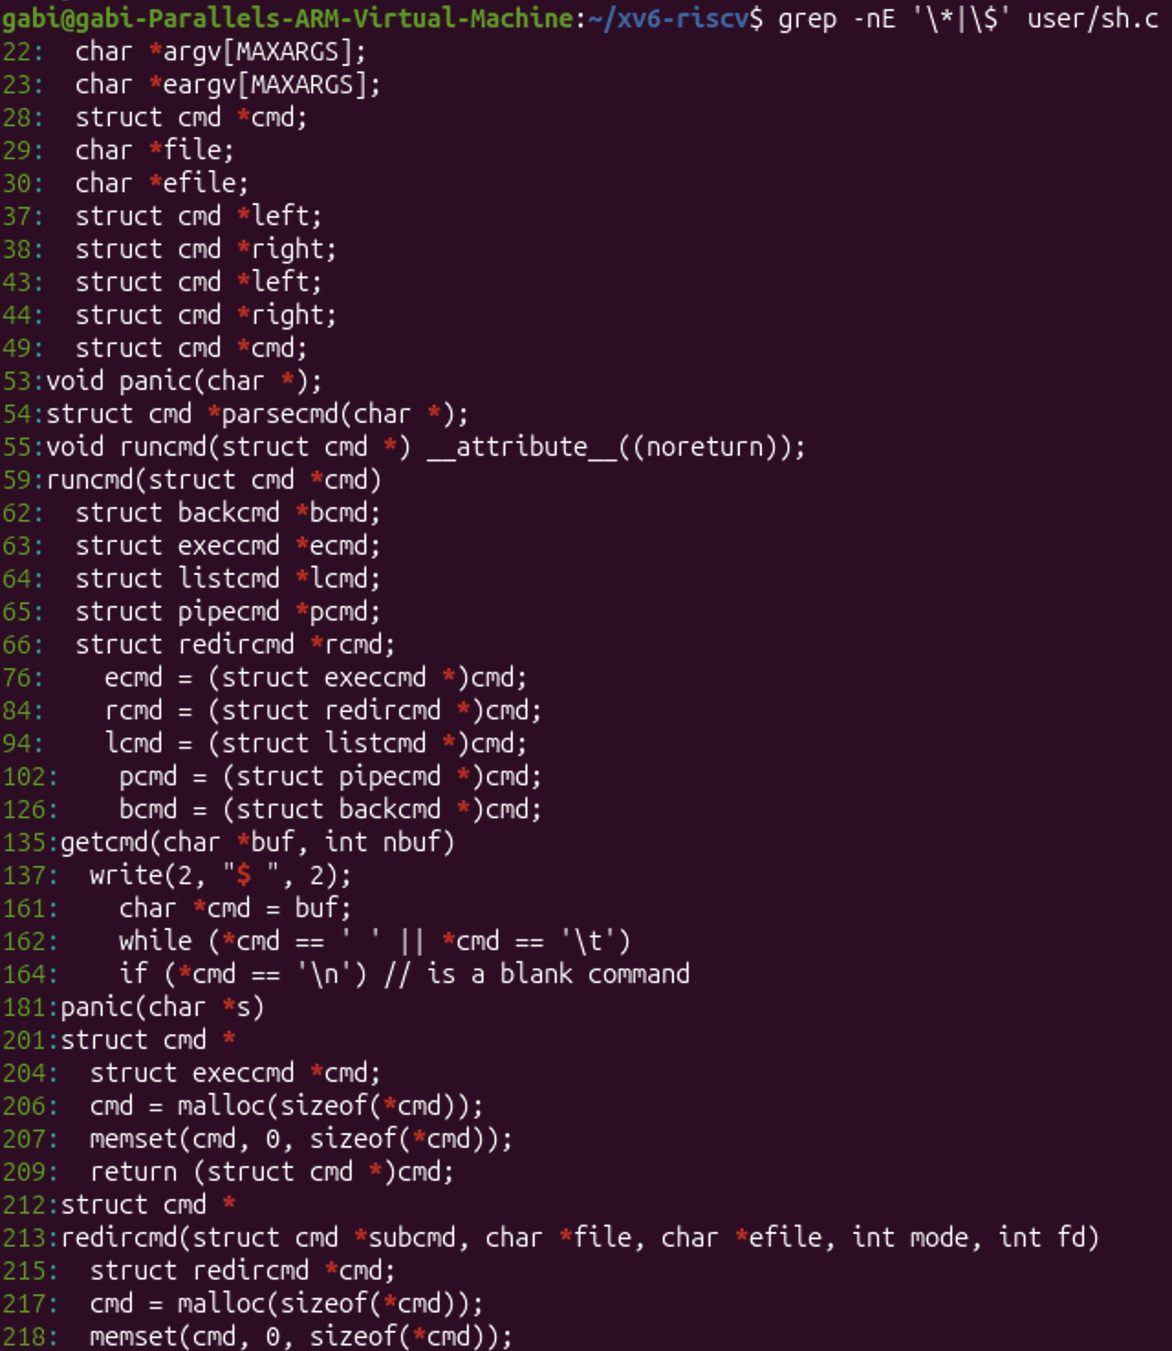
Figure 4.4 - Searching sh.c for * and $
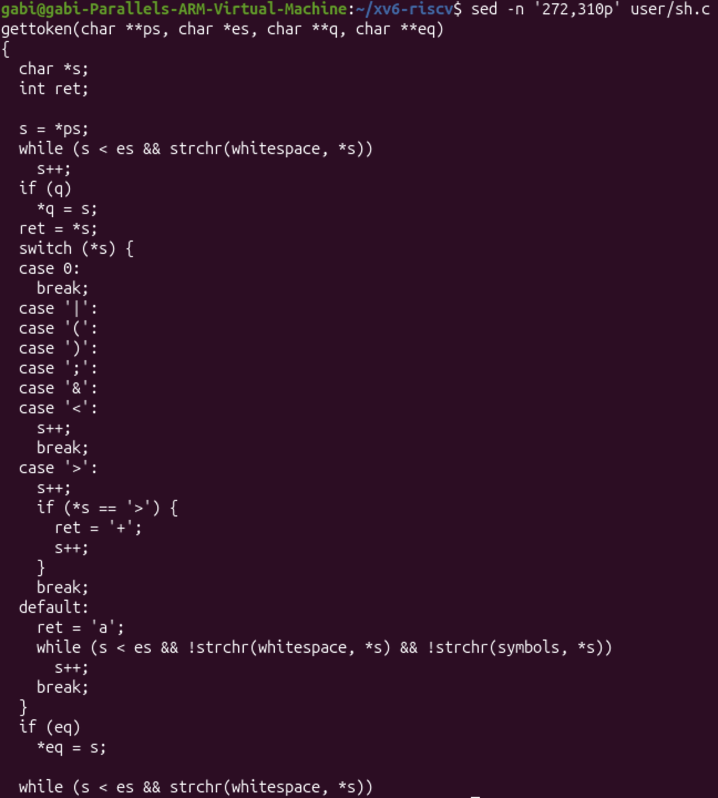
Figure 4.5 - The gettoken() function

4.2 Observations
The xv6 shell works in two steps. First, parsecmd() turns the line into a tree of small structures (execcmd, redircmd, pipecmd, listcmd, backcmd), using gettoken() to cut the line into words and special symbols. Then runcmd() walks this tree with a switch on the kind of each node (lines 75 to 125) and runs it with the system calls exec, open, pipe, fork and wait. All the * characters that grep found in sh.c are C pointers (for example char *argv[MAXARGS]), and the only $ is the prompt string in write(2, "$ ", 2).

4.3 Answers
(1) Name the five kinds of command the xv6 shell knows and the character that produces each.
• EXEC: a plain command, a program name with its arguments, produced by an ordinary word (for example echo hello); it is run with exec.
• REDIR: produced by <, > or >>; the shell closes standard input or output and opens the file in its place.
• PIPE: produced by |; the shell creates a pipe and runs the left and right commands in two child processes.
• LIST: produced by ;; the shell runs the left command, waits for it, then runs the right one.
• BACK: produced by &; the shell starts the command in a child process and does not wait for it.
Parentheses ( and ) do not create a sixth kind: they only group commands inside the tree.
(2) Where is cd handled, and why is it not run as a separate program? cd is handled directly in main(), in the loop that reads the commands (lines 155 to 175, Figure 4.3). If the line starts with c, d and a space, the shell cuts off the newline and calls chdir(cmd + 3) itself, printing "cannot cd ..." if it fails; every other line is passed to fork1() and runcmd() in a child. As the comment says, "Chdir must be called by the parent, not the child": every process has its own current directory, so if cd ran in a child process, only the child would change directory and the change would be lost when it exits, while the shell would stay where it was. This also explains Part 2: cd in the middle of a ; list or without a space is not recognised and is executed as a program, which fails.
(3) Search sh.c for any code that handles * or $. What does that explain about Part 2? There is none. The * characters in sh.c are only C pointer declarations, and $ only appears in the prompt. In gettoken() the only special characters are | ( ) ; & < >; every other character, including *, $ and ", falls into the default case and simply becomes part of an ordinary word, and words are separated only by whitespace. This explains Part 2 and Part 3: ls * passed a literal * to ls, echo $HOME printed $HOME, and echo "a b" printed the quotes, because the xv6 shell has no code for globbing, variables or quotes. All of these features are added by bash, not by the operating system.

CONCLUSION
In this laboratory work I looked at the xv6 shell from the outside and then from the inside. Updating sleep to pause() showed me how closely a user program depends on the system call interface of the kernel, and the "exec sleep failed" error showed that a program only exists in xv6 if the Makefile builds it and puts it into fs.img.
Running the same commands in bash and in xv6 showed that the core of a shell is small: reading a line, splitting it into words, and running programs with fork and exec, connected by redirections, pipes, lists and background jobs. The args program proved who is responsible for the rest: the same program received 4 arguments in xv6 and 28 in bash for the same command line, because it is the shell, not the program and not the kernel, that expands *, replaces variables and removes quotes.
Reading user/sh.c confirmed these observations: in 499 lines it defines five kinds of command (EXEC, REDIR, PIPE, LIST, BACK), handles cd itself because the directory must change in the shell process, and contains no code for * or $. Everything else that makes bash comfortable, such as globbing, variables, quotes, PATH, history and completion, is extra work done by the shell on top of the same few system calls.

