
MINISTRY OF EDUCATION, CULTURE AND RESEARCH
OF THE REPUBLIC OF MOLDOVA
Technical University of Moldova
Faculty of Computers, Informatics and Microelectronics
Department of Software Engineering and Automation

Report
on laboratory work no. 3
Operating Systems
Topic: The Command Line: Shell, Pipes and Text Filters

Done by:
st. gr. FAF-242, Gabriela Bîtca

Checked by:
Reițman Patricia, asistent universitar

Chișinău - 2026

PURPOSE OF THE WORK
The purpose of this laboratory work is to learn to work efficiently in the Linux command line (bash). I learned to move fast in the terminal using Tab completion and the command history, to find help without a browser, and to understand what the shell does to a command line before the command runs (globbing, quoting, variables and command substitution). I also practised redirecting the output and the errors of commands into files, chaining commands with the operators ;, && and ||, and running jobs in the background. Finally, I answered real questions about a web access log with one-line pipelines of small text filters (grep, cut, sort, uniq, wc, head, tail, tr), and I turned the most useful pipelines into my first bash script, report.sh.
The work was done in Ubuntu running in a Parallels virtual machine on my MacBook Air M4. The deliverables are this report, the file oneliners.sh with the answers to Q1-Q8, and the script report.sh.

PREPARATION
Before starting, I ran the course setup script os2026-setup.sh, which installs the RISC-V compiler and QEMU and prepares xv6 for the next laboratory work. The first run failed: the clock of the virtual machine was about 5 days behind, so the Ubuntu package servers rejected their own index files as "not valid yet".
I fixed it by turning on automatic time synchronisation with sudo timedatectl set-ntp true, checked the date with date and ran the script again. This time it finished successfully, and xv6 booted in QEMU.
To prepare the data for Part 4, I generated an artificial web access log with 500 lines in the folder ~/os-lab3. Each line contains a date, a time, a user (user0 to user6), a result (OK or FAIL) and a page (/page0 to /page3). The check wc -l access.log printed 500 access.log, as required.

1 PART 1: MOVE FAST, FIND HELP

1.1 Commands and output
First I tested Tab completion. I typed ls /usr/sh and pressed Tab twice, then typed cd /et and pressed Tab once.
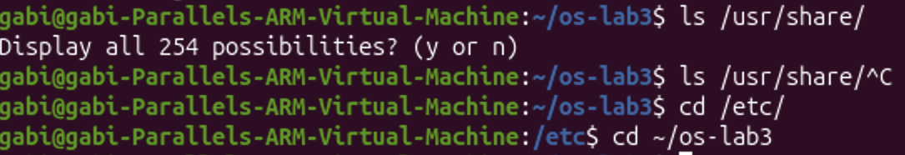
Figure 1.1 - Tab completion
Then I ran three commands (date, whoami, pwd), pressed Ctrl+R and typed da. Bash found the last command from the history that contained "da", which was date, and when I pressed Enter it ran it again (a second date output appeared, at 22:39:57).
Next, I checked which commands are built into the shell and which are external programs, where the shell looks for programs, and what happens when a command does not exist.
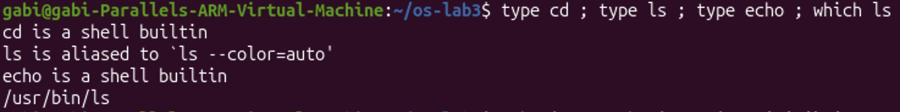
Figure 1.2 - Output of type and which
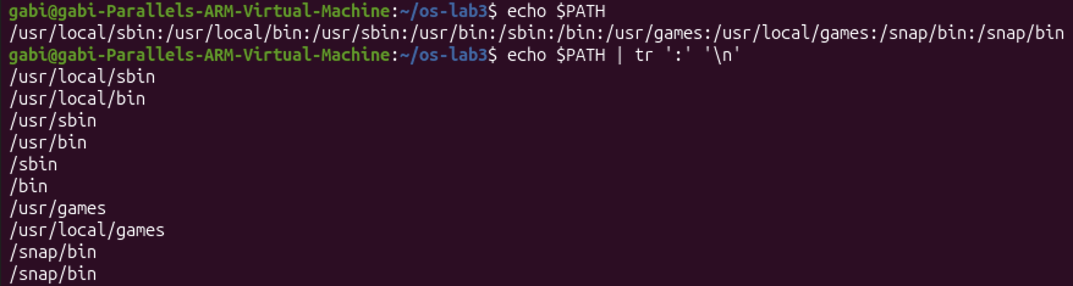
Figure 1.3 - The directories in PATH
Figure 1.4 - Exit code of a missing command
Finally, I looked for help without a browser, using ls --help | head, man -k "list directory", help cd and man ls, where I searched for "time" by typing /time inside the manual.
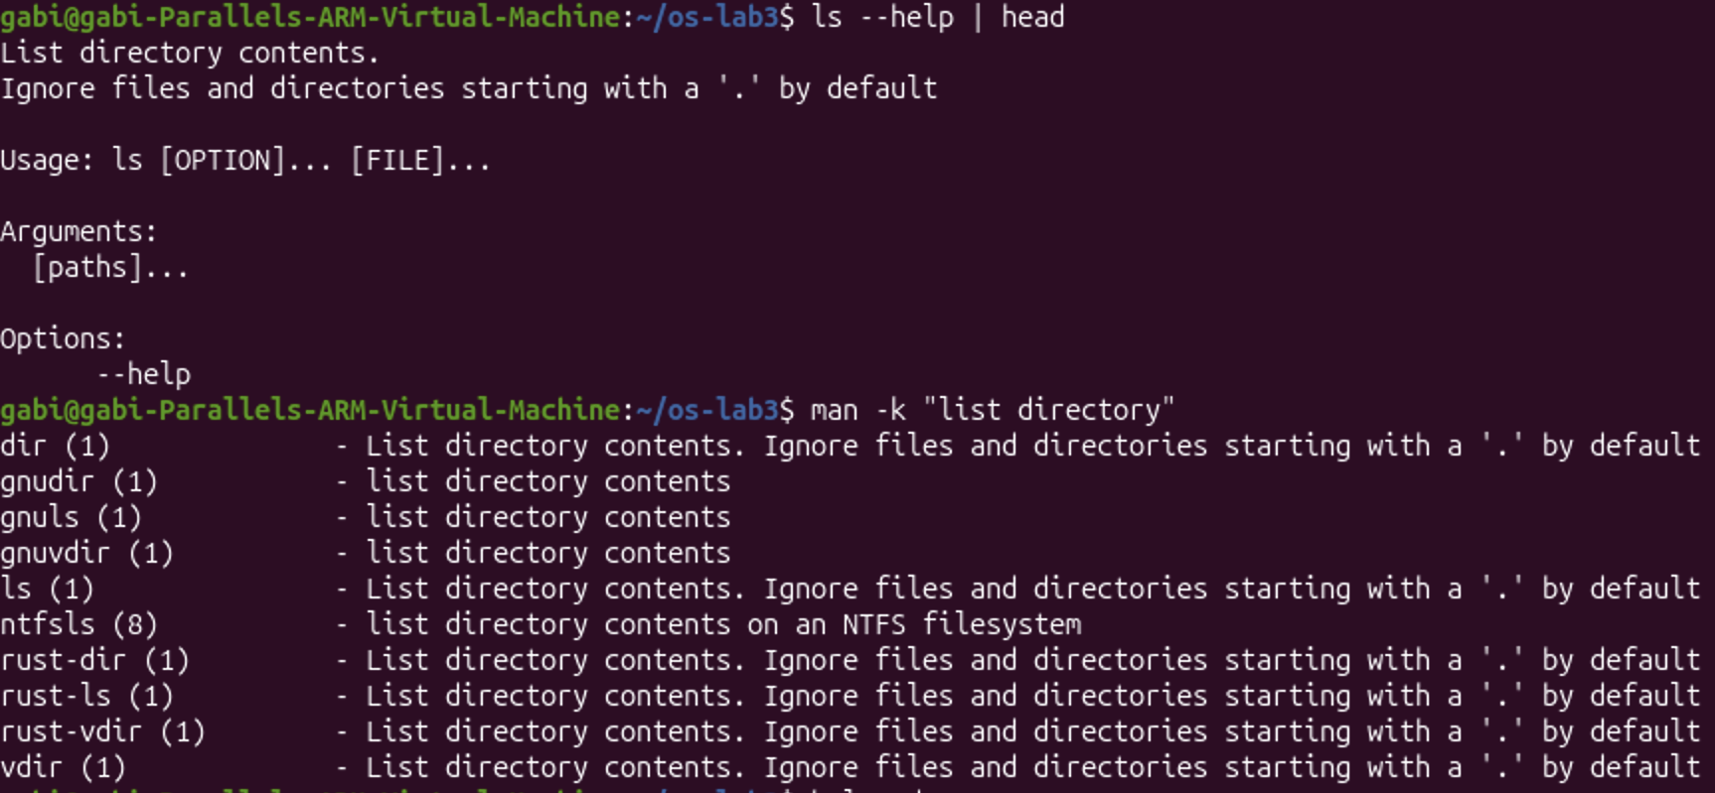
Figure 1.5 - Help from ls --help and man -k
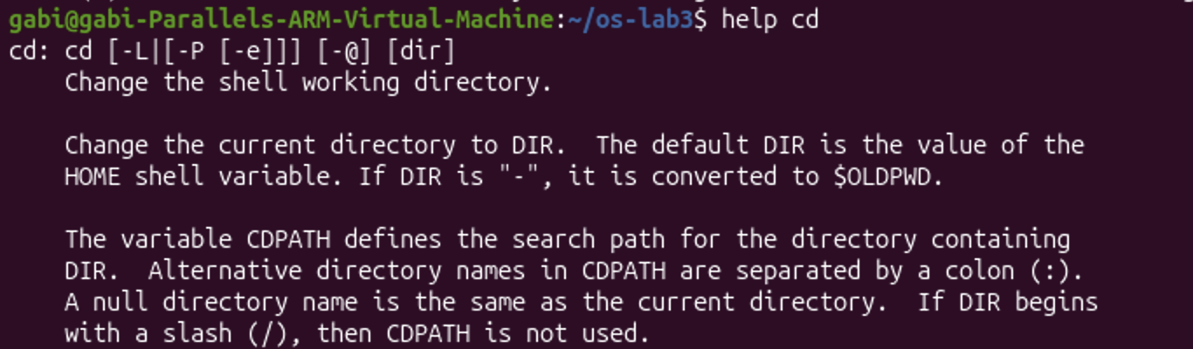
Figure 1.6 - Help for the built-in command cd (shortened)
Figure 1.7 - The -t option found in man ls

1.2 Observations
Tab completion saves typing. When only one name matches what I typed, one Tab completes it (/usr/sh became /usr/share/ and /et became /etc/). When there are several options, a second Tab lists them; inside /usr/share/ there were 254 of them, so bash first asked "Display all 254 possibilities? (y or n)". Ctrl+R searches backwards through the command history, so an old command can be repeated without typing it again.
type ls showed that on Ubuntu ls is an alias for ls --color=auto, which is why the output of ls is colored; the real program behind it is the file /usr/bin/ls. In my PATH the directory /snap/bin appears twice, which is harmless: the shell simply checks it twice. I also noticed that my Ubuntu version uses the new Rust implementation of the basic commands (uutils): man -k listed rust-ls and rust-dir, and ls --help has a slightly different format than the classic GNU version. The commands still work the same way. My first attempt, man ls /time, failed because man looked for a manual page called "/time"; the search with /time must be typed inside the manual, after it opens.

1.3 Answers
(1) Which of cd, ls, echo are built-ins, and why must cd be one? cd and echo are shell built-ins, while ls is an external program (/usr/bin/ls, used through an alias). cd must be a built-in because it changes the current directory of the shell itself. An external program runs as a separate child process, so it could only change its own directory, and the change would disappear when that process ends, leaving the shell where it was.
(2) How many directories are in your PATH, and in which one is ls? My PATH has 10 entries, but /snap/bin appears twice, so there are 9 different directories. ls is in /usr/bin.
(3) What exit code does a command that is not found return? It returns exit code 127, and bash prints "nosuchprog: command not found".
(4) Which option of ls sorts by modification time? The option -t. In man ls I found: "-t Sort by modification time (the 'mtime' in the inode), newest first."

2 PART 2: WHAT THE SHELL DOES TO YOUR LINE

2.1 Commands and output
I created a test directory with a few files, including one whose name contains a space.
Figure 2.1 - Files created in the play directory
Then, for each command, I first wrote down my prediction, and then ran it and compared it with the real output. The results are shown in Figures 2.2 to 2.5 and summarised in Table 2.1.
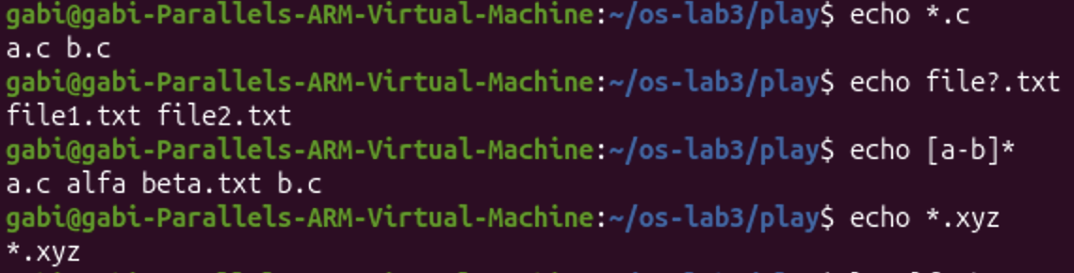
Figure 2.2 - Globbing results
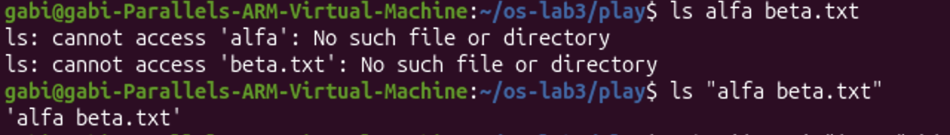
Figure 2.3 - The ls error on a name with a space, and the fix
Figure 2.4 - Single quotes, double quotes and backslash
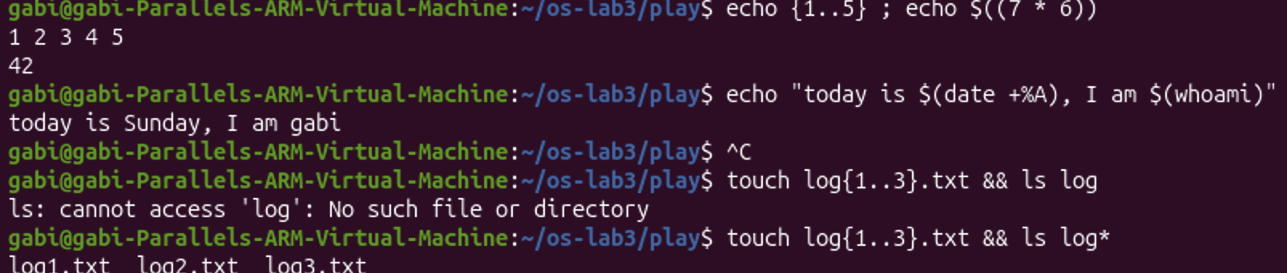
Figure 2.5 - Brace expansion, arithmetic and command substitution

Table 2.1 - Predictions and real outputs
Command | My prediction | Real output | Explanation
echo *.c | my prediction | a.c b.c | The shell replaced *.c with all names ending in .c, because * matches any characters.
echo file?.txt | my prediction | file1.txt file2.txt | ? matches exactly one character.
echo [a-b]* | my prediction | a.c alfa beta.txt b.c | [a-b] matches one character, a or b, so every name starting with "a" or "b" matched, including alfa beta.txt.
echo *.xyz | my prediction | *.xyz | No file matches, so bash leaves the pattern unchanged and echo prints it literally.
ls alfa beta.txt | my prediction | two errors: cannot access 'alfa' and 'beta.txt' | The space splits the name into two arguments, and neither file exists.
ls "alfa beta.txt" | my prediction | 'alfa beta.txt' | The quotes keep the name together as one argument.
echo '$HOME' "$HOME" \$HOME | my prediction | $HOME /home/gabi $HOME | Single quotes and the backslash stop the expansion; double quotes allow it.
echo {1..5} ; echo $((7 * 6)) | my prediction | 1 2 3 4 5 and 42 | Brace expansion generates a sequence, and $(( )) does arithmetic.
echo "today is $(date +%A), I am $(whoami)" | my prediction | today is Sunday, I am gabi | $( ) runs a command and puts its output into the line.
touch log{1..3}.txt && ls log* | my prediction | log1.txt log2.txt log3.txt | log{1..3}.txt became three names, touch created them and log* listed them.

2.2 Observations
The most important thing I learned in this part is that the shell rewrites the command line before the command runs. Patterns with *, ? and [ ] are replaced with matching file names (globbing), {1..5} is expanded into a list, $((...)) is calculated, $VAR is replaced with the value of the variable and $(...) is replaced with the output of another command. The command itself only receives the final result. I was surprised that [a-b]* also matched alfa beta.txt, and that echo *.xyz printed the pattern itself when no file matched, instead of printing nothing.
Two of my mistakes also showed how the shell works. When I accidentally left a quote open, bash showed the continuation prompt > and waited for the rest of the command, because the quoted text was not finished; I cancelled it with Ctrl+C. And when I typed ls log without the asterisk (Figure 2.5), ls failed with "cannot access 'log'", because it looked for a file named exactly "log". With ls log* the shell expanded the pattern into the three files, which shows again that it is the shell, not ls, that understands the *.

2.3 Answers
(1) Prediction, real output and explanation for each line. They are given in Table 2.1.
(2) echo knows nothing about files, yet echo *.c printed file names. Who produced them? The shell (bash) did. Before running echo, bash expanded the pattern *.c into the list of matching file names in the current directory, a.c b.c, so echo simply received these two words as arguments and printed them.
(3) Why did ls alfa beta.txt fail? Give two different ways to fix it. The shell splits the command line into words at spaces, so ls received two separate arguments, alfa and beta.txt, and neither file exists. Two ways to fix it are putting the name in quotes, ls "alfa beta.txt" (or 'alfa beta.txt'), or escaping the space with a backslash, ls alfa\ beta.txt. Tab completion also writes the escaped name automatically.
(4) What is the difference between single and double quotes? Inside single quotes everything is taken literally, so '$HOME' stays $HOME. Inside double quotes the shell still expands variables and command substitutions, so "$HOME" became /home/gabi, but it does not split the text at spaces or expand *. A backslash protects just one character, so \$HOME also printed $HOME.
Note: why ls shows 'alfa beta.txt' in quotes. When it prints to the terminal, ls puts quotes around names that contain spaces or special characters, so it is clear that the space is part of one name and not a separator between two files. It is also the exact form that can be copied and pasted back into the shell.

3 PART 3: REDIRECTION, CHAINING AND JOBS

3.1 Commands and output
First I ran ls on one directory that exists (/etc) and one that does not (/nope), sending the normal output and the errors into two different files.
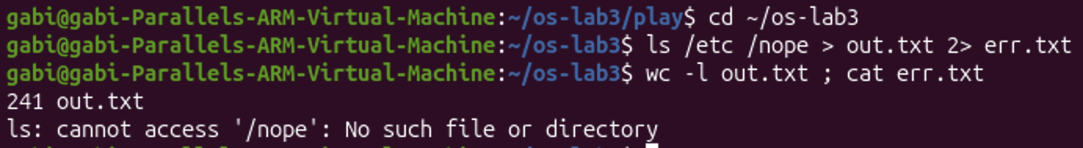
Figure 3.1 - stdout and stderr in separate files
Then I sent both outputs into one file, and compared two different orders of the redirections.
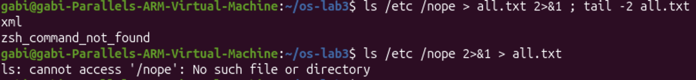
Figure 3.2 - Comparing the order of redirections
Next, I tested appending to a file, input redirection, and the operators ;, && and ||.
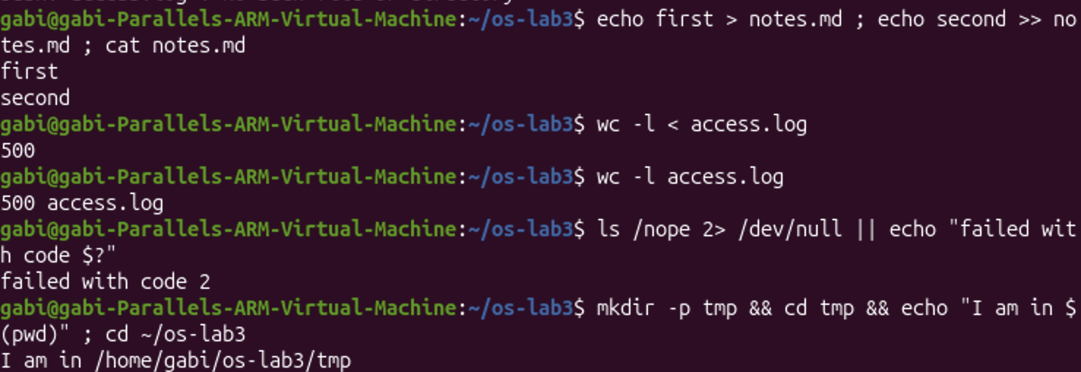
Figure 3.3 - The ; && || operators
Finally, I started a job in the background, listed it with jobs and stopped it with kill %1.
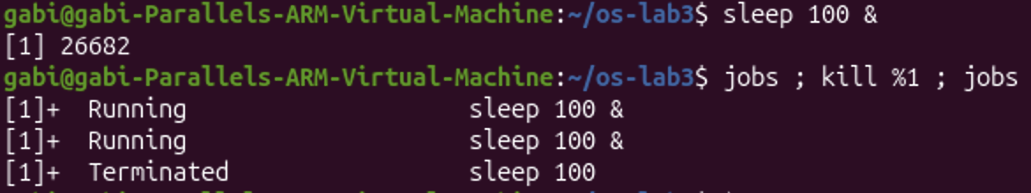
Figure 3.4 - Running a background job and stopping it

3.2 Observations
Every program has two separate output streams: standard output (stdout, number 1) for normal results and standard error (stderr, number 2) for error messages. Because they are separate, the shell can send them to different places. In the first command nothing appeared on the screen: the listing of /etc (241 lines) went into out.txt and the error about /nope went into err.txt.
With > all.txt 2>&1 both streams went into all.txt, and nothing appeared on the screen. tail -2 all.txt did not show the error, because ls reports the missing /nope before it lists /etc, so the error is at the beginning of the file, not at the end. The operator > overwrote notes.md with "first", and >> appended "second" to it instead of overwriting. ls /nope failed with exit code 2 (an error of ls itself), which is different from 127 in Part 1 (command not found). In the last test, both jobs commands showed the job as "Running", because kill only sends a signal and the shell notices a moment later that the job ended, so "Terminated" was printed right after.

3.3 Answers
(1) Which file got the error message, and which got the listing? The error message (ls: cannot access '/nope': No such file or directory) went into err.txt, because 2> redirects stderr. The listing of /etc went into out.txt, because > redirects stdout; it had 241 lines.
(2) What is the difference between > all.txt 2>&1 and 2>&1 > all.txt? The shell processes redirections from left to right, and 2>&1 means "send stderr to the place where stdout points right now". In > all.txt 2>&1, stdout is first sent to all.txt and then stderr is sent to the same place, so both the listing and the error go into the file and nothing appears on the screen. In 2>&1 > all.txt, stderr is first sent to where stdout points at that moment, which is still the terminal, and only after that is stdout moved to all.txt. So the listing goes into the file, but the error still appears on the screen, as Figure 3.2 shows.
(3) Why does wc -l < access.log print only a number, while wc -l access.log also prints the file name? With < access.log, the shell opens the file and connects it to the standard input of wc, so wc only receives a stream of data and does not know the name of the file; it prints just 500. With wc -l access.log, the file name is given to wc as an argument, so wc opens the file itself, knows its name and prints 500 access.log.
(4) Explain each operator in one sentence.
• ; runs the next command after the previous one finishes, no matter whether it succeeded or failed.
• && runs the next command only if the previous one succeeded (exit code 0); for example, cd tmp and echo ran only because mkdir -p tmp succeeded.
• || runs the next command only if the previous one failed (exit code different from 0); for example, "failed with code 2" was printed only because ls /nope failed.

4 PART 4: ANSWER QUESTIONS WITH ONE-LINERS

4.1 Commands and output
Each line of access.log has five fields separated by spaces: date, time, user, result (OK or FAIL) and page. I answered every question with a single command line made of small filters joined by pipes, and saved all of them in the file oneliners.sh, each one under a comment with the question.
Q1. How many requests failed? grep -c FAIL access.log counts the lines that contain "FAIL". 100 requests failed.
Figure 4.1 - Number of failed requests
Q2. How many different pages were requested, and which? cut -d' ' -f5 access.log | sort -u | tee /dev/stderr | wc -l. cut takes the 5th field (the page), sort -u keeps each page once, tee /dev/stderr shows the list on the screen and passes it on, and wc -l counts it. 4 different pages were requested: /page0, /page1, /page2 and /page3.
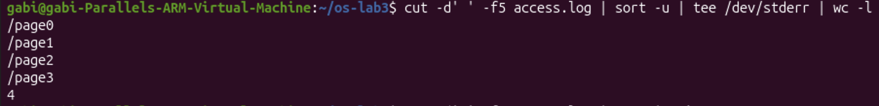
Figure 4.2 - The pages that were requested
Q3. How many requests did each page get? cut -d' ' -f5 access.log | sort | uniq -c. uniq -c counts identical neighbouring lines, which is why the list must be sorted first. Each page got 125 requests, and 4 x 125 = 500, the total number of lines in the log.
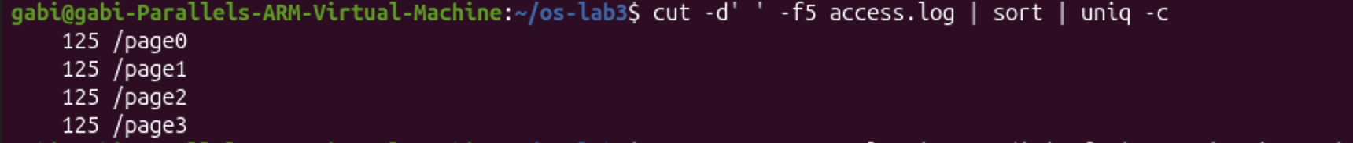
Figure 4.3 - Requests per page
Q4. Which user or users have the most failed requests, and how many? grep FAIL access.log | cut -d' ' -f3 | sort | uniq -c | sort -rn. I kept only the failed lines, took the user field, counted each user and sorted the counts from largest to smallest. user3 and user5 have the most failed requests, 15 each; all other users have 14. Check: 15 + 15 + 5 x 14 = 100, the same as Q1.
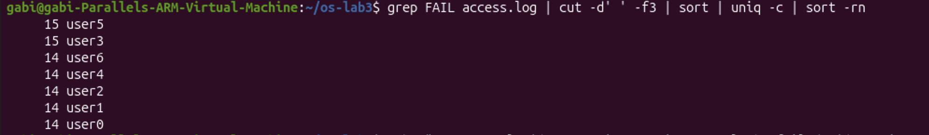
Figure 4.4 - Failed requests per user
Q5. How many requests did user3 make, and how many of them failed? echo "user3 total: $(grep -c ' user3 ' access.log), failed: $(grep ' user3 ' access.log | grep -c FAIL)". I searched for " user3 " with spaces around it so that only the user field matches. user3 made 72 requests, and 15 of them failed.
Figure 4.5 - Requests and failures of user3
Q6. Print the last 3 failed requests, showing only time and user. grep FAIL access.log | tail -3 | cut -d' ' -f2,3. 10:10 user0, 10:15 user5 and 10:20 user3.
Figure 4.6 - The last 3 failed requests
Q7. Which login shells appear in /etc/passwd, and how many accounts use each? cut -d: -f7 /etc/passwd | sort | uniq -c | sort -rn. In /etc/passwd the fields are separated by : and the 7th field is the login shell. /usr/sbin/nologin is used by 40 accounts, /bin/false by 5, /bin/bash by 2 and /bin/sync by 1. Most accounts are system accounts that are not allowed to log in, which is why they have nologin or false as their shell.
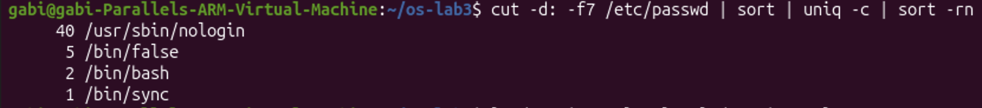
Figure 4.7 - Login shells in /etc/passwd
Q8. Why do ls /etc | wc -l and ls -l /etc | wc -l differ by exactly one? ls /etc | wc -l ; ls -l /etc | wc -l. My prediction: my prediction. The result was 240 and 241. ls prints one line per entry, so there are 240 entries in /etc. ls -l also prints one line per entry, but it adds one extra line at the top, total N, which shows the total disk space used by the files, in blocks. That extra line is the difference of exactly one.
Figure 4.8 - ls versus ls -l line count
Finally, I ran the whole file at once with bash oneliners.sh inside ~/os-lab3.
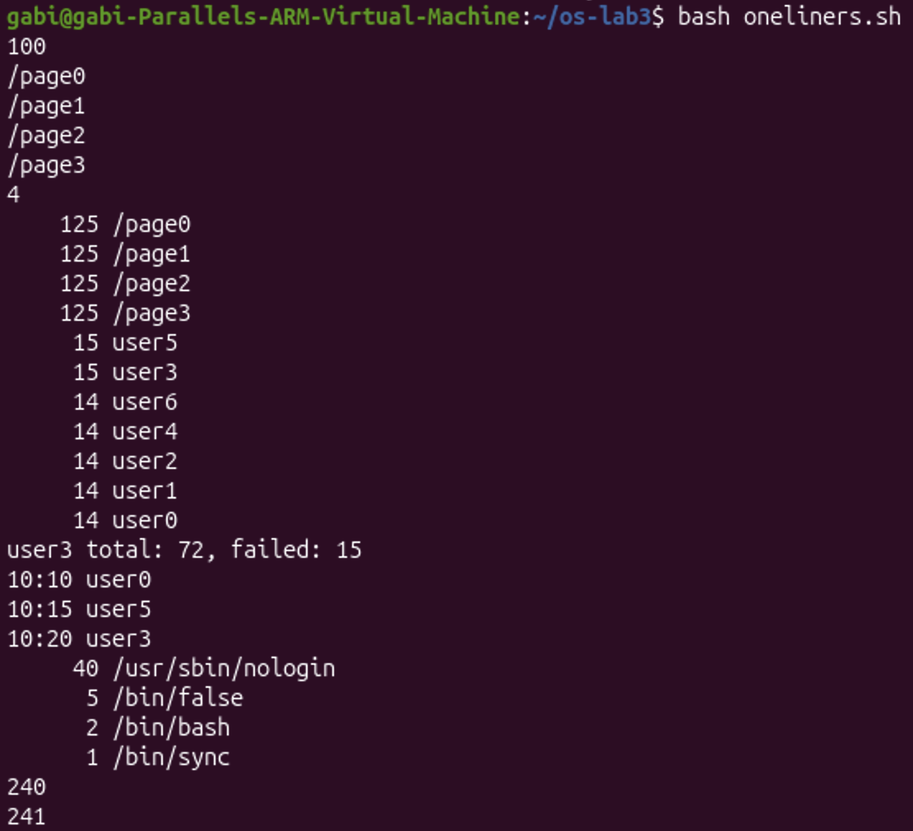
Figure 4.9 - Full run of oneliners.sh
Bonus. Lines where the minute ends in 0 and the request failed. grep -E '10:[0-5]0 [^ ]+ FAIL' access.log | wc -l. grep -E allows extended regular expressions. In the pattern, [0-5]0 matches a minute whose first digit is 0 to 5 and whose second digit is 0 (10:00, 10:10, ..., 10:50), [^ ]+ matches the user field (one or more characters that are not a space), and FAIL keeps only the failed requests. There are 50 such lines. This matches what I expected: every 5th request fails, and every 10th request (i = 10, 20, ..., 500) both fails and falls on a minute ending in 0, so 500 / 10 = 50. The red highlighting in the output shows the parts of each line that matched the pattern.
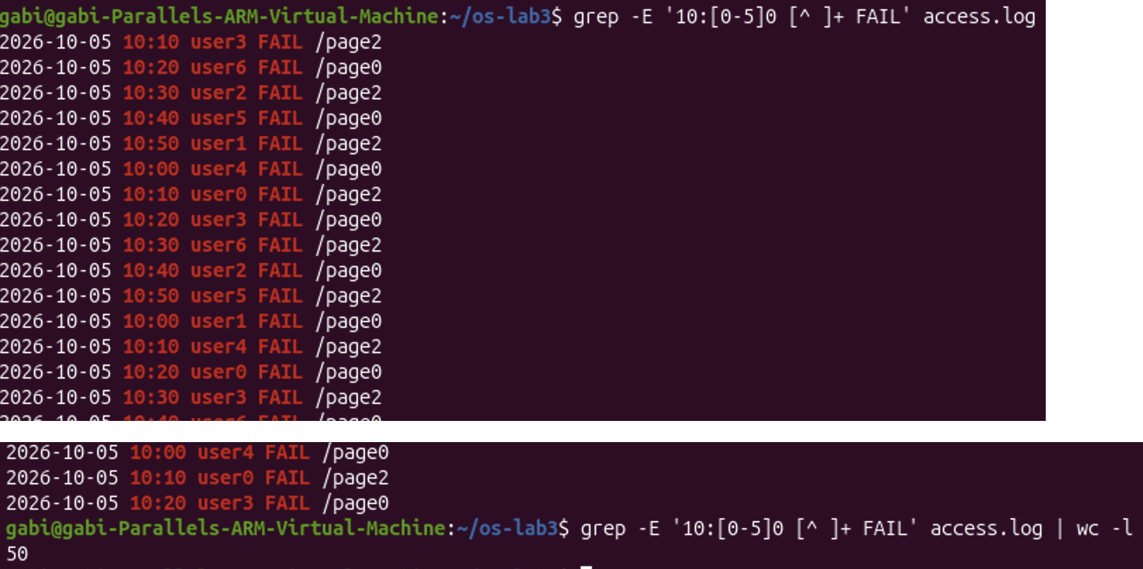
Figure 4.10 - Bonus: failed requests at minutes ending in 0 (first lines and the count)

4.2 Observations
Each tool does one small job: grep selects lines, cut selects a field, sort orders lines, uniq -c counts repeated lines, wc -l counts lines, and head and tail take lines from the beginning or the end. Joined by pipes, they can answer real questions about data without writing a program. I learned that uniq only compares neighbouring lines, so its input must always be sorted first. I also checked my results: the per-page counts from Q3 add up to 500 and the per-user failure counts from Q4 add up to the 100 failures from Q1, which shows that the pipelines filter the right things.

5 PART 5: YOUR FIRST SCRIPT

5.1 Commands and output
I turned my one-liners into a program, report.sh. The script takes the name of a log file as an argument, checks that the file exists, prints the total number of requests and the number of failed ones, and then, in a for loop (the TODO), prints the number of failures for each user from user0 to user6. I created the file with cat > report.sh << 'EOF' ... EOF, which writes all the lines up to EOF into the file without running them.
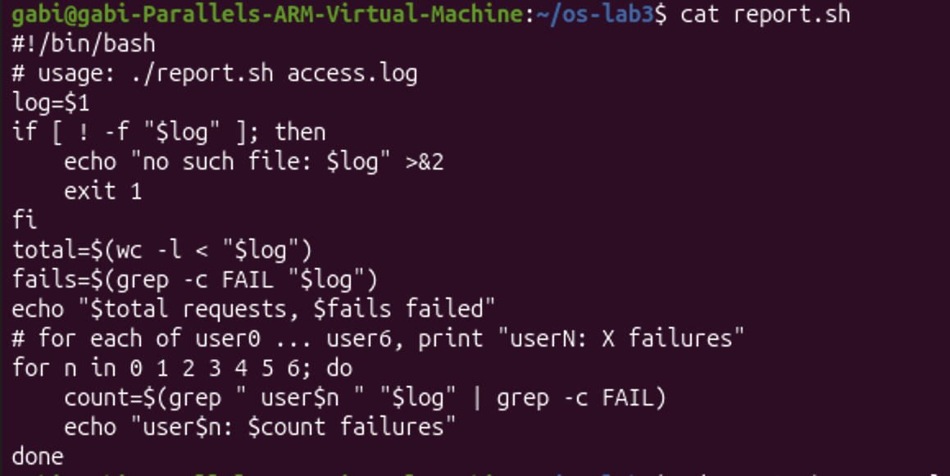
Figure 5.1 - Contents of report.sh
Before making the file executable, I tried to run it in two ways (Figure 5.4 at the end of this chapter). Then I made it executable with chmod +x report.sh and ran it on the log, and finally on a file that does not exist.
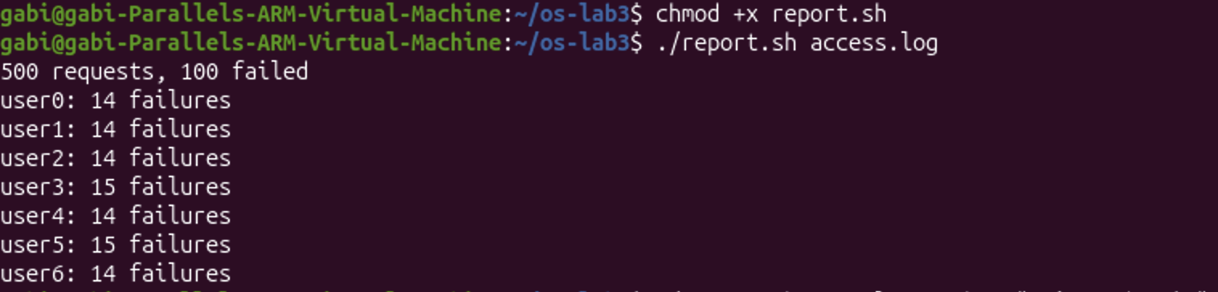
Figure 5.2 - Running the script on access.log
Figure 5.3 - Error handling for a missing file
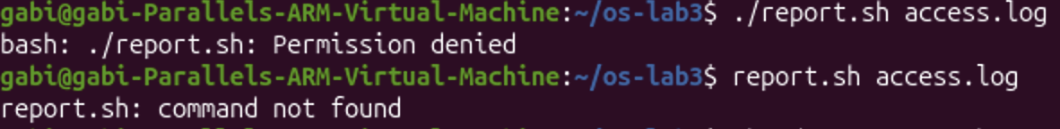
Figure 5.4 - Running the script before chmod +x and without ./

5.2 Observations
The script gave the same results as my one-liners from Part 4: 500 requests, 100 failed, 15 failures for user3 and user5 and 14 for every other user, which add up to 100. At first I pasted the script directly into the terminal instead of into a file, so bash executed its lines as commands: $1 was empty, the check [ ! -f "$log" ] was true and exit 1 closed my terminal. This showed me that a script is just a list of ordinary shell commands saved in a file.

5.3 Answers
(1) What does the first line #!/bin/bash do, and what happens if you run ./report.sh before chmod +x? The first line is called the shebang. When the file is executed directly, it tells the system which program must interpret the script, here /bin/bash. Before chmod +x, running ./report.sh fails with "Permission denied", because the file does not have the execute permission yet; chmod +x adds it. The script could still be run as bash report.sh, because then bash only reads the file.
(2) Why must you type ./report.sh and not just report.sh? When I type a command name without a path, the shell searches for it only in the directories listed in PATH (Part 1), and the current directory ~/os-lab3 is not one of them, so report.sh gave "command not found". ./report.sh gives the exact path, "report.sh in the current directory (.)", so the shell does not need to search PATH.
(3) Why does the script write the error with >&2 and end with exit 1? >&2 sends the error message to standard error instead of standard output, so it does not mix with the normal results and can be redirected separately, as in Part 3. exit 1 ends the script with a non-zero exit code, which tells the user and other programs that it failed; it is visible as "exit code: 1" in $?, and it lets operators like && and || react correctly.

CONCLUSION
In this laboratory work I learned to use the Linux command line much more efficiently. Tab completion, the command history (Ctrl+R) and the built-in help (man, --help, help) let me work fast without leaving the terminal. I understood that the shell is not just a place where I type commands: it rewrites every command line before running it, expanding wildcards, variables, braces, arithmetic and command substitutions, and quotes control which of these expansions happen. Mistakes like ls alfa beta.txt or forgetting the * in ls log* made this very clear.
I also learned that every program has separate output and error streams, which can be redirected into files independently, and that the order of redirections matters. With the operators ;, && and || I could chain commands depending on their exit codes, and with &, jobs and kill I could control background jobs.
The most useful part was Part 4: with small tools like grep, cut, sort, uniq and wc joined by pipes, I answered real questions about a 500-line log with one line each, and I verified the results by checking that the totals added up. Finally, I turned these commands into my first bash script with an argument, an error check and a loop. The work was done on Ubuntu in a Parallels virtual machine, where I also had to fix the clock of the virtual machine before the course setup script could install the tools for the next laboratory work.

