Profile  Firm promoter of Innovation and the Work Smarter and Not Harder Principle. I don't Believe in Problems, I Believe in Solutions. A scientist at heart, I apply critical and strategic thinking to materialize solid and cutting-edge business solutions to improve performance, drive innovation and achieve growth.  Employment History  HSBC Global PMO Engineering/Product Manager, Solutions/Data Science, Arcadis, Global Scope  2020 — 2023  Developing the data and analytics strategy, products and engineering capabilities. Designing and managing the implementation of the digital infrastructure. Creating and managing the engineering and advanced data team.  Solutions Architecture, Agile Development (Kanban, Scrum...), Cloud Infrastructure (Azure, GCP, Terraform...), Data (Governance, Warehousing, Engineering, Python, SQL, NoSQL, Grafana, Spark, Airflow...), Microservices (Containerization, Pub/Sub...), WebDev (Vue, JavaScript, APIs...), Artificial Intelligence (Scikit-learn, XGBoost, PyTorch, GPT...), Business Intelligence (Tableau, Plotly...), DevOps (CI/CD, SonarQube…).  Digital, Innovation and Analytics Lead for France, Arcadis, Paris, France  2020 — 2022  Shaping the Digital Strategy and enabling collaboration between regions. Driving Innovation and coordinating key initiatives across business lines and enabling functions while promoting client development.  Program Manager (PMO) Digital, Buildings France, Arcadis, Paris, France  2018 — 2019  Contributing to strategy and collaboration between countries, sub-regions, client development, other business lines and enabling functions to drive success.  Associate Director, Inversiones Inmobiliarias Tornar C.A., Porlamar, Venezuela  2015 — 2018  Management of a fully integrated Real Estate Management firm (in a harsh Political and Economic Environment).  Strategic Development, Client Negotiations, Project Planning.  Operations and Technology Manager, Inversiones Inmobiliarias Tornar C.A., Porlamar, Venezuela  2012 — 2015  Responsible for the complete Modernization and Optimization of company wide Workflow Logistics, and Implementation of the entire Information Systems Architecture.  Financial Administration, Contract Management, Feasibility Studies, Project Development.  Consultant, Inversiones Inmobiliarias Tornar C.A., Porlamar, Venezuela  2010 — 2012  General Engineering and Operational Logistics Consultant.  Education  Ingénieur diplômé de l'École Polytechnique (X06) (Engineer / Master), Engineering / Mathematics / Fundamental Physics, École Polytechnique, Paris, France  2006 — 2009  École Polytechnique is France’s and one of the World’s leading Engineering institutions. It combines top-level research, academics, leadership and innovation at the cutting-edge of science and technology.  Extensive Science Program, with specialization in Physics and Mathematics., Sorbonne Université (Formerly Université Pierre et Marie Curie/Paris VI), Paris, France  2004 — 2006  Extensive Science Program, with specialization in Physics and Mathematics. Admitted at 16 years old.  Internships  Research Intern at Rutherford Appleton Laboratory, Oxfordshire, United Kingdom  2009  Charged with the Design of a First in Class Small Size Broadband High-Energy Single-Shot Electron Spectrometer, to be incorporated into one of the Central Laser Facility (CLF) laboratories.  Nonprofit work at Ijira-en and Works Ijira, Gifu-shi, Japan  2008  Provided assistance in a social integration center for people with mental disabilities. Volunteer work at an elderly care facility.  Research Intern at Ecole Normale Superieure, Paris, France  2006  Research Internship at Pierre Aigrain Laboratory, studding the Characterization of Tera-Hertz emissions issued from the interaction of High-Power Ultra-Fast Lasers on Semiconductors.  Honors & Awards  DPM-Egide Scholarship at Campus France (Egide Association), Paris, France  2009  International Excellence Full Scholarship at École Polytechnique Foundation, Paris, France  2006  Bronze Medal - International Karate Competition (Venezuela Representative), Miami, USA  2002  Gold Medal - National Oil & Gas Science Olympiad. Issuer: Petróleos de Venezuela, S.A. (PDVSA), Caracas, Venezuela  2001  National Mathematical Olympiad, Venezuela  2000 | Info  Details  Paris, France  hello@gabrieltorcat.com  Links  Website  LinkedIn  Skills  Leadership  Strategy  Technology  Innovation  Flexibility  Adaptability  Languages  Hobbies  Movies  Travel  Gaming  Martial Arts  Football  QR  
  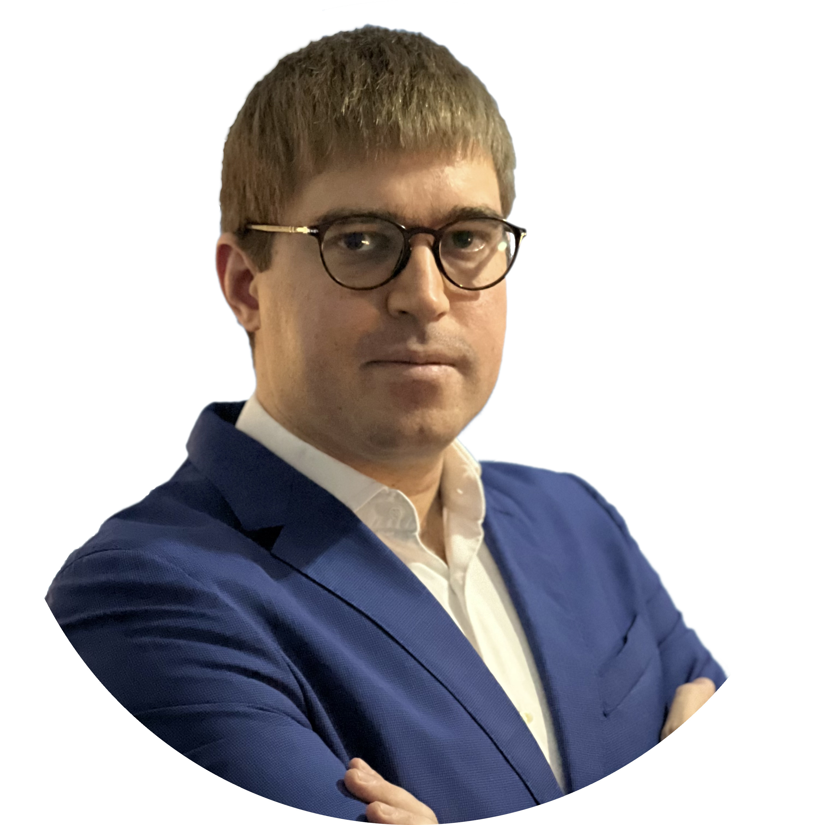 | Gabriel Torcat  Innovation / Technology / X06
  English
  Spanish
  French
  Japanese

