Introduction
Mention the Wiki version: http://otl.17slon.com/book/doku.php

Introduction to Multithreading

About

Why Multithreading
link to the Martin Harvey book - http://www.eonclash.com/Tutorials/Multithreading/MartinHarvey1.1/ToC.html

When not to Multithread

Guidelines

Think about the algorithm

Think about the interaction points between threads

Sending millions and millions of messages is bad

Banging on a critical section is bad

Hitting memory manager thousand times a second is bad

Introduction to OmniThreadLibrary

Why Use OTL

Tasks vs. Threads

Locking (vs.) Messaging

TOmniValue

High-level Multithreading

Introduction
Why high-level “abstractions”
Optimized solutions that are not trivial to achieve from own code
Thread pool is always used
Lifecycle of a Parallel interface
Ref must be stored somewhere
Must be nilled at the end
Termination depends – will be covered in separate sections

Anonymous Procedures, Methods and Normal Procedures
- All high-level tasks are coded so that accept anonymous method as a task body
- Delphi compiler allows you to use normal method or procedure instead
- (check if there’s a good description on the web)
- examples

Blocking Collection
http://www.thedelphigeek.com/2010/02/three-steps-to-blocking-collection-3.html
ref to Dynamic Queue chapter

Task Config
http://www.thedelphigeek.com/2011/04/configuring-background-otlparallel.html
IOmniTaskConfig = interface
procedure Apply(const task: IOmniTaskControl);
function CancelWith(const token: IOmniCancellationToken): IOmniTaskConfig;
function MonitorWith(const monitor: IOmniTaskControlMonitor): IOmniTaskConfig;
function OnMessage(eventDispatcher: TObject): IOmniTaskConfig; overload;
function OnMessage(eventHandler: TOmniTaskMessageEvent): IOmniTaskConfig; overload;
function OnMessage(msgID: word; eventHandler: TOmniTaskMessageEvent): IOmniTaskConfig; overload;
function OnMessage(msgID: word; eventHandler: TOmniMessageExec): IOmniTaskConfig; overload;
function OnTerminated(eventHandler: TOmniTaskTerminatedEvent): IOmniTaskConfig; overload;
function OnTerminated(eventHandler: TOmniOnTerminatedFunction): IOmniTaskConfig; overload;
function OnTerminated(eventHandler: TOmniOnTerminatedFunctionSimple): IOmniTaskConfig; overload;
function WithCounter(const counter: IOmniCounter): IOmniTaskConfig;
function WithLock(const lock: TSynchroObject; autoDestroyLock: boolean = true): IOmniTaskConfig; overload;
function WithLock(const lock: IOmniCriticalSection): IOmniTaskConfig; overload;

Async
Async is the simplest of high-level abstractions and is typically used for fire and forget scenarios. To create an Async task, call Parallel.Async.
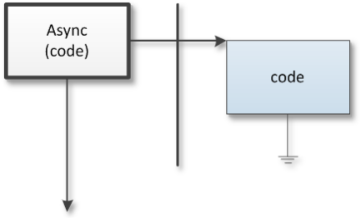
When you call Async, code is started in a new thread (indicated by the bold vertical line) and both main and background threads continue execution. At some time, background task completes execution and disappears.
Example:
Parallel.Async(
procedure
begin
MessageBeep($FFFFFFFF);
end);
This simple program creates a background task with a sole purpose to make some noise from it. The task is coded as an anonymous method but you can also use a normal method or a normal procedure for the task code (see section 4.1.1 for more information).
If the task requires access to the Task interface
procedure TfrmMultithreadingMadeSimple.btnAsyncGETClick(Sender: TObject);
begin
Parallel.Async(
procedure
var
page: string;
begin
HttpGet('otl.17slon.com', 80, '/tutorials.htm', page, '');
end);
end;

Advanced usage: Parallel.Async(procedure (const task: IOmniTask))
Advanced version can use (for example) task to send messages to the owner
“read more” links
procedure TfrmMultithreadingMadeSimple.btnAsyncGETResultClick(Sender: TObject);
begin
Parallel.Async(
procedure (const task: IOmniTask)
var
page: string;
begin
HttpGet('otl.17slon.com', 80, 'tutorials.htm', page, '');
task.Invoke(
procedure
begin
lbLogAsync.Items.Add(Format('Async GET: %d ms; page length = %d',
[time, Length(page)]))
end);
end);
end;

Warning – if the solution gets complicated, you may be using wrong abstraction. In this case, using a Future may be more appropriate.
Task Config
Typical usage - to set termination handler
http://www.thedelphigeek.com/2011/04/simple-background-tasks-with.html
http://www.thedelphigeek.com/2011/07/life-after-21-async-redux.html

Future
A future is a background calculation that returns a result. To create the task, call Parallel.Future (providing the type returned from the calculation). To get the result of the calculation, call the .Value method on the interface returned from the Parallel.Future call.

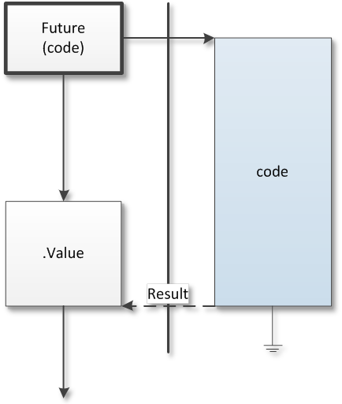
http://www.thedelphigeek.com/2011/07/life-after-21-exceptions-in.html
When you call the Parallel.Future, a background task is started immediately. The task will continue with it’s (possibly long) execution and the main thread can do some other work. When you need the result of the background calculation, call the .Value method, which will return the result immediately if it is ready or which will wait on the background code to complete its work if necessary.
procedure TfrmMultithreadingMadeSimple.btnFutureGETClick(Sender: TObject);
var
getFuture: IOmniFuture<string>;
page: string;
time: int64;
begin
time := DSiTimeGetTime64;
getFuture := Parallel.Future<string>(FutureGet);
lbLogFuture.Items.Add(Format('Future: %d ms', [DSiElapsedTime64(time)]));
// do some other processing
Sleep(1000);
page := getFuture.Value;
lbLogFuture.Items.Add(Format('Future GET: %d ms; page length = %d',
[DSiElapsedTime64(time), Length(page)]));
end;

function TfrmMultithreadingMadeSimple.FutureGET: string;
begin
HttpGet('otl.17slon.com', 80, '/tutorials.htm', Result, '');
end;

Join
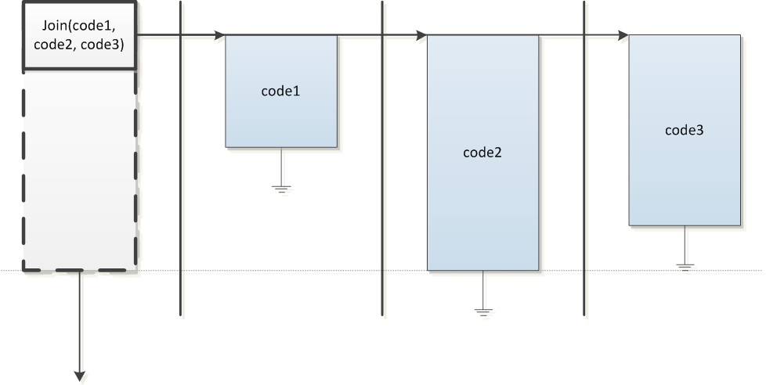
http://www.thedelphigeek.com/2011/07/life-after-21-paralleljoins-new-clothes.html

ParallelTask
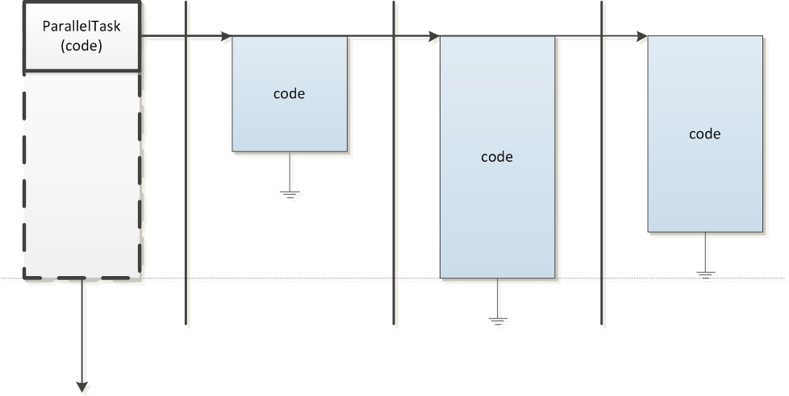
http://www.thedelphigeek.com/2011/09/life-after-21-parallel-data-production.html

BackgroundWorker
!!missing image!!
http://www.thedelphigeek.com/2012/01/background-worker.html

Pipeline
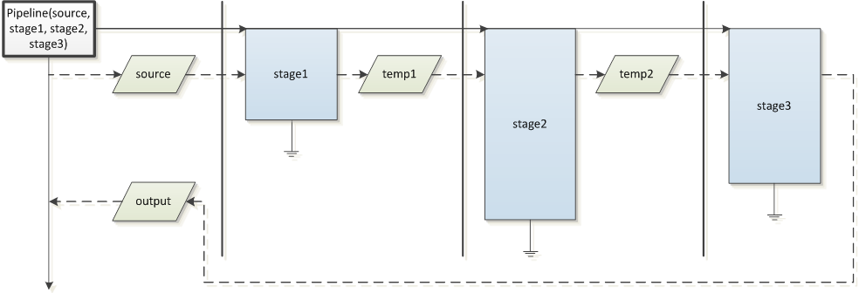
http://www.thedelphigeek.com/2010/11/multistage-processes-with.html
http://www.thedelphigeek.com/2011/09/life-after-21-pimp-my-pipeline.html

ForEach
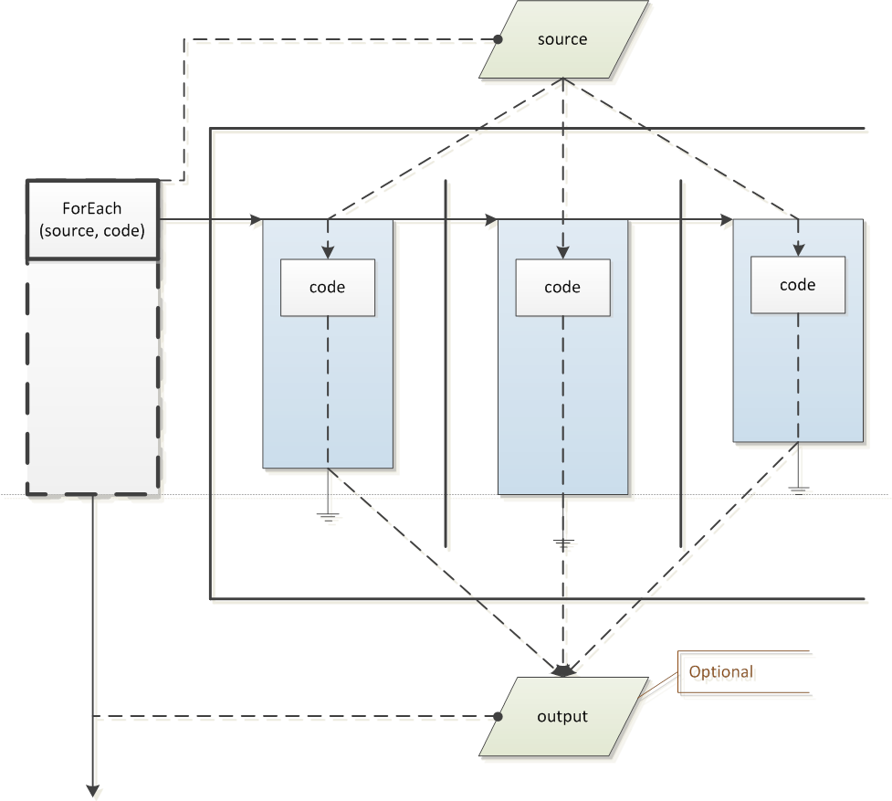
http://www.thedelphigeek.com/2010/06/omnithreadlibrary-20-sneak-preview-1.html
http://www.thedelphigeek.com/2010/02/parallelforeachaggregate.html
http://www.thedelphigeek.com/2011/01/parallel-for-implementation-1-overview.html
http://www.thedelphigeek.com/2011/01/parallel-for-implementation-2-input.html
http://www.thedelphigeek.com/2011/02/parallel-for-implementation-3-output.html

ForkJoin
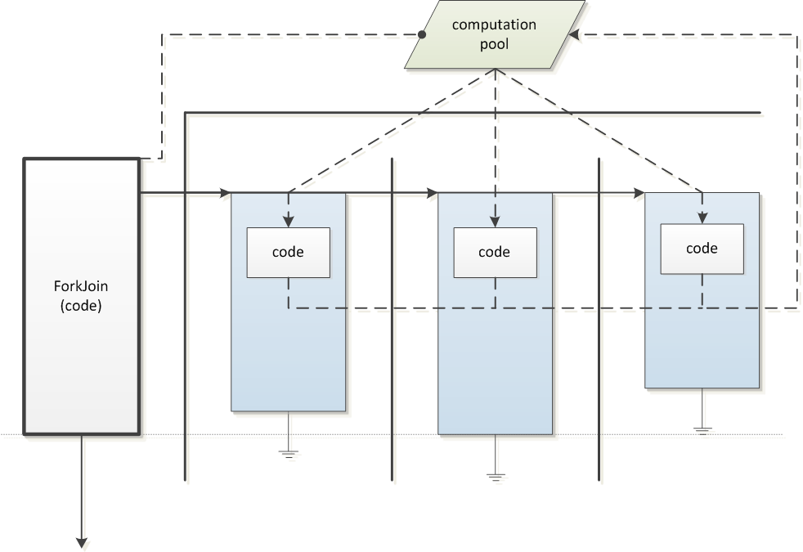
http://www.thedelphigeek.com/2011/05/divide-and-conquer-in-parallel.html

Low-level multithreading

Introduction

Four ways to create a task
http://www.thedelphigeek.com/2008/09/omnithreadlibrary-patterns-how-to-not.html

Task Controller Needs an Owner
http://www.thedelphigeek.com/2009/11/omnithreadlibrary-patterns-task.html

Thread Pooling
GOmniThreadPool

Lock-free Collections

Bounded Stack

Bounded Queue

Dynamic Queue
http://www.thedelphigeek.com/2010/02/dynamic-lock-free-queue-doing-it-right.html

Event Monitor

Simple Tasks

Name

UniqueID

Parameters

Communication
Comm

Invoke
http://www.thedelphigeek.com/2008/10/erlangenizing-omnithreadlibrary.html
http://www.thedelphigeek.com/2008/10/omnithreadlibrary-using-rtti-to-call.html
http://www.thedelphigeek.com/2011/03/synchronize-comes-to-omnithreadlibrary.html
How to simulate synchronous execution
type
TSynchroDelegate = reference to function: TOmniValue;

function TDatabaseExportTask.Synchronize(proc: TSynchroDelegate; timeout: cardinal): TOmniValue;
var
wait: IOmniWaitableValue;
begin
wait := CreateWaitableValue;
Task.Invoke(
procedure
begin
wait.Signal(proc());
end);
wait.WaitFor(timeout);
Result := wait.Value;
end; { TDatabaseExportTask.Synchronize }
Termination
Terminate
Terminated
Stopped
TerminateEvent
WaitFor
ExitCode
SetExitStatus

Exceptions
FatalException
DetachException
SetException

ChainTo

Groups – Join/Leave

MonitorWith

Enforced

Unobserved

CancellationToken/CancelWith

Lock/WithLock

Counter/WithCounter

ThreadData

SetPriority

WaitForInit

SetQueueSize

TOmniWorker Tasks

Introduction
Rationale – implements what most complicated TThread implementations do – a loop that waits for events (of various types) and responds to them
In short – it does for TThread what VCL did for a Windows program – instead of a monolothic loop-test-and-branch we have a bunch of disjoint handler
Passing parameters through the constructor

Initialize, Run, Cleanup

Timers

Communication
Rethink the structure – parts of this can also be implemented in the Simple Task scenario

Sending to the Owner

Receiving from the Owner

Talking to other tasks

Windows Message Processing
http://www.thedelphigeek.com/2008/09/processing-windows-messages-in.html

Alertable

MsgWait

UserData

RegisterWaitObject

Task Group

Synchronization

IOmniCriticalSection

Hassle-Free Critical Sections (TOmniCS)
http://www.thedelphigeek.com/2011/11/atomic-interface-initialization.html

TOmniMREW

Pessimistic, Optimistic and Busy-Wait Initialization
http://www.thedelphigeek.com/2011/12/on-optimistic-and-pessimistic.html
http://www.thedelphigeek.com/2011/12/busy-wait-initialization.html

Inverse Semaphore

Cancellation Token
GOmniCancellationToken

Miscellaneous Stuff

TOmniValue
http://www.thedelphigeek.com/2010/03/speed-comparison-variant-tvalue-and.html
http://www.thedelphigeek.com/2011/11/tomnivalue-handles-arrays-hashes-and.html

TOmniValueObj

TOmniWaitableValue

TOmniValueContainer

TOmniCounter

IOmniInterfaceDictionary

TOmniRecordWrapper

IOmniAutoDestroyObject

Environment

Hooks

IOmniTaskControlList

Atomic instructions (CAS, Move)

Communication Observers

How-to

Web Download and Database Storage
http://www.thedelphigeek.com/2011/10/omnithreadlibrary-in-practice-1web.html

Background Worker and List Partitioning
http://www.thedelphigeek.com/2012/01/omnithreadlibrary-in-practice.html

Background File Scanning
http://www.thedelphigeek.com/2008/11/background-file-scanning-with.html

Building a Connection Pool
http://www.thedelphigeek.com/2009/02/building-connection-pool.html

QuickSort

Parallel Search in a Tree

Multiple Workers with Multiple Frames

OmniThreadLibrary and Databases
Anonymous: I'm using databases (dbExpress & MSSQL) with threading (not OmniThread). So far the only gotcha is that you must ensure there's a different connection object per thread.
All I did is have a connection pool and GetConnection / FinishedWithConnection functions that ensure there's always a connection per thread ID. The connections are just reference counted to ensure they're not freed whilst in use.
To be fair though, databases are only accessed to build a cache, so perhaps I'm not seeing some of the complexities?
Moz: I think part of the reason for the paucity of documentation is that it's either very, very simple (one session or connection per thread. The end). Or it's very, very complex (ADO async, hand-rolled connection sharing, etc). If you get into NoSQL it becomes simple again, and in many ways I'd rather write sample code that does that.

I'm happy to write up some commentary on databases once there's a spot for it and I can see the style of what you're writing. I've used OTL somewhat and databases rather a lot (and the combination whenever I've used OTL seriously).

The simple approach is one connection per thread as noted above, and that's easy to do. But that can be wasteful of connections (which can lead to server thrashing), and if you're doing ye olde two tier development makes threading pretty much useless, since your database access is tied to the GUI which is tied to the main VCL thread.

In that situation you can, however, cheat this quite significantly by opening datasets in threads but re-setting datasource.Active in the main thread when the dataset has finished opening (and changing the underlying session appropriately, of course). Mostly - this sort of trickery is undocumented and unsupported, but can give you huge performance wins with relatively small code changes (because you're opening slow queries in parallel). You can sometimes do this via ADO async mode but that has its own challenges.

OmniThreadLibrary and COM/OLE

