Introduction
Mention the Wiki version: http://otl.17slon.com/book/doku.php
→ notation

Introduction to Multithreading

About

Why Multithreading
link to the Martin Harvey book - http://www.eonclash.com/Tutorials/Multithreading/MartinHarvey1.1/ToC.html

When not to Multithread

Guidelines

Think about the algorithm

Think about the interaction points between threads

Sending millions and millions of messages is bad

Banging on a critical section is bad

Hitting memory manager thousand times a second is bad

Introduction to OmniThreadLibrary

Why Use OTL

Tasks vs. Threads
- Explain IOmniTaskControl and IOmniTask

Locking (vs.) Messaging

TOmniValue

High-level Multithreading

Introduction
- Why high-level “abstractions”
- Optimized solutions that are not trivial to achieve from own code
- Thread pool is always used
- Lifecycle of a Parallel interface
  - Ref must be stored somewhere
  - Must be nilled at the end
  - Termination depends – will be covered in separate sections
- Uses OtlParallel
- Implemented using Parallel class class functions
- Fluent interface approach

Anonymous Procedures, Methods and Normal Procedures
- All high-level tasks are coded so that accept anonymous method as a task body
- Delphi compiler allows you to use normal method or procedure instead
- (check if there’s a good description on the web)
- Examples

Handling Exceptions

Blocking Collection
http://www.thedelphigeek.com/2010/02/three-steps-to-blocking-collection-3.html
ref to Dynamic Queue chapter

Task Config
http://www.thedelphigeek.com/2011/04/configuring-background-otlparallel.html
IOmniTaskConfig = interface
procedure Apply(const task: IOmniTaskControl);
function CancelWith(const token: IOmniCancellationToken): IOmniTaskConfig;
function MonitorWith(const monitor: IOmniTaskControlMonitor): IOmniTaskConfig;
function OnMessage(eventDispatcher: TObject): IOmniTaskConfig; overload;
function OnMessage(eventHandler: TOmniTaskMessageEvent): IOmniTaskConfig; overload;
function OnMessage(msgID: word; eventHandler: TOmniTaskMessageEvent): IOmniTaskConfig; overload;
function OnMessage(msgID: word; eventHandler: TOmniMessageExec): IOmniTaskConfig; overload;
function OnTerminated(eventHandler: TOmniTaskTerminatedEvent): IOmniTaskConfig; overload;
function OnTerminated(eventHandler: TOmniOnTerminatedFunction): IOmniTaskConfig; overload;
function OnTerminated(eventHandler: TOmniOnTerminatedFunctionSimple): IOmniTaskConfig; overload;
function WithCounter(const counter: IOmniCounter): IOmniTaskConfig;
function WithLock(const lock: TSynchroObject; autoDestroyLock: boolean = true): IOmniTaskConfig; overload;
function WithLock(const lock: IOmniCriticalSection): IOmniTaskConfig; overload;

Async
Async is the simplest of high-level abstractions and is typically used for fire and forget scenarios. To create an Async task, call Parallel.Async.
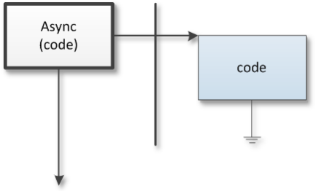
When you call Parallel.Async, code is started in a new thread (indicated by the bold vertical line) and both main and background threads continue execution. At some time, background task completes execution and disappears.
Example:
Parallel.Async(
procedure
begin
MessageBeep($FFFFFFFF);
end);

This simple program creates a background task with a sole purpose to make some noise from it. The task is coded as an anonymous method but you can also use a normal method or a normal procedure for the task code (→ 4.1.1).
The Parallel class defines two Async overloads. The first accepts a parameter-less background task and an optional task configuration block (→ 4.3) and the second accepts a background task with an IOmniTask (→ 3.2) parameter and an optional task configuration block.
type
TOmniTaskDelegate = reference to procedure(const task: IOmniTask);

Parallel = class
class procedure Async(task: TProc;
taskConfig: IOmniTaskConfig = nil); overload;
class procedure Async(task: TOmniTaskDelegate;
taskConfig: IOmniTaskConfig = nil); overload;
...
end;

The second form is useful if the background code needs access to the IOmniTask interface (→ 3.2), for example to send messages to the owner or to execute code in the owner thread (typically that will be the main thread).
The example below uses Async task to fetch the contents of a web page (by calling a mysterious function HttpGet) and then uses Invoke (→ 5.5.5) to execute a code that logs the length of the result in the main thread.
Parallel.Async(
procedure (const task: IOmniTask)
var
page: string;
begin
page := HttpGet('http://otl.17slon.com/tutorials.htm', page, '');
task.Invoke(
procedure
begin
lbLogAsync.Items.Add(Format('Async GET: %d ms; page length = %d',
[time, Length(page)]))
end);
end);

The same result could be achieved by sending a message from the background thread to the main thread. TaskConfig block (→ 4.3) is used to configure message handler.
const
WM_RESULT = WM_USER;

procedure LogResult(const task: IOmniTaskControl; const msg: TOmniMessage);
begin
lbLogAsync.Items.Add(Format('Async GET: %d ms; page length = %d',
[time, Length(page)]))
end;

Parallel.Async(
procedure (const task: IOmniTask)
var
page: string;
begin
page := HttpGet('http://otl.17slon.com/tutorials.htm');
task.Comm.Send(WM_RESULT, page);
end,
TaskConfig.OnMessage(WM_RESULT, LogResult)
);

Let me warn you that in cases where you want to return a result from a background task, Async abstraction is not the most appropriate. You would be better off by using a Future (→ 4.5).

Handling Exceptions
If the background code raises unhandled exception, OmniThreadLibrary will catch this exception and re-raise it in the OnTerminated handler. This way the exception will travel from the background thread to the owner thread where it can be processed.
As the OnTerminated handler occurs at the unspecified moment when Windows are processing window messages, there is no good way to catch this message with a try..except block. The caller must install its own OnTerminated handler instead and handle exception there.
The following example uses OnTerminated handler to detach fatal exception from the task (→ 5.5.6), log the exception details and destroy the exception object.
Parallel.Async(
procedure
begin
Sleep(1000);
raise Exception.Create('Exception in Async');
end,
Parallel.TaskConfig.OnTerminated(
procedure (const task: IOmniTaskControl)
var
excp: Exception;
begin
if assigned(task.FatalException) then begin
excp := task.DetachException;
Log('Caught async exception %s:%s', [excp.ClassName, excp.Message]);
FreeAndNil(excp);
end;
end
));

If you don’t install a OnTerminated handler, exception will be handled by the application-level filter, which will by default cause a message box to appear.

Future
A future is a background calculation that returns a result. To create the task, call Parallel.Future<T> (where T is the type returned from the calculation). This will return a result of type IOmniFuture<T>, which is the interface you will use to work with the background task.
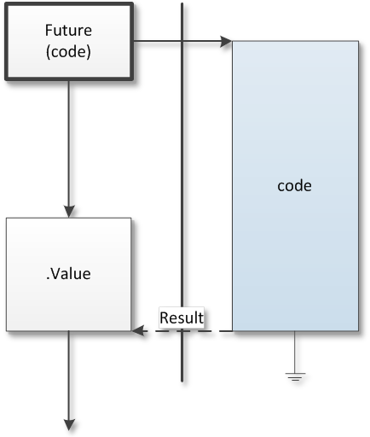
When you call Parallel.Future, a background task is started immediately. The task will continue with its (possibly long) execution and the main thread can do some other work. When you need the result of the background calculation, call the .Value method, which will return the result immediately if it is ready or which will wait on the background code to complete its work if necessary.

To get the result of the calculation, call the .Value method on the interface returned from the Parallel.Future call.
Example:
var
FCalculation: IOmniFuture<integer>;

procedure StartCalculation;
begin
FCalculation := Parallel.Future<integer>(
function: integer
var
i: integer;
begin
Result := 0;
for i := 1 to 100000 do
Result := Result + i;
end
);
end;

function GetResult: integer;
begin
Result := FCalculation.Value;
FCalculation := nil;
end;

The Parallel class implements two Future<T> overloads. The first accepts a parameter-less background task and an optional task configuration block (→ 4.3) and the second accepts a background task with an IOmniTask (→ 3.2) parameter and an optional task configuration block.
type
TOmniFutureDelegate<T> = reference to function: T;
TOmniFutureDelegateEx<T> = reference to function(const task: IOmniTask): T;

Parallel = class
class function Future<T>(action: TOmniFutureDelegate<T>;
taskConfig: IOmniTaskConfig = nil): IOmniFuture<T>; overload;
class function Future<T>(action: TOmniFutureDelegateEx<T>;
taskConfig: IOmniTaskConfig = nil): IOmniFuture<T>; overload;
...
end;

The second form is useful if the background code needs access to the IOmniTask interface (→ 3.2), for example to send messages to the owner or to execute code in the owner thread (typically that will be the main thread).
A Future task always wraps a function of some type. In the example above the function added numbers from 1 to 100000 and returned an integer result. That's why the Future task was created by calling Parallel.Future<integer> and why the result – the interface that provides a way to manage the task – is declared as IOmniFuture<integer>. But a Future could equally well return result of any type – a string or a date/time or even a record, class or interface.
The following example is a rewrite of the Async (→ 4.4) example. It uses the same mysterious HttpGet function but it is wrapped in a more flexible way. Function StartHttpGet accepts a url parameter specifying which page to retrieve from the web server. It then creates a future returning a string and passes it a simple code to execute – a one-liner anonymous function that only calls the already known HttpGet.
This example illustrates two important points:
- Anonymous methods are great for capturing variables. If you look at the StartHttpGet again, you’ll see that the url parameter is used from two different threads. StartHttpGet is called in the main thread and the anonymous code is executed in the background thread. Still, the parameter somehow makes it across this thread boundary – and that is done by the anonymous method magic.
- Don’t write long and complicated anonymous methods – it is better to call external method from the anonymous code and make the long and complicated calculation in that external method (or in code called from that method etc).
var
FGetFuture: IOmniFuture<string>;

function HttpGet(const url: string): string;
begin
// this function fetches a page from the web server and returns its contents
end;

procedure StartHttpGet(const url: string);
begin
FGetFuture := Parallel.Future<string>(
function: string
begin
Result := HttpGet(url);
end
);
end;

function GetResult: string;
begin
Result := FGetFuture.Value;
FGetFuture := nil;
end;

IOmniFuture<T> Interface
The IOmniFuture<T> interface implements other methods besides the Value.
type
IOmniFuture<T> = interface
procedure Cancel;
function DetachException: Exception;
function FatalException: Exception;
function IsCancelled: boolean;
function IsDone: boolean;
function TryValue(timeout_ms: cardinal; var value: T): boolean;
function Value: T;
function WaitFor(timeout_ms: cardinal): boolean;
end;

The interface implements exception-handling functions (→ 4.5.4), cancellation support (→ 4.5.3) and functions that check if the background calculation has completed. (→ 4.5.2)

Completion Detection
When you call the Value function you don’t know ahead what will happen. If the background code has already calculated the result, the Value call will return immediately. Otherwise, the caller thread will be blocked until the result is available and if you are executing a long calculation (or if the web or database connection did not succeed and is now waiting for a timeout to occur) this may last a while. If you created the future in the main thread, then your whole application will be blocked until Value returns.
There are few ways around this problem. One is to periodically call the IsDone function. It will return False while the background calculation is still working and True one the result is available. Another option is to call WaitFor with some (small) timeout. WaitFor will wait specified number of milliseconds and will return True if result is available. Third way to achieve the same is to call TryValue periodically. TryValue also waits some specified number of milliseconds and returns True if result is available but in addition it will also return the result in the value parameter.
The fourth and completely different way is to specify the termination handler (→ 4.3) which will notify you when the background calculation is completed. The following example sets the termination handler to get the value of the background calculation into the memo field and then destroy the Future interface.
procedure StartHttpGet(const url: string);
begin
FGetFuture := Parallel.Future<string>(
function: string
begin
Result := HttpGet(url);
end,
Parallel.TaskConfig.OnTerminated(
procedure
begin
Memo1.Text := FGetFuture.Value;
FGetFuture := nil;
end
)
);
end;

Cancellation
It is possible to cancel the background execution of the future before it is completed. The Future uses Cancellation token mechanism (→ 6.6) to achieve this. Cancellation is cooperative – if the background task does not willingly cancel itself, cancellation will fail.
To cancel a background task, the Future owner (the code that called Parallel.Future) has to call the Cancel method on the IOmniFuture<T> interface. This will signal the cancellation token which the background task must check periodically. To get access to the cancellation token, background code must be declared differently – not as parameterless function but as a function accepting an IOmniTask (→ 3.2) parameter.
The following (pretty much pointless) program illustrates this concept.
var
FCountFuture: IOmniFuture<integer>;

function CountTo100(const task: IOmniTask): integer;
var
i: integer;
begin
for i := 1 to 100 do begin
Sleep(100);
Result := i;
if task.CancellationToken.IsSignalled then
break; //for
end;
end;

procedure StartCounting;
begin
FCountFuture := Parallel.Future<integer>(CountTo100);
Sleep(100);
FCountFuture.Cancel;
FCountFuture.WaitFor(INFINITE);
FCountFuture := nil;
end;

StartCounting creates a Future which executes CountTo100 function in the background. It then sleeps 100 milliseconds, calls the Cancel function, waits for the Future to terminate and clears the Future interface.
CountTo100 function counts from 1 to 100. It sleeps for 100 milliseconds after each number, stores the current counter in the function result and then checks the cancellation token. If it is signaled (meaning that the owner called the Cancel function), it will break out of the for loop.
If you put a breakpoint on the last line of the StartCounting function and run the program, you’ll see that it will be reached almost immediately, proving that the CountTo100 did not take 10 seconds to return a result (100 repeats * 100 milliseconds = 10 seconds).
You cannot call the Value function if the calculation was cancelled as it would raise an EFutureCancelled exception. If you don’t know whether the Cancel was called or not, you can call the IOmniFuture<T>.IsCancelled and check the result (True = calculation was cancelled).

Handling Exceptions
If the background code raises unhandled exception (i.e. the exception was not captured in a try..except block), OmniThreadLibrary will catch this exception and gracefully complete the background task. When you call the Value function, this exception will be raised.
This immensely helps with debugging as the background exceptions (exceptions in background threads) are ignored. Delphi ignores all exceptions in background threads – you can handle them if you write appropriate code but they are not automatically visible – and that can be quite dangerous. As the Future exceptions are re-raised in the main thread when the Value is called this makes them equivalent to other exceptions in the main thread.
There are few different ways to handle exceptions in Futures and they are most simply explained through the code. First example catches the exception by wrapping the Value call in try..except.
procedure FutureException1;
var
future: IOmniFuture<integer>;
begin
future := Parallel.Future<integer>(
function: integer
begin
raise ETestException.Create('Exception in Parallel.Future');
end
);
Log('Future is executing ...');
Sleep(1000);
try
Log('Future retured: %d', [future.Value]);
except
on E: Exception do
Log('Future raised exception %s:%s', [E.ClassName, E.Message]);
end;
end;

Second example uses WaitFor to wait on task completion and then checks the result of the FatalException (→ 5.5.6) function. It will return Nil if there was no exception or the exception object if there was an exception. Exception object itself will still be owned by the Future task and will be destroyed when the Future is destroyed.
procedure FutureException2;
var
future: IOmniFuture<integer>;
begin
future := Parallel.Future<integer>(
function: integer
begin
raise ETestException.Create('Exception in Parallel.Future');
end
);
Log('Future is executing ...');
future.WaitFor(INFINITE);
if assigned(future.FatalException) then
Log('Future raised exception %s:%s',
[future.FatalException.ClassName, future.FatalException.Message])
else
Log('Future retured: %d', [future.Value]);
end;

Third example shows how you can detach exception from the future. By calling DetachException (→ 5.5.6) you will get the ownership of the exception object and you should destroy it at some appropriate point in time.
procedure FutureException3;
var
excFuture: Exception;
future : IOmniFuture<integer>;
begin
future := Parallel.Future<integer>(
function: integer
begin
raise ETestException.Create('Exception in Parallel.Future');
end
);
Log('Future is executing ...');
future.WaitFor(INFINITE);
excFuture := future.DetachException;
try
if assigned(excFuture) then
Log('Future raised exception %s:%s',
[excFuture.ClassName, excFuture.Message])
else
Log('Future retured: %d', [future.Value]);
finally FreeAndNil(excFuture); end;
end;

Join
Join abstraction enables you to start multiple background tasks in multiple threads. To create the task, call Parallel.Join.
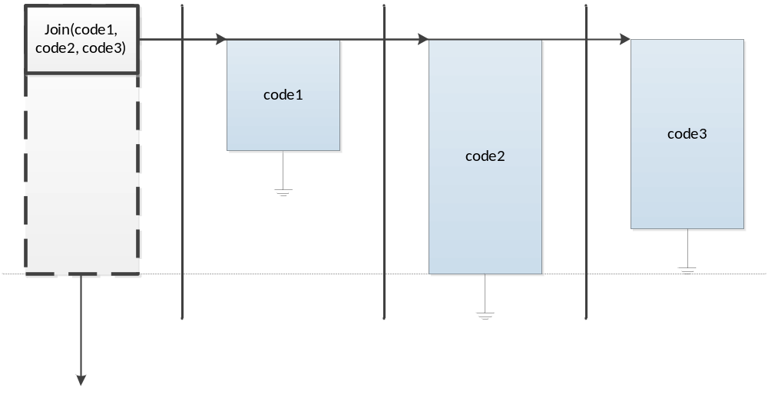When you use Parallel.Join, background tasks are started in background threads. By default, Join waits for all background threads to complete before the control is returned to the caller.
Example:
Parallel.Join(
procedure
var
i: integer;
begin
for i := 1 to 8 do begin
Sleep(200);
MessageBeep($FFFFFFFF);
end,
procedure
var
i: integer;
begin
for i := 1 to 10 do begin
Sleep(160);
MessageBeep($FFFFFFFF);
end;
end
).Execute;

This simple program executes two background tasks, each beeping at different frequency. Each task is coded as an anonymous method but you can also use a normal method or a normal procedure for the task code (→ 4.1.1).
The Parallel class defines five Join overloads. The first creates empty IOmniParallelJoin interface. Next two create same interface but configured with two tasks and last two contain this interface configured for any number of tasks. Tasks can be of two different types – parameterless methods and methods containing one parameter of the IOmniJoinState type.
type
TOmniJoinDelegate = reference to procedure (const joinState: IOmniJoinState);

Parallel = class
class function Join: IOmniParallelJoin; overload;
class function Join(const task1, task2: TProc): IOmniParallelJoin; overload;
class function Join(const task1, task2: TOmniJoinDelegate):
IOmniParallelJoin; overload;
class function Join(const tasks: array of TProc): IOmniParallelJoin; overload;
class function Join(const tasks: array of TOmniJoinDelegate):
IOmniParallelJoin; overload;
...
end;

IOmniParallelJoin Interface
Parallel.Join returns an IOmniParallelJoin interface which you can use to specify tasks, start and control execution and handle exceptions.
type
IOmniParallelJoin = interface
function Cancel: IOmniParallelJoin;
function DetachException: Exception;
function Execute: IOmniParallelJoin;
function FatalException: Exception;
function IsCancelled: boolean;
function IsExceptional: boolean;
function NumTasks(numTasks: integer): IOmniParallelJoin;
function OnStop(const stopCode: TProc): IOmniParallelJoin;
function Task(const task: TProc): IOmniParallelJoin; overload;
function Task(const task: TOmniJoinDelegate): IOmniParallelJoin;
overload;
function TaskConfig(const config: IOmniTaskConfig): IOmniParallelJoin;
function NoWait: IOmniParallelJoin;
function WaitFor(timeout_ms: cardinal): boolean;
end;

The most important of these functions is Execute. It will start appropriate number of background threads and start executing tasks in those threads. By default, Join uses as many threads as there are tasks but you can override this behaviour by calling the NumTasks function.
You can add tasks to the Join by calling the Task function. In fact, that’s just how the Parallel.Join overloads are implemented.
class function Parallel.Join(const task1, task2: TProc): IOmniParallelJoin;
begin
Result := TOmniParallelJoin.Create.Task(task1).Task(task2);
end;

class function Parallel.Join(const tasks: array of TProc): IOmniParallelJoin;
var
aTask: TProc;
begin
Result := TOmniParallelJoin.Create;
for aTask in tasks do
Result.Task(aTask);
end;

To set up task configuration block (→ 4.3), call the TaskConfig function. Following example uses TaskConfig to set up critical section which is then used in two parallel tasks to protect the shared resource. Workers use the IOmniJoinState instance to access the IOmniTask (→ 3.2) interface and through it the Lock (→ 5.5.13) property.
FSharedValue := 42;
Parallel.Join(
procedure (const joinState: IOmniJoinState)
var
i: integer;
begin
for i := 1 to 1000000 do begin
joinState.Task.Lock.Acquire;
FSharedValue := FSharedValue + 17;
joinState.Task.Lock.Release;
end;
end,
procedure (const joinState: IOmniJoinState)
var
i: integer;
begin
for i := 1 to 1000000 do begin
joinState.Task.Lock.Acquire;
FSharedValue := FSharedValue - 17;
joinState.Task.Lock.Release;
end;
end
).TaskConfig(Parallel.TaskConfig.WithLock(CreateOmniCriticalSection))
.Execute;

By default, Join will wait for all background tasks to complete execution. Alternatively, you can call the NoWait function, after which Join will just start the tasks and return immediately. If you want to be notified when all tasks are finished, you can assign the termination handler by calling the OnStop function. Alternatively, code can call WaitFor, which accepts an optional timeout parameter.

IomniJoinState Interface
Tasks can be defined to accept a parameter of type IOmniJoinState. This allows them to access the IOmniTask (→ 3.2) interface, participate in the cooperative cancellation (→ 4.6.3) and check for exceptions (→ 4.6.4).
type
IOmniJoinState = interface
function GetTask: IOmniTask;
//
procedure Cancel;
function IsCancelled: boolean;
function IsExceptional: boolean;
property Task: IOmniTask read GetTask;
end;

Cancellation
Join background tasks support cooperative cancellation. If you are using TOmniJoinDelegate tasks (that is, tasks accepting the IOmniJoinState parameter), any task can call the Cancel method of this interface. This, in turn, sets internal cancellation flag which may be queried by calling the IsCancelled method. That way, one task can interrupt other tasks provided that they are testing IsCancelled repeatedly.
Main thread can also cancel its subtasks (when using NoWait) by calling IOmniParallelJoin.Cancel and can test the cancellation flag by calling IsCancelled.
The following demo code demonstrates most of concepts mentioned above.
var
join: IOmniParallelJoin;
time: int64;
begin
FJoinCount.Value := 0;
FJoinCount2.Value := 0;
join := Parallel.Join(
procedure (const joinState: IOmniJoinState)
var
i: integer;
begin
for i := 1 to 10 do begin
Sleep(100);
FJoinCount.Increment;
if joinState.IsCancelled then
break; //for
end;
end,
procedure (const joinState: IOmniJoinState)
var
i: integer;
begin
for i := 1 to 10 do begin
Sleep(200);
FJoinCount2.Increment;
if joinState.IsCancelled then
break; //for
end;
end
).NoWait.Execute;
Sleep(500);
time := DSiTimeGetTime64;
join.Cancel.WaitFor(INFINITE);
Log(Format('Waited %d ms for joins to terminate',
[DSiElapsedTime64(time)]));
Log(Format('Tasks counted up to %d and %d',
[FJoinCount.Value, FJoinCount2.Value]));
end;

The call to Parallel.Join starts two tasks. Because the NoWait is used, the call returns immediately and stores resulting IOmniParallelJoin interface in the local variable join. Main code then sleeps for half a second, cancels the execution and immediately waits for background tasks to terminate.
Both tasks execute a simple loop which waits a little, increments a counter and checks the cancellation flag. Because the cancellation flag is set after 500 ms, we would expect five or six repetitions of the first loop (five repetitions take exactly 500 ms and we can’t tell exactly what will execute first – Cancel or fifth IsCancelled) and three repetitions of the second loop. That is exactly what the program prints out.

Handling Exceptions
Exceptions in background tasks are caught and re-raised in the WaitFor method. If you are using synchronous version of Join (without the NoWait modifier), then WaitFor is called at the end of the Execute method (in other words, Parallel.Join(…).Execute will re-raise task exceptions). If, however, you are using the asynchronous version (by calling Parallel.Join(…).NoWait.Execute), exception will only be raised when you wait for the background tasks to complete by calling WaitFor.
You can test for the exception by calling the FatalException function. It will first wait for all background tasks to complete (without raising the exception) and then return the exception object. You can also detach the exception object from the Join and handle it yourself by using the DetachException function.
There’s also an IsExceptional function (available in IOmniParallelJoin and IOmniJoinState interfaces) which tells you if any background task has thrown an exception.
There’s an additional complication – as Join executes multiple tasks, there can be multiple background exceptions. To get you full access to those exceptions, Join wraps them into EJoinException object.
type
EJoinException = class(Exception)
constructor Create; reintroduce;
destructor Destroy; override;
procedure Add(iTask: integer; taskException: Exception);
function Count: integer;
property Inner[idxException: integer]: TJoinInnerException
read GetInner; default;
end;

This exception class contains combined error messages from all background tasks in its Message property and allows you to access exception information for all caught exceptions directly with the Inner[] property. The following code demonstrates this.
var
iInnerExc: integer;
begin
try
Parallel.Join([
procedure begin
raise ETestException.Create('Exception 1 in Parallel.Join');
end,
procedure begin
end,
procedure begin
raise ETestException.Create('Exception 2 in Parallel.Join');
end]).Execute;
except
on E: EJoinException do begin
Log('Join raised exception %s:%s', [E.ClassName, E.Message]);
for iInnerExc := 0 to E.Count - 1 do
Log(' Task #%d raised exception: %s:%s', [E[iInnerExc].TaskNumber,
E[iInnerExc].FatalException.ClassName,
E[iInnerExc].FatalException.Message]);
end;
end;
end;

The iInnerExc variable loops over all caught exceptions and for each such exception displays the task number (starting with 0), exception class and exception message.
This approach allows you to either just log the exception or, if you are interested in details, examine specific inner exceptions and handle them appropriately.

ParallelTask
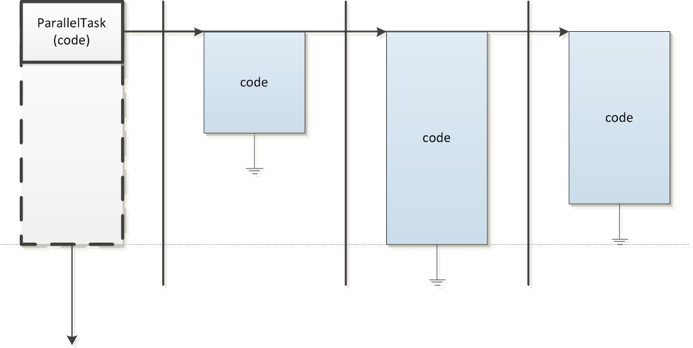
http://www.thedelphigeek.com/2011/09/life-after-21-parallel-data-production.html

BackgroundWorker
!!missing image!!
http://www.thedelphigeek.com/2012/01/background-worker.html

Pipeline
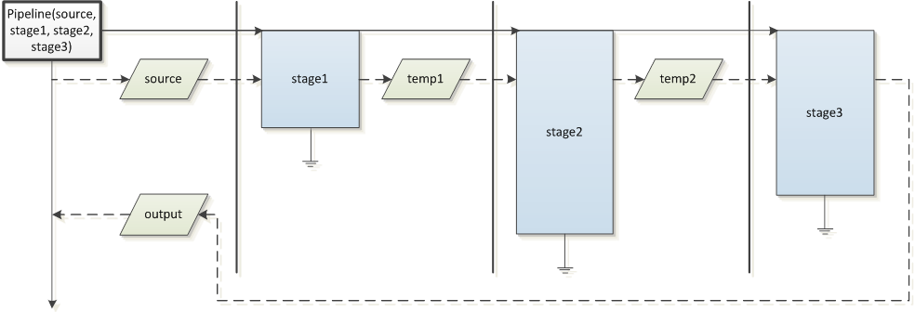
http://www.thedelphigeek.com/2010/11/multistage-processes-with.html
http://www.thedelphigeek.com/2011/09/life-after-21-pimp-my-pipeline.html

ForEach
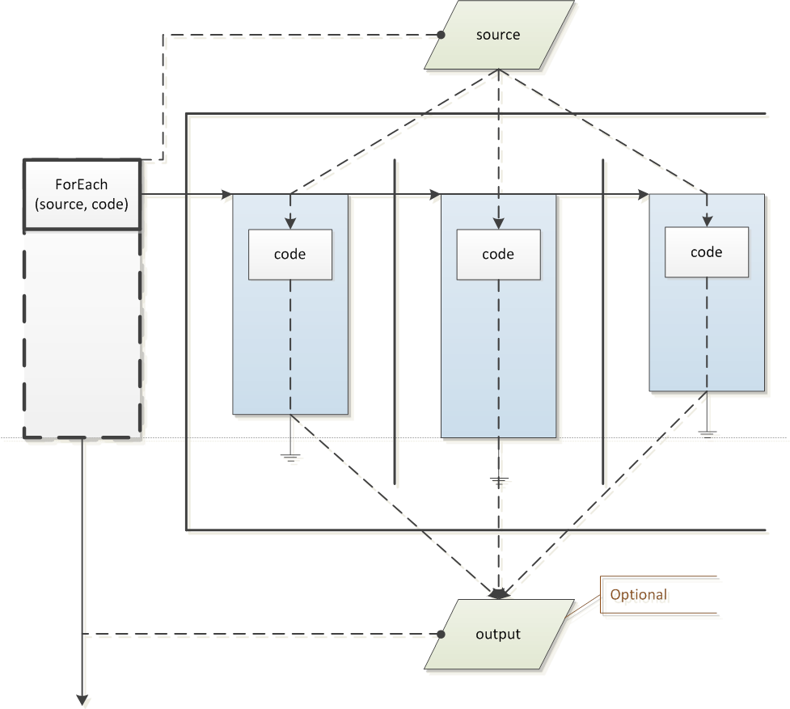
http://www.thedelphigeek.com/2010/06/omnithreadlibrary-20-sneak-preview-1.html
http://www.thedelphigeek.com/2010/02/parallelforeachaggregate.html
http://www.thedelphigeek.com/2011/01/parallel-for-implementation-1-overview.html
http://www.thedelphigeek.com/2011/01/parallel-for-implementation-2-input.html
http://www.thedelphigeek.com/2011/02/parallel-for-implementation-3-output.html

ForkJoin
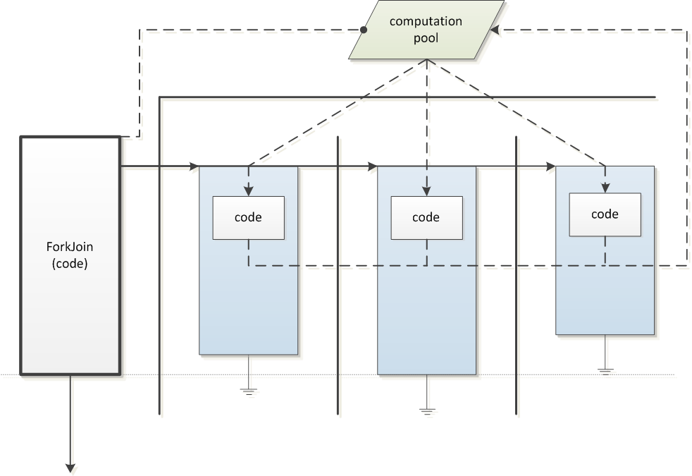
http://www.thedelphigeek.com/2011/05/divide-and-conquer-in-parallel.html

Low-level multithreading

Introduction

Four ways to create a task
http://www.thedelphigeek.com/2008/09/omnithreadlibrary-patterns-how-to-not.html

Task Controller Needs an Owner
http://www.thedelphigeek.com/2009/11/omnithreadlibrary-patterns-task.html

Thread Pooling
GOmniThreadPool

Lock-free Collections

Bounded Stack

Bounded Queue

Dynamic Queue
http://www.thedelphigeek.com/2010/02/dynamic-lock-free-queue-doing-it-right.html

Event Monitor

Simple Tasks

Name

UniqueID

Parameters

Communication
Comm

Invoke
http://www.thedelphigeek.com/2008/10/erlangenizing-omnithreadlibrary.html
http://www.thedelphigeek.com/2008/10/omnithreadlibrary-using-rtti-to-call.html
http://www.thedelphigeek.com/2011/03/synchronize-comes-to-omnithreadlibrary.html
How to simulate synchronous execution
type
TSynchroDelegate = reference to function: TOmniValue;

function TDatabaseExportTask.Synchronize(proc: TSynchroDelegate; timeout: cardinal): TOmniValue;
var
wait: IOmniWaitableValue;
begin
wait := CreateWaitableValue;
Task.Invoke(
procedure
begin
wait.Signal(proc());
end);
wait.WaitFor(timeout);
Result := wait.Value;
end; { TDatabaseExportTask.Synchronize }
Termination
Terminate
Terminated
Stopped
TerminateEvent
WaitFor
ExitCode
SetExitStatus

Exceptions
FatalException
DetachException
SetException

ChainTo

Groups – Join/Leave

MonitorWith

Enforced

Unobserved

CancellationToken/CancelWith

Lock/WithLock

Counter/WithCounter

ThreadData

SetPriority

WaitForInit

SetQueueSize

TOmniWorker Tasks

Introduction
Rationale – implements what most complicated TThread implementations do – a loop that waits for events (of various types) and responds to them
In short – it does for TThread what VCL did for a Windows program – instead of a monolothic loop-test-and-branch we have a bunch of disjoint handler
Passing parameters through the constructor

Initialize, Run, Cleanup

Timers

Communication
Rethink the structure – parts of this can also be implemented in the Simple Task scenario

Sending to the Owner

Receiving from the Owner

Talking to other tasks

Windows Message Processing
http://www.thedelphigeek.com/2008/09/processing-windows-messages-in.html

Alertable

MsgWait

UserData

RegisterWaitObject

Task Group

Synchronization

IOmniCriticalSection

Hassle-Free Critical Sections (TOmniCS)
http://www.thedelphigeek.com/2011/11/atomic-interface-initialization.html

TOmniMREW

Pessimistic, Optimistic and Busy-Wait Initialization
http://www.thedelphigeek.com/2011/12/on-optimistic-and-pessimistic.html
http://www.thedelphigeek.com/2011/12/busy-wait-initialization.html

Inverse Semaphore

Cancellation Token
GOmniCancellationToken

Miscellaneous Stuff

TOmniValue
http://www.thedelphigeek.com/2010/03/speed-comparison-variant-tvalue-and.html
http://www.thedelphigeek.com/2011/11/tomnivalue-handles-arrays-hashes-and.html

TOmniValueObj

TOmniWaitableValue

TOmniValueContainer

TOmniCounter

IOmniInterfaceDictionary

TOmniRecordWrapper

IOmniAutoDestroyObject

Environment

Hooks

IOmniTaskControlList

Atomic instructions (CAS, Move)

Communication Observers

SetThreadName

How-to

Web Download and Database Storage
http://www.thedelphigeek.com/2011/10/omnithreadlibrary-in-practice-1web.html

Background Worker and List Partitioning
http://www.thedelphigeek.com/2012/01/omnithreadlibrary-in-practice.html

Background File Scanning
http://www.thedelphigeek.com/2008/11/background-file-scanning-with.html

Building a Connection Pool
http://www.thedelphigeek.com/2009/02/building-connection-pool.html

QuickSort

Parallel Search in a Tree

Multiple Workers with Multiple Frames

OmniThreadLibrary and Databases
Anonymous: I'm using databases (dbExpress & MSSQL) with threading (not OmniThread). So far the only gotcha is that you must ensure there's a different connection object per thread.
All I did is have a connection pool and GetConnection / FinishedWithConnection functions that ensure there's always a connection per thread ID. The connections are just reference counted to ensure they're not freed whilst in use.
To be fair though, databases are only accessed to build a cache, so perhaps I'm not seeing some of the complexities?
Moz: I think part of the reason for the paucity of documentation is that it's either very, very simple (one session or connection per thread. The end). Or it's very, very complex (ADO async, hand-rolled connection sharing, etc). If you get into NoSQL it becomes simple again, and in many ways I'd rather write sample code that does that.

I'm happy to write up some commentary on databases once there's a spot for it and I can see the style of what you're writing. I've used OTL somewhat and databases rather a lot (and the combination whenever I've used OTL seriously).

The simple approach is one connection per thread as noted above, and that's easy to do. But that can be wasteful of connections (which can lead to server thrashing), and if you're doing ye olde two tier development makes threading pretty much useless, since your database access is tied to the GUI which is tied to the main VCL thread.

In that situation you can, however, cheat this quite significantly by opening datasets in threads but re-setting datasource.Active in the main thread when the dataset has finished opening (and changing the underlying session appropriately, of course). Mostly - this sort of trickery is undocumented and unsupported, but can give you huge performance wins with relatively small code changes (because you're opening slow queries in parallel). You can sometimes do this via ADO async mode but that has its own challenges.

OmniThreadLibrary and COM/OLE

OmniThreadLibrary and DLLs

OmniThreadLibrary and Console applications

Pushing Lengthy Operations into Background
Synchronize trick.

Glossary
Variable capture: http://stackoverflow.com/questions/5154914/how-and-when-are-variables-referenced-in-delphis-anonymous-methods-captured

Demos

