Tabla 4

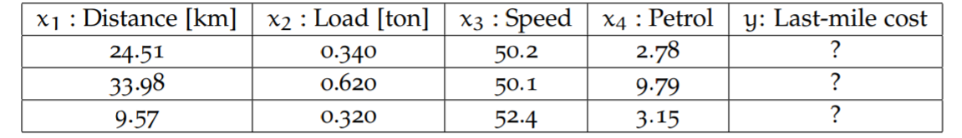

1860.79976063

3945.88000029

2217.74459453

Podemos ver que de acuerdo a los valores w obtenidos y x testing podemos aplicar matmul

Tabla 5

|  |  |  |  |  |  |  |  |
| --- | --- | --- | --- | --- | --- | --- | --- |
| **Learning Rate** | **0.0005** | **0.001** | **0.005** | **0.01** | **0.05** | **0.1** | **0.5** |
| **Computing Time [Seconds]** | 6.791 | 3.891 | 1.414 | 1.196 | 0.975 | 0.975 | 0.941 |
| **Number of Iterations** | 200902 | 100450 | 20088 | 10043 | 2006 | 1002 | 198 |

Podemos ver que de acuerdo a los valores w obtenidos y x testing podemos aplicar matmul