* OpenLeg – Open Source Dynamic Robotic Leg
  + <https://hackaday.io/project/167677-openleg-open-source-dynamic-robotic-leg>
  + <https://github.com/JoeyByrnes/OpenLeg>
* 3D Printed Quadruped Leg
  + <https://hackaday.io/project/165788-3d-printed-quadruped-leg>

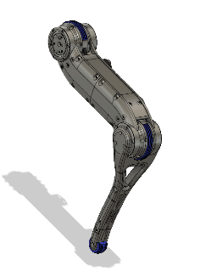

* Blackbird Bipedal Robot ($3000)
  + [https://hackaday.io/project/160882-blackbird-bipedal-robot](https://hackaday.io/project/160882-blackbird-bipedal-robot%20)

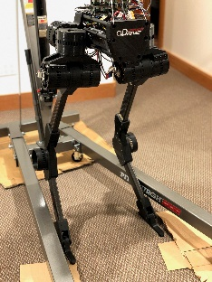

* 3D Printed Robot Actuator
  + <https://hackaday.io/project/157812-3d-printed-robot-actuator>

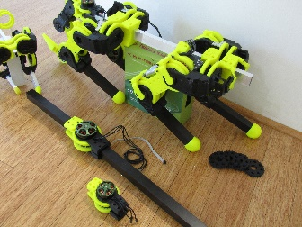

* BLDC Walker
  + <https://hackaday.io/project/166855-bldc-walker>

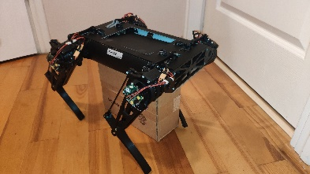

* Stanford Doggo ($3000)
  + <https://github.com/Nate711/StanfordDoggoProject>

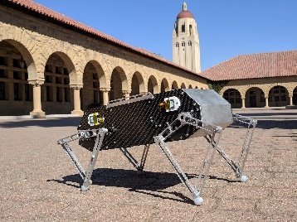

* OpenTorque Actuator ($150)
  + <https://hackaday.io/project/159404-opentorque-actuator>
  + <https://github.com/G-Levine/OpenTorque-Actuator>

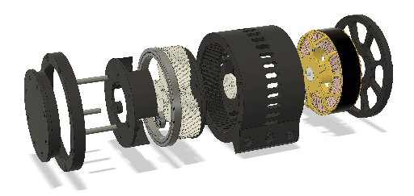

* TipTap ($500)
  + <https://hackaday.io/project/163093-tiptap>
  + <https://github.com/DarrenLevine/TipTap>

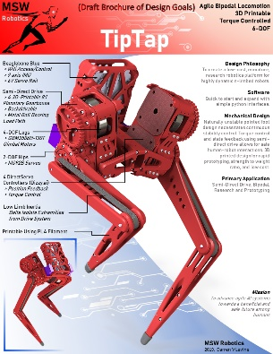

* DogBot ($1000)
  + <https://hackaday.io/project/26031-dogbot>

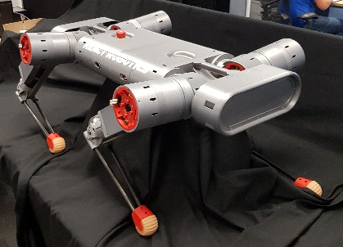

* MIT Mini Cheetah
  + <http://build-its.blogspot.com/>
  + <https://github.com/bgkatz/3phase_integrated>
  + <https://biomimetics.mit.edu/research/optimal-actuator-design>
  + Actuator -<https://pt.aliexpress.com/item/4000311364193.html?spm=a2g03.12010612.8148356.2.2c59ed23oPQZVv>
  + Robot -<https://pt.aliexpress.com/item/32985671853.html?spm=2114.12010612.8148356.4.3f551b49CcMhSK>
  + Actuator teardown - <https://www.youtube.com/watch?v=Mhxz2Bj2RXA>
  + Actuator firmware - <https://os.mbed.com/users/benkatz/code/Hobbyking_Cheetah_Compact_DRV8323/>
* Underactuated Robots
  + <https://www.youtube.com/channel/UChfUOAhz7ynELF-s_1LPpWg>
  + <http://underactuated.mit.edu/index.html>
* MJRobot
  + <https://jpieper.com/>
* GYEMS Actuator
  + <http://www.gyems.cn/866757.html>
* T-Motor Actuator, MIT Cheetah controller
  + <https://store-en.tmotor.com/category.php?id=97>