Henry Bory Prevez  Full Professor · Doctor of Sciences in Automatic Control  Full academic CV | 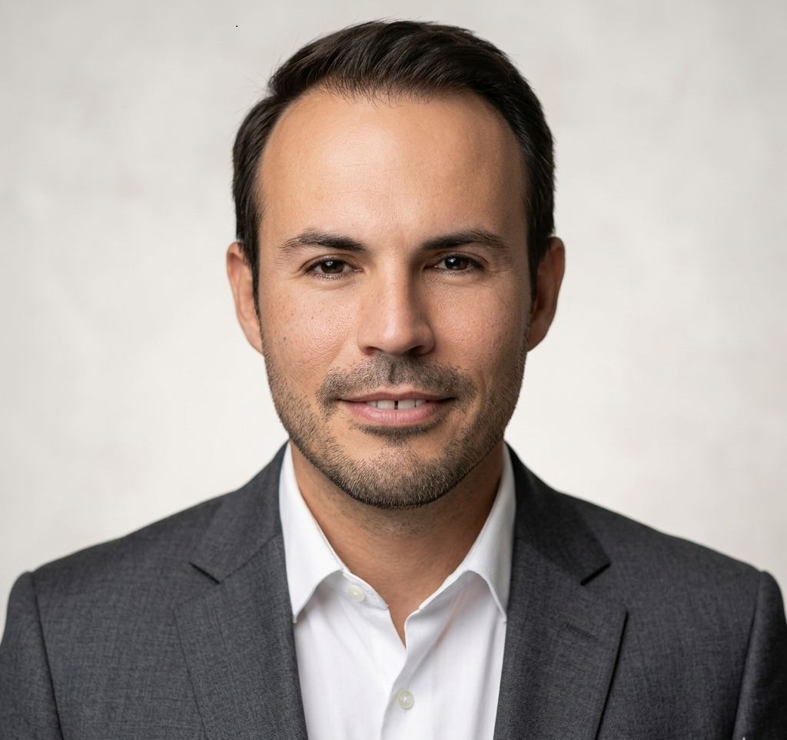
Universidad de Oriente · Santiago de Cuba
English · Functional translation for international visibility; review before official institutional use.
Profile
Full Professor at Universidad de Oriente with work in automatic control, power electronics, advanced control, renewable energy, micro-hydropower, OTEC, wave energy, scientific software and applied mathematical modelling.
Areas of expertise
- Automatic control, advanced control and power electronics.
- Micro-hydropower, Pelton turbine contexts and isolated microgrids.
- OTEC systems, ocean energy and wave energy.
- MATLAB/Simulink, Python, Octave, Arduino and virtual laboratories.
- Computational biophysics, mathematical oncology and complex systems modelling.
Publications and outputs
- IFAC-PapersOnLine and energy conversion structures for micro-hydropower contexts.
- Royal Society Open Science 2022: computational modelling in tumour growth and charge density.
- Educational software, virtual laboratories and MATLAB/Simulink-based resources.
Software and projects
- Niord v.1.0 / Niord0150-01-2022
- AnaRed V1.0
- TabPer V1.0
- Cal_Arr_Fre V1.0
- Calc_Covid19 V.1.0
Academic structure
- Education and academic appointments
- Teaching and supervision
- Publications and conference outputs
- Research projects and software
- Professional service and collaboration areas

Functional translation for international visibility; review before official institutional use.

