Henry Bory Prevez  Full Professor · Doctor of Sciences in Automatic Control  One-page CV | 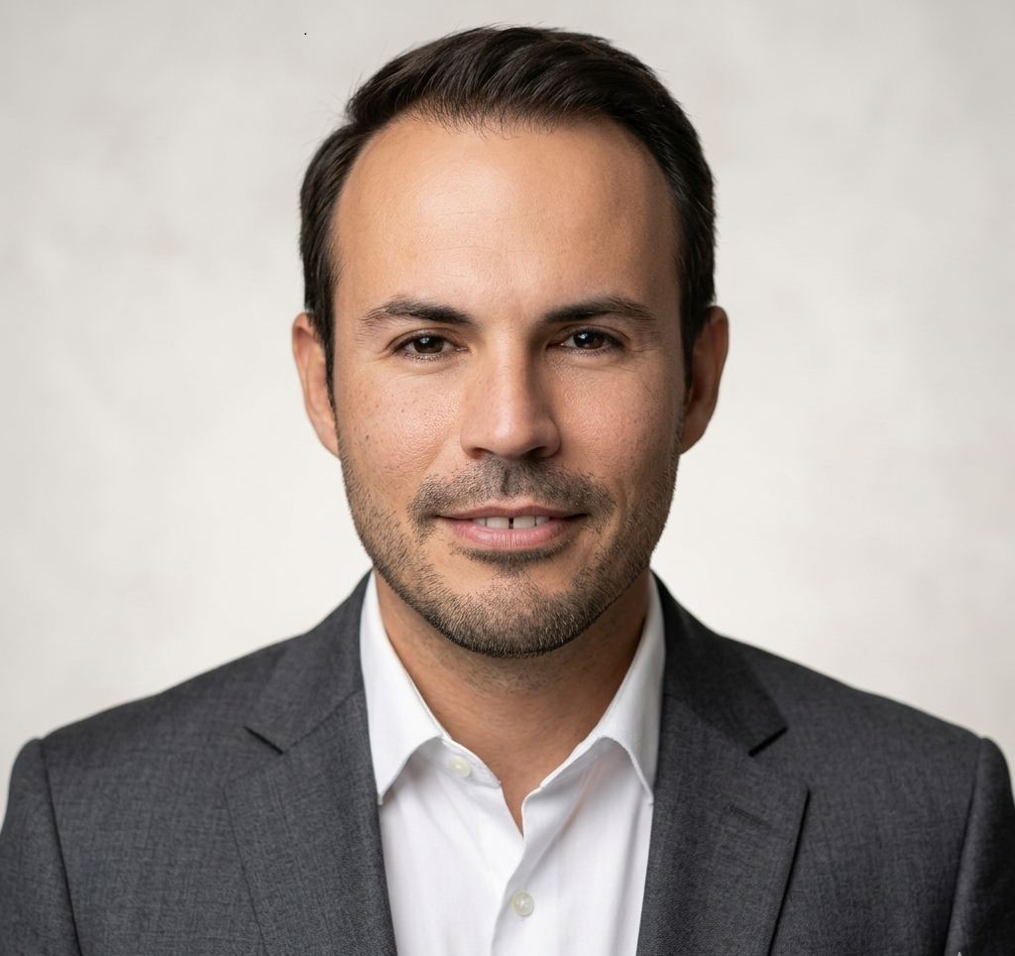
Universidad de Oriente · Santiago de Cuba
English · Functional translation for international visibility; review before official institutional use.
Profile
Full Professor at Universidad de Oriente with work in automatic control, power electronics, advanced control, renewable energy, micro-hydropower, OTEC, wave energy, scientific software and applied mathematical modelling.
Areas of expertise
- Automatic control, advanced control and power electronics.
- Micro-hydropower, Pelton turbine contexts and isolated microgrids.
- OTEC systems, ocean energy and wave energy.
- MATLAB/Simulink, Python, Octave, Arduino and virtual laboratories.
- Computational biophysics, mathematical oncology and complex systems modelling.
Core value
Full Professor at Universidad de Oriente with work in automatic control, power electronics, advanced control, renewable energy, micro-hydropower, OTEC, wave energy, scientific software and applied mathematical modelling.

Functional translation for international visibility; review before official institutional use.

