Henry Bory Prevez  Full Professor · Doctor of Sciences in Automatic Control  Professional dossier | 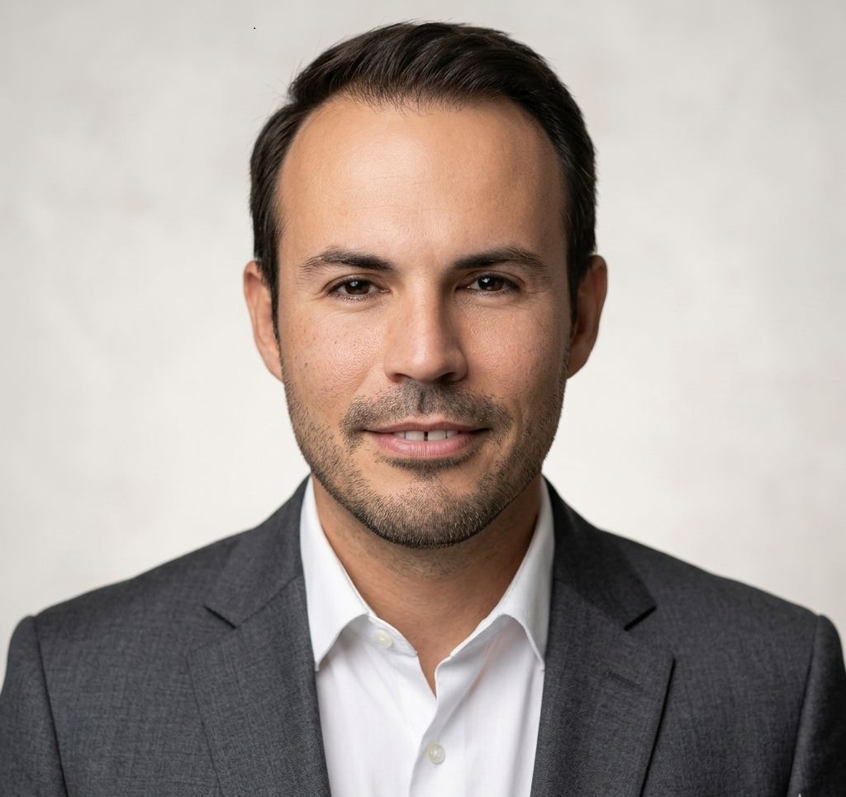
Universidad de Oriente · Santiago de Cuba
English · Functional translation for international visibility; review before official institutional use.
Profile
Full Professor at Universidad de Oriente with work in automatic control, power electronics, advanced control, renewable energy, micro-hydropower, OTEC, wave energy, scientific software and applied mathematical modelling.
Areas of expertise
- Automatic control, advanced control and power electronics.
- Micro-hydropower, Pelton turbine contexts and isolated microgrids.
- OTEC systems, ocean energy and wave energy.
- MATLAB/Simulink, Python, Octave, Arduino and virtual laboratories.
- Computational biophysics, mathematical oncology and complex systems modelling.
Publications and outputs
- IFAC-PapersOnLine and energy conversion structures for micro-hydropower contexts.
- Royal Society Open Science 2022: computational modelling in tumour growth and charge density.
- Educational software, virtual laboratories and MATLAB/Simulink-based resources.
Software and projects
- Niord v.1.0 / Niord0150-01-2022
- AnaRed V1.0
- TabPer V1.0
- Cal_Arr_Fre V1.0
- Calc_Covid19 V.1.0
Institutional positioning
This dossier summarizes the academic and technological profile for institutional presentation, cooperation initiatives and international visibility. It should be reviewed together with the evidence matrix before official submission.

Functional translation for international visibility; review before official institutional use.

