ProfDocs AI User Manual
Generated from the Astro Starlight documentation source.

Web application user manual
This manual explains the current ProfDocs AI web application and the main areas available in the MVP shell.
ProfDocs AI is a professional document intelligence workspace designed to organize documents, prepare them for future ingestion, and present a clear foundation for AI-assisted document review. The current version focuses on the user interface foundation, responsive navigation, theme behavior, and documentation evidence generated from the real Angular application.
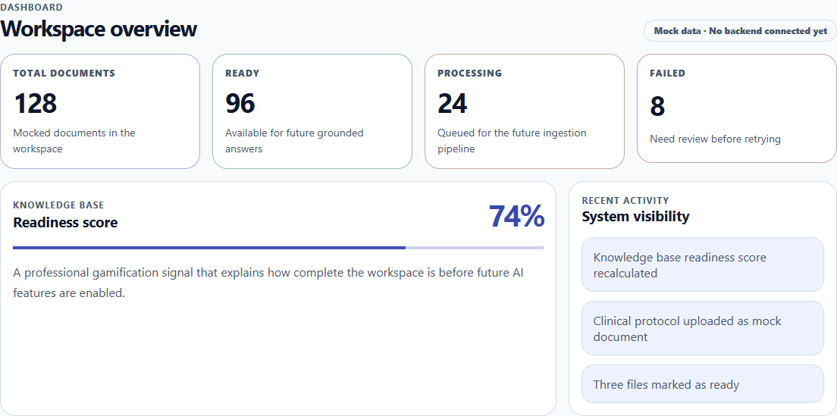
ProfDocs AI web application overview in light mode

What you can do here
Use this manual to understand the main areas of the web application:
- Review the workspace overview in the dashboard.
- Explore the mock document library.
- Understand the planned upload pipeline.
- Review the AI preview area for the future grounded RAG experience.
- See how the application adapts to desktop and mobile layouts.
- Understand which features are part of the current MVP and which ones are planned for future iterations.

How to use this manual
Read the manual section by section. Each page focuses on one user-facing area of the application and includes visual evidence generated with Playwright from the real Angular app.
The screenshots are stored as documentation evidence in:
apps/docs/public/evidence/manual
This keeps the manual aligned with the application UI and supports a documentation-as-code workflow.

Theme support
ProfDocs AI supports both light and dark visual modes. The manual uses Playwright-generated evidence for both themes where it adds value, so reviewers can evaluate the UI foundation in different viewing conditions.
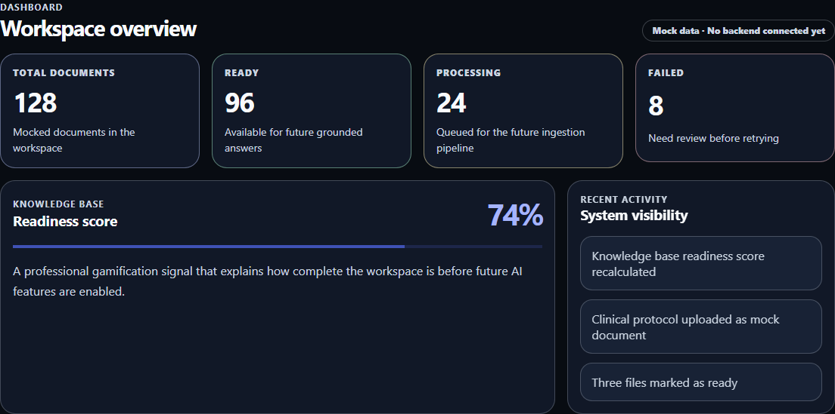
ProfDocs AI web application overview in dark mode

Current MVP status
The current MVP provides a professional frontend shell with:
- A responsive application layout.
- Desktop and mobile navigation.
- Light and dark theme support.
- A dashboard overview.
- A mock document workspace.
- Upload and AI preview placeholders.
- Automated visual evidence generated with Playwright.
The current MVP does not yet include real authentication, backend document ingestion, persistent document storage, or a connected AI/RAG backend.

Planned improvements
Future versions of ProfDocs AI are expected to add:
- Real document upload and ingestion.
- Backend integration with NestJS.
- Persistent storage with PostgreSQL.
- Document processing status.
- Grounded AI/RAG interactions.
- Authentication and role-aware access.
- More complete user workflows.
- Exportable user documentation in Word and PDF formats.

Related sections
- Dashboard
- Documents
- Upload
- AI preview
- Export guide

Dashboard
The dashboard is the main overview screen of the ProfDocs AI web application. It gives users a quick view of the current document intelligence workspace and introduces the main areas of the MVP shell.
The dashboard is generated from the real Angular application and documented with Playwright visual evidence.

ProfDocs AI dashboard overview in light mode

What you can do here
Use the dashboard to:
- Review the current workspace overview.
- Understand the main document intelligence areas available in the MVP.
- Access the document library, upload placeholder, and AI preview sections.
- Confirm that the application shell is responsive and ready for future workflows.
- Switch between light and dark visual modes.

How to use this screen
Open the web application and start from the dashboard. From here, you can review the workspace summary and move to the main sections using the application navigation.
The current dashboard is designed as a visual and product foundation. It does not yet display live backend metrics or real document processing data.

Dark mode
ProfDocs AI supports a dark visual mode. This helps validate the design system and provides a foundation for accessible theme switching in future versions.

ProfDocs AI dashboard overview in dark mode

Mobile layout
The dashboard adapts to smaller screens. The responsive layout is part of the current frontend foundation and is validated with Playwright-generated evidence.
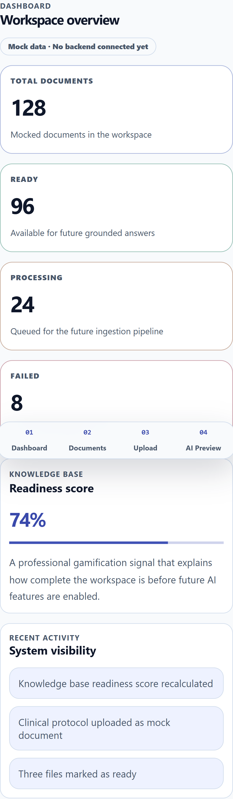
ProfDocs AI dashboard overview on a mobile viewport in light mode
The mobile layout is also validated in dark mode.
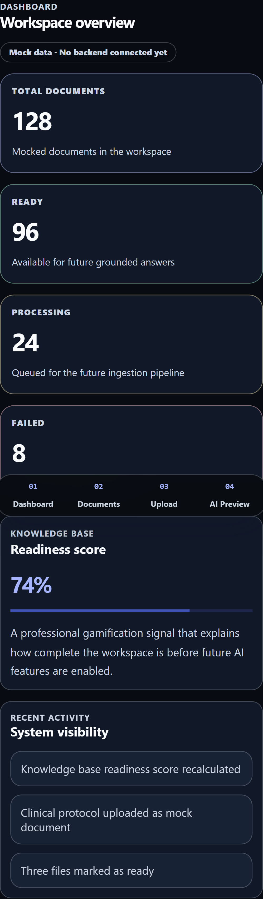
ProfDocs AI dashboard overview on a mobile viewport in dark mode

Current MVP status
The dashboard currently includes:
- A professional application shell.
- Workspace overview content.
- Responsive desktop and mobile layouts.
- Light and dark theme support.
- Static MVP information used to communicate the intended product direction.
The dashboard does not yet include live analytics, authenticated user-specific data, real document counts, backend status, or AI-generated insights.

Planned improvements
Future versions of the dashboard are expected to include:
- Real document processing metrics.
- User-specific workspace information.
- Upload and ingestion status.
- Recent document activity from the backend.
- AI/RAG readiness indicators.
- Notifications for failed or completed document processing jobs.

Related sections
- Web application user manual
- Documents
- Upload
- AI preview

Documents
The Documents section presents the current document library workspace in ProfDocs AI. It helps users understand how documents will be organized, reviewed, and prepared for future intelligence workflows.
In the current MVP, this screen uses mock document data. Its purpose is to validate the user interface, table/card layout, responsive behavior, and the direction of the future document management experience.
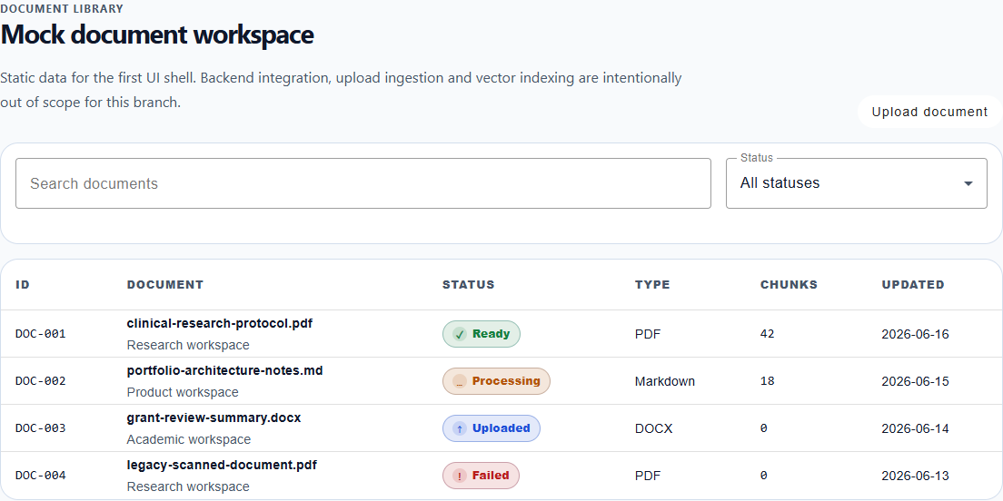
ProfDocs AI document library workspace in light mode

What you can do here
Use the Documents section to:
- Review the document library layout.
- Understand how documents may be presented in the workspace.
- See document metadata such as name, type, status, and review state.
- Preview the direction of future document processing workflows.
- Validate the visual structure that will later connect to real backend data.

How to use this screen
Open the web application and navigate to the Documents section from the main application navigation.
The current screen presents a mock document workspace. Users can review the layout and understand how future documents will be displayed, but the data is not yet connected to a real backend or database.

Dark mode
The document library layout is also captured in dark mode to validate table readability, status indicators, and spacing against the dark application theme.
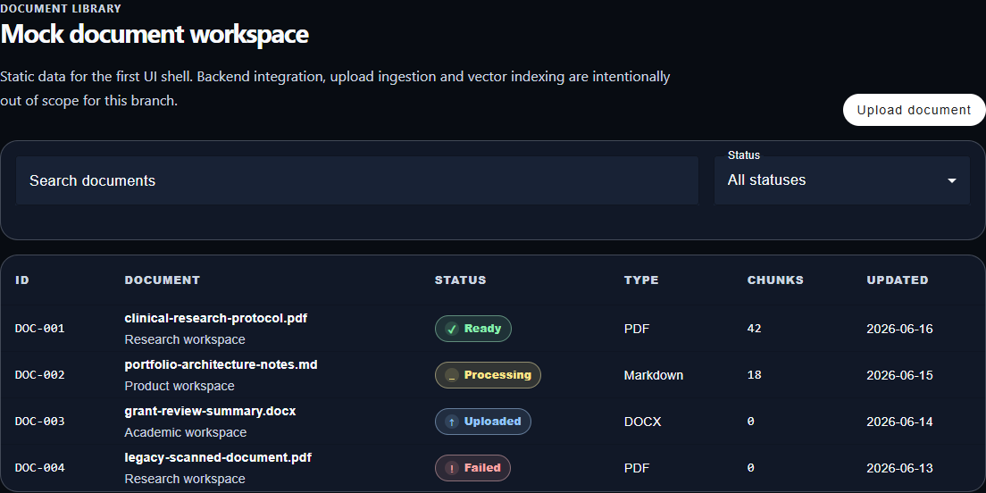
ProfDocs AI document library workspace in dark mode

Current MVP status
The current Documents section includes:
- A professional document library layout.
- Static mock document entries.
- Visual status indicators.
- A responsive presentation foundation.
- Playwright-generated visual evidence for documentation.
The current MVP does not yet include real document upload, backend persistence, search, filters, permissions, document previews, or document processing history.

Planned improvements
Future versions of this section are expected to include:
- Real document records from the backend.
- Document upload and ingestion results.
- Search and filtering.
- Processing status and error handling.
- Document detail pages.
- Metadata extraction.
- Access control and user-specific document visibility.
- Integration with AI/RAG workflows.

Related sections
- Web application user manual
- Dashboard
- Upload
- AI preview

Upload
The Upload section presents the planned document ingestion workflow for ProfDocs AI. It shows where users will eventually add documents to the workspace so they can be validated, processed, and prepared for future AI-assisted review.
In the current MVP, this screen is a placeholder. Its purpose is to communicate the intended upload experience and validate the frontend layout before real backend ingestion is implemented.
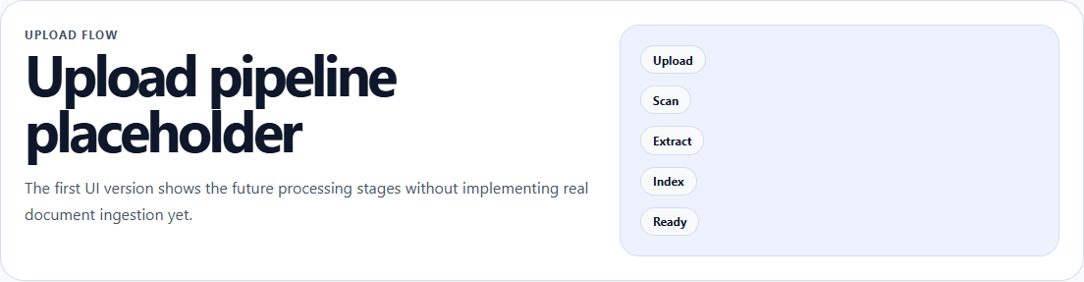
ProfDocs AI upload pipeline placeholder in light mode

What you can do here
Use the Upload section to understand the planned document ingestion experience:
- Identify where users will start a future document upload workflow.
- Understand the intended role of file validation and processing.
- Preview how the upload area will fit into the document intelligence workspace.
- Review the product direction for ingestion, metadata extraction, and processing status.
- Validate the visual foundation before connecting real backend services.

How to use this screen
Open the web application and navigate to the Upload section from the main application navigation.
The current screen does not upload files yet. It is a visual placeholder that documents the future workflow and keeps the user manual aligned with the current MVP state.

Dark mode
The upload placeholder is also documented in dark mode to keep the manual visually consistent with the application theme system.
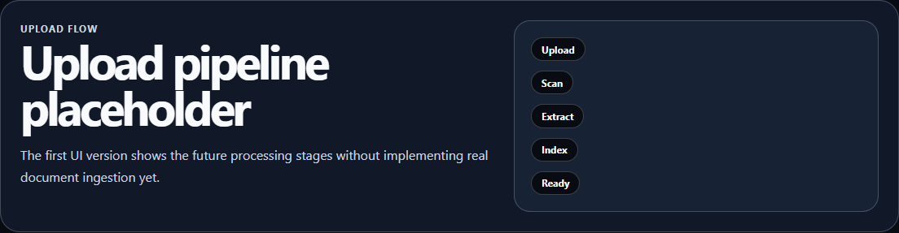
ProfDocs AI upload pipeline placeholder in dark mode

Current MVP status
The current Upload section includes:
- A professional upload workflow placeholder.
- A clear area for future document ingestion.
- Static explanatory content.
- Playwright-generated visual evidence for documentation.
The current MVP does not yet include real file selection, backend upload, validation rules, virus scanning, metadata extraction, storage, or ingestion status tracking.

Planned improvements
Future versions of the Upload section are expected to include:
- File selection and drag-and-drop upload.
- Supported file type validation.
- Upload progress feedback.
- Backend ingestion with NestJS.
- Document storage and metadata persistence.
- Processing status and error messages.
- Integration with the document library.
- Preparation of uploaded documents for grounded AI/RAG workflows.

Related sections
- Web application user manual
- Dashboard
- Documents
- AI preview

AI preview
The AI preview section presents the intended direction for grounded document intelligence in ProfDocs AI. It shows how users may eventually interact with document-based AI features after documents are uploaded, processed, and made available for retrieval.
In the current MVP, this screen is a placeholder. Its purpose is to communicate the future AI-assisted review experience while keeping the manual honest about the current implementation state.
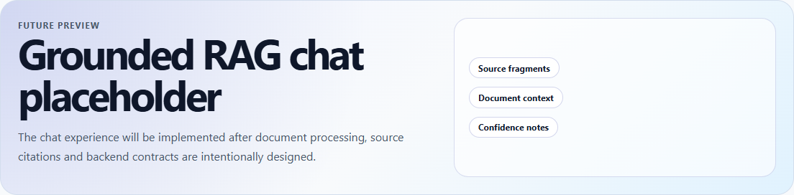
ProfDocs AI grounded RAG chat placeholder in light mode

What you can do here
Use the AI preview section to understand the planned AI-assisted experience:
- See where future grounded document questions may be asked.
- Understand the intended role of retrieval-augmented generation.
- Preview how AI responses may be presented inside the workspace.
- Understand that the AI area depends on future upload, ingestion, and retrieval features.
- Validate the product direction before connecting a real AI backend.

How to use this screen
Open the web application and navigate to the AI Preview section from the main application navigation.
The current screen does not send prompts to an AI model yet. It documents the planned interaction area and shows how grounded AI support may fit into the future document review workflow.

Dark mode
The AI preview placeholder is also documented in dark mode to confirm that the future chat area remains readable and visually aligned with the dark application theme.
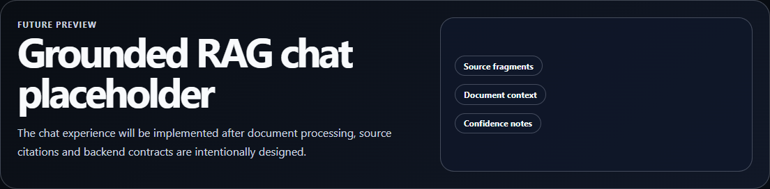
ProfDocs AI grounded RAG chat placeholder in dark mode

Current MVP status
The current AI preview section includes:
- A professional placeholder for future AI-assisted document review.
- Static explanatory content.
- A visual foundation for a future grounded RAG workflow.
- Playwright-generated visual evidence for documentation.
The current MVP does not yet include real AI chat, vector search, document retrieval, citation grounding, prompt history, model configuration, or backend AI orchestration.

Planned improvements
Future versions of this section are expected to include:
- Grounded question answering over uploaded documents.
- Retrieval-augmented generation using indexed document content.
- Source references and citations from documents.
- Conversation history.
- AI response validation patterns.
- Backend integration with NestJS services.
- Future pgvector-based retrieval support.
- Clear user feedback when an answer cannot be grounded in available documents.

Related sections
- Web application user manual
- Dashboard
- Documents
- Upload

Export guide
The Export guide explains how the ProfDocs AI user manual should be prepared for future Word and PDF generation.
The current source of truth remains the Astro Starlight documentation. Word and PDF files should be generated later from the documentation source, not edited manually as separate copies.

Available downloads
After running the manual export workflow, the generated files are available from the documentation site:
- Download the Word user manual
- Download the PDF user manual
The generated files are stored in:
apps/docs/public/exports/

What you can do here
Use this guide to understand the future export strategy for the manual:
- Keep the web manual as the canonical documentation source.
- Prepare manual pages so they can later be converted to DOCX and PDF.
- Keep screenshots in stable documentation evidence paths.
- Avoid duplicating manual content across web, Word, and PDF versions.
- Plan export outputs without implementing the exporter too early.

How to use this guide
Use the Starlight manual as the primary version during active product development.
When the manual content becomes stable, a future export workflow can convert the manual pages into downloadable files.
The expected future export folder is:
apps/docs/public/exports/
The expected future output files are:
ProfDocs_AI_User_Manual.docx
ProfDocs_AI_User_Manual.pdf

Recommended export strategy
The recommended strategy is:
Astro Starlight MDX
→ normalized Markdown
→ DOCX
→ PDF
This keeps the documentation maintainable because the team edits one source and generates other formats from it.

Content rules for export-ready pages
Manual pages should follow these rules:
- Use clear headings.
- Keep sections self-contained.
- Use stable screenshot paths.
- Avoid interactive-only components in the core manual.
- Avoid relying on web-only navigation to understand the content.
- Clearly separate current MVP behavior from planned improvements.
- Use descriptive image alt text.
- Keep terminology consistent across pages.

Screenshot rules
Screenshots used in the manual should stay in:
apps/docs/public/evidence/manual/
They should be referenced with stable public paths:
![Descriptive alt text](/evidence/manual/example.png)
This makes the images usable in Starlight now and easier to copy into DOCX/PDF exports later.

Current MVP status
The current project includes:
- A Starlight-based user manual.
- Playwright-generated visual evidence.
- Section-specific screenshots.
- Light and dark mode evidence.
- A manual structure that can later be exported.
The project includes a local export script that generates DOCX and PDF files from the Starlight manual source.

Planned improvements
Future documentation work can include:
- A dedicated export script.
- A generated DOCX version of the user manual.
- A generated PDF version of the user manual.
- A downloadable exports folder in the documentation site.
- A release workflow that publishes updated manual files.
- Optional CI validation once the export workflow is stable.

Related sections
- Web application user manual
- Dashboard
- Documents
- Upload
- AI preview

