Motivation and Problem Definition

NGSA Project Proposal
Experimental evaluation of community detection algorithms
for musical tastes predictions
Florian Bettini – Maxime Lutel – Gabriel Muller – Benjamin Pommier

Our project aims to evaluate multiple community detection algorithms when applied to predicting musical tastes. We will therefore compare two approaches: one using existing community detection algorithms, the other combining these algorithms with node embeddings.
Performances of both approaches will be evaluated on data collected from Deezer in November 2017 in 3 different countries: Romania, Croatia and Hungary. These datasets contain individuals (nodes) who have relationship (edges) and musical tastes (node attributes). Our approach is motivated by the increasing need in performance within an industry driven by a strong growth and an overwhelming pressure to generate profits.

The Problem
Improving the identification of communities within a musical network could benefit to both platforms and customers by drastically improving the quality and relevance of musical suggestions.
The difficulty of assigning individuals to musical communities is that a relationship may not reflect a potential taste for a given genre of music. Consequently, we want to implement a node embedding in addition to a community detection algorithm, and then compare the results with classical community detection algorithms.

Applications
Algorithms of community detection can be used for both:
- Suggesting new genres to individuals. For example, if someone belongs to a ‘pop’ community, but is not yet interested in ‘pop’, it could be relevant to suggest him new pop songs.
- Suggesting new relationships to individuals, thus it could be relevant to suggest a new friend to a user when both are within a same community.

Related work
Community detection aims to discover groups of nodes on a graph such that the intra-group connections are denser than the intergroup ones. In social network graphs, communities are often overlapped. Hence classical algorithms such as Louvain or Girvan-Newman cannot address the issue of soft-clustering.
New algorithms were developed to address this topic, such as CPM (Clique Percolation Methods), Fuzzy Detection or NMF and PCA based methods, as mentioned in [6].
With the recent development of neural networks and deep learning, node embedding is used to assis community detection. The general idea is to benefit from additionnal information from the nodes to generate a vector representation of the node and then learn the community by using unspervised machine learning techniques. Recent application, as GEMSEC, try to simultaneously learn the embeddings of the node and the communities.

Methodology
Our approach will be structured as in the following graph :

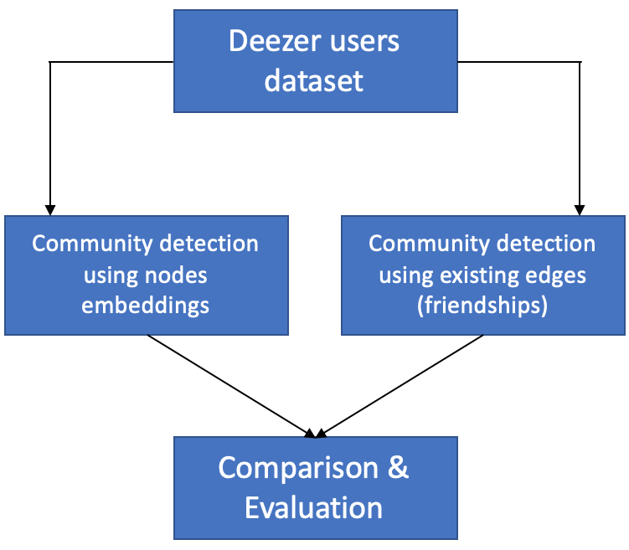
Figure 1. Methodology

As a first step, we are going to rely on friendship relations between users to detect communities. This clustering approach can be computed thanks to different kind of algorithms:

- Hierarchical clustering (FastGreedy, Leading eigenvector, Girvan-Newman…)
- Spectral clustering (Dengraph)
- Dynamic algorithms (Walktrap, Spinglass, Label propagation…)

Our objective is to test several algorithms among this non exhaustive list, and to evaluate their performance based on several criteria that will be defined in the next section.

As a second step, we will implement another methodology of community detection, which is called GEMSEC (Graph Embedding with Self Clustering). This approach is different than the one that will be developed in the first step, as nodes embeddings are learned while the clustering is performed. These embeddings are supposed to be representative of users’ musical tastes.

The comparison of these two approaches will allow us to understand if communities derived from friendships are similar to those derived from users’ tastes.

Evaluation
The evaluation of our methodology will be based on various community detection and clustering metrics based on multiples experiments.

Performance
The Deezer dataset (available here) will be used for the entire project. On this dataset, each node has attributes (musical taste: between 1 and 84 per user) which will be used as label for evaluating the performance of our community detection algorithms.
Various metrics will be used to evaluate the performance of our algorithms at each step of our approach:
- First Modularity, NMI and number of edges intra-community vs. extra-communities will allow us to determine the performance of our unsupervised community detection.
- Each community will then be assigned a label issued from the nodes’ labels based on various observation (median, mean…)
- Classification metrics such as F1 score (compared on the ground truth of each user) will then allow us to assess the performance of our clustering.

Experiments
As explained above, various experiments will be realized in order to attain an optimal clustering of the users:
- Multiple community detections algorithms will be evaluated (Girvan-Newman, Louvain, spectral clustering, …).
- Overlapping and non-overlapping community detection methods will be tested. Only the most fitted to the dataset will be conserved.
- With GEMSEC, new graphs will be generated based on the users’ music tastes. Continuous edge creation (each edge has a weighted corresponding to a similarity score) and discrete edge creation (an edge exists only if a similarity score is higher to a threshold (typically 0.5)) methods will be tested and compared.

References
Some references were selected in order to support our approach. As our focus will mainly be on the comparison of algorithms on a specific dataset, we will mainly rely on [5] to implement the algorithms and compare our results.

[1] | T. Cunchao, Z. Xiangkai and W. Hao , "A Uniﬁed Framework for Community Detection," Journal Of Latex Class Files, vol. 14, no. 8, 2015.
[2] | L. Ye, S. Chaofeng , H. Xin and Z. Yanchun, "Community Detection in Attributed Graphs: An Embedding Approach," in AAAI-18, 2018.
[3] | C. Sandro , V. W. Zheng, H. Cai, K. Chen-Chuan Chang and E. Cambria, "Learning Community Embedding with Community Detection and Node Embedding on Graphs," in CIKM, Singapore, 2017.
[4] | J. Chitra Devi and E. Poovammal, "An Analysis of Overlapping Community Detection Algorithms in Social Networks," in IMCIP, 2016.
[5] | B. Rozemberczki, R. Davies, R. Sarkar and C. Sutton, "GEMSEC: Graph Embedding with Self Clustering," ASONAM, 2019.
[6] | M. Aqib Javed , M. Shahzad Younis, L. Siddique , Q. Junaid and B. Adeel, "Community detection in networks: A multidisciplinary review," Journal of Network and Computer Applications, vol. 108, pp. 87-111, 2018.
[7] | N. Schlitter and T. Falkowski, "Mining the Dynamics of Music Preferences from a Social Networking Site," in International Conference on Advances in Social Network Analysis and Mining, Athens, 2009.

