
Goddard Procedures and Guidelines

DIRECTIVE NO. GPG 1710.1E APPROVED BY Signature: Original Signed by
EFFECTIVE DATE: November 2, 1999 NAME: A. V. Diaz
EXPIRATION DATE: November 2, 2004 TITLE: Director
Responsible Office: 300/Office of Systems Safety and Mission Assurance

Title: CORRECTIVE AND PREVENTIVE ACTION

Preface

P1. PURPOSE

This procedure establishes the process for initiating and implementing corrective and preventive actions.

P2. APPLICABILITY

This procedure applies to all Goddard Space Flight Center (GSFC) products and processes covered by the scope of the GSFC Quality Management System (QMS).

P3. AUTHORITY

NPD 8730.3, NASA Quality Management System Policy (ISO 9000)

P4. REFERENCES

- Federal Acquisition Regulations (FAR)
- NASA Federal Acquisition Regulation Supplement (NFS)
- GPG 1060.1, Management Responsibility
- GPG 4520.2, Incoming Inspection and Test
- GPG 5100.2, Supplier Performance Evaluations
- GPG 5100.4, Supplier Quality Audits
- GPG 5340.2, Control of Nonconforming Product
- GPG 5340.3, Preparation and Handling of Alerts and Safe Alerts
- GPG 9980.1, Internal Audit System

P5. CANCELLATION

GPG 1710.1D, Corrective and Preventive Action

P6. RECORDS

Quality Record Title | Record Custodian | Retention
NCR/CA database | Maintained by Code 302 and accessible to on-site employees and contractors | NRRS 5/30B -- Close file at end of survey/audit at end of FY. Destroy when 9 years old.

Procedure

1. DEFINITIONS

- Product Design Lead (PDL) - The manager or leader with overall responsibility for managing the design activity, managing the technical and organizational interfaces identified during design planning, and where required, forming and leading the Product Design Team (PDT). The term refers to flight project managers, mission managers, instrument managers, subsystem technical managers, integrated product development team leaders, lead engineers, etc.
- Nonconformance - Non-fulfillment of a specified requirement. Nonconformances requiring corrective action are documented as Nonconformance Reports (NCR's) in the NCR/CA database.

- Nonconformance Lead (NCL) – An individual identified within the NCR/CA system (see GPG 5340.2) who has the authority and responsibility to process NCR's initiated against his/her assigned project/organization.
- Audit Contact – The representative of an audited organization/function who is the primary point of contact with the Lead Auditor. For internal audits he/she is the NCL, or designates the NCL, for NCR's resulting from the audit.

- Corrective Action (CA) – Action taken, including remedial action, to eliminate the causes of an existing nonconformity in order to prevent recurrence.

- Remedial Action – Identification and correction of previously accepted or current product affected by, but not immediately associated with, an identified nonconformance.
- Preventive Action - Action taken to eliminate the causes of a potential nonconformity in order to prevent occurrence.
- NCR/CA Database – An inter-active on-line database used to document and track the status of NCR's and associated corrective actions (CA).
- Quality Management System Council (QMSC) - A group of representatives from all cognizant GSFC Directorates, chaired by the Quality Management System Representative (QMSR), responsible for advising the QMSR regarding Quality Management System administration, maintenance, status reporting, and corrective action.
2. IMPLEMENTATION

2.1 Corrective Action

  - Corrective action shall be determined and implemented for NCR's which meet one or more of the following criteria:

- The nonconformance was discovered as a result of an internal or supplier audit;
- The nonconformance was identified via a customer complaint;
- The nonconformance documents a violation of QMS process(es);
- The nonconformance occurred on-orbit;
- The nonconformance affects personnel or system safety;
- The nonconformance is classified as major in accordance with project/organization definitions (see GPG 5340.2).
The corrective action shall define the actions to be taken, action responsibility, and a schedule for completion and follow-up verification of corrective action.

    - Regardless of product disposition, nonconformances generated as a result of incoming inspection and test (see GPG 4520.2) shall, as a minimum, be provided by the NCL through the GSFC Contracting Officer to the applicable supplier for the supplier’s information. If the nonconformance in such cases meets one or more of the criteria above, the NCL shall request (through the GSFC Contracting Officer) the supplier to provide documented corrective action to GSFC. The GSFC NCL is responsible for entering supplier corrective action responses into the NCR/CA system. Supplier-oriented NCR’s and corrective action responses shall be considered during supplier performance evaluation in accordance with GPG 5100.2.

Note: The above requirement shall be implemented in a manner consistent with the FAR rules concerning inspection and acceptance, as well as the provisions of the applicable contract (FAR Part 46 and NFS 1846).

    - For NCR’s documenting product nonconformances, corrective action (when required by 2.1.1) shall be determined, documented and approved in the NCR/CA database by the responsible NCL.

Corrective action for customer complaints received after dissolution of a Project, shall be determined, documented and approved in the on-line NCR/CA database by the cognizant Directorate organization.

Determination of remedial action shall include consideration of preparation of an Alert/Safe Alert, in accordance with GPG 5340.3, when applicable to the nonconformance.

2.1.4 For NCR’s generated as a result of an internal audit (see GPG 9980.1), the designated NCL shall determine, document and approve corrective action in the NCR/CA database. For NCR's generated as a result of supplier audits (see GPG 5100.4), the applicable GSFC Lead Auditor is responsible for assuring that the supplier's corrective action responses are entered into the NCR/CA database.

2.1.5 Follow-up verification of corrective action implementation and effectiveness shall be scheduled and approved by the NCL in the NCR/CA system. The need for and performance of independent follow-up corrective action verification of internal audit NCR’s shall be determined by the Lead Auditor in accordance with GPG 9980.1.

2.1.6 An NCR that requires corrective action is considered closed when corrective action has been verified as being implemented and effective.

2.1.7 The Chief, Code 302 Systems Safety and Reliability, shall monitor nonconformances and corrective actions for cross-organizational problem areas and make applicable recommendations to the QMSC for inclusion in Management Review of the Quality Management System (see 2.2.2).

2.2 Preventive Action

    - The Chief, Code 302, shall retrieve appropriate data from the NCR/CA database for analysis to determine the nature and extent of systemic problems, trends, and patterns in nonconformances and
corrective actions. Results shall be provided to the QMSC for inclusion in Management Reviews (see GPG 1060.1).

2.2.2 Results of the analysis of NCR/CA data, and associated preventive action recommendations from the QMSR, shall be presented at Center management reviews of the QMS in accordance with GPG 1060.1.

2.2.3 The Center Director shall determine what, if any, action item(s) for preventive action shall be initiated. These actions, including responsibilities and schedules, shall be recorded as part of the Management Review (see GPG 1060.1).

2.2.4 Unless otherwise indicated by the action item, preliminary results of the action item shall be submitted to the QMSC for review and follow-up verification of effectiveness. The QMSC shall prepare the final action item response and submit it to the Center Director for approval.
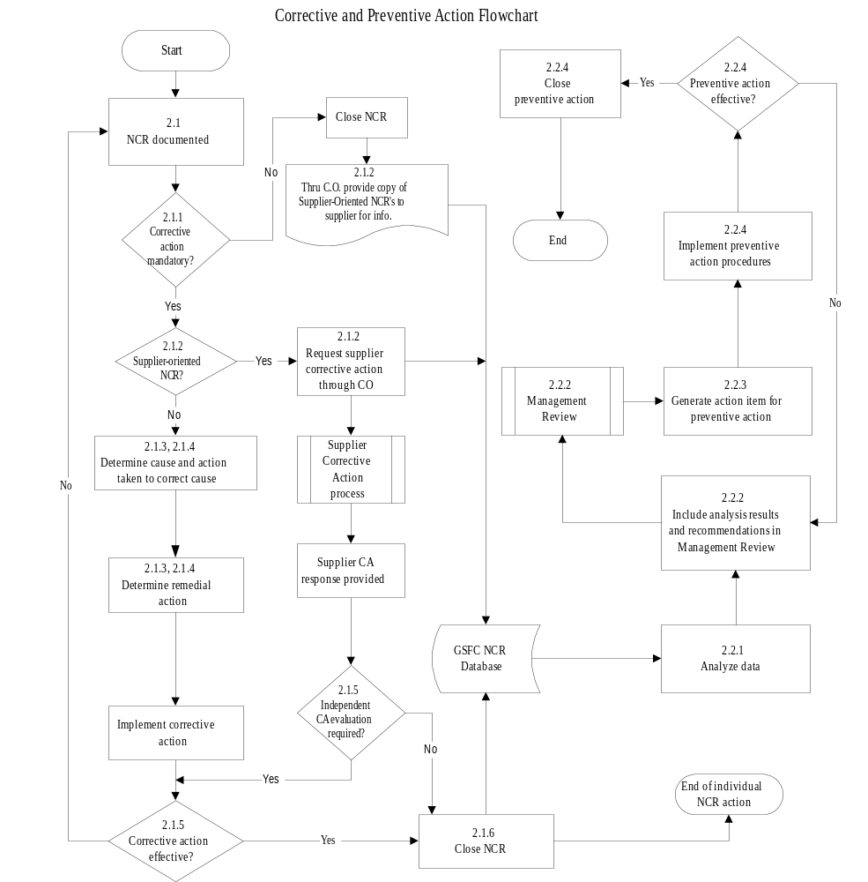

CHANGE HISTORY LOG

Revision | Date | Description of Changes
Baseline | 08/12/98
A | 10/06/98 | Header and footer changes. Added 2.1.5 and indicated responsibility for NCR/CA data retrieval and analysis in 2.2.1. Identified responsibilities for maintenance of quality records.
B | 04/21/99 | Modified records identified in P6 and reflected the NCR/CA database's accessibility. Extensive format and content changes (primarily section 2.1). Deletion of MRB references. Addition of NCL references. Expanded details of corrective action for supplier audit NCR's. Added Note in 2.1.2. Added QMSC definition. Deleted redundant "Determine remedial action" block in flowchart. Modified 2.2.2 to indicate preventive action recommendations come from the QMSR.
C | 06/23/99 | Re-titled P4(d); added P4(e); P6 - revised retention period for NCR/CA records consistent with GPG 5340.2; 1(d) and 1(f) revised to eliminate reference to "defect" and "undesirable situation"; revised 2.1.1 for consistency with GPG 5340.2; 2.1.2 & 2.1.4 - added reference to GPG 5100.4; 2.1.5 added "internal" before "audit NCR's"
D | 08/18/99 | P1 - changed "procedure" to "process". Revised last sentence of 2.1.1 to remove "when actions are to be initiated". P6 - Added parenthetical to Preventive Action Action Items record. 2.1.1(e) - re-added safety impacts to corrective action criteria list. Added "End" bubbles to flowchart.
E | 11/02/99 | P4 - Added reference to GPG 4520.2  P6 - removed Preventive Action Action Items from quality records table.  2.2.1 - Analysis provided to QMSC rather than QMSR.

