

HEADQUARTERS COMMON PROCESS

MANAGEMENT SYSTEM INTERNAL AUDITS

Approved by February 5, 2002
_________________________ ______________
Frederick D. Gregory, Date
Deputy Administrator

DOCUMENT HISTORY LOG

Status  (Baseline/  Revision/  Canceled) | Document  Revision | Effective  Date | Description
Baseline |  | January 15, 1999
Revision | A | April 28, 1999 | Revisions resulted from DNV Preregistration Audit nonconformances and ISO Project Office comments to improve the clarity and readability of the document. The changes do not materially impact the intent or usage of this HCP. For details, please see “HPC 1280-3, Internal Quality Audits Comment Disposition, Robert D. Kovach – 3/24/99”.
Admin Change | A | March 14, 2000 | Administrative change. Changed responsible office from Code R to Code B due to the ISO Project Office being reassigned.
Admin Change | A | October 29, 2000 | Administrative change. Changed Responsible Office from Code B to Code J due to the ISO Project Office being reassigned.
Revision | B | February 5, 2002 | Revisions were made to incorporate minor changes in the internal audit process identified while implementing the process and to comply with the ISO 9001:2000 Standard. Changes include deleting process steps to streamline the process, removing several appendices and making them electronic NASA HQ forms, adding the definitions for Audited Entity in Paragraph 3.3 and Audited Entity Representative in Paragraph 3.5 and modifying the definition for Internal Audit in Paragraph 3.8, creating the Internal Quality Audit Critique Report in Paragraph 6.16, deleting the reference to NPG 1441.1 Records Retention Schedules in Paragraph 4.1 and deleting the reference to HCP 1280-2, Corrective and Preventive Action in Paragraph 6.17, and making flowchart changes to correctly depict the process flow and to comply with the Headquarters document and data control HCP.
Admin  Change | B | September 10, 2003 | Revisions were made to incorporate minor changes including: change the names of forms to correspond to language in the new NPD 1280.1, Management Systems, add clarity to the request to the Administrator’s Correspondence Office to create HATS actions to track nonconformances and observations and to forward disputed issues identified during nonconformance or observation life cycles to the Headquarters ISO Executive Management Representative for resolution, and to incorporate the new Corrective Action Tracking System II (CATS II).

1. Purpose

This document describes the process for organizing and conducting Headquarters Management System internal audits. The purpose of these audits is to verify whether management activities and related results comply with the management system and to determine the system’s effectiveness.

2. Scope And Applicability

2.1 Scope This document identifies the responsible entities for staffing, planning, and conducting management system internal audits. These audits encompass all processes and documents that form the NASA Headquarters Quality Management System (QMS) as described in the “Headquarters Quality Management System Manual, HQPD 1200-1”.

The Headquarters Management System, including the management system internal audit process, shall be audited once every three years according to the process described in this document.

2.2 Applicability

This document applies only to NASA Headquarters.

3. Definitions

3.1 Audit Manager (AM). The AM or his/her designated alternate is responsible for and has the authority for implementing, managing, maintaining, and reporting on the performance of the management system internal audit process. The AM shall complete a Lead Assessor course and be granted organizational authority to manage Headquarters management system internal audits.

  - Audit Plan. Provides the audit scope, the audit time and date, the audited entity, the auditor’s names and assignments, the Point of Contact (POC) name, and the Audited Entity Representative for each audit. The Audit Plan, NHQ Form 278, is available at: ftp://ftp.hq.nasa.gov/forms/form/nhq278.itp.

  - Audited Entity. The focus of an audit. Audited Entities may include, but are not limited to, processes and subprocesses, documents, and organizations.

3.4 Audited Entity Management. The manager or designee who shall sign the Internal Audit Summary Report (NHQ Form 274, URL ftp://ftp.hq.nasa.gov/forms/form/nhq274.itp).

3.5 Audited Entity Representative. The person representing the Audited Entity for an audit.

3.6 Auditor (AT). An individual qualified through training to perform a management system audit. The AT shall complete an Internal Auditor course or Lead Assessor course. ATs may be NASA employees or qualified contractors.

3.7 Corrective Action Tracking System II (CATS II). The automated system used to support the life cycle management of nonconformances and observations.

3.8 Escort. An Audited Entity management representative who may
accompany the auditor during an audit. This individual provides access to physical areas and witnesses or is informed of potential nonconformances and observations.

3.9 Headquarters Action Tracking System (HATS). The automated system used to track Headquarters actions including nonconformances and observations.

3.10 Internal Audit. A systematic and independent examination performed by a qualified NASA Headquarters employee or contractor to verify whether management activities and related results comply with the management system and to determine the effectiveness of the system.

3.11 Lead Auditor (LA). An individual qualified through training to organize and oversee a management system internal audit and report audit findings. The LA shall complete an Internal Auditor course or Lead Assessor course. The LA may be a NASA employee or a qualified contractor.

3.12 Nonconformance. Nonfulfillment of a specified management system requirement.

3.12.1 Major Nonconformance. A systemic breakdown of the management system that impacts its ability to produce a product or service or impacts management system processes.

3.12.2 Minor Nonconformance. A nonsystemic breakdown that can have an indirect, lower order, adverse impact on a management system product or service.

3.13 Objective Evidence. Qualitative or quantitative information, records, or
statements of fact pertaining to a process or product or to the existence and implementation of a management system clause that is based on observation, measurement, or test and can be verified.

3.14 Observation. A finding that may lead to a nonconformance. Based on an analysis by the AM, related Observations may be elevated to a Nonconformance.

3.15 Point of Contact. An Audited Entity’s contact person.

3.16 Abbreviations.

AM Audit Manager
AT Auditor
HQPD Headquarters Policy Directive
HQPG Headquarters Procedures and Guidelines
LA Lead Auditor
NCR Nonconformance Report
OWI Office Work Instruction
POC Point of Contact
QMS Quality Management System

4. References

Headquarters Quality Management System Manual, HQPD 1200-1

5. Flowchart
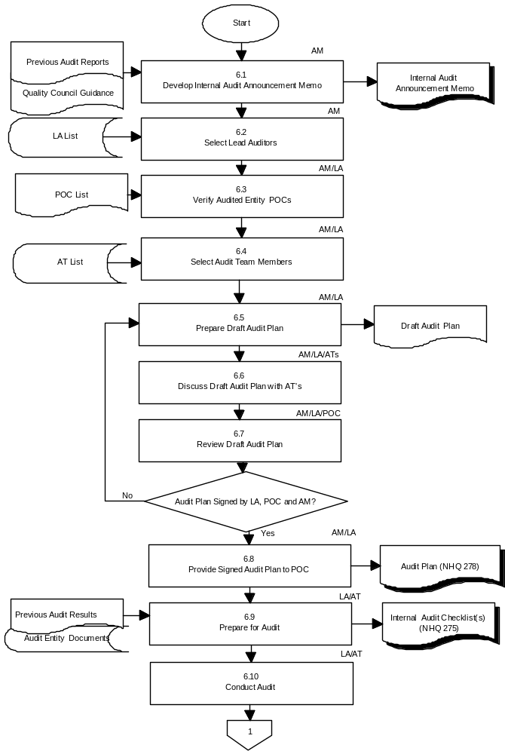

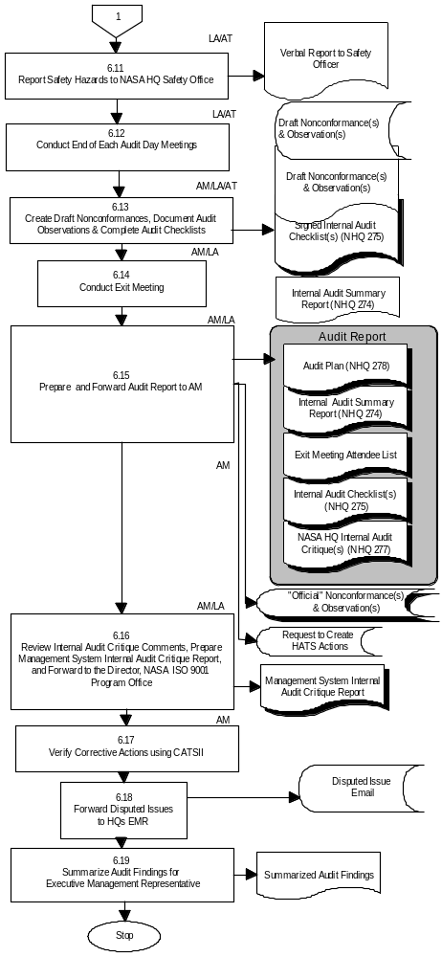
6. Procedure
Number | Actionee | Action
6.1 | AM | Draft an internal audit announcement memo for the Executive Management Representative to send to NASA Headquarters Officials-In-Charge. The memo will identify audit scope, audit dates and the Auditors. Audits will be scheduled at least every six months. Audit focus will be based on the results of internal and external management system audits and any Quality Council guidance.  Forward the memo to the Executive Management Representative for distribution.
6.2 | AM | Select LAs to oversee audits. LAs shall be assigned to  the audit for the duration of the audit and its related  activities. LAs shall be assigned in sufficient time to prepare for the audit.
6.3 | AM/LA | Verify audited entity POCs.
6.4 | LA | Work with AM to select ATs who will conduct the audit. LA shall contact ATs to ensure that they will be able to commit to the audit.
6.5 | AM/LA | Prepare draft Audit Plan, (NHQ Form 278, URL ftp://ftp.hq.nasa.gov/forms/form/nhq278.itp). The plan shall be flexible in order to permit changes in emphasis based on information gathered during the audit and to permit effective use of resources. The plan shall include the following:  - The audit scope.  - The audit time and date.  - The audited entity(s).  - The auditor(s) and assignments.  - The POCs name(s).  - The Audited Entity Representative(s).
6.6 | AM/LA | Discuss draft Audit Plan with ATs.  - Discuss the audit scope.  - Review general audit techniques and conduct.  - Review and discuss the documents to be audited.  - Confirm audit assignments.  - Distribute Internal Audit Checklist forms (NHQ Form 275, URL ftp://ftp.hq.nasa.gov/forms/form/nhq275.itp)  to each team member to tailor for each audit.
6.7 | AM/LA/ POC | Review Draft Audit Plan.  - LA and POCs review Draft Audit Plan, modify as necessary and sign.  - LA sends Audit Plan to the AM to sign, incorporates any AM changes, and coordinates changes with applicable POCs.
6.8 | AM/LA | Provide a copy of the signed Audit Plan to the applicable POCs.

6.9 | LA/AT | Prepare for Audit.  - Review results of previous internal and external management system audits.  - Review audited entity documentation applicable to the audit.  - Review and tailor Internal Audit Checklists for each audit.  - Finalize audited entity representative(s), scribe and escort with appropriate POC.
6.10 | LA/AT | Conduct the Audit.
6.11 | LA/AT | During the audit, report any safety hazards to the NASA Headquarters Safety Office.
6.12 | LA/AT | Conduct daily end-of-day meeting(s) to discuss audit activity and results.
6.13 | AM/LA/ AT | Complete and sign Internal Audit Checklists.  Create draft nonconformances and observations in the Corrective Action Tracking System II (CATS II) Quality Management System (QMS) Module at  https://neptune.hq.nasa.gov/cats/. The AM, with LA and AT recommendations, shall determine if the draft nonconformance is a Major or Minor Nonconformance.  Print draft NCRs and observations.  Complete, print and LA signs the Internal Audit Summary Report (NHQ Form 274, URL ftp://ftp.hq.nasa.gov/forms/form/nhq274.itp).
6.14 | AM/LA | Conduct exit meeting with Audited Entity Management.  - Discuss audit results.  - Provide the Internal Audit Summary Report to Audited Entity Management to sign.  - Provide the NASA Headquarters Internal Audit Critique form (NHQ Form 277, URL  ftp://ftp.hq.nasa.gov/forms/form/nhq277.itp)  to the audited entity POC to complete/return to the AM.  - Record names of exit meeting attendees on an attendee list and file list with the Audit Report.

6.15 | AM/LA | Prepare the Audit Report and forward to the AM or his/her designee. The report shall contain the following items as applicable:  - Audit Plan(s)  - The signed Internal Audit Summary Report(s)  - The exit meeting attendee list  - Internal Audit Checklists  - NASA Headquarters Internal Audit Critique forms  AM makes draft NCR(s) and Observation(s) “Official” in the CATS II QMS Module.  AM requests the Administrator’s Correspondence Office to create Headquarters Action Tracking System (HATS) actions for each nonconformance or observation. The first HATS action monitors the time until the root cause (nonconformances only), corrective action/process improvement action plan (AP) and proposed AP implementation date are entered into the QMS module for each nonconformance or observation. The second action, created after the LA approves the AP and proposed date, monitors the action implementation for each nonconformance or observation.
6.16 | AM | Review NASA HQ Internal Audit Critique comments and recommendations. Prepare Management System Internal Audit Critique Report and forward to the Director, NASA ISO 9001 Program Office.
6.17 | AM/LA | Verify completed corrective and process improvement actions using the CATS II QMS module available at: https://neptune.hq.nasa.gov/cats/.
6.18 | AM | Forward disputed issues identified during nonconformance or observation life cycles to the Headquarters ISO Executive Management Representative for resolution.
6.19 | AM | Summarize audit findings for Executive Management Representative to present at next Quality Council Meeting.
7. Quality Records

RECORD IDENTIFICATION | OWNER | LOCATION | MEDIA:  ELECTRONIC OR  HARD COPY | SCHEDULE NUMBER AND ITEM NUMBER (NPG 1441.1) | RETENTION/ DISPOSITION
Internal Audit Announcement Memo | AM | AM | Hard Copy | Schedule 5  Item 30, B. | Close file at end of survey/ audit at end of fiscal year. Destroy when 9 years old.
Audit Plan (NHQ 278) | AM | AM | Hard Copy | “ | “
Internal Audit Checklist(s) (NHQ 275) | AM | AM | Hard Copy | “ | “
Official Nonconformances  and Observations | AM | http://hqiso9000.hq.nasa.gov/ | Electronic | “ | “
Internal Audit Summary Report (NHQ 274) | AM | AM | Hard Copy | “ | “
Exit Meeting Attendee List | AM | AM | Hard Copy | “ | “
NASA HQ Internal Audit Critique forms (NHQ 277) | AM | AM | Hard Copy | “ | “
Internal Audit Critique Report | AM | AM | Hard Copy | “ | “

