DOWNLOADED AND/OR HARD COPY UNCONTROLLED
Verify that this is the correct version before use.

APPROVAL SIGNATURES |  | DATE
Greg Blaney (original signature on file) | IMS Representative | 12/17/2008

REVISION HISTORY
Revision | Description of Change | Author | Effective Date
Basic | Initial Release | John Griggs IT/204 | 05/01/1998
A | Section 2.0,3.0,5.0 And 6.0 were modified and added flow chart. | Siamak Yassini IT/332 | 07/23/1998
B | Quality Record - format change, modified section 2.2 | Siamak Yassini IT/332 | 08/26/1998
C | Consolidated forms | Siamak Yassini IT/332 | 01/28/1999
D | References to Ames Quality Manual replaced with references to IV&V Facility Quality Manual  Updated Section 5.1.4 & 6.1.2 | Siamak Yassini IT/332 | 09/10/1999
E | Adding Track wise automated tool section 3.3 | Siamak Yassini IT/332 | 03/30/2000
F | Format and Number changes; Delete Reference to Ames Research Center | John Griggs | 12/06/2000
G | Significant re-write to accommodate current process | John Griggs | 04/03/2001
H | Revise severity codes to define “immediate”, also require corrective action plans | John Griggs | 09/13/2001
I | Revise to include lower tier action tracking systems, and to modify the automated flow to allow staff to enter CAR/PARs | John Griggs | 06/06/2002

REVISION HISTORY (CONTINUED)
Rev No. | Description of Change | Author | Effective Date
J | Clarify initial assignment of CAR/PAR to Management Representative; also clarify use of IVV Form 1005 as backup to Trackwise | John Griggs | 10/21/2002
K | Updated process flow to current flow practices; verbiage updated to meet new acronym and system references (IMS) | Brian Kesecker | 04/28/2004
L | Updated reference documents to add form 1005, added section numbers in section 4.1 flow and updated section 8 | Stephanie Ferguson | 02/23/2005
M | Add corrective action plan to Section 6.4 | Stephanie Ferguson | 09/26/2005
N | Deleted definitions that were previously defined in the QM. Section 8 – Updated the Records table to reflect NPR 1441, NASA Records Retention Schedules | Stephanie Ferguson | 01/10/2006
O | Deleted metric from Section 7.0 | Stephanie Ferguson | 09/11/2006
P | Update process flow diagrams to align with Facility Management paradigm | Stephanie Ferguson | 08/06/2007
Q | Deleted unnecessary definitions and removed the words administrative from section 3.5 and observation from section 4.1 | Stephanie Ferguson | 01/09/2008
R | Remove references to PMR | Stephanie Ferguson | 05/05/2008
S | Removed the procedure requirement for lower-tier AI systems. | Stephanie Ferguson | 09/17/2008
T | Changed “IV&V Facility” to “IV&V Program” | Stephanie Ferguson | 12/17/2008

REFERENCE DOCUMENTS
Document | Title
Form 1005 | Finding Report
IVV QM | IV&V Quality Manual
IVV 16 | Control of Records
NPR 1441.1 | NASA Records Retention Schedules
- Purpose

The purpose of this system level procedure (SLP) is to define the corrective and preventive action processes at NASA IV&V that track the identification and resolution of product and process nonconformities and Customer complaints.

The processes include the formal Corrective and Preventive Action (CAR/PAR) System and lower-tier action tracking systems that support internal objectives.

- Scope

This SLP applies to all nonconforming or potentially nonconforming processes, products, and services pursuant to the NASA IV&V Management System (IMS).

- Definitions and Acronyms

Official NASA IV&V roles and terms are defined in the Quality Manual. Specialized definitions identified in this SLP are defined below.

  - Assignee

The Assignee is the person assigned action for a corrective action request (CAR) or preventive action request (PAR) by the IMS Representative.

  - Corrective Action Plan

A Corrective Action Plan is a plan constructed to describe the course of action taken to resolve a CAR/PAR in the CAR/PAR System.

  - Corrective or Preventive Action Request (CAR/PAR)

A CAR/PAR is the documentation of a nonconformance or potential nonconformance, respectively. CARs/PARs can result from multiple activities or come from multiple sources (e.g., internal or external audits, actions from Program Management’s review of the IMS, Customer complaints, etc.).

  - Initiator

The Initiator is any NASA IV&V personnel member working within the IMS who originates a CAR/PAR for change or improvement in the IMS.

  - Lower-Tier Action Tracking Systems

Research Management, Program Senior Management, and Resource Management Action Tracking Systems not requiring NASA IV&V access are used for the internal process of tracking action items (AIs), including delivery dates, etc. These systems support the CAR/PAR System, and issues that are systemic to NASA IV&V or issues that can affect the quality of NASA IV&V products are upgraded into the CAR/PAR System.

    - Research Management Action Tracking System

The Research Management group maintains an informal AI tracking database within the Center Initiative Management (CIM) Tool. The primary purpose of this database is to track the progress of day-to-day assignments and AIs.

    - Senior Staff Action Tracking System

The Senior Staff Action Tracking System tracks AIs generated from Senior Staff meetings. AIs from previous Senior Staff meetings are reviewed, dispositioned, and/or closed.

    - Resource Allocation Committee (RAC) Action Tracking System

The RAC Action Tracking System tracks AIs generated from RAC meetings. AIs from previous RAC meetings are reviewed, dispositioned, and/or closed.

  - Nonconformance

A nonconformance represents a lack of compliance with a specified process or procedure associated with the IMS, a nonconforming product, or a deficiency in the IMS. For the purposes of this SLP, nonconformities are categorized into three levels of severity.

    - Major Nonconformance

A major nonconformance is characterized by one or more of the following:

      - An IMS deficiency
      - An issued nonconforming product that has a significant effect on Customer success, safety, or resources
      - A lack of documented procedures
      - A documented procedure not being implemented consistently
      - A series of minor nonconformities indicating an overall IMS deficiency that has an adverse effect upon overall product quality

    - Minor Nonconformance

A minor nonconformance is characterized by a defined system with an acceptable level of implementation having one or more of the following:

      - Minor discrepancies or lapses in discipline
      - An issued nonconforming product with little or no effect on the Customer

    - Observation

One or more of the following characterize an observation:

      - An issue noted by an auditor that may lead to a major or minor nonconformance if not corrected
      - A suggestion to improve a process
      - Editorial corrections to a procedure (e.g., typing errors, spelling errors, etc.)

  - Acronyms

AI Action Item
CAR Corrective Action Request
CIM Center Initiative Management
IMS NASA IV&V Management System
NPR NASA Procedural Requirements
PAR Preventive Action Request
QM Quality Manual
RAC Resource Allocation Committee
SLP System Level Procedure

- Process Flow Diagram

The following diagrams depict processes described in this document, and the responsibilities and actions that shall be performed by process participants. Any information supplemental to the depicted processes will appear after the diagram.
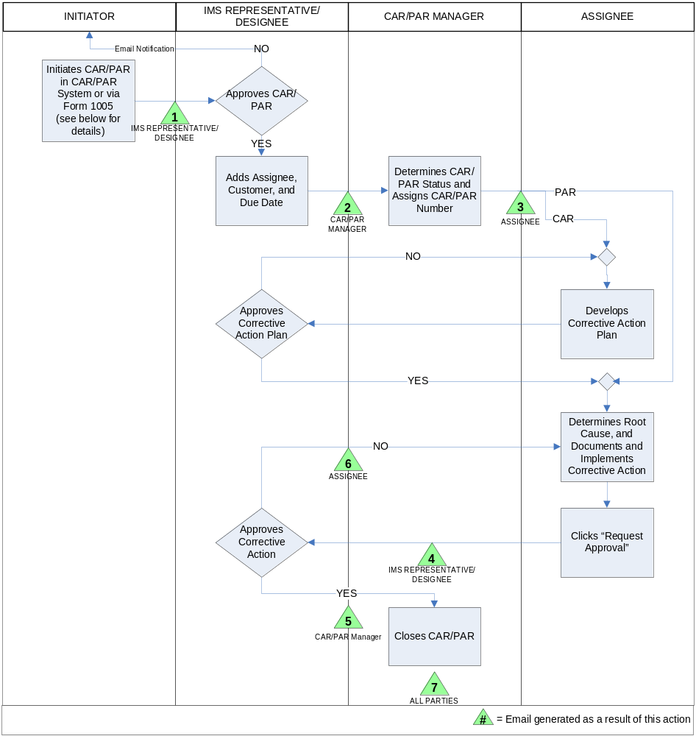

If using Form 1005, Finding Report, the Initiator shall use the form located at http://www.nasa.gov/centers/ivv/ims/forms/index.html. The Initiator shall forward the completed Finding Report to the CAR/PAR Manager for action. The CAR/PAR Manager will enter this information into the CAR/PAR System when available and discard the completed Finding Report.

If using the CAR/PAR System, the Initiator shall visit the tool located at http://trackwise.ivv.nasa.gov. The Initiator shall complete all fields on the CAR/PAR System “Action Item” form. The “Customer” and “Assigned To” fields must contain the name of the IMS Representative. The bottom-most drop-down list on the left side of the form must contain either “ISO Finding (CAR)” or “ISO Potential Problem (PAR)”. These fields must be completed in order for the CAR/PAR to be processed.

When documenting CAR/PAR resolutions in the CAR/PAR System, Assignees shall document the root cause of the issue, the action taken to correct it, and objective evidence that demonstrates resolution of the CAR/PAR.

  - Minor Nonconformance

A CAR with a minor nonconformance expected to require over thirty days to resolve requires an approved Corrective Action Plan within thirty days of assignment.

  - Major Nonconformance

A CAR with a major nonconformance requires a completed corrective action or an approved Corrective Action Plan within two weeks.

- Metrics

Any metrics associated with this SLP are established and tracked within the NASA IV&V Metrics Program.

- Records

The following records are generated and filed in accordance with this SLP and IVV 16, Control of Records, and in reference to NASA Procedural Requirements (NPR) 1441.1, NASA Records Retention Schedules.
Record Name | Original | Vital | Responsible Person | Retention Requirement | Location
CAR/PAR | Y | N | CAR/PAR Manager | Destroy when 7 yrs old (1/26.5A) | CAR/PAR System

