Overall Duty | Apply remedies to protect the rights of the Government under commercial item contracts and simplified acquisitions.
Overall  Conditions | Given contracts with the Contract Terms and Conditions – Commercial Items clause (FAR 52.212-4) or purchase orders for other than commercial items, the contract file, evidence of performance problems, and documentation of informal attempts to resolve the problems.
Overall  Standard | Select the remedy that will best minimize the impact of contractor performance problems on performance, delivery, and cost. Obtain reasonable consideration for any relief granted the contractor from the contract’s original terms and conditions. Document all decisions and contacts with the contractor sufficient to support the Government’s position in disputes or court proceedings. Correctly follow prescribed procedures for the remedy.
Part A: Select a Formal Contract Remedy

Sub-Duty | Select a formal contract remedy for a performance problem.
Sub-Duty Standard | Select the formal contract remedy that is appropriate for the contracting situation.

Part B: Cure Notice

Sub-Duty | Remedy performance problems using a cure notice, the contractor’s response, and related action.
Sub-Duty Standard | Issue the cure notice when there is sufficient time for the contractor to cure identified performance problems and a formal remedy is required. Based on an evaluation of the contractor’s response, take appropriate action to modify the contract, terminate the contract, or allow the contractor to continue performance without contract modification.
Part C: Reject Nonconforming Supplies or Services

Sub-Duty | Reject nonconforming supplies or services.
Sub-Duty Standard | Reject nonconforming supplies or services unless the contractor provides adequate consideration or acceptance is otherwise in the Government’s best interest.
Part D: Enforce Warranty Clause

Sub-Duty | Obtain redress under a warranty clause.
Sub-Duty Standard | Exercise the Government’s rights under a warranty clause contained in the contract or purchase order.

Part E: Enforce Implied Warranties

Sub-Duty | Obtain redress under implied warranties (e.g., merchantability or fitness for a particular purpose).
Sub-Duty Standard | Exercise the Government’s rights under a warranty implied by the contract and related information.

Policies

FAR | Agency  Suppl. | Subject
8.405-4 |  | Delinquent performance on Federal Supply Schedules.
12.208 |  | Contract quality assurance.
12.213 |  | Other commercial practices.
12.301 |  | Solicitation provisions and contract clauses for the acquisition of commercial items.
12.302 |  | Tailoring of provisions and clauses for the acquisition of commercial items.
12.402 |  | Acceptance.
12.403(c) |  | Termination for cause.
12.404 |  | Warranties.
12.503 |  | Applicability of certain laws to Executive agency contracts for the acquisition of commercial items.
22.1022 |  | Withholding of contract payments.
22.1023 |  | Termination for default.
22.1307 |  | Actions because of noncompliance with Affirmative Action for Special Disabled and Vietnam Era Veterans (FAR 52.222-35).
22.1407 |  | Actions because of noncompliance with Affirmative Action for Workers with Disabilities (FAR 52.222-36).
23.506 |  | Failure to comply with requirements to maintain a drug-free workplace.
46.101 |  | Definitions for quality assurance.
46.407 |  | Nonconforming supplies or services.
46.702 |  | General policy relating to warranties.
46.706 |  | Warranty terms and conditions.
46.709 |  | Warranties of commercial items.
46.8 |  | Contractor liability for loss of or damage to property of the Government.
49.402 |  | Termination of fixed-price contracts for default.
49.607 |  | Delinquency notices.
52.212-4(a) |  | Inspection/acceptance.
52.212-4(j) |  | Risk of loss.
52.212-4(m) |  | Termination for cause.
52.212-4(o) |  | Warranty.
52.212-4(p) |  | Limitation of liability.

FAR | Agency  Suppl. | Subject
52.212-5 |  | Contract terms and conditions required to implement statutes or Executive Orders – commercial items. Alternate I added for waiving Examination of Records.
52.213-1 |  | Fast payment procedure.
52.213-4(d) |  | Inspection/acceptance.
52.213-4(g) |  | Termination for cause.
52.213-4(h) |  | Warranty.
52.219-16 |  | Liquidated damages subcontracting plan (if FAR 52.219-16 was incorporated by an addendum to FAR 52.212-4).
52.222-26 |  | Equal opportunity (incorporated by reference if checked in FAR 52.212-5).
52.222-35 |  | Affirmative Action for Special Disabled and Vietnam Era Veterans
52.222-36 |  | Affirmative Action for Workers with Disabilities
52.222-41 |  | Service Contract Act of 1965, as amended (incorporated by reference if checked in FAR 52.212-5).
52.232-29 |  | Terms for financing of purchases of commercial items.
52.232-30 |  | Installment payments for commercial items.
52.246-17 |  | Warranty of supplies of a noncomplex nature.
52.246-18 |  | Warranty of supplies of a complex nature.
52.246-19 |  | Warranty of systems and equipment under performance specifications or design criteria.
52.246-20 |  | Warranty of services.

Other KSA’s

1. Knowledge of the most likely procedural errors in using remedies and ways to avoid them.

2. Knowledge of implied warranties and the need for a contractor to provide consideration to the Government for breaching one.

3. Knowledge of the purpose of liquidated damages clauses (as motivation, not as penalty).

4. Knowledge of the possibility that the Government may lose some or all of remaining rights if it manifests acceptance of nonconforming acts.

5. Knowledge of the possibility that continuing acceptance of partial performance will constructively modify the contractor’s responsibility for substantial performance.

6. Knowledge of tests for invoking remedies.

7. Knowledge of examples of actual implied warranties and language that Boards of Contract Appeals have ruled to be merely “sales talk” or “puffing” by the contractor (e.g., the “very best Oldsmobile”).

8. Knowledge of commercial contract law.

9. Ability to identify and apply rules, principles, and relevant information in making an accurate analysis of contractor performance problems.

10. Ability to conscientiously evaluate the details involved in evaluating contractor performance.

11. Ability to remain open to new information related to contractor performance.

12. Ability to persuade others to accept recommendations about which remedies to use to influence contractor performance.

13. Ability to make sound, well-informed, and objective decisions about contract remedies.

14. Ability to maintain the honesty and integrity of the acquisition process.

Other Policies and References (Annotate As Necessary):

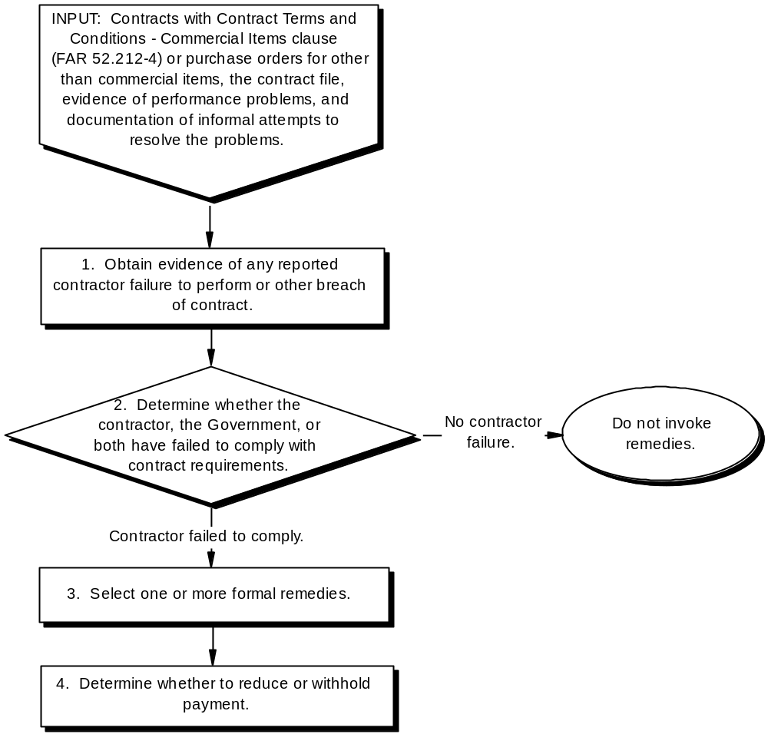

Tasks | Related Standards
1. Obtain evidence of any reported contractor failure to perform or other breach of contract. | Collect all related facts, including the contractor’s reactions to Government complaints. Reports on contractor failure to perform typically relate to:  - Anticipated or actual late delivery;  - Failure to control costs; or  - Unsatisfactory performance.

Tasks | Related Standards
2. Determine whether the contractor, the Government, or both have failed to comply with contract requirements. | Consider both:  - Contract language; and  - Other evidence (e.g., contractor representations regarding the deliverable).  If at issue, determine whether contractor representations regarding the quality, condition, description, or performance potential of the deliverable were:  - Part of the basis of the bargain, given the:  - Price negotiation memorandum (i.e., what transpired during contract negotiations);  - The contractor’s proposal; and  - The contract itself; or  - Mere “sales talk” or “puffing” about the offered supply or service.  Verify that the Government has carried out its promises and responsibilities, for example:  - Furnishing of suitable Government property at the specified time and place;  - Implied duty to not hinder performance;  - Implied duty to disclose information vital for offer preparation or contract performance;  - Implied duty to provide factually correct information; and  - Implied warranty of specifications.  Analyze potential defenses to allegations that the:  - Contractor failed to comply with contract requirements, such as:  - Impracticability of performance;  - Mutual mistakes; or  - Unconscionable requirements.  - Government failed to comply with contract requirements, such as:  - Disclaimers during negotiations; or  - The Sovereign Acts Doctrine.

Tasks | Related Standards
3. Select one or more formal remedies. | Select the remedy or remedies that best match the problem and the extent (if any) to which the Government is at fault. Generally, consider the following remedies:  - Cure notice and the possibility of contract termination for cause;  - Rejection of supplies or services before or after acceptance and possible termination for cause;  - Remedies under a warranty clause (if incorporated as an addendum to FAR  52.212-4);  - Remedies under implied warranties (e.g., the warranty of merchantability or the warranty of fitness for a particular purpose);  - Termination for convenience or cause (see the Termination Unit); or  - Any other remedies provided in the specific clause that was breached.  Alternatively, it may be in the Government’s best interest to accept a supply or service nonconformance with additional contractor consideration. (FAR 46.407(f)).
4. Determine whether to reduce or withhold payment. | Withhold or reduce payment:  - As provided in the contract, for example no payment is due under the:  - Terms for Financing Purchases of Commercial Items clause (FAR 52.232-29) when supplies or services will not be delivered or performed in accordance with the contract; or  - Installment Payment for Commercial Items clause (FAR 52.232-30) when supplies or services will not be delivered or performed in accordance with the contract.  - For delivered and accepted supplies or services to reflect any downward adjustment in the price agreed to by the contractor.

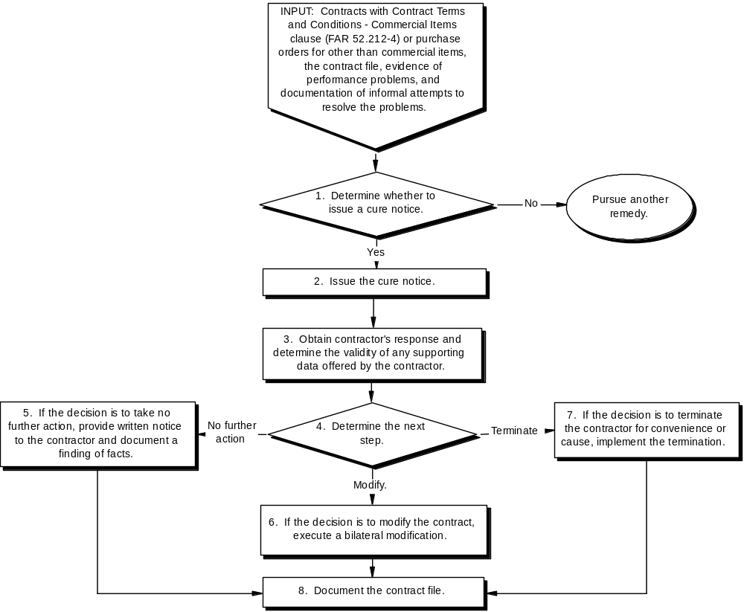

Tasks | Related Standards
1. Determine whether to issue a cure notice. | Use a cure notice in situations where the contractor:  - Fails to:  - Make progress as to endanger performance of the contract; or  - Perform some of the other requirements of the contract (e.g., provide required insurance); and  - Has sufficient time remaining in the contract delivery or performance schedule to permit a realistic cure period (i.e., 10 days or more).  Otherwise, prepare a termination notice and send it to the contractor immediately upon expiration of the delivery period.
2. Issue the cure notice. | The notice must:  - Follow the format presented in FAR 49.607(a);  - Clearly identify the contractor’s failure or failures in performance of the contract; and  - Provide the contractor 10 days to cure its failure or failures, but may provide any longer time that is reasonably necessary.  If the contractor is a small business, immediately provide a copy of the cure notice to the:  - Contracting office small business specialist; and  - Small Business Administration Regional Office nearest the contractor.

Tasks | Related Standards
3. Obtain contractor’s response and determine the validity of any supporting data offered by the contractor. | Examples of possible contractor responses include:  - An offer to cure performance;  - An offer to provide substantial performance in exchange for relief from some provisions of the contract;  - Presentation of a case for excusable delay;  - Agreement with the notice’s facts with no solution offered; or  - No response.

Tasks | Related Standards
4. Determine the next step. | Typically, alternatives include the following:  - Take no further action. Only choose this alternative when the contractor provides sufficient evidence that performance failures will be cured to complete the contract on time.  - Modify the contract. Only choose this alternative when:  - The contractor provides evidence of excusable delay that merits an extension of the delivery or performance period or other contract modification to permit completion within the original period; or  - The modification is in the Government’s best interests and the contractor provides:  - Sufficient evidence that the contract will be completed as modified; and  - Appropriate consideration for any relief from the contract’s requirements.  - Begin proceedings to terminate for cause. Consider the following factors before determining to terminate a contract for cause:  - The terms of the contract and applicable laws and regulations.  - The specific failure of the contractor and the excuses for the failure.  - The availability of the supplies or services from other sources.  - The urgency of the need for the supplies or services and the period of time required to obtain them from other sources.  - The degree of essentiality of the contractor in the Government acquisition program and the effect of a termination for default.  - The effect of a termination on the contractor’s ability to liquidate any Government financing.  - Any other pertinent facts and circumstances.

Tasks | Related Standards
5. If the decision is to take no further action, provide written notice to the contractor and document a finding of facts. | In the notice, state that:  - The Government accepts the contractor’s commitments to cure performance.  - Contractor failure to fulfill its commitments to cure performance failures will restore the Government’s right to terminate for cause.
6. If the decision is to modify the contract, execute a bilateral modification. | In the modification, clearly describe the contract changes, including any:  - Change in the delivery schedule;  - Change in other terms and conditions; and  - Consideration provided by the contractor in return for the modification.
7. If the decision is to terminate the contractor for convenience or cause, implement the termination. | Implement the termination following the procedures described in the Termination Unit.
8. Document the contract file. | Documentation should include:  - The cure notice;  - The contractor’s response;  - A summary of any other facts that affected the decision on the appropriate course of action;  - A price negotiation memorandum covering any negotiations with the contractor; and  - Any contract modification or written notice to the contractor.

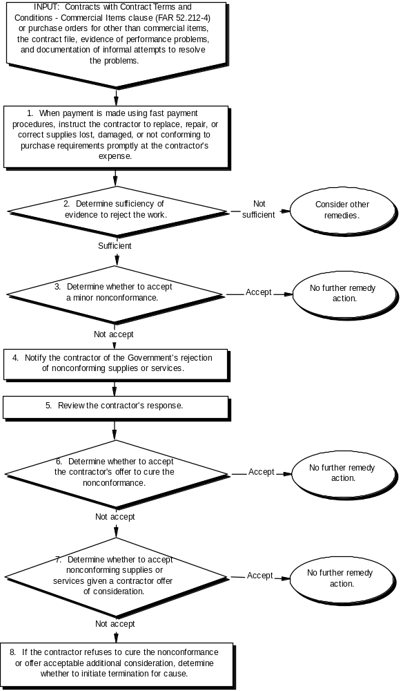

Tasks | Related Standards
1. When payment is made using fast payment procedures, instruct the contractor to replace, repair, or correct supplies lost, damaged, or not conforming to purchase requirements promptly at the contractor’s expense. | Correctly determine the date that title to the supplies was vested in the Government and issue instructions to the contractor within 180 days from that date.  The Contracting Officer is primarily responsible for collecting any debts resulting from the contractor’s failure to replace, repair, or correct supplies lost, damaged, or not conforming to purchase requirements.

Tasks | Related Standards
2. Determine sufficiency of evidence to reject the work. | Ensure that the Government is not at fault and consider relevant case law and questions such as:  - Has the Government accepted the deliverable either explicitly or implicitly by silence, late rejection, or retention and use of goods?  - Did the Government inspect the deliverable prior to acceptance? If so:  - Was the defect patent (i.e., discoverable through inspection) or latent?  - Was fraud or gross mistake amounting to fraud the reason a discoverable patent defect survived inspection prior to acceptance?  - Was acceptance predicated on the reasonable assumption that the nonconformance would be cured (discovery at time of acceptance)?  - Was acceptance reasonably induced by the seller’s assurances (no discovery at the time of acceptance)?  - Is the Government estopped by reason of accepting nonconforming work under a prior contract for the same requirement?  If the Government has accepted the deliverable, only consider revoking acceptance if the Government reports the defect to the contractor:  - Within a reasonable time after the defect was discovered or should have been discovered; and  - Before substantial change occurs in the condition of the item, unless the change is due to the defect in the item.  Note: If the Government is at fault, options may include modifying the contract or terminating for convenience.

Tasks | Related Standards
3. Determine whether to accept a minor nonconformance. | A minor nonconformance may be accepted without additional contractor consideration as long as the nonconformance does not adversely affect the safety, health, reliability, durability, performance, interchangeability of parts or assemblies, weight, or appearance (where a consideration), or any other basic objective of the Government requirement.  To assist in making this determination, the Government may establish a joint contractor-Government review group. Acceptance of supplies and services with any critical or major nonconformance is outside the scope of such a review group.  Discourage the repeated tender of nonconforming supplies or services, including those with only minor nonconformance, by appropriate action, such as rejection and documenting the contractor’s performance record.
4. Notify the contractor of the Government’s rejection of nonconforming supplies or services.  . | Promptness in giving the rejection notice is essential because, if timely notice of rejection is not furnished, acceptance may in certain cases be implied as a matter of law. The notice must:  - Include the reasons for rejection.  - Require the contractor to repair or replace the supplies or reperform the service at no increase in the contract price.  - Be in writing if:  - The supplies or services have been rejected at a place other than the contractor’s plant;  - The contractor persists in offering nonconforming supplies or services for acceptance; or  - Delivery or performance was late without excusable cause.  Allow time (usually 10 days) for the contractor to respond.

Tasks | Related Standards
5. Review the contractor’s response. | Examples of possible contractor responses include:  - Correction of the nonconformance without further comment;  - An offer to correct the nonconformance;  - Proposal that the Government accept the nonconforming supplies or services for a lower price or other consideration;  - Refusal to correct work or offer consideration; or  - No response.
6. Determine whether to accept the contractor’s offer to cure the nonconformance. | Normally:  - Accept the offer at no change in contract price if the nonconformance can reasonably be cured within the contract’s delivery or performance schedule.  - If a cure is not possible within the delivery or performance schedule:  - Determine whether to extend the delivery or performance schedule; and  - If the decision is to extend the delivery or performance schedule, determine:  - The reasonableness of the proposed extension.  - Whether to require consideration from the contractor and the amount of such consideration.  - If the contractor had reasonable grounds to believe that the deliverable was acceptable, do not require consideration for a reasonable extension of the delivery or performance schedule.  - Otherwise, obtain consideration.

Tasks | Related Standards
7. Determine whether to accept nonconforming supplies or services given a contractor offer of consideration. | Only accept nonconforming supplies when in the Government’s interest. Consider any:  - Consideration offered by the contractor.  - Information regarding the nature and extent of the nonconformance.  - Written warranty that requires the contractor to make any necessary repairs or corrections after acceptance at no cost to the Government.  - Recommendation for acceptance or rejection from other members of the Government acquisition team along with the rationale supporting that recommendation. Give special attention to any recommendation about the ability of the supply or service to meet health, safety, and performance requirements.
8. If the contractor refuses to cure the nonconformance or offer acceptable additional consideration, determine whether to initiate termination for cause. | Do not terminate for cause, if the contractor makes a persuasive case that:  - There has been acceptance, or  - Work is acceptable under the contract’s terms and conditions.  Terminate for cause if:  - The contractor refuses or is not likely to cure the nonconformance, and  - Offered consideration (if any) is not acceptable.

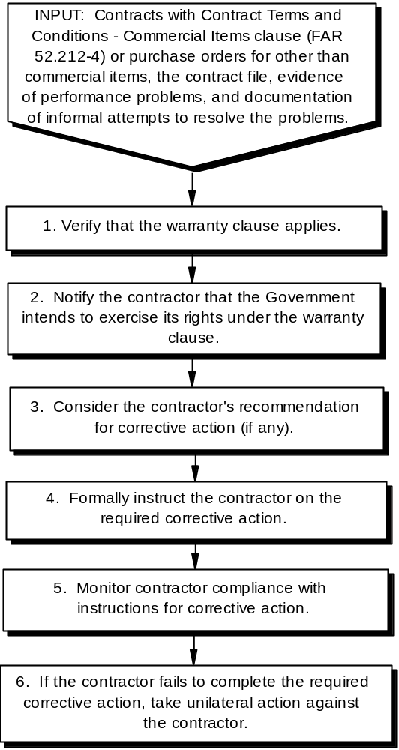

Tasks | Related Standards
1. Verify that the warranty clause applies. | Base the verification on:  - The terms and conditions of the applicable warranty clause in the contract (e.g., duration of the warranty);  - Whether Government obligations under the clause have been met; and  - Whether the facts support the Government’s case for invoking the warranty.
2. Notify the contractor that the Government intends to exercise its rights under the warranty clause. | Prepare a written notice to the contractor of any breach of warranty. Assure that the notice:  - Meets any requirements established in the contract warranty clause; and  - Is provided to the contractor within the time constraints established in the clause.
3. Consider the contractor’s recommendation for corrective action (if any). | If the warranty clause (e.g., Warranty of Supplies of a Complex Nature (FAR 52.246-18)) and Warranty of Systems and Equipment Under Performance Specifications or Design Criteria (FAR 52.246-19)) requires the contractor to submit a recommendation for corrective action, consider that recommendation in determining the appropriate corrective action.  Whenever practicable, reach agreement with the contractor on the appropriate corrective action.  Document results of any agreement with the contactor.
4. Formally instruct the contractor on the required corrective action. | When not part of the original notice of the breach of warranty, provide written notice of the required contractor action with a reasonable period to complete that action. Select the best alternative for making the Government whole available under the warranty clause, given the circumstances. Choose from among the alternatives presented in the contract clause.
5. Monitor contractor compliance with instructions for corrective action. | Ensure that the Government receives the full measure of relief provided by the warranty terms and conditions.

Tasks | Related Standards
6. If the contractor fails to complete the required corrective action, take unilateral action against the contractor. | If the contractor fails to take the required corrective action, obtain the required supplies or services from other sources and charge the related cost to the contractor. This cost may be recovered by:  - An offset against an existing contract; or  - A claim against the contractor.

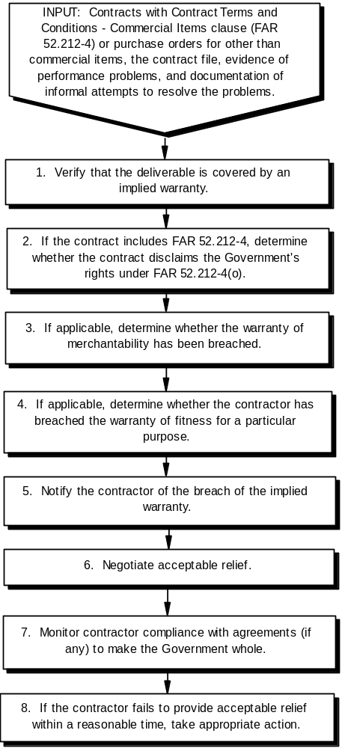

Tasks | Related Standards
1. Verify that the deliverable is covered by an implied warranty. | Consider invoking the warranty of merchantability or fitness for a particular purpose only:  - If the:  - Contract or purchase order includes FAR 52.212-4 or 52.213-4; or  - Purchase order for other than commercial items does not include inspection terms that make acceptance final and conclusive absent latent defects, fraud, or gross mistake amounting to fraud; and  - The Government has not waived the warranty with respect to the defect at issue under the Uniform Commercial Code (UCC).  Correctly identify other implied warranties (if any) under the contract.
2. If the contract includes FAR 52.212-4, determine whether the contract disclaims the Government’s rights under FAR 52.212-4(o). | If the contractor accepted a purchase order (i.e., offer from the Government), correctly determine the legal effect of any disclaimer in a letter of acceptance.  If the Government accepted the contractor’s offer, correctly ascertain whether the resulting contract excludes or limits the Government’s rights under 52.212-4(o).

Tasks | Related Standards
3. If applicable, determine whether the warranty of merchantability has been breached. | Correctly determine whether the item is or is not merchantable under the tests in the UCC. Under the UCC 2A-314, for goods to be merchantable they must:  - Pass without objection in the trade under the contract description;  - In the case of fungible goods, be of fair average quality within the description;  - Be fit for the ordinary purposes for which such goods are used;  - Be, within the variations permitted by the agreement, of even kind, quality and quantity within each unit and among all units involved;  - Be adequately contained, packaged, and labeled as the agreement may require; and  - Conform to the promise or affirmations of fact made on the container or label if any.
4. If applicable, determine whether the contractor has breached the warranty of fitness for a particular purpose. | Determine whether:  - The seller knew the particular purpose for which the Government intended to use the item; and  - The Government relied upon the contractor’s skill and judgment that the item would be appropriate for that particular purpose.
5. Notify the contractor of the breach of the implied warranty. | Notify the contractor within a reasonable time after discovery of the breach and within any deadlines established by the contract. The notification:  - Should identify:  - The contract;  - The item; and  - State the basis for believing that an applied warranty exists.  - May:  - State the Government’s position on resolving the breach of warranty (e.g., request replacement of the item); or  - Request a contractor recommendation on the best way to resolve the breach.

Tasks | Related Standards
6. Negotiate acceptable relief. | Based on any contractor response to the notice of the breach of warranty and other available information, negotiate acceptable relief. Alternatives typically include:  - No cost to the Government:  - Repair;  - Replacement; or  - Reperformance; or  - Refund all or part of the purchase price.
7. Monitor contractor compliance with agreements (if any) to make the Government whole. | Ensure that the Government is made whole.
8. If the contractor fails to provide acceptable relief within a reasonable time, take appropriate action. | If the contract has already closed out, file a claim against the contractor.  If time remains in the delivery or performance period (at least 10 days) issue a cure notice.  If the delivery or period has expired, prepare a termination notice.

Problem | Options | Comments
The deliverable has been or will be delivered late and the delay is not excusable. | Reschedule the delivery date in exchange for consideration. | Appropriate when:  - There is a reasonable probability of delivery by the new date; and  - The requiring activity can live with the new date.
 | Reduce or suspend commercial finance payments under FAR 52.232-29(a) or 52.232-30(a). | Appropriate when:  - Commercial finance payments are being made; and  - Performance of the contract is endangered by the contractor’s failure to make progress.
 | Accept late delivery and impose liquidated damages.  (Note: Liquidated damages can be incorporated by addendum to FAR 52.212-4 if a customary commercial practice for the market.) | Appropriate when:  - The contract provides for liquidated damages; and  - There is a reasonable probability of delivery by a date that the requiring activity can tolerate.
 | Send a cure notice 10 days or more prior to the contract’s delivery date, or termination notice immediately upon expiration of the delivery period. | Appropriate when there is little probability of delivery by a date that the requiring activity can tolerate and/or the contractor has not offered adequate consideration.

Problem | Options | Comments
The deliverable has not been implicitly or explicitly accepted and does not conform to contract requirements. | Accept the deliverable without consideration. | Appropriate when the nonconformance is minor and obtaining consideration is not in the Government’s interests (per FAR 46.407(f)).
 | Accept the deliverable in exchange for consideration. | Appropriate when the requiring activity can tolerate non-conformance (per FAR 46.407(c)).
 | Accept the deliverable and invoke a warranty to have the deliverable brought up to specification after acceptance. | Appropriate when the defect is covered by a warranty clause or an implied warranty (see FAR 52.212-4(o)) and immediate acceptance will benefit the requiring activity.
 | Reject the deliverable and obtain correction or replacement at no cost to the Government.  Tell the payment office to withhold payment until an acceptable deliverable has been furnished. | Appropriate when there is a reasonable expectation that a satisfactory replacement will be provided by the delivery date in the contract, or, for consideration, within a reasonable time thereafter.
 | Reject the deliverable and send a cure or termination notice. | Appropriate when there is little expectation of receiving an acceptable product within a reasonable time.

Problem | Options | Comments
The deliverable has been accepted but does not conform to contract requirements. | Reject the supply or service after acceptance as provided in FAR 52.212-4(a). | Appropriate when the Government reports the defect to the contractor:  - Within a reasonable time after the defect was or should have been discovered; and  - Before substantial change occurs in the condition of the item, unless the change is due to the defect in the item.
 | Invoke an express warranty. | Appropriate when a warranty clause has been incorporated by an addendum to 52.212-4.
 | Invoke an implied warranty. | Appropriate when an implied warranty applies (FAR 52.212-4(o)).
Other breaches when the Contracting Officer has exhausted all efforts at informal resolution of the problem. | Invoke whatever remedy (if any) is established in FAR clauses (if any) incorporated by addenda or checked in FAR 52.212-5. | Examples:  - Liquidated damages under; the Liquidated Damages – Subcontracting Plan (FAR 52.219-16) for failing to comply with the subcontracting plan.  - Cancellation, suspension, or termination of the contract under Equal Opportunity (FAR 52.222-26) (incorporated by reference if checked in FAR 52.212-5).  - Withholding of payments and termination under Service Contract Act of 1965, As Amended (FAR 52.222-41) (incorporated by reference if checked in FAR 52.212-5).
 | Suspend or reduce payments under FAR 52.232-29 or 30. | Appropriate when the supplies deliverable or services will not be delivered or performed in accordance with the contract.
 | Send a cure notice (10 days or more prior to the contract’s delivery date). | Appropriate when the breach is of sufficient magnitude to warrant termination for cause.

Note: For the purpose of training this unit, do not use contracts with addenda to FAR 52.212-4 that incorporate additional remedies (e.g., liquidated damages). Use contracts that incorporate commercial warranties; also use contracts with no addenda that limit or replace the language at FAR 52.212-4(a) and 212-4(o).

