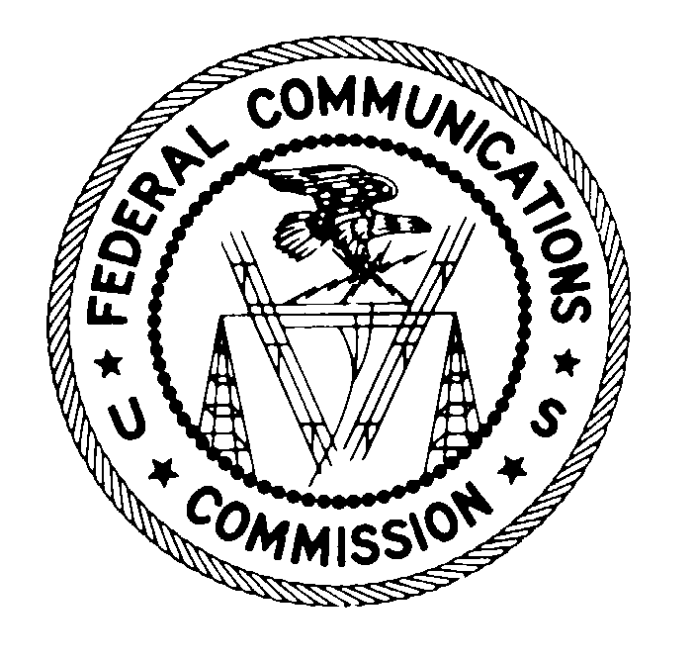
FEDERAL COMMUNICATIONS COMMISSION
WASHINGTON, D.C. 20554
June 1, 2007

VIA CERTIFIED MAIL
RETURN RECEIPT REQUESTED

CompUSA, Inc.
721 Central Expressway
Collin Creek Village VI
Plano, TX 75075

CompUSA, Inc.
14951 North Dallas Parkway
Dallas, TX 75254
Attn: Roman Ross, President and CEO

Re: File No. EB-07-DL-097
Citation No.: C2007325003

This is an official CITATION, issued pursuant to Section 503(b)(5) of the Communications Act of 1934, as amended (“Act”), 47 U.S.C. § 503(b)(5), to CompUSA, Inc. (“CompUSA”) for failure to provide appropriate Consumer Alert disclosures on analog tuner only television receiving equipment in violation of Section 302(b) of the Act, 47 U.S.C. § 302a(b), and Section 15.117(k) of the Commission’s Rules (“Rules”), 47 C.F.R. § 15.117(k). As explained below, future violations of the Commission’s rules in this regard may subject your company to monetary forfeitures.

On May 29, 2007, agents from the Commission’s Dallas Office of the Enforcement Bureau visited the CompUSA location at 721 Central Expressway, Collin Creek Village VI, Plano, Texas and observed that CompUSA did not have the proper Consumer Alert label displayed on equipment that contained an analog tuner but not a digital tuner at the point of sale.

Section 302(b) of the Act provides that “[n]o person shall manufacture, import, sell, offer for sale, or ship devices or home electronic equipment and systems, or use devices, which fail to comply with regulations promulgated to this section.” Section 15.117(k) of the Commission’s Rules states:

(k) The following requirements apply to all responsible parties, as defined in §2.909 of this chapter, and any person that displays or offers for sale or rent television receiving equipment that is not capable of receiving, decoding and tuning digital signals.

(1) Such parties and persons shall place conspicuously and in close proximity to such television broadcast receivers a sign containing, in clear and conspicuous print, the Consumer Alert disclosure text required by subparagraph (3). The text should be in a size of type large enough to be clear, conspicuous and readily legible, consistent with the dimensions of the equipment and the label. The information may be printed on a transparent material and affixed to the screen, if the receiver includes a display, in a manner that is removable by the consumer and does not obscure the picture, or, if the receiver does not include a display, in a prominent location on the device, such as on the top or front of the device, when displayed for sale, or the information in this format may be displayed separately immediately adjacent to each television broadcast receiver offered for sale and clearly associated with the analog-only model to which it pertains.

(2) If such parties and persons display or offer for sale or rent such television broadcast receivers via direct mail, catalog, or electronic means, they shall prominently display in close proximity to the images or descriptions of such television broadcast receivers, in clear and conspicuous print, the Consumer Alert disclosure text required by subparagraph (3). The text should be in a size large enough to be clear, conspicuous, and readily legible, consistent with the dimensions of the advertisement or description.

(3) “CONSUMER ALERT
This television receiver has only an analog broadcast tuner and will require a converter box after February 17, 2009, to receive over-the-air broadcasts with an antenna because of the Nation’s transition to digital broadcasting. Analog-only TVs should continue to work as before with cable and satellite TV services, gaming consoles, VCRs, DVD players, and similar products. For more information, call the Federal Communications Commission at 1-888-225-5322 (TTY: 1-888-835-5322) or visit the Commission’s digital television website at: www.dtv.gov.”

Accordingly, it appears that CompUSA has violated Section 302(b) of the Act, and Section 15.117(k) of the Rules by failing to place conspicuously and in close proximity to the following equipment, in clear and conspicuous print, the Consumer Alert label required under Section 15.117(k):

Brand | Model | Type of Equipment
LG Electronics | RC199H | DVD/VCR Recorder
Samsung | DVD-R135 | DVD Recorder
Samsung | DVD-VR357 | DVD/VCR Recorder
Zenith | XBR617 | DVD/VCR Recorder
Syntax-Brillian | 20-Inch LCD TV | Television.

We caution you that failure to display the appropriate Consumer Alert label on any television receiving equipment that is not capable of receiving, decoding and tuning digital signals would constitute a further violation of Section 302(b) of the Act and Section 15.117(k) of the Rules.

If, after receipt of this citation, any CompUSA retail outlet or any other retail outlets under common ownership or control violates the Communications Act or the Commission’s rules in any manner described herein, the Commission may impose monetary forfeitures not to exceed $11,000 for each such violation or each day of a continuing violation up to $97,500 for a single continuing violation.

If you choose to do so, you may respond to this citation within 10 days from the date of this letter either through (1) a personal interview at the Commission’s Field Office nearest to your place of business, or (2) a written statement. Your response should specify the actions that CompUSA is taking to ensure that it does not violate the Commission’s rules governing the marketing of unauthorized radio frequency devices in the future.

CompUSA may request an interview at the closest FCC Office, which is Federal Communications Commission, 9330 LBJ Freeway, Suite 1170, Dallas, Texas 75243. You may contact this office by telephone, (XXX) XXXX-XXXX to schedule this interview, which must take place within 10 days of this Citation. CompUSA may also submit a written statement to the above address within 10 days of the date of this Citation. Any written statements should specify what actions have been taken to correct the violation[s] outlined above. Please reference file number EB-07-DL-097 when corresponding with the Commission.

Under the Privacy Act of 1974, 5 U.S.C. § 552a(e)(3), we are informing you that the Commission’s staff will use all relevant material information before it, including information that you disclose in your interview or written statement, to determine what, if any, enforcement action is required to ensure your compliance with the Communications Act and the Commission’s rules.

The knowing and willful making of any false statement, or the concealment of any material fact, in reply to this citation is punishable by fine or imprisonment under 18 U.S.C. § 1001.

Thank you in advance for your anticipated cooperation.

Sincerely,

FEDERAL COMMUNICATIONS COMMISSION

James D. Wells
District Director, Dallas Office
Enforcement Bureau

See 47 C.F.R. § 1.80(b)(3).
? 47 U.S.C. § 503(b)(5).

