ABDOMINAL EXERCISES FOR BEGINNERS
Date | . | Time | .
BREATH | HIP ROLL | NORMAL | BRIDGING
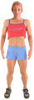. | ..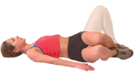 | 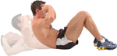. | 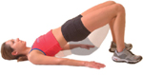.
10 Deep Breaths | 2 Sets of 10 slow rolls each side - with 20 seconds rest. | 2 Sets of 10 lifts with 20 seconds rest. | 1 Set of 10 slow lifts. Hold for 3 - 5 seconds in upward phase.
STANDING ROTATION | HANDS VIA KNEES | SEATED KNEE TUCKS | SUPERMANS
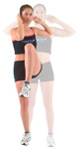 | .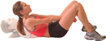 | 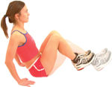. | 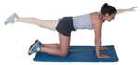.
Alternate sides for 30 - 45 seconds. | 2 Sets of 10 lifts with 20 seconds rest between sets. | 2 Sets of 6 - 10 lifts with 20 seconds rest between sets. | Alternate sides for 45 - 60 seconds.
FGF = Feel Good Factor - Write down how you feel after your sets.
Record the amount of reps you performed for each exercise.

Exercise | Reps | Sets | FGF | Exercise | Reps | Sets | FGF
1 | . | . | . | 5 | . | . | .
2 | . | . | . | 6 | . | . | .
3 | . | . | . | 7 | . | . | .
4 | . | . | . | 8 | . | . | .
Notes:

ABDOMINALS SWISS BALL EXERCISES FOR INTERMEDIATES
Date | . | Time | .
SEATED CIRCLES | CHEST PRESS | REVERSE TWIST | NORMAL SIT - UPS
.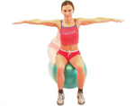 | ..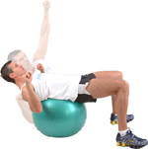 | .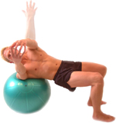 | .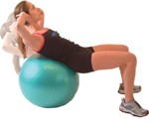
15 Deep Circles in each direction. | 2 Sets of 12 - 15 lifts each side - with 20 seconds rest. | 2 Sets of 10 - 15 turns each side with 20 seconds between sets. | 3 Sets of 10 slow lifts. Hold for 3 - 5 seconds in upward phase.
HIP ROLLS | BRIDGING | NORMAL PLANK | NORMAL OBLIQUE
.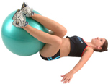 | 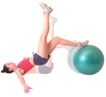 | 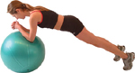. | 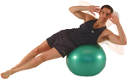.
12 Slow rolls each side for 2 sets - 20 seconds rest between sets. | 2 Sets of 12 - 15 lifts with 20 seconds rest between sets. | 2 Sets of 45 seconds lift with 20 seconds rest between sets. | 2 Sets of 15 slow lifts with 20 seconds rest between sets.
REVERSE BACK EXTENSION | SUPERMANS | SCISSOR LEG REVERSE CURL | LIFT AND TWIST
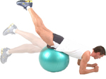 | 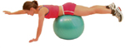 | 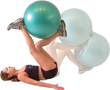 | 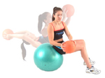
15 Slow lifts aim for 3 - 5 seconds per exercise. | 2 Sets of 12 - 15 lifts each hand, with 20 seconds rest between sets. | Perform 12 slow lifts each leg, holding in upward phase for 3 seconds. | Perform 10 - 15 slow lifts each side, holding in upward twist phase for 3 seconds.
ABOMINALS MEDICINE BALL EXERCISES FOR ADVANCED
Date | . | Time | .
STANDING SIDE BENDS | LYING MEDICINE BALL OBLIQUES | AROUND THE BODY (SMALL BALL) | SEATED TWISTS
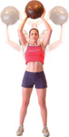 | ..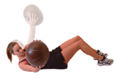 | .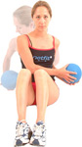 | 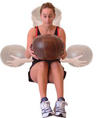.
12 - 15 slow turns each side. Breathe deeply throughout. | 2 Sets of 12 - 15 slow rolls each side - with 20 seconds rest. | 2 Sets of 8 - 12 turns each direction with a light ball or tennis ball. | 1 Set of 8 - 10 slow bends each side. Hold for 3 - 5 seconds in down phase.
WEIGHTED GOLF SWING | SEATED ROTATIONS | LIFT ONTO CROSSED LEGS | WEIGHTED LEG EXTENSIONS
.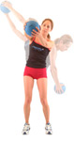 | .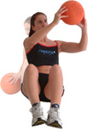 | 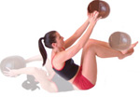. | 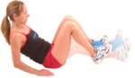.
Alternate sides for 30 - 45 seconds. | 2 Sets of 10 - 15 slow lifts each side. Aim to keep your arms straight. | 2 Sets of 10 - 12 lifts of the ball with 20 seconds rest between sets. | Work smoothly for 45 - 60 seconds, holding a small ball between feet.
WEIGHTED V-SITS | AROUND BOTH LEGS | THROUGH SINGLE LEGS | FINAL CIRCUIT FEEL THE BURN
.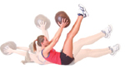 | .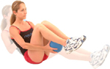 | .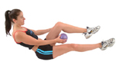 | Use the last 3 exercises.  Work continuously for 30 seconds or (15 each way) on each exercise.  Rest for 60 seconds then repeat again.
Smoothly lift ball up to your feet. 12 - 15 reps 2 sets. | Pass small ball under both legs for 30 seconds each direction. | Alternate each leg coming up, passing the ball under then over for 60 seconds
FGF = Feel Good Factor - Write down how you feel after your sets.
Record the amount of reps you performed for each exercise.

