 |  | Structures/Mechanical | Payload | Ground Supportability
Integrate |  | - Cross sections of tankage/load bearing structure to reduce closed compartments & aeroshells (1, p4)  - Tankage and TPS to eliminate aeroshells & closed compartments (2, p30-31, p39-40)  - Tanks for common fluids (LOX, LH2, GHe…) (2, p37)  - Tanks for multiple systems (MPS, OMS, RCS, power, thermal management) (1, p3) (2,p34-35) (3) | - Payload containment with the vehicle structure & outer mold line function (5) | - Flight to ground interfaces (1, p9)  - Components of launch umbilical (electrical connectors, fluid disconnects, structure,…) (5)  - Ground test, launch, and flight control software (5)  - Processing facility and control room infrastructure (4, Gen15)  - Loading umbilicals (fill, drain, power, comm.,…) and tank vents (GOX, GH2) into same umbilicals at base (5).
Eliminate |  | - Toxic waterproofing for TPS (2, p22-24) (5)  - Need for waterproofing TPS (2,p22-24) (5)  - Complex heat shielding (5)  - Hazardous pyrotechnic/ordnance devices (5)  - Closed structural compartments (without compromising safety and maintainability) near tanks, around MPS manifold, and near areas containing systems which are prone to outgassing or leakage. (2, p30-31, p39-40) (3) (5)  - Unnecessary penetrations in pressurized compartments (4,TC1)  - Mechanical joints (3) | - Access/entry for removal of integrated cargo element (5)  - Dependence of payload support on launcher (5)  - Fluid interfaces between payload and launcher (5)  - Electrical interfaces (power and communication) between payload and launcher (5)  - Monitoring of payload during cruise phase (5) | - Toxic fluids for servicing, manufacturing, assembling, and cleaning (1, p4,8) (2, p22-24, 58-59,68)  - High parts count (1, p6) (2, p63-64)  - Large support staff (1, p5)  - Hands-on, intrusive ground support activity (1, p10) (2, p52-54) (5)  - Hard-line data links from vehicle to launch pad and LCC (5)  - Need for complex sound suppression systems (5)  - Swing arms / arm type vents at pad and ordnance / events at launch (3, p30,37,39) (5)  - Vehicle cannibalization (5)
Design In | Maintainability | - Accessibility without requiring special GSE, access kits, or non-affected line replaceable unit removal (1, p6)  - Fluid/gas connections that do not require process control (i.e. leak-checking) after assembly (1, p11) (2, p44-47)  - Robustness and/or Built-in-Test and verification devices to verify/assure structural safety (2, p27-28) (5)  - Common fasteners (5)  - Robustness and/or TPS quick removal and replacement (2,p53) (4, p48) | - Standard payload interfaces (5)  - Standard communication/data protocols (5)  - Fluid/gas connections that do not require process control (i.e. leak-checking) after assembly (1, p11) (2, p44-47)  - Built-in-tests to verify payload health (5)  - Minimum attachment interfaces (5)  - Minimum number of different fluids (5)  - Minimum wire count (5) | - Minimum test hardware interfaces, utilize built-in-test to verify launch readiness (5)
 | Reliability | - Corrosion resistant materials (5)  - TPS that does not require routine inspection (2,p53) (5)  - Minimum parts count (2,p63-64) (5)  - Minimum susceptibility to critical fatigue (5) | - Commercial off-the-shelf products produced in high quantities (bus, electronics, power, actuators,…) (1, p5) | - Commercial off-the-shelf (COTS) products produced in high quantities (quick disconnects, valves, software, controllers, PLCs, sensors,…) (2,p41-43) (5)
 | Margin | - Margins in structures that eliminate intrusive inspections for corrosion, primer, defects (5)  - Robust, weather tolerant TPS (2, p22-24)  - Robust, weather tolerant windows (5) (2,p13-16,p25-26) | - Performance to provide for payload flexibility and growth (1, p12) (2, p58-59) | - Ground systems robust to failures through redundancies for critical systems (5)  - Ground/flight sys. with requirements capable of being satisfied by wide array of COTS products (5)
Automate |  | - Leak location / diagnostics (not just detection) (3)  - Landing gear ground (test) operations (4, GNC8)  - Add / build in integrated vehicle health management (IVHM) systems (4, GNC 13)  - Brake/anti-skid test and checkout (4, GNC9) | - Checkout of payload interface to vehicle (4, p33)  - Cruise operations (5)  - Scientific data collection and distribution process (5) | - Maintenance tracking and scheduling to subsystem level (5)  - Failure reporting system (5)  - Launch processing operations and mission planning (5)  - Flight crew active control functions (5)  - Checkout and troubleshooting of flight to ground interfaces (fluid, power, communication, and structural) (5)  - Ground System Checkout & troubleshooting (5)  - Loading/servicing of launch vehicle (5)

REFERENCES
- Architectural Assessment Tool, Space Propulsion Synergy Team (SPST), Oct., 1997.
- A Guide for the Design of Highly Reusable Space Transportation, SPST, Aug., 1997.
- Operationally Efficient Propulsion System Study (OEPSS), Rocketdyne Division, Rockwell International, Aug., 1993.
- Shuttle Avionics Testing Constraints and Considerations, Carey McCleskey, NASA Kennedy Space Center, June, 1995.
- For further information, contact Edgar Zapata, 407-861-3955, NASA Kennedy Space Center.

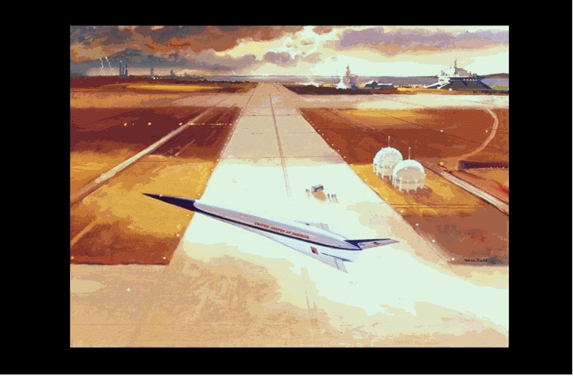

DESIGN GUIDELINES
- Reduce the overall number of different fluids; do not use toxic fluids.
- Integrate propulsion system components.
- Use reliable, commercial off-the-shelf products that are produced in high quantities.
- Automate checkouts of systems and turnaround facilities.
- Design for accessibility without requiring special GSE, access kits, or non-affected line-replaceable unit removal.
- Minimize interfaces between flight and ground.

Prepared by
Rebecca Cutri-Kohart

 |  | Propulsion | Avionics  (GNC, communication, computing, power management)
Integrate |  | - MPS and OMS engine function (1, p3) (2, p34-35,72) (3) (5)  - OMS and RCS tanks (1, p3)  - Oxidizer for MPS, OMS, RCS, power, thermal management (1, p8) (2, p22,34,58)  - Fuel types, use identical fuel grades for common fluid systems (2, p58) (5)  - Interfaces (connectors/quick disconnects) between flight and ground (3) (5)  - N-turbopumps with X-engines to minimize the count of turbopumps (shared turbopumps) (2, p72) (3) (5)  - Engine controllers (share with engines and/or avionics) (3) | - Hardware (avionics controls with engine controller, vehicle health system, or ground equipment) (3)  - Electrical connectors between flight and ground (5)  - Navigation equipment and traditional direct air-stream sensing (4, GNC16)
Eliminate |  | - Toxic propellants (1, p8) (2, p22-24,68) (5)  - Confined spaces with hazardous fluid potential (2, p30-31,68) (3) (5)  - GHe/GN2 purges for confined spaces (1, p 6) (2, p39-40)  - Confined spaces requiring environmental conditioning (1, p 6) (2, p 39-40)  - Fluid joints and electrical conductor counts (2, p58-59)  - Large number of gases for flight operations (1, p9)  - Active engine events during flight (staging, mixture ratio changing, throttling, mode changes) (1, p4) (3)  - Turbopump inner seal purge (2, p44-45) (3)  - LOX pump seal leakage (3)  - Helium gas usage, pneumatic valve actuators (5) (3)  - Helium gas usage for pressurization (3)  - Leak potentials (minimize) (3)  - Distributive hydraulic systems (1, p8) (2, p22-24,68) (5) | - Toxic cooling fluids, such as freons, ammonia (1,p8) (2, p22-24,58-59,68)  - Need for multiple telemetry formats (downlink and downlist) (4, Gen2)  - Active cooling for avionics boxes (4, Gen3)  - Checkout requirements due to connector demates/remates (4, Gen4)  - Possibility of engine collision (4, GNC2)  - Procedural restrictions on actuator movement (4, GNC5)  - Special cleaning/access requirements (such as for the star tracker lens and light shade inspections) (4,GNC14)  - Materials that outgas (4,GNC15)
Design In | Maintainability | - Built-in-test, troubleshooting, and diagnostics (1, p10) (2, p27-28) (3) (5)  - Accessibility without requiring special GSE, access kits, or non-effected line replaceable unit removal (1, p 6) (5)  - Minimum number of different propellants (5)  - Electro-mechanical actuators (EMA) or electro-hydrostatic (EHA) actuators for gimbaling/TVC (5) (3) | - Minimum fluid interfaces (2, p44-47)  - Minimum wire count (4, Gen4)  - Minimum connector interfaces (2, p44-47)  - Minimum attachment interfaces (5)  - Minimum the number of checkouts required (2, p67)  - Ergonomic access to line replaceable units (LRU) - accessibility without requiring special GSE, access kits or non-effected LRU removal (4, Gen9)  - Built-in-Tests (BIT) to monitor vehicle health and troubleshoot (5)  - Installation and fastening devices (4, Gen10)
 | Reliability | - Commercial off-the-shelf products produced in high quantities (such as electronics, controls, valves, sensors,…) (1, p5) (3)  - Expert systems to control complex loading and launch operations (5) | - Commercial off-the-shelf products produced in high quantities (such as software, processors, displays,…) (1, p5)
 | Margin | - Operate engines farther from the design edge - less than 100% of design/test thrust rating (2, p25-26) | - In temperature and other operating environment restrictions (4, GNC6)  - Hardware immunity to contamination and physical damage (4, GNC15)
Automate |  | - Turnaround functions, such as leak, valve, electrical, hydraulic, and engine systems checkouts (2, p49-51)  - Interface connection/disconnection for fluid and electrical checkouts (5) | - Functions on-board vehicle instead of or in addition to ground (4, Gen6)  - Redundant power verification during power-up or system activation (4, Gen13)  - Checkout of redundant systems (4, Gen8)  - Checkout functions for motorized systems (5)

Space Transportation Systems

Operability



Quick Reference

