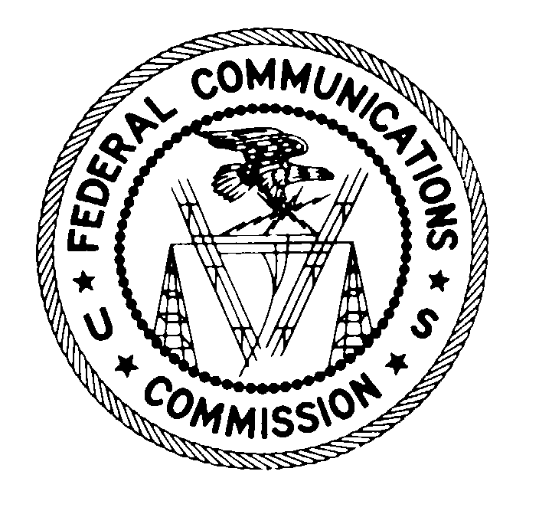
FEDERAL COMMUNICATIONS COMMISSION
WASHINGTON, D.C. 20554
November 22, 2004

VIA CERTIFIED MAIL
RETURN RECEIPT REQUESTED

NY Industrial Roofing & Waterproofing Co.
204 Crookedhill Road
Brentwood, New York 11717

RE: EB-04-TC-161

Dear Correspondent:

This is an official CITATION, issued pursuant to section 503(b)(5) of the Communications Act of 1934, as amended (the Act), 47 U.S.C. § 503(b)(5), for violations of the Act and the Federal Communications Commission’s rules that govern telephone solicitations and unsolicited advertisements. As explained below, future violations of the Act or Commission’s rules in this regard may subject your company to monetary forfeitures.

It has come to our attention that your company apparently sent one or more unsolicited advertisements to telephone facsimile machines in violation of Section 227(b)(1)(C) of the Communications Act makes it “unlawful for any person within the United States, or any person outside the United States if the recipient is within the United States . . . to use a telephone facsimile machine, computer, or other device to send an unsolicited advertisement to a telephone facsimile machine.” The term “unsolicited advertisement” is defined in the Act and the Commission’s rules as “any material advertising the commercial availability or quality of any property, goods, or services which is transmitted to any person without that person’s prior express invitation or permission.” Under Commission rules and orders currently in effect, the Commission considers an established business relationship between a fax sender and recipient to constitute prior express invitation or permission to send a facsimile advertisement. Mere distribution or publication of a fax number, however, does not establish consent to receive advertisements by fax.

If, after receipt of this citation, you violate the Communications Act or the Commission’s rules in any manner described herein, the Commission may impose monetary forfeitures not to exceed $11,000 for each such violation or each day of a continuing violation.

You may respond to this citation within 30 days from the date of this letter either through (1) a personal interview at the Commission’s Field Office nearest to your place of business, or (2) a written statement. Your response should specify the actions that you are taking to ensure that you do not violate the Commission’s rules governing telephone solicitation and unsolicited advertisements, as described above.

The nearest Commission field office appears to be the New York Office, New York, New York. Please contact Al McCloud at (202) 418-2499 if you wish to schedule a personal interview. You should schedule any interview to take place within 30 days of the date of

this letter. You should send any written statement within 30 days of the date of this letter to:

Kurt A. Schroeder
Deputy Chief
Telecommunications Consumers Division
Enforcement Bureau
Federal Communications Commission
445-12th Street, S.W.
Rm. 4-C222
Washington, D.C. 20554

Reference EB-04-TC-161 when corresponding with the Commission.

Reasonable accommodations for people with disabilities are available upon request. Include a description of the accommodation you will need including as much detail as you can. Also include a way we can contact you if we need more information. Please allow at least 5 days advance notice; last minute requests will be accepted, but may be impossible to fill. Send an e-mail to fcc504@fcc.gov or call the Consumer & Governmental Affairs Bureau:

For sign language interpreters, CART, and other reasonable accommodations:
202-418-0530 (voice), 202-418-0432 (tty);

For accessible format materials (braille, large print, electronic files, and audio
format): 202-418-0531 (voice), 202-418-7365 (tty).

Under the Privacy Act of 1974, 5 U.S.C. § 552(a)(e)(3), we are informing you that the Commission’s staff will use all relevant material information before it, including information that you disclose in your interview or written statement, to determine what, if any, enforcement action is required to ensure your compliance with the Communications Act and the Commission’s rules.

The knowing and willful making of any false statement, or the concealment of any material fact, in reply to this citation is punishable by fine or imprisonment under 18 U.S.C. § 1001.

Thank you in advance for your anticipated cooperation.

Sincerely,

Kurt A. Schroeder
Deputy Chief, Telecommunications Consumers Division
Enforcement Bureau
Federal Communications Commission

Enclosures

47 U.S.C. § 227; 47 C.F.R. § 64.1200. A copy of these provisions is enclosed for your convenience. Section 227 was added to the Communications Act by the Telephone Consumer Protection Act of 1991 and is most commonly known as the TCPA. The TCPA and the Commission’s parallel rules restrict a variety of practices that are associated with telephone solicitation and use of the telephone network to deliver unsolicited advertisements, including fax advertising.
47 U.S.C. § 227(b)(1)(C); see also 47 C.F.R. § 64.1200(a)(3) (providing that no person or entity may . . . use a telephone facsimile machine, computer, or other device to send an unsolicited advertisement to a telephone facsimile machine). Both the TCPA and the Commission’s rules define “telephone facsimile machine” as “equipment which has the capacity to transcribe text or images, or both, from paper into an electronic signal and to transmit that signal over a regular telephone line, or to transcribe text or images (or both) from an electronic signal received over a regular telephone line onto paper.” 47 U.S.C. § 227(a)(2); 47 C.F.R. § 64.1200(f)(8). The Commission has stated that “[t]he TCPA’s definition of ‘telephone facsimile machine’ broadly applies to any equipment that has the capacity to send or receive text or images.” Thus, “faxes sent to personal computers equipped with, or attached to, modems and to computerized fax servers are subject to the TCPA’s prohibition on unsolicited faxes. . . [although] the prohibition does not extend to facsimile messages sent as email over the Internet.” Rules and Regulations Implementing the Telephone Consumer Protection Act of 1991, Report and Order, 18 FCC Rcd 14014, 14131-32 (2003) (2003 TCPA Report and Order).
47 U.S.C. § 227(a)(4); 47 C.F.R. § 64.1200(f)(10).
Rules and Regulations Implementing the Telephone Consumer Protection Act of 1991, Memorandum Opinion and Order, 10 FCC Rcd 12391, 12405 (1995) (1995 TCPA Reconsideration Order). In June 2003, the Commission amended its rules to specify that prior express invitation or permission to receive a facsimile advertisement must be recorded in a “signed written statement that includes the facsimile number to which any advertisements may be sent and clearly indicates the recipient's consent to receive such facsimile advertisements from the sender.” 2003 TCPA Report and Order, 18 FCC Rcd at 14124-28 (adopting new section 64.1200(a)(3)(i). This new provision, which supercedes the established business relationship exception, is scheduled to take effect June 30, 2005. Rules and Regulations Implementing the Telephone Consumer Protection Act of 1991, Order, FCC 04-223 (rel. Oct.1, 2004). The Commission currently is considering petitions that seek to retain the established business relationship exception or require methods other than a signed written statement to demonstrate prior express consent to receive fax advertising.
1995 Reconsideration Order, 10 FCC Rcd at 12408-09; see also 2003 TCPA Report and Order, 18 FCC Rcd at 14128 (concluding that publication of a fax number in a trade publication or directory does not demonstrate consent to receive fax advertising).
See 47 C.F.R. § 1.80(b)(3).

