Flowers found at Mount Rushmore
National Memorial

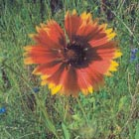
Blanket Flower (Gaillardia aristata)
Blooms late June – August

Uses: This flower was used by many Native Americans. An adhesive substance (poultice) was used to treat skin disorders. The plant also was used to make eyewash, nose drops, foot wash, and the flower heads were rubbed on rawhide bags for waterproofing.

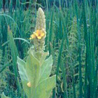

Common Mullein (Verbascum thapsus)
Blooms July – August

Uses: Native American used the leaves to treat rashes under the arm pits. Leaves were also used to treat swollen glands; the flowers were rubbed on sores. The smoke produced by burning the plants was used to treat asthma and bronchitis.

False Dandelion (Agoseris glauca)
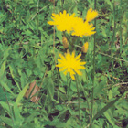
Blooms June – August

Uses: This plant produced a sap which the Native Americans used to clean their teeth.

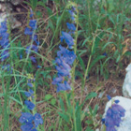

Smooth Beardtongue (Penstemon glaber)
Blooms Late May – July

Uses: Several tribes took the leaves of this plant and made an adhesive substance out of them and used it to treat snakebites. A tea was also made from the leaves to treat cramps.

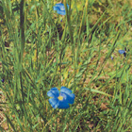

Wild Blue Flax (Linum lewisii)
Blooms: June – August

Uses: Many Native American tribes used the seeds of this plant to add flavor to their food. The flower tops were also used to make eyewash.

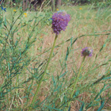
Purple Prairie Clover (Petalostemum purpureum)
Blooms: June - August

Uses: The Plains tribes chewed the roots of this plant like gum. They also used the clover to make tea.

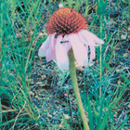
Purple Cone Flower (Echinacea angustifolia)
Blooms: June - July

Uses: This plant was a mainstay for Native Americans. It was used for many things from treating headaches, stomach aches, and sore throats, to snakebites.

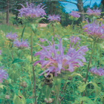

Wild Bergamot (Monarda fistulosa)
Blooms: June - August

Uses: The Native Americans used this plant to make a tea that was used to treat colds.

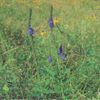
Wooly Vervain (Verbena stricta)
Blooms: July - September

Uses: Many Native tribes made a tea out of this plant for enjoyment and also to treat stomach problems.

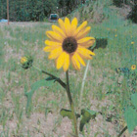
Annual Sunflower (Helianthus annuus)
Blooms: Late July – September

Uses: The seeds of this plant provided many tribes with a food source. They could be eaten raw, roasted, or boiled.

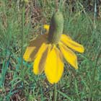

Prairie Cone Flower (Rudbeckia columnifera)
Blooms: July – September

Uses: A tea was made from this plant by many Native tribes to treat headaches. The yellow petals were also used to make a yellow dye.

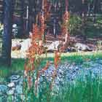

Western Dock (Rumex occidentalis)
Blooms July – August

Uses: Many Native tribes used the leaves of this plant in a sweat bath to treat rheumatism. They also took the plant and made an adhesive substance which could be used to treat cuts and wounds.

