Weather Impact Playbook (WIP)
Example

Facility and NWS Management Contact Information
  - Air Route Traffic Control Center (ARTCC) ______ Boondocks Center ZBX____
    - Air Traffic Manager (ZBX1) Ms. Elizabeth Lynn______________________
Contact Information ________555-555-5555___________________________
    - Assistant Air Traffic Manager (ZBX2) Mr. George Washington____________
Contact Information ________555-555-5555___________________________
    - Air Traffic Executive Secretary Ms. Marcela North_____________________
Contact Information ________555-555-5555___________________________
    - Air Facilities Mr. Ray Marland_____________________________________
Contact Information ________555-555-5555___________________________
    - Quality Assurance Mr. Eric Muther___________________________________
Contact Information ________555-555-5555___________________________
    - Training Officer Mr. Willy Wilson___________________________________
Contact Information ________555-555-5555___________________________
    - Logistics Officer Mr. George Supplies________________________________
Contact Information ________555-555-5555___________________________
    - Flight Data Ms. Betty Boop_________________________________________
Contact Information ________555-555-5555___________________________
  - Supporting Warning Forecast Office (WFO) Boondocks GA____BDK________
    - WFO Meteorologist in Charge (MIC) Mr. Jasper Phishface_______________
Contact Information 555-555-5555 x222 or CP 555-555-5555______________
    - WFO Science Operations Officer (SOO) Mr. Gary Goofy_________________
Contact Information 555-555-5555 x224______________________________
    - Regional Aviation Meteorologist (RAM) Mr. Paul Bunion_________________
Contact Information 555-555-5555 x000 or CP 555-555-5555______________
    - CWSU Meteorologist in Charge (MIC) Mr. Luke Warmwater _____________
Contact Information 555-555-5555 x000 or CP 555-555-5555______________
    - WFO Administrative Services Assistant (ASA) Mr. Dan Cobell_____________
Contact Information 555-555-5555 x221_______________________________
    - Electronics Systems Analyst (ESA) Mr. Rick Richard ____________________
Contact Information 555-555-5555 x260_______________________________
    - Aviation Focal Point (AFP) _Mike Flier_______________________________
Contact Information ___555-555-5555 x250____________________________
  - Supporting WFOs writing TAFs within the airspace (e.g., BOU)
    - Boondocks GA.___BDK________________________________________
      - TAF Identifiers (e.g., COS, DEN, etc.) KBDK, KABC, KCDF__________
      - Contact Information ___555-555-555 x242________________________
    - Neverland AL GHI____________________________________________
      - TAF Identifiers (e.g., COS, DEN, etc.) ___ KGHI, KJKL___________
      - Contact Information ___555-555-555 x242________________________ Amityville SC MNO___________________________________________
      - TAF Identifiers (e.g., COS, DEN, etc.) KPUV, KWXY________________
      - Contact Information 555-555-555 x242____________________________

  - Traffic Management Unit (TMU)
Traffic Management Officer (TMO) Mr. Al Tone _________________
Contact Information 555-555-555 x242__________________________
    - Supervisory Traffic Management Coordinators
Contact Information 555-555-555 x242________________________________
      - Mr. Tom Toms________________________________________________
      - Mr. Curt Curtis________________________________________________
      - Mr. Tim Tiny_________________________________________________
      - Mr. Joe Coffee________________________________________________
      - Ms. Mary Thompson____________________________________________
  - Air Route Traffic Control Centers
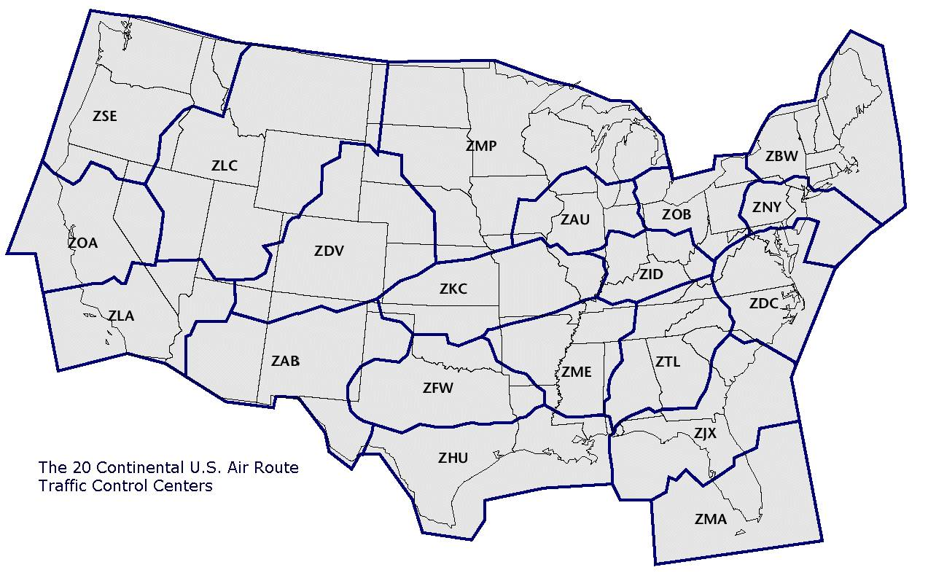

ARTCC Facility Structure
  - TMU Positions:
    - BDX Meter
      - Weather Impacts:
- TS within 20 NM of airport
- IFR/LIFR conditions at airport
- Direct cross wind > 25 kt
- SFC-120 winds > 50 kt shear
- Winds swinging E or W of due N or S
    - ABC Meter
      - Weather Impacts
- TS within 20 NM of airport
- IFR/LIFR conditions at airport
- Direct cross wind > 25 kt
- SFC-120 winds > 50 kt shear
- Winds swinging N or S of due E or W

    - En Route
      - Weather Impacts
- SVR lines of weather that will result in playbook reroutes
- Mod-Sev turbulence/chop will result in altitude compression which can overload a sector

    - Military Ops./ Weather Coordinator
      - Weather Impacts:
- SVR weather dramatically increases workload on Weather Coordinator due to MISs, CWAs, and reroutes.

    - Monitor Alert
      - Weather Impacts:
- TS within the airspace that will relocate traffic from one sector to another.

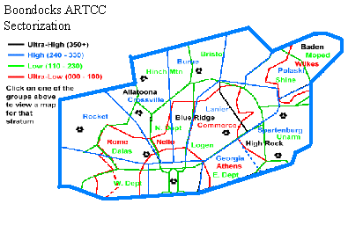
  - Area 1 Sectors: General Area _7_Sectors in N-NE ZBX______________________
Operations Manager/Area Supervisor ____ Ed Horse_________________________
    - Ultra High# 0
    - High# 2
    - Low# 4
    - Ultra Low# 1
    - VORs__KDI, BLF, SPV, BUE___________________________________
    - En Route Weather Impacts: TS above FL250, Turbulence > lgt., svr icing.
  - Area 2 Sectors: General Area _7 Sectors in _NE-E ZBX _____________________
Operations Manager/Area Supervisor ____Bob Goat________________________
    - Ultra High# 1
    - High# 3
    - Low# 3
    - Ultra Low# 0
    - VORs_______VIS, BIE, PLM__________________________________
    - En Route Weather Impacts: TS above FL250, Turbulence > lgt., svr icing.
  - Area 3 Sectors: General Area __6_Sectors in N GA ________________________
Operations Manager/Area Supervisor ____ John Deer_______________________
    - Ultra High# 1
    - High# 2
    - Low# 1
    - Ultra Low# 2
    - VORs_______ASD, BND, JKI_________________________________
    - En Route Weather Impacts: TS above FL250, Turbulence > lgt., svr icing
  - Area 4 Sectors: General Area __7_Sectors in Central GA_____________________
Operations Manager/Area Supervisor ___ Ed Horse_________________________
    - Ultra High# 2
    - High# 2
    - Low# 2
    - Ultra Low# 1
    - VORs_____________THR, FJT____________________________________
    - En Route Weather Impacts: TS above FL250, Turbulence > lgt., svr icing
  - Area 5 Sectors: General Area _7_Sectors in _S AL_________________________
Operations Manager/Area Supervisor __ Bob Goat_________________________
    - Ultra High# 1
    - High# 2
    - Low# 4
    - Ultra Low# 0
    - VORs__________WED, GTR, IKU____________________________
    - En Route Weather Impacts: TS above FL250, Turbulence > lgt., svr icing
  - Area 6 Sectors: General Area __6_Sectors in _N AL________________________
Operations Manager/ Area Supervisor ____ Penny Money___________________
    - Ultra High# 1
    - High# 2
    - Low# 2
    - Ultra Low# 1
    - VORs________________YUE_________________________________
    - En Route Weather Impacts: TS above FL250, Turbulence > lgt., svr icing
  - Area 7 Sectors: General Area ___6_Sectors in N-Central ZBX________________
Operations Manager/ Area Supervisor ___ John Deer_______________________
    - Ultra High# 2
    - High# 2
    - Low# 2
    - Ultra Low# 0
    - VORs__________OPT,GHY, KIJ_______________________________
    - En Route Weather Impacts: TS above FL250, Turbulence > lgt., svr icing
  - TRACONs and Phone #s within ARTCC 7
    - BDK TRACON VSCS# 435 89
    - ABC TRACON VSCS # 321 55/53
    - CDF APCH VSCS # 348 54
    - GHI TRACON VSCS # 343 57/58
    - JKL APCH VSCS # 372 03/04
    - MNO APCH VSCS # 430 02
    - PQS TRACON VSCS # 331 07/08
  - FAA Towers and Phone #s within ARTCC 20
    - BDK Tower VSCS# 435 90
    - ABC Tower VSCS # 321 56
    - CDF Tower VSCS # 348 55
    - GHI Tower VSCS # 343 59
    - JKL Tower VSCS # 372 06
    - MNO Tower VSCS # 430 01
    - PQS Tower VSCS # 331 07/08
    - TUV Tower VSCS # 379 05
    - WXY Tower VSCS # 344 39

Hub/Pacing Airports
  - __________ Boondocks International BDK__________________________
    - Time of Daily Pushes (i.e., aviation “rush hour”)
      - Morning 0800-0930 1100-1200
      - Afternoon 1400-1600
      - Evening 2000-2100
      - Other None noted
    - Runways _________4___________________________________________

08R
27R
09L
27L
09R

08L
26R
26L
08R

      - 09R/27L
          - Approaches.__ILS/VIS____________________
          - Minimums. _______100ft ¼ vis____________
          - Limiting Issues._________________________
      - 09L/27R
          - Approaches.____ ILS/VIS ________________
          - Minimums. _____100ft ¼ vis_____________
          - Limiting Issues._________________________
      - 08R/26L
          - Approaches._____ILS/VIS_______________
          - Minimums. ______100ft ¼ vis____________
          - Limiting Issues._________________________
      - 08L/26R
          - Approaches.______ILS/VIS______________
          - Minimums. _____100ft ¼ vis____________
          - Limiting Issues._________________________
    - Significant Weather
      - TS ____>FL250 affecting Gates or runways._______________
      - Visibility
- > 6 sm
- 3-6 sm
- 1-3 sm
- < 1 sm
      - Ceilings
- > 4500ft -Visuals
- 3500-4500ft -Mostly visuals/some ILS
- 3000-3500ft -ILS/ some visuals
- 1000-3000ft -ILS
- 500-1000ft -ILS
- < 500ft -ILS
      - Weather
- FZ -Deicing operations
- SN -Snow removal operations
      - Other: Winds East or West of due North or South
- 0-5 kt
- 5-10 kt
- 10-15 kt
- 15-25 kt
- 25+ kt
    - Climatology
 | Jan | Feb | Mar | Apr | May | Jun | Jul | Aug | Sep | Oct | Nov | Dec | Annual
Mean Max. Temp. (°F) | 51.9 | 56.8 | 65.0 | 72.9 | 80.0 | 86.5 | 89.4 | 87.9 | 82.3 | 72.9 | 63.3 | 54.6 | 72.0
Highest Mean Max. Temp. (°F) | 60.8 | 65.2 | 71.6 | 79.2 | 85.8 | 91.4 | 96.7 | 94.0 | 88.0 | 78.6 | 70.0 | 63.4 | 96.7
Year Highest Occurred | 1974 | 1976 | 1997 | 1994 | 1996 | 1981 | 1993 | 1980 | 1980 | 1984 | 1985 | 1984 | 1993
Lowest Mean Max. Temp. (°F) | 38.5 | 49.9 | 58.2 | 66.7 | 74.9 | 79.1 | 84.4 | 84.4 | 78.1 | 66.7 | 55.1 | 45.4 | 38.5
Year Lowest Occurred | 1977 | 1978 | 1971 | 1983 | 1997 | 1997 | 1971 | 1992 | 1974 | 1976 | 1976 | 2000 | 1977
Mean Temp. (°F) | 42.7 | 46.7 | 54.3 | 61.6 | 69.8 | 76.8 | 80.0 | 78.9 | 73.3 | 62.8 | 53.4 | 45.4 | 62.1
Highest Mean Temp. (°F) | 53.2 | 54.4 | 60.6 | 67.7 | 74.9 | 81.3 | 85.4 | 83.8 | 78.9 | 69.8 | 62.0 | 53.7 | 85.4
Year Highest Occurred | 1974 | 1990 | 1997 | 1981 | 1996 | 1981 | 1993 | 1980 | 1980 | 1984 | 1985 | 1984 | 1993
Lowest Mean Temp. (°F) | 29.3 | 39.3 | 47.5 | 56.4 | 64.8 | 71.5 | 76.3 | 76.0 | 69.8 | 56.2 | 44.2 | 37.2 | 29.3
Year Lowest Occurred | 1977 | 1978 | 1971 | 1983 | 1997 | 1997 | 1971 | 1976 | 1976 | 1976 | 1976 | 2000 | 1977
Mean Min. Temp.( °F) | 33.5 | 36.5 | 43.6 | 50.4 | 59.5 | 67.1 | 70.6 | 69.9 | 64.3 | 52.8 | 43.5 | 36.2 | 52.3
Highest Mean Min. Temp. (°F) | 45.6 | 44.2 | 49.6 | 56.4 | 64.5 | 71.1 | 74.5 | 73.5 | 69.7 | 61.0 | 54.0 | 43.9 | 74.5
Year Highest Occurred | 1974 | 1990 | 1997 | 1991 | 1991 | 1994 | 1980 | 1980 | 1980 | 1984 | 1985 | 1984 | 1980
Lowest Mean Min. Temp. (°F) | 20.0 | 28.4 | 36.8 | 46.1 | 53.8 | 61.8 | 66.7 | 66.4 | 60.0 | 45.7 | 33.3 | 29.0 | 20.0
Year Lowest Occurred | 1977 | 1977 | 1971 | 1983 | 1973 | 1972 | 1976 | 1976 | 1976 | 1976 | 1976 | 2000 | 1977
Mean Precipitation (in.) | 5.03 | 4.68 | 5.38 | 3.62 | 3.95 | 3.63 | 5.12 | 3.67 | 4.09 | 3.11 | 4.10 | 3.82 | 50.20
Highest Precipitation (in.) | 9.26 | 9.75 | 11.66 | 11.86 | 8.37 | 9.99 | 17.71 | 7.28 | 11.64 | 11.04 | 10.04 | 9.27 | 17.71
Year Highest Occurred | 1972 | 1990 | 1980 | 1979 | 1980 | 1991 | 1994 | 1979 | 1989 | 1995 | 1992 | 1983 | 1994
Lowest Precipitation (in.) | 0.84 | 0.77 | 1.86 | 0.49 | 1.23 | 0.16 | 0.57 | 0.50 | 0.04 | 0.26 | 1.27 | 0.69 | 0.04
Year Lowest Occurred | 1981 | 1978 | 1985 | 1986 | 1998 | 1988 | 1995 | 1976 | 1984 | 1998 | 1990 | 1979 | 1984
Heating Degree Days (°F) | 692. | 523. | 346. | 150. | 26. | 1. | 0. | 0. | 11. | 126. | 352. | 600. | 2827.
Cooling Degree Days (°F) | 0. | 1. | 11. | 52. | 170. | 354. | 463. | 430. | 262. | 58. | 8. | 1. | 1810.
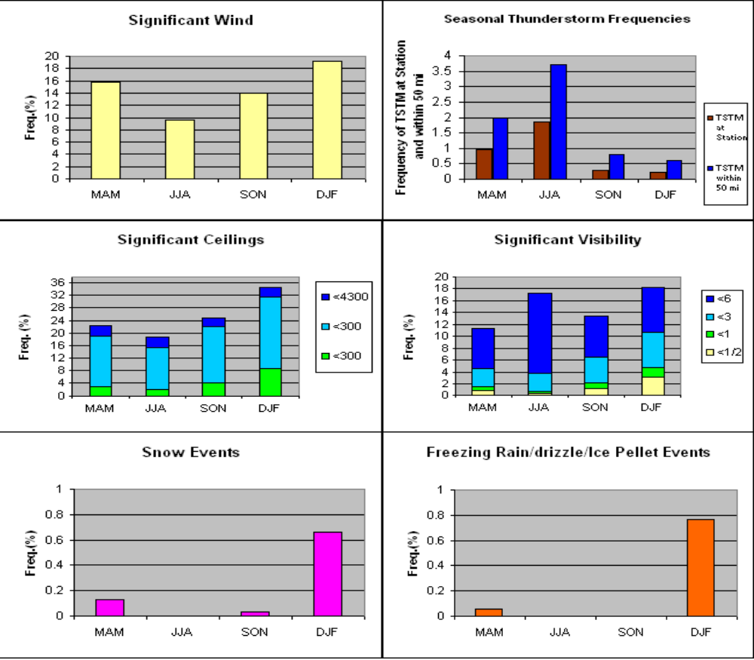

    - Arrival Fixes/Gates
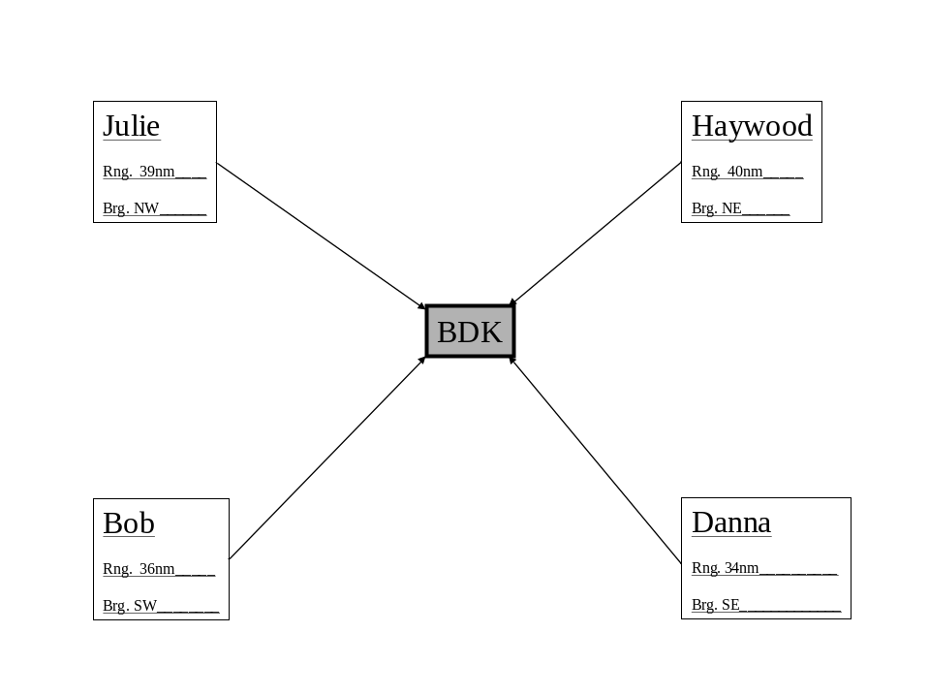
    - Arrival Fix/Gate Significant Weather
      - TS impacting arrival corridors will cause aircraft to deviate into departure gates or reroutes to other arrival gates.
      - Visibility - No issues.
      - Ceilings - No issues.
      - Weather - No issues.
      - Other ______________________________________
    - Departure Fixes/Gates
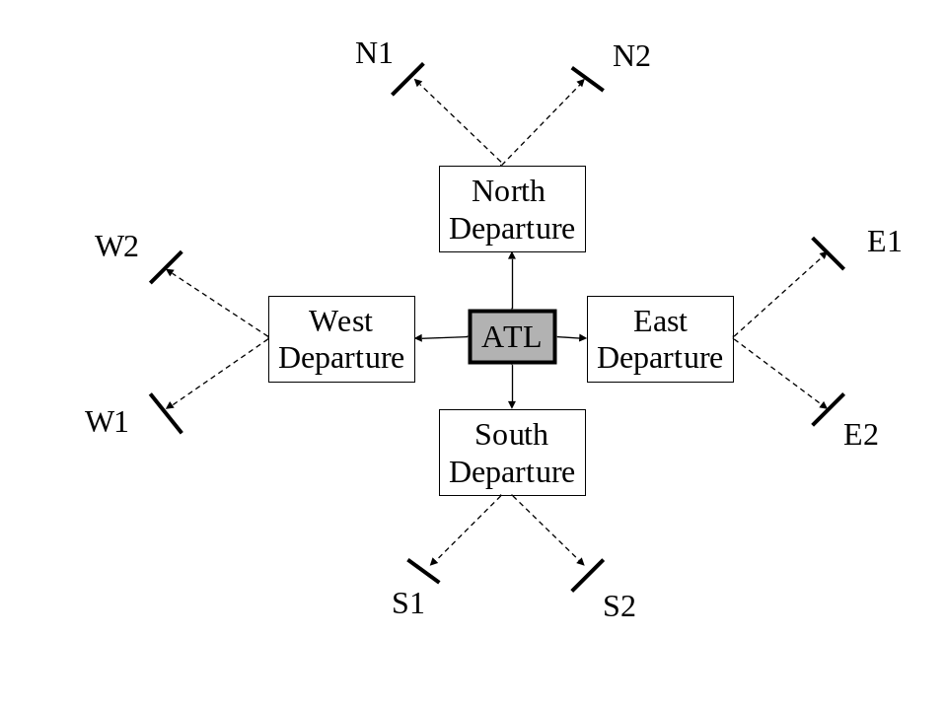
BDX
    - Departure Fix/Gate Significant Weather
      - TS impacting departure corridors will cause aircraft to depart into arrival gates or reroutes to other departure gates.
      - Visibility - No issues.
      - Ceilings - No issues.
      - Weather - No issues.
      - Other Significant Weather-Related Issues:
      - Weather impacting one gate will cause departures to come out in a single stream rather than two streams, if both gates are blocked, coded Departure Routes (CDRs) will be used which will route impacted departures via a different direction.
      - Snow fall will delay departures and arrivals due to snow removal delays.
      - Freezing precip or snow ill cause delays due to deicing operations.
  - Atlantic Basin International ABC
    - Time of Daily Pushes (i.e., aviation “rush hour”)

Morning – 0830-0930 1100-1230

Afternoon - 1400-1600

Evening - 2000-2100

Other – None noted

    - Runways ____________3______________

18L
18R
23

05
36R
36L

      - 36R/18L
          - Approaches ________ILS/VIS_____________
          - Minimums _________100ft ¼ vis_____________________
          - Limiting Issues _________________________________________
      - 36L/18R
          - Approaches ________ILS/VIS_____________
          - Minimums _________100ft ¼ vis________________________
          - Limiting Issues ________________________________________
      - 05/23
          - Approaches __________ILS/VIS _______________
          - Minimums. ______100ft ¼ vis____________
          - Limiting Issues ____________________________________________
    - Significant Weather
      - TS > FL250 affecting Gates or runways.
      - Visibility
        - > 6 sm
        - 3-6 sm
        - 1-3 sm
        - < 1 sm
      - Ceilings
        - > 4500 ft -Visuals
        - 3500-4500 ft -Mostly visuals/some ILS
        - 3000-3500 ft -ILS/ some visuals
        - 1000-3000 ft -ILS
        - 500-1000 ft -ILS
        - < 500ft -ILS
      - Weather
        - FZ -Deicing operations
        - SN -Snow removal operations
      - Other: Winds East or West of due North or South
        - 0-5 kt
        - 5-10 kt
        - 10-15 kt
        - 15-25 kt
        - 25+ kt
    - Climatology
 | Jan | Feb | Mar | Apr | May | Jun | Jul | Aug | Sep | Oct | Nov | Dec | Annual
Mean Max. Temperature (°F) | 51.3 | 55.9 | 64.1 | 72.8 | 79.7 | 86.6 | 90.1 | 88.4 | 82.3 | 72.6 | 62.8 | 54.0 | 71.7
Highest Mean Max. Temp. (°F) | 60.2 | 65.4 | 69.8 | 77.9 | 84.8 | 91.2 | 96.5 | 94.1 | 87.0 | 79.3 | 68.9 | 63.0 | 96.5
Year Highest Occurred | 1974 | 1976 | 1997 | 1981 | 1982 | 1998 | 1993 | 1980 | 1973 | 1984 | 1985 | 1984 | 1993
Lowest Mean Max. Temp. (°F) | 41.0 | 48.2 | 57.5 | 67.2 | 75.3 | 81.4 | 86.6 | 84.1 | 78.2 | 66.7 | 56.3 | 44.9 | 41.0
Year Lowest Occurred | 1977 | 1978 | 1996 | 1983 | 1992 | 1997 | 1984 | 1992 | 2000 | 1988 | 1976 | 2000 | 1977
Mean Temperature (°F) | 41.7 | 45.2 | 52.8 | 60.9 | 69.0 | 76.5 | 80.3 | 78.9 | 72.7 | 61.7 | 52.3 | 44.4 | 61.4
Highest Mean Temperature (°F) | 51.5 | 52.3 | 58.3 | 65.6 | 74.4 | 80.8 | 85.5 | 82.6 | 76.3 | 69.1 | 60.0 | 52.2 | 85.5
Year Highest Occurred | 1974 | 1990 | 1997 | 1981 | 1998 | 1998 | 1993 | 1980 | 1980 | 1984 | 1985 | 1971 | 1993
Lowest Mean Temperature (°F) | 31.8 | 38.3 | 47.3 | 56.2 | 65.9 | 73.0 | 76.9 | 76.1 | 69.1 | 56.2 | 45.5 | 35.2 | 31.8
Year Lowest Occurred | 1977 | 1978 | 1996 | 1983 | 1999 | 1972 | 2000 | 1992 | 2000 | 1987 | 1976 | 2000 | 1977
Mean Min. Temperature (°F) | 32.1 | 34.4 | 41.6 | 49.1 | 58.2 | 66.5 | 70.6 | 69.3 | 63.0 | 50.9 | 41.8 | 34.9 | 51.0
Highest Mean Min. Temp. (°F) | 42.7 | 41.9 | 46.8 | 54.1 | 64.6 | 70.4 | 74.4 | 71.8 | 67.3 | 59.0 | 51.1 | 43.2 | 74.4
Year Highest Occurred | 1974 | 1990 | 1997 | 1991 | 1991 | 1981 | 1993 | 1987 | 1980 | 1984 | 1985 | 1971 | 1993
Lowest Mean Min. Temp. (°F) | 22.5 | 28.3 | 35.1 | 45.1 | 53.5 | 61.5 | 67.0 | 66.3 | 56.9 | 43.7 | 34.6 | 25.5 | 22.5
Year Lowest Occurred | 1977 | 1978 | 1999 | 1983 | 1999 | 1972 | 2000 | 2000 | 1999 | 1987 | 1976 | 2000 | 1977
Mean Precipitation (in.) | 4.00 | 3.55 | 4.39 | 2.95 | 3.66 | 3.42 | 3.79 | 3.72 | 3.83 | 3.66 | 3.36 | 3.18 | 43.51
Highest Precipitation (in.) | 6.80 | 7.59 | 8.76 | 6.47 | 12.48 | 6.85 | 8.94 | 8.18 | 9.69 | 14.72 | 8.68 | 7.49 | 14.72
Year Highest Occurred | 1978 | 1979 | 1980 | 1979 | 1975 | 1997 | 1997 | 1991 | 1979 | 1990 | 1985 | 1983 | 1990
Lowest Precipitation (in.) | 0.45 | 0.74 | 0.58 | 0.30 | 0.99 | 0.15 | 0.53 | 0.61 | 0.64 | 0.00 | 0.46 | 0.83 | 0.00
Year Lowest Occurred | 1981 | 1978 | 1985 | 1976 | 1987 | 1993 | 1983 | 1972 | 1982 | 2000 | 1973 | 1980 | 2000
Heating Degree Days (°F) | 739. | 571. | 401. | 179. | 36. | 1. | 0. | 0. | 16. | 164. | 400. | 655. | 3162.
Cooling Degree Days (°F) | 0. | 1. | 7. | 40. | 145. | 332. | 459. | 415. | 231. | 45. | 5. | 1. | 1681.

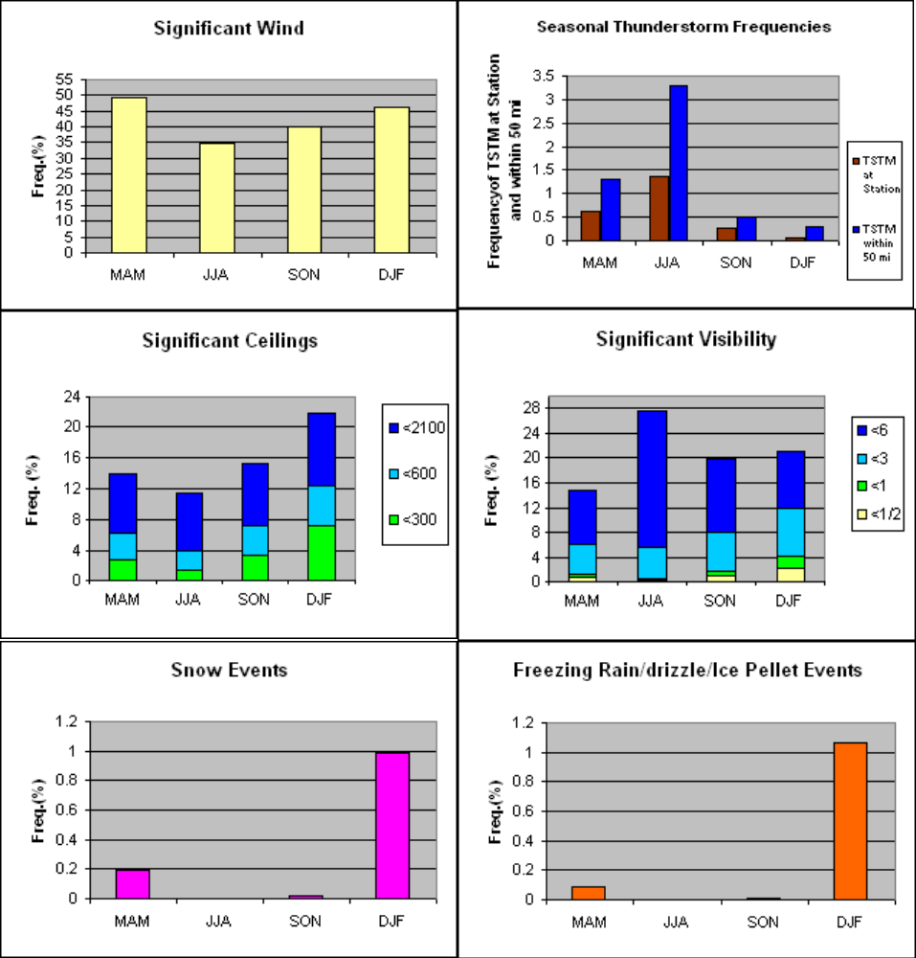
    - Arrival Fixes/Gates
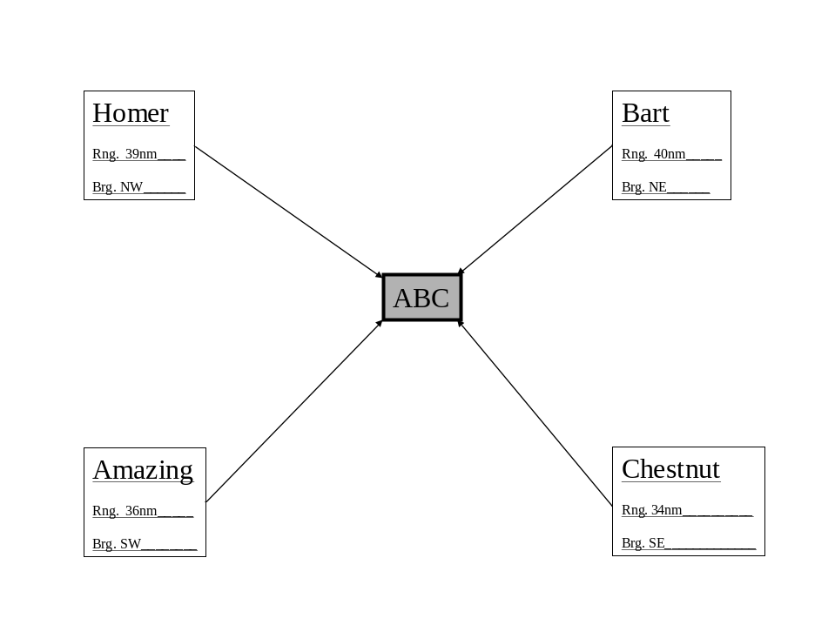
    - Arrival Fix/Gate Significant Weather
      - TS impacting arrival corridors will cause aircraft to deviate into departure gates or reroutes to other arrival gates.
      - Visibility ____________ No issues.____________________________
      - Ceilings _______________ No issues.__________________________
      - Weather ____________ No issues.____________________________
      - Other ___________________________________________________

    - Departure Fixes/Gates
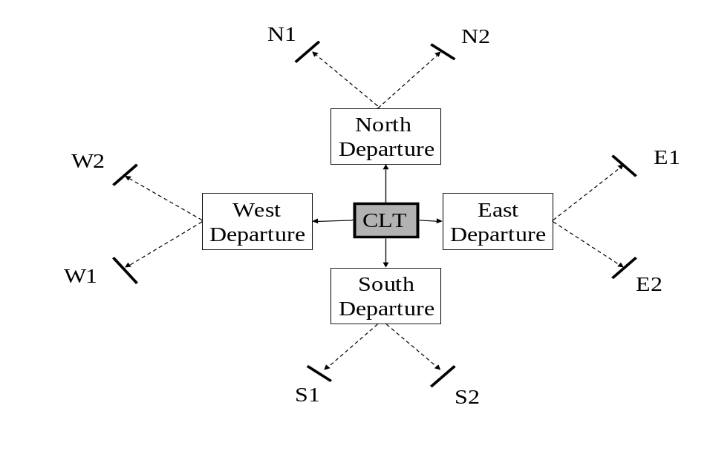
ABC
    - Departure Fix/Gate Significant Weather
      - TS impacting departure corridors will cause aircraft to depart into arrival gates or reroutes to other departure gates. However, not as bad as BDX.
      - Visibility ____________ No issues.____________________________
      - Ceilings ____________ No issues.____________________________
      - Weather ____________ No issues.____________________________
      - Other Significant Weather-Related Issues:
        - Weather impacting one gate will cause departures to come out in a single stream rather than two streams, if both gates are blocked, coded Departure Routes (CDRs) will be used which will route impacted departures via a different direction. However, not as bad as BDX.
        - Snow fall will delay departures and arrivals due to snow removal delays.
        - Freezing precip or snow will cause delays due to deicing operations.

FAA Playbook Operations and CCFP
  - Support to Strategic Plan of Operations Telcon
    - Participants ____ARTCC, Tower, TRACON, Delta, Southwest, American, Command Center ______
    - Telcon Schedule 0600-2200 every 2 hours_________________
    - Weather Requirements __Answer questions as needed during telcon_________

  - Weather Impacts to Internal Airports
    - BDX LGC…BDX ARRIVALS VIA THE LGC
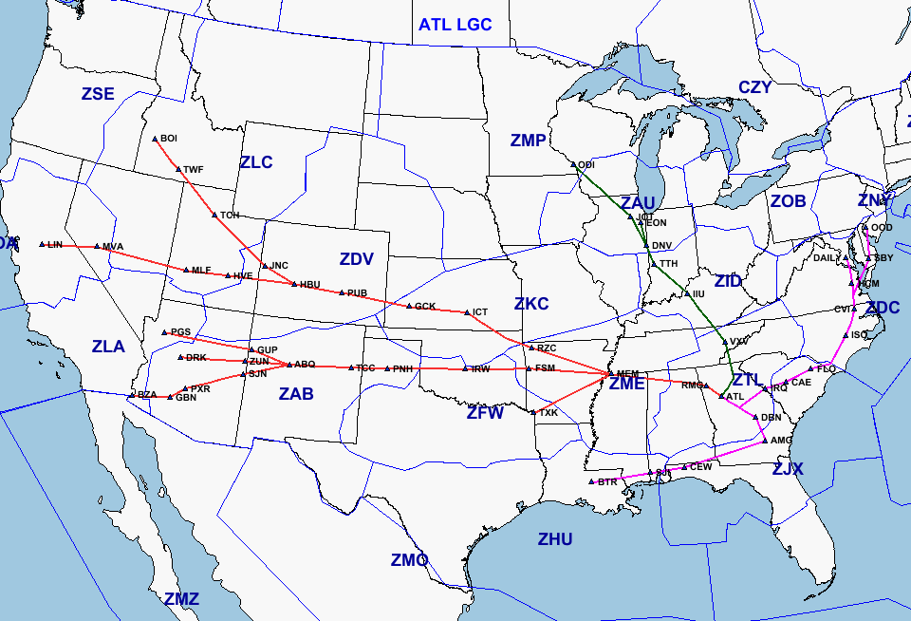
    - BDX RMG…BDX ARRIVALS VIA RMG STAR
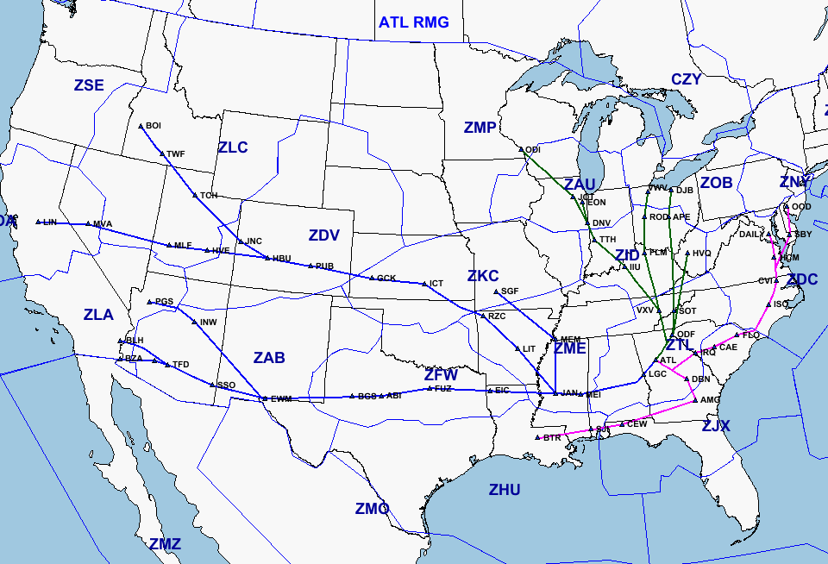
  - Weather Impacts to Outer-Tier Airports
    - None noted for ZBX

  - Airway Closers
    - _ BDX RMG…BDX ARRIVALS VIA FRE STAR

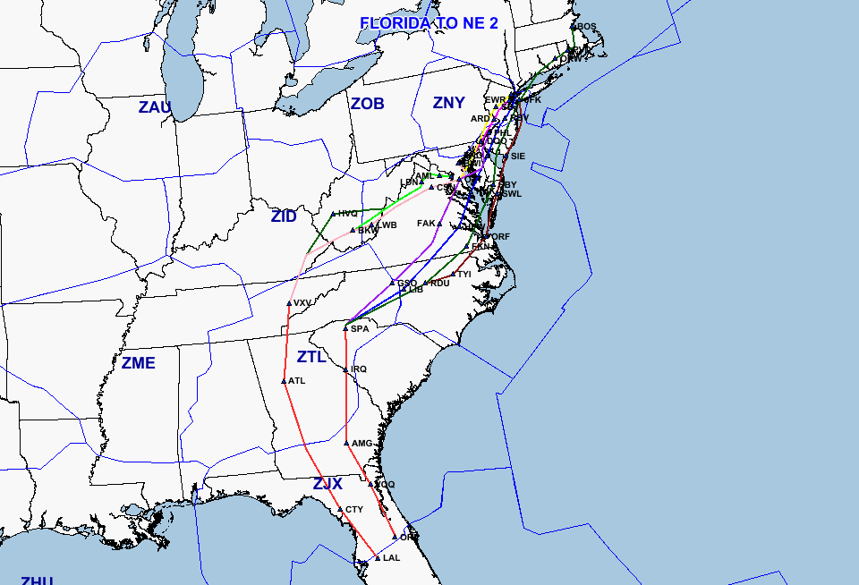

  - East to West Transcon Routes
    - __ BDX …BDX Transcon VIA RMG STAR ___________________________

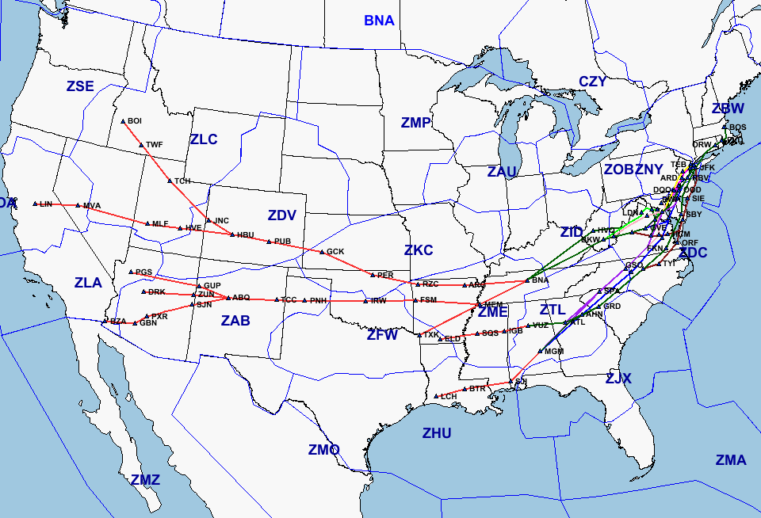

  - West to East Transcon Routes
    - None noted for ZBX
  - Regional Routes
    - None noted for ZBX
  - Weather impacts to en route
    - None noted for ZBX

Special ARTCC Requirements
  - Quality Control Office Weather Support Requirements for
    - Operational Errors
      - 3 Observations, 1 hr before – 1 hr after the occurrence
      - Active Sigmets for the area
      - Active Airmets
      - Active CWAs
      - Active MISs
    - Aircraft Accidents (fatal and non-fatal)
      - 3 Observations, 1 hr before – 1 hr after the occurrence
      - Active Sigmets for the area
      - Active Airmets
      - Active CWAs
      - Active MISs
      - RADAR Image (reflective)
      - Satellite image (vis or IR)
  - Routine Briefings to ARTCC and other FAA Facilities
    - ARTCC Verbal Briefings
      - Standup/Management Briefing Times
- 0815L
- 1610L
      - Locally Required Briefing Content
- Current and forecasted HUB weather
- Icing
- Turbulence
- Upper level winds (high and ultra-high)
- HUB approach winds
- Pacing airport weather
- Area Convection
- 24 hr outlook
- Pressures below 29.92

    - ARTCC Written Briefings
      - Full Forecast Briefings ___2 ZWBs NLT 0645L and 1500L__________
- Synopsis to include icing and turbulence
- ZBX Areas effected by cigs under 050
- BDX and ABC 9 hr forecast (TAF)
- BDX and ABC forecast winds at 030, 060, 090, and 120
  - Forecast Updates
      - 2 HUBs NLT 1100L and 2000L
      - BDX and ABC 9 hr forecast (TAF)
  - Special Event Briefings
    - NASCAR Downsouth Race
      - Date of Event - First weekend in March
      - Weather Issues – local airport mins for race track airport
      - Requested Products – as needed by TMU
    - Swingandmiss Master Golf Tournament
      - Date of Event – July
      - Weather Issues - local airport mins for airports near golf course.

  - Automated Flight Service Station (AFSS) Support
    - Donegan GA AFSS
      - Morning area weather discussions
      - Pilot report relays
    - Beback AL AFSS
      - Pilot report relays
  - Outreach Programs
    - Meteorology for Flight School Instructors (MEFSI)
    - Local school visits
  - Center-Unique Support to FAA and NWS Components
    - None noted for ZBX

