Proposal submitted to
Innovative Partnerships Program Office, NASA Ames
In response to Partnership Seed Fund Call for Proposals--2006

Partnership for Airborne Sun-Sky Spectrometry
Partnership Manager: [To be named by Ames IPP Office]

NASA Co-Principal Investigator: Philip B. Russell, Research Scientist, Earth Science Division, MS 245-5, NASA Ames Research Center, Moffett Field, CA 94035-1000, Philip.B.Russell@nasa.gov
External Co-Principal Investigator: Beat Schmid, Associate Director, Atmospheric Science & Global Change Division, Pacific Northwest National Laboratory, P.O. Box 999, Richland, WA 99352, Beat.Schmid@pnl.gov
IPP Product Area Supported: Emergent Technologies
Mission Directorate Supported: Science Mission Directorate (New Remote Sensing Technologies)
Abstract: We propose to establish a Partnership between NASA Ames Research Center (ARC) and Pacific Northwest National Laboratory (PNNL) that enables and conducts research using airborne sun-sky spectrometry. Principal goals of the spectrometry will be to test and improve NASA satellite measurements and, more generally, to advance knowledge of atmospheric composition and the effects of aerosols and gases on solar energy and climate. In Partnership Year 1, with joint support from the IPP Partnership Seed Fund, SMD Radiation Sciences Program and PNNL cost sharing, we will conduct experiments to answer key questions about the technologies of combining a spectrometer, fiber optics, entrance optics, tracking/scanning sensors and motors, and airworthy seals, to meet the scientific and validation requirements in the demanding aircraft environment. These experiments and technology answers will culminate in a field-worthy ground prototype suitable for ground use in NASA and PNNL missions, as well as a design and cost estimate for an airborne instrument, called the Spectrometer for Sky-Scanning, Sun-Tracking Atmospheric Research (4STAR). In later years the partnership will use joint NASA-Department of Energy (DOE) funding to develop 4STAR and use it in NASA and DOE programs. Under separate funding NASA Goddard Space Flight Center (GSFC) will participate in the Partnership, starting in Year 1, by providing algorithms to analyze the sky radiance data, and by advising in algorithm use.
The proposed partnership will build on NASA’s current world leadership in airborne sunphotometry and skylight retrievals. It will extend that leadership by incorporating the state-of-the-art technologies of ruggedized spectrometry and fiber optics in NASA-owned ground and air instruments. And it will ensure broader application of these technologies through a shared use agreement with DOE.
In addition to its immediate value to NASA and DOE Earth science programs, the technologies are relevant to NASA’s Exploration Initiative. In particular, if made light and efficient enough, they could be used on a Mars airplane or rover to study dust aerosols (the primary driver of Mars climate) and gaseous constituents in the Mars atmosphere.
Technical Approach

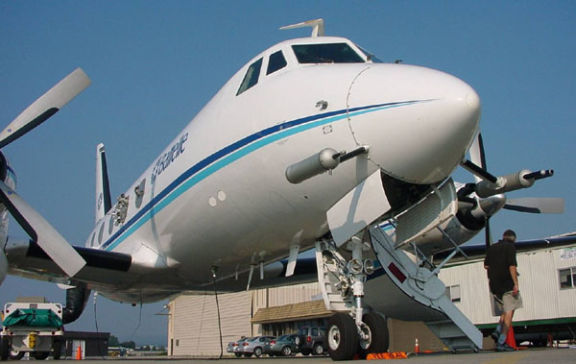
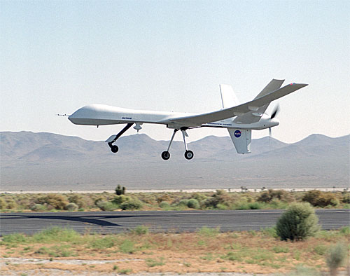
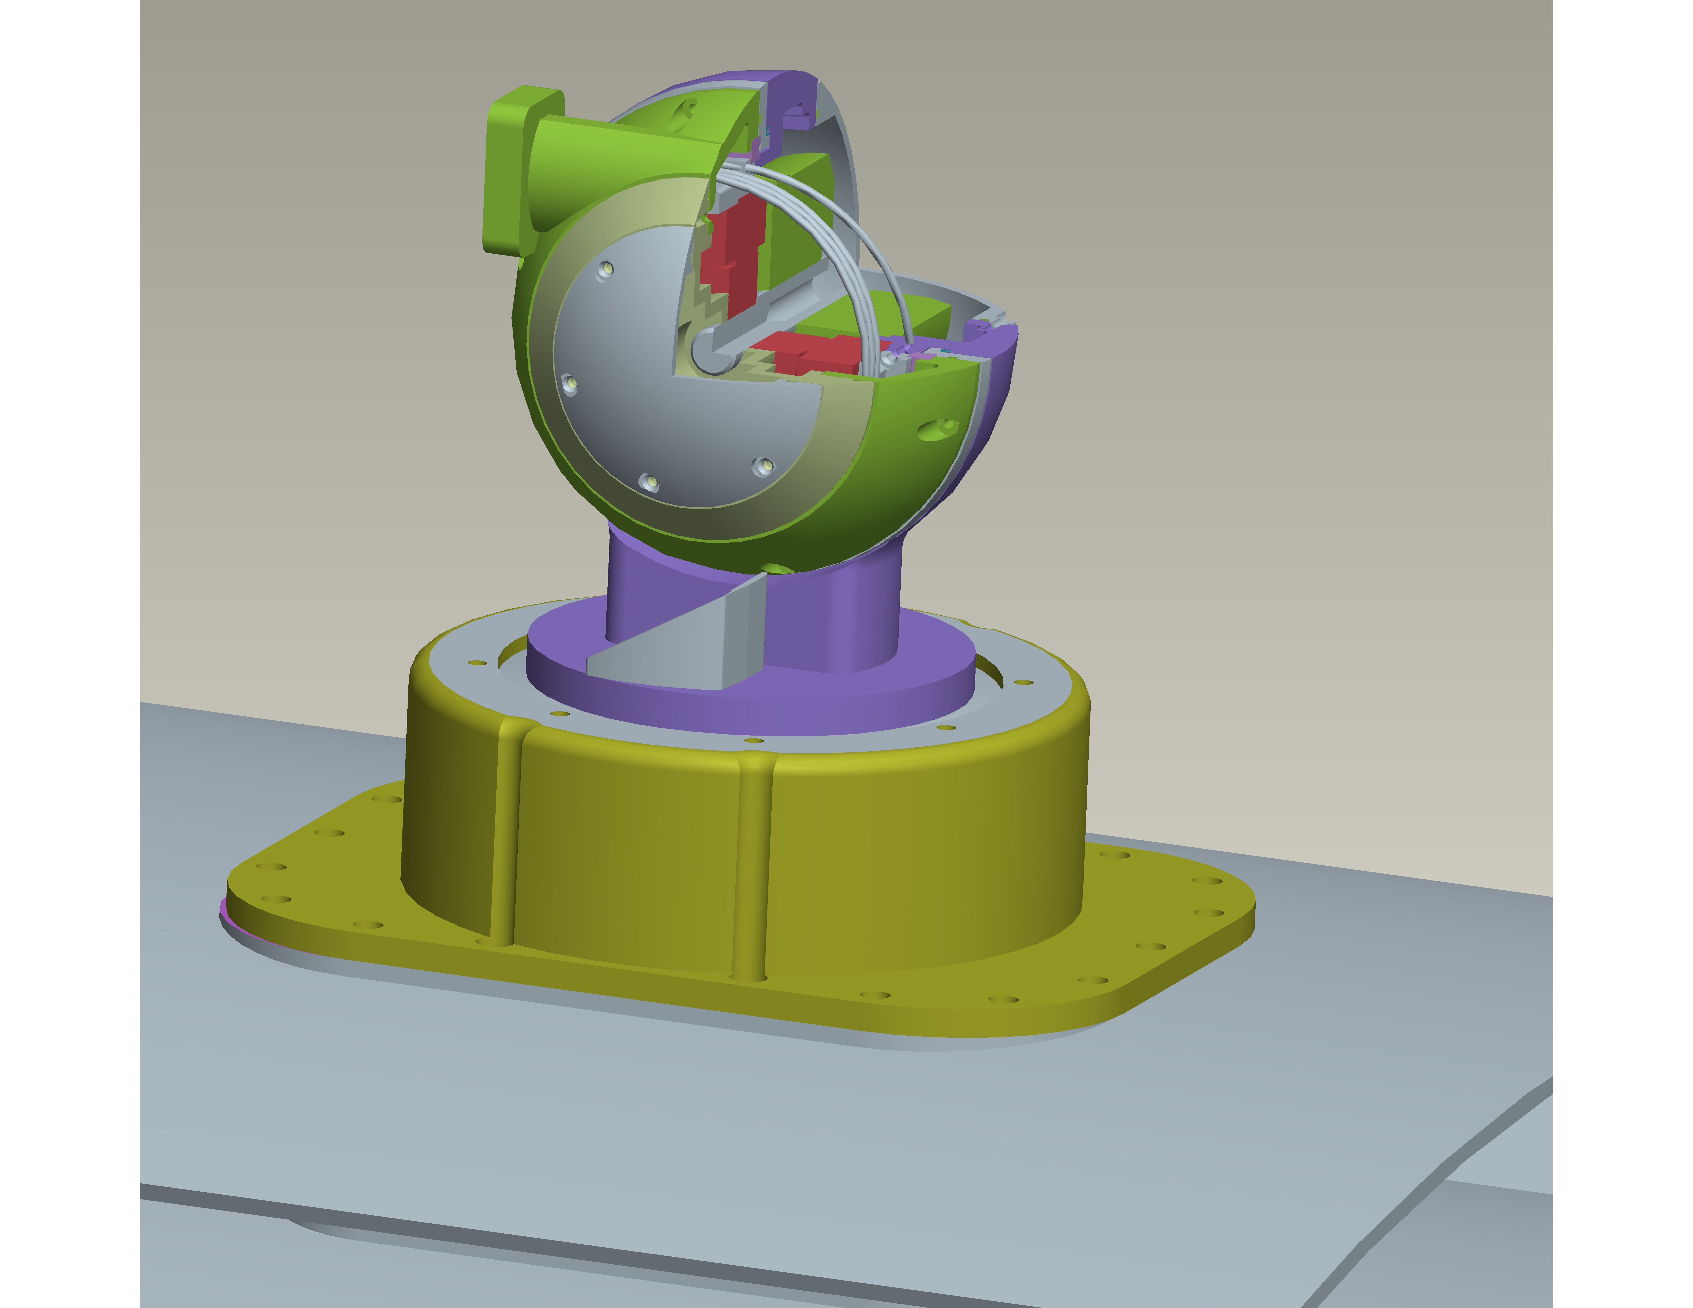
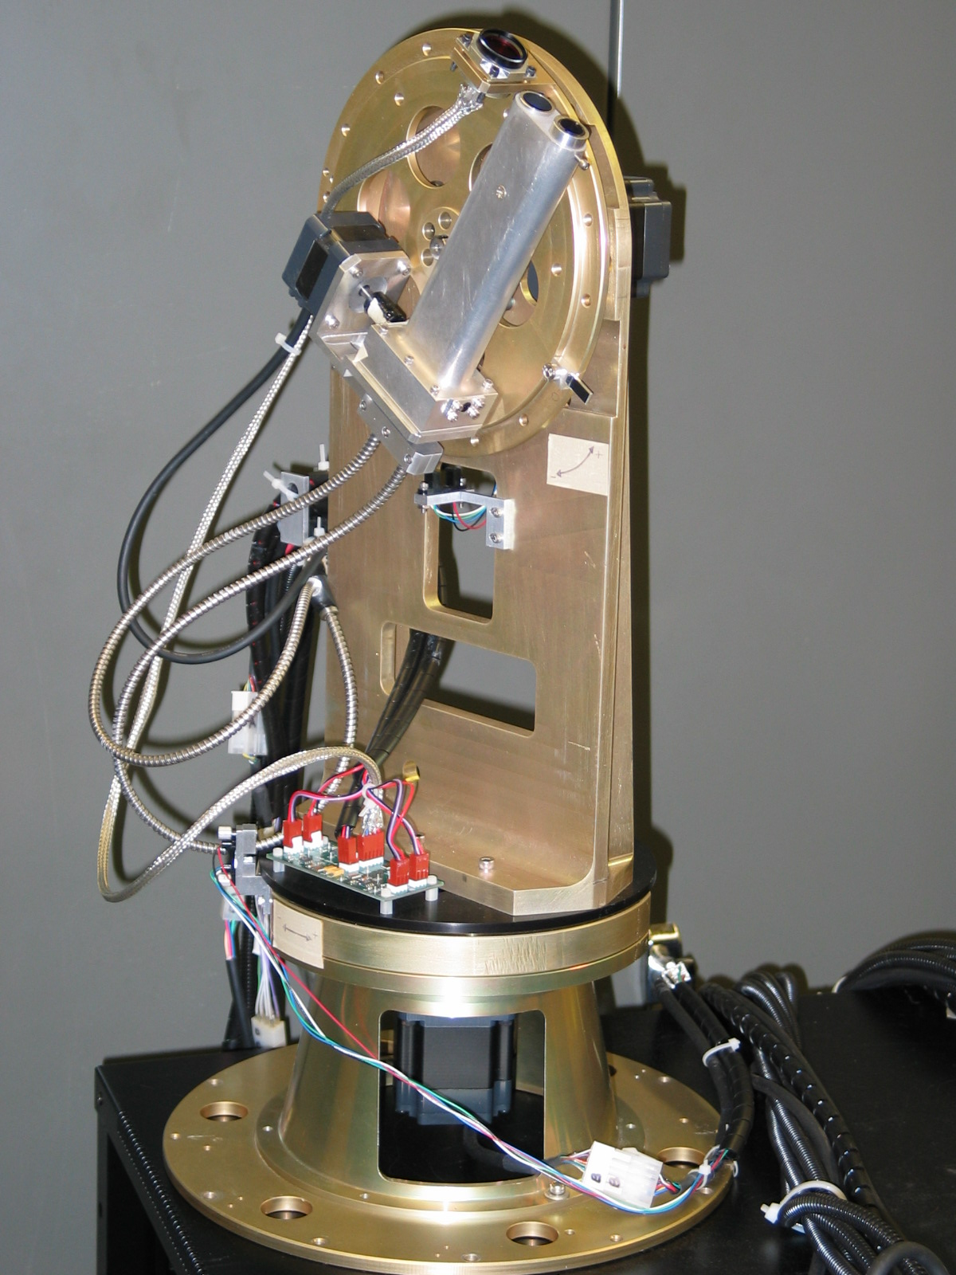
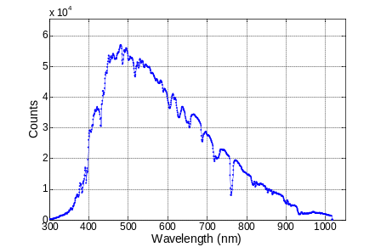
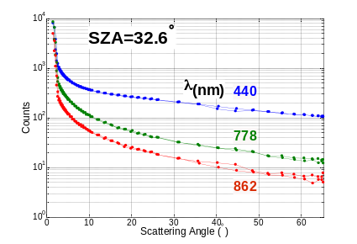
Background, instrument concept, and advantages: Atmospheric aerosols and trace gases play crucial roles in the Earth’s radiation balance and climate. Absorbing aerosols may hold a major key to combating global warming. However, more knowledge is needed about aerosol and gas sources, distributions and properties. This requires continuous observations from satellites, networks of ground-based instruments, and dedicated field experiments using state-of-the-art airborne instruments. The existing Ames airborne sunphotometers have contributed significantly to such field experiments by making sunlight transmission measurements at 6 or 14 discrete wavelengths. An airborne instrument that measures a continuous spectrum of the direct solar beam and of the scattered sunlight as a function of angular distance from the Sun will deliver considerably more information on atmospheric aerosols and gases but does not currently exist. Advantages of the scattered sunlight measurements would be the ability to determine the size of larger particles (e.g., mineral dust) than is possible with the direct-beam transmission measurements by our current 14-wavelength sunphotometer, plus the ability to retrieve aerosol type, composition and absorption information via retrievals of complex refractive index and shape. Advantages of the continuous spectrum measurements over our current 14 discrete wavelengths would be the ability to measure trace gases not possible with our current instrument, such as SO₂and NO₂, plus improved accuracy of our current H₂O and O₃ measurements. The increased information content of scattered sunlight measurements has been demonstrated by NASA’s AERONET program, but never on an airborne instrument. The increased trace-gas measurement capability of continuous spectra (i.e., spectrometry) has been demonstrated by many NASA space and air instruments, but never in a compact airborne instrument also capable of the well calibrated transmission measurements needed for aerosol studies. The instrument concept (Fig. 1a) is targeted for autonomous operation on small or unmanned aircraft. If made light and efficient enough, it could also operate on a Mars airplane or rover, producing unique measurements on the dust aerosols that are the main driver of Mars climate.
Sun-tracking head
Optical fiber
Entrance aperture
(a)
(b)
(c)
(d)
Related current state-of-the-art and prior work: NASA Ames has been the world leader in airborne sunphotometry since the first flights of the Ames 6-channel airborne sunphotometer (AATS-6) in 1985. A second, enhanced 14-channel unit, AATS-14, was completed in 1996. Both instruments have been flown in many campaigns focusing on atmospheric aerosols and trace gases all over the world and have, to date, contributed to validating 11 satellite sensors, producing >80 publications (listed in Appendix D). The new instrument with its enhanced capabilities would build on this heritage and be in high demand for future missions sponsored by NASA, NOAA, DOE, Navy, etc., provided some key technological hurdles can be overcome.
Fig. 1: (a) Concept for a Spectrometer for Sky-Scanning, Sun-Tracking Atmospheric Research (4STAR). (b) Ground prototype. (c,d) Data measured by ground prototype: Transmitted sunlight spectrum and skylight angular scan.
Technological hurdles, ground prototype, and remaining design questions: The basic concept of the envisioned instrument is to marry the technologies of a small, rugged spectrometer, fiber optics, and an entrance port capable of sun tracking and skylight measurements near the sun. The Key Technological Hurdles that must be overcome to meet the scientific requirements are:
- Maintaining calibration (output counts per input radiance or irradiance) to 1% stability over a period of months.
- Demonstrating stray light rejection to permit measuring skylight within a few degrees of the sun
- Devising a fiber optic coupling that maintains 1% calibration stability with as many as possible of the following desirable charactertics: detachable during assembly before calibration; detachable between calibration and scientific measurements; rotatable during measurements.
To address these hurdles, Ames has developed a ground prototype over the past several years (Fig. 1b). This prototype is serving as a technology test bed and has produced data (Fig. 1c,d) that prove the basic concept is viable, including Hurdle 2 above. However, Hurdles 1 and 3 remain to be overcome, and they must be before proceeding to the design of an airborne instrument. For example, we do not know whether instrument calibration can be maintained when using either a rotating or fixed fiber optic coupling. Without using such a coupling, airborne measurements would be possible, but aircraft installation would be greatly simplified by using either type of coupling, and aircraft flight patterns could be much more flexible with a
Tasks, schedule and key milestones:
Task or Event | Year 1 |  |  |  |  |  |  |  |  |  |  |  | Year 2 |  |  |  |  |  |  |  |  |  |  |  |  | Year 3
Task or Event | FY 2007 |  |  |  |  |  |  |  |  |  |  |  | FY 2008 |  |  |  |  |  |  |  |  |  |  |  |  | FY 2009
Task or Event | O | N | D | J | F | M | A | M | J | J | A | S |  | O | N | D | J | F | M | A | M | J | J | A | S |  | O | N | D | J | F | M | A | M | J | J | A | S
Radiance-calibrate ground prototype
Ruggedize & weatherproof prototype
Field-test prototype with Cimel & AATS
Rebuild ground prototype with option of upper fiber rotating and lower fiber fixed
Test calib. stability of fiber couplings
Langley-calibrate ground prototype
Design airborne instrument (4STAR)
Airworthiness review of 4STAR design

Build 4STAR
Ground-test 4STAR
Langley- & radiance-calibrate 4STAR
Integrate 4STAR on A/C (e.g., G1, J31)
Flight test 4STAR
 | O | N | D | J | F | M | A | M | J | J | A | S |  | O | N | D | J | F | M | A | M | J | J | A | S |  | O | N | D | J | F | M | A | M | J | J | A | S
 | Year 1 |  |  |  |  |  |  |  |  |  |  |  | Year 2 |  |  |  |  |  |  |  |  |  |  |  |  | Year 3

rotating coupling. In Year 1 of the Partnership we propose to determine the extent to which Hurdles 1 and 3 can be overcome, leading up to a final design of the airborne instrument (see also other tasks in Schedule, above). The ground prototype could also be very useful in NASA and DOE field experiments, but only if ruggedized and weatherproofed. This will be another major effort and result of the Year 1 work.
Expertise and capabilities of technical team
Dr. Philip B. Russell (NASA Co-PI) led the development of AATS-6 and -14 and co-holds the patent on AATS-6. As leader of the ARC Sunphotometer-Satellite Group he is responsible for the scientific productivity of those instruments (>80 publications to date) and for overseeing the conception and development of new instruments to apply state-of-the-art technology to current science questions. He is a Fellow of the American Association for the Advancement of Science (AAAS), elected for “pioneering work and scientific leadership in the measurement of aerosol properties and the effects of haze on the Earth’s energy budget and climate”.
Dr. Beat Schmid (PNNL Co-PI) led the development of the ground prototype, working in Dr. Russell’s group under a NASA Ames Co-operative Agreement. He was recently appointed Associate Director, Atmospheric Science & Global Change Division at PNNL and plans to start work there in October 2006. He is a recognized leader in developing and using advanced instruments to answer questions of interest to NASA and DOE programs in atmospheric composition and climate. His accomplishments are documented in >50 peer reviewed publications.
Both Drs. Russell and Schmid are experienced at assembling teams of scientists, engineers, and technicians to design, develop and use advanced airborne instrumentation. As Co-PIs of the Partnership they will continue to do this at ARC and PNNL.
Dr. Brent Holben (GSFC lead collaborator) leads the global Aerosol Robotic Network (AERONET) of sun-sky radiometers, including use of standardized, state-of-the-art algorithms to retrieve aerosol size and complex refractive index from measured skylight radiance. He recently received Goddard’s highest award for contributions to environmental science, the William Nordberg Memorial award.
See Appendix A for resumes of the Co-PIs and other team members, and the Budget section for projected FTE & WYE.
Approach to Partnering
The primary partners will be NASA ARC and DOE PNNL, with NASA GSFC as a collaborating partner. These partners will provide the technical team members identified above, plus supporting scientific, engineering and technical personnel, with FTE and WYE labor as detailed in the Budget section.
ARC will provide (while retaining ownership) the ground prototype that was developed with ARC funding under Dr. Schmid’s leadership in 2005-6. Under Dr. Schmid’s leadership, PNNL will design experiments and analyze data to answer key questions regarding airborne instrument design to accomplish scientific specifications. Under Dr. Russell’s leadership, ARC personnel (Co-op and Civil Servant) will participate in experiments and analyses and will ruggedize the ground prototype to make it suitable for field experiments in a variety of weather conditions. PNNL and ARC will jointly produce a design for an airborne instrument to be built by the Partnership in Years 2 and 3. ARC will have primary responsibility for ensuring that the design meets airworthiness requirements while meeting scientific specifications.
The proposed partnership mechanism is an Interagency Agreement. Commercialization opportunities are possible if the instruments generate sufficient user-community demand—a prospect enhanced by the spectrometer’s increased ability to measure gaseous constituents relative to current instruments that use discrete detectors and filters.
Benefit to NASA
The proposed Partnership aligns with the IPP element Emergent Technologies and the Science Mission Directorate Technology Focus Area New Remote Sensing Technologies. NASA will benefit by obtaining a NASA-owned ruggedized ground instrument and airborne instrument, both suitable for validating NASA satellites and advancing knowledge of atmospheric composition and climate on Earth, and potentially Mars. The instruments and analysis algorithms will reflect the expertise of Dr. Schmid and his PNNL team, another benefit to NASA. A shared use agreement will benefit both NASA and PNNL by broadening the use of the instruments and facilitating collaboration in advancing scientific knowledge.
The next step after Year 1 will be to continue the Partnership with joint funding from NASA’s SMD and a DOE program (e.g., its Atmospheric Science Program (ASP)).
Budget

ARC Costs |  | 2007
ARC Labor
Philip Russell, Co-PI | FTE
 | CS
Roy Johnson, Engineer | FTE
 | CS
ARC Procurement, Travel & Other
ADP/Computer Services
Parts and Equipment
Other
Shipping
Co-op Loaded Labor*
Co-op Loaded Travel
ARC Travel
ARC M&O
ARC Totals
External Partner Costs
DOE/PNNL**
External Partner Totals
Total Project Costs

Contributions |  | 2007
NASA contributions (other than IPP)
HQ SMD Radiation Science Program
M&O
External Partner contributions
DOE/PNNL**
Total Contributions
Total Budget Requested from IPP

Cost Notes:
*Co-op personnel work years |  | 2007
J. Redemann, Co-I (BAERI)
J. Livingston Co-I (SRI)
N. Truong, Engineer (BAERI)
C. Chang, Engineer (BAERI)
DOE/PNNL personnel work years
B. Schmid, Co-PI, PNNL
Engineer

**Total PNNL cost-sharing. Includes value of in-kind labor from PNNL shown in Cost Notes (above), + value of facilities used + value of other work being done at PNNL that will contribute to the proposed Partnership.
Letter of intent from an authorized official of the proposed external partner(s): See Appendix B.
Letter of concurrence from contributing NASA HQ Program Office Representative: See Appendix C.

Appendices

A. Short Resumes A1
B. Letters of Intent from PNNL Partner and GSFC Lead Collaborator B1
C. Letter of Concurrence from Contributing NASA HQ Program Office Representative C1
D. Publications Using AATS-6 or AATS-14 Results or Describing Methods D1
E. Acronyms E1

Appendix A: Short Resumes

Philip B. Russell, NASA Co-PI

Education
Ph.D. and M.S., Physics, Stanford University (1971 and 1967, Atomic Energy Commission Fellow).
M.S., Management, Stanford University (1990, NASA Sloan Fellow).
B.A., Physics, Wesleyan University (1965, Magna cum Laude; Highest Honors).

Professional Experience
NASA Ames Research Center: Research Scientist (1995-present); Chief, Atmospheric Chemistry and Dynamics Branch (1989-95); Acting Chief and Acting Deputy Chief, Earth System Science Division (1988-89); Chief, Atmospheric Experiments Branch (1982-89).
SRI International (1972-82): Physicist to Senior Physicist, Atmospheric Science Center.
National Center for Atmospheric Research (1971-72, at University of Chicago and NCAR): Postdoctoral Appointee.

Scientific Contributions
Studies of atmospheric aerosol and trace gas effects on radiation, climate, and chemistry using remote and in situ measurements from space, air, ground, and ship platforms.
Member, Science Team for Earth Observing System Inter-Disciplinary Science (EOS-IDS).
Member, Science Team for Solar Occultation Satellites (SOSST).
Patent, "Airborne Tracking Sunphotometer Apparatus and System" (U.S. Pat. No. 4,710,618, awarded 1987)

Honors and Awards
NASA Ames Honor Award (2002, for excellence in scientific research). NASA Ames Associate Fellow (1995, for excellence in atmospheric research). NASA Exceptional Service Medal (1988, for managing Stratosphere-Troposphere Exchange Project). NASA Space Act Award (1989, for invention of Airborne Autotracking Sunphotometer). NASA Group Achievement Awards (1989-94).
Member, Phi Beta Kappa and Sigma Xi.

Scientific Societies/Committees
Fellow, American Association for the Advancement of Science (elected 2005 for “pioneering work and scientific leadership in the measurement of aerosol properties and the effects of haze on the Earth’s energy budget and climate”). Editor-in-Chief (1994-95) and Editor (1993, 1996), Geophysical Research Letters; Member, Board of Editors and Atmospheric Science Executive Committee, American Geophysical Union. Guest Editor, Journal of Geophysical Research Special Issues (1988-1993). Chair, American Meteorological Society International Committee on Laser Atmospheric Studies (1979-82, Member, 1978-82). Member, National Research Council Committee on Army Basic Research (1979-81). Member, American Meteorological Society Committee on Radiation Energy (1979-81).

Publications. Over 120 peer-reviewed publications. Selected publications relevant to this Call are listed below or included in Appendix D of this proposal.
Russell, P. B., J. M. Livingston, J. Redemann, B. Schmid, S. A. Ramirez, J. Eilers, R. Kahn, A. Chu, L. Remer, P. K. Quinn, M. J. Rood, W. Wang, Multi-grid-cell validation of satellite aerosol property retrievals in INTEX/ITCT/ICARTT 2004, J. Geophys. Res., ICARTT special section, submitted May 2006.
Russell, P. , et al., Aerosol optical depth measurements by airborne Sun photometer in SOLVE II: Comparisons to SAGE III, POAM III and airborne spectrometer measurements, Atmos. Chem. Phys., 5, 1311–1339, 2005 (SRef-ID: 1680-7324/acp/2005-5-1311, www.atmos-chem-phys.org/acp/5/1311/).
Russell, P. B., J. M. Livingston, O. Dubovik, S. A. Ramirez, J. Wang, J. Redemann, B. Schmid, M. Box, and B. N. Holben, Sunlight transmission through desert dust and marine aerosols: Diffuse light corrections to Sun photometry and pyrheliometry, J. Geophys. Res., 109, D08207, doi:10.1029/2003JD004292, 2004.
Schmid B., J. Redemann, P. B. Russell, et al., Coordinated airborne, spaceborne, and ground-based measurements of massive, thick aerosol layers during the dry season in Southern Africa, J. Geophys. Res., 108(D13)8496, doi:10.1029/2002JD002297, 2003.
Russell, P. B., et al., Comparison of aerosol single scattering albedos derived by diverse techniques in two North Atlantic experiments, J. Atmos. Sci., 59, 609-619, 2002.
Redemann, J., P.B. Russell, and P. Hamill, Dependence of aerosol light absorption and single scattering albedo on ambient relative humidity for sulfate aerosols with black carbon cores, J. Geophys. Res., 106, 27,485-27,495, 2001.
Russell, P. B., and J. Heintzenberg, An overview of the ACE-2 Clear Sky Column Closure Experiment (CLEARCOLUMN), Tellus B 52, 463-483, 2000.
Bergstrom, R. W., and P. B. Russell, Estimation of aerosol radiative effects over the mid-latitude North Atlantic region from satellite and in situ measurements. Geophys. Res. Lett., 26, 1731-1734, 1999.
Russell, P. B., P. V. Hobbs, and L. L. Stowe, Aerosol properties and radiative effects in the United States Mid-Atlantic haze plume: An overview of the Tropospheric Aerosol Radiative Forcing Observational Experiment (TARFOX), J. Geophys. Res., 104, 2213-2222, 1999a.
Russell, P. B., J. M. Livingston, P. Hignett, S. Kinne, J. Wong, and P. V. Hobbs, Aerosol-induced radiative flux changes off the United States Mid-Atlantic coast: Comparison of values calculated from sunphotometer and in situ data with those measured by airborne pyranometer, J. Geophys. Res., 104, 2289-2307, 1999b.
Russell, P. B., S. Kinne and R. Bergstrom, "Aerosol Climate Effects: Local Radiative Forcing and Column Closure Experiments," J. Geophys. Res., 102, 9397-9407, 1997.
Russell, P. B., et al.. Global to Microscale Evolution of the Pinatubo Volcanic Aerosol, Derived from Diverse Measurements and Analyses. J. Geophys. Res., 101, 18,745-18,763, 1996a.
Russell, P.B., L. Pfister, and H.B. Selkirk. "The Tropical Experiment of the Stratosphere-Troposphere Exchange Project (STEP): Science Objectives, Operations, and Summary Findings." J. Geophys. Res., 98, 8563-8589, 1993.
Russell, P.B., et al., "Post-Pinatubo Optical Depth Spectra vs. Latitude and Vortex Structure: Airborne Tracking Sunphotometer Measurements in AASE II." Geophys. Res. Lett., 20, 2571-2574, 1993.
Russell, P.B., and M.P. McCormick. "SAGE II Aerosol Data Validation and Initial Data Use: An Introduction and Overview." J. Geophys. Res., 94, 8335-8338, 1989.
Russell, P.B., M.P. McCormick, T.J. Swissler, J.M. Rosen, D.J. Hofmann, and L.R. McMaster. "Satellite and Correlative Measurements of the Stratospheric Aerosol: III. Comparison of Measurements by SAM II, SAGE, Dustsondes, Filters, Impactors, and Lidar." J. Atmos. Sci., 41, 1791-1800, 1984.
Russell, P.B., T.J. Swissler, M.P. McCormick, W.P. Chu, J.M. Livingston, and T.J. Pepin. "Satellite and Correlative Measurements of the Stratospheric Aerosol: I. An Optical Model for Data Conversions." J. Atmos. Sci., 38, 1270-1294, 1981.
Russell, P.B., J.M. Livingston, and E.E. Uthe. "Aerosol-Induced Albedo Change: Measurement and Modeling of an Incident." J. Atmos. Sci., 36, 1587-1608, 1979.

Beat Schmid, PNNL Co-PI
Education and Training
Institution | Degree | Field | Dates
University of Bern, Switzerland | Liz. Phil. Nat. (M.S.) | Physics | 1991
University of Bern, Switzerland | Ph.D. | Physics | 1995

Research and Professional Experience
2006 – present Associate Director, Atmospheric Science and Global Change Division, Pacific Northwest National Laboratory, Richland, WA
2003 – 2006 Group Leader, Bay Area Environmental Research Inst., Sonoma, CA.
Responsible for research and financial administration of 4.4 fulltime positions
1997 – 2003 Senior Research Scientist, Bay Area Environmental Research Inst., Sonoma, CA
1995 – 1997 Research Assistant (Postdoctoral Researcher), University of Bern, Switzerland
1995 (Oct.) – 1996 (Jan.) Visiting Scientist, University of Arizona, Tucson, AZ
1989 – 1995 Research Assistant, University of Bern, Switzerland

Synergistic Activities:
      - Chair of DOE ARM Aerosol Working Group, member ARM Science Team Executive Committee and member ARM Climate Research Facility Science Board (2005 – present)
      - PI for CIRPAS Twin Otter aircraft in Cloud and Land Surface Interaction Campaign (CLASIC, planned for June 2007)
      - Lead scientist for ARM September 2005 Aerosol Lidar Validation Experiment (ALIVE)
- Platform scientist for portions of the EVE (Monterey, 2004) and INTEX-NA/ITCT (Gulf of Maine, 2004) missions. Direction and execution of research flights of the CIRPAS Twin Otter and Sky Research J-31 aircraft.
- Co-led planning of ARM May 2003 Aerosol Intensive Observation Period. Led 10 principal investigators during field campaign as platform scientist on CIRPAS Twin Otter aircraft.
- Employed NASA Ames Airborne Sun photometers in campaigns all over the world and made processed data available to the research community through web-based archives.
- Extensive experience in aerosol closure studies, lidar and satellite validation.
      - Associate Editor, Journal Geophysical Research – Clouds and Aerosols (2002- present)
- NASA Group Achievement Awards: INTEX and SOLVE II Science Teams

Grants:
- PI and member DOE ARM Science Team
- Co-PI and member MODIS Science Team
- Member of Glory/APS Advisory Board
- PI, Co-PI and Co-I on research grants funded by NASA, NOAA, and DOE

Bibliography
- 52 peer-reviewed journal articles (10 first-authored and 42 co-authored) + 4 submitted
- 189 conference publications (39 first-authored and 150 co-authored)
- 18 invited talks at conferences, workshops and seminars

Publications relevant to this Call are listed in Appendix D of this proposal.

Brent Holben, GSFC Lead Collaborator

Present  Position | AERONET Project Scientist  Code 614.4  Biospheric Sciences  NASA’s Goddard Space Flight Center | Phone: 301 614-6658-2975  FAX: 301 614-6695  E-mail: brent@aeronet.gsfc.nasa.gov
Research  Interests | Aerosol optical and radiometric properties and measurements, Global radiative forcing and vegetation remote sensing in the SW and Mid IR region.
Summary of  Experience | Brent Holben has worked at NASA’s GSFC for 28 years performing research in both ground-based and satellite remote sensing of vegetation and aerosols. Additionally he has developed innovative methods for in orbit calibration of satellite visible and near-IR sensors. He is the project leader for the AERONET sun-sky radiometer network that is providing aerosol spectral concentrations and properties for the EOS algorithm validation program as well as validation for a variety of other satellite systems. Holben has received several awards most recently in November 2005 for Goddard’s highest award for contributions to environmental science, the William Nordberg Memorial award. Holben has over 140 peer reviewed journal articles, three with citations exceeding 500.
Recent Selected Papers
2006, Zibordi, G., B Holben, S.B. Hooker, F.Melin, J-F Berthon, I. Slutsker, D. Giles, D. Vandemark, H. Feng, K. Rutledge, G. jSchuster and A. Mandoos, 2006, A Network forStandardized Ocean Color Validation Measurements, Eos Geophysical Transactions, accepted for publication.
2005, Eck, T.F., B.N. Holben, O. Dubovik, A. Smirnov, P. Goloub, H.B. Chen, B. Chatenet, L. Gomes, X.Y. Zhang, S.C. Tsay, Q. Ji, D. Giles, and I. Slutsker, Columnar aerosol optical properties at AERONET sites in central eastern Asia and aerosol transport to the tropical mid-Pacific, J. Geophys. Res., 110 , D06202, doi:10.1029/2004JD005274.
2002, Dubovik, O., B.N.Holben,T. Lapyonok, A.Sinyuk, M. I. Mishchenko, P. Yang, and I.Slutsker: Non-spherical aerosol retrieval method employing light scattering by spheriods,Geophys. Res. Lett., 29, 54-1 - 54-4.
2001, Holben, B.N., D. Tanré, A. Smirnov, T.F. Eck, I. Slutsker, B Chatenet, F. Lavenue,Y. Kaufman, J.V. Castle, A. Setzer, B.Markham, D. Clark, R. Frouin, N A. Karneli. O'Neill, C. Pietras, R. Pinker, K. Voss, G. Zibordi, An emerging ground-based aerosol climatology: Aerosol Optical Depth from AERONET, J. Geophys. Res, 106, 12067-12097.
2000, Smirnov, A., B.N.Holben, T.F.Eck, O.Dubovik, I.Slutsker, Cloud screening and quality control algorithms for the AERONET data base, accepted to Rem. Sens. Environ., 73, 337-349.
2000, Dubovik, O., A.Smirnov, B.N.Holben, M.D.King, Y.J. Kaufman, T.F.Eck, and I.Slutsker, “Accurasy assessments of aerosol optical properties retrieved from AERONET Sun and sky-radiance measurements”, J. Geophys. Res., 105, 9791-9806.
1998, Holben, B.N., T.F. Eck, I Slutsker, D. Tanré, J.P. Buis, A. Setzer, E. Vermote, J.A. Reagan, Y.J. Kaufman, T. Nakajima, F. Lavenu, I. Jankowiak, A. Smirnov, 1998. AERONET-A Federated Instrument Network and Data Archive for Aerosol Characterization, Rsens. Environ.E, 66,1-16.

Roy Johnson, Electrical Engineer
Education:
Embry-Riddle Aeronautical University (1987 –1993): B.S. Electrical Engineering (Mathematics Minor) with concentration in Avionics

San Jose State University (1998 – 2000): Incomplete B.S. Psychology/Human Factors (39 credits)

Professional:
2005-present: NASA Ames Research Center: Electronics Engineer
-Projects: ALIVE, INTEX-B
-Maintain electronics, optics and mechanics of the AATS-14 sunphotometer instrument.
-Lead efforts for upgrading computers and electronics in the AATS-14 instrument.
-Perform a wide variety of duties with the deployed instrument in Hawaii, Oklahoma and Mexico including basic aircraft maintenance, logistics, translating (Spanish), and basic technician duties.
-Operate the AATS-14 instrument in ground tests and in aircraft deployments.
- Manage AATS laboratory.

1997-present: NASA Ames Research Center: Electronics Engineer
Projects: IRAC instrument (Spitzer Space Telescope), MIRI instrument (James Webb Space Telescope), WISE instrument (MIDEX)
-Design electronics systems for IR detector testing.
-Design mechanical assemblies including cryogenic vessels and optics for IR applications.
-Perform tests for optimizing and screening development IR detector arrays and flight candidate IR detector arrays.
-Assist in radiation hardness testing of IR detector space flight devices.
-Assist in data reduction and data package assembly.
-Perform laboratory management duties including safety inspections, equipment calibration and electrostatic bench maintenance.

1993-1997: NASA Goddard Space Flight Center: Electronics Engineer
Projects: CIRS instrument (Cassini Spacecraft), IRAC (Spitzer Space Telescope)
-Designed and built IR camera electronics for both field astronomy and lab tests.
-Wrote assembly and some C software code for detector timing.
-Performed testing, screening and data package assembly for space flight IR detectors.
-Designed simple mechanical assemblies for cryogenic and general applications.

1991-1993: NASA Goddard Space Flight Center: Co-operative education student
Projects: MODIS-T, ASAS, IRAC
-Built and tested electronics and mechanical assemblies.
-Performed basic electronics testing in a clean room environment.

Nicholas Truong, Mechanical and Control Engineer
Summary: | Mechanical and Control Engineering experience including Design, Testing, and Manufacturing Process in Automotive, Class II Medical Device, and Atmospheric Science Research. Master of Science in Mechanical Engineering, M.S.M.E.. Extensive knowledge of PRO-E, LABVIEW, SOLIDWORKS, and AUTOCAD.
Experience: | Sr. Research & Development Engineer Nov 2004 – present  Bay Area Environmental Research Institute  Atmospheric Chemistry and Dynamics Branch  Earth Science Division  NASA Ames Research Center, CA  Developing the ground prototype of the new NASA Ames Airborne Sun/ Sky-Scanning Spectrometer instrument which will yield detailed information on aerosol optical properties and gases and which is targeted for autonomous operation on small or unmanned aircraft. Activities include:  Develop and write technical specifications for the Ground based and airborne sunphotometers.  Design the ground based Sun/Sky-Scanning Sunphotometer mechanical components and subassemblies using Pro-E. Major mechanical subsystems are elevation and azimuth subassemblies, entrance optics subassembly.  Design entrance optics / baffle subsystem for suppression of unwanted stray light.  Design and integrate electronic subsystems. These include stepping motors and drivers, motion controller board, spectrometer electronics, signal processing board, and quad tracking detector board.  Write and test control applications programs using LabView. The LabView programs control the sun tracking function while allowing the atmospheric measurements to be taken by the spectrometer at various wavelengths for direct-sun and skylight applications.  Test, trouble shoot, and maintain documentation.  Continue design work toward an airborne version  Sr. Mechanical Design Engineer March 2004 – Sept 2004  Logitech Inc., Fremont, CA (contract)  Worked in the Video Hardware R & D Engineering group on the design of web cams. Activities included:  Defined, developed, wrote, and implemented the required functional specifications for the web cam gear boxes.  Designed the web cam injection molding components using Pro-E (cam housing, lenses, armatures, base, spindle).  Developed and implemented Engineering Test plan for gear boxes and web cams for V & V. Wrote test results and analysis.  Developed and wrote gear box top level engineering analysis, breakaway torque analysis, hard stop analysis, and gear breakage analysis.  Developed and wrote gear box ECO’s (Engineering Change Order).  Developed and designed tool fixtures.  FMEA, Risk Analysis, First Article Inspection.  Worked with gear box vendor and outside technical resources.  Sr. Manufacturing / Mechanical Engineer 2000 – Dec 2003  Philips Medical Systems, Milpitas, CA  Product Research and Development Project / Manufacturing Engineer 1995 - 2000  Ford Motor Company, MI
Education: | University of Michigan, Dearborn, MI  Master of Science in Engineering - Mechanical Engineering, M.S.M.E., June 1997.  Areas of study: Fiber reinforced composite materials, Theory of finite element analysis, advanced stress analysis, stress/strength considerations in design, viscous theory, heat transfer, mechanical vibrations, and engineering analysis.  Michigan State University, East Lansing, MI  Bachelor of Science in Mechanical Engineering, B.S.M.E. (with honor), June 1985.  Minor: Aerospace Engineering
Skills: | Computer skills. SolidWorks 2004, Pro/E WildFire 2.0, LabVIEW 7.0, Autocad 2005, Microsoft Excel, Microsoft Word, Power Point, Flow Charting 4, Minitab, MATLAB, FORTRAN, Finite Element Analysis (ANSYS), Intergraph Workstation (UNIX-based), Intergraph Microstation 5.0 (PC-based).

Cecilia Chang, Software Engineer

Education
- M.S. Software Engineering, International Tech University, Santa Clara, CA
- B.A. Fu-Jen Catholic University, Taipei, Taiwan

Work Experience
- Staff Scientist/Software Programmer, Bay Area Environmental Research Institute, NASA Ames Research Center, Moffett Field, CA 1997 - present

- Upgrading Sunphotometer AATS-14 system for NASA Ames Sunphotometer/Satellite team. Responsible for porting C code to new hardware and operating system.
- Developed PC/104 format real-time airborne data acquisition software for NASA Ames Meteorological Measurement System team (MMS).
- Developed MMS web page.
- Field integration and support for NASA field experiments CAMEX3, SOLVE, CAMEX4, CRYSTAL-FACE, MidCIX , AVE and CR_AVE.
- Developed LabView routine to monitor in-flight real-time data string.
- Developed IGOR (an integrated program for visualizing, analyzing, transforming and presenting data) routine to analyze and present science data in graphics.

Awards
- NASA Group Achievement Awards for CRYSTAL-FACE, CAMEX4, SOLVE and SONEX Science Teams
- Member of Phi Theta Kappa society

Jens Redemann, Co-I
Professional Experience
Senior Research Scientist | BAERI, Sonoma, CA | April 1999 to present
Research Assistant | UCLA, CA | May 1995 to March 1999
Lecturer | UCLA, CA | Jan. 1999 to present
Research Assistant | FU Berlin, Germany | June 1994 to April 1995

Education
Ph.D. in Atmospheric Sciences, UCLA. | 1999
M.S. in Atmospheric Sciences, UCLA. | 1997
M.S. in Physics, FU Berlin, Germany. | 1995

Relevant Research Experience
- Co-Principal Investigator for the study of the spatial variability of aerosol products in the vicinity of clouds from MODIS and MISR. MODIS science team member.
- Mission Principal Investigator and Mission Scientist for the Extended-MODIS-λ Validation Experiment (EVE) in 2004, an airborne field campaign to validate MODIS near-IR AOD measurements of Asian dust transported across the Pacific basin.
- PI, NASA New Investigator Program (NIP), 2003-2005.
- PI for the participation of AATS (an airborne sunphotometer) in the CLAMS satellite validation study (July 2001). Responsible for proposal writing and experiment design, instrument integration, as well as scheduling and supervision of three group members. Member of the CLAMS science team.
- Related airborne sunphotometer, lidar and spectral solar flux radiometer measurements to in situ measurements of atmospheric aerosols and gases to model and derive the vertical structure of aerosol-induced radiative flux changes in Earth’s atmosphere.
- Participated in the SAFARI-2000, ACE-Asia, PRIDE, CLAMS, ADAM , ARM Aerosol IOP, EVE and INTEX-A&B field experiments aimed at investigating atmospheric aerosols. Responsible for daily flight planning and platform coordination in CLAMS, INTEX and EVE.
- Utilized satellite derived aerosol optical depth fields and aerosol properties from the ACE-Asia campaign to determine the aerosol radiative forcing of climate in the Pacific Basin troposphere.
- Developed a coupled aerosol microphysics and chemistry model to study the dependence of the aerosol single scattering albedo on ambient relative humidity.

Honors / Organizations
AGU Fall meeting invited presentation | 2005
NASA Group Achievement Awards – INTEX-A Science Team | 2005
Member of technical committee: NASA Earth System Scholars Network | June 2004 -
NASA Group Achievement Awards - SOLVE II Science Team | 2004
Invited Presentation at the 5th International APEX workshop, Miyazaki, Japan. | July 2002
Invited Presentation at the Atmospheric Chemistry Colloquium for Emerging Senior Scientists (ACCESS V). | 1999
Outstanding Student Paper Award, AGU Fall meeting. | 1998
NASA Global Change Research Fellowship Awards. | 1995-1998
UCLA Neiburger Award for excellence in teaching of the atmospheric sciences. | 1997

Summary of bibliography: 34 (+1 submitted) peer-reviewed journal articles [9 (+1 submitted) first-authored], 100+ conference presentations (45+ first-authored).

Publications relevant to this Call are listed in Appendix D of this proposal. A complete list of publications can be found at http://geo.arc.nasa.gov/sgg/AATS-website/CV_info/redemann.html.

John Livingston, Co-I
Education
Notre Dame Year-in-Japan Program | 1971-72 | Sophia University, Tokyo, Japan
B.S., Earth Sciences | 1974 | University of Notre Dame, Notre Dame, IN
M.S., Atmospheric Sciences | 1977 | University of Arizona, Tucson, AZ
M.B.A. | 1992 | Santa Clara University, Santa Clara, CA

Professional Experience
SRI International (formerly Stanford Research Institute), Menlo Park, CA (1978-present)
Senior Research Meteorologist, Center for Geospace Studies, Engineering and Systems Division
University of Arizona,Tucson, AZ (1974-1977)
Research assistant, Institute of Atmospheric Physics
NASA Kennedy Space Center (summers, 1975-1976): thunderstorm electrification studies
Scientific Contributions
- Acquisition and analysis of ground-based, airborne, and shipboard sunphotometer measurements (NASA Ames 6-channel and 14-channel airborne sunphotometers) in a variety of coordinated international field campaigns to study the radiative impact on climate of anthropogenic pollution, volcanic aerosol, and African and Asian dust
- Validation of satellite aerosol extinction measurements (SAM II, SAGE I, SAGE II, SAGE III, and POAM III), and corresponding studies of the global distribution of stratospheric aerosols
- Analysis of in situ measurements of stratospheric and tropospheric aerosols
- Analysis of ground-based lidar measurements obtained at Sondrestrom, Greenland to retrieve atmospheric density and temperature profiles in the polar stratosphere and mesosphere and to characterize the physical properties of noctilucent clouds
- Acquisition, modeling and analysis of Differential Absorption Lidar measurements of tropospheric ozone
- Simulation of passive sensor radiance measurements to infer range to an absorbing gas
- Error analysis and simulation of lidar aerosol measurements
- Analysis of lidar propagation through fog, smoke, and dust clouds
- Weather forecasting for large-scale air pollution field study
- Testing and evaluation of an offshore coastal dispersion computer model
- Application of objective wind field/trajectory models to meteorological measurements

Honors and Awards
- 1997 NASA Ames Research Center Contractor of the Year

Scientific Societies
- Member, American Geophysical Union

Publications
- Over 52 peer-reviewed publications in various atmospheric science journals. Selected relevant publications are listed in Appendix D of this proposal.

Appendix B: Letters of Intent from PNNL Partner and GSFC Lead Collaborator

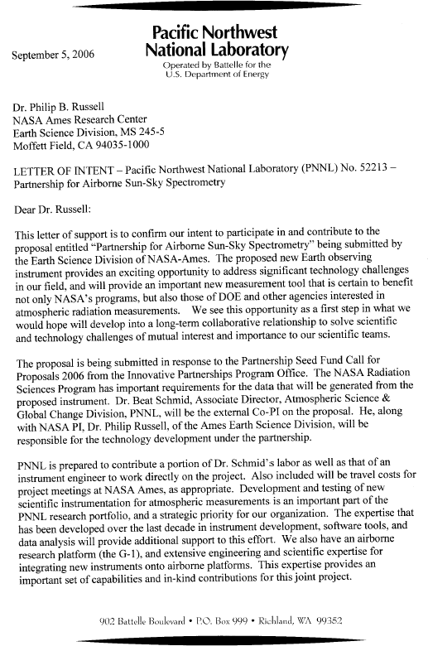
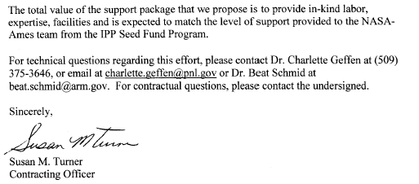

TO: Philip B. Russell, NASA ARC

FROM: Brent Holben, NASA GSFC

I acknowledge that I am identified by name as the NASA GSFC Lead Collaborator in the proposal entitled “Partnership for Airborne Sun-Sky Spectrometry” that is submitted by NASA ARC in response to the Partnership Seed Fund Call for Proposals—2006 of the Innovative Partnerships Program Office. I intend to carry out all responsibilities identified for me in this proposal. I understand that the extent and justification of my participation as stated in this proposal will be considered during peer review in determining in part the merits of this proposal.

Signed:

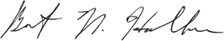

Brent N. Holben
Date: August 18, 2006

Appendix C: Letter of Concurrence from Contributing NASA HQ Program Office Representative

To Whom it may concern,
The proposal entitled: Partnership for Airborne Sun-Sky Spectrometry is of great interest to the NASA Radiation Science Program, Earth Science Division, Science Mission Directorate. The value of this effort is twofold. First, the instrument developed will be necessary for the validation of current and future NASA satellites. Second, the new sunphotometer will generate critical data addressing the broader goals of the Program in understanding the impacts of atmospheric composition on the earth’s radiation budget and climate.
Therefore, I concur with the proposal submitted by NASA ARC in response to the Partnership Seed Fund Call for Proposals–2006 of the Innovative Partnerships Program Office. In addition, I commit to providing funding from the Radiation Sciences Program at the level specified in the proposal budget, provided the other elements of the proposal are selected and funded.
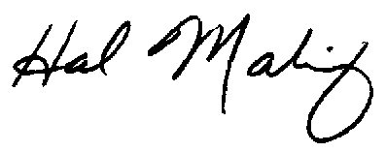
Hal Maring
Radiation Sciences Program
Earth Science Division
Science Mission Directorate
Mail Suite 3F71
NASA Headquarters
Washington, DC 20546-0001
hal.maring@nasa.gov
202.358.1679 (voice)
202.358.2770 (fax)
FedEx Delivery Address
Science Mission Directorate
Attn: Receiving & Inspection (Rear of Building)
NASA Headquarters
300 E Street SW
Washington DC 20024-3210

Appendix D: Publications Using AATS-6 or AATS-14 Results or Describing Methods

Anderson T. L., Y. Wu, D. A. Chu, B. Schmid , J. Redemann, O. Dubovik. Testing the MODIS satellite retrieval of aerosol fine-mode fraction. J. Geophys. Res., 110 , D18204, doi:10.1029/2005JD005978, 2005.
Andrews E., P.J. Sheridan, M. Fiebig, A. Mccomiskey, J. Ogren, W. P. Arnott, D. Covert, R. Elleman, R. Gasparini, D. Collins, H. Jonsson, B. Schmid , J. Wang, Comparison of methods for deriving aerosol asymmetry parameter. J. Geophys. Res., 111, D05S04, doi:10.1029/2004JD005734, 2006.
Bergstrom, R. W., and P. B. Russell, “Estimation of aerosol radiative effects over the mid-latitude North Atlantic region from satellite and in situ measurements.” Geophys. Res. Lett., 26, 1731-1734, 1999
Bergstrom, R. W., P. B. Russell, and P. Hignett, Wavelength dependence of the absorption of black carbon particles: Predictions and results from the TARFOX experiment and implications for the aerosol single scattering albedo, J. Atmos. Sci., 59, 568-578, 2002.
Bergstrom, R. W., P. Pilewskie, B. Schmid, and P. B. Russell, Estimates of the spectral aerosol single scattering albedo and aerosol radiative effects during SAFARI 2000, J. Geophys. Res., 108(D13), 8474, doi:10.1029/2002JD002435, 2003.
Bergstrom, R. W., P. Pilewskie, J. Pommier, M. Rabbette, P. B. Russell, B. Schmid, J. Redemann, A. Higurashi, T. Nakajima, and P. K. Quinn, Spectral absorption of solar radiation by aerosols during ACE-Asia, J. Geophys. Res., 109, D19S15, doi:10.1029/2003JD004467, 2004.
Bergstrom, R. W., P. Pilewskie, J. Pommier, M. Rabbette, P. B. Russell, B. Schmid, J. Redemann, A. Higurashi, T. Nakajima, and P. K. Quinn, Spectral absorption of solar radiation by aerosols during ACE-Asia, J. Geophys. Res., 109, D19S15, doi:10.1029/2003JD004467, 2004.
Chowdhary, J, B. Cairns, M.I. Mishchenko P. V. Hobbs, Glenn Cota, Jens Redemann, Ken Rutledge, Brent N. Holben, Ed Russell, 2005: Retrieval of aerosol scattering and absorption properties from photo-polarimetric observations over the ocean during the CLAMS experiment, J. Atmos. Sci., 62, 1093-1117.
Chu, D. A., L. A. Remer, Y. J. Kaufman, B. Schmid, J. Redemann, K. Knobelspiesse, J.-D. Chern, J. Livingston, P. Russell, X. Xiong, and W. Ridgway, Evaluation of aerosol properties over ocean from Moderate Resolution Imaging Spectroradiometer (MODIS) during ACE-Asia, J. Geophys. Res., VOL. 110, D07308, doi:10.1029/2004JD005208, 2005.
Colarco, P. R., O. B. Toon, J. S. Reid, J. M. Livingston, P. B. Russell, J. R. Redemann, B. Schmid, H. B. Maring, D. Savoie, J. Welton, J. R. Campbell, B. N. Holben, and R. Levy, Saharan dust transport to the Caribbean during PRIDE: Part 2. Transport, vertical profiles, and deposition in simulations of in situ and remote sensing observations, J. Geophys. Res., 108(D19), 8590, doi:10.1029/2002JD002659, 2003.
Collins, D. R., Jonsson, H. H., Seinfeld, J. H., Flagan, R. C., Gasso, S., Hegg, D., Russell, P. B., Livingston, J. M., Schmid, B., Öström, E., Noone, K. J., and Russell, L. M. In situ aerosol size distributions and clear column radiative closure during ACE 2. Tellus B 52, 498-525, 2000.
Durkee, P. A., K. E. Nielsen, P. B. Russell, P. B., B. Schmid, J. M. Livingston, D. Collins, , R. Flagan, J. Seinfeld, K. Noone, S. Gasso, D. Hegg, T. S. Bates, and P. K. Quinn, “Regional aerosol properties from satellite observations: ACE-1, TARFOX and ACE-2 results.” J. Aerosol Sci. 29(Suppl 1): S1149, 1998.
Durkee, P. A., Nielsen, K. E., Russell, P. B., Schmid, B., Livingston, J. M., Collins, D., Flagan, R. C., Seinfeld, H. H., Noone, K. J., Ostrom, E., Gassó, S., Hegg, D., Bates, T. S., Quinn, P. K., and Russell, L. M. Regional aerosol properties from satellite observation: ACE-1, TARFOX and ACE 2 results. Tellus B 52, 484-497, 2000.
Ferrare, R., et al. (with P. B. Russell), Comparison of aerosol optical properties and water vapor among ground and airborne lidars and Sun photometers during TARFOX, J. Geophys. Res., 105, 9917-9933, 2000a.
Ferrare, R., et al. (with P. B. Russell), Comparisons of LASE, aircraft, and satellite measurements of aerosol optical properties and water vapor during TARFOX, J. Geophys. Res., 105, 9935-9947, 2000b.
Ferrare R., D. Turner, M. Clayton, B. Schmid , J. Redemann, D. Covert, R. Elleman, J. Ogren, E. Andrews, J. Goldsmith, H. Jonsson, Evaluation of Daytime Measurements of Aerosols and Water Vapor made by an Operational Raman Lidar over the Southern Great Plains J. Geophys. Res., 1111, D05S08, doi:10.1029/2005JD005836, 2006.
Gassó, S., Hegg, D. A., Covert, D. S., Noone, K., Ostrom, E., Schmid, B., Russell, P. B., Livingston, J. M., Durkee, P. A., and Jonsson, H. Influence of humidity on the aerosol scattering coefficient and its effect on the upwelling radiance during ACE-2. Tellus B 52, 546-567, 2000.
Gatebe, C. K., M. D. King, S. Platnick, G. T. Arnold, E. F. Vermote, and B. Schmid, 2003: Airborne spectral measurements of surface-atmosphere anisotropy for several surfaces and ecosystems over southern Africa. J. Geophys. Res., 108, 8489, doi:10.1029/2002JD002397.
Hartley WS, Hobbs PV, Ross JL, Russell PB, Livingston JM, Properties of aerosols aloft relevant to direct radiative forcing off the mid-Atlantic coast of the United States, J. Geophys. Res., 105, 9859-9885, 2000.
Hegg, D. A., J. Livingston, P. V. Hobbs, T. Novakov, and P. B. Russell, "Chemical Apportionment of Aerosol Column Optical Depth Off the Mid-Atlantic Coast of the United States," J. Geophys. Res. , 102 , 25,293-25,303, 1997.
Hobbs, P. V., T. Novakov, P. Russell, J. M. Livingston, and J. L. Ross, “Relative contributions of atmospheric aerosol constituents to optical depths and direct radiative forcing on the United States east coast.” J. Aerosol Sci. 29(Suppl 1): S1297-S1298, 1998.
Huebert, B. J., T. Bates, P. B. Russell, G. Shi, Y. J. Kim, K. Kawamura, G. Carmichael, and T. Nakajima, An overview of ACE-Asia: Strategies for quantifying the relationships between Asian aerosols and their climatic impacts, J. Geophys. Res., 108(D23), 8633, doi:10.1029/2003JD003550, 2003.
Ismail S, Browell EV, Ferrare RA, Kooi SA, Clayton MB, Brackett VG, Russell PB, LASE measurements of aerosol and water vapor profiles during TARFOX, J. Geophys. Res., 105, 9903-9916, 2000.
Jin, Z., T.P. Charlock, W.L. Smith Jr., K. Rutledge, G. Cota, R. Kahn, J. Redemann, T. Zhang, D. Rutan, and F. Rose, Radiative Transfer Modeling for the CLAMS Experiment, J. Atmos. Sci. , doi: 10.1175/JAS3351.1, Vol. 62, No. 4, pp. 1053-1071, 2005.
Kahn, R., J. Anderson, T.L. Anderson, T. Bates, F. Brechtel, C.M. Carrico, A. Clarke, S.J. Doherty, E. Dutton, R. Flagan, R. Frouin, H. Fukushima, B. Holben, S. Howell, B. Huebert, A. Jefferson, H. Jonsson, O. Kalashnikova, J. Kim, S-W. Kim, P. Kus, W-H. Li, J.M. Livingston, C. McNaughton, J. Merrill, S. Mukai, T. Murayama, T. Nakajima, P. Quinn, J. Redemann, M. Rood, P. Russell, I. Sano, B. Schmid, J. Seinfeld, N. Sugimoto, J. Wang, E.J. Welton, J-G. Won, S-C. Yoon, Environmental Snapshots From ACE-Asia, J. Geophys. Res., Vol. 109, No. D19, D19S14 10.1029/2003JD004339, 2004.
Kaufman Y. J., J. M. Haywood, P. V. Hobbs, W. Hart, R. Kleidman and B. Schmid . Remote sensing of vertical distributions of smoke aerosol off the coast of Africa during SAFARI 2000. Geophys. Res. Lett. , Vol. 30, No. 16, doi:10.1029/2003GL017068, 2003.
Levy, R. C. L. Remer, D. Tanré, Y. Kaufman, C. Ichoku, B. Holben, J. Livingston, P. Russell, H. Maring, Evaluation of the MODIS retrievals of dust aerosol over the ocean during PRIDE, J. Geophys. Res., Vol. 108, No. D19, 8594 10.1029/2002JD002460, 23 July 2003.
Levy, R.C., L.A. Remer, J.V. Martins, Y.J. Kaufman, A. Plana-Fattori, J. Redemann, B. Wenny, Evaluation of the MODIS aerosol retrievals over ocean and land during CLAMS, J. Atmos.c Sci. , Vol. 62, No. 4, pp. 974–992., 2005.
Livingston, J.M. and P.B. Russell, Comparison of satellite-inferred (SAGE II) aerosol optical depths with corresponding airborne sun-photometer optical depths, Preprint AIAA 27th Aerospace Sciences Meeting, January 9-12, 1989, Reno Nevada.
Livingston, J. M., V. Kapustin, B. Schmid, P. B. Russell, P. A. Durkee, T. S. Bates, and P. K. Quinn, “Shipboard sunphotometer measurements of aerosol optical depth spectra and columnar water vapor during ACE-2, J. Aerosol Sci. 29(Suppl 1): S257-S258, 1998.
Livingston, J. M., V. Kapustin, B. Schmid, P. B. Russell, P. K. Quinn, T. S. Bates, P. A. Durkee, P. J. Smith, V. Freudenthaler, D. S. Covert, S. Gassó, D. A. Hegg, D. R. Collins, R. C. Flagan, J. H. Seinfeld, V. Vitale, and C. Tomasi, Shipboard sunphotometer measurements of aerosol optical depth spectra and columnar water vapor during ACE 2 and comparison to selected land, ship, aircraft, and satellite measurements. Tellus, B 52, 594-619, 2000.
Livingston, J. M., et al., Airborne sunphotometer measurements of aerosol optical depth and columnar water vapor during the Puerto Rico Dust Experiment, and comparison with land, aircraft, and satellite measurements, J. Geophys. Res., 108 (D19), 8588, doi:10.1029/2002JD002520, 2003.
Livingston, J. M., B. Schmid, P. B. Russell, J. A. Eilers, R. W. Kolyer, J. Redemann, S. A. Ramirez, J-H. Yee, W. H. Swartz, C. R. Trepte, L. W. Thomason, M. C. Pitts, M. A. Avery, C. E. Randall, J. D. Lumpe, R. M. Bevilacqua, M. Bittner, T. Erbertseder, R. D. McPeters, R. E. Shetter, E. V. Browell, J. B. Kerr, K. Lamb, Retrieval of ozone column content from airborne Sun photometer measurements during SOLVE II: Comparison with coincident satellite and aircraft measurements, Atmos. Chem. Phys., 5, 2035–2054, 2005, www.atmos-chem-phys.org/acp/5/2035/, SRef-ID: 1680-7324/acp/2005-5-2035.
Magi, B. I., P. V. Hobbs, B. Schmid , and J. Redemann, Vertical profiles of light scattering, light absorption and single scattering albedo during the dry, biomass burning season in southern Africa and comparisons of in situ and remote sensing measurements of aerosol optical depths, J. Geophys. Res. , 108(D13), 8504, doi:10.1029/2002JD002361, 2003.
Magi B. I., P. V. Hobbs, D. A. Hegg, T. W. Kirchstetter, T. Novakov, S. Gao, J. Redemann B. Schmid , Aerosol Properties and Chemical Apportionment of Aerosol Optical Depth at Locations off the United States East Coast in July and August 2001. J. Atmos. Sci. , doi: 10.1175/JAS3263.1, Vol. 62, No. 4, pp. 919–933, 2005.
Matsumoto, T., P. Russell, C. Mina, W. Van Ark , and V. Banta, 1987: "Airborne Tracking Sunphotometer," J. Atmos. Ocean . Tech., 4 , 336-339.
McGill M., D. Hlavka, W. Hart, J. Spinhirne, S. Scott, and B. Schmid . The Cloud Physics Lidar: Instrument Description and Initial Measurement Results. Applied Optics -LP, Volume 41, Issue 18, 3725-3734, June 2002.
Murayama, Toshiyuki, Sarah J. Masonis, Jens Redemann, Tad Anderson, Beat Schmid, John Livingston, Philip Russell, Barry J. Huebert, D. Steven Howell, Cameron McNaughton, Antony Clarke, Makoto Abo, Atsushi Shimizu, Nobuo Sugimoto, Masanori Yabuki, H Kuze, Shunsuke Fukagawa, Kari Maxwell, Rodney Weber, Douglas Orsini, Byron Blomquist , Alan R. Bandy, Donald Thornton, An intercomparison of lidar-derived aerosol optical properties with airborne measurements near Tokyo during ACE-Asia, J. Geophys. Res, 108(D23), 8651, doi:10.1029/2002JD003259, 2003
Pilewskie P, Rabbette M, Bergstrom R, Marquez J, Schmid B, Russell PB, The discrepancy between measured and modeled downwelling solar irradiance at the ground: Dependence on water vapor, Geophys. Res. Lett., 27, 137-140, 2000.
Pilewskie, P., J. Pommier, R. Bergstrom, W. Gore, S. Howard, M. Rabbette, B. Schmid , P.V. Hobbs, and S. C. Tsay, Solar Spectral Radiative Forcing During the Southern African Regional Science Initiative, J. Geophys. Res. , 108(D13), 8486, doi:10.1029/2002JD002411, 2003.
Pitts, M. C., L. W. Thomason, J. M. Zawodny, B. N. Wenny, J. M. Livingston, P. B. Russell, J.-H. Yee, W. H. Swartz, R. E. Shetter, Ozone observations by the Gas and Aerosol Measurement Sensor during SOLVE II, Atmos. Chem. Phys. Discuss., 5, 9953–9992, 2005, www.atmos-chem-phys.org/acpd/5/9953/, SRef-ID: 1680-7375/acpd/2005-5-9953 http://www.copernicus.org/EGU/acp/acpd/recent_papers.html.
Pueschel, R.F., J.M. Livingston, P.B. Russell, D.A. Colburn, T.P.Ackerman, B.V. Zak, D.A. Allen, and W. Einfeld, 1988: "Smoke Optical Depths: Magnitude, Variability and Wavelength Dependence," J. Geophys. Res., 93 , 8388-8402.
Pueschel, R.F. and J.M. Livingston, Aerosol spectral optical depths: Jet fuel and forest fire smokes, J. Geophys. Res., 95, 22,417-22,422, 1990.
Pueschel, R. F., S. A. Kinne, P. B. Russell, K. G. Snetsinger, and J. M. Livingston, 1992: "Effects of the 1991 Pinatubo Volcanic Eruption on the Physical and Radiative Properties of Stratospheric Aerosols," Current Problems in Atmospheric Radiation (Proc. IRS '92), S. Keevallik, ed., A. Deepak Press.
Pueschel, R.F., J.M. Livingston, P.B. Russell, and S. Verma, 1994: "Physical And Optical Properties of The Pinatubo Volcanic Aerosol: Aircraft Observations with Impactors and a Sun-tracking Photometer," J. Geophys. Res., 99, 12,915-12,922, 1994.
Redemann, J., R.P. Turco, K.N. Liou, P.B. Russell, R.W. Bergstrom, B. Schmid, J.M. Livingston, P.V. Hobbs, W.S. Hartley, S. Ismail, R.A Ferrare, E.V. Browell, Retrieving the vertical structure of the effective aerosol complex index of refraction from a combination of aerosol in situ and remote sensing measurements during TARFOX, J. Geophys. Res. 105, 9949-9970, 2000a.
Redemann, J., R.P. Turco, K.N. Liou, P.V. Hobbs, W.S. Hartley, R.W. Bergstrom, E.V. Browell, and P.B. Russell, Case Studies of the Vertical Structure of the Direct Shortwave Aerosol Radiative Forcing During TARFOX, J. Geophys. Res., 105, 9971-9979, 2000b.
Redemann, J., S. Masonis, B. Schmid, T. Anderson, P. Russell, J. Livingston, O. Dubovik, A. Clarke, Clear-column closure studies of aerosols and water vapor aboard the NCAR C-130 in ACE-Asia, 2001, J. Geophys. Res. 108(D23), 8655, doi:10.1029/2003JD003442, 2003.
Redemann, J., B. Schmid , J. A. Eilers, R.A. Kahn, R. C. Levy, P. B. Russell, J. M. Livingston, P. V. Hobbs, W. L. Smith Jr., B. N. Holben, Suborbital measurements of spectral aerosol optical depth and its variability at sub-satellite grid scales in support of CLAMS, 2001, J. Atmos. Sci. , doi:10.1175/JAS3387.1,Vol. 62, No. 4, pp. 993-1007, 2005.
Redemann, J., P. Pilewskie, P. Russell, J. Livingston, S. Howard, B. Schmid, J. Pommier, W. Gore, J. Eilers, and M. Wendisch, Airborne measurements of spectral direct aerosol radiative forcing in INTEX/ITCT, J. Geophys. Res., in press, February 2006.
Reid, J.S, J.E. Kinney, D.L. Westphal, B.N. Holben, E.J. Welton, S-C.Tsay, D.P. Eleuterio, J. Campbell, S.A. Christopher, H.H. Jonnson, J.M. Livingston, H.B. Maring, M.Meier, P. Pilewskie, J.Prospero, E.A. Reid, L.A. Remer, P.B. Russell, D. Savoie, A.Smirnov and D. Tanre, Analysis of measurements of Saharan dust by airborne and ground-based remote sensing methods during the Puerto Rico Dust Experiment (PRIDE), J. Geophys. Res., VOL. 108, NO. 0, XXXX, doi:10.1029/2002JD002493, 2003.
Revercomb H.E., D.D. Turner, D.C. Tobin, R.O. Knuteson, W.F. Feltz, J. Barnard, J. Bösenberg, S. Clough, D. Cook, R. Ferrare, J. Goldsmith, S. Gutman, R. Halthore, B. Lesht, J. Liljegren, H. Linné, J. Michalsky, V. Morris, W. Porch, S. Richardson, B. Schmid , M. Splitt, T. Van Hove, E. Westwater, and D. Whiteman. The Atmospheric Radiation Measurement (ARM) Program's Water Vapor Intensive Observation Periods: Overview, Accomplishments, and Future Challenges . Bull. Amer. Meteor. Soc ., Vol. 84, No. 2, 217-236, February 2003.
Ricchiazzi P., C. Gautier, J. Ogren, and B. Schmid . A comparison of aerosol optical properties obtained from in-situ measurements and retrieved from Sun and sky radiance observations during the May 2003 ARM aerosol intensive observation period. J. Geophys. Res. 2005JD005837, in press.
Russell, P. B., et al., Measurements with an airborne, autotracking, external-head sunphotometer, Preprint Volume, Sixth Conference on Atmospheric Radiation, May 13-16, 1986, pp. 55-58, Amer. Meteor. Soc., Boston, MA, 1986.
Russell, P. B., J. M. Livingston, E. G. Dutton, R. F. Pueschel, J. A. Reagan, T. E. DeFoor, M. A. Box, D. Allen, P. Pilewskie, B. M. Herman, S. A. Kinne, and D. J. Hofmann, "Pinatubo And Pre-Pinatubo Optical Depth Spectra: Mauna Loa Measurements, Comparisons, Inferred Particle Size Distributions, Radiative Effects, And Relationship To Lidar Data, J. Geophys. Res., 98, 22,969-22,985, 1993a.
Russell, P.B., J. M. Livingston, R. F. Pueschel, J. A. Reagan, E.V. Browell, G. C. Toon, P.A. Newman, M.R. Schoeberl, L.R. Lait, L. Pfister, Q. Gao, and B. M. Herman, 1993: "Post-Pinatubo Optical Depth Spectra vs. Latitude and Vortex Structure: Airborne Tracking Sunphotometer Measurements in AASE II," Geophys. Res. Lett., 20, 2571-2574, 1993b.
Russell, P. B., J. M. Livingston, R. F. Pueschel, J. J. Bauman, J. B. Pollack, S. L. Brooks, P. J. Hamill, L. W. Thomason, L. L. Stowe, T. Deshler, E. G. Dutton, and R. W. Bergstrom. "Global to Microscale Evolution of the Pinatubo Volcanic Aerosol, Derived from Diverse Measurements and Analyses." J. Geophys. Res. , 101, 18,745-18,763, 1996.
Russell, P. B., S. Kinne, and R. Bergstrom, "Aerosol Climate Effects: Local Radiative Forcing and Column Closure Experiments," J. Geophys. Res. 102, 9397-9407, 1997.
Russell, P. B., P. Hignett, J. M. Livingston, B. Schmid, A. Chien, P. A. Durkee, P. V. Hobbs, T. S. Bates, and P. K. Quinn, Radiative flux changes by aerosols from North America, Europe, and Africa over the Atlantic Ocean: Measurements and calculations from TARFOX and ACE 2. Fifth International Aerosol Conference, Edinburgh, Scotland, 14-18 September 1998, J. Aerosol Sci. 29(Suppl 1): S255-S256, 1998a.
Russell, P. B., J. M. Livingston, B. Schmid, A. Chien, S. Gasso, D. Hegg, K. Noone, D. Collins, H. Jonsson, K. Nielsen, P. Durkee, R. Flagan, J. Seinfeld, T. S. Bates, and P. K. Quinn, “Clear column closure studies of urban-marine and mineral-dust aerosols using aircraft, ship, and satellite measurements in ACE-2.” J. Aerosol Sci. 29(Suppl 1): S1143-S1144, 1998b.
Russell, P. B., P. V. Hobbs, and L. L. Stowe, Aerosol properties and radiative effects in the United States Mid-Atlantic haze plume: An overview of the Tropospheric Aerosol Radiative Forcing Observational Experiment (TARFOX), J. Geophys. Res., 104, 2213-2222, 1999a.
Russell, P. B., J. M. Livingston, P. Hignett, S. Kinne, J. Wong, and P. V. Hobbs, Aerosol-induced radiative flux changes off the United States Mid-Atlantic coast: Comparison of values calculated from sunphotometer and in situ data with those measured by airborne pyranometer, J. Geophys. Res., 104, 2289-2307, 1999b.
Russell, P. B., and J. Heintzenberg, An Overview of the ACE 2 Clear Sky Column Closure Experiment (CLEARCOLUMN), Tellus B 52, 463-483, 2000.
Russell, P. B., J. Redemann, B. Schmid, R. W. Bergstrom, J. M. Livingston, D. M. McIntosh, S. Hartley, P. V. Hobbs, P. K. Quinn, C. M. Carrico, M. J. Rood, E. Öström, K. J. Noone, W. von Hoyningen-Huene, and L. Remer, Comparison of aerosol single scattering albedos derived by diverse techniques in two North Atlantic experiments, J. Atmos. Sci., 59, 609-619, 2002.
Russell, P. B., J. M. Livingston, O. Dubovik, S. A. Ramirez, J. Wang, J. Redemann, B. Schmid, M. Box, and B. N. Holben (2004), Sunlight transmission through desert dust and marine aerosols: Diffuse light corrections to Sun photometry and pyrheliometry, J. Geophys. Res., 109, D08207, doi:10.1029/2003JD004292, 2004.
Russell, P. , J. Livingston, B. Schmid, J. Eilers, R. Kolyer, J. Redemann, S. Ramirez, J-H. Yee, W. Swartz, R. Shetter, C. Trepte, A. Risley, Jr., B. Wenny, J. Zawodny, W. Chu, M. Pitts, J. Lumpe, M. Fromm ,C. Randall, K. Hoppel, R. Bevilacqua, Aerosol optical depth measurements by airborne Sun photometer in SOLVE II: Comparisons to SAGE III, POAM III and airborne spectrometer measurements, Atmos. Chem. Phys., 5, 1311–1339, 2005 (SRef-ID: 1680-7324/acp/2005-5-1311, www.atmos-chem-phys.org/acp/5/1311/).
Russell, P. B., J. M. Livingston, J. Redemann, B. Schmid, S. A. Ramirez, J. Eilers, R. Kahn, A. Chu, L. Remer, P. K. Quinn, M. J. Rood, W. Wang, Multi-grid-cell validation of satellite aerosol property retrievals in INTEX/ITCT/ICARTT 2004, J. Geophys. Res., ICARTT special section, submitted May 2006.
Schmid, B., J. M. Livingston, P. B. Russell, P. A. Durkee, H. Jonsson, K. E. Nielsen, S. Gasso, E. J. Welton, K. Voss, P. Formenti, and M. O. Andreae, “Three dimensional investigation of lower tropospheric aerosol and water vapor during ACE-2 by means of airborne sunphotometry.” J. Aerosol Sci. 29(Suppl 1): S1145-S1146, 1998.
Schmid, B., J. J. Michalsky, R. N. Halthore, M. C. Beauharnois, L. C. Harrison, J. M. Livingston, P. B. Russell, B. Holben, T. Eck, and A. Smirnov, Comparison of aerosol optical depth from four solar radiometers during the Fall 1997 ARM Intensive Observation Period, Geophys. Res. Lett., 17, 2725-2728, 1999.
Schmid, B., J. M. Livingston, P. B. Russell, P. A. Durkee, H. H. Jonsson, D. R. Collins, R. C. Flagan, J. H. Seinfeld, S. Gassó, D. A. Hegg, E. Öström, K. J. Noone, E. J. Welton, K. J. Voss, H. R. Gordon, P. Formenti, and M. O. Andreae, Clear sky closure studies of lower tropospheric aerosol and water vapor during ACE 2 using airborne sunphotometer, airborne in-situ, space-borne, and ground-based measurements, Tellus, B 52, 568-593, 2000.
Schmid B., J.J. Michalsky, D.W. Slater, J.C. Barnard, R.N. Halthore, J.C. Liljegren, B.N. Holben, T.F. Eck, J.M. Livingston, P.B. Russell, T. Ingold, and I. Slutsker. Comparison of columnar water-vapor measurements from solar transmittance methods. Applied Optics, Vol. 40, No. 12, 1886-1896, 2001.
Schmid, B., D. A. Hegg, J. Wang, D. Bates, J. Redemann, P. B. Russell, J. M. Livingston, H. H. Jonsson, E. J. Welton, J. H. Seinfeld, R. C. Flagan, D. S. Covert, O. Dubovik, A. Jefferson, Column closure studies of lower tropospheric aerosol and water vapor during ACE-Asia using airborne sunphotometer, airborne in-situ and ship-based lidar measurements, J. Geophys. Res., Vol. 108 D23, doi:10.1029/2002JD003361, 2003a.
Schmid B., J. Redemann, P. B. Russell, P. V. Hobbs, D. L. Hlavka, M. J. McGill, B. N. Holben, E. J. Welton, J. Campbell, O. Torres, R. A. Kahn, D. J. Diner, M. C. Helmlinger, D. A. Chu, C. Robles Gonzalez, and G. de Leeuw, Coordinated airborne, spaceborne, and ground-based measurements of massive, thick aerosol layers during the dry season in Southern Africa, J. Geophys. Res, 108, doi:10.1029/2002JD002297, 2003b.
Schmid B., R. Ferrare, C. Flynn, R. Elleman, D. Covert, A. Strawa, E. Welton, D. Turner, H. Jonsson, J. Redemann, J. Eilers, K. Ricci, A. G. Hallar, M. Clayton, J. Michalsky, A. Smirnov, B. Holben, J. Barnard. How well do state-of-the-art techniques measuring the vertical profile of tropospheric aerosol extinction compare? J. Geophys. Res. Vol. 111, D05S07 doi:10.1029/2005JD005837, 2006.
Smith Jr., W.L., Charlock, T.P., Kahn, R., Martins, J.V., Remer, L.A., Hobbs, P.V., Redemann, J., Rutledge, C.K., EOS-TERRA aerosol and radiative flux validation: An overview of the Chesapeake Lighthouse and Aircraft Measurements for Satellites (CLAMS) experiment, , J. Atmos. Sci. , doi: 10.1175/JAS3398.1, Vol. 62, No. 4, pp. 903-918, 2005.
Strawa A. W., R. Elleman, A. G. Hallar, D. Covert, K. Ricci, R. Provencal, T. W. Owano, H. H. Jonsson, B. Schmid, A. P. Luu, K. Bokarius, E. Andrews. Comparison of in situ aerosol extinction and scattering coefficient measurements during the Aerosol Intensive Operations Period. J. Geophys. Res. 111, D05S03, doi:10.1029/2005JD006056, 2006
Swartz, W. H., J.-H. Yee, R. E. Shetter, S. R. Hall, B. L. Lefer, J. M. Livingston, P. B. Russell, E. V. Browell, M. A. Avery, Column ozone and aerosol optical properties retrieved from direct solar irradiance measurements during SOLVE II, Atmos. Chem. Phys., 5, 611-622, 2005 (SRef-ID: 1680-7324/acp/2005-5-611, www.atmos-chem-phys.org/acp/5/1311/).
Toon, O., E. Browell, B. Gary, L. Lait, J. Livingston, P. Newman, R. Pueschel, P. Russell, M. Schoeberl, G. Toon, W. Traub, F.P.J. Valero, H. Selkirk, J. Jordan, 1993: "Heterogeneous Reaction Probabilities, Solubilities, and the Physical State of Cold Volcanic Aerosols," Science, 261, 1136-1140.
Wang, J., R.C.Flagan, J.H.Seinfeld, H.H.Jonsson, D.R.Collins, P.B.Russell, B.Schmid, J.Redemann, J.M.Livingston, S.Gao, D.A.Hegg, E.J.Welton, and D.Bates, Clear-column radiative closure during ACE-Asia: Comparison of multiwavelength extinction derived from particle size and composition with results from sunphotometry J. Geophys. Res., 107(D23), 4688, doi:10.1029/2002JD002465, 2002.
Wang, J., S. A. Christopher, J. S. Reid, H. B. Maring , D. L. Savoie , B. N. Holben, J. M. Livingston, P. B. Russell and S-K. Yang, GOES-8 retrieval of dust aerosol optical thickness over the Atlantic Ocean during PRIDE, J. Geophys. Res., 108 D19, doi: 10.1029/2002JD002494, 2003a.
Wang, Jun, Sundar Christopher, Fredrick Brechtel, Jiyoung Kim, Beat Schmid, Jens Redemann, Philip Russell, Patricia Quinn, Brent Holben, Geostationary Satellite Retrievals of Aerosol Optical Thickness during ACE-Asia, J. Geophys. Res.Vol. 108, No. D23, 8657, 10.1029/2003JD003580, 2003b.
Welton, E. J., Voss, K. J., Gordon, H. R., H. Maring, Smirnov, A., Holben, B., Schmid, B., Livingston, J. M., Russell, P. B., Durkee, P. A., Formenti, P., and Andreae, M. O., Ground-based lidar measurements of aerosols during ACE 2: Instrument description, results, and comparisons with other ground-based and airborne measurements. Tellus B 52, 636-651, 2000.
Wrigley, R.C., M.A. Spanner, R.E.. Sly, R.F. Pueschel, and H.R. Aggarwal, Atmospheric correction of remotely sensed image data by a simplified model. J. Geophys. Res., 97, 18797-18814, 1992.

Appendix E: Acronyms

AATS | Ames Airborne Tracking Sunphotometer
AERONET | Aerosol Robotic Network
ARC | Ames Research Center
ARM | Atmospheric Radiation Measurement
ASP | Atmospheric Science Program
ASTL | Airborne Science & Technology Laboratory
BAER | Bay Area Environmental Research Institute
DOE | Department of Energy
FTE | Full-Time Equivalent
GSFC | Goddard Space Flight Center
IPP | Innovative Partnerships Program
NASA | National Aeronautics and Space Administration
PNNL | Pacific Northwest National Laboratory
SMD | Science Mission Directorate
4STAR | Spectrometer for Sky-Scanning, Sun-Tracking Atmospheric Research
WYE | Work-Year Equivalent

