USDA Foreign Agricultural Service
GAIN Report

Template Version 2.09

Global Agriculture Information Network

Required Report - Public distribution
Date: 10/28/2008
GAIN Report Number: CH8093
CH8093
China, Peoples Republic of
Agricultural Situation
Agricultural Inputs Report
2008

Approved by:
William W. Westman
Minister Counselor for Agricultural Affairs
Prepared by:
Jorge Sánchez, Josh O'Rear, Renée Vassilos, Tian Li

Report Highlights:
Although China is moving towards a market-based economy, the remnants of the planned economy continue to plague the agricultural sector. Returns to farmers are limited by price caps and export controls on major grain crops. Meanwhile, restrictive land policies hinder production efficiencies, further hindering farm returns. In recent years, rising prices of agricultural inputs, such as fuel, seeds, and fertilizers have added new pressure on farm profitability. While government subsidies and other support programs have partly offset rising farm input costs, these efforts have not significantly improved farm viability. Small farm size, low productivity, and slow introduction of high yielding seed varieties are major constraints. Emerging challenges include ensuring sufficient water supplies for agriculture in the future, as competing urban and industrial demand for water continues to spiral upward.

Includes PSD Changes: No
Includes Trade Matrix: No
Annual Report
Beijing [CH1]
[CH]

Executive Table of Contents
Executive Summary 3
A- Land Management 3
B-Water as an Agricultural Input 5
C- Seeds 7
D- Fertilizer 7
I. Current Market Situation 7
II. Future 11
E- Pesticides 12
I. Current Market Situation 12
II. Future 17
F- Conclusions 18
Bibliography 18E

Executive Summary

Although China is moving towards a market based economy, the remnants of the planned economy plague the agricultural sector. Even with remarkable economic growth and industrialization, many aspects of this sector remain unchanged such as land tenure and water management practices. Seeds are developed and produced mostly by state-owned and funded research facilities. The distribution of seeds is coordinated by local officials with most grains seeds sold at affordable prices. Grain farmers face a wide escalation of prices for agricultural inputs, rising fuels costs, price caps, and export control policies and combined serve counter to farmer profitability (See GAIN 8011, 8012, 8025).

The agriculture sector in China is also a default employer of the nation’s 800 million peasants and the unemployed. China relies heavily on farmers’ ability to produce at affordable prices in order to secure that there is an adequate food supply. Only 40 years ago (between 1958 and 1961), the country witnessed widespread famine with an excess of 36 million deaths. Reliving this memory is something China’s current leading generation will avoid at all costs. The leadership understands that the famine was largely the effect of planning errors such as institutional and policy modifications which accompanied the Great Leap Forward. Ensuring consumers have enough to eat is top priority, leaving who will produce the food and under what conditions second, which is why farmer’s are exposed to a number of risks including natural disasters, poor harvests, low prices and high input costs, to name a few.

Recently, the central government debated the justification for support programs in general and specifically how these supports, although extremely costly, do not necessarily provide a remedy the needs. Many experts add that breakdowns are symptomatic of the endemic structural breakdown of China’s agricultural production model. National debates surrounding support programs focus on who will receive end support: direct cash payments to farmers, middle consumers (food processers), or cede to imports for the sake of maintaining what the GOC considers reaching an acceptable national grain supply capacity.

A- Land Management
Production begins with land, and China possesses less than 10 percent of the world’s arable land with 21 percent of the world’s population. Although several reforms have been introduced in the last decades, western–style mechanized production is extremely limited. The amount of cultivated land available is shrinking annually with competition from industry and urban areas and also, the continual degradation of the land due to multi-cropping, surplus irrigation, and the overuse of fertilizers and pesticide (Lin and Ho, 2003).

The fundamental input for agricultural production, land, is becoming increasingly valuable with a growing population, expansion of urban areas, and increasing demand for higher-value agricultural commodities (specifically meat, fruits, and vegetables). However, the land market, particularly in the country-side, is still heavily government influenced and not transparent thus, land is not valued correctly on the market and is often not used for the most economically efficient purposes. The rural land tenure system established in the early 1980s remains in place. Farmers have partial rights to their land for a 30-year period.

These short terms and the lack of full rights to the land (the collective or local government maintains partial rights to the land) prohibits farmers from using land as equity for attaining banks loans and from renting land (in order to receive maximum economic gain) (Lohmar, 2006). The pending challenge facing the government is the competition for land resources between industry/urban expansion and agricultural production and the often competing policies of food security and economic growth. There are concerns with granting farmers full land rights as the land many rural Chinese own is there one piece of security (there is no social welfare system in China). If full rights were granted and the majority of farmers sold their land, they would lose their one asset. Another concern with granting full land rights is the potential flood of migrants from rural to urban areas; large cities are already strained under the pressure migrants put on their health care and education systems.
China has made considerable advances since 1979 when land was slowly removed from state and collective ownership, implemented during Mao’s social revolution starting in 1949. A land market has developed and there are laws in place to protect land for agricultural use mainly to support national food security policies (Ding, 2003). A brief history of China’s land management follows.

Before 1949, a system of private land ownership was in place. From the start of Mao Zedong’s social revolution in late 1949, land was redistributed in order to close the gap between the wealthy and poor. By 1958, all land was either state (urban areas) or collectively (farm land) owned. During this period, land was allocated free of charge, transactions were banned. Land was not considered a commodity, could not yield a market value, and was not efficiently allocated (Ding, 2003).

The “open door” policy implemented by Deng Xiaoping in 1979 and the fast in-flow of foreign direct investment that quickly followed created an urgent need for land reform policies. Foreign businesses needed to secure land rights in order to develop and thus, government created special economic zones with a land-use rights system. However, it was not until 1986 when the Bureau of Land Administration was established that the rest of China began reforming its land policy (Ding, 2003).

In a move towards developing China’s land market, a Land Administration Law was passed in 1986 which legalized private organizations and individuals to access state-owned land. This law was supported in 1991 by “the Provisional Regulation on the Granting and Transferring of Land Rights over State-Owned Land in Cities and Towns” released by the State Council. As established by the regulation, land users were now allowed to let, transfer, rent, and mortgage land-use rights (Ding, 2003).

The rapidly developing land market brought new concerns to China’s land-use rights system, the urbanization of highly productive farmland which hampered the food security policy. This concern was first addressed in 1994 by the State Council through the passing of the “Basic Farmland Protection Regulations,” which prohibited the conversion of farmland to non-agricultural uses. It also mandated counties and townships to designate farmland protection districts. In 1998, the Land Management Law (written in 1988) was revised in an effort to better protect environmental and agricultural lands. The major development of this law was the ‘no net loss of cultivated land’ mandate. This requires developers to reclaim farmland in the equivalent amount to what was lost in development or pay the full cost of farmland exploitation (Ding, 2003). While this mandate is a positive initiative to protect farmland, it does not ensure that the land reclaimed as farmland is of the same quality; reclaimed land is often of lower quality and not as productive.

The government faces serious challenges on how to regulate land use between the competing users: developers and farmers. Another challenge faced by regulators is corruption which occurs, in large part, because land is undervalued under the current land-use rights system. The latest incarnation of China’s land policy took place in the mid-October of 2008, when the GOC granted farmers’ the ability to transfer land ownership, albeit with many restrictions, and create a model similar to urban areas where leasing of land is a 70 year term instead of the traditional 30 years for agriculture.

B-Water as an Agricultural Input

China has the fifth largest water supply in the world, but also the world’s largest population thus, the per capita water supply is among the lowest in the world. The limited water supply is further stressed by its uneven distribution (see Figure 1). Water resources are mainly located in the south; which has 80 percent of the country’s total water supply but only 36 percent of the total farmland (Ministry of Agriculture). Northern China has the majority of cultivated land and agricultural production on this arable land is increasingly relying on irrigation as the number of cash crops in demand increases and yields are continually expected to rise. This increased demand for irrigation strains the limited water available. Also adding to the strain is the competition from urban and industrial water users.

Similar to the demands on land, the demand for clean water is increasing from all users while available supply is decreasing. Additionally, much of the existing water supply is polluted, particularly in those areas with heavy industrialization. The government faces a challenge in not only regulating usage but also in maintaining supply which meets the quality requirements of all users.

Figure 1: Map of China’s Surface Water Resources
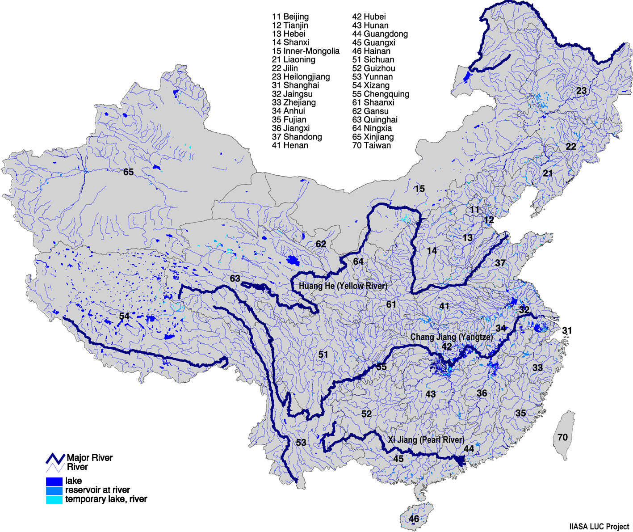

Source: International Institute for Applied Systems Analysis, 1999

In the past, agriculture received priority for water resources, due to the government’s food security policy, and the sector still receives the majority of the water supply (see Figure 2). However, the rapidly growing urban population and the expanding industrial sector, aided by an economic growth policy instituted by the government, have changed the dynamics of water usage. Urban and industrial consumers are rapidly increasing their water demands and the government is slowly increasing the supply allotted to these two sectors.

Figure 2:
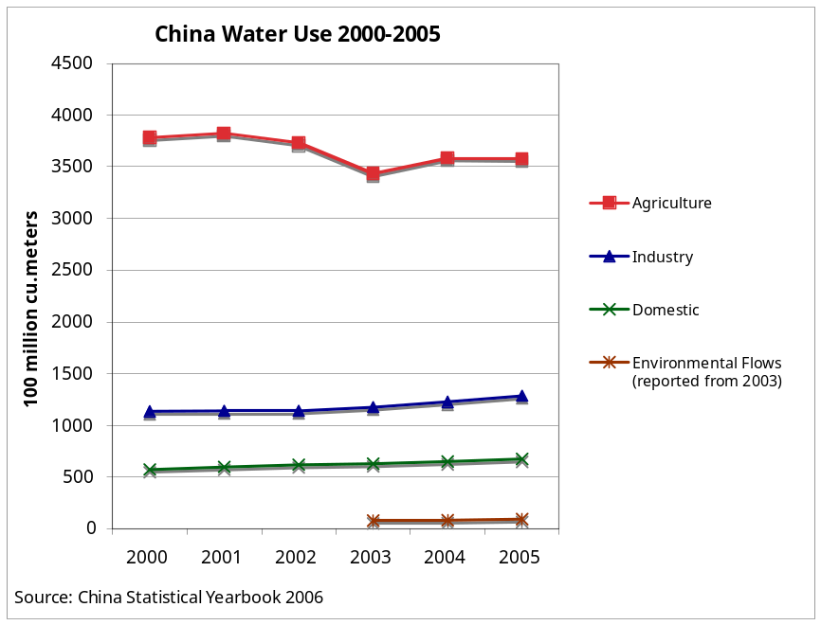

Water resources played a pivotal role in the incredible increase in agricultural production, economic growth, and rapid development that occurred in China over the last 20 years. The speed in which this growth took place and the lack of government oversight led to the abuse of water resources and the current crisis facing China today: the overexploitation and pollution of water resources.

Groundwater exploitation is the greatest concern as aquifers are being depleted at a faster rate than they can be replenished naturally. Farmers typically dig their own wells and while they must pay for pumping costs (which increase as water levels drop and wells must be dug deeper), they do not pay any additional fees for the actual water used. The lack of a government monitoring system has resulted in groundwater being severely exploited. Surface water is easier to monitor as it typically reaches consumers via an established irrigation district however, regulations and fees are not well established thus, there exist few incentives for farmers and other users to monitor or reduce the quantities used.

The pollution of China’s water resources is also a critical issue. Untreated industrial and municipal water are the main sources of pollutants which severely affect China’s major rivers and, in some areas, ground water supplies. Agricultural inputs, such as fertilizers and pesticides, along with human and animal waste also contribute to polluted water. The government has begun taking pollution seriously with a recent pledge to allocate $200 billion annually towards the environment. An important element in the government’s new efforts must be the enforcement of existing laws against industrial polluters.

Growth in water demand, lack of a sufficient monitoring structure, and a stagnant water supply, all contribute to the overexploitation of water resources. The government is working towards improving water-use efficiency and also, addressing pollution issues. Yet, they face a significant challenge as the food security policy and economic growth initiative are at odds with water conservation and quality protection. Please refer to GAIN report CH8049 Water Situation in the North China Plain for more detailed information.

C- Seeds

Maintaining a stable supply of high quality seeds for major grain crops is a stated priority for China’s relevant government agencies. Though seed and grain price ratios are lower in China than in developed countries due to lower quality varieties which reduces germination rates, seed production was not exempt from inflationary pressure. However, the industry reportedly adjusted quickly. In major grain production regions, farmers have moved past using traded seeds to local hybrids that rely less on agricultural inputs such as water and fertilizer. According to government sources, in 2008 China’s seed production for all major crops met domestic demand, but certain corn high yielding hybrid varieties in the Northeast were in higher demand and experienced record-high prices. Additional demand came from a recently implemented grains subsidy which encouraged corn and soybean production, however by the mid-year many farmers in Northeast China had already opted for rice instead of corn and soy. According to local government sources and seed researchers, there were two major reasons for this development. First, low grain prices and high fertilizer costs were a major disincentive to increasing or maintaining corn and soybean production. Secondly, higher costs for hybrid corn and soy varieties priced out a segment of farmers.

D- Fertilizer

I. Current Market Situation

1. Supply

The largest issue facing the production of fertilizer in China is the lack of affordable inputs. The universal rises in input costs have suppressed Chinese companies’ ability to produce fertilizers at a reasonable price. There are a number of reasons attributed to this global trend. The main influencers include increasing competition for scarce fertilizer inputs by developing countries and the world-wide rise of oil prices. Analysts remain uncertain whether the recent drop in crude oil prices (under $70/barrell) will relief some of this pressure. In order to suppress further increases in prices in the short term, the government of China (GOC) has implemented a series of price control policies and requires fertilizer producers to report any changes in their selling price for urea, phosphate, and compound fertilizers.

The surge in fertilizer price has sent shockwaves throughout the industry, forcing many smaller to middle size producers to shut down, or be acquired by larger companies. This consolidation is supported by the central government, as an incentive, hoping that larger companies will bring stability and consistency to an inefficient and sporadic market that has traditionally depended on strong government support.

Fertilizer manufacturing in China is small scale, scattered, and currently not centralized. Numerous small scale producers, whose product is sub-standard and poorly understood by farmers, have proliferated across the country side and sell their product for a fraction of the cost of large domestic and foreigner brands. Major producers within China have begun to absorb these “back-yard” producers as the industry loses affordability, and created education programs with the assistance of China’s Ministry of Agriculture (MOA).

Major production centers in China for fertilizers are located in Hunan, Guizhou, Sichuan, Hubei, Qinghai, and Shandong provinces. The ability to produce goods for the common farmer, in a world of sky-rocketing prices, is an obstacle to China’s fertilizer market. Price control policies keep the price of fertilizers lower than the world price: stifling investment and profitability and discouraging new market entrants. Although fertilizer producers receive no direct subsidy, they do enjoy sizeable discounts on energy inputs (such as electricity), transportation, production inputs (such as natural gas and oil), and other necessities. A 100 to 135 percent export duty was levied from April 30 until the beginning of September 2008, after which the GOC extended the duty until the end of December. Even with these measures, there is still a collective discontent among farmers because their real income is decreasing, amidst record high grains prices worldwide. China’s farmers can not capitalize on high grains prices as long as price supports and export controls for grains remain in place.

In the last two years, China has suffered a number of recent natural disasters that include flooding, snow storms, and earthquakes. Some producers report that while distribution networks have been disrupted, there has been no additional impact on the fertilizer industry as a whole. However flooding and heavy rains, which hit South China this year, will require farmers to apply additional amounts of fertilizer to the land.

2. Consumption

The erratic nature of China’s fertilizer industry makes observation of distribution networks difficult. Major producers are located in the urban east and use differing methods to market their products to consumers. Most of the large companies manage their own facilities in production regions and sell directly to farmers using their own staff, while smaller producers often opt to use middlemen to facilitate reaching out to remote or rural communities. In most rural areas, deliveries of fertilizer may be sold directly from the back of a truck with little formality.

The vast majority of fertilizer produced in China is destined for domestic use, and much of it is destined for the northern part of the country, for use in grains and oilseeds production. The GOC keeps a massive storage of grains, known as a State Reserve, and places the maintenance of this stock as a top national food security priority. This practice indirectly stimulates the market by adding to the already huge demand for fertilizer usage. The GOC’s goal of self sufficiency in grain production has exacerbated the inflation of fertilizer prices as farmers try to increase yield on shrinking acreage and mismanaged or improperly rotated land that require larger amounts of nitrogen inputs.

Demands by the rising middle class in urban areas of China and environmental policies have created a growing niche for organic fertilizers. Growers wishing to produce a high value crop for the domestic or export market have begun to sprout in different parts of the country. These growers are still a small minority, though, as the price of high value and organic fertilizers are well above that of most farmers’ budgets.

- Imports
China must supplement its domestic raw materials for fertilizer production with lower cost imports to meet its massive demand. Potassium-based fertilizer imports alone rose from 15 billion lbs in 2006 to almost 20 billion lbs in 2007. This is placing fertilizer producers in a bind as they must maintain their price, due to strict price control policies, as their necessary production inputs become increasingly expensive. China’s domestic cost of consumption is artificially low, a direct result of government subsidies, making many Chinese producers reluctant to enter into production agreements or invest in the building of new plants in foreign countries, where the cost of production is much higher.

Table 1

Top Five Countries Exporting Fertilizers to China, in Millions $
Rank | Country | 2005 | 2006 | 2007 | 2005 | 2006 | 2007
 |  |  |  |  | Market | Market | Market
 | --World-- | 3,051 | 2,485 | 2,907 | % | % | %
1 | Russia | 1,300 | 1,051 | 1,134 | 43 | 42 | 39
2 | Canada | 492 | 312 | 653 | 16 | 13 | 22
3 | Belarus | 347 | 285 | 384 | 11 | 11 | 13
4 | Israel | 110 | 63 | 197 | 4 | 3 | 7
5 | United States | 446 | 337 | 121 | 15 | 14 | 4

b. Exports

In the beginning of 2008, the GOC enacted a duty on fertilizer exports to maintain stable prices during the main growing season. A duty, of 100 to 135 percent, was originally implemented place from April 30 through September 30, 2008, but the GOC has extended the duty until the end of December and increased the tax to 150 percent. The tax was also extended to cover certain animal and plant based fertilizers, with the exception of guano. The duty covers most fertilizers, but does not include organics or high value fertilizers. Producers indicated that they did not see much change in their business models after the duty was implemented: most of their product was already geared towards domestic use for this season. Some speculate that, in the future, the government will implement a seasonal phase mechanism, by which the government will dictate different export duties depending on the quarter of the year. Some analysts believe that certain fertilizers, such as urea, might be singled out, if prices continue to grow, and be placed under tariffs exceeding the 150 percent already in place.

Figure 3
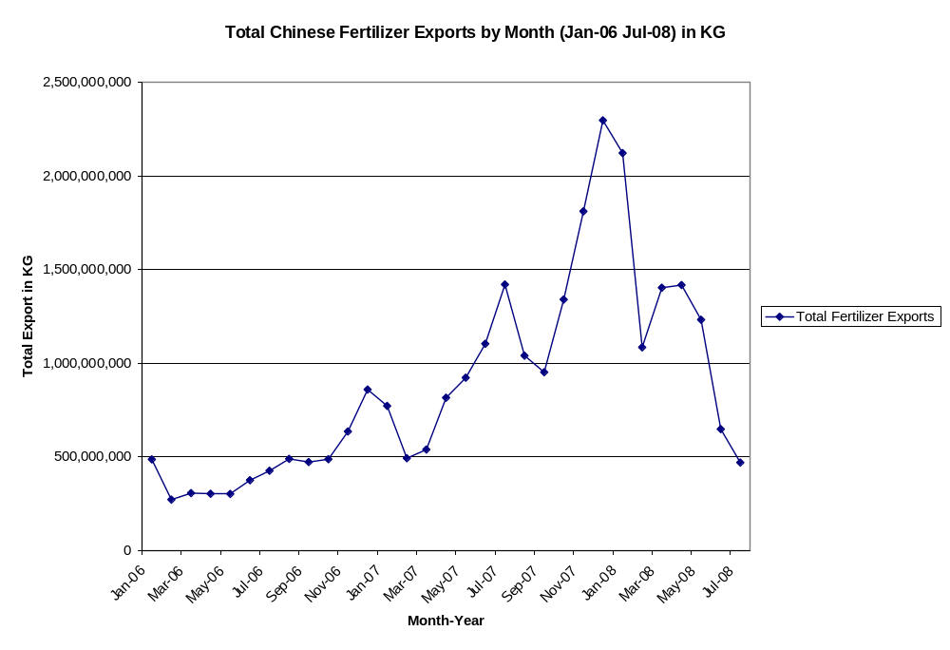
(Source: China Customs; Composed of HS Codes: 3101, 3102, 3103, 3104, and 3105)

Figure 4
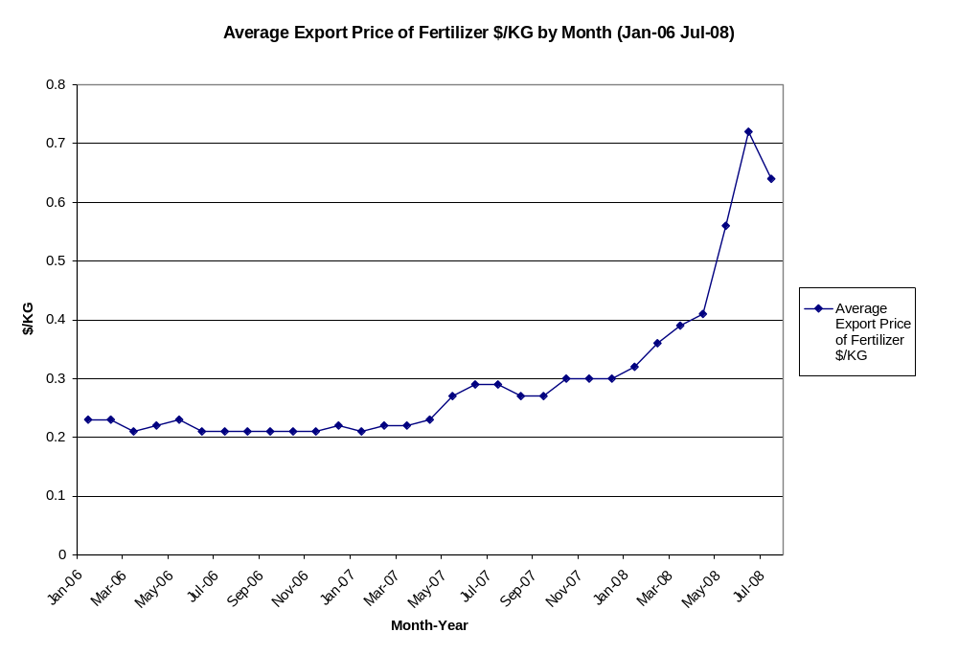
(Source: China Customs; Composed of HS Codes: 3101, 3102, 3103, 3104, and 3105)

II. Future

1. Expansion and Environmental Protection

Growth in China’s fertilizer production will be restrained by low domestic prices (compared to international prices) and environmental policies that discourage output and halt new construction of production facilities. There still is a possibility for large amount of growth, through the reduction of production costs, as the largely inefficient sector becomes increasingly consolidated and economies of scale begin to take affect. While companies may wish to expand their operations, industry sources indicate that to do so at this point may not be profitable. Not all companies are producing at peak capacity, and government subsidy policies restrict Chinese producers from investing in foreign businesses.

There is a real potential for growth in the organics and high value sector, as the GOC has taken a keen interest in this area. Currently, there is no specific subsidy to promote organic or high value fertilizer production, but subsidies are given to farmers that prove their plots of land are grown organically. The market is very much consumer driven and technology is helping companies to create higher quality, environmentally friendly fertilizers. Producers are beginning to invest in controlled release and fertilizer/pesticide mixes in an effort to help offer the highest quality to the farmer. Organic and high value fertilizer producers are optimistic that the central government will begin to pay greater attention to them in the future.

- Counterfeit and Misused Products

A thorn in the side of the fertilizer industry in China for some time has been the use of counterfeit or low quality fertilizers. Unfortunately this trend has increased with the recent rise of fertilizer prices, unleashing a crackdown by government officials and industry members. There have also been claims of less-expensive Chinese fertilizers being smuggled out of China to be sold in neighboring countries.

The industry, with the help of the MOA’s extension service, has taken a stance to promote education about fertilizers in rural communities. Experts and industry staff are being sent into the field to teach farmers the proper use and dosage of fertilizers in an effort to improve the profitability of the farmer and protect the environment.

E- Pesticides

I. Current Market Situation

- Supply

In 2007, China’s pesticide production was estimated at 1.7 million metric tons (MMT), a 24- percent increase over 2006. China took over the United States in 2007 as the largest pesticide producing-country (National Bureau of Statistics of China (NBS)). Within China, Jiangsu, Zhejiang, and Shandong provinces produced the largest amount of pesticides.

Of the three major pesticide groups: insecticides, fungicides, and herbicides, herbicides experienced the largest growth rate. In 2007, herbicide production was 0.5 MMT, a 32-percent increase over 2006. Table 1 shows the 9 major types of herbicides and the 16 different varieties produced in China. Insecticide production was estimated at 0.6 MMT and fungicide production was estimated at 0.6 MMT.

According to an announcement issued by the Ministry of Agriculture (MOA) on January 1, 2007, production of 5 types of insecticides is now illegal: methamidophos, parathion, parathion-methyl, monocrotophos, and phosphamidon. The move is associated with the greater attention paid by the MOA on food safety and environmental issues. Out of China’s total pesticide output, high-value bio-pesticides accounted for about 9 percent of the total, much higher than other producing countries (excluding pesticides produced using transgenic techniques).

In 2008, China suffered several major natural disasters that included: snow storms, earthquakes, and heavy rainfall. In early June, nine provinces (Zhejiang, Anhui, Jiangxi, Hubei, Hunan, Guangdong, Guangxi, Guizhou, and Yunnan) in southern China suffered serious damage to crops due to heavy rainstorms and water logging. Vegetable and other horticulture crops were hit especially hard. After continuous rainfall and water immersion coupled with high temperatures and humidity, disease and pest outbreaks are increasing in the regions and will add greater pressure for disease and pest control.

The impact of the winter storms on crops was significantly higher in 2007/2008 because of the devastating record snowfall that covered almost all the provinces in southern China (Hunan, Hubei, Jiangsu, Zhejiang, Anhui, Jiangxi, Henan, Guangxi, Chongqing, Sichuan, Guizhou, Yunnan, Shanxi, Gansu, Qinghai, and Xinjiang). Some agricultural experts suggested that even though frost injury caused serious damage to crops, the loss to diseases and insects would be less, due to colder temperatures.

Table 2:
Herbicide Form of application | Herbicide variety
可湿性粉剂  Wettable powder  颗粒剂  Granules  水剂  Water agent  可溶性粉剂  Soluble powder  乳油  Emulsifiable concentrate  悬浮剂  Suspension concentrate  浓乳剂  Concentrate emulsion  熏蒸剂  Fumigant  片剂  Tablets | 苯氧羧酸类  Phenoxy carboxylic acid  苯甲酸类  Benzoic acid  芳氧苯氧基丙酸类  Aromatic-phenoxy-propionicacids  环己烯酮类  Cyclohexyl-ketene  酰胺类  Amides  取代脲类  Disubstituted urea  磺酰脲类  Sulfonylurea  咪唑啉酮类  Imidazolinone  三氮苯类（三嗪类）  Triple-N-Benzene  氨基甲酸酯类  Carbamate  硫代氨基甲酸酯类  Thiocarbamate  二苯醚类  Diphenyl Ether  N-苯基肽亚胺类  N-phenyl peptide imine  二硝基苯胺类  Dinitroaniline  有机磷类  Organophosphorus  联吡啶类  Bipyridyliums  其他  Others
(Source: China Weed Network)

2. Consumption
China is a major pesticide consumer and domestic pesticides are mainly consumed in southern China, especially in Guangdong, Fujian, Jiangsu, Zhejiang, Jiangxi, Hunan, Hubei, and Shandong provinces. Due to abundant rainfall, summer typhoons, and long planting season, there is a greater occurrence of insect and disease outbreaks in south China. In the north and west of China, pesticide production is on a relatively small scale and scattered with consumption estimated at 10 percent of the national average.

Insecticides are used more than herbicides and fungicides in southern China, especially in Jiangsu, Zhejiang, and Hunan provinces where large-scale rice planting areas need four to five applications of insecticides and only one application of herbicides before planting. The provinces in northern China, Heilongjiang, Inner Mongolia, and Xinjiang, require large amounts of herbicides, due to their large-scale crops operations, but require fewer insecticides because of their more temperate climates.


Heilongjiang
Jilin

Liaoning
Hebei
Shandong
Anhui
Hubei

Guangxi
Henan
Gansu
Xinjiang
Jiangsu

Beijing

Figure 5: Pesticide Production and Consumption

Wei Fang Agrochemical Industry Park
Inner Mongolia

Zhejiang
Fujian

Guangdong

Hunan

Jiangxi

Ru Dong Agrochemical Industry Park
Herbicide

Fungicide

Insecticide

Increasing bio-pesticide use is a central government priority. Research is focused on developing high efficiency and low residue pesticides. However, despite government bio-pesticide support, farmers are reluctant to change. Most farmers continue to favor conventional chemical pesticides due to their lower price, easy application, and effective use. Bio-pesticide consumption was only 1 percent of total pesticide consumption in 2007 and was mainly consumed in large cities and organic agriculture parks, or exported to international markets.

- Imports

In 2007, China imported 0.3 MMT of pesticides, a 28-percent increase over 2006 (Figure 2), with a value of $1.5 billion (Table 2). Nitrile-Function Compounds, and Heterocyclic Compounds With Nitrogen Hetero-Atom were the largest volume pesticides imported largest pesticides, at 83,132 tons and 78,837 tons, respectively. Japan and South Korea were the largest volume exporters to China. In 2007, the trade volume from Japan reached $133 billion and from Korea $104 billion. As a result of low domestic research capacity and large demand, many companies import high grade insecticides. A large percentage of the imports are reprocessed, sometimes blended with domestically-produced pesticides or watered down, before they reach the end consumer.

Figure 6:

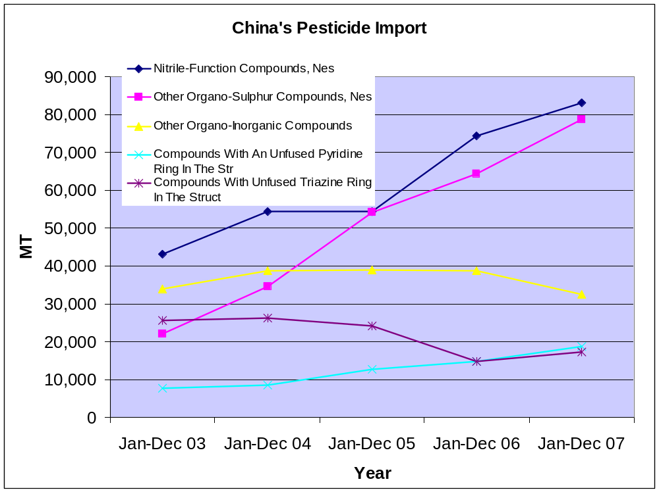
China’s Pesticide Imports

- Exports

In China, there are more than 2,000 pesticide producers and over 600 different varieties. In this report, 20 pesticides described in Table 3, were selected as a representative group for export data (insecticides, fungicides, and herbicides). Pesticide exports have increased significantly since 2006. Chemical pesticide exports are estimated at 1.2 MMT. In 2007, for the first time, China’s herbicide exports exceeded 0.2 MMT, due to strong global demand for herbicides and small-scale domestic consumption. Some of the herbicides produced in China, such as glyphosate (HS 29310000 41), are mainly produced for export.

Table 3:
HS | Description
29310000 | Other Organo-Inorganic Compounds
29339900 | Heterocyclic Compounds With Nitrogen Hetero-Atom(S
38089319 | Herbicides, Not Put Up For Retail Sale,Nes
29349990 | Other Heterocyclic Compounds, Nes
29329990 | Other Heterocyclic Compounds With Oxygen Hetero-Ato
29333990 | Compounds With An Unfused Pyridine Ring In The Str
29309090 | Other Organo-Sulphur Compounds, Nes
29242990 | Cyclic Amides & Derivatives; Salts Thereof, Nes
29336990 | Struct
29322900 | Lactones, Nes
29269090 | Nitrile-Function Compounds, Nes
29189900 | Carboxylic Acids With Othr Oxygen Function, Etc, T
38089290 | Fungicides, Not Put Up For Retail Sale,Nes
38089311 | Herbicides, Put Up For Retail Sale,Nes
29162090 | Cyclanic, Cyclenic / Cycloterpenic Monocarboxylic
29302000 | Thiocarbamates & Dithiocarbamates
38089210 | Fungicides, Put Up For Retail Sale,Nes
38085090 | Chapt
29201100 | Parathion (Iso) & Methyl-Parathion(Iso)
38085010 | Goods Specified In Subheading Note 1 To This Chapt
Figure 7
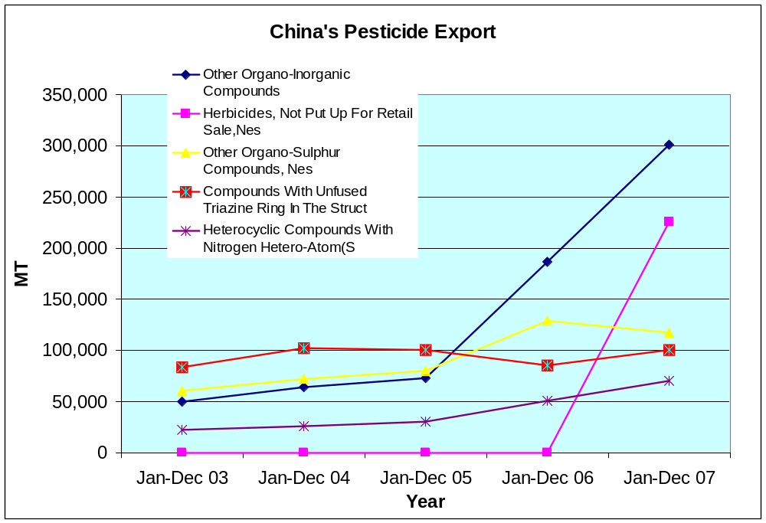
China’s Pesticide Exports

In 2007, the United States, India, and Argentina were the three largest importing countries. The United Stated was the top buyer, valued at $799 million, a 74-percent increase over 2006. India and Argentina imports totaled $495 and $382 million respectively. In 2007, China’s pesticides exports to the world totaled $5.8 billion.

Table 4

Top Importers of Chinese Pesticides in Millions $
Rank | Country - | Jan-Dec 2003 | Jan-Dec 2004 | Jan-Dec 2005 | Jan-Dec 2006 | Jan-Dec 2007
0 | --World-- | 1,057 | 1,356 | 1,838 | 3,024 | 5,800
1 | United States | 140 | 213 | 275 | 459 | 799
2 | India | 82 | 132 | 213 | 346 | 495
3 | Argentina | 21 | 33 | 31 | 134 | 382
4 | Japan | 68 | 97 | 158 | 190 | 270
5 | Germany | 62 | 70 | 101 | 156 | 239
6 | Israel | 21 | 29 | 37 | 102 | 219
7 | Thailand | 10 | 14 | 20 | 39 | 209
8 | Brazil | 31 | 52 | 71 | 99 | 168
9 | S. Korea | 45 | 67 | 79 | 106 | 161
10 | Spain | 106 | 59 | 86 | 92 | 151
Source: China Customs

II. Future

In 1997, the State Council of China released the “Pesticide Management Regulation, PRC”, and in 1999, MOA released the “Implementation Measures to the Pesticide Management Regulation, PRC.” These two edicts are the main guiding polices for the pesticide industry.

In China, even small-scale producers have the opportunity to compete with large-scale, high quality producers. These farmers represent small and diverse groups of consumers. Smaller, poorer farmers will typically purchase low-priced, low-quality pesticides where as mid-to-large-size farmers will purchase from large, well-known producers in bulk. Smaller farmers are vulnerable to poor quality pesticides because they posses limited knowledge about the industry and are largely unaware of substandard goods including, counterfeit or low quality products. The MOA and the industry recently acknowledged that the pesticide market was dysfunctional and inefficient. They recognized the lack of enforcement of national quality standards which would maintain the numerous and scattered producers. MOA issued “The Pesticide Label and Guide Management Measures” in December 2007 and began implementation in January 2008. The measures were set in response to fake pesticide production that seriously affected the entire industry along with farmers’ profit margins. MOA ceased authorizing trade names for product brands as of January 2008; all pesticides are forbidden from using a brand name in lieu of the common or scientific name.

The pesticide industry is diverse and the majority of production occurs on a small-scale basis. Limited research capability and thin profit margins intensify competition. Non-consolidated factories may soon be forced out of the open market, while some domestic companies are receiving government support as an incentive to merge. In Weifang, Shandong province, and Rudong, Jiangsu province, two large-scale agrochemical industry parks were constructed by the Crop Protection Industry Association in cooperation with the local government to push the pesticides industry to integrate and become more efficient producers. The recent average 10 percent price increase for pesticides is also stimulating government involvement as any type of input price increase will have an immediate, negative impact on farmers’ incomes.

F- Conclusions
A major concern in China’s agricultural sector is ensuring that price increases to inputs appreciate proportionally with domestic grains prices. The impact of pricing agricultural outputs at low levels while allowing the price of agricultural inputs to rise at market rates creates asymmetrical disincentives that will maintain subsidized production and will preclude a stable growth in yearly production. Not only are farmers shifting crops from year to year based on subsidy amounts but they are also hedging risk by double and triple cropping instead of consolidating production to maximize total use of land and the economic returns from scaled production. Grain support policies are having long term implications to China’s national food security and rural economy. Since mid-2007, mostly due to shortages in the world fertilizer market and higher oil prices, agricultural input prices surged at a faster pace than grains prices. During this period, grains prices were being moderately contained through central government controls. With a mounting producer price index (PPI) appreciating at a precipitous pace, the GOC scrambled to offer protection to the supply side of China’s agriculture: the rural sector.

Farm subsidy programs are designed to influence planting intentions. However, some farmers planting decisions are not necessarily made based on determining which crop will yield the highest return but on what they can afford to produce after the subsidy and how useful the crop is the farmer’s survival. For example, generally speaking, corn farmers in northeast China will not be shifting away from corn production because households rely on the corn stalk and other agricultural waste as a feedstock for heating their homes during the winter. However, the agricultural production pipeline has demonstrated its might in absorbing inflationary pressures originating from rising fuels costs that impact transportation, processing, and overall marketing; the added burden of rising input costs is also a debilitating factor. During the spring planting season compound fertilizer (N, P and K) prices appreciated by up to 70 percent for most products nationwide and although oil prices have recently dropped entering into the final quarter of 2008, there is no indication from the market that fertilizer prices will decline in the near future. However, given a recent 10-percent increase to the grain floor price, there are still strong incentives in place to sustain annually double digit increases in grain production. This should explain why despite this sharp increase in price, most grains farmers did not reduce the use of fertilizers/ha.

Bibliography

Ding, Chengri. 2003. Land Policy Reform in China: Assessment and Prospects. Land Use Policy. Volume 20 p. 109-120.

Lin, George C.S. and Ho, Samuel, P.S. 2003. China’s Land Resources and Land-Use Change: Insights from the 1996 Land Survey. Land Use Policy. Volume 20 p. 87-107.

Lohmar, Bryan. 2006. Feeling for Stones but Not Crossing the River: China’s Rural Land Tenure after Twenty Years of Reform. Chinese Economy. Volume 39, Number 4 p. 85-102.

