NATIONAL SCIENCE FOUNDATION
Directorate for Engineering

Making the Case for Engineering

Study and Recommendations



“An opportunity to improve and better position engineering to ensure that innovation continues to improve our safety, health, and economic prosperity.”

NATIONAL SCIENCE FOUNDATION
Email: engcase@nsf.gov

Making the Case for Engineering

Contents Page

I. Introduction 3
II. Charge to Task Force and Methodology 7
III. Executive Summary 8
IV. Building Public Support for Engineering 9
- The Current State of Public Understanding 11
- Conclusions 16
VI. Recommendations and Action Plan 17
VII. Next Steps 21
VIII. References 22

Appendix Documents Attached to this Document
1. Get ENG’s Communities Involved 24
2. Better Focus ENG’s Portfolio 27
3. Partnerships 29
4. Effectively Serving the Engineering Community 31
5. NAE Study 35

Appendix Documents Available on Public ENG Drive
1. PowerPoint Slides
2. Survey NSF, PD, Outside Communities
3. Brown Bag Lunch Minutes and Presentation by Marshall Lih
4. NAE Proposal on Messaging

CASE Task Group
Cheryl Albus
Fil Bartoli
Charles Blue
Ken Chong (Chair)
Delcie Durham
Darren Dutterer
Bruce Hamilton
Sue Kemnitzer
Glenn Larsen (Secretary)
I. Introduction: Engineering Innovation

Throughout the last century, the United States has remained the world leader in basic research and innovation.

Over that time, bold investments have catalyzed our nation’s capacity to innovate, producing remarkable advances in communications, health care, information technology, transportation, and infrastructure. These innovations continue to improve our quality of life.

As we move through the 21st century, engineering innovation will continue to be of unmatched value to our nation, particularly in areas of security, job creation, and environmental stewardship.

The National Science Foundation (NSF), through its Directorate for Engineering (ENG), is a major contributor to advancing engineering innovation in the United States. ENG does this by serving as the principal source of federal funding for university-based fundamental engineering research, providing over 42 percent of the total federal support in this area. ENG also focuses its investments in critically important areas for today's needs—such as nanotechnology, bioengineering, information and communication systems, homeland security, environment and earthquake engineering, smart and engineered materials, sensors and control systems, and manufacturing frontiers. ENG also supports the Small Business Innovation Research (SBIR) and Small Business Technology Transfer (STTR) Programs, which address important scientific, engineering, or science/engineering education problems.

To ensure the continued pace of engineering innovation, ENG also invests in the development of a U.S. engineering and technical workforce to maintain leadership in an increasingly competitive global environment.

The ability of the United States to retain this preeminence in innovation, however, is not guaranteed. Current and projected federal budgets suggest a flat or even declining trend in funding for non-medical science and engineering research. While other nations -- particularly China, India, Japan and the European Union -- are increasing their investments in these vital areas.

The impact of these disparities is compounded by the fact that the public – whose support is mandatory for a national environment that fosters innovation – does not adequately understand the role of engineering in advancing our nation.

To address this concern, John Brighton, the NSF Assistant Director for Engineering, established a task force to "Make the Case" for engineering in August 2004 to highlight the importance of engineering innovation, and its role and impact on the U.S. economy, national security, and quality of life.

ENG and the engineering community face major hurdles in accomplishing this goal. One of the greatest obstacles is the “disconnect” between engineering innovations and the people who use, rely on, and prosper because of them. Additionally, research demonstrates that the general public is not well aware of the nature of the engineering profession and its impact on quality of life, even though engineering has compelling success stories to tell.
Greatest Engineering Achievements CNN/Lemelson MIT
of the 20th Century[NAE 2001] Top 25 Innovations
1. Electrification 1. The Internet 21. Nanotechnology
2. Automobile 2. Cell Phones 22. Flash Memory
3. Airplane 3. Personal Computers 23. Voice Mail
4. Water Supply and Distribution 4. Fiber Optics 24. Modern Hearing Aids
5. Electronics 5. E-Mail 25. Short-Range, High
6. Radio and Television 6. Commercialized GPS Frequency Radio
7. Agricultural Mechanization 7. Portable Computers
8. Computers 8. Memory Storage Disks
9. Telephone 9. Consumer Level Digital Camera
10. Air Conditioning and Refrigeration 10. Radio Frequency ID Tags
11. Highways 11. MEMS
12. Spacecraft 12. DNA Fingerprinting
13. Internet 13. Airbags
14. Imaging 14. ATMs
15. Household Appliances 15. Advanced Batteries
16. Health Technologies 16. Hybrid Cars
17. Petroleum and Petrochemical Technologies 17. OLEDs
18. Laser and Fiber Optics 18. Display Panels
19. Nuclear Technologies 19. HDTV
20. High-performance Materials 20. Space Shuttle

Figure 1

The Great Achievements project and the recent Lemelson-MIT/CNN Innovations program provide numerous, well-recognized examples of engineering’s pervasive impact on society [Figure 1]. These and other outreach programs, announcements, and efforts certainly help to communicate select elements of engineering, but as with many public relations activities, after the initial “splash” of an announcement the impact fades.

Beyond the broader understanding of engineering, NSF and ENG also need to communicate their role and impact on advancing the U.S. engineering and innovation enterprise.

ENG success stories of this impact do exist, such as the Civil and Mechanical Systems Division's (CMS) grantee and 2003 Nobel Laureate Paul C. Lauterbur, whose pioneering work on Magnetic Resonance Imaging [Figure 2] has had profound impact on the health of this nation and the world. There are many more examples, large and small.

It may be, however, that the most compelling messages will not come from our past successes, but from the potential to improve our lives in the future through new technology and new engineering innovations.
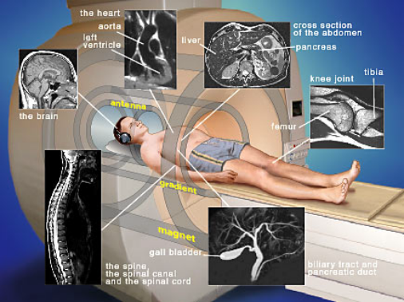
To highlight the timeliness of this effort, the Making the Case report comes at a time when other related reports and recommendations from the U.S. science and engineering community have been, or are in the process of being issued by such leading institutions as the National Academy of Engineering and the Council on Competitiveness. These are:
Figure 2: MRI

The Engineer of 2020: Visions of Engineering in the New Century [NAE, 2004], which centers on envisioning future scenarios, and determining what sort of education engineers will require to address them.

Innovate America: National Innovation Initiative Report [Council on Competitiveness, 2004], which recommends programs to ensure the talent, investment, and infrastructure necessary for the United States to continue to excel in innovation on a global scale.

Assessing the Capacity of the U.S. Engineering Research Enterprise: Preliminary Report for Public Review [NAE Draft, 2005], which recommends specific programs on a local and national level the United States should embrace, particularly Discovery-Innovation Institutes.

Each of these reports highlights fundamental challenges that have to be overcome before we can hope to advance engineering in the United States, and not the least of which is a lack of appreciation for what is engineering, how is it distinct from science, and what is its impact on the U.S. economy and quality of life. These concepts may be considerably more difficult to communicate than success stories, since there are no accepted definitions, even within the engineering community. Additionally, there is a dearth of research on what messages and programs will help make the case with our target audiences.

It is clear that ENG and the engineering community must make a more effective case for the promise of engineering research, education, and investment. This report attempts to address this by providing a flexible framework that can be utilized as ENG moves forward with its strategic planning process.

This need can be summed up in the words of Craig Barrett, CEO of Intel and NAE chairman: "We are not graduating the volume [of scientists and engineers], we do not have a lock on the infrastructure, we do not have a lock on the new ideas, and we are either flat-lining, or in real dollars cutting back, our investments in physical science. The only crisis the U.S. thinks it is in today is the war on terrorism. It’s not!”

II. Task Force Charge and Methodology

The Task Force was initially directed to prepare an action plan to enable ENG to better define and communicate its role in serving the nation, NSF, and the engineering community by addressing the following issues:
- How can we better educate the general public and policymakers about the role of engineering and ENG?
- How can we get the engineering communities (in government, academe, and industry) to help make the case for moving ENG forward?
- How can we better focus ENG's portfolio of funding of research and education in order to move ENG forward? (Review the current portfolio to see if we can bring better focus on certain problem/opportunity areas.)
- What partnerships are needed in order to move ENG forward?
- Are the engineering communities being effectively served by NSF? If not, what needs to change? How can we better communicate with them?

Based on feedback from the Assistant Director for Engineering, the charge was modified to reflect an “outreach” oriented approach. The task force prepared an action plan that communicates the value and impact of engineering innovation to the nation. The report also presents specific strategies that communicate ENG's role in supporting innovation that advances our safety, health, and economic prosperity. The report specifically addresses how the engineering communities can help make the case for engineering, and what partnerships (i.e. media partners, the science community, engineering societies, science centers, etc.) are necessary to communicate most effectively. Key elements from the first draft are included in the report appendices for reference and as a resource.

Under a very tight schedule, the following tasks have been accomplished:
- Each Task Force member led one or more major segment of this report.
- Input was sought from all ENG, other NSF directorates, engineering deans, university presidents, industry leaders, NAE members, professional societies and others.
- A brown bag lunch discussion involving 24 professional members from ENG was held.
- Numerous reference books and reports were reviewed. Selected findings are included in this report.
- The ENG AdCom helped to further refine the report.
- The DRAFT report was presented at the ENG AdCom and EMT meetings.
- The DRAFT report was circulated among other members of the Directorate Management Team for in-depth review and comment.
- A revised draft was prepared reflecting a more focused charge.
III. Executive Summary

The reasons for making the case for engineering are clear and compelling. First, engineering drives our economy; it builds the foundation for a prosperous and secure future. Second, the engine of engineering innovation does not run solely on the value of its contributions to society; it requires a committed and active public and private investment. It also requires a strong educational foundation and a world-class workforce. Finally, the public awareness and understanding of engineering – its process and its impact – are not well understood by the public. This final point hinders our nation’s ability to adequately attract a diverse, world-class engineering workforce, and to enact the bold programs necessary to ensure our continued leadership in engineering innovation.

This task force answers its charge in two ways: first, by making recommendations on what internal changes (cultural and programmatic) the NSF and ENG should undertake to help make the case within NSF, throughout the engineering community, and to the public. It also makes recommendations on how it can catalyze and support external activities that will have a broad, long-term impact on the public understanding and awareness of engineering innovation.

A common theme to both the internal and external recommendations is the clear understanding that a unified message and approach across all sectors of engineering is vital to ensure the ultimate success of these efforts.

Internal Recommendations

- Develop a formal mechanism to support Public Understanding of Engineering programs within ENG
- Support and expand linkages with the Office of Legislative and Public Affairs
- Ensure NSF adopts the terms “engineering” and “innovation” appropriately and pervasively
- Work with SRS to ensure engineering is addressed specifically in attitude surveys
- Expand NSF-communications through ENG Distinguished Lecture Series
- Make “outreach” a stronger element of the “Broader Impacts” section of proposals.

External Recommendations

- Fund research on how to improve the public understanding of engineering through messages and outreach programs
- Sponsor workshops and conferences on public understanding to help unify engineering community behind messages
- Support and catalyze engineering community-wide outreach activities and cultivate a young, exciting “voice” or spokesperson for engineering
- Work with engineering societies to promote engineering with a unified voice
- Work with engineering community to communicate and promote the recommendations from (Engineer of 2020, Innovate America, Assessing the Capacity)
- Catalyze effort to add “engineering” as a formal category for the Nobel Prize

IV. Building Public Support for Engineering

The public understanding of engineering is a critical and growing concern for engineering research, engineering education, and the progress of engineering innovation in the United States.

Recent reports by the Council on Competitiveness and the National Academy of Engineering echo longstanding concerns that the United States is in jeopardy of falling behind other nations economically and technologically, and that our nation’s capacity to innovation is being challenged.

Many developing countries (e.g., China and India) are now educating excellent engineers, and in large quantities. [Workforce Report, NSF/ENG, 2005]
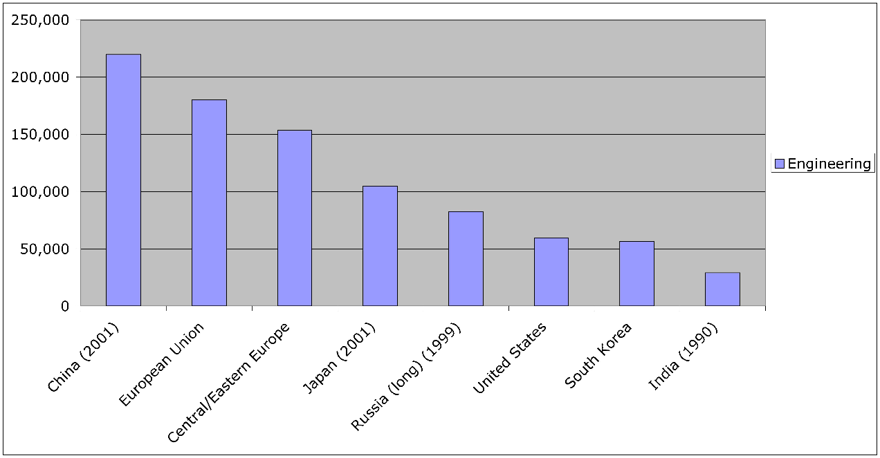
Figure 3: Engineering degrees granted by country [NSF, 2004]

These data reinforce one of the assertions of the Council on Competitiveness’ report on innovation, which reads: “While we remain the world’s leader, the capacity for innovation is going global… .” The report also states that sustaining our competitive advantage will require “innovating continuously on a global basis.”

This report and others recommend bold new programs that could turn the tide and reinvigorate the U.S. engineering innovation enterprise. But, they also acknowledge that to move these bold programs forward, the United States requires broad public understanding and support for engineering innovation. As noted in the DRAFT NAE report on innovation, “… as the American public comes to understand the importance of leadership in technological innovation to national economic prosperity and security, the committee believes bold initiatives of this magnitude could be given a higher priority in the federal budget process, just as funding for biomedical research was doubled in the 1990s” [NAE, Draft 2005]. Public understanding, therefore, is the linchpin in moving engineering forward and preserving the U.S. global leadership in innovation.

Public understanding is also seen as critical to developing and maintaining a world-class engineering workforce. In the Engineer of 2020 report, the NAE notes that, “Encouraging greater understanding of the value of engineering and the contributions it makes to society can help attract undecided students to engineering as well” [NAE, 2004].

This greater understanding may help engineering contend with the fact that the diversity of the profession is far from parity with the population of the United States.

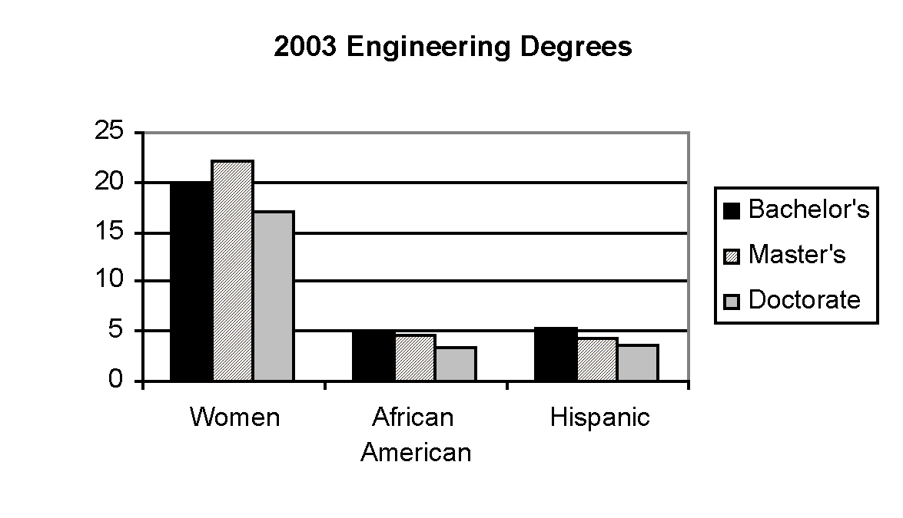
Figure 4: Percentage engineering degrees earned by women, African Americans, and Hispanics in 2003 [NSF 2004]
Women and minorities make up more than two-thirds of the United States’ workforce; yet only represent 23 percent of engineering graduates [NSF/ENG Workforce Report, 2005]. Among the factors contributing to this disparity are: disillusionment with engineering and the lack of interest in the potential lifestyle, and lack of role models [Johnson and Shepperd, 2004].
Engineering, however, can make a solid case for both of these concerns. A recent survey indicates that engineers make up the largest percentage of Fortune Magazine’s top 200 CEOs (Figure 5). Clearly, there are strong, positive messages about lifestyle and role models that can and should be made.
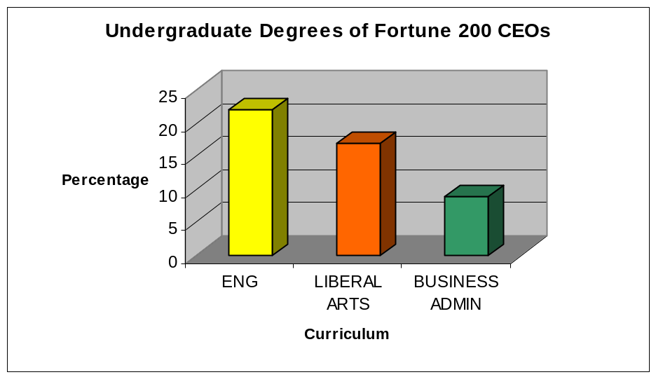
This ties in to the data found in the final report from the Extraordinary Women Engineers project. From a series of focus groups, several questions were asked that shine light on why girls may or may not choose to pursue a career in engineering. Two examples follow:
Figure 5
[Neff and Ogden, 2003]

What do high school girls think about engineering?

High school girls believe engineering is for people who love both math and science. They do not have an understanding of what engineering is. They do not show an interest in the field nor do they think it is “for them.”

What messages is the engineering community sending to high school students?

Current engineering messages portray engineering as challenging and stress the importance of superior math and science abilities. These messages are not relevant for this audience. Messages do not include the benefits and rewards of engineering.

What these results show is that engineering has failed to demonstrate to young women, and perhaps even to the public, an exciting, recognizable face. It also fails to explain the rewards – both financial and life-style – that an engineering career can offer.

V. The Current State of Public Understanding

In 1998 and 2003, the American Association of Engineering Societies (AAES) commissioned a Harris Poll to provide a better understanding of the public’s attitudes toward engineering and engineers.

Among the results from these surveys, the following data, published in 2004, stand out as relevant to our work:

Figure 6: Excerpts from the Harris Poll Indicating the Level of Prestige American’s Impart to Various Professions

 | Very Great | Considerable | Some | Hardly  Any | Don’t  Know
Doctor | 61 | 27 | 10 | 2 | 1
Scientist | 55 | 30 | 10 | 3 | 1
Teacher | 53 | 26 | 15 | 5 | 1
Minister | 46 | 28 | 19 | 7 | 1
Police | 41 | 31 | 20 | 7 | 0
Engineer | 34 | 39 | 22 | 4 | 1
Military Off. | 34 | 36 | 23 | 6 | 1
Architect | 26 | 42 | 26 | 4 | 2
Congressman | 25 | 31 | 26 | 17 | 1
Lawyer | 23 | 30 | 28 | 18 | 1
Athlete | 20 | 28 | 34 | 17 | 0
Entertainer | 19 | 29 | 36 | 15 | 1
Businessman | 18 | 37 | 38 | 6 | 1
Banker | 18 | 33 | 39 | 10 | 0
Accountant | 17 | 33 | 39 | 11 | 1
Journalist | 15 | 33 | 37 | 13 | 1
Union Leader | 16 | 28 | 33 | 22 | 1
Note: Not all percentages add up to 100 because not all respondents answered every question.

It is shown in the research that engineers have a moderate-to-high level of prestige -- though at a level lower than other professions, namely scientists, doctors, teachers, ministers, and police. This is a good data point for certain elements, such as the weight a particular profession’s viewpoint would add to a debate on a topic of national interest. It does not, however, help in understanding why certain people choose a particular profession, or why it is perceived differently by men, women, and minorities.

Certainly, the lower prestige of professions like “Lawyer” does not dissuade people from choosing the legal profession as a career path. Likewise, the extremely high prestige of “Teachers” does not result in an abundance of qualified teachers in the United States. Other factors, such as lifestyle and financial rewards may be of greater impact.

Figure 7: Results of Periodic Polls by Harris Interactive on the Prestige of Various Professions, 1977-1988, Percentage that rated prestige as “very great”
 | 1977 | 1982 | 1992 | 1997 | 1998
Doctor | 61 | 55 | 50 | 52 | 61
Scientist | 66 | 59 | 57 | 51 | 55
Teacher | 29 | 28 | 41 | 49 | 53
Minister | 41 | 42 | 38 | 45 | 46
Police | NA | NA | 34 | 36 | 41
Engineer | 34 | 30 | 37 | 32 | 34
Military Off. | NA | 22 | 32 | 29 | 34
Architect | NA | NA | NA | NA | 26
Congressman | NA | NA | 24 | 23 | 25
Lawyer | 36 | 30 | 25 | 19 | 23
Athlete | 26 | 20 | 18 | 21 | 20
Artist | 21 | 20 | 13 | 19 | NA
Entertainer | 18 | 16 | 17 | 18 | 19
Businessman | 18 | 16 | 19 | 16 | 18
Banker | 17 | 17 | 17 | 15 | 18
Accountant | NA | 13 | 14 | 18 | 17
Union Leader | NA | NA | 12 | 14 | 16
Journalist | 17 | 16 | 15 | 15 | 15

One valuable point from the Harris Poll, however, is shown by tracking prestige over time. As noted here, engineers, even during a time of rapid technological advance and improvements in our standard of living, have not been perceived more prestigiously.

Part of that lack of change may in fact be due to broad misconceptions by the public as to what engineering is, what engineers do, and how engineers contribute to society.

Figure 8: Comparative Perception of Scientists, Technician, and Engineers

 | Scientists | Technicians | Engineers
Invents | 11 | 2 | 2
Builds |  | 10 | 26
Designs/plans | 1 | 1 | 27
Is creative | 3 | 1 | 3
Discovers | 18 | 1
Pioneers | 1
Measures |  | 1 | 1
Works in lab | 8
Conducts research | 11
Equipment repair |  | 15
Works w/ computers |  | 9
Specially qualified in their field |  | 6
Works with Electronics | 5
Train Operator |  |  | 5
Cures disease | 9
Seeks Knowledge | 6
Conducts experiments | 5

This chart demonstrates that the participants think of scientists as inventors and discoverers; of technicians as having specialized equipment-related qualifications; and of engineers as builders, makers, designers, and planners.

Also, most people did not recognize the contributions of engineers to the areas where they have been instrumental: the development of new forms of energy, working in space, and the development of new drugs and medications. In general, scientists were more strongly associated with these activities.

Also shown in the Harris Poll data is the fact that adults do not consider themselves very well informed about or interested in engineering and engineers.
Only one-third of adults consider themselves fairly or very well informed about engineering and engineers, compared to nearly half who would say the same about science and scientists. Similarly, four in ten adults are interested in learning about engineering and engineers, compared to more than half who are interested in science and scientists.

Other studies indicate that most Americans are probably not technologically literate. They have little conception of how science, technology, and engineering are related to one another, and they do not clearly understand what engineers do and how engineers and scientists work together to create technology. Those are the major findings of a recent report issued by the NAE’s Committee on Technological Literacy 2002. In addition, the International Technology Education Association (ITEA) concluded from its 2001 survey that, "adults are very interested in but relatively poorly informed about technology" [NSF Indicators 2004].
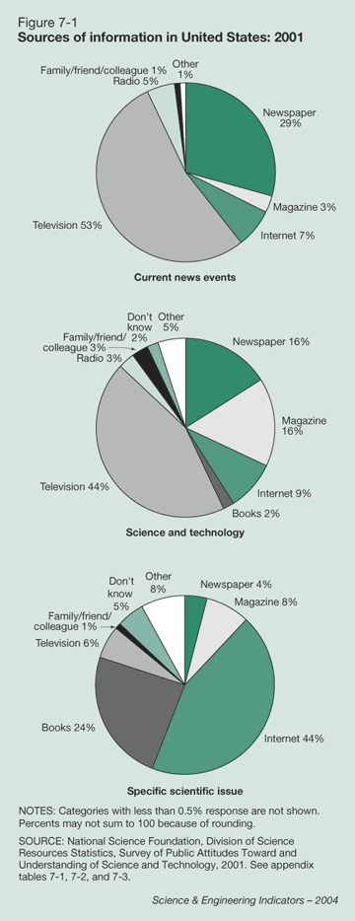
In the ITEA survey, respondents were asked to name the first word that comes to mind when they hear the word "technology." Approximately two-thirds said "computers." Moreover, when given a choice of two definitions for "technology," 63 percent chose "computers and the Internet," whereas 36 percent chose "changing the natural world to satisfy our needs."
A majority of survey respondents (59 percent) associated the word design (in relation to technology) with "blueprints and drawings from which you construct something" rather than "a creative process for solving problems."
These data, however, are of limited value in understanding the public’s perception of engineers and engineering in a broader context. For example, they do not answer questions such as: What does engineering do for me? Do you want to be an engineer; if not, why? Is engineering research as important or more important than medical research? What impact has engineering had on society? What serious problems – environmental, security, health – demand new and innovation engineering solution? (The public may not even understand that engineers are capable of solving these problems.)

Additionally, the surveys do not provide any guidance (such as effective messages or outreach tools) on improving the public awareness and understanding of the impact of engineering. As shown in the 2004 Science and Engineering Indicators report (Figure 9), the public clearly relies on television for its general information on science and engineering, though the Internet has emerged as the leading information source for specific questions. This clearly demonstrates that not all outreach is equally effective in reaching the broadest audiences and having the most significant impact. If engineering wants to have meaningful impact, it will have to understand how the public receives their information, along with the messages that best connect to their needs and wants.
Figure 9

Even without such guidance, however, the engineering community continues to maintain an active outreach effort to improve the understanding and awareness of engineering. Corporations, professional societies, the National Academy of Engineering, and universities have all made commitments to public outreach, with an estimated annual investment of approximately $400 million [NAE, 2004].

Though evaluation of these programs is difficult, some programs could be viewed as successful in the short term (such as Great Achievements, Lemelson-MIT Innovation, and Engineers Week). Others outreach efforts have come along with lofty goals, yet failed due to lack of investment and broad buy-in, or they were localized and focused on a particular event or program.

The "lessons learned" from past outreach endeavors demonstrate that individual efforts can be very successful, yet tend to have very narrow impact. Larger scale "comprehensive" outreach activities typically lack effective messages, and fail to gain broad community buy-in and financial investment.

VI. Conclusions

The conclusions that can be drawn from these data indicate that: 1) the public support of engineering innovation is critical to advancing the U.S. engineering enterprise; 2) the public understanding of engineering is insufficient to support this outcome as fully as it could and should; 4) NSF/ENG can be of service to the engineering community by helping to research the messages that will best “make the case” and in helping to bring together the engineering community for broad-based efforts to improve the public understanding and awareness of the impact of engineering innovation.
VII. Recommendations and Action Plan

Making the case to the general public is long-term and complex challenge. It will require support from other organizations and collaboration with other directorates. ENG, however, has to understand its niche in this endeavor and pursue those activities where its added value will have the greatest impact.

This report addresses two objectives:
- Developing Internal strategies to make the case – both within NSF and in the engineering community.
- Developing External strategies that primarily address making the case through activities outside of the NSF that ENG can catalyze and help support.

Internally, ENG must communicate more effectively within NSF and make palpable cultural changes to foster and encourage the public understanding of engineering. There are four strategies -- with supporting tactics -- that are recommended.

Strategy 1: Develop Mechanism to Support Public Understanding of Engineering: The task force recommends that ENG support proposals that specifically address the public understanding of engineering. The task force does not advocate a particular mechanism to do this, but rather presents a spectrum of options for consideration. The political and budgetary climate of ENG and NSF would need to be weight against these options to determine the optimal approach. Timing: Medium- to long-term (2005-2006); Budget: To be determined, depending on level of commitment.

- Option 1: Informal Science Education Collaboration: ENG should co-fund proposals with the office of Informal Science Education (ISE). Each year, ISE funds numerous public outreach activities that have a strong engineering content. Many others are unfunded or under-funded due to limited resources. ENG can identify those worthy programs with strong engineering content that would benefit from co-funding. This collaboration could then be used as a steppingstone to add “engineering” to the title of the office.
- Option 2: Formal ENG Solicitation: ENG could announce a cross-directorate solicitation for public understanding proposals.
- Option 3: Formal Entity: Create either a Program or Office of Public Understanding of Engineering within ENG to both help coordinate the outreach components of all ENG-funded proposals, and to fund specific proposals that related to the public understanding of engineering.

Strategy 2: Set and Enforce the Lexicon: ENG should work to infuse key terms such as "engineering" and "innovation" more prominently into the vocabulary and culture of the NSF.

- Internal Education: Frequently terms such as “technology” and “applied science” replace the term “engineering” in both external and internal publications of the NSF. NSF publications, including press releases and publications such as the Facilities Plan and Annual Reports should be reviewed to ensure that “engineering” is used where “engineering” is meant. Regular attention to this fact will help the internal comprehension of ENG’s contributions and will ensure that the public more broadly recognizes the impact of engineering innovation. Timing: Immediate; Budget: Covered under existing operations.

- SRS Surveys: In their influential surveys and publication of Science and Engineering Indicators, SRS does not normally differential between science and engineering, and substitutes the term “technology” for “engineering.” ENG should work with SRS to include survey questions that provide quantitative and qualitative data on engineering. Timing: Immediate; Budget: Covered under existing operations.

- Distinguished Lecture Series: ENG should reinvigorate the ENG Distinguished Lecture Series to communicate within NSF the contributions of engineers and the latest research from the engineering profession. This will also foster the cross-fertilization of ideas. Timing: Short-term (2005); Budget: Covered under existing operations.

Strategy 3: Continue and Build on Strong Linkages with the Office of Legislative and Public Affairs (OLPA): ENG has established directorate and division-wide media liaisons who provide timely information for press releases and web publication. The first step in this was to appoint a primary and deputy liaison for each division with active participation by all program directors. Next, OLPA provided media training to ensure that each person is comfortable performing these tasks. As a final step, currently in development, the liaisons will work with their grantees to ensure they are aware of our needs for information about ENG-sponsored research. This will allow for a two-way flow of information between OLPA and ENG. Additionally, ENG should support other OLPA activities, such as staffing booths at AAAS meetings and working on event-specific outreach activities as they materialize. Timing: Ongoing; Budget: Covered under existing operations.

Strategy 4: Change Proposal Criteria: ENG should make outreach (public and K-12) a stronger element of the "Broader Impacts" of larger proposals ($1 million or more), and use that as a criterion for funding. ENG also should insist that PIs inform ENG of technical presentations of their sponsored research. This would multiply the effectiveness of our funding, ensuring that those who received government funding better communicate the value of that work to the public who ultimately support them. Note, these criteria are similar in scope to those already imposed by NASA. Timing: Short-term (2005); Budget: Covered under existing operations.

Externally, ENG should build an engineering community-wide effort to ‘make the case’ under a unified message. This requires researching messages and then catalyzing community-wide outreach efforts.

Strategy 1: Define the Message: ENG should fund the basic research to understand which messages and outreach activities will most effectively "make the case" to the public. As stated in a draft White Paper by the National Academy of Engineering "the words engineers use to describe what they do are not easily understood by most members of the public. In addition, the contribution of engineering to the betterment of society is not self-evident to many people. Despite these challenges, … effective messages for PUE [public understanding of engineering should] be developed and the engineering community [should] be encouraged to adopt them." Additionally, the messages used to encourage women and minority high school students to consider engineering as a career are not going to be the same as those used to convince the public and decision makers that engineering innovation is vital to the continued leadership of the United States. Beyond this, the specific programs (commercial or public television programs, museum exhibits, hands-on school demonstrations, revised text books, etc.) have different impact and are more effective on different audiences. Understanding the interrelationships among message, audience, and program will vastly improve the effectiveness of any effort to make the case for engineering.

This research would be done by professional public opinion polling institutions. A first step in the research – currently underway by the NAE – is to convene a meeting of professional marketing experts to evaluate the current suite of messages that are being used in engineering and propose more focused and compelling messages. This preliminary study would be the foundation of the more comprehensive research. Timing: Short-term (2005); Budget: $350,000

Strategy 2: Build the Community: ENG should help unify the engineering community, help it speak with one voice, and adopted the messages that research shows will truly improve public understanding.

a. Conferences and Workshops: Just as ENG-sponsored workshops help to build community around certain topics, such as bioinformatics, and ADVANCE (Increasing the Participation and Advancement of Women in Academic Science and Engineering Careers), ENG should sponsor workshops and conferences that endeavor to build unity in the engineering community for making the case. NSF-sponsored conferences such as “Communicating Astronomy to the Public” helped to galvanize specific and impactful programs around which community-wide support could be mustered. Timing: Short-to-mid term (late 2005, early 2006); Budget: $40,000

b. Spreading the Word: The results from the Message and Program Survey will be of little or no value if the engineering community does not have access to these data and does not understand their importance. ENG should help enable the dissemination of the results of this research, with the ultimate goal of building a unified voice for engineering. This could be done at a specific conference or workshop. Timing: Short-to-mid term (late 2005, early 2006); Budget: $25,000

Strategy 3: Unified Actions: After the messages are researched, and the community of engineers are more closely united in outreach, ENG also should stimulate and help lead engineering-community wide outreach activities. No one institution can sustain the broad-based efforts needed to communicate the impact of engineering to the public. ENG can fill an important role by helping to unite the engineering community in making the case, and by undertaking specific projects that highlight ENG's and engineering's contributions to the national economy, security, health, and standard of living. Additionally, the engineering community can work to identify and cultivate a nationally recognized, young, and telegenic spokesperson for engineering. Timing: Mid-to-long term: Budget: Dependent on program and co-funding. (This may be best achieved through long-term support of a consortium or similar organization.) Potential activities of such as group may include:

- Formal Education Collaboration: Work with the engineering community and educators to integrate engineering and technology into the pre-college curriculum and textbooks. Specifically, encourage textbook publishers and editors to correctly identify engineering and its impact where it has a major bearing on existing studies (history, science, social studies, etc.)
- Grand Challenges for the Public: Build on successful models (such as Great Achievements and the Lemelson/MIT Innovations) to undertake a community-wide effort to identify and communicate the grand challenges of engineering that would resonate most with the public (this is meant as an outreach effort, not to replace any priority-setting activities of ENG). ENG could partner with other institutions, such as the NAE, and media outlets such as Discover Magazine.
- Engineering Series: Develop a major PBS or commercial television program on engineering and innovation that would communicate the core messages developed from the messaging research or through the proposed Grand Challenges activity. This program could also be a mechanism to spotlight and publicize a national “voice” for engineering.

Strategy 4: Greater Society Support: ENG should work with the engineering societies to advance engineering with a collective voice. ENG should become a more active participant in Engineers Week, supporting specific programs in addition to merely sponsoring the activity. Also, ENG could become one of the rotating lead organizations or sponsors for Engineers Week. (This is a one-year commitment.) Timing: Current and Long-term (ENG currently is a contributor to E-Week); Budget: $50,000 annually plus $15,000 annual membership dues to Engineers Week, lead society sponsorship would be higher.

Strategy 5: Champion a Common Cause: Work with the NAE and the Council and Competitiveness, and through engineering societies, colleges of engineering, and industry leaders to communicate messages on a local level, and promote the recommendations found in the 3 key reports (Engineer of 2020, Innovate America, and Assessing the Capacity). Timing: Current and ongoing; Budget: Included under current operations.

Strategy 6: Help to Catalyze Nobel Prize: ENG should catalyze an effort to explore the addition of “engineering” as the category of the Nobel Prize. The Bank of Sweden (Sveriges Riksbanks) Prize in Economic Sciences in Memory of Alfred Nobel was instituted in 1968, at the tercentenary of the bank. The awarding ceremony takes place on 10 December, the anniversary of Alfred Nobel’s death. The laureates in economics are announced and published on the Academy’s and the Nobel Foundation web sites every year in mid-October immediately after they have been chosen. It has since been judged and administered by the Nobel Foundation. It was suggested the NSF together with the NAE and the engineering society, along with support from industries could explore with the Nobel Foundation the possibility of the Engineering Nobel Prize. Timing: Short- through long-term; Budget: Included under current operations.

VII. Next Steps

Clearly, many of the recommendations in this report are geared toward the long term. They require fundamental research and broad support. However, ENG and other sectors of the engineering community are poised to enact many of these ideas – funding, administrative approval, and proper guidance are all that are necessary to proceed.

References

AAES/Harris Poll "American Perspectives on Engineers and Engineering: Final Report." 13 Feb. 2004.

AAES/ASCE/WGBH Educational Foundation, “Extraordinary Women Engineers Final Report” 2005

American Institute of Physics, FYI No. 149, 2004

Brighton, J. A. " Making the Case for Engineering." AD/ENG Policy Memo No. 04-05. Aug. 2004.

Brighton, J. A. "The Role of Engineering in Enabling the Nation's Future: Making the Case;" ASEE, ERC Meeting March 29, 2004

Council on Competitiveness, “Innovate America: National Innovation Initiative Report,” 2004

Davis, L. and Gibbin, R.; "Raising Public Awareness of Engineering," National Academy of Engineering 2002.

Duderstadt, J.J. "Making the Case for Enhanced Federal Investment in Engineering Research and Education". Presentation NSF ENG AdCom meeting, May 2004.

Engineering Trends, "Trends in College Enrollments and Graduations," 2003

Johnson, M. J., and Sheppard, S. D., “Relationships Between Engineering Student and Faculty Development Demographics and Stakeholders Working to Affect Change", Journal of Engineering Education, vol. 93, no. 2, pp. 139-151, 2004.

Hill, Susan T. and Jean M. Johnson; "Science and Engineering Degrees: 1966-2001," NSF 04-311, National Science Foundation.

National Academy of Engineering, "The Engineer of 2020; Visions of Engineering in the New Century," 2004

National Academy of Engineering “Greatest Engineering Achievements of the 20th Century,” 2004

National Academy of Engineering,” The Impact of Academic Research on Industrial Performance,” 2004

National Academy of Engineering, “Developing Effective Messages for Public Understanding of Engineering Programming, NAE Draft Concept Paper,” 2004

National Academy of Engineering, DRAFT for public comment, “Assessing the Capacity of the U.S. Engineering Research Enterprise,” 2005

National Science Foundation, “Science and Engineering Indicators 2004”

National Science Foundation / Directorate for Engineering, “The Engineering Workforce: Current State, Issues, and Recommendations,” 2005

Neff, T. and D. Ogden; "Route to the Top: The Demand for Performance Chief
Executive;" www.chiefexecutive.net 2003
Appendix 1: Get ENG’s Communities Involved

Engineering enables the production of goods and services that make our modern standard of living possible. The infrastructure and technologies that make the United States competitive depend on engineers to innovate and implement scientific and engineering discoveries that translate knowledge into physical goods and services.

Engineers give us so much, but society takes them for granted. The engineering community needs to raise public awareness and appreciation for what engineers provide. So how can this be done?

Impact of Engineering Innovation

The products of engineering innovation represent wealth that can be used either to improve everyday life, or to discover new scientific knowledge. From microcircuits and computers, to bridges and skyscrapers, engineers move science into day-to-day products that improve our standard of living. Engineering develops improvements in agricultural machinery for more efficient food production and distribution, new building materials for housing that conserve energy, and improve our standard of living. Engineers develop sanitation systems that provide clean water. Engineers design new medical devices to enable early discovery of life threatening illnesses. They develop new computers that perform complex tasks and procedures, and improve banking and communications services. Products and services that depend on engineering include: appliances, furniture, clothing, energy production, transportation, and entertainment. As the beneficiaries of these goods and services, we should understand that engineering makes our modern standard of living possible.

The National Academy of Engineering’s study [NAE, Davis and Gibbin, 2002] points out that many organizations (colleges and universities, engineering societies, museums, national laboratories, etc.) are doing outreach to educate the public on the benefits of engineering. It is estimated that the expenditures could be as much as $400 million. So why isn’t the public better informed? The NAE study observes that most of the outreach efforts have been local and regional with no coordination at a national level [NAE, Davis and Gibbin, 2002].

It is therefore recommended that a coordinated national campaign be initiated to promote public awareness of the benefits of engineering to the national economy. A national understanding of the contribution of engineering should be developed and promoted by all engineering professionals (at the highest levels), e.g. CEOs, Deans of Engineering, government executives.

The economic and social impact of engineering should be explained through the media (web, speeches, newspapers, radio, and television). National laboratories, university research labs, as well as small businesses are constantly developing new innovative engineering projects. Good practice would be to invite local media to showcase these projects to educate local, state, and federal officials as well as the general public. Most importantly, we need to rebuild our nation’s engineering workforce. As the engineering workforce is aging, we need to be concerned with how we can prepare the next generation for developing the next generation of technology.

Sir Isaac Newton developed the scientific knowledge required to get us to the Moon, but it was engineering that built the rockets and spacecraft that actually got us there. The national pride of getting into space exploration was the principal causative agent for the rise in the enrollment in engineering schools [Trends, 2002]. This same sense of pride needs to be revived today. The engineering community (government, academe, and industry) collectively should coordinate their message and resources to maximize public awareness of the role that engineering plays in society.

Recommendations:

First and foremost, the benefits of engineering should be disseminated via the web and media (e.g. engineering society magazines, local newspapers, television, etc.). Twenty-one percent of Fortune 200 Company CEOs have undergraduate degrees in Engineering [Neff and Ogden, 2003] while only 6 percent of college graduates are in the engineering field [Hill and Johnson, 2004]. Enlist these CEOs to promote and encourage the engineering profession by giving speeches and interviews (see Figure 6).

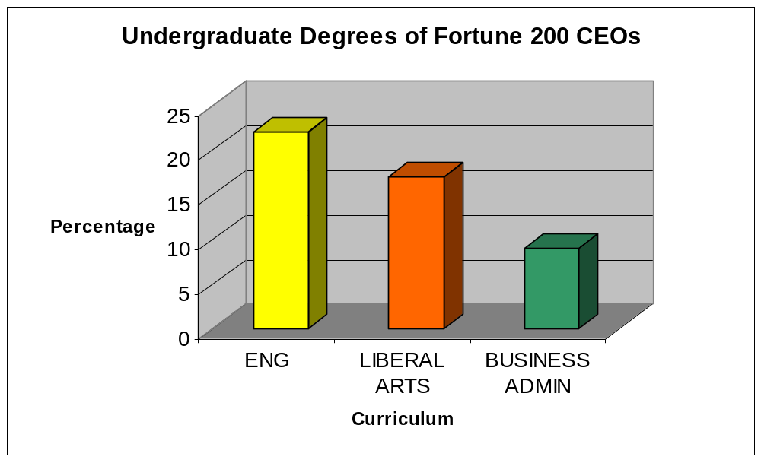
Figure 6
Second, ask Deans of Engineering to encourage outreach in surrounding schools (K-12) to excite youngsters with the work that engineers do. It is known that children make up their minds whether or not they like Math or Science as early as third grade [NAE, 2004]. It is therefore suggested that educators, government agencies, and private industry promote a mentorship program whereby the nation’s engineering schools would receive supplemental funding for engineering students to mentor K-12 students during a school year. This interaction could help form the foundation for young students to see the many exciting and innovative things that engineers do and create.

Third, encourage government agencies to promote engineering by funding students to intern during school breaks at government research facilities.
Finally, these efforts should be reinforced through television programs and advertisements sponsored by the government and industry. Local businesses could also encourage children to consider the engineering profession by offering tours of their facilities to stimulate interest. It is an obvious fact that both young and old like to see and understand how things are made and put together.
Over the past 50 years advances made by U.S. engineers has been spectacular – we must find a way to continue this momentum for the next 50 years! [Brighton, 2004]

Appendix 2: Better Focus ENG’s Portfolio

In collaboration with engineering outreach, ENG must take a critical look at how it allocates its funding. This will build a better case for investment by demonstrating a focused approach to allocating its portfolio. Before we can make these decisions, however, it is important to understand the current financial underpinnings of the ENG budget. Financial analysis of ENG's portfolio demonstrates the following focuses:

(1) Nano. In FY 2004, 23 percent of ENG's total funds (not counting SBIR/STTR) were invested into Nano. In FY 2005, this will rise to over 28 percent. Clearly, Nano is a major ENG focus, with increasing financial support. NSF is recognized as the leader of the Federal government Nano effort. Within NSF, ENG is recognized as the Nano leader.

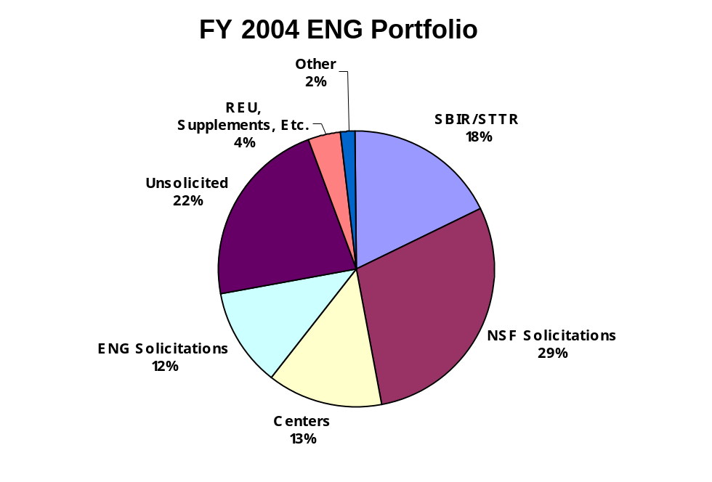

(2) Centers. In FY 2004, ENG invested over $75 million in Centers (ERCs, EERCs, I/UCRCs), which was about 16 percent of ENG's total funds (not counting SBIR/STTR). Clearly, Centers are a major ENG focus. At NSF, and to some extent beyond NSF, ENG is recognized as a leader in the Center area.

(3) CAREER Grants. In FY 2004, ENG invested over $33 million in CAREER grants, or about 7 percent of its total funds (not counting SBIR/STTR). In proportion to its size, ENG is the strongest supporter of the CAREER grant program at NSF. However, it can be argued that ENG receives basically no recognition from NSF for this strong support of the CAREER program. For example, ENG receives no additional funds as a result of its strong CAREER support.

(4) Grants to Support Unsolicited Proposals. In FY 2004, over 27 percent of ENG's total funds (not counting SBIR/STTR) were invested in unsolicited proposals. Unsolicited proposals are a "hallmark" of NSF within the academic community. Unfortunately, the success rate for unsolicited proposals is rapidly dropping in ENG. One primary reason for the rapid drop is the decreased availability of funds due to the increasing allocation of funds to Nano items (NSE solicitation, NSEE solicitation, NNIN, etc.) and the Sensor and Sensor Networks solicitation. In FY 2005, this situation will be even more marked due to the new allocation of $20 million to support NEES operations, coupled with a probable decrease in ENG's total budget. As already cited, NSF and ENG hold leadership positions in Nano. Within NSF, the same is true for the Sensor and Sensor Networks solicitation, and NEES. It can be argued that the recognition afforded to ENG by leadership of Nano, Sensors, and NEES is worth the cost incurred, namely lower success rates for ENG unsolicited proposals.

(5) Special ENG Solicitations. Not counting the solicitations already cited (such as Nano, Centers, Sensors, CAREER) and some other mandatory solicitations such as BE and ITR, in FY 2004, ENG invested about $36 million, or 7.8 percent of its total funds (not counting SBIR/STTR) in special solicitations. This is a relatively small proportion of ENG's total funds. These special solicitations gain ENG significant visibility and recognition with Federal government partners (NIH, USDA, EPA, etc.) and in academic communities. Also, some argue that it is through special solicitations that ENG program officers are able to be innovative leaders in advancing engineering research and education.

ENG (through STG, EDDG, EMG) has recently drafted the following ENG Vision, which it aspires to achieve within 5 to 10 years:

ENG is the acknowledged leader for advancing the frontiers of engineering research, innovation, and education, in partnership with the engineering community, in service to society and the nation.

As ENG makes future investment decisions, each candidate investment can be gauged against this vision: Will such an investment move ENG in the direction of acknowledged leadership? If the answer to this question is "no," then perhaps the investment should not be made, particularly in times of a declining budget for ENG.

The above financial analysis shows where ENG has been putting its money in the past. In light of ENG's draft vision, the key question is, where should ENG put its money in the future?

The “ENG Portfolio" Details

1. Financial Analysis

Darren Dutterer has compiled a financial analysis of ENG's portfolio for each of the four (4) most recently completed fiscal years. Data are presented for each of these fiscal years -- ENG division by ENG division (for all 6 ENG divisions) plus OAD/ENG. Taking totals of the data yields the following results:

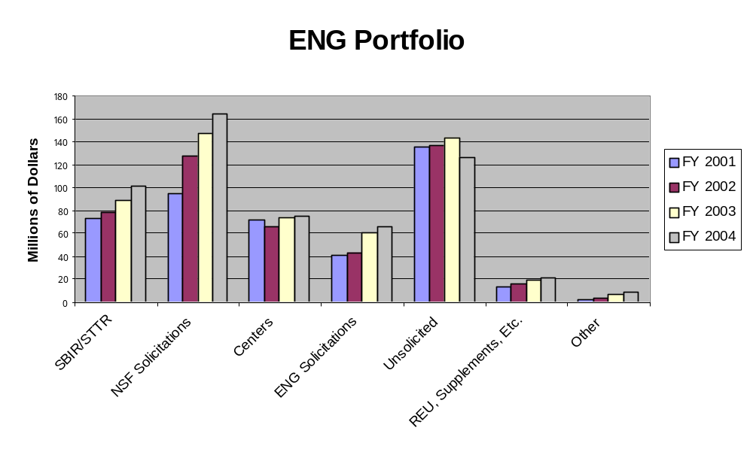

2. ASTG Related Work
The ENG Awards and Solicitations Task Group (ASTG) is currently compiling data for ENG solicitations. These data include, for each ENG solicitation, the number of proposals, the number of awards, and the success rate for each solicitation.

3. AIA Related Work

The ENG Awards Impact and Assessment Task Group (AIA) is "responsible for recommending how ENG should determine the impact of its investments in research, education, and innovation." In the long run, the outcome of such assessments will be of use in tuning the focus of investments in ENG's funding portfolio.

4. STG Related Work

The Strategic Thinking Group (STG) is doing a SWOT analysis of ENG, working on Vision statements, and thinking about strategy.

5. Workforce
The Workforce Task Group is recommending actions to enhance the quality and diversity of the engineering workforce.

Recommendations

- Create a Vision that is embraced by ENG.
- Better focus ENG's portfolio to be congruent with:
(a) ENG's Vision
(b) Serving the "community"
(Action by EMT)

Appendix 3: Partnerships

The Directorate for Engineering at NSF has established numerous partnerships over the past decade to support a broad spectrum of engineering research and educational activities. These collaborations are viewed as essential to fulfilling ENG’s Vision.

In making the case for engineering, partnerships have been embraced as a means to reach out to a broad community of researchers and educators, by establishing relevance through connectivity with those in other government agencies, industry, professional societies, and non-profit organizations. Many of the partnerships that have formed over the past decade have focused on either a specific research topic, the realization of new devices, or the creation of an educational agenda that addresses a national need, national security, issues around globalization, or the advancement of specific new technologies. In numerous instances, ENG has taken a leadership role in the management of the partnership. At other occasions, ENG has been a key constituent of a broad-based activity. The value of these partnerships have included the advancement of knowledge in an emerging area, the setting of new directions for the nation, and the creation of centers of excellence that integrate across science and engineering.

External partnerships with other agencies, professional societies, and technical groups have been formed to support research, education, and studies into emerging technologies. The table on the following page provides a partial listing of recent activities.

Some of the partnerships were a result of interests of program officers in different agencies committing program funds to a one-time, or short span of activity. The NSF/SRC Mixed Signal Electronic Technologies represents this time of solicitation, which ran through just one cycle. The NSF/Sandia program is an ongoing activity, again supported by a working group of program officers across four of the engineering divisions at NSF. This activity has had three calls for proposals, each announcement reflecting current interests of the programs at NSF and Sandia.

Other, longer-term relationships have been established such as the NSF/EPA Technologies for Sustainable Systems, which ran joint solicitations from 1997 through 2003. The management of each of the examples focused on a working group with a lead program officer in each agency to marshal the management plan, a memorandum of agreement and the text of the solicitation through each agency or entity.

Partners | Solicitation | Partner  Funding $ | ENG  Funding $
NSF/EPA | A. Environmental Technologies and Systems (03-510) | 9,500,000 | 5,500,000
NSF/NIH/DOE/  NASA | B. Multiscale Modeling in Biomedical, Biological,  And Behavioral Systems (04-607) | 15,000,000 | 2,500,000
NSF/industry | C. IUCRC | 68,000,000 | 5,200,000
NSF/SANDIA | D. Systems Modeling and Simulation (03-505) | 2,000,000 | 2,000,000
NSF/SRI | E. Semiconductor Factory and Supply Chain (04-532 | 2,700,000 | 900,000
Interagency | F. Opportunities in Metabolic Engineering (03-516) | 6,000,000 | 1,500,000
Interagency | G. Nanotechnology (NNIN) | 849,000,000 | 46,500,000
NSF | H. Quantitative Systems Biology (04-516) | 4,000,000 | 2,400,000
NSF | I. ITR (04-012) | 90,000,000 | 11,170,000
NSF | J. Biocomplexity in the Environment (03-597) | 51,000,000 | 6,000,000
NSF / EU | K. Cooperative Activities in Mat’ls Research (03-565) | 2,000,000 | 500,000
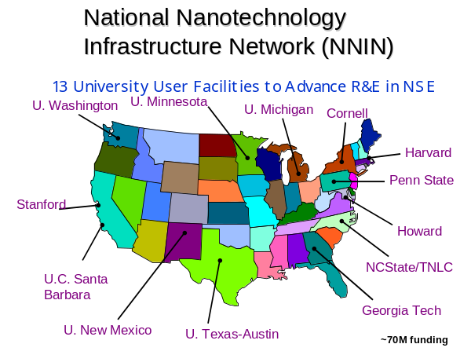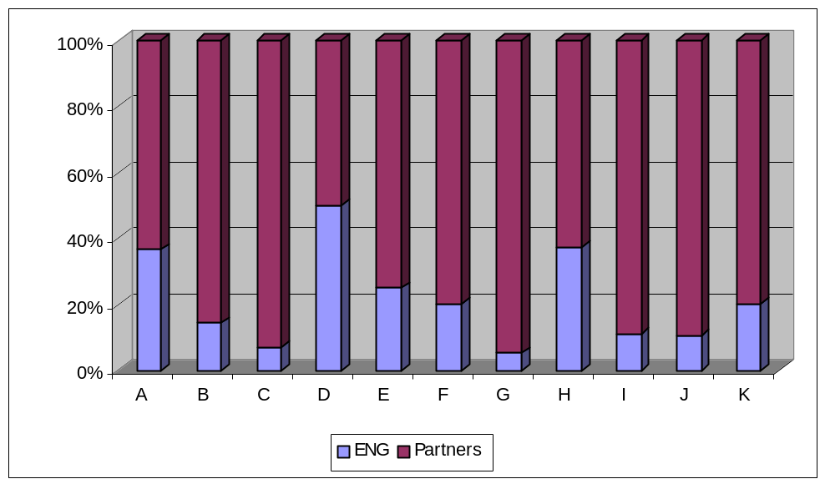

NSF ENG has also taken a different role in establishing long-term partnerships to create a vision for future directions in emerging areas. One example is the leadership role ENG took in advancing nanotechnologies through sustained efforts in NNUN, Partnerships in Nanotechnologies, NSE, and NNIN. The effectiveness of the engineering leadership in pulling together a broad coalition of agencies, national labs and cross-directorate support, starting in the mid-90s is demonstrated by the growth of the engineering research and educational activities in the global nano-technology arena.

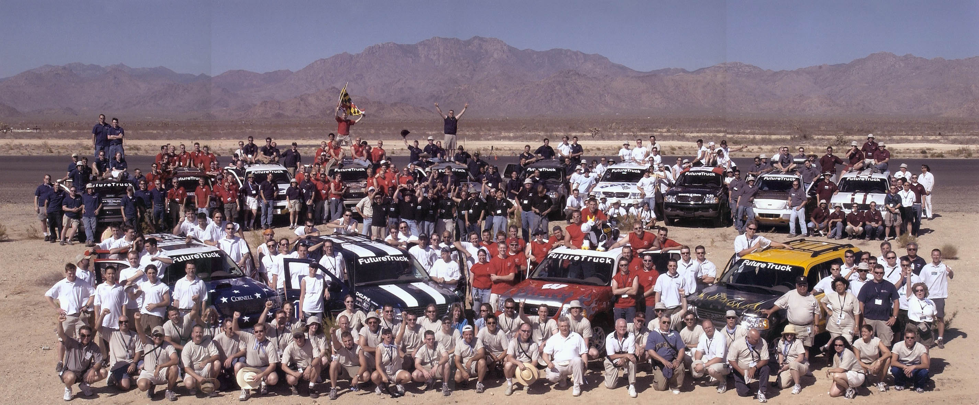
Internal partnerships within NSF have become a fact of life for the Engineering Directorate. Examples of these include current activities in ITR, Biocomplexity, and with EHR that focus on multi-disciplinary research and curricular development at levels extending well beyond the engineering domain. These collaborations can occur from either a top-down directive or a bottom-up teaming of program officers with a common vision. Each of the activities that represent an NSF-wide priority area appears to have a different management scheme. In all cases, coordination, collaboration, and communication are key issues for ENG when resources have been committed to a multi-year, NSF-wide solicitation. The success of these partnerships is often dependent upon the management plan developed to support the long-term goals of the various divisions and directorates. The potential of bringing communities of researchers together to address highly complex systems research can be of significant value to the desired progression from scientific discovery through to the realization of these ideas.
FUTURETRUCK 2003 – A DOE / NSF / Automotive Industry (FORD & GM) partnership sponsoring the student team competition for reducing environmental impact while maintaining performance of vehicles.

Vertically-aligned partnerships provide a framework for a NSF ENG to enhance activities that include both education and research, with direct collaboration with professional societies or industry, aimed at integrating and advancing multi-disciplinary thrusts in emerging and important areas. The Engineering Research Centers program, the NEES infrastructure program, and the BEES program between engineering and EHR provide examples where engineering has establish the necessary support for comprehensive programs that incorporate goals to educate the engineering workforce while advancing knowledge through sustained research activities with industrial or professional society input.

The challenges and potential failures that can occur in any of the different types of partnerships can include:
- Proposals that are not adequately responsive to the new directions in the solicitation;
- Changes in personnel resulting in less than enthusiastic support for an ongoing activity;
- Budgetary changes that redirect funds;
- Insufficient timeline to get the full community involvement in an emerging area.

In addition, there is a constant tension to maintain the appropriate balance between core programmatic research and the priority areas or directed solicitations. The management of resources for the directorate needs to be aligned with the vision for ENG that comes forward from the STG.

Recommendations

The Engineering Directorate can establish a sustainable framework supporting collaborative partnerships across agencies and outside entities, or within NSF at the cross-directorate or cross-division level. This framework will recognize the need to manage all resources – financial, IT, and human, necessary to assure successful collaborations in the future.

- Create a flexible format and a realistic timeline in which to inform and build community capabilities;
- Recognize management needs in terms of time and staffing to adequately support commitments to collaborations;
- Develop a prioritized list of ongoing and emerging areas that can provide a sustainable framework for discussion between agencies and directorates with an open format for introducing, maturing, and graduating areas of activity.

Appendix 4: Effectively Serving the Engineering Community
The NSF has a long history of success in serving the broad community of engineers and the industries that rely on them, through its support for enabling technologies, technology transfer, and the education of a strong diverse workforce. These lead to greater economic competitiveness, a stronger industrial base, more jobs, and commercial products that better society and improve quality of life.

There is a continuing need for wise research investment and leadership from NSF/ENG to stimulate the development of a technology base in areas critical to the nation’s economy and to provide for industry’s present and future workforce needs. (If these contributions are not always fully appreciated, NSF’s past successes and vision for the future need to be better communicated to the engineering community.)

NSF/ENG programs serve the engineering research community specifically through support of academic research and education, sound stewardship of federal research funds, management of a fair and effective proposal review and award process, the engineering research centers program, infrastructure investments such as NNIN and NEES, and technical leadership to help stimulate interdisciplinary research activity in areas ripe for innovation. These communities also benefit from proactive efforts within NSF and ENG to increase funding levels for engineering research.
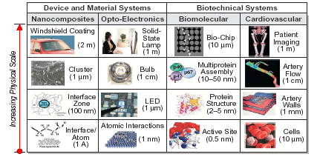

Engineering Across Multiple Scales (RPI, Award CMS 030596)

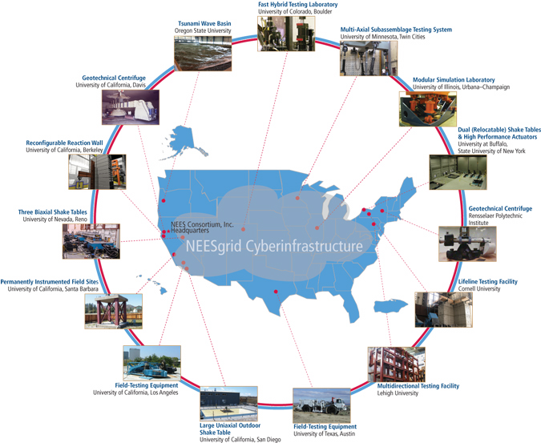

While NSF/ENG has been proactive in supporting research at the intersection of diverse disciplines through program solicitations, it does not do so well in unsolicited core proposal competitions. When, as often happens, highly innovative research does not fall neatly into areas defined by targeted solicitations, a significant portion of the engineering research community is not being particularly well served. Further, a good portion of the investment in solicitations has come in recent years at the expense of core programs. The table in the Portfolio section of this report shows that unsolicited proposals accounted for slightly over one quarter of the 2003 ENG budget. This causes serious disruptions since the core programs are the primary means through which NSF/ENG supports the full spectrum of the engineering research community.

Opportunities:
Support for “transforming” interdisciplinary research has the potential to educate students with broad skill sets who are ready to hit the ground running in an industrial environment, transition critical technology to industry, and provide the United States a competitive edge in the global marketplace. At the same time it is important that enabling discoveries and innovation continue to occur within single-investigator research grants, which are supported by core programs. Sound stewardship of NSF research funds requires that NSF/ENG maintain a careful balance between core programs and program solicitations.

Open communication and information exchange between NSF/ENG and the research community is essential, both to receive guidance and feedback from the engineering research community, and to provide a clear and up-to-date picture of present funding opportunities. Hopefully, clearly communicated expectations will help lead to higher, more historical success rates.

It is important to ensure that the NSF funding for core research programs not fall below critical levels. Budget programming should be corrected to provide a “safety net” and prevent such an occurrence in the future. One possible guiding principle would be to prevent core budgets from falling below historical levels, e.g., averaged over the most recent five-year period.

An unfortunate gap exists in the ENG portfolio. Awards for broadly based engineering research range from individual investigator grants to large engineering research centers, but funding vehicles for intermediate-size engineering research groups do not exist outside special solicitations (e.g., NIRT or SIRG). Interdisciplinary research usually requires community building and formation of partnerships that bridge diverse disciplines. What opportunities will be there for interdisciplinary engineering research groups after the solicitations that supported them are terminated? Effective funding vehicles are needed within core programs across ENG to permit interdisciplinary group investigations to continue.

Recommendations

A multi-pronged approach is needed, including:

- Avoid abrupt and unpredictable reversals in funding patterns, which make it difficult for the research community to plan effectively. These could arise from:
  - Holding a solicitation for interdisciplinary research, and discontinuing it after one year leaving the teams that were formed with nowhere to go, and
  - Faulty budgeting and planning algorithms.
- Organized workshops to develop a strategic vision for the Engineering Directorate with the several-fold goal to:
  - Identify those areas of engineering research with the potential for the greatest economic and societal impact over the next several decades, particularly at the intersection of technical disciplines experiencing rapid growth and innovation,
  - Fully engage the engineering community in these discussions to promote greater awareness and communication regarding NSF research opportunities,
  - Help ENG exercise leadership in stimulating research that bridges critical gaps between diverse disciplines and promoting interdisciplinary partnerships, and
  - Enunciate a clear and compelling argument for greater congressional support for the nation’s research infrastructure.
- Strategic planning within ENG to strike a dynamic balance between exercising leadership in newly emerging areas through program solicitations and serving the full spectrum of ENG community through core programs.
- Meet with engineering leaders in the university, commercial and government communities to establish a consensus regarding workforce needs for the coming decades.
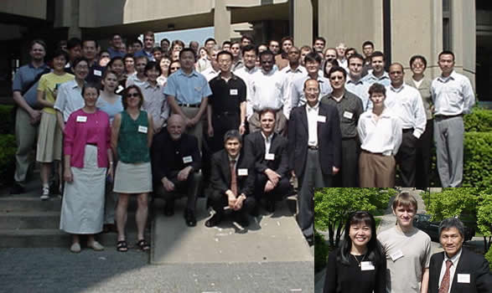
- Encourage partnerships among diverse disciplines at academic institutions to better prepare a workforce suited to projected challenges in the industrial sector, as well as between engineering schools and industry to better define educational needs.
- Meet with Deans of Engineering to identify the primary education and workforce challenges for the first quarter of the century and determine how NSF can help them meet these challenges.
NSF Summer Institute on Nano Mechanics and Nano Materials at Northwestern University, training 130 professors and post-docs a year, in 2 sessions.

- Engage industry to reexamine how U.S. research expertise and accomplishments can transition to industry effectively and contribute to the nation’s economic competitiveness on global markets.

Appendix 5: NAE study: “Assessing the Capacity of the U.S. Engineering Research Enterprise”

In this report we identify Priorities and Actions to better make the case for engineering. In order to make these concrete, we review one of example of how they can be addressed, namely the National Academy of Engineering study to assess the capacity of the U. S. Engineering Research Enterprise [NAE, 2005].

It is an example of the Directorate for Engineering serving “as a catalyst to build and communicate with the engineering community a shared vision for engineering” (Priority #1) and building “on existing linkages and enable new flexible and collaborative partnerships” (Priority #4). The goals of these efforts were to conduct a “fast-track” evaluation of (1) the past and potential impact of the U.S. engineering research enterprise on the nation’s economy, quality of life, security, and global leadership, and (2) the adequacy of public and private investment to sustain U.S. preeminence in basic engineering research.

The NAE assessed the capacity of the U.S. engineering research enterprise, evaluated recent contributions of U.S.-based engineering research to the nation’s interests, assessed potential contributions to meeting emerging national challenges and opportunities, and outlines a national strategy to ensure that the engineering research foundations of American global economic, military, scientific, and technological preeminence remain rock solid in the face of rapid, often disruptive, societal and global changes. The report puts forward findings, recommendations, and a national action plan designed to engage all major constituents of the U.S. engineering enterprise.

The preliminary report is posted on the NAE website [www.nae.edu] so that the public at large and the engineering community in particular can comment on it. The discussion generated will refine and strengthen the recommendations.

The draft recommendations focus on critical changes in public- and private-sector investment priorities, programs, and activities. The draft report proposes a new, nationwide initiative to encourage and support technological innovation, including:

Recommendation 1. Federal research and mission agencies should increase significantly their investments in engineering and physical sciences research, particularly long-term fundamental research, to sustain broad-based science and engineering advancement across disciplines. These agencies should also continue to encourage multidisciplinary research through support of project-specific research teams and other institutionalized mechanisms, such as engineering research centers and university-industry research centers.

Recommendation 2. Federal and state governments should invest more resources in upgrading and expanding laboratories, equipment, information technologies, and other infrastructural needs of research universities to ensure that the national capacity to conduct world-class engineering research is sufficient to address the technical challenges that lie ahead. Geographically dispersed, world-class research facilities will have the added benefit of making engineering attractive to more students (at home and from abroad), will stimulate a competition of ideas among research groups working on related problems, and will provide a basis for the emergence of networks of researchers and clusters of industry across the nation.

Recommendation 3. State and federal governments, academic institutions, accreditation bodies, and the private sector should take steps to cultivate U.S. student interest in, and aptitude for, careers in engineering, and in engineering research in particular. These steps should include providing more funding for graduate fellowships and traineeships and faculty development, as well as supporting efforts to improve K–12 math and science education to prepare high school students for careers in science and engineering.

Recommendation 4. Academic institutions, accreditation bodies, and other public and private-sector stakeholders should encourage the development and implementation of innovative curricula that address the realities of contemporary engineering practice and the needs of the nation, without compromising the teaching of fundamental engineering principles.

Recommendation 5. Immigration procedures should be addressed to enable American industry and universities to continue to attract top scientific and engineering talent from around the world. Although the committee recognizes that many other study panels, committees, and task forces have made similar recommendations, little progress has been made toward fulfilling them.

We offer this as an example of the role that NSF can play to stimulate the engineering community to formulate compelling visions of the future and to plan for that future.

American Perspectives on Engineers and Engineering, AAES, 2004
The Engineer of 2020 (NAE); Assessing the Capacity of the U.S. Engineering Research Enterprise (NAE); Innovate America (Council on Competitiveness)
Raising Public Awareness of Engineering [Davis, Gibbin, NAE, 2002]
New York Times columnist Thomas Friedman , Reported in Assessing the Capacity Report [NAE, 2005]
AdComm liaisons include: Joan F. Brennecke; Legand L. Burge, Jr.; Patricia D. Galloway; Richard Miller; Cherri Pancake; Jacquelyn (Jackie) Sullivan; and Judy Vance
Extraordinary Women Engineers Final Report 2005, AAES, ASCE, WGBH Educational Foundation

