

TOXNET:

Toxicology & Environmental Information

http://toxnet.nlm.nih.gov/

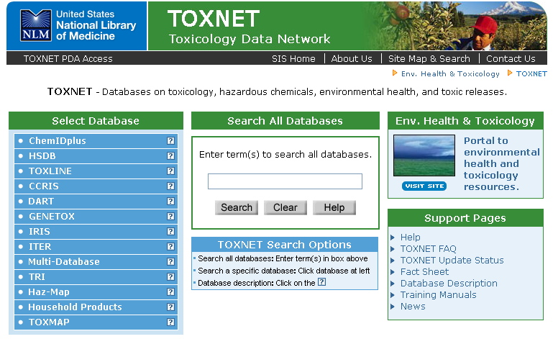

National Network of Libraries of Medicine, South Central Region
Houston Academy of Medicine-Texas Medical Center Library
1133 John Freeman Blvd.
Houston, TX 77030

NLM Contract No.: N01-LM-6-3505

January 2007

TOXNET (TOXicology Data NETwork)
http://toxnet.nlm.nih.gov/

- A FREE web-based integrated system of databases on toxicology, environmental health, hazardous chemicals, toxic releases, chemical nomenclature, and specialty areas such as occupational health and consumer products
- A product of NLM’s Toxicology and Environmental Health Information Program (TEHIP)

Five Types of Databases

- Chemical Information: ChemIDplus
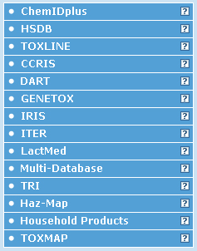
- Toxicology Data Files (one record per chemical):
  - HSDB
  - CCRIS
  - GENE-TOX
  - IRIS
  - ITER
  - LactMed

- Toxicology Literature Files (bibliographic references):
  - TOXLINE
  - DART

- Toxic Releases (chemicals into the environment)
  - TRI
  - TOXMAP

- Other Databases:
  - Haz-Map
  - Household Products

TOXNET Data Files

Hazardous Substances Data Bank (HSDB)
- From NLM
- About 5,000 chemical records
- Toxicology of potentially hazardous chemicals
- Information on human exposure, industrial hygiene, emergency handling procedures, environmental fate and regulatory requirements
- Data from books, government documents, technical reports and selected primary literature
- Some data is compiled expressly for HSDB
- Peer reviewed by the Scientific Review Panel

Chemical Carcinogenesis Research Information System (CCRIS)
- From the National Cancer Institute (NCI)
- Data and information on carcinogenicity, mutagenicity, tumor promotion, and tumor inhibition test results
- Data derived from studies cited in primary journals, current awareness tools, NCI reports, and other special sources
- About 9,000 chemical records
- Scientifically evaluated and fully referenced

Genetic Toxicology (GENE-TOX)
- From the U.S. Environmental Protection Agency (EPA)
- Note: GENE-TOX not updated since January 2000
- Mutagenicity studies
- Data Structure – assay type, assay code, results, panel report, reference
- 3,214 Chemical Records
- Selected literature was reviewed by scientific experts

Integrated Risk Information System (IRIS)
- From the EPA
- Contains EPA consensus scientific positions and quantitative values on cancer and non-cancer health effects that may result from lifetime oral or inhalation exposure to specific chemical substances in the environment
- About 550 chemical records
- Scientifically reviewed by groups of EPA scientists and represent EPA consensus

International Toxicity Estimates for Risk Assessment (ITER)
- From Toxicology Excellence for Risk Assessment (TERA), a non-profit corporation
- Provides a comparison of international risk assessment information derived by different organizations (U.S. and International)
- About 650 chemical records
- Includes synopses, links to organization source documents

LactMed

From NLM

Database of drugs and other chemicals to which breastfeeding mothers may be exposed and the possible effects in nursing infants
- Over 400 records
- Peer-reviewed and fully referenced

Searching TOXNET

- Each TOXNET database may be searched individually or by using the Search All Databases option (record counts may vary somewhat when databases are searched individually)
- The databases employ very similar search engines. Search techniques for Search All Databases can be used for each database

Searching All Databases
- Search by chemical names, other terms (including multiple terms), and numbers (including CAS numbers)
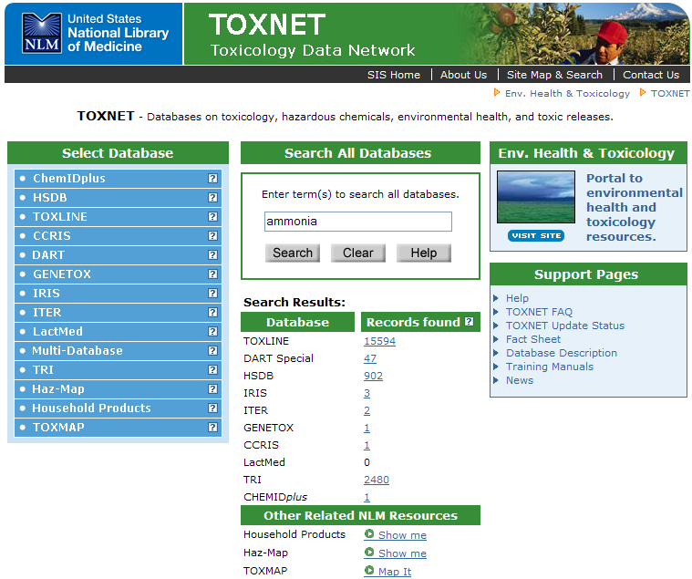
- Search results display a summary of the number of records retrieved in each database
Clicking on the number takes you into that database
TOXNET Data Files

Example: HSDB (Hazardous Substances Data Bank)
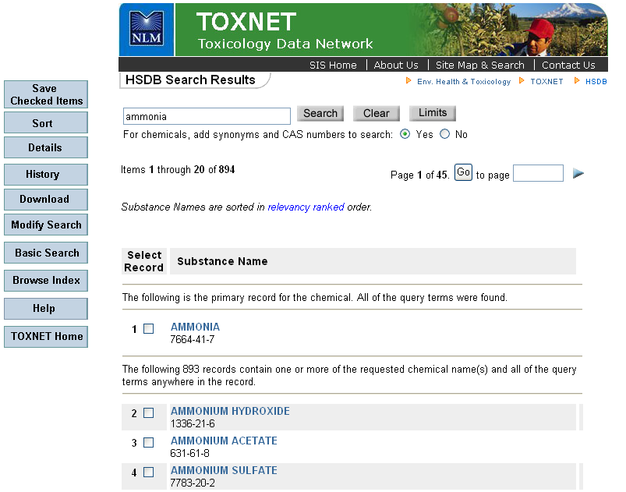
- Results display best matches first
Click on chemical name to access full record

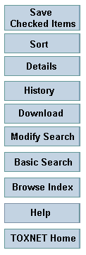
- Saved Checked Items option allows you to display selected records only
  - Check box next to record number(s)
  - Click Saved Checked Items
  - Click Display Saved Items to view only the selected records
- Sort allows selected records to be resorted in ascending or descending order. TIP: This is best used with Saved Checked Items
- Details displays the search strategy
- History displays your recent searches
- Download allows some or all of the records retrieved to be downloaded in brief or full format. TIP: This is best used with Saved Checked Items
  - Browse Index opens the Browse the Index search screen
Full Record Display
- The Full Record Display for each TOXNET data file has a similar look and navigation
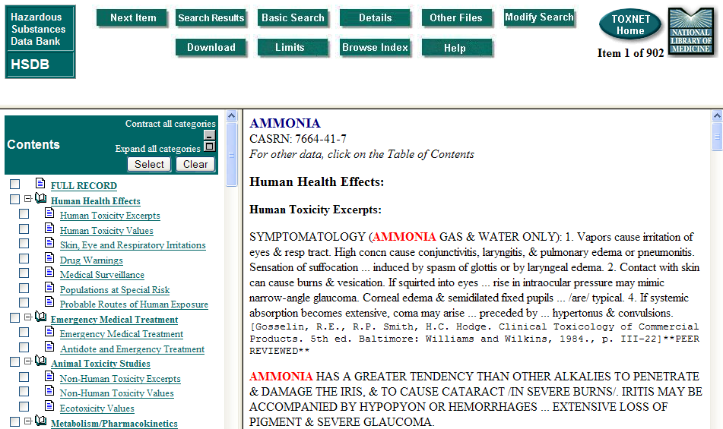

- The search term(s) is highlighted in red in the full record
- Each database has the Table of Contents in the left frame and the full record in the right frame
- The Table of Contents includes quick links to the specific fields and categories within the record. Items of note include:
  - Human Health Effects (which is the default display in HSDB)
  - Emergency Medical Treatment
  - Animal Toxicity Studies
  - Environmental Fate and Exposure
  - Manufacturing/Use Information (includes the major uses of the substance and manufacturers)


Moving between Databases
- The Other Files button, located at the top of the results page, allows the search to be conducted in other TOXNET files

Searching Individual Databases

- Boolean searching using AND, OR, and NOT is available
- Truncation using the asterisk (*) is allowed at the end of a word and will search any number of characters
- Phrase searching by quotation marks is allowed

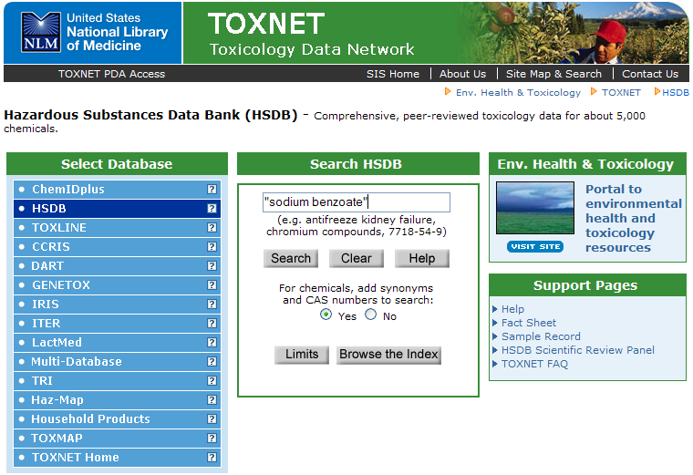

- Clicking on the Limits button allows you to search specific fields in the record
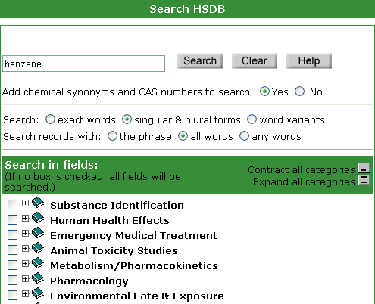

Customizable search fields
Practice Exercises

- What are the adverse effects of exposure to phenol?

- What is lithium chromate used for?

- Is coal tar a carcinogen?

TOXNET Literature Files

TOXLINE (TOXicology Literature onLINE)
- Bibliographic information on pharmacological, biochemical, physiological, environmental, and toxicological effects of chemicals and other agents on living systems
- Sources of information include: toxicology journals, technical reports, research projects and archival collections
- About 3.5 million citations
- Links to PubMed citations

Developmental and Reproductive Toxicology/Environmental Teratology Information Center (DART/ETIC)
- Managed by NLM and funded by the EPA, the National Institute of Environmental Health Sciences (NIEHS), the National Center for Toxicological Research (NCTR) of the Food and Drug Administration (FDA), and NLM
- Bibliographic information on teratology and other aspects of developmental and reproductive toxicology
- Over 100,000 citations
- 2 components – DART Core and DART Special
  - DART Core searchable via TOXNET
    - links to PubMed citations
  - DART Special searchable via TOXNET
    - non-PubMed citations including meeting abstracts, technical reports, and non-MEDLINE journals

Searching TOXLINE

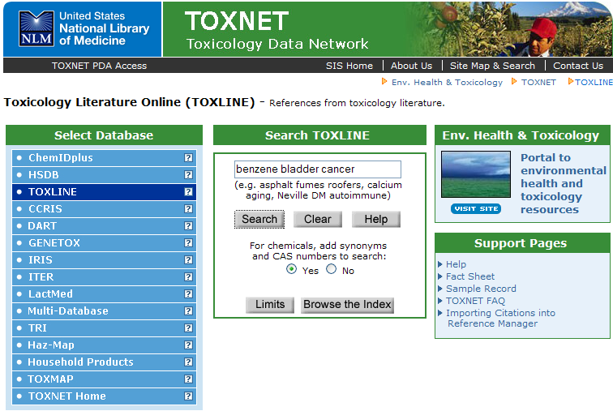

- Search options:
  - Text word search
  - Browse the Index
  - Search using limits
- NOTE: TOXLINE and DART employ very similar search engines. All search techniques for TOXLINE can be used for DART

Browsing TOXLINE
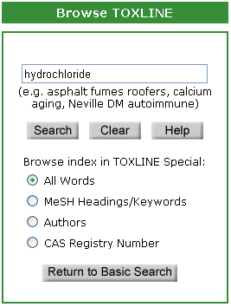
- Browse the Index allows browsing by terms, MeSH headings or Keywords, Authors or CAS number

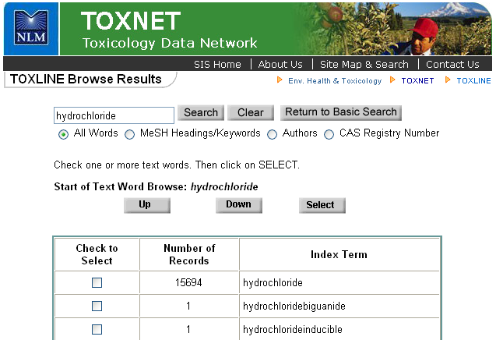
Search using limits

- Search by chemical names, other terms (including multiple terms), and numbers (including CAS numbers)
- Click on the Limits button to limit your search. Type of Limits include
  - Title or Author fields
  - Searching exact words or variants
  - Maximum number of results retrieved
  - Year of publication
  - Search by languages
  - TOXLINE components

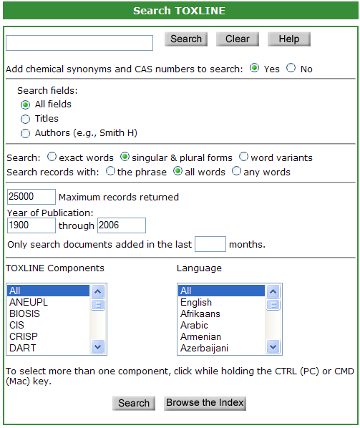

TOXLINE Results
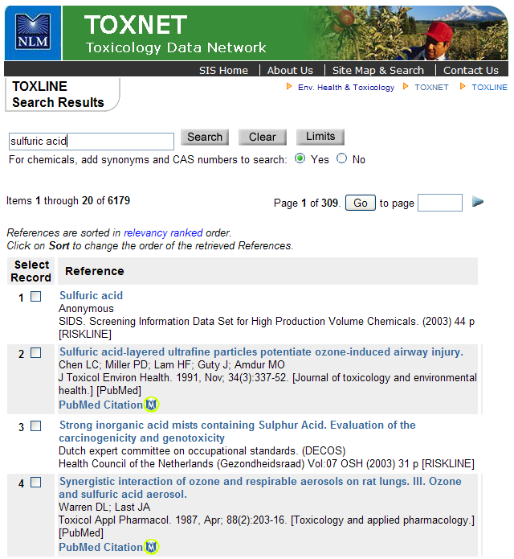
- Citations that can also found in PubMed will be displayed with an icon that will link directly to PubMed

Practice Exercise

- Find citations to literature, journals or reports on environmental exposure to acetone in salons.

- What are the effects of cocaine and alcohol usage on a fetus?

Toxic Releases Databases

Toxics Release Inventory (TRI)

- Set of publicly available databases containing information on releases of specific toxic chemicals and their management as waste
- Based on data submitted to the EPA from industrial facilities in U.S.
- Describe the releases of toxic chemicals into the environment annually (1987 – 2004)
- Data includes names and addresses of facilities, the amounts of toxic chemicals released to the air, water, land, or transfer to waste sites
- About 1,562,569 records
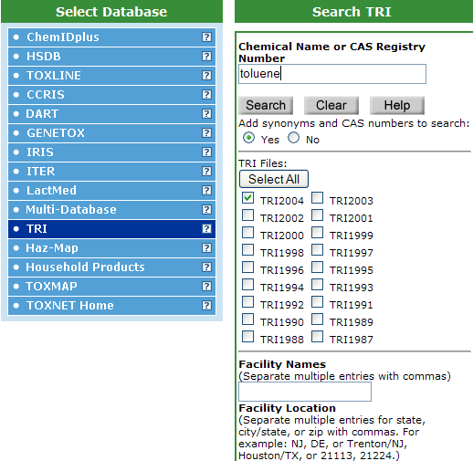

- Results display in brief format with the facilities and chemical list
- The Map it with TOXMAP button displays the results in TOXMAP

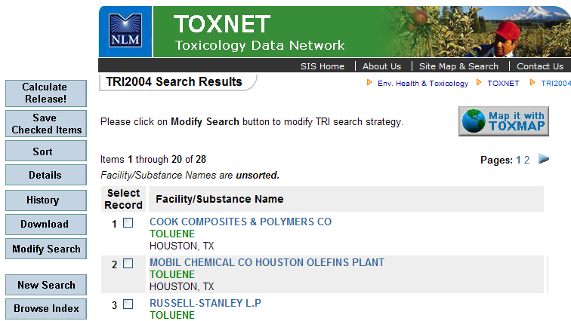

- To find the total release of the chemical by facility, select the record and click on Calculate Release! Results summarize the total amount released
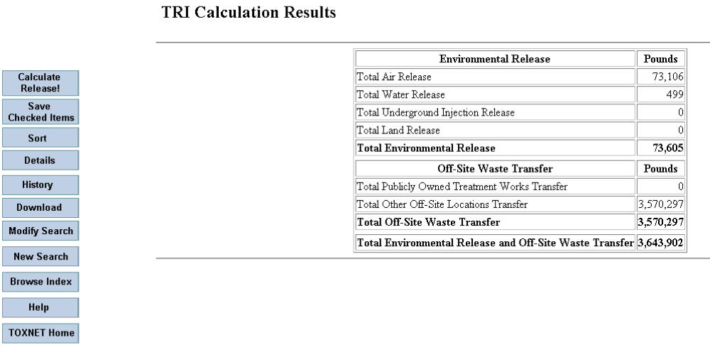

TOXMAP

- From NLM
- Provides maps of the United States to help users visually explore data from the U.S. Environmental Protection Agency (EPA)’s Toxic Releases Inventory (TRI) and the Superfund National Priorities List (NPL)
- Displays air, water, and land releases as reported by US industrial facilities
- Search by chemical name, facility name and/or location

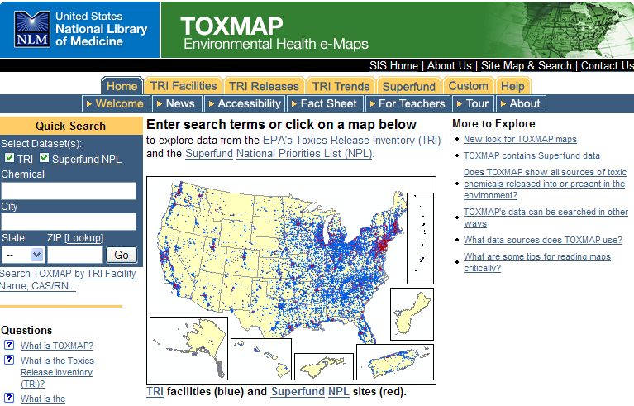
- Trend a chemical released by facility or location
- Links to HSDB and ATSDR information as well as TOXLINE searches
- Can include census and reference data on map

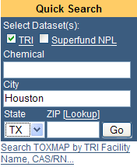
Searching TOXMAP

- To locate toxic releases in your area, type in your city and state into the quick search box and select the Go button

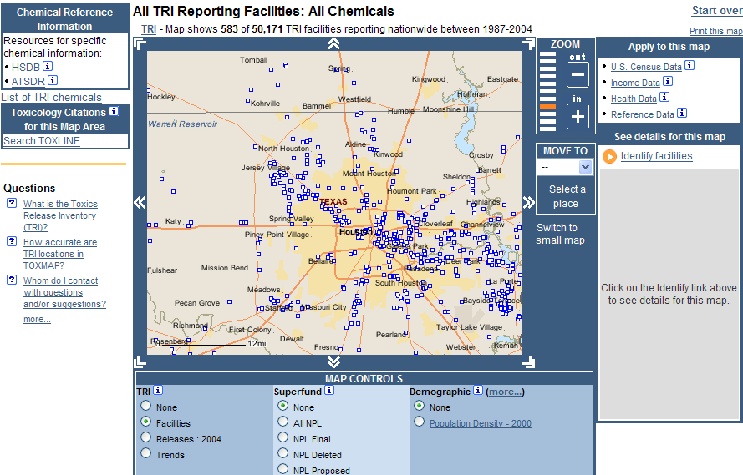
- Toxic reporting facilities will be displayed in a map

- To identify the specific facilities, click on the Identify Facilities link under the See details for this map heading
- To access information on a particular facility, clicking on the facility name
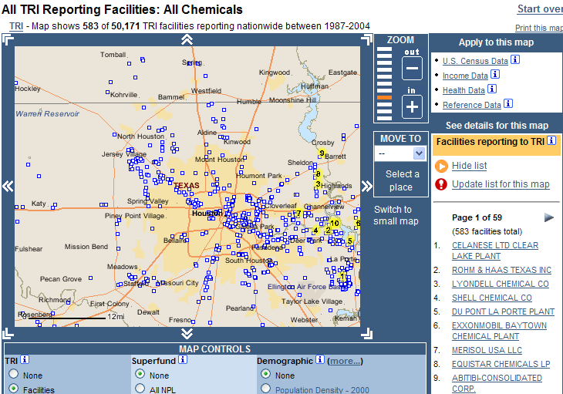
- After a facility is selected, the top six toxic chemical releases will be displayed in a table
- To find out the hazardous effects of the chemical, select the chemical name from the table

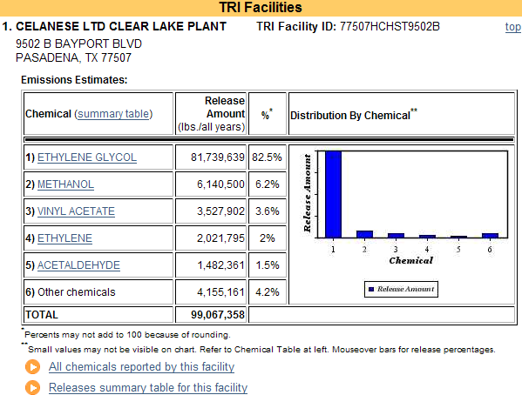
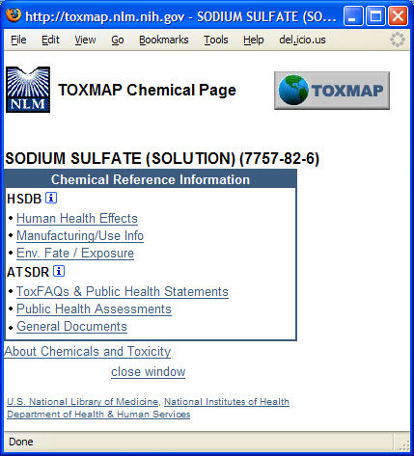

- The TOXMAP chemical page will appear allowing you to select from the Hazardous Substances Data Bank (HSDB) or the Agency for Toxic Substances and Disease Registry (ATSDR)
- Select the link to Human Health Effects

- The results will be displayed within the Hazardous Substances Data Bank (HSDB)

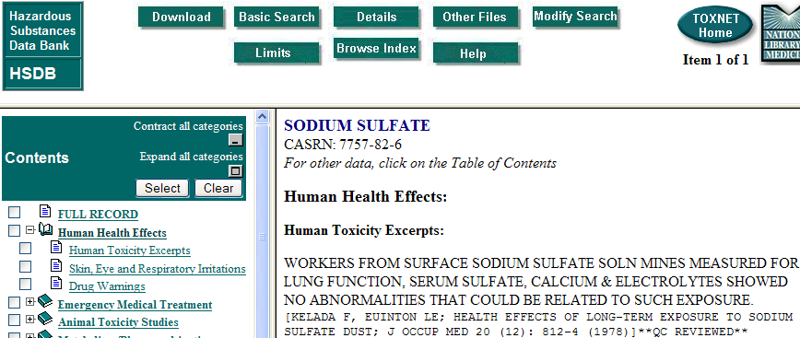


- Searches can be conducted on TRI releases, TRI trends and Superfund data by selecting the appropriate tab on the top TOXMAP menu
Other Databases

Haz-MAP

- From NLM
- Occupational health database designed for health and safety professionals and for consumers seeking information about the health effects of exposure to chemicals and biological substances at work
- Search or browse by agent, disease or job
- Contains approximately 1,000 chemicals and 180 occupational diseases

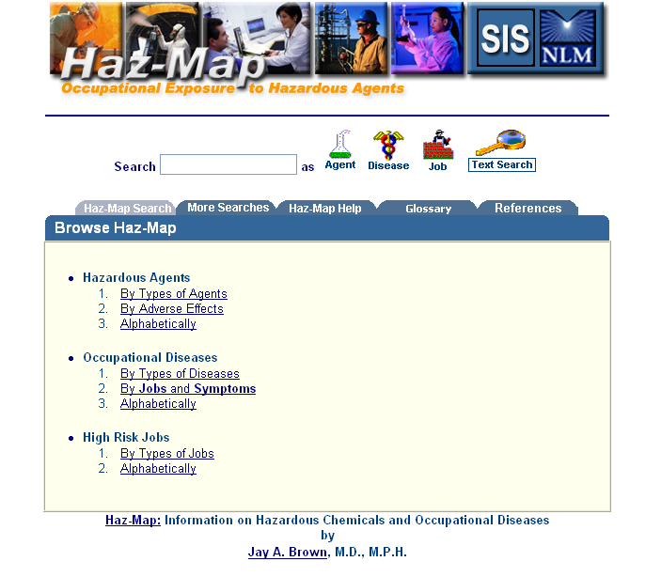

Household Products Database

- From NLM
- Information on potential health effects of chemicals or substances contained in more than 6,000 common household products
- Users can browse by a product category such as ‘Pesticides’ or by alphabetical listing of brand names
- Products can also be searched by type, manufacturer, product ingredient/chemical name and by health effects
- Record for each product shows ingredients as reported in the manufacturer’s Material Safety Data Sheets (MSDS)
- Links to TOXNET, PubMed and other NLM databases

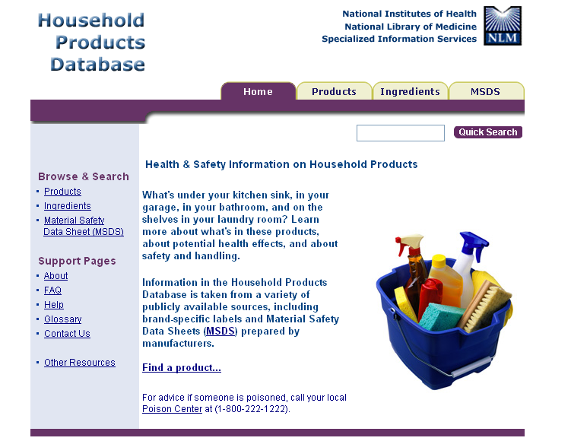
Searching Household Products Database

- To conduct a quick search, type in the name of the product or brand name into the quick search box


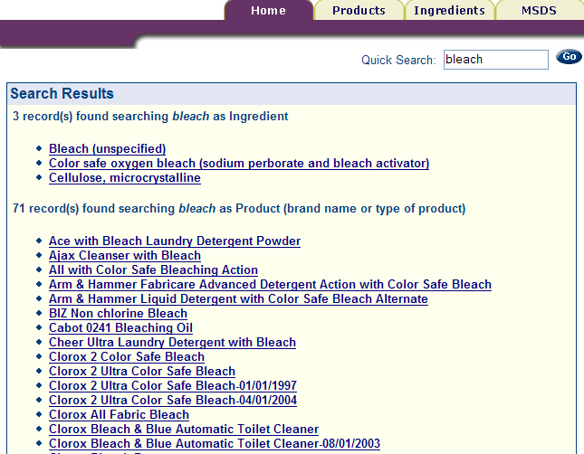
- Search results will include the search term as an ingredient and as a text word in the product name

- Select a record for more information about the product/item

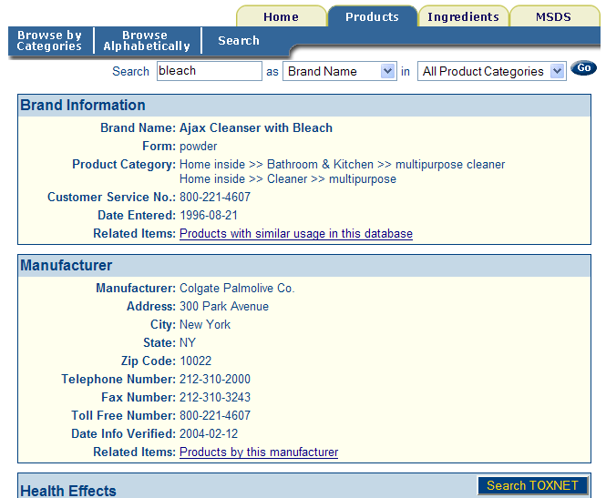
- The detailed record will contain links to further information on the manufacturer of the product, handling/disposal and ingredients
- Links within the record will access other NLM databases including PubMed and other TOXNET databases

ChemIDplus

- Structure and name file used for the identification of chemical substances
- Contains over 380,000 chemical records, of which over 263,000 include chemical structures
- Search options include ChemID Lite (Basic Search) and Advanced Search

Basic Search (ChemID Lite)

- Yields a list of results from different sources

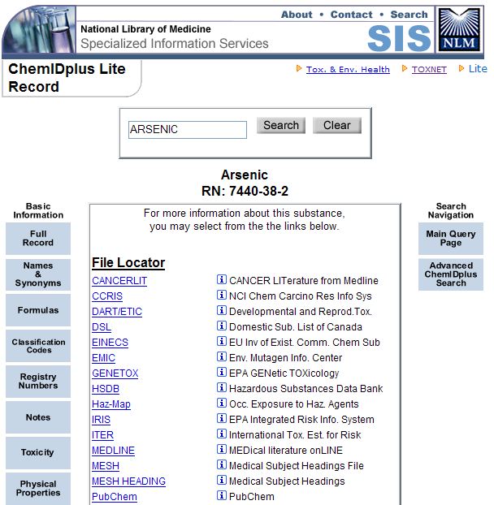
- The Basic Information buttons on the left of the results allows you to access the ChemIDplus Full Record, or a specific portion of the record, such as Names & Synonyms, Formulas, Classification Codes, Registry Numbers, Notes, Toxicity and Physical Properties
- The Search Navigation button on the right allow you to go back to a basic search (Main Query Page) or to the advanced search (Advanced ChemIDplus Search)
- The middle of the results pages lists the Locators where further information on the chemical is found
- The File Locators point to NLM associated databases

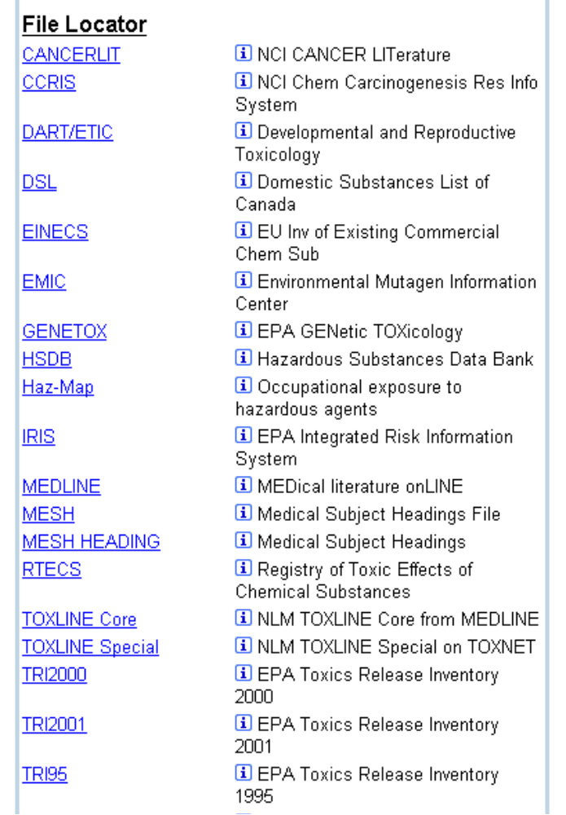
- Internet Locators link to web resources containing biomedical data
- Superlist Locators link to regulatory and scientific lists
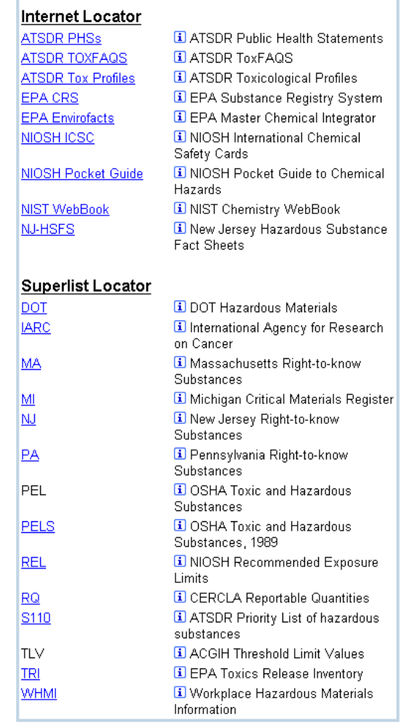

- The i button gives you more information about the Locator
- To view the results in any Locator, click on its name

Advanced Search (ChemIDplus Advanced)

- Allows chemical structure and biological/chemical property searching
- Provides structural drawings that can be manipulated
- To use ChemIDplus Advanced, you will need a web browser that has a recent version of Java installed

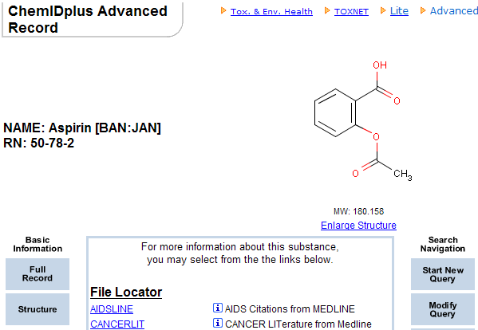
- After clicking the Enlarge Structure link, you will be able to display a three-dimensional model of the structure
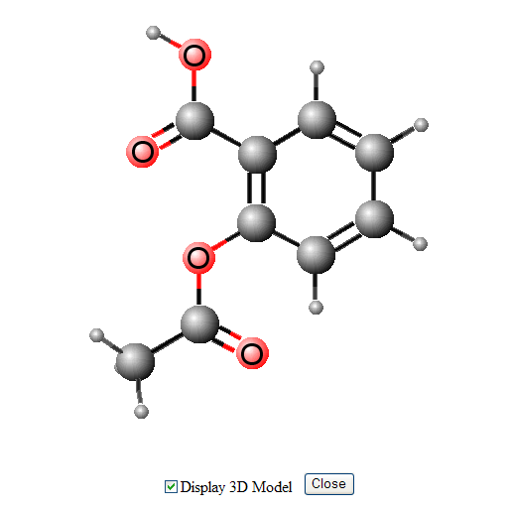
Practice Exercises

- Find the Mercury releases in Houston, Texas. Which facility has the highest amount of releases?

- What are the acute health effects associated with Victor Roach Killing Powder?

- Find the chemical structure for Furosemide

