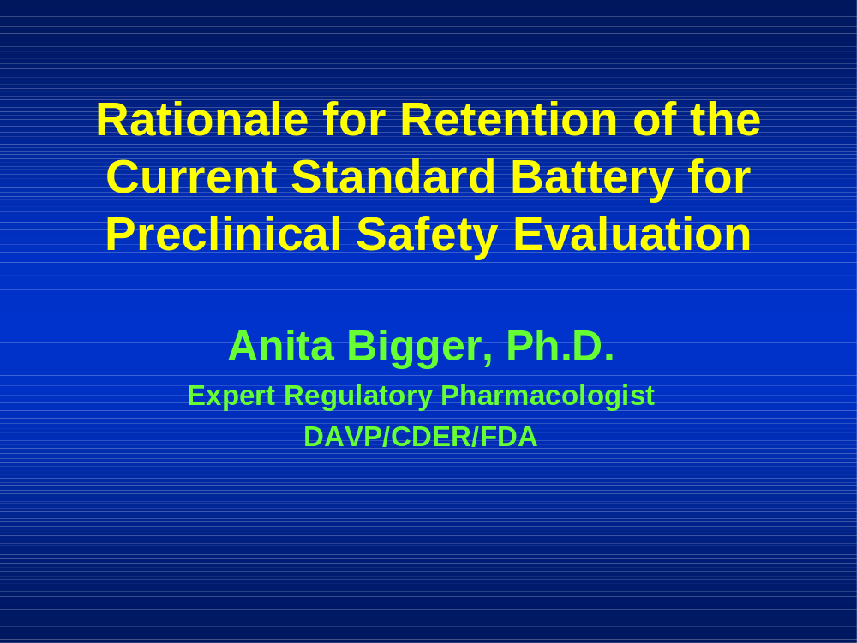

I am Anita Bigger, an Expert Regulatory Pharmacologist in the area of genetic toxicology in the Division of Antiviral Products in the CDER at the FDA.

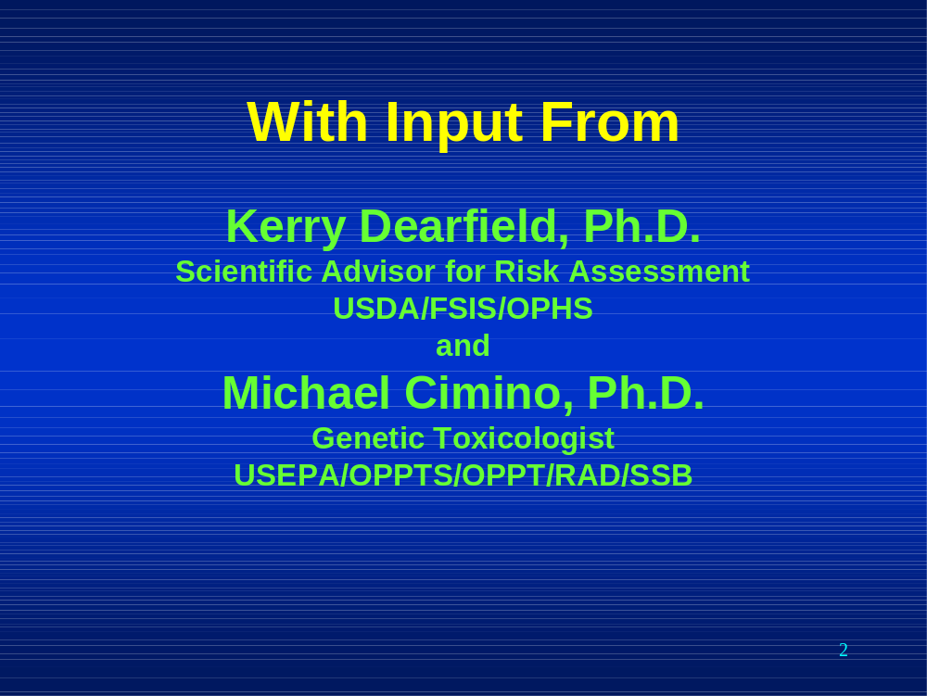

This is a joint presentation with major input from Dr. Kerry Dearfield, Scientific Advisor for Risk Assessment with the USDA and Dr. Michael Cimino, Genetic Toxicologist with the USEPA. Both Dr. Dearfield and Dr. Cimino were unable to attend this Public Hearing but wished to have their opinions conveyed at the hearing.



I’ll briefly summarize our expertise. Between the three of us, we have over 80 years experience in the field of genetic toxicology. I spent 18 years performing basic research into mechanisms of mutagenicity and carcinogenicity and was a study director for mammalian cell mutation assays. I joined the FDA in 1993. I was CoChair of the CDER Genetic Toxicology Committee from 1994 to 2006 and participated in the creation of the current S2 guidances.

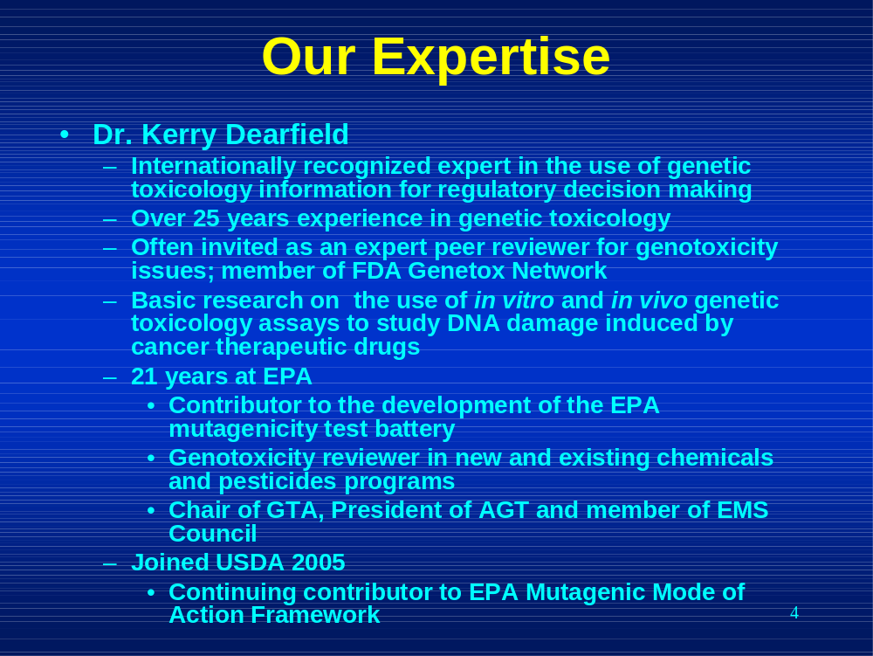

Kerry Dearfield performed basic research on the use of in vitro and in vivo genetic toxicology assays to study DNA damage by cancer therapeutic drugs. He was at the EPA for 21 years before joining the USDA in 2005.

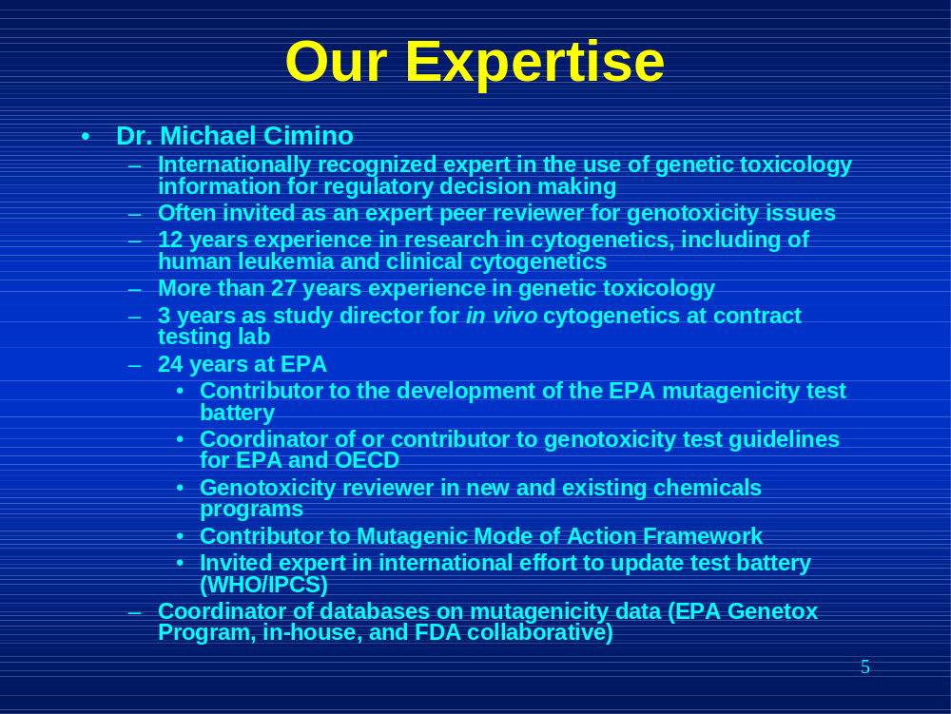

Michael Cimino spent 12 years performing basic research in cytogenetics and was a study director for in vivo cytogenetics tests. He has been with the EPA for 24 years. Both Dr. Dearfield and Dr. Cimino were major contributors to the development of the EPA mutagenicity test battery and are currently contributors to the EPA Mutagenic Mode of Action Framework. Both are internationally recognized experts in genetic toxicology and are often invited as expert peer reviewers for genotoxicity issues.

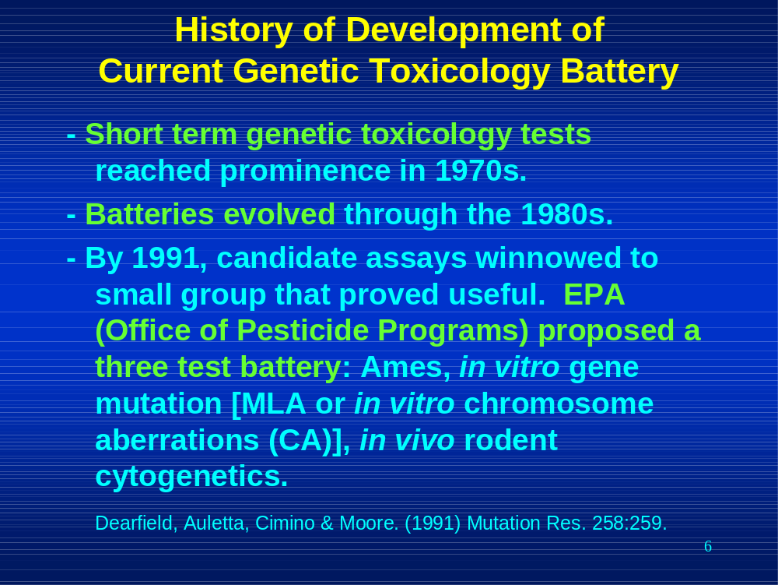

Short term genetic toxicology tests reached prominence in the 1970s. Throughout the 1980s batteries of tests evolved. By 1991, candidate assays for a battery had been winnowed down to a small group. An EPA working group proposed a three test battery consisting of the Ames assay, an in vitro gene mutation assay that could be the mouse lymphoma assay or the in vitro chromosomal aberrations assay and, the 3rd element, an in vivo rodent cytogenetics assay. This working group consisted of Kerry Dearfield, Michael Cimino, Angela Auletta and Martha Moore and I’d just like to point that three of this group are participating in this hearing.

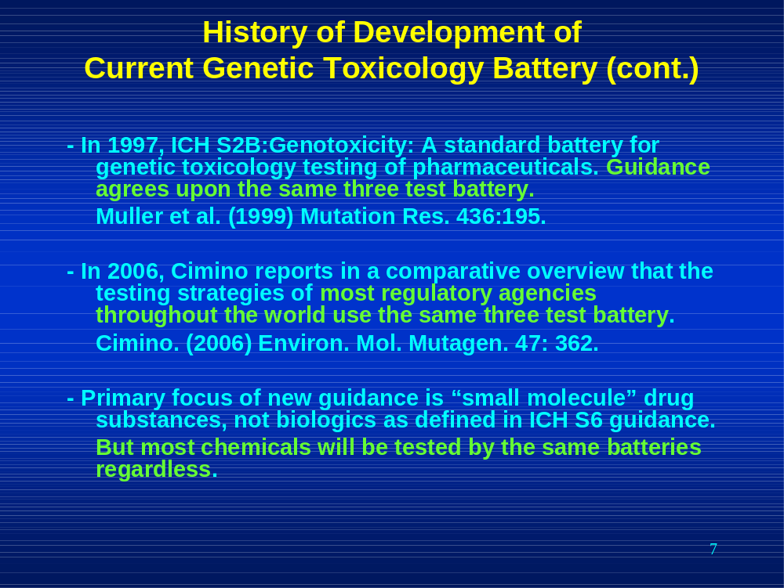

In 1997, the ICH S2B guidance was finalized. This guidance recommends the same three test battery.

In 2006, Michael Cimino reported in his overview that the same three test battery was being used in regulatory agencies worldwide.

In 2008, the focus of the revised ICH S2 guidance is small molecule drug substances and does not include biologics as defined in the ICH S6 guidance. This is an unreasonable limitation, since most chemicals will be tested by the same batteries regardless of their ultimate use.

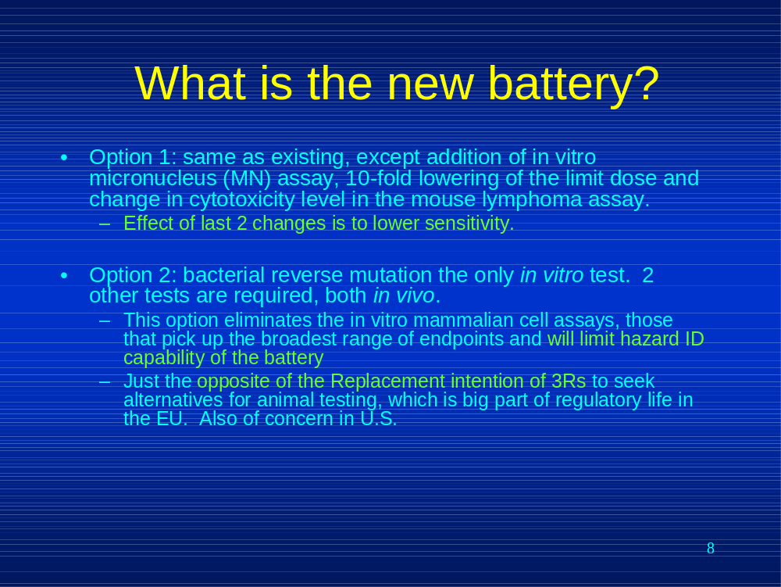

Option 1 is the same as the current battery with certain exceptions such as the addition of the in vitro micronucleus assay and lowering of the limit dose for the in vitro mammalian cell assays and change in the cytotoxicity level in the mouse lymphoma assay. The last two changes will lower the sensitivity of the in vitro mammalian cell assays.

Option 2 is different. It consists of an Ames test and two in vivo tests.

This option eliminates the in vitro mammalian cell assays. These are the assays that pick up the broadest range of endpoints. Removing these assays will limit hazard ID

This option is likely to increase animal use and takes the battery in the opposite direction of the Replacement intention of the 3Rs to find alternatives to animal testing. This is very important in the EU and also important in the US.

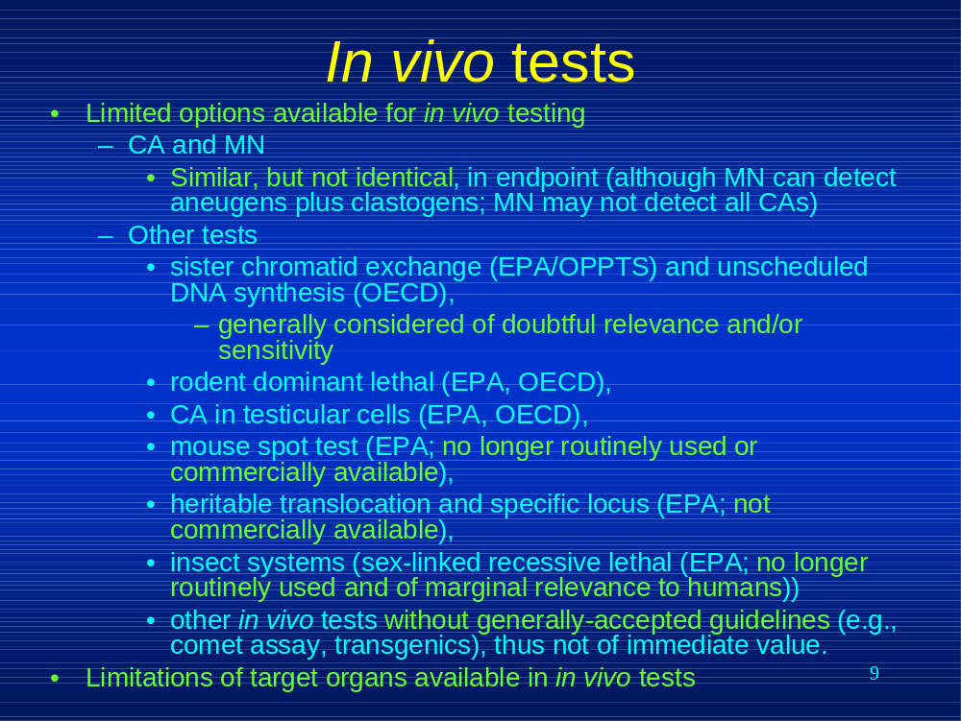

In addition, the options for in vivo testing are severely limited. The in vivo chromosomal aberrations assay and the in vivo micronucleus assay are the current validated tests. They are similar, but not identical, in endpoint, as the micronucleus assay can detect aneugens plus clastogens but may not detect all types of chromosome aberrations (e.g. translocations).

This slide lists other in vivo tests. Test guidelines exist for tests listed in the first 6 bullets. Please note the highlighted portions of the text that indicate that many of these are now considered irrelevant or insensitive or are not commercially available.

The 7th small bullet in that list addresses Other tests, such as the Comet assay and transgenics that are without generally-accepted guidelines and thus are not of immediate value.

The problem of available in vivo tests is exacerbated by the fact that there are a limited number of target organs validated for analysis in the in vivo tests. (Bone marrow, peripheral blood, testicular cells and liver are validated.)

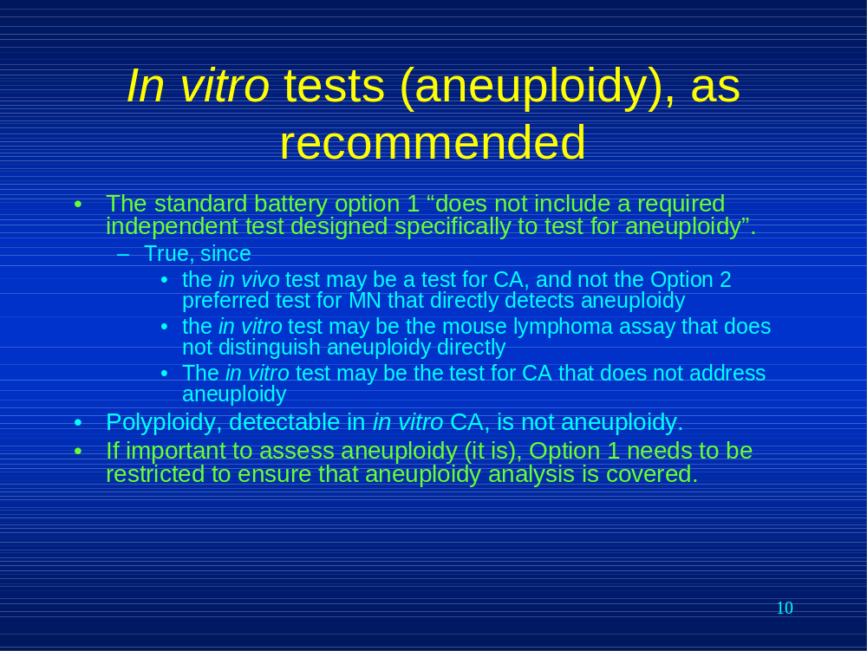

This slide addresses how aneuploidy is handled in the revised guidance.

The revised S2 guidance states that Option 1 does not include a required independent test designed specifically to test for aneuploidy. This is true because tests such as the in vivo and in vitro chromosomal aberrations assays and the mouse lymphoma assay do not directly detect aneuploidy. Polyploidy, detectable in the in vitro chromosome aberrations assay, is not aneuploidy. It is important to be able to detect aneuploidy and a requirement for testing for aneuploidy should be added to Option 1.

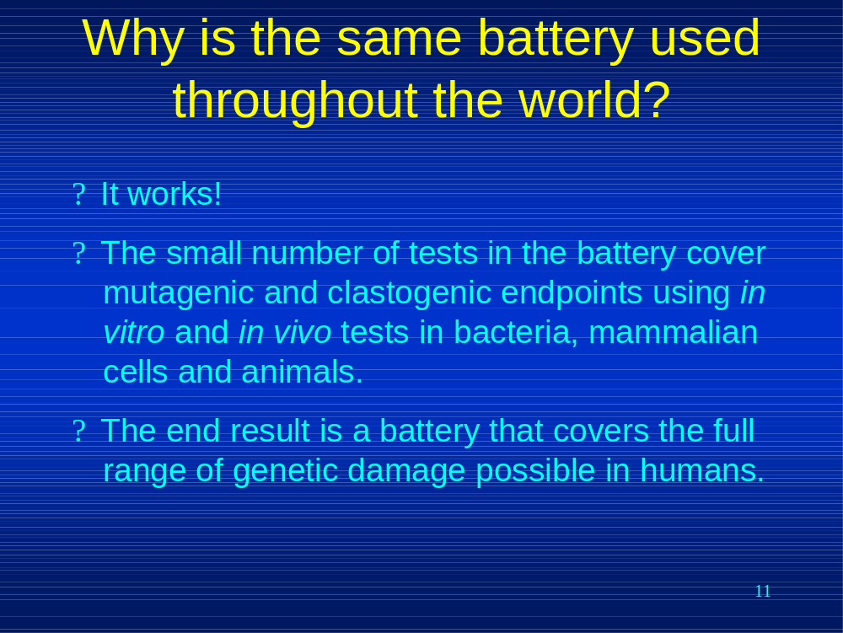

Why is the same battery used throughout the world?

It works the way it was designed to work. The tests in the battery cover the full range of genetic damage possible in humans.

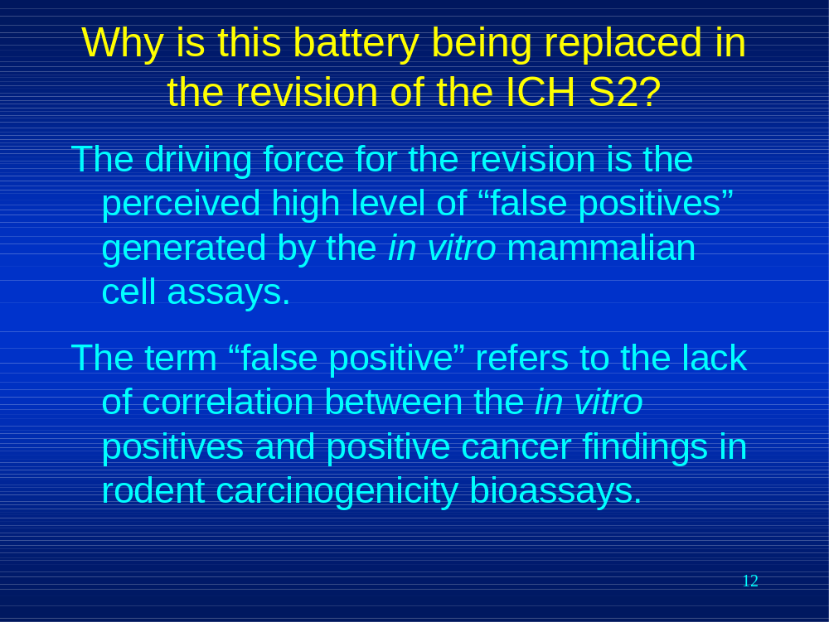

Why is this battery being replaced in the revision of the ICH S2?

The driving force for this revision is the perceived high level of “false positives” generated by the in vitro mammalian cell assays. In this case, false positive refers to the lack of a correlation with the results of rodent carcinogenicity bioassays.

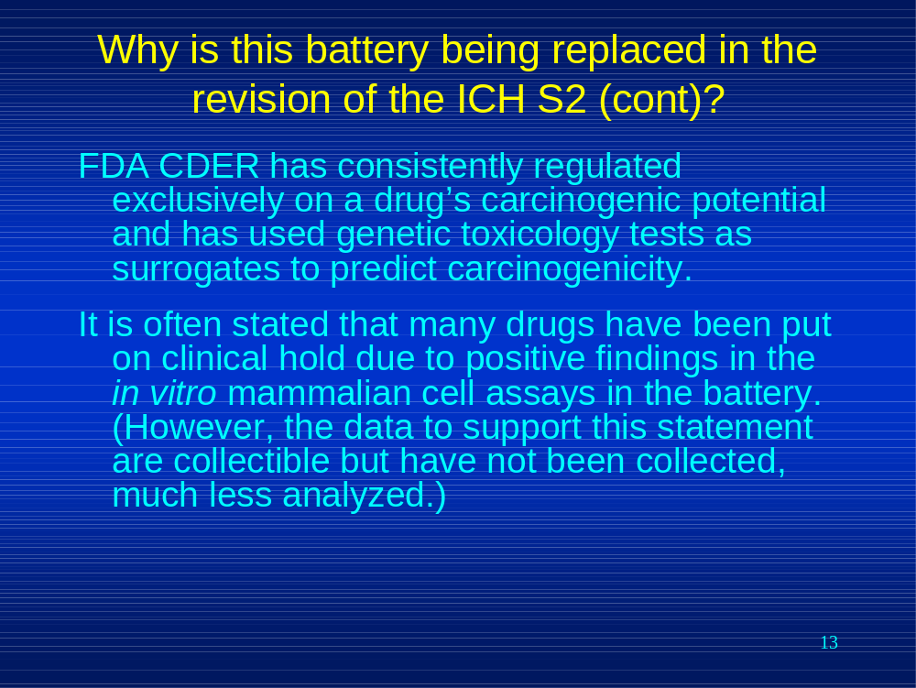

CDER has always regulated exclusively on a drug’s potential to induce cancer and has used the genetic toxicology tests early in drug development as a surrogate to predict carcinogenicity. It is often stated that many drugs have been put on clinical hold because of “false positive” findings in the in vitro mammalian cell assays. However, it is important to note that the data to support this statement are collectible, granted not easily so. However, the data have not yet been collected, much less analyzed. This should be done before major changes are made to the current battery.

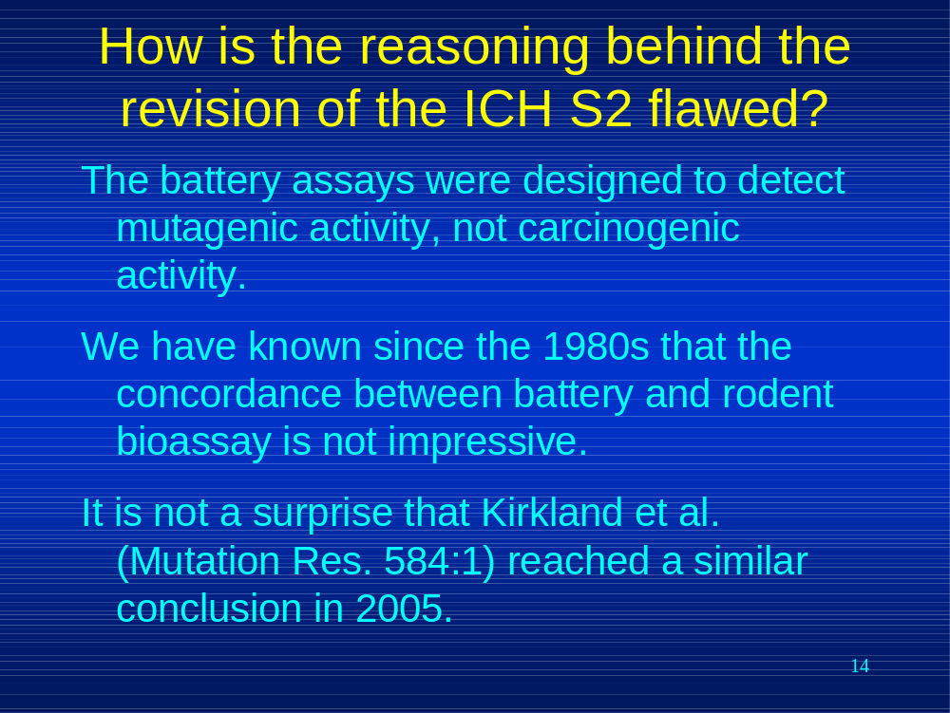

How is the reasoning behind the revision of the ICH S2 flawed?

The battery was designed to detect mutagenic activity, not carcinogenic activity. We have known since the 1980s that the concordance between battery and rodent bioassay is not impressive. Therefore, it’s not a surprise that Kirkland and coauthors reached a similar conclusion in a 2005 publication.

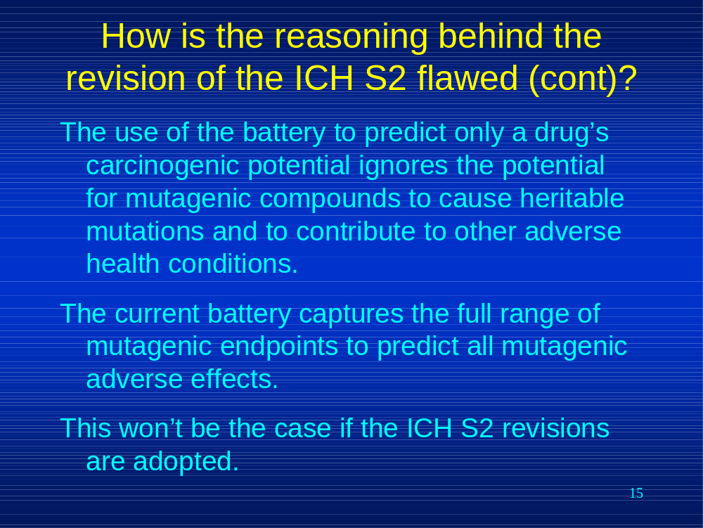

The use of the battery to predict only a drug’s carcinogenic potential ignores the potential for mutagenic compounds to cause heritable mutations and to contribute to other adverse health conditions. The current battery captures the full range of mutagenic endpoints to predict all mutagenic adverse effects. This will not be the case if the ICH S2 revisions are adopted.

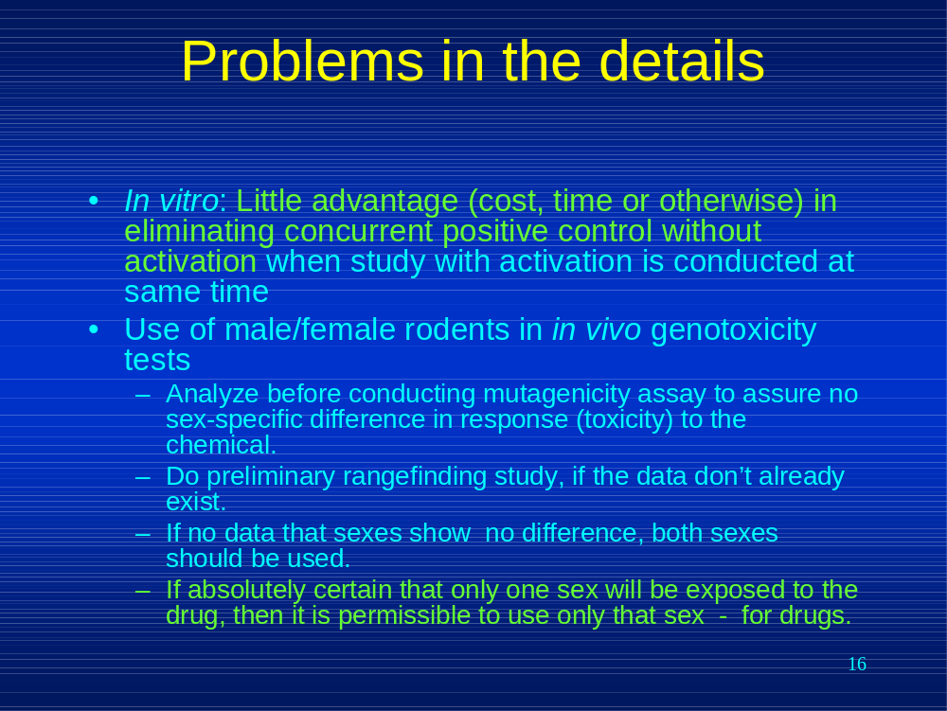

Problems in the details in the revised guidance. I’ll summarize these briefly.

There seems to be little advantage to eliminating the concurrent positive control without activation when the activated study is conducted at the same time in the in vitro assays.

The use of only one sex in the in vivo genotoxicity tests should only be allowed after sex-specific differences in response to the drug have been thoroughly ruled out.

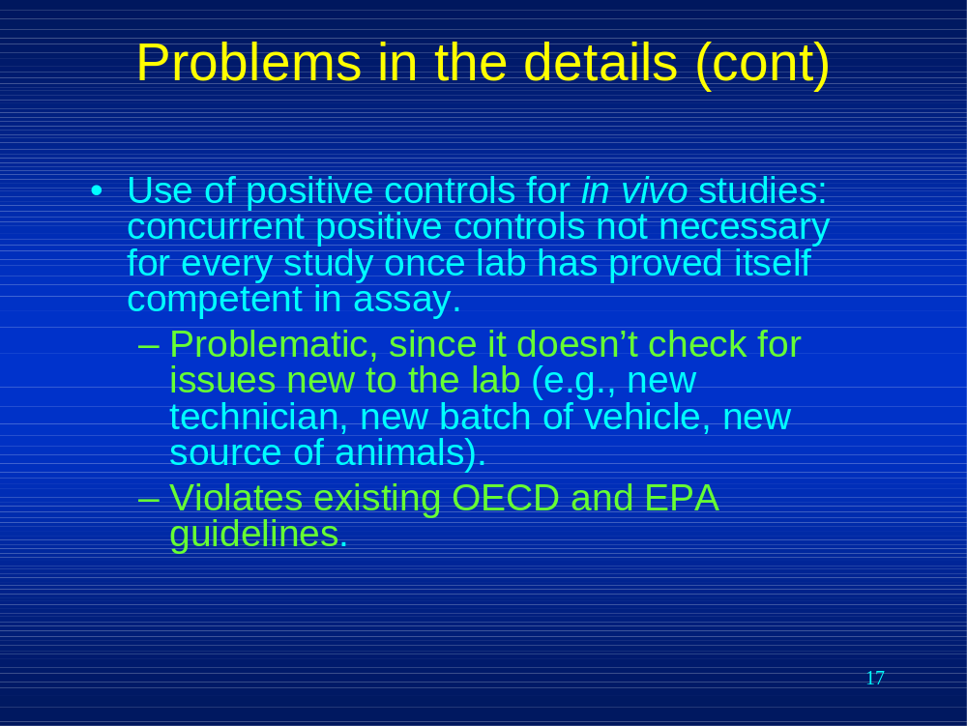

Elimination of the concurrent positive control for every in vivo assay once the lab has proven its competency can be problematic if there are new issues in the lab (new technician, new source of animals, new batch of vehicle), plus this violates existing OECD and EPA guidelines.

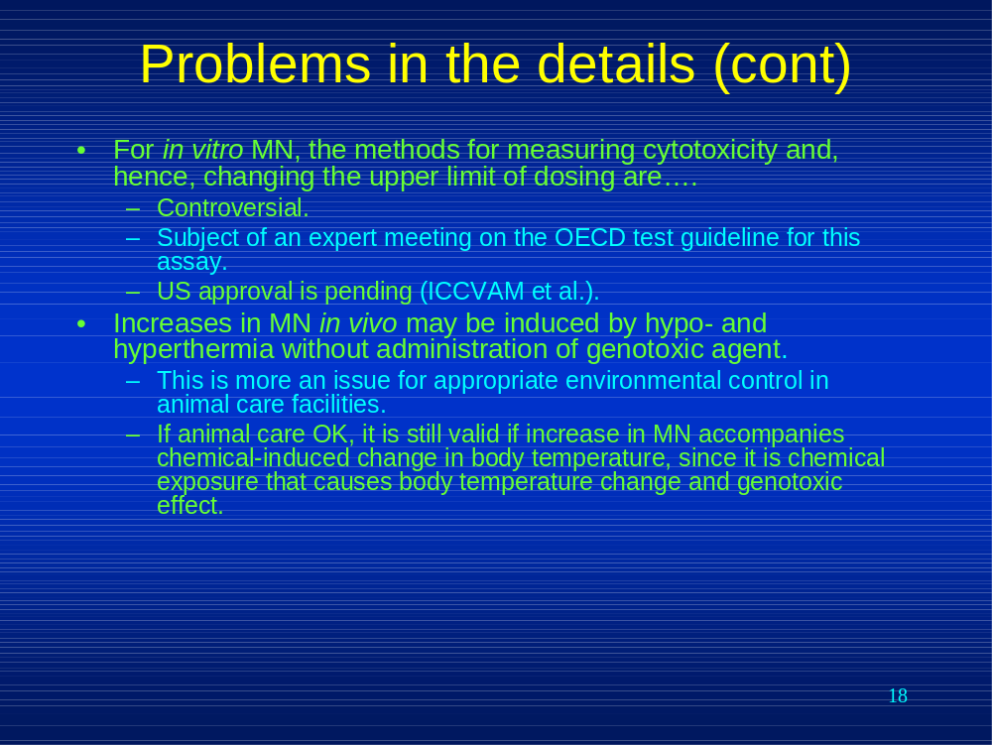

For the in vitro micronucleus test, the methods for measuring cytotoxicity are controversial as the choice may lead to possible lowering of the upper limit of dosing which will affect the sensitivity of the assay. US approval is pending

Micronuclei may be induced by changes in temperature without the administration of a genotoxic agent. However, as long as the environment is controlled and animal care is appropriate, chemical-induced changes in body temperature in the in vivo micronucleus assay do not invalidate a positive result of the test since the chemical has caused both effects.

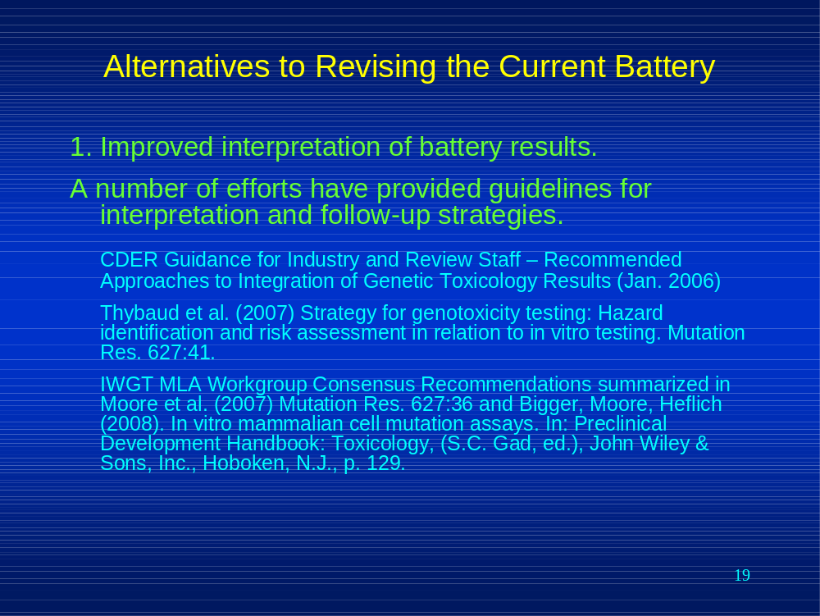

First, we believe that improved interpretation of battery results can resolve the issue of “false positives” in the current battery. A number of efforts have provided guidelines for interpretation and follow-up strategies. These include a CDER guidance and the consensus reports from two IWGT working groups.

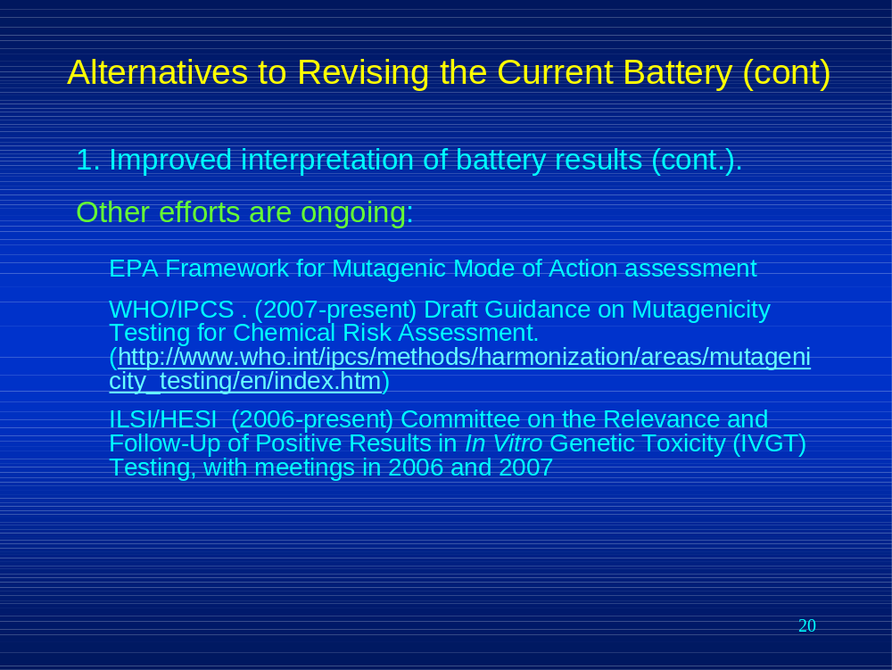

Other efforts are ongoing, including WHO/IPCS and ILSI/HESI working groups.

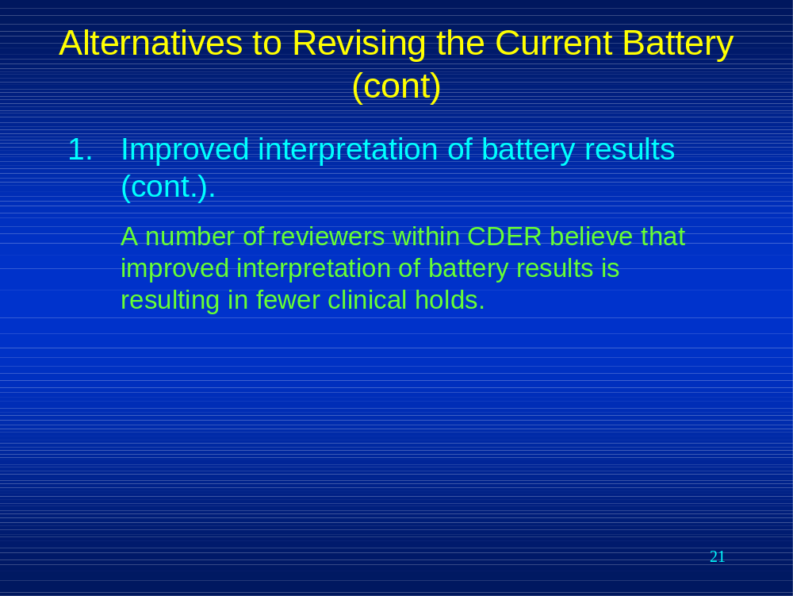

In addition, a number of CDER reviewers believe that these efforts have resulted in improved interpretation of battery results and that clinical holds have been reduced. Tim Robison spoke of the experience in his division in his earlier talk at this public hearing.

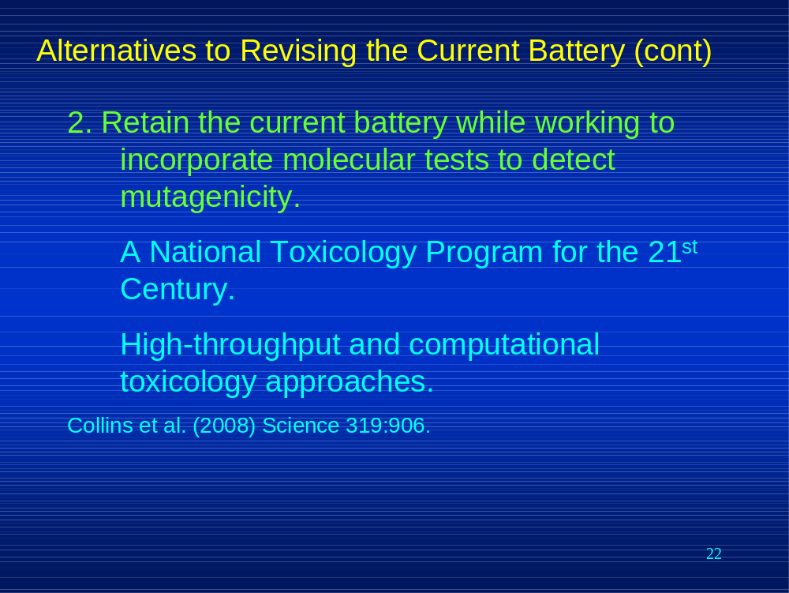

A recent publication by Francis Collins outlined the National Toxicology Program for the 21st Century that is studying the possibility of using high-throughput and computational toxicology approaches. We recommend retaining the current battery while working to incorporate molecular tests to detect mutagenicity as suggested by the National Toxicology Program for the 21st Century.

