modeling radiation effects and dosage on a commercial mobile router
Prepared by:
Alan Chmiel
David Carek
Allison Hess*

Abstract
The report details the modeling effort of a commercial mobile router for space applications. This report should be used as a reference if radiation testing of the Cisco Mini Router is performed in the future. In addition the report adds to the body of knowledge study of the radiation effects on commercial mobile routers.

Introduction
NASA Glenn Research Center is currently involved in defining next-generation communication architectures for space. These architectures are attempting to utilize Internet Protocols to ensure interoperability between terrestrial and space based systems. Current research efforts are examining the use of mobile networking devices to support Internet Protocols in future space networks[]. One such device is a commercial-off-the-shelf (COTS) mobile router, which includes hardware and software to support conventional network routing, and software to support network mobility. To be fully successful in space, COTS mobile router hardware and software will require rigorous analysis and testing to determine if the device can be used or modified for use in extreme space environments.
Mobile router technology offers the potential for transparent end-to-end connectivity with standardized protocols. However, this capability comes at the expense of more complicated software that may be difficult to certify for space flight use. The demands for software verification and validation of space rated systems will likely limit the use of many COTS products in high reliability space applications. Determining the feasibility for qualifying mobile router software is an area for future research and not included within the scope of this investigation. For the purposes of this analysis, only hardware considerations are evaluated. However, to be fully realizable in space applications, software qualification issues must be addressed.
This report provides background into the sources of radiation, potential susceptibility testing options, and some of the tools available to help model and analyze the effects radiation has on electronics and other hardware.
This report derives numerical models for several mission scenarios for the mobile router technology. The scenarios derived are: low earth orbit (LEO); ISS orbit (external to the craft); ISS orbit (internal to the craft); and lunar orbit. This report presents data on the environment for each scenario. This data is used to help define testing levels for potential future radiation failure mitigation testing. In addition this data is also used to model the dosage and flux through each integrated circuit on a Cisco Mini Router. The primary card examined within this analysis is the Mobile Access Router card (CISCO3220TMARC). However, it should be noted that two additional cards are typically used with the bundled Cisco Mini Router product. The bundled product includes a Serial Mobile Interface Card (CISCO3220TSMIC) that provides two sets of serial signals, and a Fast Ethernet Mobile Interface Card (CISCO3220TFESMIC) that provides two sets of 10/100 Fast Ethernet signals. These additional cards have not been examined within this report.
Electronics employed during space missions must be able to operate in the radiation environment of space for the duration of the mission. The two mechanisms by which radiation can create damage in electronics are ionization and atomic displacement. Ionization is caused by the collision of charged particles with matter. The charged particle passing through the medium may lose some or all of its kinetic energy. Atomic displacement is damage that results when high energy particles displace atoms from their usual site within the medium.
The goal of radiation susceptibility testing is to determine the effects of this ionizing radiation on microelectronics. The purpose of testing is to estimate ionizing radiation-induced functional interrupt rates and other error rates that can be expected in space.
Modeling performed on hardware that may be deployed into the high radiation environment can assist in engineering design, risk mitigation testing, reliability analysis, or failure analysis. The results presented here aid in the development of suitable test definitions to assess the Mini Routers for space flight applications.
The energy imparted by the ionization process is most commonly referred to as Total Ionizing Dose (TID). The TID accumulated by hardware is a function of orbit, shielding, and time. This dose is a cumulative total of the energy of all of the incident particles, causing the device to break down. A TID level is established by analysis. If that level appears to be of concern, a test should be performed to that level.
Single event effects (SEE) testing typically requires the operation of hardware in a high-energy radiation environment, such as a proton stream. Once errors are observed, an analysis is done to make an estimate of the expected error rates. This testing is typically quick as high-energy particles can be used to achieve an accelerated testing profile.

definitions
absorbed dose – the absorbed dose (D) is the quotient of ΔE_{D} by Δm, where ΔE_{D} is the energy imparted by ionizing radiation to the matter in a volume element and Δm is the mass of matter in the volume element.
apoapsis – the point in an orbit farthest from the body being orbited.
apogee – the apoapsis in earth orbit; the point in its orbit where a satellite is at the greatest distance from the earth.fluence – the time integrated particle flux (also know as integral flux).flux – The amount of particles passing through an area per unit time.
functional interrupt (FI) – an event requiring a software reboot or a power cycle.
integral flux – the number of protons, particles, or incident energy per unit area integrated over time.
ionization – the separation of a normally electrically neutral atom or molecule into electrically charged components.
ionizing radiation – any radiation consisting of directly or indirectly ionizing particles or a mixture of both.
linear energy transfer (LET) – generally described as: 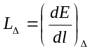where dE is the energy lost in traversing distance dl and Δ is an upper bound on the energy transferred in any single collision.
periapsis – the point in an orbit closest to the body being orbited.
perigee – periapsis in earth orbit; the point in its orbit where a satellite is nearest to the earth.single event burnout (SEB) – an event where the device has an abnormal conduction path established by the ionizing radiation and is destroyed almost immediately.
single event effect (SEE) - an event caused by atomic displacement that results in permanent or temporary damage in a device.
single event latchup (SEL) – an event where the device has an abnormal conduction path established by the ionizing radiation and as indicated by a primary power supply current change. Power must be recycled to regain control and/or to save the device from destruction.
single event upset (SEU) – an event like a bit flip resulting in a data error only.
total ionizing dose (TID) - the total dose absorbed by a device over its operational life.

SOurces of radiation
Charged particles emanate from three sources: terrestrial, solar, and galactic.
Terrestrial sources refer to those particles trapped by the earth and are generally referred to as the Van Allen Belts. The Van Allen Belts are divided into two toroidal belts, an outer belt and an inner belt. The inner belt, discovered by Van Allen, is made up of ions from galactic sources that are trapped by the earth. The inner belt extends to about 45° north and south geomagnetic latitudes and from about 800 km to about 8000 km in altitude. The inner belt can produce a flux of about 3x10⁴ protons/(cm²∙s) at energies greater than 30MeV. The second, outer belt is made up of plasma trapped by the magnetosphere. The outer belt extends to about 70° geomagnetic latitudes, north and south, and to altitudes of 130,000km. The outer belt can produce a flux of about 1x10⁷protons/(cm²∙s) at energies greater than 1MeV.
The second source, solar, is divided into four major contributing parts: Solar particle events (energetic protons), flares, prominence eruptions, and coronal mass ejections. Solar radiation is about 88% protons, 2% electrons, and 8% alpha particles; the remainders are various heavier nuclei. Solar radiation can produce a flux of about 2x10¹³protons/(cm²∙s) at energies around 20keV. Periods of solar activity can last between 10 to 100 hours and can occur two to fourteen times a year. The number of significant events is typically one to two times a year.[][]
The third source of radiation is Galactic. Galactic Cosmic Rays (GCR’s) originate outside the solar system. GCR’s are 98% atomic nuclei and 2% electrons. Of the atomic nuclei about 90% are protons. Energies range from 10⁷ to 10¹⁹ eV with an average of about 10¹² eV.

Types of Radiation
The types of radiation that dominate space are protons and heavy charged particles, electrons, neutrons, and electromagnetic radiation. The following is a very brief description of each type of radiation. A more detailed explanation can be found is NASA CR-1871 in the section titled “Effects of the Interaction of Radiation with Matter.”[]

Protons and Heavy Charged Particles
A proton is a positively charged hydrogen ion. Most of the radiation that a spacecraft encounters is proton radiation. Energies in space will range from 2000eV to 10¹⁹ eV. The primary process by which a proton imparts energy is Coulomb-force interaction with atomic electrons.

Electrons
An electron is a particle with a mass of 1/1800 that of a proton and has a negative charge. Electrons in space are primarily found in the Van Allen belts and as secondary particles that result from collisions with other charged particles.

Neutrons
Neutrons are uncharged particles whose mass is almost equal to a proton. They are typically produced by nuclear reactions, but can also be produced when alpha particles interact with light elements such as lithium.

Electromagnetic Radiation
Electromagnetic radiation is a discrete quantity of energy, which travels in a straight line at the speed of light. High-energy electromagnetic radiation is usually gamma rays that emanate from the nucleus of an atom.

Mobile Router Use Scenarios
This section identifies several mission scenarios with the potential to use mobile router technology. These mission scenarios are used to define radiation characteristics that the device must withstand. While other mission scenarios are plausible, this subset represents a reasonable cross section of potential mission applications.
Scenario 1 – Polar Orbit Science Satellite
A mobile router onboard a science satellite could serve several purposes. First, the device could act as a gateway to isolate and rate limit data traffic between various onboard subsystems, such as command and data handling, attitude control, data storage, sensor data acquisition, and external communications interfaces[]. In addition, the device could use mobility aspects in software to maintain end-to-end connectivity to a single ground processing site through a disperse ground station network. The operating environment for this scenario is an unpressurized volume requiring an active or passive thermal control system.
Scenario 2 – International Space Station (external)
NASA Glenn Research Center has investigated concept architectures for a direct to ground communications system to augment the downlink of International Space Station science payload data (the Advanced Communications Architecture Demonstration). The location for this scenario is an external pallet adapter. Similar to scenario 1, a router device could be used to isolate and rate limit subsystem communications as well as provided end-to-end connectivity to disperse ground stations. The operating environment for this scenario is an unpressurized volume requiring an active or passive thermal control system.
Scenario 3 – International Space Station (internal)
Two uses are envisioned for this scenario. The first is the use of the device within a single payload to route data among various computers associated with the experiment. Similarl to scenario’s 1 and 2, the ability to isolate and rate limit data traffic allows mitigation of problems associated with competing traffic flows. The second use is to route and isolate data among different payload racks. Current International Space Station hardware uses a payload Ethernet hub gateway (PEHG) to perform this function. In a hub configuration all payloads see each other’s traffic. A router in this scenario could isolate data among different legs of the network as well as provide rate limits to avoid exceeding bandwidth limitations for downlink paths. These scenarios would not necessarily need the mobility aspect of the router for return links that go through the Tracking Data Relay Satellite System (TDRSS) network. However, if a direct to ground option was available, the mobility aspect could potentially be used. The operating conditions for this scenario are a pressurized environment internal to the Space Station, allowing for air-cooling or cold plate cooling through rack cooling loops.
Scenario 4/5 – Lunar Orbit Communications Satellite
A lunar communications relay satellite may need to communicate with multiple lunar surface assets in addition to Earth. Data transmission from one lunar surface asset to another, or from a surface asset to Earth could be established through the relay satellite. A mobile router device onboard the lunar relay satellite could direct the data to the appropriate RF device based on the destination address. The mobility aspect of the router for the lunar/earth link would have limited application due latency problems with standardized protocols (e.g. transmission control protocol) over those distances. However, mobility features might be used among lunar surface assets. The operating environment for this scenario is an unpressurized volume requiring an active or passive thermal control system.

Orbital Parameters

Scenario 1
Scenario 1 is a 90° orbit at an apogee of 400km. The solar weather is quiet. The model assumes no shielding, case shielding is added using the MNCP modeling package.

Scenario 2
Scenario 2 is a 51.6° orbit at an apogee of 450km (This is the standard ISS orbit). The solar weather is quiet. The model assumes no shielding and the location is assumed to be the ISS exposed facility.

Scenario 3
Scenario 3 is the same 51.6° orbit at an apogee of 450km (ISS orbit), with the solar weather quiet. The model assumes no case shielding. The location is assumed to be internal to the US-lab.

Scenario 4
Scenario 4 is a lunar orbit at an apoapsis/periapsis of 85 km. The solar weather is quiet. The model assumes no shielding.

Scenario 5
Scenario 5 is identical to scenario 4 but uses the peak flux model for solar flare activity. This model is based on the peak five-minute averaged fluxes observed on GOES in October 1989. This model is not realistic for a whole orbit transmission model, but is used in this analysis to bound worst-case limits.

environment Models
Cosmic Ray Effects on Micro Electronics - 1996 Revision (CREME96) is used for creating the numerical model of the ionizing radiation environment in near-earth orbits. CREME was originally developed in 1981[] by the Naval Research Laboratory. The CREME96 update takes into account additional knowledge collected experimentally about the ionizing environment of space. CREME96 is the DOD standard for radiation environment modeling (MIL-STD-809.) CREME96 has been found to be in good agreement with measured near-earth data.[][] Additional updates to CREME96 include the introduction of a trapped proton model.
For clarification, several items should be explained before the data is presented. The solar radiation environment is not taken into account explicitly in the requirements. For completion, a fifth scenario is added to help account for the addition of solar particles. To accomplish this AP-8, Trapped Proton Environment Model[] is used. This report does not include the trapped electron environment, which is defined in AE-8[].

AP-8 is a model that predicts min and max proton environments

AE-8 same but for electrons
For each scenario the target material is assumed to be silicon. Each model assumes one orbit. The range of elements is assumed to be Z<28, or all elements with an atomic number less than or equal to 28 (nickel). For most applications this is sufficient. Energetic particles with Z>28 are rare and are generally negligible. If the target device has a very high SEE threshold, or if the mission scenario has a requirement for a very low SEE rate then Z will be expanded to 92. All of the results presented start at an LET of 0.1MeV. LET’s less than 0.1MeV are excluded because they are generally absorbed by the cover layer.
Each scenario is presented below. Using the CREME96 model described above a numerical model was generated for each scenario. Figures 1 through 5 presented in Appendix A show the relationship between flux and LET or energy for each scenario.

The left-hand plot shows the relationship between integral flux and LET. The center plot represents the relationship between the trapped proton flux and the particle energy. Scenarios 4 and 5 do not have a trapped proton flux plot. The lunar position is outside the Earth’s Magnetosphere, therefore there is no significant contribution of trapped protons. The right-hand plot shows the flux of the first five elements Z<5. Some plots do not show all five elements as the excluded elements make minimal contributions to the total flux.

The model results for scenario 2 show a much higher flux than scenario 1; this is the result of the South Atlantic Anomaly.

 | Scenarios
 | 1 | 2 | 3 | 4 | 5
Orbiting Body | Earth | Earth | Earth | Lunar | Lunar
Apoapsis | 400 | 450 | 450 | 85 | 85 |  | km
Periapsis | 400 | 450 | 450 | 85 | 85 |  | km
Inclination | 90 | 51.6 | 51.6 | 0 | 0 |  | °
Shielding | 0.00 | 0.00 | 0.63 | 0.00 | 0.00 |  | cm
Proton Model | AP8MIN | AP8MIN | AP8MIN | AP8MIN | AP8MIN
Solar Weather | Quiet | Quiet | Quiet | Quiet | Peak
Elements | <28 | <28 | <28 | <28 | <28 |  | Z
Min. Energy | 0.1 | 0.1 | 0.1 | 0.1 | 0.1 |  | MeV
Table I - Operational Scenarios

SHIELDING

Absorbed dose is a function of the material and the shielding between the radiation environment. Doses in silicon at the center of an aluminum sphere, representative of doses to electronic devices shielded by an equivalent thickness of aluminum, are given in Figure 8. These doses are based on the proton environment presented in scenario 2 and are given for a range of aluminum shield thicknesses. All doses are calculated from the trapped proton /electron environment using the SHIELDOSE model. The SHIELDOSE model is documented in NBS Technical Note 1116. The data shows the importance a good shielding philosophy has on the total dose.

Testing
To successfully conduct testing and establish the effects of radiation on a device an understanding of available test facilities and potential test methods is required. This section briefly elaborates on potential test facilities and a possible approach to testing.

Facilities
Facilities able to mimic the environment in space are required for testing because the heavy ion and proton flux on Earth is much smaller than is encountered in space. A survey of facilities available for testing electronics that will undergo space flight are detailed in the attached tables. Table 1 lists some of the accelerators that are being used for heavy ion research. Table 2 lists some facilities that are exclusively proton accelerators. Heavy ion facilities are useful if engineering concerns persist about a devices susceptibility to heavy ions. As detailed earlier, protons make up the great majority of the environment to which most hardware is exposed. Typically proton testing is sufficient and the approach method discussed below is centered on that approach.

Approach
Of all electronic components, semiconductors are the most sensitive to radiation. For most applications semiconductor-device performance will determine the maximum radiation flux that an electronic circuit will tolerate. Radiation can cause both permanent and temporary damage to the device. Permanent effects are attributed to bulk damage. The term “bulk damage” is used to describe changes in the properties of structures caused by atomic displacement as a result of exposure to a radiation environment. Temporary effects are generally attributed to the generation of excess free carriers in the junction regions as resulting from exposure to high energy particles.
The most effective way to determine the effects of radiation on microelectronics is through testing the devices in radiation environments.
Several methods exist for conducting radiation testing. Not all of these methods are discussed in detail in this report. The omitted methods are described in references , , and . Each method of radiation susceptibility testing requires use of SEU test data, which is measured at a testing facility.
During testing, electronics are exposed to a uniform particle beam to extract failure rate information. A general method for this type of testing is to use the beam test results to determine a failure rate (failures/unit time). The failure rate divided by the particle flux gives the SEE cross section and is usually defined as
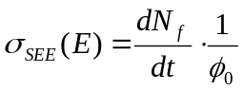,
where dN_{f}/dt is the failure rate, and ₀ is the particle flux. This data can now be used to calculate the soft error rate (SER). To determine the SER, the product of the differential energy flux and SEU cross section are integrated over the energy spectra of interest. The SER is expressed as
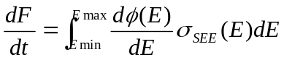.
This result gives a number of failures per unit time for a given range of particle energies.
For the purpose of data taken, the SER cannot be determined for any energy other than beam energies. Therefore, data taken during testing is reduced statistically, using the data from the modeling effort rather than numerically, to give an approximate failure rate. This statistical approach can be calculated using the Bendel A method.[] Efforts have been made by NASA to create computer codes to perform this analysis from test data. []
Another method, sometimes referred to as the Burst Generation Rate (BGR) method, was developed by Ziegler and Lanford [] to numerically determine the SEU rate induced by proton/neutron interactions with microelectronics. The BGR method hinges on the statistical theory that only recoil reactions cause upsets. According to the BGR method the SEU rate can be approximated by
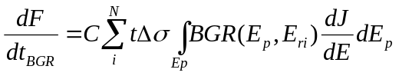
where C is the collection efficiently, t is the collection depth in µm, Δσ_{i}=σ_{i}-σ_{i-1} where σ_{i} is the heavy ion SEU cross section for the i^{th} portion of the curve expressed in cm², BGR(E_{p},E_{ri}) is the burst generation rate is cm²/µm³, E_{p} is the energy of the incoming particle in MeV, E_{ri} is the ith recoil energy, (E_{ri} = t  0.23  LET_{i} [MeV]) and dJ/dE is the differential flux in particles/cm²∙sec∙MeV. []
The BGR method is effective for older devices, but does not handle modern devices with smaller sensitive volumes. The method also assumes that the charge collection region is constant, which in actuality it is not. The charge collection region changes dimensions depending on the total deposited energy and location because the depletion region collapses if the energy is sufficiently high. Modern devices have complex charge collection regions because diffused charge in the substrate, well beyond the depletion region, can be collected by a reverse-biased junction. []

Another method of testing is to determine the threshold values for both failure modes (permanent and temporary). This test requires a source where the ion species and energies can be changed. Once the threshold is observed experimentally the expected SEU rate can be determined numerically by integrating the fluence from the threshold to infinity. This method has proven to be more costly than the previous method. In general each of these methods is considered a reliable predictor of error rates, but the last method is more valuable to the reliability analysis effort.
Assuming the use of the Bendel A method described above the following may be a testing option. Using the Midwest Proton Radiotherapy Institute facility at Indiana University (Described in Appendix A) each scenario can be tested, scenario 1 will be detailed here. All the data for each scenario is presented in table form at the end of this section. From the data in Appendix A the average integral flux, discounting solar flares, for the entire spectrum of scenario 1 can be calculated to be 0.652x10⁶ protons/cm²·day. For this example the total mission duration will be assumed to be ten years. Therefore for the entire mission the total integral flux will be 2.38x10⁹ protons/cm². Each cm² of the device under test will be exposed to 2.38x10⁹ protons. Given the capabilities at the IU Cyclotron Facility the exposure of each square centimeter will take approximately two minutes. Therefore for each test position the total run time should not exceed three hours. This total test time can be reduced by only testing critical components, but a critical component analysis is beyond the scope of this report. The testing will yield a number of failures, hard and soft, permanent or temporary, for the mission duration. The Bendel A method can then be applied to predict a mean time between failures for this mobile router.
 | Fluence /  Day | Fluence/  10 Year | Test Time per component [minutes] | Total Test Time [Hours]
Scenario 1 | 652.00E+03 | 2.38E+09 | 2 | 3
Scenario 2 | 2.63E+06 | 9.60E+09 | 6 | 10
Scenario 3 | 3.79E+06 | 13.83E+09 | 9 | 15
Scenario 4 | 9.09E+03 | 33.18E+06 | 1 | 2
Scenario 5 | 67.00E+09 | --- | 41 | 70

Scenerio 5 does not have a calculation for fluence per mission life since during any 11 year cycle the peak solar activity should only occur during a single day.

Reliability
As stated above data gathered from testing is used to perform analysis to estimate the SEE susceptibility of the device under test. The results collected for a given particle and energy can be used in conjunction with available analysis tools to generate a composite MTBF number due to atomic displacement for a device. In general a failure can be defined as one of the following:
• Single Event Upset (SEU) – an event like a bit flip resulting in a data error only.
• Functional Interrupt (FI) – an event requiring a software reboot or a power cycle.
• Single Event Latchup (SEL) – an event where the device has an abnormal conduction path established by the ionizing radiation and as indicated by a primary power supply current change. Power must be recycled to regain control and/or to save the device from destruction.
• Single Event Burnout (SEB) – an event where the device has an abnormal conduction path established by the ionizing radiation and is destroyed almost immediately.
Microelectronics can experience a reduction in reliability due to TID[]. A relationship between component life reduction in a transistor is generally given as:
τ_{Φ}= τ_{o}+ (1/Κ_{τ}φ)
Where:
τ_{Φ} is the component life after exposure
τ_{o} is the component life before exposure
Κ_{τ} is the lifetime damage constant (cm²/particles)
Φ is fluence (particles/cm²)
Each of the dependant variables can be observed directly through an elaborate test program.
Damage from atomic displacement—as previously discussed—can occur from primary or secondary effects. If a particle enters a material and is of high enough energy to impart recoil energy it will displace an atom by the primary collision and several more through secondary effects. The number of atoms displaced by secondary collisions is given through the equation:
N_{s}(E)=fE/2E_{d}
Where:
N_{s}(E) is the number of atoms displaced
f is the fraction of recoil atoms energy that will be consumed by ionization
E is the displacement energy
E_{d} is average over all directions of the displacement energy
This relationship was theorized by Lindhard[] and has been confirmed experimentally for silicon by Sattler [].
These atoms create vacancies in the structure which, if not annealed, can cause contamination in materials. It is not known how contamination can effect long term reliability.[] However, a device that has been recovered through low-temperature annealing, may tend to be more sensitive to further radiation.^{[13]}
There exists a particle of high enough energy to permanently damage microelectronics in an SEE, thereby affecting reliability numbers. Since this particle is undetermined by theory, the reliability numbers cannot be devalued for the purposes of analysis without direct observation during testing.

Radiation Modeling
Modeling the effects of radiation on matter is a complex task that requires the understanding of both the environment and the exposed material. The modeling effort must include the effects of neutrons and protons and give both the initial energy of the particles as well as the energy deposited by recoiling atoms and their directions. The physical environment, material composition, physical size, and other variables must also be included in the models. For this task MCNP[] will be used. MCNP is a good general application particle modeling toolkit. Modeling is effective in providing absorbed dose rates, and fluence at locations within the electric circuit.

Modeling
The collision of energetic particles into electronic devices can cause two types of damage to the device. Both types of damage result from incident energetic particles imparting energy upon the atoms in the silicon. The damage is called ionization damage when an electron-hole pair is produced. The operation of semiconductor devices is highly dependent on the number of carriers. The current through the device can become too great if the number of carriers is too high, thus damaging the device. The modern silicon chips are especially susceptible to damage of this variety as the physical dimensions are small. As mentioned in previously the damage is referred to as displacement damage when an atom is displaced from its normal position to an interstitial or another lattice site. [] The displacement of an atom inevitably leaves a vacancy in its former position. The problem with this type of damage is that one displaced atom displaces other atoms and creates a disordered region.[] This damage can be reversed by annealing. This reduces the defects in the material and reunites vacancies and interstitials.

Shielding can prevent damage to electronics. All electronics have a threshold LET above which damage is done to the device. Shielding the device with some other material will allow the particle to expend its energy prior to reaching the electronics of the device in question. Hence, when the particle does reach the electronics, the energy imparted is not enough to cause damage. The energetic particles that this will still have enough energy to cause damage are very few in number and are unlikely to be encountered.

The modeling was completed with MCNP. MCNP is a general-purpose Monte Carlo N-Particle code that can be used for particle transport. Specific areas of application include, but are not limited to, radiation protection and dosimetry, radiation shielding, radiography, medical physics, nuclear eriticality safety, Detector Design and analysis, nuclear oil well logging, Accelerator target design, Fission and fusion reactor design, decontamination and decommissioning. The code treats an arbitrary three-dimensional configuration of materials in geometric cells bounded by first- and second-degree surfaces and fourth-degree elliptical tori.

The five scenarios were all set up using the Visual Editor for MCNP5. This editor was useful for providing an input deck window as well as for providing a graphical interface for the geometry being described in the input deck. The Visual Editor was not useful for running the scenarios and returned many errors. A DOS command window was used to run the scenarios. MCNP5 has three possible particle modes: neutron, photon, and electron. All of the scenarios were set up to run under the neutron mode to ensure that no errors were made in the geometry or other cards in the input file.

Setting up the geometry required the dimensions for the fiberglass circuit board, each silicon chip, and any other components of interest. Each surface is represented by a single input card by a plane oriented perpendicular to either the x-,y-, or z-directions. An additional spherical surface was added in order to provide a surface from which the particles are originating. The cells were then defined on the input deck cards by defining the surfaces that enclose them. Also defined on the cell cards are the material of the cell, as well as the density of that material. The volume inside the sphere, but outside of the mini router also had to be defined as a cell. As all space has to be accounted for and be a part of a cell, the space outside of the sphere was also designated as a cell.

The data cards were the next to be defined in the input deck. The material cards were defined on input deck cards by defining each element in the material, the abundance of that element, and the location of the cross section for that element. The mode was classified to be the proton mode. The importance of protons in each non-void cell was given an importance of 1, while those in the void outside of the sphere was given an importance of 0. The PHYS card was used to define the maximum energy for a given proton, which is approximately 30,000 MeV.

The SI and SP cards differentiate between the five scenarios. While the SI, or source information cards, are the same for all five scenarios, the corresponding SP, or source probability, cards are different for each scenario. The SI card defines the energy bins for the protons and the SP card defines the probability of the incident proton having an energy in a given energy bin. It was important to note that an energy of less than 1 MeV is not permissible on the SI card.

The reason that low energy particles are negligible is that local case shielding on the electronics would be sufficient to fully shield these low energy particles.

The tally cards are use to find the proton flux through a given cell or the number of protons passing over a given surface. The useful data from the scenario is the same as the data from the tallies. Calculations can be made using the result of these tallies to get other desired quantities—fluence and dose in this case.

The five scenarios were run using MCNPX 2.4.0. The advantage of MCNPX 2.4.0 over MCNP5 was that it has more particle modes than does MCNP5. Proton energy data was provided, and therefore the proton mode was necessary for accurate data. The relative error given with the tally data is dependent on the number of incident protons being aimed at the mini router.

The data can come in two forms under the tally counts. It can either tally the number of protons, or it can tally the cumulative energies of the incident protons. In this problem, it was most beneficial to use the energy tally for the surface count and the number tally for the cell flux.

Also important to the problem is the number of particle histories run, as designated by the NPS card. The higher the number of particle histories run, the lower will be the relative error for the tallies. The writers of the MCNP5 manual emphasize that the relative errors and tallies cannot be considered reliable unless the relative error is less than 10%. A combination of trial and error and calculation led to the NPS being set to 120,000,000 particles. Each scenario took approximately 20 hours to run and only one scenario could be run at a time.

Upon completion of running the scenarios, calculations where performed to find the fluence and dose of radiation entering the silicon chips. In order to do the calculations, it was noted that the output of the *F4 tally is in the units of MeV/cm² when the input is in MeV. Since the LET data was given in MeV•cm²/g, the output of the tally is in MeV/g. Using the mass and surface area of the cells of interest, the data was manipulated in order to achieve the units consistent with fluence (flux across some surface over time) and absorbed dose (energy deposition per mass over time).

The fluence and dose data, combined with data on the tolerance of the silicon chips to radiation can be used to estimate the lifetime of the mini router in any of the given radiation environments.

RESULTS
All modeling was completed and the results are displayed in appendix A. Figures 7 and 8 show the models used by MCNP. The visual representations are rendered with Autocad using a program written in visual basic to transfer the geometry data from MCNP to Autocad. Colors and labels were added in Autocad for orientation, Figures 9 and 10 show actual images of the Cisco Mini Router for comparison.
Figure 11 shows top and bottom layouts of the Cisco Mini Router and how the each Cell was mapped into MCNP (Numbers in Black with Leaders.) The Surfaces in the X and Y planes are also identified (in red.)

Energy loss as a function of penetration is commonly characterized by Bragg’s Curve as shown in Figure 1.

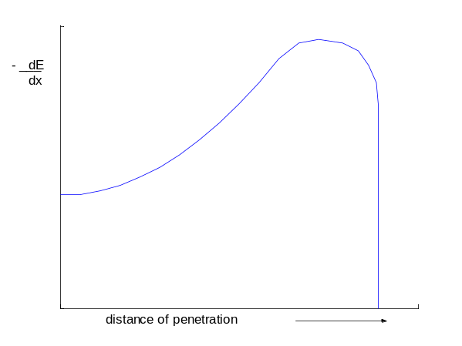
Figure 1. Bragg’s Curve

Energy distribution in a substrate is a function of the number of particles and the energy of each particle. This was demonstrated experimentally and is shown in Figure 2. E is the particle energy, f is distribution and X is distance.
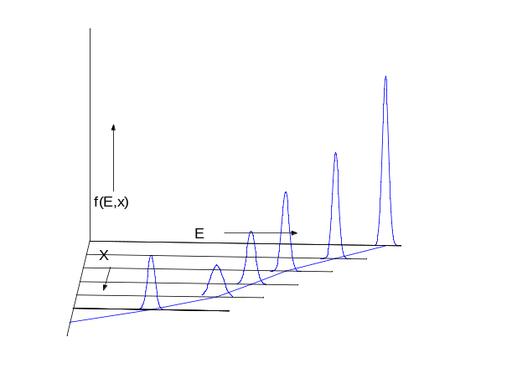
Figure 2. Substrate energy distribtuion
The energies imparted by the energetic particle into the substrate is modeled with MCNP.

Table 3 shows the flux across each cell during the run for each scenario. Table 4 shows the total absorbed dose in Rads(Si) for the Mini Router in each run configuration. Please note that the results for scenario 5 are not presented per year as the duration of a solar flare typically last for only minutes or hours.

Figure 12 shows the flux versus energy for Cell 8 in Scenario 1. For the sake of brevity not all of the flux data is shown for each cell in graphical form. The data is presented in the appendix for each cell and each scenario. Figure 12 does show some very interesting results. It shows that the particles of low energy are absorbed either by the air or by the cover layer and as a result does not contribute to the total flux through the cell, this result was expected, and supports the decision to exclude low energy particles from the model.

The results show that all parts are dosed evenly as a function of surface area, and suggests that all parts should be tested to the flux levels presented here. The results of testing can be analyzed using one of the methods outlined earlier and a reliability analysis can be performed.

Conclusion
This preliminary report presents operational scenarios for the use of a mobile router in space applications. These operational scenarios were translated in to specific mission classes with orbital parameters to prepare environmental models. The results and background information presented here will be used along with further analysis to present a study of the effects of radiation on a specific implementation of a commercial mobile router.

This report details an approach, method and options for using testing combined with analysis and modeling to generate error rates and reliability data for microelectronics based on an operating radiation environment. Future research used in conjunction with the test method detailed above and the operations scenarios defined previously can help mitigate the effects of radiation on microelectronics.

The modeling completed here suggests that the Cisco mini router, with proper testing is a candidate for space applications in a high radiation environment. The Cisco mini router should be tested to the flux levels presented here. The results must then be analyzed before an MTBF for radiation damage can be assessed.

APPENDIX A – Figures and REsults

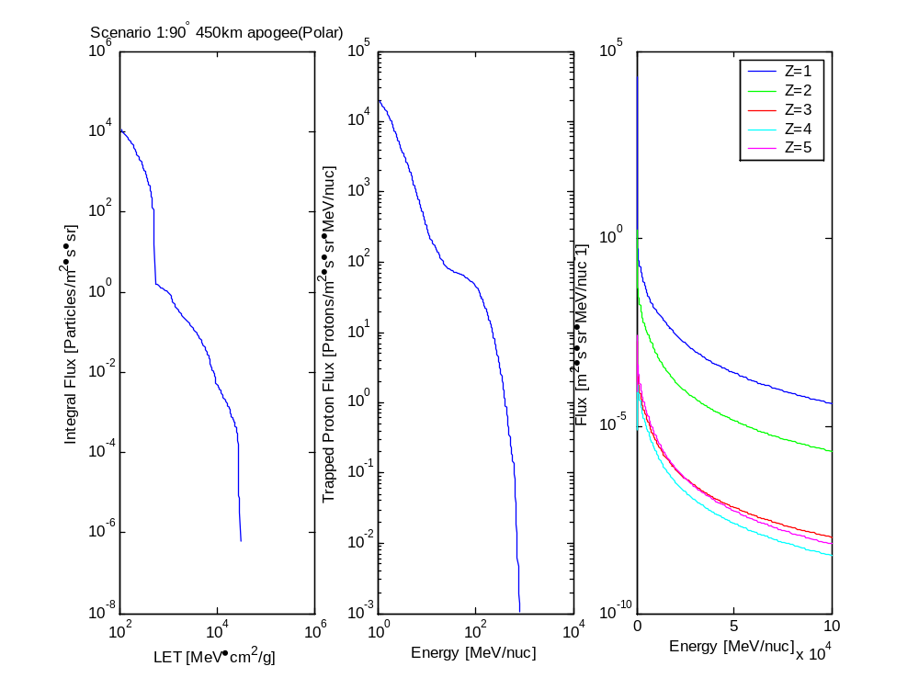
Figure 3 - Scenario 1 Environment Numerical Model. Integral flux over one orbit.
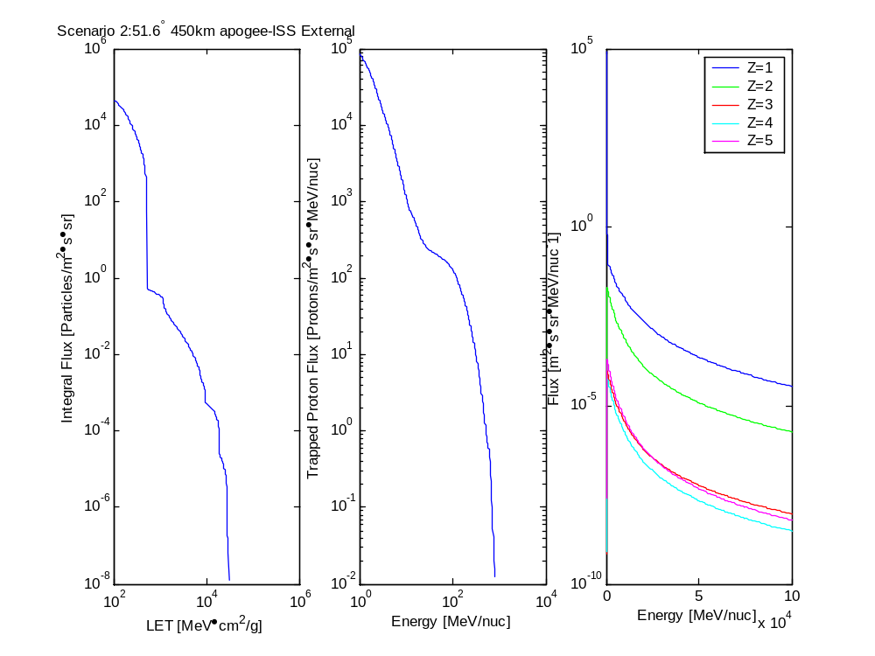
Figure 4 - Scenario 2 Environment Numerical Model
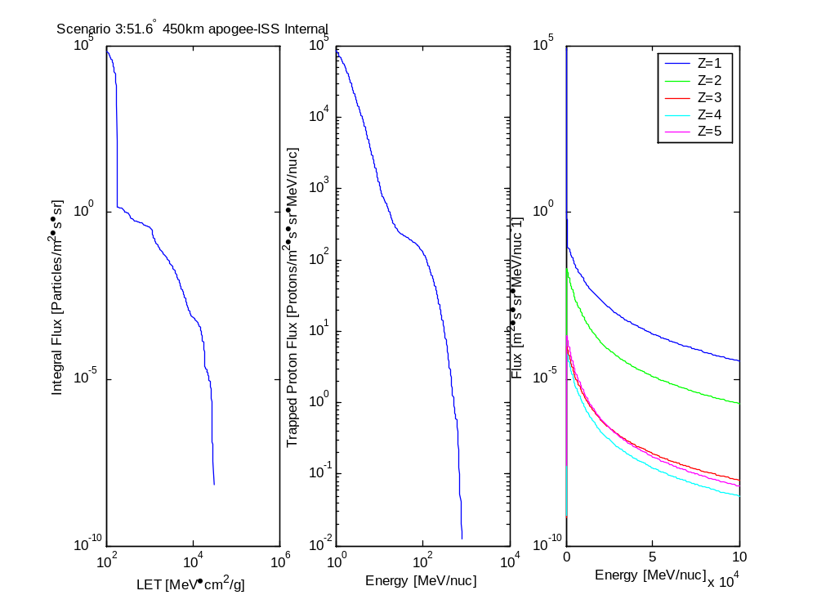
Figure 5 - Scenario 3 Environment Numerical Model
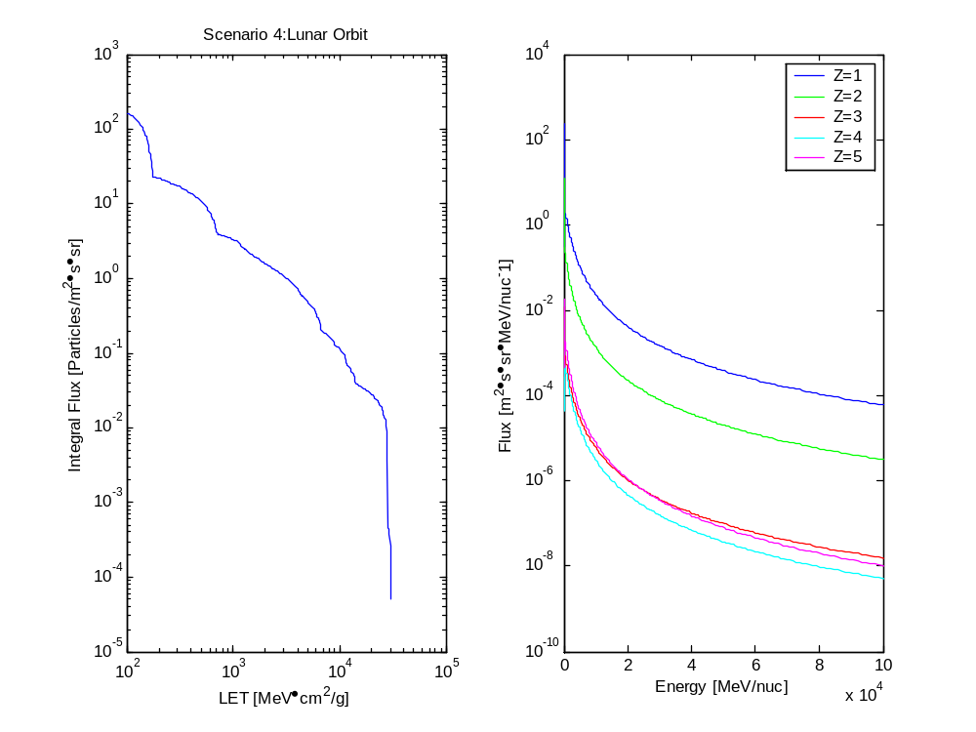
Figure 6 - Scenario 4 Environment Numerical Model

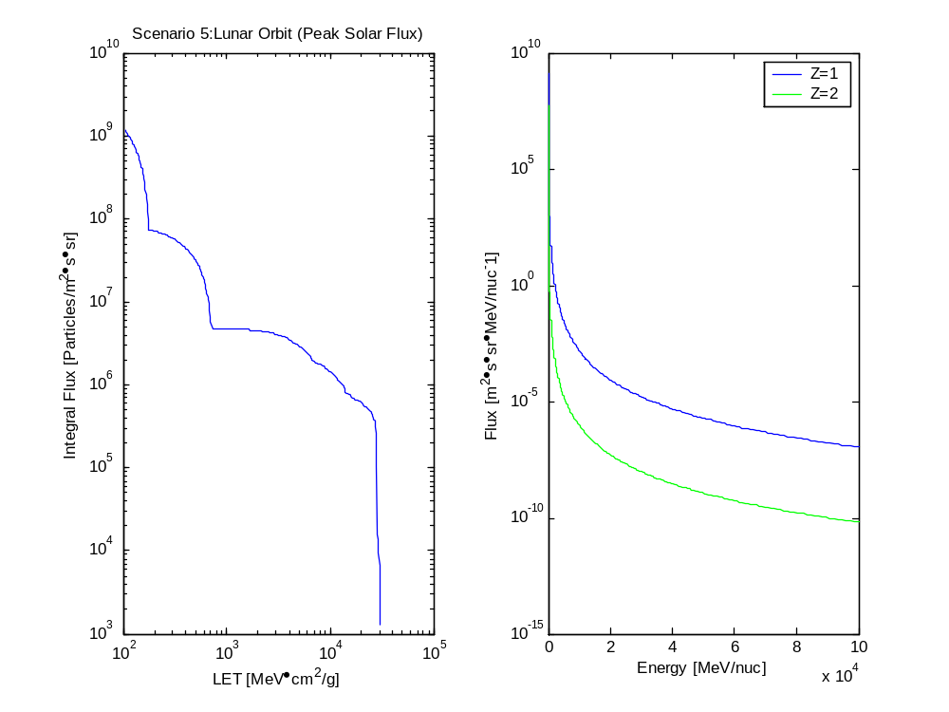
Figure 7 - Scenario 5 Environment Numerical Model

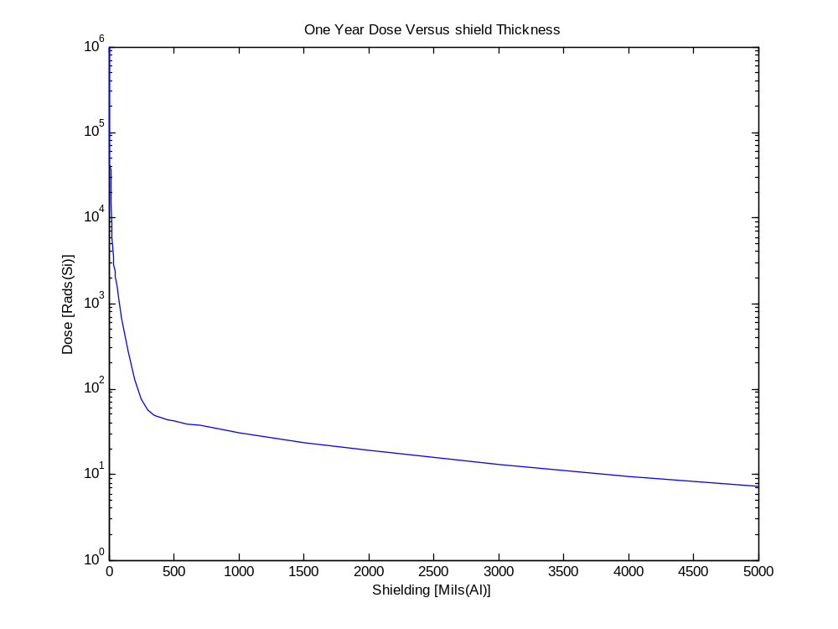
Figure 8 - Dose versus Thickness from SHIELDOSE Model

Facility | Zproj | Eproj | Eproj(⁵⁶Fe)
 |  | (MeV/nuc) | (MeV/nuc)
Alternating Gradient Synchrotron (AGS) | 1–79 | 600–30K | 600–1K
Brookhaven National Laboratory (BNL)
Brookhaven, New York, USA
NASA Space Radiation Laboratory (NSRL) | 1–79 | 100–3K | 100–1K
Brookhaven National Laboratory
Brookhaven, New York, USA
Centro Nazionale di Adrotera Oncologica | 1,6 | 250 | —
(planned)
Italy
88" Cyclotron
Lawrence Berkeley National Laboratory | 1–8 | 55 | —
Berkeley, California, USA
Grand Accelerateur National D’Ions Lourds | 6–92 | 25–95 | —
Caen, France
Heavy Ion Medical Accelerator at Chiba | 1–54 | 100–800 | 500
National Institute for Radiological Sciences
(Chiba, Japan)
Tandem-ALPI | 1–8 | 8–20 | —
Laboratori Nazionali di Legnaro (LNL)
Legnaro, Italy
Superconducting Cyclotron | 1–6 | 70 | —
Laboratori Nazionali del Sud (LNS)
Catania, Italy
ETOILE | 1,6 | 50–400 | —
(2007)
Lyon, France
National Superconducting Cyclotron Lab. | 1–92 | 90 | —
Michigan State University
East Lansing, Michigan, USA
Nuclotron | 1–26 | 6K | 6K
Joint Institute for Nuclear Research (JINR)
Dubna, Russia
Ring Cyclotron
Inst. for Physical and Chemical Research | 6 | 137 | —
Wako Saitama, Japan
(Wako Saitama, Japan)
SIS-18 Heavy Ion Synchrotron | 1–92 | 50–2K | 1K
Gesellschaft für Schwerionenforschung
Darmstadt, Germany
Synchrophasotron | 1–16 | 4K | —
Joint Institute for Nuclear Research
Dubna, Russia
Table 1 - Heavy Charge Particle Accelerators

Facility | E_{max}
 | (MeV)
Brookhaven National Laboratory Linear Accelerator | 200
Brookhaven, NY USA
Crocker Nuclear Laboratory Cyclotron | 70
University of California
Davis, California, USA
Loma Linda Proton Treatment Center | 250
Loma Linda University Medical Center
Loma Linda, California USA)
iThemba Laboratory for Accelerator-Based Sciences | 200
Medical Radiation Group
Capetown, South Africa
Midwest Proton Radiotherapy Institute | 210
Indiana University Cyclotron Facility
Bloomington, Indiana, USA
Northeast Proton Therapy Center | 230
Massachusetts General Hospital
Boston, Massachusetts, USA
Paul Scherrer Institut Proton Therapy Facility | 270
Villigen, Switzerland
Proton Medical Research Center | 500
University of Tsukuba
Tsukuba, Japan
Table 2 - Proton-Only Accelerators

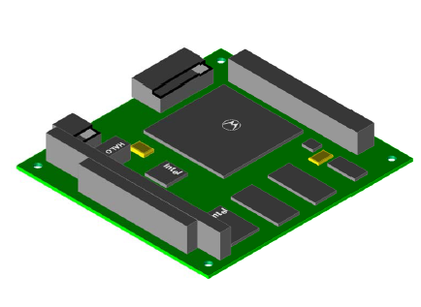
Figure 9 - Rendered Model Top View

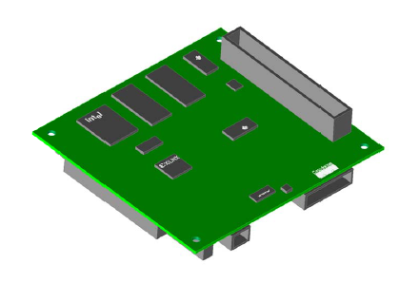
Figure 10 - Rendered Model Bottom View
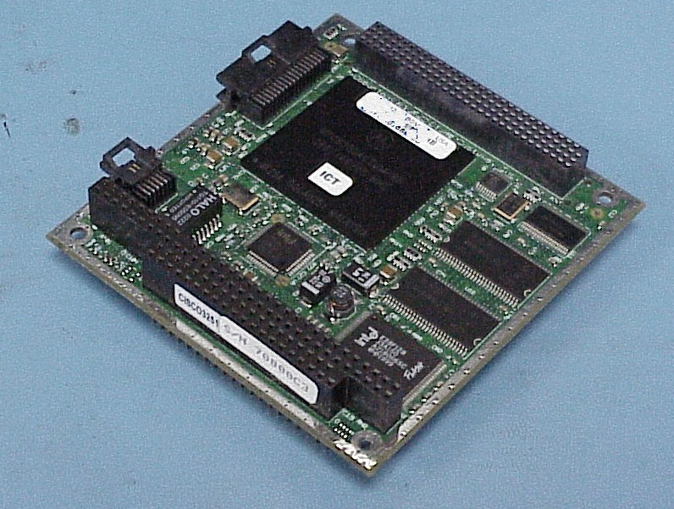
Figure 11 - Cisco Mini Router Top View
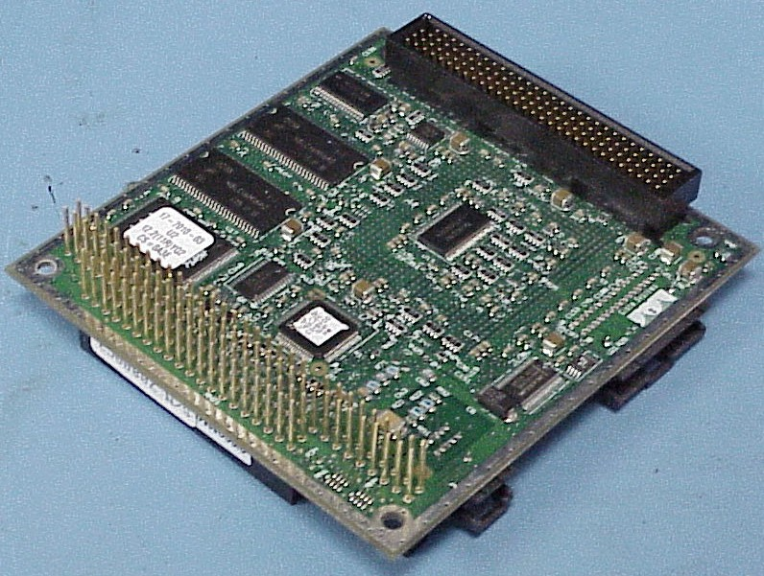
Figure 12 - Cisco Mini Router Bottom View

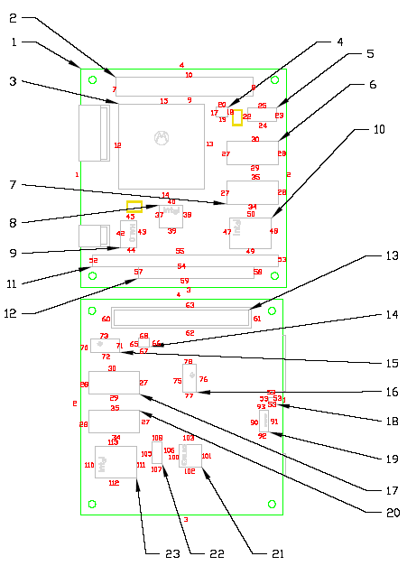
Figure 13 - Cell and Surface Mapping to MCNP
Scenario | 1 | 2 | 3 | 4 | 5
 | Flux | Flux | Flux | Flux | Flux
cell | (Particles/Cell∙yr) | (Particles/Cell∙yr) | (Particles/Cell∙yr) | (Particles/Cell∙yr) | (Particles/Cell∙s)
3 | 9.49E+08 | 3.84E+09 | 2.94E+09 | 1.23E+07 | 2.04E+06
4 | 1.28E+07 | 5.19E+07 | 3.98E+07 | 1.67E+05 | 2.76E+04
5 | 4.74E+07 | 1.92E+08 | 1.47E+08 | 6.15E+05 | 1.02E+05
6 | 1.30E+08 | 5.27E+08 | 4.04E+08 | 1.69E+06 | 2.80E+05
7 | 1.30E+08 | 5.27E+08 | 4.04E+08 | 1.69E+06 | 2.80E+05
8 | 6.86E+07 | 2.77E+08 | 2.12E+08 | 8.91E+05 | 1.47E+05
9 | 2.68E+08 | 1.08E+09 | 8.30E+08 | 3.48E+06 | 5.76E+05
10 | 1.49E+08 | 6.03E+08 | 4.62E+08 | 1.94E+06 | 3.21E+05
14 | 6.75E+06 | 2.73E+07 | 2.09E+07 | 8.76E+04 | 1.45E+04
15 | 4.75E+07 | 1.92E+08 | 1.47E+08 | 6.16E+05 | 1.02E+05
16 | 4.32E+07 | 1.75E+08 | 1.34E+08 | 5.61E+05 | 9.28E+04
17 | 1.40E+08 | 5.65E+08 | 4.33E+08 | 1.81E+06 | 3.00E+05
18 | 5.87E+06 | 2.37E+07 | 1.82E+07 | 7.62E+04 | 1.26E+04
19 | 1.69E+07 | 6.83E+07 | 5.24E+07 | 2.20E+05 | 3.63E+04
20 | 1.40E+08 | 5.65E+08 | 4.33E+08 | 1.81E+06 | 3.00E+05
21 | 5.19E+07 | 2.10E+08 | 1.61E+08 | 6.74E+05 | 1.12E+05
22 | 2.70E+07 | 1.09E+08 | 8.35E+07 | 3.50E+05 | 5.79E+04
23 | 1.49E+08 | 6.03E+08 | 4.62E+08 | 1.94E+06 | 3.21E+05
????? | 2.38351E+09 | 9.63446E+09 | 7.38409E+09 | 3.09543E+07 | 5.12106E+06
Table 3 - Flux per Cell

Scenario | 1 | 2 | 3 | 4 | 5
 | Absorbed Dose | Absorbed Dose | Absorbed Dose | Absorbed Dose | Absorbed Dose
 | [Rads(Si)/yr] | [Rads(Si)/yr] | [Rads(Si)/yr] | [Rads(Si)/yr] | [Rads(Si)/min]
 | 60.7 | 245.4 | 188.1 | 0.8 | 7.8
Table 4 - Dose per Scenario

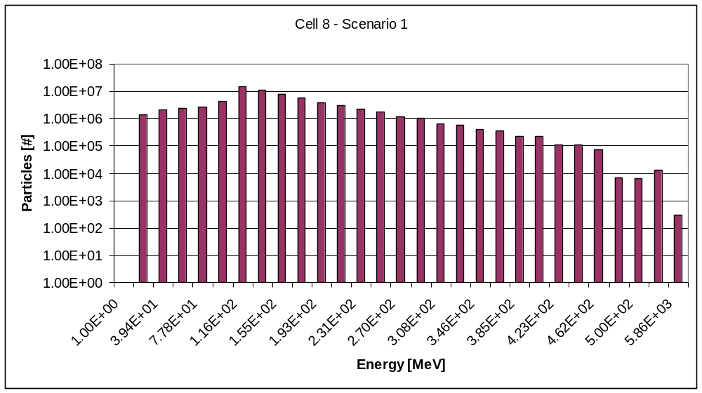

Figure 14 - Cell 8 - Scenario 1 Flux versus Energy

APPENDIX B – REFERENCES

ZIN Technologies, Inc., Brook Park, Ohio
NASA – Glenn Research Center, Cleveland, Ohio
There are special considerations for air-cooling, which have limitations on fan noise as well as how much heat can be transferred into the crew volume.
D. Shell,J. Courtenay, W. Ivancic, D. Stewart, T. Bell: “Mobile IP & Mobile Networks Promise New Era of Satellite and Wireless Communications,” Second Integrated Communications, Navigation and Surveillance Technologies Conference & Workshop, April 29 - May 2nd, 2002
Burrell, et al., “An Analysis of the Energetic Space Radiation and Dose Rates” MSFC, NASA TN D-4404 (Feb, 1968)
Robert, W.T., “Space Radiations: A Compilation and Discussion”, MSFC, MTP-AERO-64-4 (Jan, 1964.)
Green, M.L. and Hammon D.J., “Radiation Effects Design Handbook: Section 5.The radiation in space and Their Interaction With Matter,” NASA Contractor Report 1871, (September, 1971)
Rich Slywczak, “Conceptual Design of an IP-based Satellite Bus Using Internet Technologies,” AIAA/Small Satellite Conference, August 2003
James H. Adams, Jr. "Cosmic Ray Effects on Micro-Electronics (CREME), Part IV" , Naval Research Laboratory Memorandum Report 5901, December 31, 1986.
A.J. Tylka, William F. Dietrich, Paul R. Boberg, Edward C. Smith, James H. Adams, Jr., "Single Event Upsets Caused by Solar Energetic Heavy Ions" , IEEE Transactions on Nuclear Science 43, 2758-2766 (1996).
A.J. Tylka, James H. Adams, Jr., Paul R. Boberg, Buddy Brownstein, William F. Dietrich, Erwin O. Flueckiger, Edward L. Petersen, Margaret A. Shea, Don F. Smart, and Edward C. Smith, "CREME96: A Revision of the Cosmic Ray Effects on Micro-Electronics Code", IEEE Transactions on Nuclear Science, 44, 2150-2160 (1997).
D.M. Sawyer and J.I. Vette, "Trapped Particle Environment for Solar Maximum and Solar Minimum (AP8)", NSSDC Report 76-06, (1976).
National Space Science Data Center/WDC-A-R&S 91-24 (1991)
Calvel, P., et al., “An Empirical Model for Predicting Proton Induced Upset”, IEEE Trans. Nucl. Sci., 43, 2827, 1996.
Barak, J., et al., “A Simple Method for Calculating Proton Induced SEU,” IEEE Trans. Nucl. Sci.. 43, 979, 1996.
Reed, R., et al,. “A Simple Algorithm for Predicting Proton SEU Rates in Space Compares to the Rates Measured on the CRRES Satellite,” IEEE Trans. Nucl. Sci.. 41, 2389, 1994.
Bendel, W. L. and E. L. Petersen, “Proton Upsets in Orbit,” IEEE Trans. Nuclear Science, NS-30, 4481, (Dec. 1983).
O’Neill, P. M., “Computer Code for Calculating On Orbit Single Event Effect (SEE) Rates Based on Proton Test Data,” NASA Internal Memo EA44-98-28, (Nov. 1998).
Ziegler J. F. and Lanford W. A., “Effect of Cosmic Rays on Computer Memories,” Science, (776 1979).
Normand, Eugene, “Extensions of the Burst Generation Rate Method for Wider Application to Proton/Neutron-Induced Single Event Effects,” Boeing.
Johnston, Allan, “Scaling and Technology Issues for Soft Error Rates”, Presented at the 4th Annual Research Conference on Reliability, Stanford University, (October 2000).
Hanks, C. L. and Hammon, D. J., “Radiation Effects Design Handbook: Section 1,” NASA CR-1785, (July 1971).
Lindhard, J., et al., Kgl. Danske Videnskad. Selskab Mat. – Fys. Medd., 33 (14), (1963).
Sattler, A., Phys. Rev., 138, A1815 (1965).
Radiation Effects Design Handbook, Section 5. NASA CR-1871, (September 1971). ¹³ Pierret, Robert F., Semiconductor Device Fundamentals. Reading, MA: Addison-Wesley, 1996.
LA-UR-03-1987 “General Monte Carlo N-Particle Transport Code, Overview and Theory,” Volume I, 2003.
Johnston, A.H. and Guertin, S.M., “The Effects of Space Radiation on Linear Integrated Circuits” Jet Propulsion Laboratory, California Institute of Technology.
J.R. Srour, Cheryl J. Marshall, and Paul W. Marshall, “Review of Displacement Damage Effects in Silicon Devices”, IEEE Transactions on Nuclear Science 50, 653-670 (2003)
B. Wilken, T.A. Fritz, Nucl. Instrum. Meth. 138, 331 (1976).

