IEEE P1451.3 Proposal

Proposal Title: | Transducer Block
Proposal Number: | P03-004
Revision Number:
Date: | 01/27/2003
Name: | Mark Slack
Company: | Boeing Commercial Airplanes
Phone Number: | 206-662-4771
Fax Number:
Email Address: | mark.b.slack@boeing.com
Proposal Status: | Initial Draft  Revised Draft  X Ready for Vote
Impacts: | __  __
Action: | __ Approved  __ Approved with changes  _X_ Rejected  __ Returned for revision

Background:

Multiple comments related to Clause 9, draft D2.0, are summarized below:
Lee-1
comment_type = Technical
comment = For someone who is not familiar with the term "dot3", what does it mean?
suggested_remedy = Somewhere in the document, the term “dot3” has to defined, for example, dot3 means .3, that is, IEEE 1451_dot3 means IEEE 1451.3

Lee-2
comment_type = Technical
comment = The term "TOM" should be replaced.
suggested_remedy = All the terms “TOM” (Transducer Object Model) is requested to be changed to “TBOM” (Transducer Block Object Model). TBOM will make more sense according to the context.

Lee-3
Comment Type: Technical
File Format: Powerpoint file
Original Name (can supply needed clues): D:\kang\Temp\1451\1451.3\balloting\NIST comments\diagram-IEEE1451.3.ppt
Description: Figure 25 on p128 should be the whole picture or big picture of class diagram of Transducer Block. It should be replaced with the diagram suggested in the attached file.

Lee-4
page = p134 and others
subclause = 9.x (varies -- see page references)
comment_type = Technical
comment = TriggerSource is defined in Fig. 75 (p129). There is no TriggerGenerator class, but it is used in the document.
suggested_remedy = TriggerGenerator should be changed to TriggerSource in Fig. 32 (p134), Fig. 42 (p140), Fig. 44 (p141), Fig. 45 (p141).

Lee-5
page = p140
subclause = 9.3.3
comment_type = Editorial
comment = editorial
suggested_remedy = Figure 43. GenerateTriggerEvent> should be GenerateTriggerEvent

Lee-6
page = p133 and p137
subclause = 9.2.4 and 9.2.7
comment_type = Technical
comment = In Fig. 30 (p133) and Fig. 37 (p137), the multiplicity between TBIM and TransducerChannel should be consistent, for instance, in Fig. 30 it is 1 to *, whereas, in Fig. 37 1 to 1..*
suggested_remedy = Use the right convention.

Catlin-54
page = p127
subclause = 9
comment_type = Editorial
comment = Figure 24 – This figure appears to be incomplete.

The IEEE P1451.3 Working Group is comprised of industry and government participants with broad technical experience. However, we do not have adequate representation in the area of Object Oriented Technology. The content of Clause 9, as submitted for ballot, was a derivative of the preliminary work originally submitted by Carlos Lopez-Reyna (Scite-Fair). Although we gratefully acknowledge the original work, we have lingering concerns regarding the scope of this standard.
We believe that this standard should not trespass on the detailed design process. As balloted, Clause 9 appears to cross a threshold that is best left to implementers, as illustrated by the abstraction layer called the Common Object Interface (COI). Although this design concept has significant merit, it is best viewed as a feature that will distinguish the implementation in a free marketplace, in contrast to an essential element of a standardized offering.
Our decision to seriously reduce the scope of Clause 9 is influenced by several pragmatic observations:
- We are obligated to tie our model into the Dot 1 object model. What was previously balloted did not close that loop.
- A reference implementation of IEEE 1451.1 has yet to evolve. As a consequence, the adequacy of the IEEE1451_TransducerBlock abstract base class (and all specializations) has not been stressed by actual implementations. Until the development community embarks on a faithful (fully functional) T-Block implementation, we can do little more than re-articulate the interface & behavior already described in the 1451.1 Object Model. In the proposal that follows, we have attempted to provide a model to cover the basic features of the standard without dictating design of the fine details.
- There is current activity in the OMG to produce an object model for smart transducers. Dot 1 comes under periodic review in approximately one year. We anticipate reconciliation of these model(s).
- The 1451 family of standards are evolving. We anticipate that the 1451.3 standard will be decomposed into an over-arching functional specification, supported by a several physical layers. Specification of a generic T-Block that addresses the needs of multiple physical layers is best deferred to that working group. It is our sincere hope that the new working group will have contributors with strong OOT credentials.

Proposal -- Part A

Replace the entire body of draft D2.00 Clause 9 with the following text. This text is formatted for inclusion into draft D2.03 using "drag and drop" logic. Relative paragraph numbering and Figure/Table numbers will adjust to the point of insertion. In D2.03, this topic should appear as Clause 11. The editor will have to insert automated cross-reference for all text highlighted with a blue background.

Transducer block specification
The Transducer Block is a software component that executes on an NCAP or host processor, as depicted in Figure 1. It encapsulates all management responsibility for the Transducer Bus Controller (TBC) and the associated transducer bus.
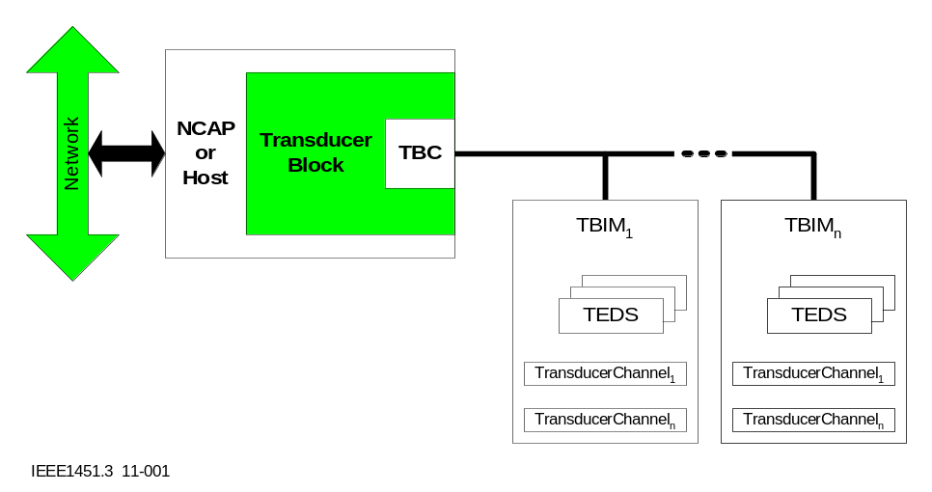
Figure 1—Transducer block context diagram

Introduction
IEEE Std. 1451.1-1999 provides the information model applicable to all standards in the IEEE 1451 family. That standard specifies a comprehensive object model in which the IEEE1451_Dot3TransducerBlock class is introduced without supporting definition. This strategy reserved space within the IEEE 1451.1 class hierarchy while deferring its definition to this standard. Within the name of this class, the substring IEEE1451_Dot3 refers to IEEE Std. 1451.3 (this standard).
This clause defines the Transducer Block. Throughout the remainder of this clause, the term Transducer Block (two words, each capitalized) shall denote the collective logic required to manage the transducer bus and all external components. All class names will be presented in boldface type. When referring to an object instantiated from a class, a fixed-space "computer" font is used. Therefore, the term IEEE1451_Dot3TransducerBlock (one word, note typeface) shall denote an object instantiated from the IEEE1451_Dot3TransducerBlock class.
The Transducer Block described herein may be extended or abbreviated to support deployment in execution environments other than systems compliant with IEEE Std. 1451.1-1999. If an IEEE 1451.1 compliant NCAP is used, the use of the model described in this clause is required. If the NCAP or host processor does not execute in a IEEE 1451.1 environment, the use of this model is optional.

Functional Overview
The Transducer Block is a software component that provides logic for:
— Configuring and managing the TBC
— Configuring and managing TBIMs and their associated TransducerChannels
The Transducer Block provides the required functionality of any IEEE 1451 transducer block by exposing TransducerChannels and TEDS as network accessible objects. The Transducer Block also supports information services unique to this standard (i.e., Virtual TEDS support.).

Relationship to IEEE 1451.1
The relationships between the IEEE1451_Dot3TransducerBlock and associated objects defined by IEEE Std. 1451.1-1999 are depicted in Figure 2. The figure is presented using notation and semantics of the Universal Modeling Language (UML). See [A1], [A3] and [A5] in the bibliography for more information about UML. In this figure, classes described in IEEE Std. 1451.1-1999 are shown shaded (grey background).

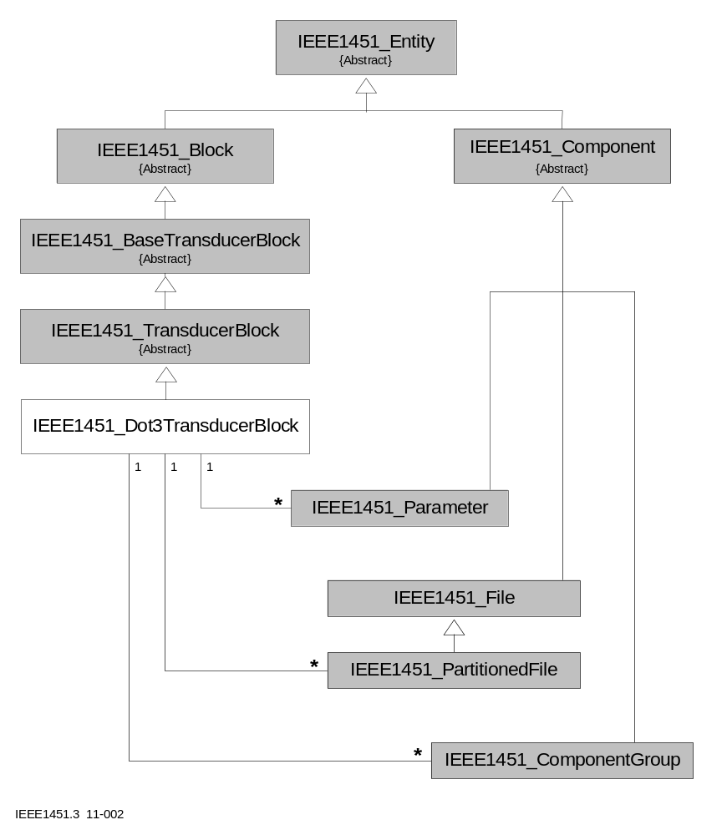
Figure 2—Class hierarchy

Each individual TransducerChannel and each proxy are exposed as a Network Visible Object. These interface objects are instantiated from various sub-classes of the IEEE1451_Parameter class, and throughout this clause, these objects are referred to as Public Transducers. During initialization, the IEEE1451_Dot3TransducerBlock establishes the mapping between the individual channels of each TBIM and the Public Transducers. Each Public Transducer represents information and data associated with a TransducerChannel or a proxy. TransducerChannel number zero is reserved for communication to the TBIM as a whole and shall not be represented as a Public Transducer.
All TEDS information is represented by objects instantiated from the IEEE1451_PartitionedFile class. During initialization, the IEEE1451_Dot3TransducerBlock populates these objects before exposing them as Network Visible Objects. The information content may be embedded in the TBIM or located remotely (Virtual TEDS). In an implementation of a Transducer Block that supports dynamic plug and play with periodic discovery logic, there may be a need to derive a class from the IEEE1451_PartitionedFile class to dynamically add partitions to the image. Throughout the remainder of this clause, all references to the IEEE1451_PartitionedFile class shall be interpreted to mean that class or a derived sub-class.
During system operation, the user may elect to define address groups (see 5.2). Creation & deletion of the address groups are network visible operations on the IEEE1451_Dot3TransducerBlock. Creation involves instantiation of an object from the IEEE1451_ComponentGroup class, or more precisely, a sub-class thereof that is specialized for the IEEE 1451.3 environment, and the Transducer Block exposes the empty group as a Network Visible Object. The user (or host) then interacts with the object directly to define group membership and perform triggering operations.

Conceptual model
IEEE Std. 1451.1-1999 advances a simple conceptual model. This model, as applied to this standard, is provided in Figure 3.
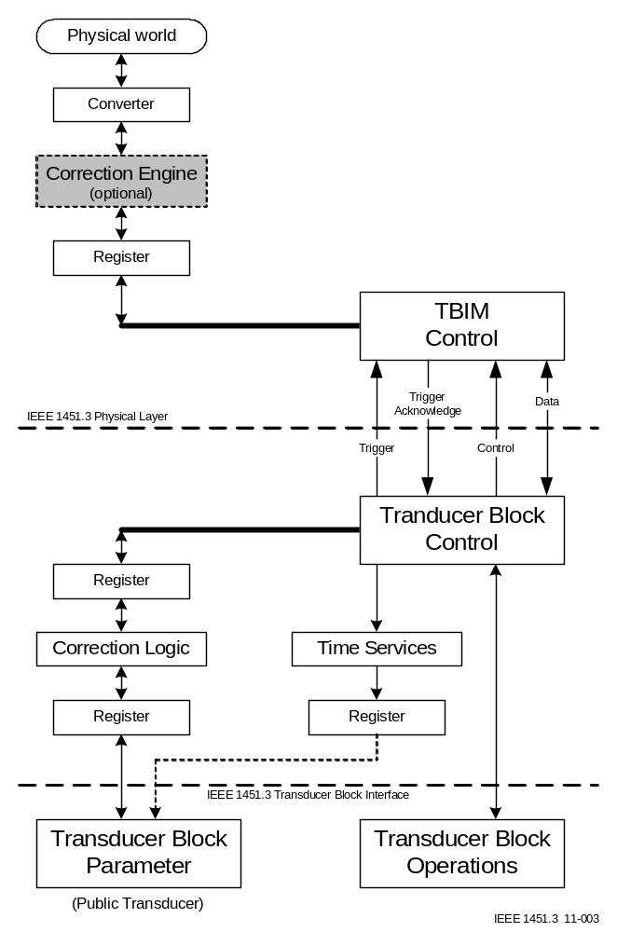
Figure 3—Conceptual model
TBIMs are modeled to have a combination of inputs and/or outputs, each associated with a "register". Within the context of this standard, a register should be visualized as a buffer large enough to accommodate a data set, as determined by information found in the Meta-TEDS, the TransducerChannel TEDS, and the current value of the TransducerChannel Data Repetition Count. These registers are accessed via the IEEE1451.3 physical interface as a result of actions taken by the IEEE1451_Dot3TransducerBlock. These registers agree with the corresponding physical world values only after a supported triggering operation.
The Transducer Block is modeled to contain a set of registers, comprised of one register for each register found on a TBIM, for all TBIMs extant. Any register on the Transducer Block agrees with its corresponding register on the TBIM only after an exchange of values over the interface. The content of a register is expressed in a numeric representation compatible with the Data model found in the TransducerChannel TEDS. This value may or may not express engineering units, depending on the value of the Calibration key in the TransducerChannel TEDS.
The Transducer Block is modeled to contain a second set of registers that contain values transformed from the first set of data registers using the correction information provided by the Calibration TEDS, where indicated by the Calibration key in the TransducerChannel TEDS. Details related to behavior of the correction logic are provided in 1.2.2. The second set of registers shall be used as the ‘currently held values’ of a Physical Parameter object exposed as the Public Transducer.

Terminology
Throughout the remainder of this clause, certain terms defined in IEEE Std. 1451.1-1999 are used. For brevity, these terms are not redefined herein. Please consult that standard for definition of the following terms:
Block Major State
Full Implementation
Interface Only Implementation
Network Visible Object
All Interface Definition Language (IDL) specifications within this clause utilize data types defined in IEEE Std. 1451.1-1999.

IEEE1451_Dot3TransducerBlock

Class: IEEE1451_Dot3TransducerBlock
Parent Class: IEEE1451_TransducerBlock
Class ID: 1.1.1.3.1.2
Description: The IEEE1451_Dot3TransducerBlock, instantiated from the IEEE1451_Dot3TransducerBlock class, provides an interface to all transducers supported by this standard. The global properties of the Public Transducers are provided by operations on the Transducer Block itself. The basic operations inherited from the IEEE1451_TransducerBlock class provide for direct manipulation of the IEEE1451.3 interface. These basic operations may be used to access transducer properties or types not easily managed using Component class objects.
Network Visible operations:
See recommendations below.
Inherited operations with additional specifications:
See recommendations below.
Local operations:
See recommendations below.
Publications: There are no publications defined for this class.
Subscriptions: There are no subscriptions defined for this class.

Initialization behavior
During the initialization phase of the Block Major State life cycle, the IEEE1451_Dot3TransducerBlock instantiates zero or more objects of class IEEE1451_Parameter and IEEE1451_PartitionedFile. These objects may be registered to create the Network Visible interface appropriate to the specific transducer. This activity shall be successfully completed before entering the BL_INACTIVE state defined for all objects in the IEEE1451_Block class.
The selection of the interface objects to represent TransducerChannels and the assignment of their names during registration shall be based on information supplied in the TEDS and the following clauses.

Selection of components to represent TransducerChannels
Every implemented TransducerChannel address in a TBIM is associated with a resource. During initialization, the Transducer Block will attempt to represent each resource in each TBIM with an Object instantiated from a sub-class of the IEEE1451_Parameter class. The decision regarding the class of the Object relies on information acquired during the discovery process, information found in the Meta-TEDS, and information found in the TransducerChannel TEDS. An inability to access the TEDS or inconsistent or incomplete information content in the TEDS shall cause the Transducer Block to abandon the attempt to represent that resource as a Public Transducer, and the TransducerChannel address will be included in the list of unrepresented channels (see operation GetUnrepresentedChannelNumbers, inherited from the IEEE1451_TransducerBlock class).
Within the context of this clause,
— the term 'scalar' object is any object instantiated from class IEEE1451_ScalarParameter or class IEEE1451_ScalarSeriesParameter.
— the term 'vector' object is any object instantiated from class IEEE1451_VectorParameter or class IEEE1451_VectorSeriesParameter.
— the term 'singleton' object is any object instantiated from class IEEE1451_ScalarParameter or class IEEE1451_VectorParameter.
— the term 'series' object is any object instantiated from class IEEE1451_ScalarSeriesParameter or class IEEE1451_VectorSeriesParameter.
— the term ‘analog’, as applied to 'scalar' or 'vector' objects, shall be interpreted as one of the IEEE1451.1 Parameter types:
— PP_SCALAR_ANALOG
— PP_SCALAR_ANALOG_SERIES
— PP_VECTOR_ANALOG
— PP_VECTOR_ANALOG_SERIES
— the term ‘discrete’, as applied to 'scalar' or 'vector' objects, shall be interpreted as one of the IEEE1451.1 Parameter types:
— PP_SCALAR_DISCRETE
— PP_SCALAR_DISCRETE_SERIES
— PP_VECTOR_DISCRETE
— PP_VECTOR_DISCRETE_SERIES
— the term ‘digital’, as applied to 'scalar' or 'vector' objects, shall be interpreted as one of the IEEE1451.1 Parameter types:
— PP_SCALAR_DIGITAL
— PP_SCALAR_DIGITAL_SERIES
— PP_VECTOR_DIGITAL
— PP_VECTOR_DIGITAL_SERIES
Basic guidelines:
— Individual sensors and actuators shall be represented by 'scalar' objects.
— Event sensors shall be represented as objects in the IEEE1451_TimeParameter class.
— A proxy shall be represented by a 'vector' object with N members, where N is the Number of TransducerChannels represented by this proxy, as found in the Meta-TEDS (7.3).
Note—Using a 'vector' object to represent a proxy presents a potential semantics problem. The choice is dictated by data set organization, and shall not be interpreted to mean that the members are not to be treated as a mathematical vector. The choice of representation is made without consideration for the definition of VectorGroups, as found in the Meta-TEDS (7.3). If desired, implementers are free to preserve the semantic intent of the 'vector' classes by deriving new sub-classes from the IEEE1451_PhysicalParameter class that have identical implementation and data structure as found in the 'vector' classes.
Pathological situations:
— A proxy, when one or more proxy members are declared to be a member another proxy.
— A proxy, when one or more proxy members are declared to be an event sensor.
— A proxy, when one proxy member is declared to be a member of a VectorGroup and at least one member of that VectorGroup is not a member of that proxy.
— A member of one VectorGroup is declared to be a member of another VectorGroup, unless the proxy fully represents all members of both groups.
The sole criteria for determining whether a TransducerChannel is represented by a 'scalar' object or a 'vector' object is whether the TransducerChannel is a proxy, as defined in the Meta-TEDS (7.3). A proxy may be demoted to a 'scalar' object when the TransducerChannel proxy data set organization and the definition of ControlGroups within the Meta-TEDS logically results in a scalar parameter preceded by a single time-of-day reading.
Determination of whether a TransducerChannel is represented by a 'singleton' object or a 'series' object is based on the following rules:
— For individual sensors and actuators, the decision shall be based solely on the value of the Maximum data repetitions field in the TransducerChannel TEDS (7.4). If Maximum data repetitions is one, the resource shall be represented by a 'singleton' object. Otherwise, the resource shall be represented by a 'series' object.
— For proxies, the proxy shall be a 'series' object if any individual member is a 'series' object.
The final datum required to satisfy the information model is to finalize the Physical Parameter Type, which is the value returned from operation GetPhysicalParameterType. This determination is only required for 'scalar' and 'vector' objects.
For individual sensors and actuators, the logic used to determine Physical Parameter Type is summarized in Table 1. The logic is based on the following information:
— The Physical units interpretation code (4.11) found in field 1 of the Physical units structure in the TransducerChannel TEDS (7.4.2.4)
— The Data model found in the TransducerChannel TEDS (7.4.2.9)
Table 1—Physical parameter type determination
 | N-octet integer
 |  | Single precision real
 |  |  | Double precision real
 |  |  |  | N-octet fraction
 |  |  |  |  | Bit sequence
Physical units interpretation |  |  |  |  |  | Time of Day
PUI_SI_UNITS | 4 | 1 | 1 | 1 | x | 2
PUI_RATIO_SI_UNITS | x | 1 | 1 | 1 | x | x
PUI_LOG10_SI_UNITS | x | 1 | 1 | 1 | x | x
PUI_LOG10_RATIO_SI_UNITS | x | 1 | 1 | 1 | x | x
PUI_DIGITAL_DATA | 3 | x | x | x | 3 | x
PUI_ARBITRARY | 2 | 1 | 1 | 1 | x | x
Symbols:
1 = 'analog'
2 = 'discrete'
3 = 'digital'
4 = ambiguous
x = illegal
Any TransducerChannel using a Data model of Long integer or a Data model Long fraction shall not be represented by a Public Transducer.

An ambiguous case exists when the Physical units interpretation is PUI_SI_UNITS and the Data model is N-octet integer. The ambiguity is resolved by examining the units declared. If the parameter is unitless (all remaining fields in the Physical units structure are set to 128), the parameter shall be classified as 'discrete'. Otherwise, the parameter is classified as 'analog'.
Illegal combinations shall cause the Transducer Block to abandon the attempt to represent that resource as a Public Transducer, and the TransducerChannel address will be included in the list of unrepresented channels (see operation GetUnrepresentedChannelNumbers). Resources at these addresses can only be accessed via operations on the IEEE1451_Dot3TransducerBlock.
For proxies, the Physical Parameter Type is specified on a per element basis, as determined by the Physical Parameter Type of each proxy member. When a proxy has a member that cannot be represented as a Public Transducer, the proxy shall not be represented as a Public Transducer.

Parameter naming conventions
The Object Name returned by the operation GetObjectName for a Parameter serving as a Public Transducer shall be determined according to the first of the following alternatives to apply:
If the Parameter represent a TransducerChannel or a TransducerChannel proxy for which a Commissioning TEDS exists and if the string therein is not null, the Object Name shall be the value specified in the Commissioning TEDS.
Otherwise, the name of the Parameter shall consist of a sequence of characters designating the Parameter class followed by an ordinal number assigned starting with the value ‘0’ for the first Parameter named. Independent ordinals shall be maintained for each Parameter class. The String shall be represented in the IEEE1451.1 character set.

Required files and their naming conventions
TEDS data structures shall be represented as objects of class IEEE1451_PartitionedFile. The contents of these Files shall deliver the exact representations and information as defined in clause 7 of this standard.
The Transducer Block is responsible for instantiating one File Object per TEDS type. These Partitioned File Objects shall have fixed names, as defined in Table 2.
Table 2—File object names
TEDS type | Defining clause | Partitioned File Object name
Module Meta-TEDS | 7.3 | IEEE1451_3_MetaTeds
Meta-Identification TEDS | 7.8.3 | IEEE1451_3_MetaIdTeds
TransducerChannel TEDS | 7.4 | IEEE1451_3_ChanTeds
TransducerChannel Identification TEDS | 7.8.4 | IEEE1451_3_ChanIdTeds
Calibration TEDS | 7.5 | IEEE1451_3_CalTeds
Calibration-Identification TEDS | 7.8.5 | IEEE1451_3_CalIdTeds
End Users’ Application Specific TEDS | 7.9 | IEEE1451_3_EuasTeds
Frequency Response TEDS | 7.6 | IEEE1451_3_FreqRespTeds
Transfer Function TEDS | 7.7 | IEEE1451_3_TransferFunctTeds
Commands TEDS | 7.8.6 | IEEE1451_3_CommandsTeds
Location and Title TEDS | 7.8.7 | IEEE1451_3_LocationTitleTeds
Commissioning TEDS | 7.10 | IEEE1451_3_CommissioningTeds
PHY TEDS | 7.12 | IEEE1451_3_PhyTeds
Manufacturer defined TEDS | 7.11 | —

File objects are abstractions of data resources, and they should be conceptualized as blocks of memory that may be opened, closed, read, or written. There is no logic within the File object to ensure that a write operation propagates to the target TBIM. If persistence is desired, any write to a File object must be followed by appropriate operations on the IEEE1451_Dot3TransducerBlock .
Manufacturer defined TEDS are not accessible through the interface of a Partitioned File Object.

Correction engine behavior
For TransducerChannels with Calibration key values of CAL_NONE, TBIM_CAL_SUPPLIED, TBIM_CAL_SELF, or TBIM_CAL_CUSTOM, there shall be no corrections applied by the Transducer Block. The Transducer Block correction logic shall pass the associated value without modification in both the TB_CORRECTED and TB_UNCORRECTED states
For TransducerChannels with a Calibration key value of CAL_SUPPLIED, the Transducer Block shall provide correction logic according to the following rules. In the TB_UNCORRECTED state, the Transducer Block correction logic shall pass the associated value without modification. In the TB_CORRECTED state, corrections shall be applied using the methods and coefficients specified in 7.5.1.2.
For TransducerChannels with a Calibration key value of CAL_CUSTOM, the correction behavior is outside the scope of this standard. TransducerChannels with this value of Calibration key shall not be represented by Public Transducers. The channel number shall be returned by the GetUnrepresentedChannelNumbers operation of the IEEE1451_Dot3TransducerBlock.

Read/write/update semantics
The Transducer Block conceptually supplies the highest layer of abstraction in the ISO model. The fundamental Network Visible Read functionality, on Data Communications Channel 0, shall map to the Reply protocol (8.x). The fundamental Network Visible Write functionality, on Data Communications Channel 0, shall map to the Command protocol (8.x). All update operations shall translate to messages issued using the Trigger protocol (8.x). These operations shall be Network Visible.
Transducer Block implementations may expose the concept of a Data Communications Channel and require its specification as an argument to the Network Visible read, write, and update operations. This approach extends functionality to a knowledgeable host, but it has questionable semantics in a IEEE1451.1 environment.
Alternately, the Transducer Block can encapsulate and hide the concept of a Data Communications Channel defining local read/write operations to utilize the Streaming data protocol (8.x). If this approach is taken, it is recommended that these operations be implemented as Local operations, available to Public Transducers that have registered with the Transducer Block as participants in a streaming session.
The recommended model for implementing a streaming session assumes that all data will be exchanged via the publish/subscribe mechanisms defined in IEEE Std. 1451.1-1999.

Network Visible operations
Network Visible operations specific to this sub-class are not overtly defined herein. Required functionality is discussed and recommendations follow.

Correlation between a Parameter Object and the TEDS
The Transducer Block is responsible for instantiating Parameter Objects that represent the TransducerChannels and registering these objects as Network Visible. The Transducer Block is also responsible for instantiating Partitioned File Objects that represent TEDS and registering these objects as Network Visible.
In order to access the TEDS information, the user requires a correlation between the TransducerChannel (or the Object Tag of the Object representing that TransducerChannel) and the partition_id of the partition in which the TEDS information resides. The Transducer Block shall provide a translation service. Recommended Network Visible operations are:
GetPartitionIdByObjectTag
GetPartitionIdByChannelAddress
Both functions return an array of UInteger16 values. Each element of this array shall be interpreted as an appropriate partition_id argument for operations on a specific Partitioned File Object that represent the collections of all TEDS of a particular type. The array may be indexed using the following enumerated list:

IDL: enumeration PartitionIdIndex;
Manifest constant | Value | Partitioned File Object
PID_MetaTeds | 0 | IEEE1451_3_MetaTeds
PID_MetaIdTeds | 1 | IEEE1451_3_MetaIdTeds
PID_ChanTeds | 2 | IEEE1451_3_ChanTeds
PID_ChanIdTeds | 3 | IEEE1451_3_ChanIdTeds
PID_CalTeds | 4 | IEEE1451_3_CalTeds
PID_CalIdTeds | 5 | IEEE1451_3_CalIdTeds
PID_EuasTeds | 6 | IEEE1451_3_EuasTeds
PID_FreqRespTeds | 7 | IEEE1451_3_FreqRespTeds
PID_TransferFunctTeds | 8 | IEEE1451_3_TransferFunctTeds
PID_CommandsTeds | 9 | IEEE1451_3_CommandsTeds
PID_LocTitleTeds | 10 | IEEE1451_3_LocTitleTeds
PID_CommissioningTeds | 11 | IEEE1451_3_CommissioningTeds
PID_PhyTeds | 12 | IEEE1451_3_PhyTeds

For example, element 4 of the returned array is the partition_id that may be used when interacting with the IEEE1451_3_CalTeds object. The objects referenced in this paragraph are defined in 1.2.1.3.

Support for plug and play
A system that supports the dynamic plug and play features of this standard will be required to engage in the discovery process (see 9.4) on a periodic basis. This is a system decision, not a Transducer Block decision. To support the system that elects to periodically probe for new bus participants, the IEEE1451_Dot3TransducerBlock may support a Network Visible operation to perform discovery. The recommended name for this operation is Discover.
Upon invocation of the Discover operation, the Transducer Block shall orchestrate a discovery process that does not perturb the existing complement of TBIMs. If a new participant is found, the Transducer Block will perform the initialization steps described above (1.2.1) to expose the resources of the new participant as Network Visible Objects. An issue to be addressed during design is the ability to dynamically add a new partition to the existing IEEE1451_PartitionedFile objects after the object has been exposed as Network Visible. The new partitions are required to support the TEDS information associated with the new participant(s).

Support for address groups
The formation of address groups is a user domain issue. The Transducer Block will support this feature with Network Visible operations to create and delete address groups. Creation involves instantiation of an object from the IEEE1451_ComponentGroup class, or more precisely, a sub-class thereof that is specialized for the IEEE 1451.3 environment. The Transducer Block exposes the empty group as a Network Visible Object. The user (or host) then interacts with the object directly to define group membership.
It is recommended that this object be endowed with read/write/update logic similar to other Public Transducers from the IEEE1451_Parameter class. The update operation shall be implemented with a trigger message addressed to the address group. Read and write operations would iterate through each member of the Component Group to issue read and write operations addressed to a specific TransducerChannel.

Inherited operations with additional specifications
The following operations inherited from the IEEE1451_BaseTransducerBlock class may have Interface Only Implementations. As clarified in IEEE Std. 1451.1-1999, this means that these operations have no meaning within this class, and any attempt to invoke these operations shall return immediately with the major return code of MJ_NOP_OPERATION.
— IORead
— IOWrite
— SetIOControl
— GetIOStatus
If IORead and IOWrite are provided as Full Implementations, they shall provide the interface to the Reply protocol (8.x) and the Command services protocol (8.x), respectively.
The following operations inherited from the IEEE1451_TransducerBlock class shall all have Full Implementations:
— EnableCorrections
— DisableCorrections
The following operations inherited from the IEEE1451_TransducerBlock class shall abide to the additional specifications provided herein:
— GetChannelParameterObjectTags
— GetParameterObjectChannelNumbers

Inherited operation GetChannelParameterObjectTags
Input argument channel_number has data type UInteger16. The most significant octet in this UInteger16 shall specify the TBIM alias, and the least significant octet shall specify the TransducerChannel number, as defined in 5.2. A further constraint imposed by this class is that channel_number shall resolve to an address in the TransducerChannel Address Class.
Output argument parameter_object_tags has data type ObjectTagArray. Each element of the array is an Object Tag that identifies a Public Transducer that uses channel_number. A further specialization of this operation within this class is that the 0th element shall always be the Object Tag of the Public Transducer that represents the data resource interfaced through the specified channel_number. This operation returns an array with multiple elements when channel_number specifies a resource that is a component of a TransducerChannel proxy.
If channel_number does not resolve to an address in the TransducerChannel Address Class (see 5.2), this operation shall return MJ_FAILED_INPUT_ARGUMENT in the Major Field of OpReturnCode. If channel_number resolves to an address in the TransducerChannel Address Class and if the Transducer Block has no mapping to a Public Transducer for that channel_number, this operation shall return MJ_FAILED_OUPUT_ARGUMENT in the Major Field of OpReturnCode.

Inherited operation GetParameterObjectChannelNumbers
Input argument parameter_object_tag has data type ObjectTag and specifies the Object Tag of a Public Transducer for which the corresponding TransducerChannel number is desired.
Output argument channel_numbers has data type UInteger16Array. Each element of the array is a TransducerChannel address (see 5.2) identifying a resource on the physical interface represented by the Public Transducer. A further specialization of this operation within this class is that the 0th element shall always be the TransducerChannel address of the data resource for that Public Transducer. This operation returns an array with multiple elements when the Public Transducer is a proxy. The 0th element shall always be the TransducerChannel address of the proxy, and subsequent elements define the TransducerChannel address of the individual contributors to that proxy.
If parameter_object_tag does not resolve to a known Public Transducer, this operation shall return MJ_FAILED_INPUT_ARGUMENT in the Major Field of OpReturnCode.

Local operations
Local operations may only be invoked in the process space of the object. Recommendations for Local Operations available from the IEEE1451_Dot3TransducerBlock are defined herein.

Support for service requests
Service requests are conceptually similar to interrupts, as described in 5.12, but the indication of the request is embedded in the status octet found in every reply received. The Transducer Block shall provide a mechanism to articulate the existence of a service request to an object in the local process space. Recommended operations are:
— RegisterServiceRequestNotification
— DeregisterServiceRequestNotification

Support for streaming data
Whether a Public Transducer participates in a streaming data exercise is decision in the user domain. The Transducer Block shall provide a mechanism to enable a Public Transducer to register and deregister as a streaming data consumer or a streaming data producer. This functionality may be implemented through specialization of the RegisterNotifyOnUpdate and DeregisterNotifyOnUpdate operations inherited from the IEEE1451_Block class. Additional or alternative local operations may be introduced to manage the streaming session.

Public Transducers
Classes used to represent Public Transducers may require specialization to use the full set of features implemented in the IEEE1451_Dot3TransducerBlock. When specialization is required, class names shall be formed by inserting the "Dot3" qualifier into the class name, immediately following the "IEEE1451_" sub-string. For example, if a sub-class is derived from the IEEE1451_VectorParameter class, it shall be named IEEE1451_Dot3VectorParameter.

Proposal -- Part B

Incidental changes to draft D2.02 follow. (Microsoft Word -- Revisions ON)

Clause 3 -- Definitions

3.2.11 Code-Division Multiple Access: Code-Division Multiple Access (CDMA) uses …
3.2.12 CommunicationsChannel: For the purposes of this standard, ...
3.2.13 ControlGroup: ControlGroups are manufacturer specifications that define the inherent relationships between the TransducerChannels of a multi-channel TBIM. This ControlGrouping information is not normally used by the TBIM itself. This information is used to identify TransducerChannels that are used to control some characteristic of another TransducerChannel. For example, a ControlGroup could be used to identify an actuator that is used to set the threshold of an analog event sensor.

3.2.67 VectorGroup: VectorGroups are manufacturer specifications that define the inherent relationships between the TransducerChannels of a multi-channel TBIM. This VectorGrouping information is not normally used by the TBIM itself. This information is normally used by bus controller applications to properly compose human readable displays or in formulating other computations. For example, VectorGroupings may be used to indicate which TransducerChannels represent the three vector axes of a three-axis vector measurement.

Clause 4 -- Data types
Break Table 1 into 2 components to assign manifest constant. No change to textual description

Table 1—Physical units data type structure
Field | Description | Data Type | Number of octets
1 | Physical units interpretation -- see Table 2 | U8E | 1
2 | (2 * <exponent of radians>) + 128 | U8C | 1
3 | (2 * <exponent of steradians>) + 128 | U8C | 1
4 | (2 * <exponent of meters>) + 128 | U8C | 1
5 | (2 * <exponent of kilograms>) + 128 | U8C | 1
6 | (2 * <exponent of seconds>) + 128 | U8C | 1
7 | (2 * <exponent of amperes>) + 128 | U8C | 1
8 | (2 * <exponent of kelvins>) + 128 | U8C | 1
9 | (2 * <exponent of moles>) + 128 | U8C | 1
10 | (2 * <exponent of candelas>) + 128 | U8C | 1

Table 2—Physical units interpretation
Value | Manifest constant | Definition
0 | PUI_SI_UNITS | Unit is described by the product of SI base units, plus radians and steradians, raised to the powers recorded in fields 2 through 10. Units for some quantities, such as the number of people through a turnstile, cannot be represented using these units. Enumeration zero, with fields 2-10 set to 128, is the appropriate enumeration for these cases when a quantity is being defined.
1 | PUI_RATIO_SI_UNITS | Unit is U/U, where U is described by the product of SI base units, plus radians and steradians, raised to the powers recorded in fields 2 through 10.
2 | PUI_LOG10_SI_UNITS | Unit is log₁₀(U), where U is described by the product of SI base units, plus radians and steradians, raised to the powers recorded in fields 2 through 10.
3 | PUI_LOG10_RATIO_SI_UNITS | Unit is log₁₀(U/U), where U is described by the product of SI base units, plus radians and steradians, raised to the powers recorded in fields 2 through 10.
4 | PUI_DIGITAL_DATA | The associated quantity is digital data (e.g. a bit vector) and has no unit. Fields 2-10 shall be set to 128. The "digital data" type applies to data that does not represent a quantity, such as the current positions of a bank of switches.
5 | PUI_ARBITRARY | The associated physical quantity is represented by values on an arbitrary scale (e.g. hardness). Fields 2-10 are reserved, and shall be set to 128.
6-255 | — | Reserved

Clause 5 -- Functional spec
New sub-clause, inserted before 5.6 (TransducerChannel Proxy)

5.6 TransducerChannel groups
There are two types of TransducerChannel groups defined in this standard. They are VectorGroups and ControlGroups. They are similar in implementation but are used for two different functions.
5.6.1 VectorGroups
VectorGroups are used to define relationships between TransducerChannels within a single multi-channel TBIM that imply a display or mathematical relationship between the TransducerChannels. For example, they can be used to identify the relationships between the components of a three-axis accelerometer. VectorGroups are used by the software in the TBC/NCAP or host processor to group the outputs of the individual TransducerChannels into vectors for display or computational purposes.
Note: VectorGroups are in some ways similar to TransducerChannel proxies. TransducerChannel proxies are used to identify TransducerChannels that are grouped together for reasons such as efficient transmission of the data and/or simultaneous triggering. Proxies may or may not represent a vector for display or computational purposes. However, it is recommended that all vectors be implemented as proxies, especially in spatial vector applications (like velocity or acceleration), where the measurements of the three components at different points in time could lead to misinterpretation.

5.6.2 ControlGroups
ControlGroups are used to define collections of TransducerChannels when one TransducerChannel is the primary channel and the remaining TransducerChannels in the group provide either additional information about the primary TransducerChannel or are used to control some aspect of the primary TransducerChannel. For example, a ControlGroup can be used to define up to three additional TransducerChannels associated with an analog event sensor. One is a sensor that is used to measure the analog input to the event sensor. The second is an actuator that is used to set the threshold for the event sensor. The third is an actuator that can be used to set the hysteresis for the event sensor.

Change Meta-TEDS

7.3.2 Data block
Table 37 summarizes the content of the data block. Subordinate subclauses explain each data field in this data block.
Table 37—Structure of the Meta-TEDS data block
Field | Description | Type | # octets
— | Length | U32L | 4
1 | TEDS identifier | U8E | 1
2 | IEEE P1451 standards family number | U8E | 1
3 | TEDS version number | U8E | 1
— | Timing related information | — | —
4 | TEDS hold-off time (t_{th}) | F32 | 4
5 | Operational hold-off time (t_{oh}) | F32 | 4
6 | Load current drawn from the transducer bus | F32 | 4
7 | Multi-range Capability | U8E | 1
— | VectorGroup information sub-block | — | —
8 | Number of VectorGroups (N_{v}) | U8C | 1
— | Fields 9, 10, and 11 comprise a structure that defines one VectorGroup. All VectorGroup structures (N_{v} occurrences) shall be specified consecutively. | — | —
9 | VectorGroup type | U8E | 1
10 | Number of TransducerChannels in the VectorGroup (NT_{v}) | U8C | 1
11 | VectorGroup member list | array of U8E | NT_{v}
— | ControlGroup information sub-block | — | —
12 | Number of ControlGroups (N_{c}) | U8C | 1
— | Fields 13, 14, and 15 comprise a structure that defines one ControlGroup. All ControlGroup structures (N_{c} occurrences) shall be specified consecutively. | — | —
13 | ControlGroup type | U8E | 1
14 | Number of TransducerChannels in the ControlGroup (NT_{c}) | U8C | 1
15 | ControlGroup member list | array of U8E | NT_{c}
— | TransducerChannel proxy definition sub-block | — | —
16 | Number of TransducerChannel proxies (N_{p}) | U8C | 1
— | Fields 17, 18, 19, and 20 comprise a structure that defines one TransducerChannel proxy. All proxy definition structures (N_{p} occurrences) shall be specified consecutively. | — | —
17 | TransducerChannel number of the TransducerChannel proxy | U8E | 1
18 | TransducerChannel proxy data set organization | U8E | 1
19 | Number of TransducerChannels represented by this proxy (NT_{p}) | U8C | 1
20 | TransducerChannel proxy member list | array of U8E | NT_{p}
— | Checksum | U16C | 2

7.3.2.8 Number of VectorGroups
Data type: unsigned octet integer used for enumeration (U8C, 1 octet)
This field identifies the number of VectorGroups that follow.
7.3.2.9 VectorGroup type
Data type: unsigned octet integer used for enumeration (U8E, 1 octet)
This field contains the relationship between the TransducerChannels comprising the specific VectorGroup. It is defined by the enumeration in Table 40.
Table 40—Enumeration of VectorGroup types
Value | Meaning
0 | an arbitrary relation
1 | x, y, z right hand rectangular spatial coordinates
2 | ρ, φ, z right hand cylindrical spatial coordinates
3 | r, θ, φ right hand spherical spatial coordinates
4 | latitude, longitude, altitude planetary coordinates
5 | in-phase, quadrature temporal coordinates
6 | red, green, blue color coordinates
7-127 | Reserved
128-255 | open to manufacturers

The arbitrary relation, when the enumeration value is equal to zero, shall be used to convey VectorGrouping semantics not specifically enumerated by this subclause, but deemed necessary by the TransducerChannel manufacturer, for the correct operation or interpretation of the data related to the TransducerChannels that are members of the VectorGroup.
The arbitrary relation may be used to convey that correct behavior of TransducerChannels with coupling terms in the calibration assumes that all TransducerChannels involved are triggered at the same time.

7.3.2.10 Number of TransducerChannels in the VectorGroup
Data type: unsigned octet integer used for enumeration (U8C, 1 octet)
This field identifies the number of TransducerChannels in the group, which is the number of entries required in the list described in 7.3.2.11.
7.3.2.11 VectorGroup member list
Data type: an array of unsigned octet integers used for enumeration (U8E, 0 to 255 octets)
This field contains a one-dimensional array (list) of 1-octet elements. Each element is the TransducerChannel number for a member in the specific VectorGroup. The values of the elements in this list shall be in the sequence specified by the VectorGroup type field.
An element with value zero shall indicate that the TransducerChannel does not implement this particular element of the enumerated relationship. For example, a two axis vector measurement implemented by TransducerChannels 1, x, and 2, y, may be specified by designating the VectorGroup type (7.3.2.9) as 1 (x, y, z) with the VectorGroup member list of (1, 2, 0). The value zero shall not appear in the VectorGroup member list for a VectorGroup of VectorGroup type ‘arbitrary relation.’
A TransducerChannel may not be represented in multiple VectorGroups.

7.3.2.12 Number of ControlGroups
Data type: unsigned octet integer used for enumeration (U8C, 1 octet)
This field identifies the number of ControlGroups that follow.
7.3.2.13 ControlGroup type
Data type: unsigned octet integer used for enumeration (U8E, 1 octet)
This field contains the relationship between the TransducerChannels comprising the specific ControlGroup. It is defined by the enumeration in Table 41.
Table 41—Enumeration of ControlGroup types
Value | Entry | Meaning
0 |  | Reserved
1 | 1  2  3  4 | Analog event sensor TransducerChannel,  Analog input sensor TransducerChannel  Upper threshold embedded actuator TransducerChannel  Hysteresis embedded actuator TransducerChannel
2 | 1  2  3  4 | Sensor TransducerChannel (any type)  High pass filter embedded actuator TransducerChannel  Low pass filter embedded actuator TransducerChannel  Scale factor embedded actuator TransducerChannel
3 | 1  2 | TransducerChannel (any type)  Sample interval embedded actuator TransducerChannel
4 | 1  2  3 | Digital event sensor TransducerChannel  Digital input sensor TransducerChannel  Event pattern embedded actuator TransducerChannel
5 | 1  2 | Time interval sensor TransducerChannel  TransducerChannel number of the transducer that causes the output of the time interval sensor to be latched.
6 | 1  2 | Time-of-day sensor TransducerChannel  TransducerChannel number of the transducer that causes the output of the time-of-day sensor to be latched.
7 | 1  2  — | TransducerChannel number of an event sensor used to trigger other transducers.  The number, N, of transducers triggered by the event sensor.  The remaining N entries give a list of TransducerChannels triggered by the event
8 | 1  2 | TransducerChannel (any type),  Embedded time delay actuator TransducerChannel
9-127 |  | Reserved for future expansion
128-255 |  | open to manufacturers

Enumerations 1 and 4 may be used to identify the embedded actuator TransducerChannels used to set up an event sensor. They also identify a sensor TransducerChannel that may be used to read the level of the signal in an analog event sensor or the current pattern input to a digital event sensor.
Enumeration 2 may be used to identify the embedded actuator TransducerChannels used to set the high pass filter, low pass filter, and scale factor associated with a sensor of any type.
Enumeration 3 is used to identify an embedded actuator TransducerChannel that may be used to set the TransducerChannel sampling period.
7.3.2.14 Number of TransducerChannels in the ControlGroup
Data type: unsigned octet integer used for enumeration (U8C, 1 octet)
This field identifies the number of TransducerChannels in the group, which is the number of entries required in the list described in 7.3.2.15.
7.3.2.15 ControlGroup member list
Data type: an array of unsigned octet integers used for enumeration (U8E, 0 to 255 octets)
This field contains a one-dimensional array (list) of 1-octet elements. Each element is the TransducerChannel number for a member in the specific ControlGroup. The values of the elements in this list shall be in the sequence specified by the ControlGroup type field.
An element with value zero shall indicate that the TransducerChannel does not implement this particular element of the enumerated relationship. For example, a ControlGroup describing an analog event sensor that implements the ability to change the threshold and hysteresis but does not implement a sensor to read the analog input could be specified by (1,0,2,3), where the TransducerChannel number for the event sensor is 1, for the threshold actuator is 2 and the hysteresis actuator is 3.
NOTE—a TransducerChannel may be represented in multiple ControlGroups.

7.3.2.16 Number of TransducerChannel proxies
No change to text for the remainder of 7.3. Paragraph numbers and Table/Figure numbers ripple.

Incidental change TransducerChannel TEDS
7.4.2.2 Calibration key
Data type: unsigned octet integer used for enumeration (U8E, 1 octet)
This field contains an enumeration that denotes the calibration capabilities of this TransducerChannel. Table 43 provides the list of enumerated values and their meanings. The column labeled “Name” defines manifest constants to symbolize the enumerated values, and these names are used throughout the remainder of this standard.
Table 43—Enumeration of calibration keys
Value | Calibration capability | Name
0 | No calibration information needed or provided by the TBIM. This implies that there is no Calibration TEDS associated with this TransducerChannel. See Note. | CAL_NONE
1 | Calibration information provided as a Calibration TEDS, as specified in 7.5. Correction is performed outside of the TBIM. | CAL_SUPPLIED
2 | (reserved) | -
3 | Calibration information is provided but in a form that is not described in this standard. Correction is performed outside of the TBIM. See Note. | CAL_CUSTOM
4 | Calibration information is provided as a Calibration TEDS, as specified in 7.5. Correction is applied in the TBIM. See 7.5.1.2 for additional details. | TBIM_CAL_ SUPPLIED
5 | Calibration information is provided as a Calibration TEDS, as specified in 7.5, and is applied in the TBIM. The calibration is adjusted by a self-calibration capability. See 7.5.1.2 for additional details. | TBIM_CAL_SELF
6 | Calibration information is provided but in a form that is not described in this standard. It may be a manufacturer-defined TEDS. Correction is performed in the TBIM. See Note. | TBIM_CAL_CUSTOM
7-255 | Reserved | —
Note—If the Calibration TEDS is accessed, the Calibration TEDS Length shall be zero
7.4.2.2.1 System corrections
Calibration key enumerations CAL_SUPPLIED or CAL_CUSTOM are to be used when the correction is performed in the NCAP, a host processor or elsewhere in the system.
7.4.2.2.2 TBIM corrections
Calibration key enumerations TBIM_CAL_SUPPLIED and TBIM_CAL_SELF are to be used when the correction is performed in the TBIM using the correction method specified in 7.5.1.1 and information stored in the Calibration TEDS (7.5.3). TBIM_CAL_CUSTOM is used when the correction method is not the one specified in 7.5.1.1.
7.4.2.3 TransducerChannel type key <<No change>>
7.4.2.4 Physical units
Data type: physical units (UNITS, 10 octets).
The physical units that apply to the TransducerChannel data. If the Calibration key is CAL_SUPPLIED or CAL_CUSTOM, the physical units apply only to the TransducerChannel data after correction for the case of sensors, or before correction for the case of actuators.
See 4.11 for details on how to construct the value placed in the Physical units fields.
7.4.2.5 Design operational lower range limit <<No change>>
7.4.2.6 Design operational upper range limit <<No change>>
7.4.2.7 Worst case uncertainty <<No change>>
7.4.2.8 Self-test key <<No change>>
7.4.2.9 Data model
Data type: unsigned octet integer used for enumeration (U8E, 1 octet)
This field describes the data model used when issuing Read TransducerChannel data or Write TransducerChannel data commands to this TransducerChannel. Values are enumerated in Table 46.
Table 46—Enumeration of data models
Value | Model | Constraint on  data model length
0 | N-octet integer (unsigned) | 0≤N≤8
1 | Single precision real | N=4
2 | Double precision real | N=8
3 | N-octet fraction (unsigned) | 0≤N≤8
4 | Bit sequence | 0≤N≤255
5 | Long integer (unsigned) | 9≤N≤255
6 | Long fraction (unsigned) | 9≤N≤255
7 | Time of day | N=8
8 - 255 | Reserved for future expansion | —

There are two differences between the integer forms (enumeration zero and five) and fractional forms (enumeration three and six):
The radix point (which divides integer from fractional bits) is to the right of the least significant bit for N-octet integer. It is immediately to the right of the most significant bit for N-octet fraction.
Justification of the significant bits differs, as explained in the Model significant bits field (xxx).
The use of enumerations 5 and 6 is expected to be rare. An NCAP is not expected to process data with these enumerations but may pass them on unprocessed to the entity requesting the data.
The N-octet fraction type may be used to keep the multinomial coefficients (see xxx) within representable bounds and to avoid overflows when converting the data to physical units.
The bit sequence data model is for collections of bits that have no numeric value. An example of this type is the position of each switch in a bank of switches. Bit significance is user defined.
Boolean data (such as {0,1} or {false, true}) shall be represented as a bit sequence with a length of one octet, in which the data resides in the least significant bit.
7.4.2.10 Data model length <<No change>>
7.4.2.11 Model significant bits
Data type: unsigned 16-bit integer used for counting (U16C, 2 octets)
When the Data model is N-octet integer (enumeration 0 or 5) or N-octet fraction (enumeration 3 or 6), the value of this field is the number of bits that are significant.
For example, if data from a TransducerChannel comes from a 12-bit ADC, then:
Data model = 0 (N-octet integer)
Data model length = 2 (the number of octets needed to hold 12 bits)
Model significant bits = 12
When the Data model is N-octet integer, N-octet fraction, long integer or long fraction, the Model significant bits shall not exceed eight times the Data model length.
When the Data model is N-octet integer or long integer, the data bits shall be right justified within the octet stream. Model significant bits specifies the number of bits that are significant. A value of zero is illegal.
When the Data model is N-octet fraction or long fraction, the data bits shall be left justified within the octet stream. Model significant bits is ignored.
When the Data model is single or double precision real (enumerations one or two), the value of this field is the number of bits in the TransducerChannel’s signal converter.
When the Data model is Time of day, Model significant bits is ignored.

Incidental change Calibration TEDS
7.5.1.2 Application
If the value of the Calibration key field (7.4.2.2) in the TransducerChannel TEDS is CAL_SUPPLIED, the correction algorithm shall be performed in the NCAP, a host processor or elsewhere in the system. It is recommended that it be performed in the NCAP.
If the value of the Calibration key field is TBIM_CAL_SUPPLIED or TBIM_CAL_SELF, then the correction algorithm shall be performed in the TBIM.
All remaining text in 7.5.1.2 remains unchanged.

Incidental change Commisioning TEDS
7.10.2 Data block
Table 63 shows the structure of the data block for this TEDS. The content is user defined.
Table 63—Structure of the Commissioning TEDS data block
Field | Description | Type | # octets
— | TEDS length | U32L | 4
1 | Character set | U8E | 1
2 | Character code | U8E | 1
3 | Language | U8E | 1
4 | Length, in octets | U8C | 1
5 | Parameter name | U8E | N
— | Checksum | U16C | 2

The manufacturer shall determine the size of this TEDS, but as a minimum, the TEDS shall be at least 42 octets to accommodate a 32-character parameter name.

Incidental change to text that was located at 5.8.6 in D2.02, but moved to Appendix J by Proposal P03-002

J.4 Trigger logic based on event recognition

The functional block diagram in Figure J.4 depicts a TransducerChannel that is triggered by an event sensor. An event sensor may have additional embedded actuators to implement features such as a programmable analog threshold and hysteresis or a programmable digital pattern.
Figure J.4
The event sensor has a special hardware relationship to one or more TransducerChannels. This should be identified as a ControlGroup with enumeration 7 in the Meta TEDS. A trigger message issued to the event sensor causes the event sensor to begin monitoring. The occurrence of the event, which may cause the Data Transport Logic to issue a trigger acknowledgment (if appropriate), may also be used to trigger the associated TransducerChannel(s).
The manufacturer may not honor a trigger message addressed to the TransducerChannels so configured.

