IEEE P802.19
Wireless Personal Area Networks

Project | IEEE P802.19 Coexistence TAG
Title | Organizing Matrix for Coexistence
Date Submitted | 18 January, 2007
Source | [David Cypher]  [NIST]  [100 Bureau Drive, Stop 8920]  [Gaithersburg, MD 20899-8920] | Voice: [301 975 4855]  Fax: [301 975 6238]  E-mail: [david.cypher@nist.gov]
Re: | N/A
Abstract | Provides some background information on coexistence and proposes coexistence assessment items to be included in one of the guidelines on coexistence defined by this group.
Purpose | To record the background information so that a common understanding is well documented and to propose the coexistence assessment items for inclusion into one of the coexistence guidelines.
Notice | This document has been prepared to assist the IEEE P802.19. It is offered as a basis for discussion and is not binding on the contributing individual(s) or organization(s). The material in this document is subject to change in form and content after further study. The contributor(s) reserve(s) the right to add, amend or withdraw material contained herein.
Release | This is contribution of the NIST and is not subject to copyright within the USA  The contributor acknowledges and accepts that this contribution becomes the property of IEEE and may be made publicly available by P802.19.

Introduction
There have been and will continue be differing views of
- what is coexistence,
- who should define it,
- how to measure coexistence, and
- what technique(s) can be use for coexistence.
Without a firm agreement on these items, no useful work will ever be produced by this or any other group.

The IEEE 802.15.2 task group was tasked to write a recommended practice to provide at least coexistence between the competing wireless technologies: IEEE 802.15.1 and IEEE 802.11b. To this end the task group agreed on the items above. However during the balloting process, a number of unfamiliar and non-participating members wanted to change some of these items. Had some of those changes been accepted the recommended practice would have had to begin again. So in about five years of working on coexistence, the IEEE 802 membership is still no closer to a term that can firmly be agree on.

What is coexistence?
Every one thinks they know what coexistence means, but when it comes down to a definition there is no firm agreement. There are a number of definitions for this term in areas outside of wireless communications. However trying to apply them to wireless communications is not so easy.

The issues with coexistence and the issues with over population share a lot of characteristics. For one both are using a finite resource. For wireless it is the radio frequency that is the limiting resource, while for the population it is the earth. Each when separated by distance can create pockets of stability, but when the distance is reduce unwanted behavior occurs.

For another both consist of a number of heterogeneous parts, which want to use the limited resources differently. For the radio frequency usage there are many different devices that share the same band. Each person on earth has his/her own vision of how resources should be used for the “good” of society.

Yet another is the individual’s regulation versus the government’s regulations. The radio frequencies are individually determined by a regulatory body for a particular country and at the same time are determined by international organizations. This is similar to the rules and regulations that govern the peoples, and countries to the world.

There have been numerous submissions and discussions about coexistence over the past five years within the IEEE 802.15 working group.

Is coexistence a broad or narrow term? That is, is coexistence seen as a whole or as a part? Is coexistence applicable only to the one layer of the seven layer OSI model? Or is coexistence applicable to the entire system? For some in the narrow view, coexistence lies only in the use of the frequency band and the energy levels used by the transmitters. The terms for this are signal interference or radiant energy, and the term, coexistence, should not be used. This interference or radiant energy level is already regulated in some manner by the Federal Communication Commission (FCC) within the US, so it is pointless to debate this here and call it coexistence. In this case the frequency band(s) and the associated the maximum radiated energy level(s) are already specified and must be accommodated. However, what is not specified under these conditions are the number of devices, the distances between devices, or the technology(ies) used by the devices. Usually a technology uses this information as a basis for its initial system design. For example IEEE 802.11 defined a wireless physical layer and medium access control (MAC) sublayer. Assumptions were assumed about the energy levels within the given frequency band and environmental effects (e.g., white noise) on the radio signal.

The IEEE 802.15.2 – 2003 recommended practice included a definition that provides as tight, and yet flexible, as possible solution.

“3.1.2 coexistence: The ability of one system to perform a task in a given shared environment where other systems have an ability to perform their tasks and may or may not be using the same set of rules.”

Who should define it
The term coexistence should be defined by whomever wants to use the term, so that a consistent understanding of the term can be applied across the documents under his, their, or its control, as well as those who will measure and test its application. In this case at least the IEEE 802 wireless working groups through this Technical Advisory group (TAG) should provide the basis.

How to measure coexistence
If the term coexistence is not measurable, then having a term provides no benefit. Some use the term interference, while others use performance. However neither provides a complete measurable criterion.

Any time there are tests to do, there is a possibility that one will not pass at least one of the tests. It is this possibility that prevents agreement on the tests, since no one will accept a test that their product will not pass. However if only tests are agreed which every device can initially pass, then there is no need for this work.

What techniques can be used for coexistence.
Until a definition is agreed on, no technique will be valid.

However, if defining tests will help lead to a definition in the reverse direction, then here is an attempt. During the November 2006 meeting of the 802.19 TAG some contributions were presented containing suggested coexistence scenarios. From the discussion of some major characteristics needed to be called out to organize and differentiate the coexistence scenarios. From this discussion four (4) characteristics were thought to be important enough to warrant further review, while two were not. This contribution covers these characteristics in an attempt to define the major coexistence scenarios from which one can choose the most applicable for one’s needs.

Major characteristics

The four (4) major characteristics are:
- Number of Networks
- Frequency static vs. frequency hopping
- Number of Stations
- Proximity of Operating Frequency

Number of Networks
The number of networks to consider when studying coexistence. A minimum of two networks is needed. More than two networks would provide for a more realistic environment, but will be much harder to control and evaluate. For simplification and easy of study we will assume that only two (2) networks are operating.

Types of networks: communicating,

Frequency static vs. frequency hopping
A frequency static system / network is one where the entire amount of frequency band is used and fixed for the duration of the study. For frequency hopping the amount of the frequency band used is fixed, but it is not the entire frequency band. Rather over time the entire frequency band will be used at one point or another.

Number of Stations
The number of stations per network is an influential characteristic. For communications networks there are at least two stations/nodes (2). However for some, like the access point view, there is one station acting as a focal point for the communications while one or more other stations send and receive to this focal point. There is also the distributed network where many stations (N) communicate with each other.

There are special scenarios where one station is all that is present, such as a microwave oven. When considering a radar system, it may be considered as a one station system, however for this document the radar systems are considered to be composed of a co-located transmitter and receiver and is therefore considered a network of two stations/nodes (2).
When considering a broadcast system (i.e., television or radio) , it is considered as many station/nodes (N) within the network.

Possible number of stations/nodes: 2 or more than 2. The value of 1 station/node is not considered, since for a communicating network system there must be at least two stations/nodes.

Types of stations: Transmitting, Receiving, both Transmitting and Receiving

Proximity of Operating Frequency
Since frequency is the limited resource that is to be shared, one needs to understand how the frequency is being operated and how close (frequency speaking) that signal is to your frequency. This is further subdivided into whether the frequencies are:
- Non-overlapping
- Overlapping
- Partial
- Entirely
The entire electromagnetic spectrum is divided into “frequency bands”. An example frequency band is the 2400 MHz Industrial, Scientific, Medical (ISM) band. Within this frequency band further segmentation is possible. This further segmentation called channels. For example in the IEEE 802.15.1, 79 1 MHz wide channels are defined for use within the 2400 MHz ISM band, while in IEEE 802.15.4, 16 5 MHz wide channels are defined for the same band.

This characteristic is strongly influenced by the major characteristic: Frequency static vs. frequency hopping.

See Figure 1 for a visual representation of this major characteristic.

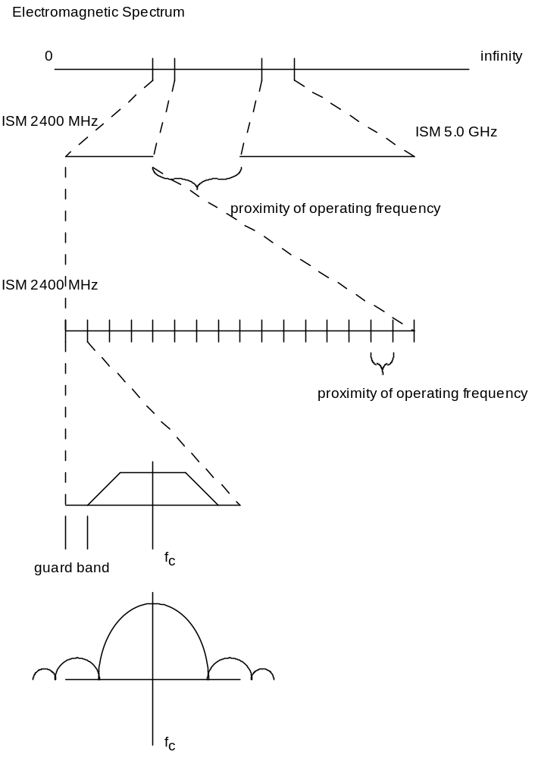
Figure 1 Proximity of operating frequency

Types of frequency: Actual overlapping frequencies vs. harmonics (lobes).

Other characteristics considerations
The following characteristics were considered as major to be used to differentiate coexistence scenarios, but were later determined not to be.

License versus unlicensed
License versus unlicensed wireless systems was considered as a major characteristic, but there is really no difference for the study of coexistence. For this reason coexistence scenarios will not be differentiated using this characteristic.

Adaptation to spectral activity.
As networks and systems develop to overcome wireless characteristics, methods may be employed to overcome or take advantage of the current condition of this wireless media.
For example, if it is determined that the wireless link is causing more bit errors, an alternative method of sending and receiving the signal may be used (e.g., change its forward error correction technique, or change its modulation and coding).

The triggers for determining that an action should be taken are out of scope. The action to be taken is also out of scope.

Examples:
Change modulation technique
Change forward error correction method
Change to another frequency (e.g., DFS)
Change to another channel within the band (e.g., 802.15.4)
Change to another band (e.g., 2.4 GHz to 5.0 GHz)
Transmit power control (TPC)
Change bandwidth (e.g., 11n 20/40 MHz (i.e., bandwidth selection))
Adaptive Frequency hopping (AFH)
TDMA
CDMA
FDMA

Based on discussion held during the January 2007 London, UK meeting of 802.19 TAG, it was decided that adaptive techniques are protocol specific details and therefore cannot be covered in a generic manner. For this reason it will no longer be considered as a major characteristic to differentiate major categories of coexistence scenarios. Instead will be treated as special scenarios separate from the generic coexistence scenarios.

Organizing Matrix

Given that there are two networks (A and B) to be studied for coexistence the following possibilities exist considering whether the network is using frequency hopping (FH) or not and whether the number of stations (nodes) within the network is 2 or more.

The following truth table considers three of the major characteristics: Number of Networks,
Number of Stations, and Frequency static vs. frequency hopping.

Table 1 – Truth table for three major characteristics
Unique | Network A |  | Network B
 | FH | two | two | FH
1 | T | T | T | T
2 | F | T | T | T
3 | T | F | T | T
4 | F | F | T | T
Same as 3 | T | T | F | T
5 | F | T | F | T
6 | T | F | F | T
7 | F | F | F | T
Same as 2 | T | T | T | F
8 | F | T | T | F
Same as 5 | T | F | T | F
9 | F | F | T | F
Same as 4 | T | T | F | F
Same as 9 | F | T | F | F
Same as 7 | T | F | F | F
10 | F | F | F | F

If one treats Network A and Network B as variables in the previous truth table, then one has 10 unique combinations. (Line 3 and line 5(same as 3) are same with one network being a FH but not two stations(nodes) and another network being a FH and consisting of two stations/nodes). The only difference was which network was which. From this 10 unique combinations exist and follow with short descriptions. The resultant ten (10) generic coexistence scenarios are graphically shown in figure XX. Each of the ten (10) generic scenarios are considered in the following sub-clauses. The ordering of the generic scenarios is based on the order presented in the truth table.

Scenario 1
Both network A and network B are employing frequency hopping and both network A and Network B consist of two stations/nodes. When considering the proximity of operating frequency in this scenario, one must consider the width and number of hopping channels used in both Network A and Network B. If the width and number of hopping channels are the same for both network A and network B, then there will exist two possibilities. Either both hop in the same channel which results in a

Scenario 2
Network A is not FH and Network B is FH. Both Network A and Network B consist of two stations/nodes.

Scenario 3
Both Network A and Network B are FH. Network A consists of more than 2 stations/nodes and Network B consists of two stations/nodes.

Scenario 4
Network A is not FH and Network B is FH. Network A consists of more than 2 stations/nodes and Network B consists of two stations/nodes.

Scenario 5
Network A is not FH and Network B is FH Network A consists of two stations/nodes and Network B consists of more than 2 stations/nodes.

Scenario 6
Both Network A and Network B are FH. Both network A and Network B consist of more than 2 stations/nodes.

Scenario 7
Network A is not FH and Network B is FH. Both network A and Network B consist of more than 2 stations/nodes.

Scenario 8
Both Network A and Network B are not FH. Both network A and Network B consist of two stations/nodes.

Scenario 9
Both Network A and Network B are not FH. Network A consists of more than 2 stations/nodes and Network B consists of two stations/nodes.

Scenario 10
Both network A and network B are not employing frequency hopping and both network A and Network B consist of more than 2 stations/nodes.

Applying another major characteristic
Applying the major characteristic: Proximity of Operating Frequency; to the above 10 scenarios as sub-scenarios.

Reason number one:
The choice of FH or not FH directly affects how to relate the proximity of the operating frequency. See Figure 2

Special Scenarios

Dynamic Frequency Selection (DFS)

Adaptive Frequency Hopping (AFH)

Bandwidth Selection (20/40 MHz)(maybe)

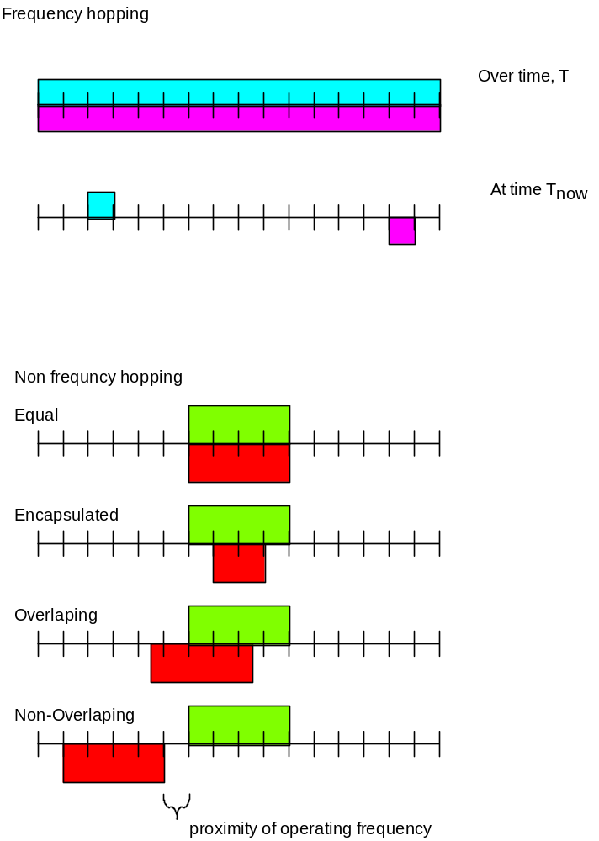
Figure 2 Proximity frequency overlapping possibilities

