THOMAS JEFFERSON
NATIONAL ACCELERATOR FACILITY


STRATEGIC FACILITIES PLAN

FY 2003 – FY 2013

DRAFT

August 2002

Operated by Southeastern Universities Research Association, Inc.
Under Contract with the U.S. Department of Energy
Contract DE-AC05-84ER-40150

TABLE OF CONTENTS

EXECUTIVE SUMMARY……………………………………………………… ii

- INFRASTRUCTURE VISION, GOALS AND OBJECTIVES ……………… 1

- MISSION FUTURE OF THE LABORATORY.…………………………….... 2
- Overall
- Programmatic

- PLANNING ASSUMPTIONS.………………………………………………... 4

- CHANGES FROM 2000 STRATEGIC FACILITIES PLAN………………....5

- SITE DEVELOPMENT AND INFRASTRUCTURE NEEDS
AT JEFFERSON LAB.……………………………………………………..…. 6

- Site Development and Major Facilities Maintenance………6
- Infrastructure Needs at Jefferson Lab……………………….7

- PLAN DEVELOPMENT AND PRIORITIZATION PROCESS.………….… 8

- LOGIC OF THE FACILITIES PLAN.………………………………………… 9

- PERFORMANCE METRICS AND INDICATORS………………………... 11

- APPENDICES……………………………………………………….……….. 12

EXECUTIVE SUMMARY

Thomas Jefferson National Accelerator Facility (Jefferson Lab or JLab), as one of the Office of Science (SC) program-dedicated labs, primarily studies hadronic physics through the use of continuous wave (cw) electron beams. Operating as a user facility, JLab provides experimenters with beams and detection equipment that are unique worldwide. JLab maintains its core competencies in support of its nuclear physics programand broader Office of Science missions in the context of the national lab system (i.e. Spallation Neutron Source (SNS)), and applies its related technologies to activities in the national interest (i.e. Free Electron Laser (FEL)).

Jefferson Lab’s Institutional Plan flows from the longer-term 20 year strategic vision of the Lab. The Institutional Plan is the guiding document outlining programmatic plans, as well as goals and objectives, for the Laboratory in a five-year timescale. It also includes ten year funding and staffing projections. This Strategic Facilities Plan flows from the Institutional Plan. The programmatic goals included in these plans include the following key elements:

Current Mission Activities
- Execution of a world-class hadronics physics program
- Partnering on the SNS project to deliver the superconducting linac and supporting cryogenic facilities
- Completing the 10 kilowatt (kW) infrared (IR) and 1 kW ultraviolet upgrade to the existing IR FEL device
- Development of advanced computational techniques to solve Quantum Chromodynamics (QCD) numerically termed Lattice QCD (LQCD).

Projected Mission Activities
- Extending accelerator capabilities via an energy upgrade to 12 GeV (12 billion electron volts)
- Contributing to the planning, R&D, and construction for the Rare Isotope Accelerator (RIA)
- Preparing a program in basic science utilizing the capabilities of the FEL
- Providing X-Rays to the FEL facility from installation of High Energy Lithography Source (HELIOS) Compact Synchrotron X-ray Source
- Extending the FEL capabilities to 100 kilowatt (kW) infrared (IR)
- Expanding the Lab’s leadership position in accelerator technologies

Delivering this scope of work requires an increase in personnel (staff, users & subcontractors) as high as 223 (20%) over ten years. These manpower requirements drive our space and infrastructure needs and therefore the tenets of this plan.

While Jefferson Lab was built on a green site, with primarily new facilities, the scope of the construction project at JLab did not include enough space for the scope of work described above. Thus far, we have managed this lack of space through the use of trailers and the leasing of space built adjacent to the site by a third party (City of Newport News). This Strategic Facilities Plan sets Jefferson Lab on a path to meet its infrastructure needs on the ten-year timescale consistent with the needs of a world-class research facility. A total of $22M in General Plant Projects (GPP) and $32.3M in line item projects are described in the plan (FY03 - FY13). This represents the addition of 233,345 square feet (SF) of new space and the elimination of 66,200 SF of temporary structures.

Resource Needs Summary (GPP)
FY | 03 | 04 | 05 | 06 | 07 | 08 | 09 | 10 | 11 | 12 | 13
M$ | 0.8 | 4.8 | 3.6 | 4.4 | 1.5 | 1.9 | 1.0 | 1.0 | 1.0 | 1.0 | 1.0

Resource Needs Summary (Line-Item Facility Projects)
FY | 03 | 04 | 05 | 06 | 07 | 08 | 09 | 10 | 11 | 12 | 13
M$ | 1.5 | 4.6 | 5.9 | 7.0 | 7.3 | 6.0 | 0 | 0 | 0 | 0 | 0
- INFRASTRUCTURE VISION, GOALS, AND OBJECTIVES

Our vision is a facility that provides a safe and secure world-class environment for research and development, allows staff and users to work together effectively, and is cost effective to operate and maintain.

In developing a long-term (ten-year) strategy for facilities, the driving force is providing the infrastructure needed to perform current and planned mission-related activities, including collaborative work in support of sister laboratories in the national lab system. Appendix A gives the projected funding and associate staffing requirements based on programmatic needs. Appendix B outlines the associated space requirements for described projects and staffing levels. New facilities are indicated on the site plan attached as Appendix C. Appendix D lists individual projects. These lists include both projects to support current and planned mission-related activities as well as infrastructure needs to significantly improve the research environment for users and staff on a ten-year timescale. For all infrastructure projects, programmatic need and available funds guide the timing and priority assigned.

The major objectives of infrastructure projects included in our Strategic Facilities Plan are:

- Maintain existing facilities and making alterations to realize energy and cost savings.
- Provide office and technical space corresponding to manpower projections.
- Eliminate substandard storage space and structures that have reached the end of their useful lives.
- Co-locate work groups to the extent possible to enhance effectiveness.
- Eliminate leases that do not lead to building ownership.
II. MISSION FUTURE OF THE LAB

- Overall

Jefferson Lab’s mission is to provide forefront scientific facilities, opportunities, and leadership essential for discovering the fundamental nature of nuclear matter; to partner with industry to apply its advanced technology; and to serve the nation and its communities through education and public outreach—all with uncompromising excellence in environment, health, and safety.

- Programmatic

Jefferson Lab (JLab), an Office of Science “program-dedicated lab,” primarily studies hadronic physics through the use of continuous wave electron beams, providing worldwide unique capabilities to its user community. As an integral part of its core mission, Jefferson Lab supports the national lab system by applying its core technologies to the broader Office of Science missions, specifically the Spallation Neutron Source (SNS) and the planning of the Rare Isotope Accelerator (RIA). In addition, Jefferson Lab’s core competency in SRF technology led to the development of a Free Electron Laser that has advanced accelerator concepts and exceeded power levels available in the IR with similar devices, offering unique capabilities for basic science, industrial processing of materials, and defense applications.

To expand the current physics program and to answer key questions remaining in hadronic physics, Jefferson Lab users are pursuing a 12 GeV upgrade to the accelerator and an additional experimental hall for meson spectroscopy, which are included in the current NSAC Long-Range Plan. R&D required for the upgrade is synergistic with maintaining our forefront position in SRF and the resulting work with SNS and possibly RIA. For planning purposes, we have assumed that the 12 GeV upgrade will be part of our facility’s future, and that we will follow our role in SNS with a similar role for RIA should it be approved.

In addition to the 12 GeV upgrade of the main accelerator and the additional hall (Hall D), JLab anticipates that its Free Electron Laser (FEL), which is currently being upgraded to deliver 10 kW IR and 1 kW UV, will, by offering facilities unique in the world, attract users in basic and applied sciences and build a strong user program based on these capabilities. The 12 GeV upgrade and the anticipated expansion of the FEL program are seen as logical extensions of our current program and synergistic with our nuclear physics mission. Therefore, we have included them as an integral part of planning for our facility. The above scope of work constitutes our current and planned programs and points to infrastructure needs associated with accomplishing that scope. Square footage—but not cost—associated with the proposed 12 GeV Upgrade line item projects is addressed in this plan.

We also have included in the facilities plan projects that would enhance the research environment at Jefferson Lab by creating better synergy among working groups, enhancing facilities to create a world-class environment for research, and eliminating leased space. The present leasing arrangements represent an ongoing, open-ended expense to the program.

III. PLANNING ASSUMPTIONS

- Program-driven manpower requirements will drive infrastructure needs.
- The present base Nuclear Physics program plus the SNS and FEL define within a few percent the level of staff and users to be accommodated on site in the next decade and beyond.
- The SNS will continue as a high priority activity for JLab through 2004 and will utilize key facility resources near-term.

- We expect to have a clear defined mission through the period of this plan (2003 – 2013).

- We will be able to obtain an excess facility waiver for the square footage of new construction exceeding that disposed of at this facility.

- The FEL upgrade will continue and will lead to an operational program for the next decade demanding additional facility resources.

- Within this decade, failing temporary facilities (trailers and transportainers) must be replaced, upgrades will be made to existing facilities and equipment, and additional space will be needed for expanded staff for program requirements identified above.

- Age and increased loads in the accelerator enclosure will require major HVAC upgrades. The two large older buildings at the facility will require replacement of their HVAC systems. Upgrades will be required for systems in two additional buildings.

- Information technology advancements will continue to require major upgrades to support systems, such as phone switches, computer lines, and computer storage.

- There will be no impact on the existing building code variances (waivers) from the transition to external regulation.

IV. CHANGES FROM 2000 STRATEGIC FACILITIES PLAN

Projects that are not capital improvements or do not extend the useful life of a facility are viewed as maintenance and therefore should be funded from operations instead of General Plant Projects (GPP). There were a number of maintenance projects in the 2000 Strategic Facilities Plan shown as GPP funding. These projects have been deleted from the projects list. Leases also were previously shown as GPP funding but now are supported by operating funds.

The CEBAF Center Addition project has been redefined into two phases. Phase 1, a 59,000 square foot addition, has been approved as a line item project for funding in FY03 – 05. Phase 2 is a 71,000 square foot addition, which is being submitted as a FY05 line item project.

Projects in support of the planned 12 GeV upgrade also have been changed from GPP funding to part of the line item project.

The number of users has been updated to reflect the number of staff workstations required instead of the previous average number of users at the site at one time.

Technology projects are no longer included since Jefferson Lab does not receive any General Plant Equipment (GPE) funding.

V. SITE DEVELOPMENT AND INFRASTRUCTURE NEEDS AT JEFFERSON LAB

- Site Development and Major Facilities Maintenance

Jefferson Lab is somewhat unique among the national labs in that it was built on an essentially green site in 1987-1995 and therefore has no existing environmental legacies. Buildings and facilities on site are fairly new and therefore require primarily routine maintenance. A site map is attached as Appendix C and a Site Description is attached as Appendix E.

Currently, major facility maintenance is done at a rate of expenditure of $2.9M per year, 1.3% of their replacement value as shown in Appendix D. While this has proved adequate for maintaining most of the infrastructure of new buildings, additional resources are required for replacing systems in the 30-plus year old buildings and for replacing aging trailers. We are using third party financing through Bonneville Power Authority to replace aging mechanical systems and to upgrade lighting systems.

Site development continues to be guided by the area themes identified by Jefferson Lab’s Site Development Plan, written in 1988, revised in 1993, and now superseded by this planning document. Important principles of this plan are to co-locate compatible functions and to reserve the maximum amount of space near the accelerator site for future additional end stations or technical facilities requiring proximity.

We have thus far dealt with space issues resulting from the growth in our user community and increased mission needs by working in innovative ways with the surrounding community—specifically to lease space that was built by the City of Newport News (the Applied Research Center). This arrangement has helped us meet our urgent space needs without a construction line item and is synergistic with the region’s wishes to use the Laboratory as a magnet for high-tech business and services deriving from Jefferson Lab-related technologies. While this has been a very good short-term solution to our space problems, it is not the most cost effective approach over time and sometimes forces us to make less than optimum decisions regarding the siting of groups. In addition, we have on our site a collection of trailers that were meant as temporary quarters. However, with the growth in our user community and site population, we have been unable to decommission these trailers, and we continue to use them even though they are increasingly expensive to maintain and operate due to their age and construction. Consequently, the two line items in this plan and the largest GPP projects are for additions to our main office building, CEBAF Center, to replace trailers and some leased space.

If growth in programmatic requirements require space beyond what the CEBAF Center additions can accommodate, the City of Newport News has agreed to build an addition to the Applied Research Center and lease additional space to the Lab.

To meet technical space needs, there are additions to accommodate Computer Center hardware and staging areas for 12 GeV and four-hall operation work and for storage space to replace the inefficient transportainers and leased off-site space. To meet several of these needs, third party financing is being considered for a grouping of several GPP projects (construct technical, storage, and some FEL support space, relocate shipping and receiving) into one $4-5M project to be located at the southeast site boundary.

Working with the Commonwealth of Virginia, the proposed Education/Visitor Center also is a candidate for third party financing.

B. Infrastructure Needs at Jefferson Lab

Jefferson Lab is an Office of Science (SC) program-dedicated lab, and all of these current and planned activities support the SC mission. The projects listed fall into three primary categories:

- Infrastructure to support current Mission scope
- Routine scheduled GPP projects.
Improvements are needed to existing facilities to correct discrepancies or improve the performance of existing systems.
- Currently there is inadequate space for users and staff (2-3 to an office, carrels in hallways, technical space set up in equipment rooms, etc.).
- Replacement of aging trailers with permanent facilities.
- Replacement of shipping containers used for long-term storage.

- Infrastructure to support planned Mission scope
- Changes/systems to support planned programs (LQCD)

- 12 GeV and Hall D
- FEL user needs and HELIOS addition

- Infrastructure to Increase Cost Effectiveness
- Optimize co-location of related groups
- Eliminate leased space that does not result in building ownership

Costs associated with these projects are in Appendix D – Project List and Resource Needs

VI. PLAN DEVELOPMENT AND PRIORITIZATION PROCESS

- Assess condition and adequacy of existing facilities.

- Identify all projects that are part of existing GPP and maintenance plans for a 5-year timeframe (Plant Engineering).

- Determine current and projected staffing space needs as guided by programs (Director’s Council and cross-functional lab team).

- Identify additional projects that would benefit laboratory if additional funding sources were available, and identify possible funding sources (cross functional lab team).

- Prioritize projects based on programmatic needs and funding availability (Director’s Council).

VII. LOGIC OF FACILITIES PLAN

This plan is driven by the needs of current and envisaged research programs.

It is necessary to maintain infrastructure in place and to operate with energy efficiency.

These goals are met by proper repair and maintenance and the use of tools such as third party financing for the energy projects.

It is necessary to provide:
- Office space required to house the staff and users that the ten year program demands.
- Adequate technical work areas, including computer center space.
- Building and infrastructure modifications that ensue from higher powered operation in the context of the current research program.

Jefferson Lab has obtained third party financing to accomplish HVAC system replacement and lighting upgrades in various buildings. Work has begun and will be completed in FY03. As noted earlier, there are other potential candidate projects for third party financing.

Computer space needs described in the previous Strategic Facilities Plan have been met to date by converting office space to computer space and increasing power and air conditioning through GPP projects. Another GPP project is in progress to convert computer technical workspace to further expand the existing computer room and upgrade the air conditioning and power. This will provide sufficient capacity to support the program through FY03. New computer space is programmed through a GPP project to meet the FY04 computing space requirements.

CEBAF Center Addition Phase 1 is programmed for funding in FY03 through
FY05 with construction scheduled for completion by the end of FY05. Assuming there is no change or delay in this project funding, adequate office space and computing should be in place to meet the FY05 through FY12 computing needs, and new office space will allow removal of 22,000 square feet of aging trailers.

Construction of CEBAF Center Addition Phase 2 consists of a double-wide three story wing and a single-wide two story wing to replace an additional 15,200 square feet of existing trailers and, depending on staffing level, a portion of off-site leased office space in the City of Newport News Applied Research Center (ARC). This project will consolidate an additional major portion of our staff and provide a much-needed large meeting room to support the larger collaborations and conferences. Completion of this project by the end of FY07 would coincide with the end of our current lease. The labs and associated office space would be retained in the ARC for at least an additional five years until suitable replacements can be constructed or the need no longer exists. The CEBAF Center Addition Phase 2 single wide two-story wing would be used to provide office space for occupants currently in the Test Lab Building during the proposed project to rehabilitate the building.

If staffing materializes as outlined in Appendix A, there will be a need to retain all of the existing leased space in the ARC as well as obtain additional temporary office space from FY04 through FY07. (Acceleration of CEBAF Center Phase 2 would reduce the need for this additional leased space.) With 14 to 16 months notice, the City of Newport News could construct additional offices adjacent to our site. Otherwise, temporary office trailers or office space separated from JLab would be required.

The remainder of these goals is attained by increasing the amount of GPP funding available to the Lab to allow construction of additional technical space and central storage to eliminate the use of transportainers for long-term storage.

Delay of specific projects or increased staffing may require JLab to retain some of the office trailers slated for removal until construction of new facilities or other alternatives are implemented.

In developing the plan, Return on Investment was a key consideration. Other benefits looked at include the improved work environment efficiency due to co-location, enhanced facilities, reduced risk from severe weather events (especially true with trailers), and lower long-term maintenance.
VIII. PERFORMANCE METRICS AND INDICATORS

The performance metrics and indicators are based on the criteria given in Section I “Infrastructure Vision, Goals and Objectives.”

- Maintain existing facilities and make alterations to realize energy savings.

- Provide real property maintenance sufficient to maintain building functionality.

- Provide office and technical space corresponding to our manpower projections. (Staff and users have adequate office space, i.e. one staff member or two users per standard office.)

- Eliminate substandard storage space and structures that have reached the end of their useful lives.

- Eliminate to the extent possible the use of trailers for office space, and phase out the use of transportainers for storage.

- Co-locate work groups to the extent possible to enhance effectiveness. (Staff members are optimally located based on proximity to related work groups and equipment.)

- Eliminate leases that do not lead to building ownership, and minimize off-site leases.

IX. APPENDICES

Appendix A Outyear Funding and Staffing Projections….…………………13

Appendix B Space Requirements…………………………………………….14

Appendix C Site Plan………………………………………………………......15

Appendix D Projects List and Resource Needs.……………………….……16

Appendix E Site Description…………………………………………….…….19

JEFFERSON LAB
OUTYEAR FUNDING AND STAFFING PROJECTIONS

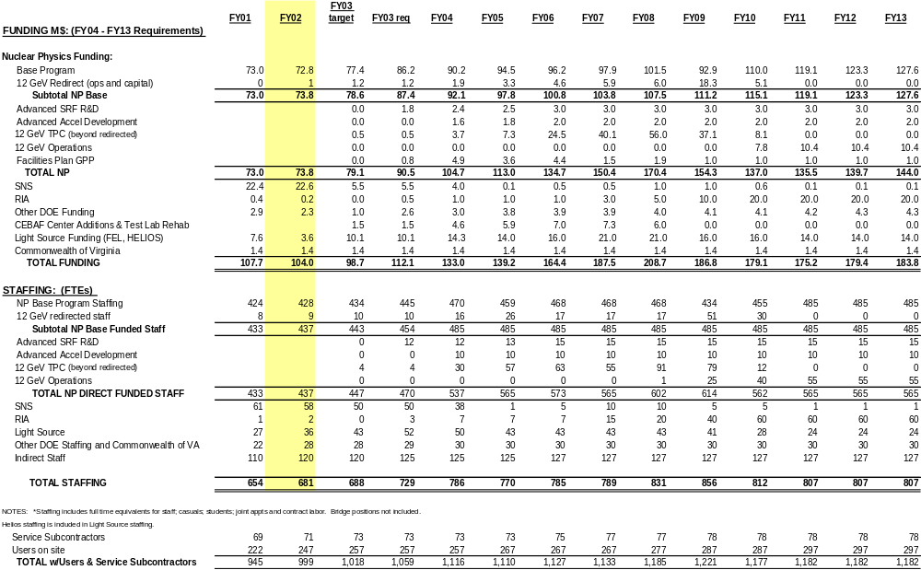
JEFFERSON LAB
Space Requirements
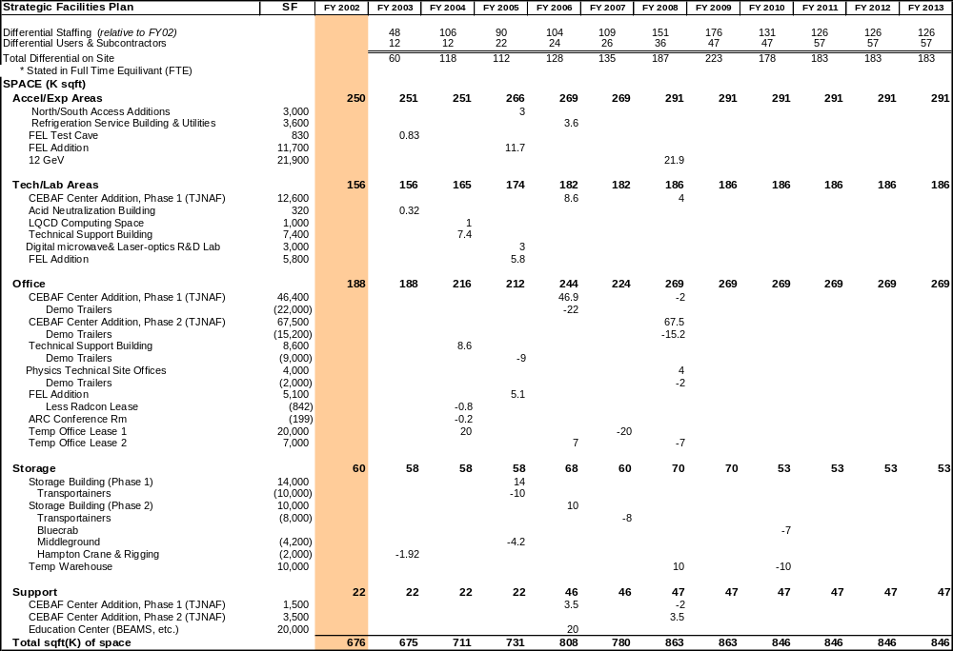
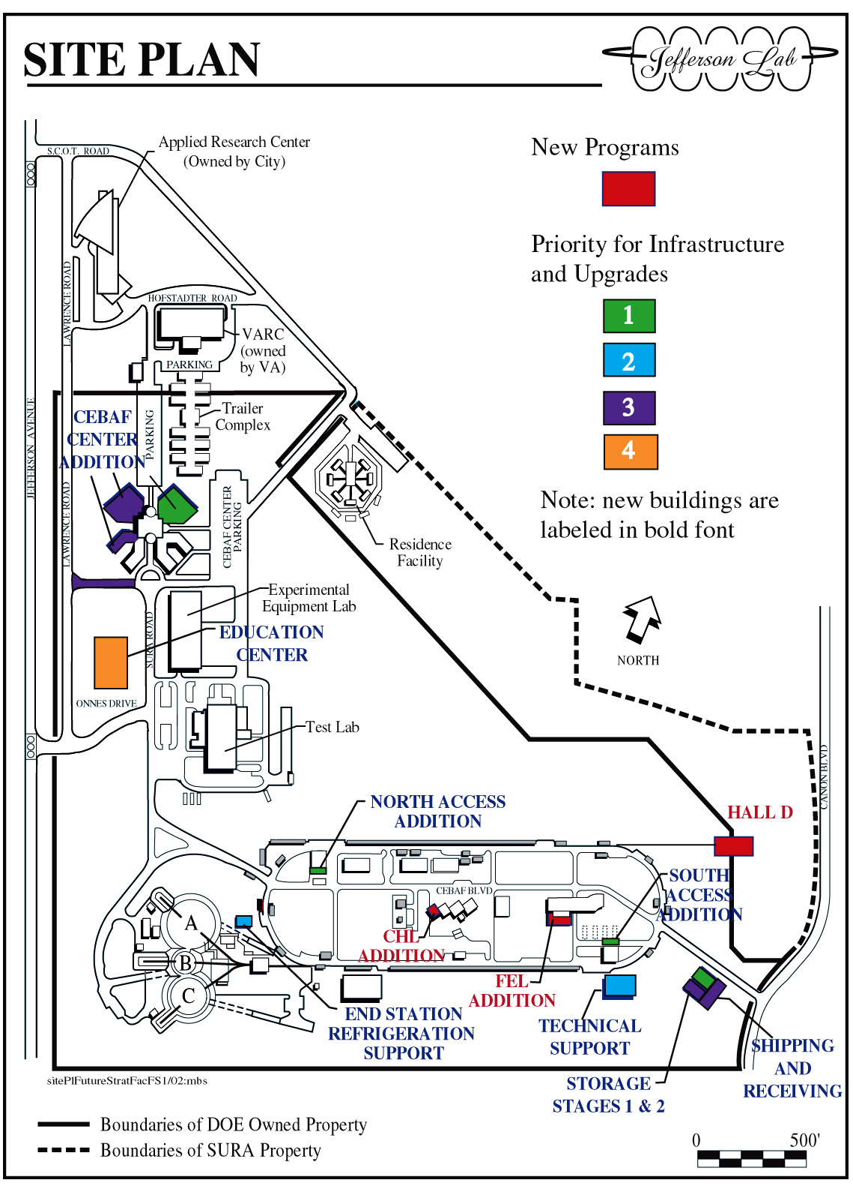
PROJECT LISTING and RESOURCE NEEDS
(Not including cost of 12 GeV)
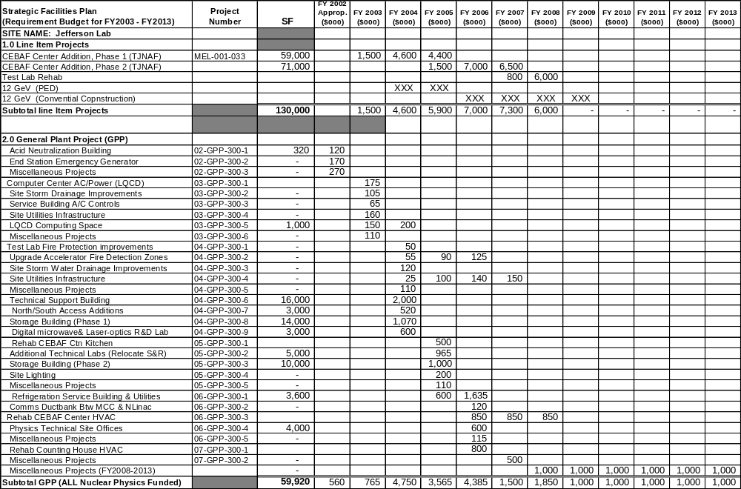
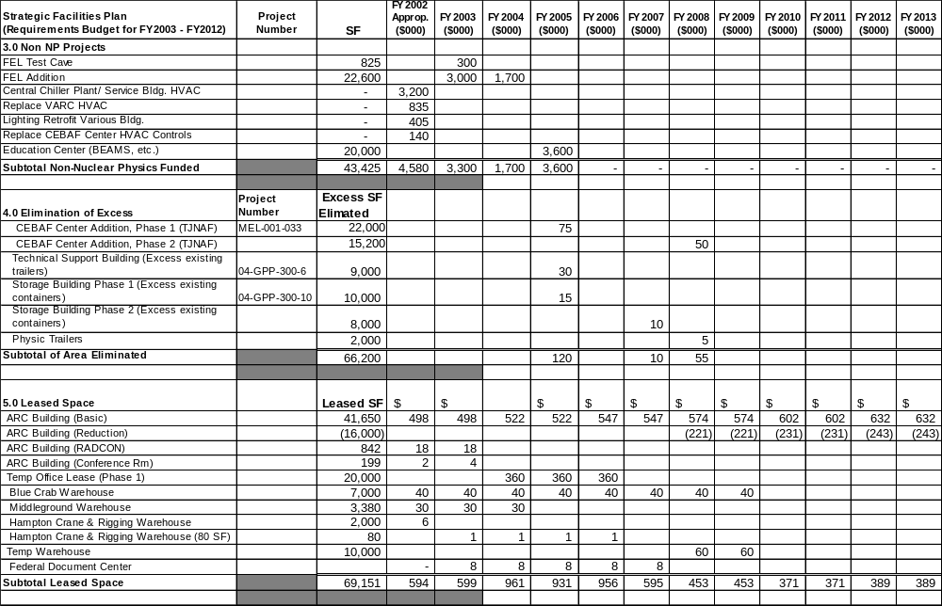PROJECT LISTING and RESOURCE NEEDS (Continued)

PROJECT LISTING and RESOURCE NEEDS (Continued)

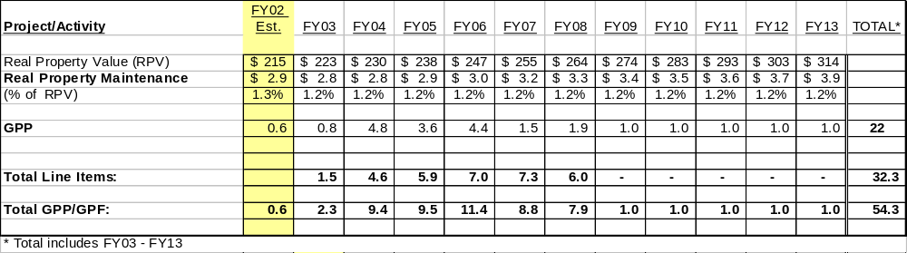
SITE DESCRIPTION

The Jefferson Lab site, located in Newport News, Virginia, includes 162 acres owned by the DOE and 8 acres owned by the Commonwealth of Virginia. SURA owns 44 acres adjacent to the site. The facilities include the accelerator complex serving three experimental halls, the Free-Electron Laser Facility, a central office building (CEBAF Center), two major laboratory buildings, and various other support structures.

The accelerator enclosure is a 7/8-mile racetrack-shaped concrete tunnel, 25 feet underground. The tunnel houses a 45 MeV injector, two 400 MeV linacs—one in each straight section of the racetrack—and 6 kilometers of beam transport lines. The Central Helium Liquefier (CHL), a 75,000 liquid liter, 4800 watt refrigerator plant located in the interior of the racetrack, supplies liquid helium at 2 K to the accelerator for the ultra cold needed for superconducting operation. The Machine Control Center (MCC) houses the computer systems that control and monitor accelerator operations. The Free-Electron Laser generates high power infrared light using the accelerator technology and shares the CHL.

The experimental area consists of three large domed concrete halls, partially underground and mounded with earth for shielding. The floors are about 36 feet below existing grade, and the domes extend up to 45 feet above grade. Hall C is 150 feet in diameter, Hall A 174 feet, and Hall B 98 feet. The major support building for the experimental physics area is the Counting House, where physicists control and monitor the experimental runs. Some 35 support structures in the accelerator/experimental area complement these major structures.

Major structures on the remainder of the site provide administrative, laboratory, and technical support facilities. CEBAF Center provides office space, an auditorium, and a cafeteria, and houses the computer center. The Experimental Equipment Laboratory (EEL) provides light laboratory space for detector fabrication and machine shops. The Test Lab is a high-bay building housing major component assembly, test, and maintenance functions.

The FEL Building was completed in late 1997. Commissioning of the FEL began in the spring of 1998. The 15,000 square foot physics storage/assembly building was completed in 1998.

The city of Newport News constructed the Applied Research Center (ARC) on a site directly adjacent to the laboratory. The 121,000 square foot structure, completed in the spring of 1998, provides office and light laboratory space for lease to qualified tenants. Jefferson Lab has leased 41,600 SF. Several collaborating universities also have leased space. The ARC will be the anchor for the 200-acre Jefferson Center for Research and Technology, a technology park for high technology R&D and production activities.

 | Laboratory Space Distribution |  |  |  |  |  | Facilities Replacement Value (FY02 M$)
 |  |  |  |  |  |  |  |  |  | Replacement
 |  | Location |  | Area (Sq. Ft.) |  |  |  | Facility Type |  | Value
 |  | Main Site |  | 621,089 |  |  |  | Buildings |  | 203
 |  |  |  |  |  |  |  | Utilities/Roadways |  | 12
 |  | Leased -Off Site |  | 54,872 |  |  |  | Accelerator Technical Systems |  | 315
 |  |  |  | _______ |  |  |  | Experimental Equipment |  | 197
 |  |  |  | 675,961 |  |  |  | TOTAL |  | 727

USE AND CONDITION OF LABORATORY SPACE
 |  |  | (000's SF)
 | Accel/ Exp Areas | Tech Support/ Lab Area | Office | Storage | Support | Total
excellent | 198 | 54 | 58 | 28 | 4.9 | 343
good | 6 | - | 29 | 7 | 3 | 45
adequate | 15 | 4 | 47 |  | 11.5 | 76
fair | 8 | 96 | 20 | 5.5 | 3 | 133
poor | 23 | - | - | - | 0 | 23
fail | - | 2 | 35 | 19 | 0 | 56
Total | 250 | 156 | 188 | 60 | 22 | 676

Because the project hasn’t been approved, costs for construction of programmatic facilities (12 GeV and Hall D) are not included in this plan. These projects are included in the line item project.
These projects are included as Non-NP funded projects.

