Healing Forest
Materials: Healing Forest chart; plant list; 14 - 3x5 index cards per group; pencils
Subject: Science, Social Studies
Length: 1 Hour
Location: Outdoors


Objectives: To encourage awareness of surroundings. To show historical use of plants. To demonstrate the importance of diversity.

Method: Students will search for medicinal plants, then make observations about them.

Background: The Timucuan Indians were the first known people to live on Cumberland Island (then called Missoe, meaning "beautiful island"). They utilized the island's resources such as the marine life in the sound and marshes, animals roaming the forest and plants growing throughout. The Timucuans and later the early settlers used the plants not only for food but also as a source of medicine. Many medicines and cures used today began as a folk medicine - one that was used traditionally. Some plants were chosen as a treatment due to the Doctrine of Signatures, the idea that a part of the plant resembled a part of the body and so could be used to cure it. Occasionally it proved to be true. More often than not, it was a placebo. Other plants were used successfully but the origin of their use is unclear.

After being tested in modern laboratories, substances in plants were found to indeed treat certain ailments. For example, salicylic acid was found in willow twigs - ancient aspirin. Scientists believe there are thousands of cures out there still unknown. Taxol is a good example. Derived from the bark of the yew, a tree that was being cut down as a nuisance plant, this plant is now valued for a substance used to treat many types of cancer. Examples like this should encourage the protection of our ecosystems and the diversity they hold for there are many unknowns hiding like a treasure.

Procedure:
- Ask the students to name a few plants they know that live in the forest. Are these all the plants in the forest? Have students explain the role of the plants in the forest. (food, oxygen, shade, shelter, medicine) Are they all necessary? What would happen if an important food source disappeared? (animals would die) Does anyone know which plant is more important than any others? (they are all equally important - even if a specific benefit is not known to man)
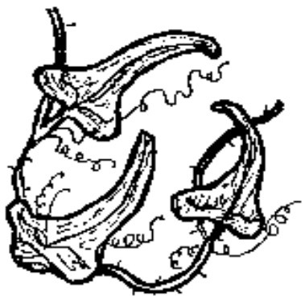

- Ask the students for uses of plants. (food, oxygen, shade, shelter, medicine) These are the same roles plants play for animals. How might it affect humankind if one or any of those plants disappeared? (sometimes results are unpredictable) Explain the concept of diversity. All organisms on our planet are equally important, whether plant or animal.

- Explain to the students that they will be taking a discovery hike, where they will discover some of the secrets of the plants found in the maritime forest. Explain that they will create a "medicine kit" and in doing so, figure out why some of the plants are important, both now and historically.

- Remind the students of the Park policy of not picking plants. Take a hike! Try to find as many of the plants on the list as possible. As the students find the plants have them sketch the leaf on one of the 3x5 cards and write the medicinal use along one side.
- Together these plants make a natural medicine kit. Ask if they would be willing to use these cures today. Explain that many of today's medicines are derived from chemicals in plants. (CAUTION - Students should NOT use any of these plants as a substitute for current medicine. Many are toxic if used improperly. Use them only as demonstration models) Ask them how they might feel if a medicinal use of a plant was found but few, if any, of that plant still lived.
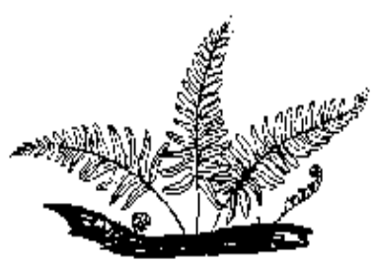

Evaluation: Ask students to define diversity. Have them explain why it's important to maintain diversity in our world.

Healing Forest Chart
 | boils/ cuts/ ulcers | head  aches | colds/  coughs | rheumatism | stomachache | relief from itching | dysentery/diarrhea
Prickly Ash | X |  | X | X |  |  | X
Resurrection Fern | X | X | X
Bracken Fern | X |  |  |  | X |  | X
Prickly Pear Cactus | X |  |  | X
Mullein | X | X | X
Saw Palmetto |  | X | X
Red Cedar |  |  | X | X
American Holly |  |  | X |  |  | X | X
Prickly Poppy | X | X | X |  |  | X
Beauty Berry |  |  |  | X | X |  | X
Greenbrier | X |  |  | X | X | X
Staggerbush |  |  |  |  |  | X
Virginia Creeper | X |  |  |  |  |  | X
Wax Myrtle |  | X | X |  |  | X | X
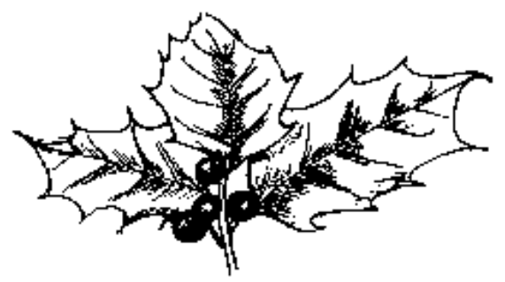

Prickly Ash (Zanthoxylum clava-hercules) - shrub with compound leaves; leaves have a camphor odor when crushed; bark has large corky knobs
Plant List

Resurrection Fern (Polypodium polypodioides) - an epiphyte that grows on tree limbs; resembles a healthy fern when humid, turns brown and crunchy when dry (forest)

Bracken fern (Pteridium aquilinum) - a triangular-leaved fern; leaf divided into three parts (forest)

Prickly pear cactus (Opuntia humifusa) - a succulent with long spines; leaves are rounded pads; purple fruits are oval (field)

Mullein (Verbascum thapsus) - a fuzzy light green rosette of leaves, often with the old flower stalk in the middle (field)

Saw palmetto (Serenoa repens) - shrub with evergreen fan-shaped leaves; petiole has spines along edges (forest)

Red cedar (Juniperus virginiana)- evergreen tree with shedding brown bark; leaves scalelike (field, forest edge)

American holly (Ilex opaca) - evergreen tree with spine-tipped leaves; fruits red (forest)

Prickly poppy (Argemone albiflora) - short prickly annual; leaves with spines; seeds enclosed in a 5 sectioned capsule (dunes)

Beauty berry (Callecarpa americana) - deciduous shrub with arching branches and opposite leaves; fruit violet-magenta(forest)

Greenbrier (Smilax sp) - climbing vines with prickles along the stem (forest, dunes)

Staggerbush (Lyonia mariana) - evergreen shrub with rusty scales on underside of leaves (forest)

Virginia Creeper (Parthenocissus quinquefolia) - smooth woody vine with 5 leaflets; deciduous (forest, dunes)

Wax myrtle (Myrica sp) - aromatic evergreen shrub; leaves thick with waxy covering; fruits round (dunes)

