Landsat Data Continuity Mission (LDCM)
Functional Description

November 1, 2001



Goddard Space Flight Center
Greenbelt, Maryland 20771
REVISION HISTORY

Document Title: Landsat Data Continuity Mission Functional Description
Issue | Date | Pages  Affected | Description
Initial | 11/01/01 | All | Initial Release

DOCUMENT CHANGE HISTORY

Mod. # | Date | CCR # | Date | Section(s)

Table of Contents

1 INTRODUCTION 5
1.1 PURPOSE 5
1.2 SCOPE 5
1.3 FUNCTIONAL ALLOCATIONS 6
1.4 ORGANIZATION 7
1.5 APPLICABLE DOCUMENTS 7
1.6 CONVENTIONS 7
2 FUNCTIONAL DESCRIPTION 8
2.1 SCHEDULE ACQUISTIONS 10
2.1.1 Manage Long Term Acquisition Plan 11
2.1.2 Manage Special Requests 13
2.1.3 Manage Scheduler 14
2.1.4 Validate LTAP Priorities 14
2.2 ACQUIRE DATA 15
2.2.1 Control Observatory 15
2.2.2 Operate Sensor 16
2.2.3 Downlink Data 16
2.2.4 Generate Archive Data Sets 16
2.3 ARCHIVE DATA 17
2.3.1 Ingest And Assess Data 17
2.3.2 MAINTAIN ACTIVE ARCHIVE 17
2.3.3 Provide Data On Request 18
2.3.4 Long Term Archive 18
2.4 ORDER DATA PRODUCTS 19
2.4.1 Search & Query LDCM Active Archive 19
2.4.2 Order Products 20
2.4.3 Billing and Accounting 20
2.5 PRODUCE DATA PRODUCTS 21
2.5.1 Generate Products 21
2.5.2 Validate Products 22
2.5.3 Distribute Products 22
2.6 CALIBRATE LDCM DATA 23
2.6.1 Characterize Sensor Performance 24
2.6.2 Generate Calibration Parameters 24
2.6.3 External Validation of Calibration 24
2.6.4 Technical Support 24
2.7 SYSTEM QUALITY MANAGEMENT 25
3 EXAMPLE OPERATIONS SCENARIOS 26
3.1 ACQUIRING GLOBAL LDCM DATA 26
3.1.1 Objective 26
3.1.2 Assumptions 26
3.1.3 Scenario Description – Acquiring Global LDCM Data 27
3.2 ORDER AND DISTRIBUTE AN ARCHIVED LDCM DATA PRODUCT 30
3.2.1 Objective 30
3.2.2 Assumptions 30
3.2.3 Scenario Description – Order And Distribute An Archived LDCM Product 31
3.3 SPECIAL DAR – LOS ANGELES EARTHQUAKE 33
3.3.1 Objective 33
3.3.2 Assumptions 33
3.3.3 Scenario Description – Special DAR – Los Angeles Earthquake 34
3.4 UPDATE SENSOR AND CALIBRATION PARAMETERS 36
3.4.1 Objective 36
3.4.2 Assumptions 36
3.4.3 Scenario Description – Update Sensor And Calibration Parameters 37
4 DOCUMENT DATA DICTIONARY 39

INTRODUCTION

The Land Remote Sensing Policy Act of 1992 requires the U.S. Government Landsat Program Management to “assess options for a successor land remote sensing system to Landsat 7.” The act further requires that the assessment of options consider the ability to “maintain data continuity with the Landsat system” and to “incorporate system enhancements ... which may potentially yield a system that is less expensive to build and operate, and more responsive to data users.” In pursuit of these objectives, the Government is issuing a Request for Proposals for a mission formulation study. The ultimate aim is to procure data and services using a data specification based procurement.

PURPOSE

This document is intended to describe a potential functional process for LDCM system by taking the existing Landsat-7 functional flows and applying them to the LDCM Data Specifications found in the LDCM Phase 1 RFP. This document uses a series of Data Flow Diagrams (DFDs) to enhance the understanding of these functions and for illustration a minimal set of potential Operations Scenarios. Great effort was made to make the process in the DFDs as architecture independent as possible These DFDs are not part of the requirements; but, do reflect some of the process metrics called out in the RFP. These sections should offer the Contractor some perspective, given the specifics of the DFDs presented, as to what the government's involvement would be under these circumstances.

SCOPE

This functional process descriptions of the DFDs applies to an operational LDCM system after the Initial Operational Capability (IOC) milestone has been achieved. Any development or other pre-IOC activities are not included, nor are any End-Of-Life activities included. Any related commercial activities pertaining to data not purchased by the government are not included in this document.

Because the LDCM is a data and services mission, with government insight, DFDs pertaining to the calibration verification of the LDCM data and the Systems Quality Management are included.

FUNCTIONAL ALLOCATIONS
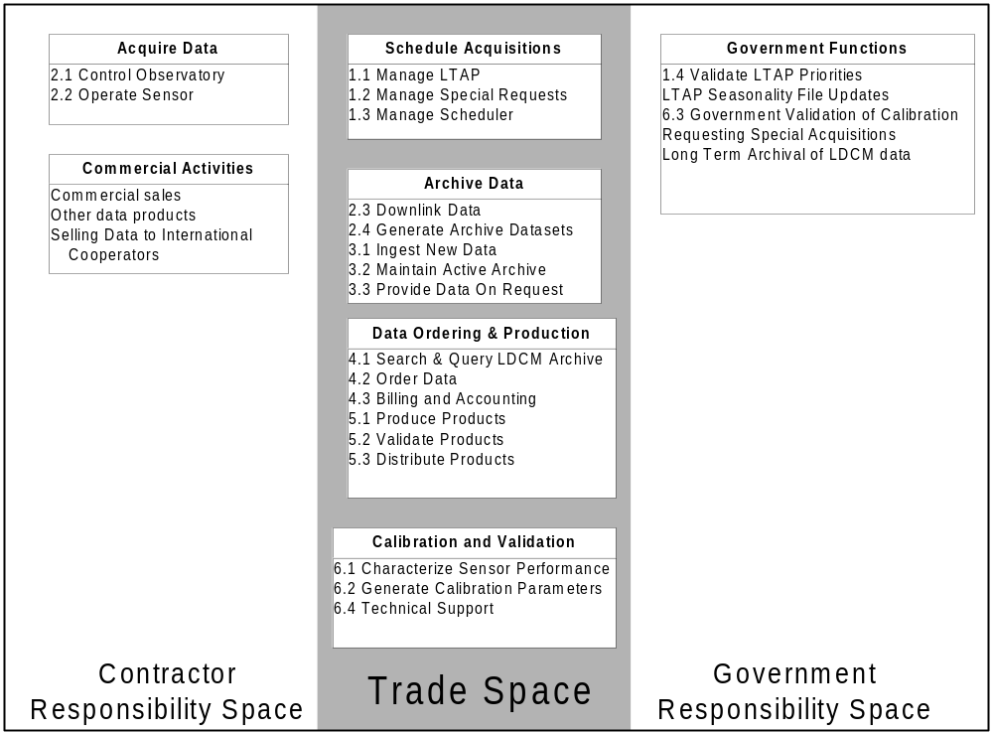

Figure 1 – Definition of the functional allocation trade space for the LDCM system. The functions the Contractor must perform are shown on the left, while functions the Government must perform are shown on the right. This does not include procurement-related functions or functions that take place before IOC is achieved.

The DFDs in the following section, attempt of break out the Government's functions from the Contractor's functions while indicating the areas of overlap that has to be decided in the Contractor's specific proposal. See Figure 1, above, for the breakout.

The Contractor is responsible for the design, construction, launch and operation of any system(s) proposed to generate the data requested by the Government (sections 2.2.1 and 2.2.2). The Contractor must provide for any ground station services necessary for the operation of the system(s) (sections 2.2.1 and 2.2.3).

The Government owns & operates the long-term archive, which will receive and archive all LDCM data generated under the Implementation Phase RFP (section 2.3.4). The Government will perform it’s own on orbit science validation of data calibration (section 2.6.3); however this does not preclude the contractor from doing its necessary calibration function. The Government will also perform other verification processes related to contract performance, including validation of Long Term Acquisition Plan (LTAP) priorities (section 2.1.4).

ORGANIZATION

This document is organized as follows:

Section 2 – A set of Data Flow Diagrams that describe the LDCM mission processes and data flows for LDCM data and services.
Section 3 – A limited set of operational scenarios that illustrate how the DFDs in section 2 relate.
Section 4 – A data dictionary for this document.

APPLICABLE DOCUMENTS

[1] The Land Remote Sensing Policy Act of 1992 (Public Law 102-555)

[2] LDCM Formulation Phase RFP Package, including contractual attachments.

CONVENTIONS

All Contractor and Trade Space processes in the Data Flow Diagrams (DFDs) are represented by circles. Solely Governmental processes are represented with rectangles. Each process is labeled with a number and the name of the process. The lines between the processes represent data flows and the names of the data flowing between the processes are noted next to the line. Section 6 contains short definitions for all the data flows appearing in this document. Related flows, i.e. query / response, are grouped with circles indicating their association with each other. The system-level DFD (Figure 2) uses some notational shortcuts to facilitate comprehension.

Throughout this document the term “Government” is used to refer to the U.S. Federal Government. The term “Contractor” is used to refer to the contractor who is responding to this RFP. The term “LDCM User” or “User” is used to refer to any person who uses the Government's LDCM data, which can include government, academia, commercial users, the general public and people from other countries.

FUNCTIONAL DESCRIPTION

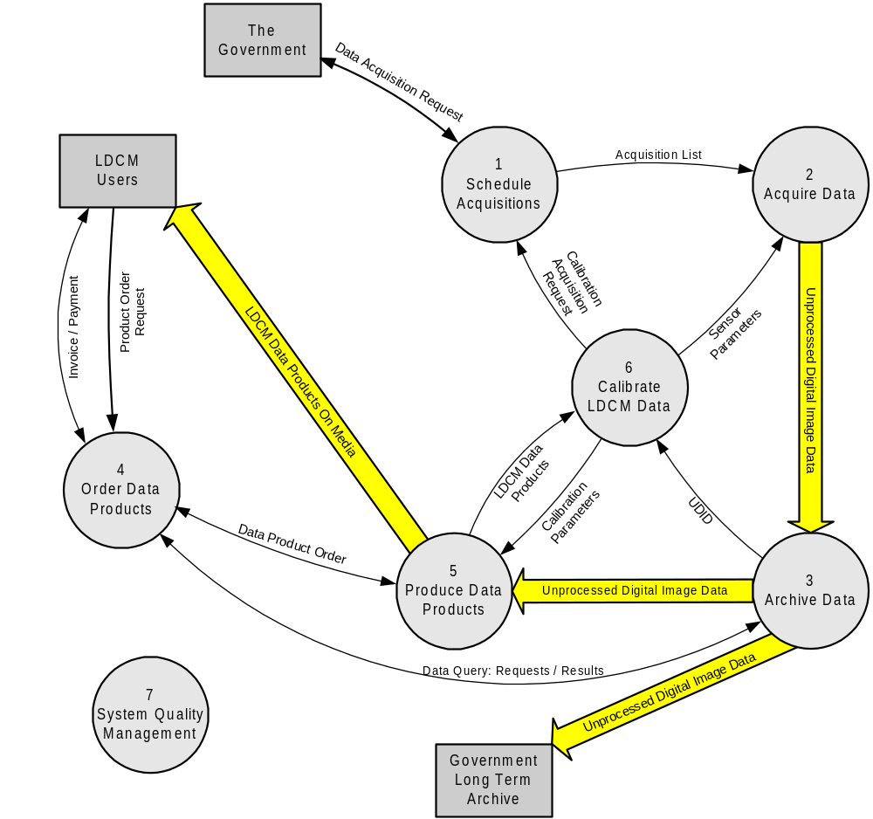

Figure 2 – Data Flow Diagram for the overall LDCM functional description. Data flows are summaries and do not capture all those defined in section 2. Refer to each process breakdown DFD for the fully developed
data flows.

The function of the LDCM is to provide continuity of Landsat data beyond the Landsat 7 mission. The Government is pursuing buying the LDCM data through a Data Specification-based procurement. Figure 2 shows one possible overview of the essential processes to operate a system to deliver these data. The top level processes are: 1 Request Data Acquisitions, 2 Acquire Data, 3 Archive Data, 4 Order Data Products, 5 Produce Data Products, 6 Calibration and 7 System Quality Management. Each of these processes is further described in the remainder of section 2.

The output from the Schedule Acquisitions process is a list of acquisitions to be made. The list of acquisitions is passed to the Acquire Data process where the actual data acquisition events take place. The acquired data is passed on to the Archive Data process where the LDCM Active Archive resides. LDCM Users can search for and order LDCM Data Products through the Order Data Products process. Data Product Orders are passed to the Produce Data Products process where the actual LDCM Data Products are produced from the Unprocessed Digital Image Data that is housed in the Active Archive. The completed LDCM Data Products on media are shipped to the User as requested. The Calibrate LDCM Data process monitors the LDCM sensor and maintains the system calibration. The System Quality Management process provides overall statistics and reporting functions as noted in 427-SPEC-00001, LDCM Data Specification.

In the remainder of section 2 each of these processes is broken down in more detail. The reader should keep in mind that this process breakdown is just one possible interpretation of the processes required to implement a system to deliver LDCM data, as required by 427-SPEC-00001, LDCM Data Specification.

SCHEDULE ACQUISTIONS

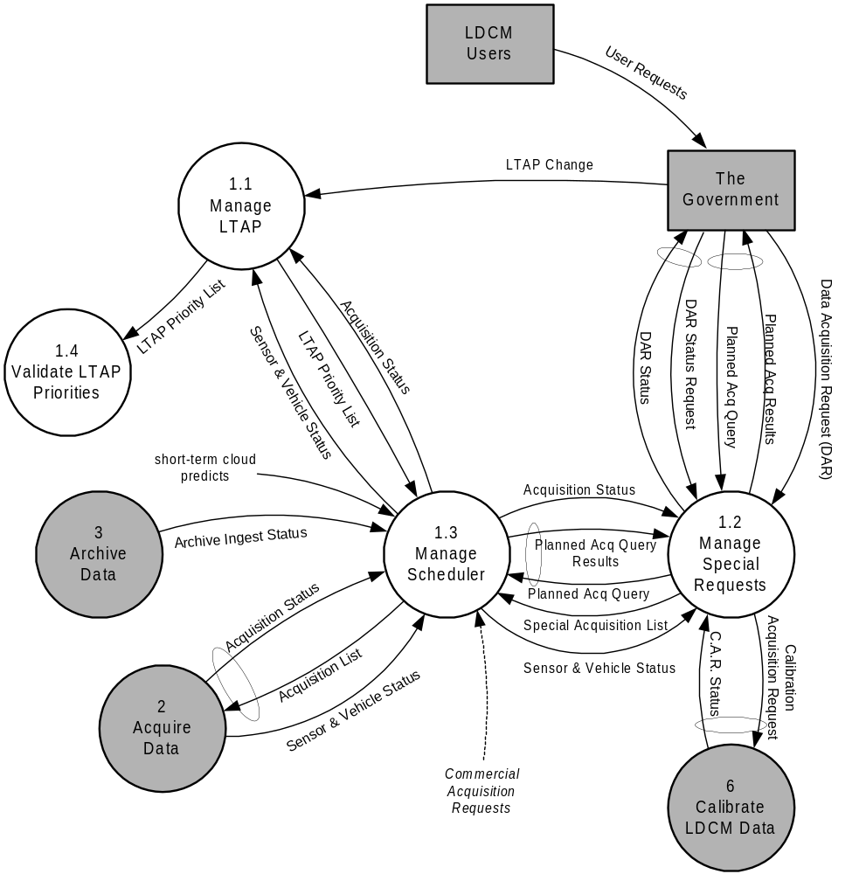

Figure 3 – Data Flow Diagram for the Schedule Acquisitions process. (Circles around dataflow arrows indicate associated flows, such as a query and response.)

In order to obtain LDCM data from the system, acquisitions must first be requested. The bulk of the LDCM data acquired will be scheduled by an automated process, analogous to the Landsat-7 Long Term Acquisition Plan (LTAP) software, represented as Manage LTAP process in Figure 3. Special acquisitions requested by the Government are handled within the Manage Special Requests process. All the acquisition requests are merged with the latest cloud cover predictions and system constraints into a single acquisition list in the Manage Scheduler process.

Manage Long Term Acquisition Plan

The Government will be procuring an average of 250 Worldwide Reference System Two (WRS-2) scenes of LDCM data each day. However, on any given day many more WRS-2 scenes over land could potentially be acquired. In order to select the “best” 250 scenes for acquisition, an algorithm is executed to evaluate a number of factors. This algorithm is called the long-term acquisition plan and is run within the Manage LTAP process. The Government can modify the parameters of this algorithm, as outlined in 427-SPEC-00001, LDCM Data Specification, typically by submitting new seasonality file updates.

Landsat 7 LTAP Overview

The Landsat 7 Long Term Acquisition Plan (LTAP) automates the selection of Landsat scenes to periodically refresh a global archive of sunlit, substantially cloud-free land images. By applying a set of algorithms on a daily basis, the LTAP has evolved to optimally collect Landsat 7 ETM+ imagery for scientific applications, while minimizing the effects of cloud-cover and system constraints.

The Landsat-7 LTAP includes several aspects that influence whether a particular scene should be acquired or not. These include:

1. Seasonality of vegetation, niche-science communities
2. Predicted vs. nominal cloud-cover
3. Sun angle
4. Missed opportunities for previous acquisitions
5. Quality (cloud-cover) of previous acquisitions
6. Scene clustering
7. System constraints (duty cycle, ground station locations, recorder capacity, etc).

Factors 1-6 feed directly to calculating the priority of each potential acquisition, while the actual acquisition list is obtained by incorporating system constraints (factor 7). Factor 4 requires feedback between the list of archived scenes and the LTAP, while factor 5 requires feedback between cloud assessment of archived scenes and the LTAP. Each of these factors is discussed in the following sections.

Seasonality – An objective of the LTAP is to schedule acquisitions more frequently during periods of change, such as growth and senescence of vegetation, and less frequently during relatively stable periods, such as when full growth canopy exists or during winter quiescence. An 8-year Advanced Very High Resolution Radiometer (AVHRR) Normalized Difference Vegetation Index (NDVI) data set was used to determine where and when changes occurred (Goward, et al., 1994, 1999). To flag seasonal change within a WRS-2 scene, a statistical test was applied to each NDVI 45-km sample mapped to that scene. Comparing each sample or pixel to the same pixel two months later revealed periods of significant change in the NDVI mean and standard deviation, when multiple acquisitions are meaningful, and periods of minimal change, when only a single acquisition is necessary.
The year is broken into a set of temporal “windows” for each path-row location. During each window, a location may be labeled as “acquire once”, “acquire always”, or ”never acquire”, and this information is stored in the LTAP seasonality file. It should be noted that “acquire always” does not imply that an actual acquisition will occur for every overpass during that time window. Instead, that scene will always be a candidate for acquisition, and other factors within the LTAP (cloud-cover, system constraints, etc) will govern whether or not an acquisition actually takes place. Conversely, “acquire once” means that once a successful acquisition occurs during the time window, that path-row location is no longer eligible for acquisition.

Niche Science Communities – Defining acquisitions solely through semi-monthly NDVI change does not fully capture the science and user interest in the Landsat mission. To supplement the NDVI-based seasonality metric, specific niche science communities have requested locations for more frequent acquisitions. These locations currently include:

- 282 agriculture (acquire literally every opportunity within season when the cloud cover prediction is less than 60%)
- 35 calibration (acquire "always")
- 896 reefs (acquire from 2 to 6 times per year)
- 30 fire (acquire "always")
- 1392 land ice (acquire once during certain months)
- 3601 Antarctica (acquire once during Jan-Feb)
- 60 oceanic islands (acquire twice per year)
- 1175 rainforest (acquire "always" all year)
- 352 sea ice (acquire from 1 to 3 times per year)
- 11 Siberia (acquire "always" over 9 months)
- 72 volcanoes (acquire from 2 to 12 times per year, including 33 at night)

The exact makeup of these niche science acquisitions varies each quarter of operations, depending on user needs and science priorities. In general, approximately 27% of the 250 scenes/day acquired by Landsat-7 are devoted to satisfying “niche” requests, approximately 70% are devoted to satisfying routine acquisitions from the seasonality file, and 3% are devoted to night images or special high-priority acquisitions (natural disasters, national needs, etc).

Predicted Cloud-Cover – The cloud-avoidance strategy is based on the near-term predicted cloud cover with respect to the seasonal average cloud cover for each scene. The LTAP scheduling software compares near-term predictions to the historical average cloud cover for that scene for that month, to determine acquisition priorities each day. Scenes with better-than-average cloud-cover predictions are given a priority boost, while those with poorer cloud cover predictions are given a lower priority. Global historical cloud data were obtained from International Satellite Cloud Climatology Project (ISCCP) records (Rossow et al., 1996) that give monthly estimates of cloud-cover percentage for 2.5˚ grid cells from 1989 to 1993. Monthly averages over the 5 years were computed and mapped to the Landsat WRS grid to produce a cloud climatology. The National Oceonographic and Atmospheric Administration (NOAA) National Centers for Environmental Prediction provide daily global forecasts of cloud-cover percentage at a 0.7˚ grid scale (Campana, 1994). The forecasts are compiled at 0600 (universal time system) each day and apply to each 3-hour interval up to 84 hours. Once received from NOAA, these cloud predictions are translated to the Landsat WRS-2 coordinate system. The forecast nearest in time to a candidate acquisition is compared to the ISCCP climatology to determine whether the predicted observing conditions are better or worse than typical for that location. Acquisition priority is then adjusted upward to favor the better conditions or downward to avoid the worst conditions.

Sun Angle – Requests for high-latitude scenes are rejected during local winter when the solar elevation is below a threshold. This threshold is currently 5 degrees for Landsat-7.

Missed Opportunities – A request is granted a priority boost as a function of the number of consecutive past cycles in which the opportunity to acquire the requested scene was not fulfilled. This occurs when the scene was not scheduled for acquisition, or when the acquired image fails to meet minimum quality standards, such as cloud cover. For example, if the last successfully acquired image of a scene was 48 days ago, then a request for this scene is granted a priority boost based on two missed opportunities—from 32 and 16 days ago. In addition, all new requests (i.e. when an acquisition window opens) are given a priority boost.

Image Quality – Quality (cloud-cover) of the best or most recently acquired image of a WRS-2 scene from past cycles factors into the relative demand for another acquisition. At high latitudes, the scheduler also considers the quality of the best image that could be spliced together as a mosaic of imagery of adjacent scenes acquired in the recent past. Quality is a function of cloud contamination in the image, as determined during image processing.

Clustering – Within the Landsat-7 LTAP, a higher priority is given to scenes that form “clusters” – contiguous groups of along-path acquisitions. This (i) reduces the on-off cycling of the ETM+ instrument and (ii) promotes the archiving of continuous swath data, which in turn allows “floating scene” subsetting of user-defined areas without regard for scene boundaries.

Manage Special Requests

This is the process of accepting specific data acquisition requests from the Government. All Government requests will come through one source to the LDCM system. If an LDCM User wants to request a special acquisition, this request is submitted to the Government Acquisition Manager, who will review this request and determine whether the Government wishes to support the request.

The Manage LTAP process will schedule the bulk of the Government’s LDCM data. The Manage Special Requests process is used for specific Government requirements, such as coverage of natural disasters, coordinated acquisitions with other sensors, calibration acquisitions and others. This process includes providing an ability to see what acquisitions are planned in the future, and submit specific requests for a particular path/row on a particular date or dates. Each request is called a Data Acquisition Request (DAR).

Manage Scheduler

The Manage Scheduler process assembles a list of pending acquisitions based on input from processes 1.1 and 1.2, commercial sales and international cooperators. This includes factoring in engineering and operational constraints of the data source and resolving conflicting acquisition requests using a priority-based schema. The most recent cloud coverage predictions are also applied for requests that have constraints on allowable cloud cover.

The acquisition list contains future acquisitions, and is updated periodically as appropriate. This list is passed on to the Acquiring Data process for use in scheduling the actual vehicle & sensor activities.

The Manage Scheduler process also tracks the status of acquisitions as they are acquired, and notifies the Government of the final success or failure.

Validate LTAP Priorities

The Validate LTAP Priorities process is where verification of the LDCM LTAP priorities is performed. The Government intends to perform validation of LDCM LTAP priorities for the data purchased under an LDCM contract. The LDCM system may also perform this function for other long-term acquisition strategies for other customers.

ACQUIRE DATA
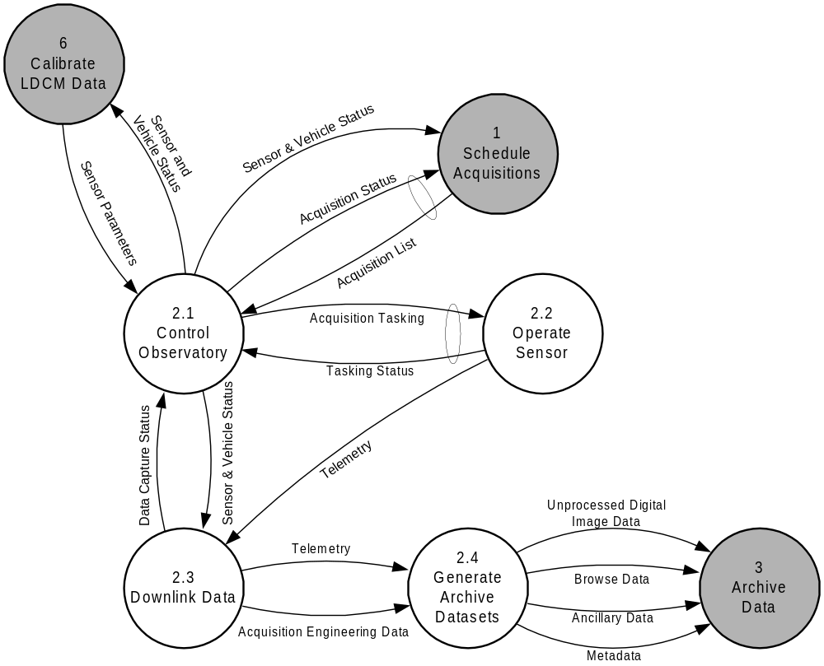

Figure 4 – Data Flow Diagram breakdown for the Acquire Data process.

The Acquire Data process is where the acquisitions planned in the Request Acquisitions process are planned and executed. The source is tasked, the radiances are captured by the sensor and the resulting data is transferred from the vehicle to a location where the LDCM archive datasets are generated.

Control Observatory

The Control Observatory process translates the acquisition list into a command schedule for the vehicle and sensor. This command schedule is then transmitted to the vehicle for execution. In a traditional space-based system, this process would execute as part of a Mission Operations Center (MOC) through uplink-capable ground station(s). All the necessary vehicle and sensor management activities execute within the Control Observatory process. Some examples include station-keeping, thruster burns, systems management, orbit determination, developing ground contact schedules and battery maintenance.

Operate Sensor

In the Operate Sensor process the sensor captures at-aperture radiances. This process also includes stored vehicle command execution and any internal data manipulation or translation processes to prepare the sensor data for transmission to the ground reception facility.

Downlink Data

The Downlink Data process transfers the sensor data and associated platform information from the vehicle to one or more data reception facilities on the ground. For a space-based system this would include the Tracking Telemetry & Command (TT&C) components of the vehicle, transmitting the data to one or more receiving stations, and possible transferring of the data from the receiving stations to a data processing facility.

Generate Archive Data Sets

The Generate Archive Data Sets process translates the data transferred in the Downlink Data process into the LDCM archive elements. This includes any necessary sub setting or aggregating necessary to produce the image data, generation of metadata, and other ancillary data and browse images.

ARCHIVE DATA

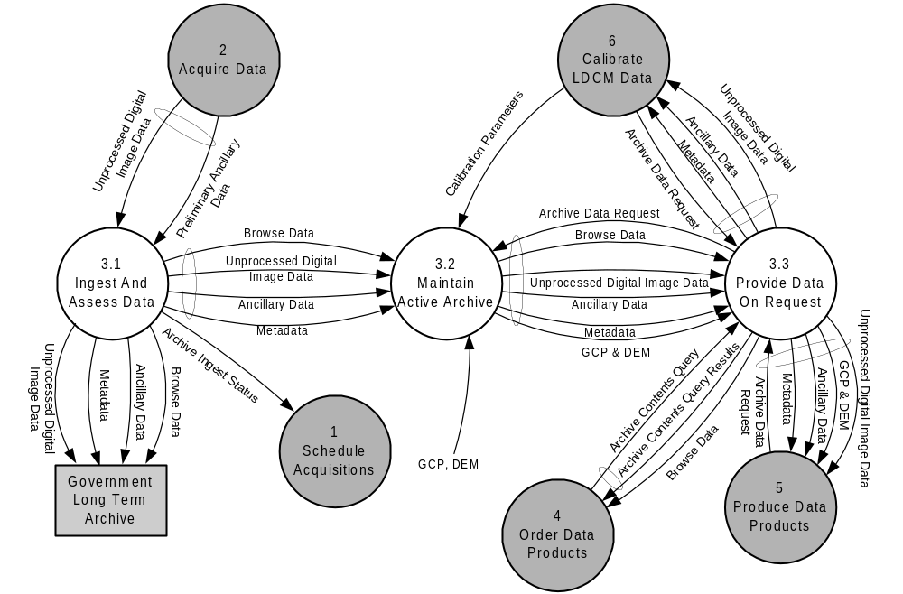

Figure 5 – Data Flow Diagram breakdown for the Archive Data process.

The Archive Data process is decomposed in the DFD shown in Figure 5. Data coming in to the archives are ingested in the Ingest And Assess Data process. The Maintain Active Archive process manages the LDCM data, while copies of all data are sent to the Government Long Term Archive. Various processes are then able to access data in order to search for, and request data, from the archive through the Provide Data On Request process.

Ingest And Assess Data

This is the process of evaluating, indexing and distributing new data into the archives. The Ingest And Assess Data process includes data generated in the Acquire Data process as well as transfers between different archives holding LDCM data.

Maintain Active Archive

The Maintain Active Archive process maintains the Active Archive data integrity. Maintenance of the Active Archive can include migration from aging media, verifying archive contents, managing data, managing databases and any other activities necessary to protect the data from loss.

Provide Data On Request

The Provide Data On Request process provides archived LDCM data to other processes as requested. The Provide Data On Request process does not include the production of LDCM Data for users, which is outlined in 2.2.5. This process includes supporting data search and browse distribution to other internal LDCM processes.

Long Term Archive

This is the ultimate destination for all the LDCM products that the Government is procuring, as outlined in 427-SPEC-00001, LDCM Data Specification.

ORDER DATA PRODUCTS

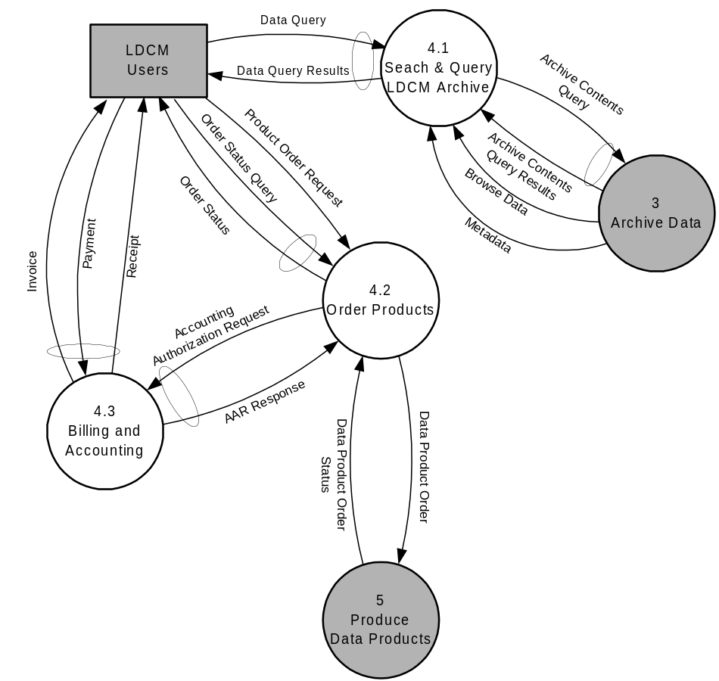

Figure 6 – Data Flow Diagram breakdown for the Order Data
Products process.

The Order Data Products process is where users of LDCM data search for and order LDCM data products. The Search & Query LDCM Archive process provides the functionality for users to search for data products of interest. Orders are placed through and managed by the Order Products process, which refers orders to the Billing And Accounting process to handle the monetary portions of the ordering process. Authorized orders are passed along to the production processes outlined in section 2.5. Note that the Calibrate LDCM Data process will place orders through the same interfaces and methods as the Users in the context of this process.

Search & Query LDCM Active Archive

The users ability to construct and execute searches of the Active Archive is provided in this process. This could include inquiries made by interactive on-line system, phone, FAX, and email.

Order Products

The Order Products process includes the placing of new orders, tracking the status of existing orders, and canceling or updating existing orders. This process coordinates the related activities within the Billing and Accounting process, prior to scheduling data product for production.

Billing and Accounting

This process includes all the monetary-related functions associated with the ordering of LDCM Data Products. This could include invoicing for data orders, accepting payments in various forms, and sending receipts, as appropriate.

PRODUCE DATA PRODUCTS

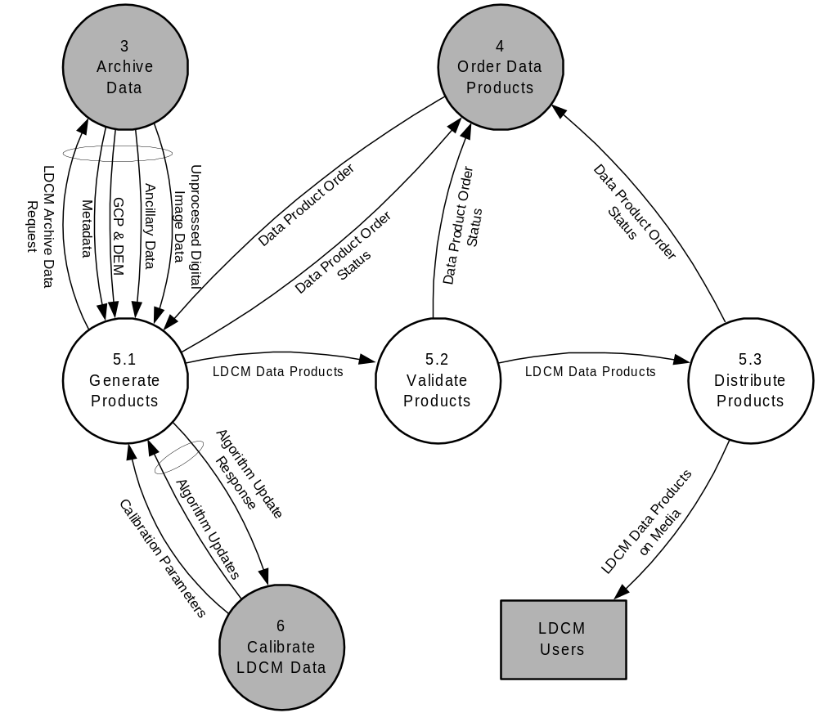

Figure 7 – Data Flow Diagram breakdown for the Produce Data
Products process.

The Produce Data Products process is the production of the LDCM data products to fulfill the customer’s order. The Generate Products process is where all the necessary input data are collected together, and the algorithms executed to produce the requested products. All data products are validated prior to being written to media for distribution.

Generate Products

The Generate Products process starts by pulling data from the archive, including calibration parameters, engineering data, metadata, ancillary data, digital elevation models and ground control points (as required). After all the necessary data are retrieved, the LDCM Data Products are processed according to that Data Product Order. All the products for the LDCM data procurement listed in 427-SPEC-00001, LDCM Data Specification are produced in this process.

Validate Products

The Validate Products process provides the quality assurance and quality control checks associated with data product production.

Distribute Products

The Distribute Products process compiles one or more data products, specified in the data product order, onto the specified media. For electronic distribution of products this process simply stages the products to the appropriate distribution site. For physical media this process includes the packaging and shipping of the products to the LDCM User.

CALIBRATE LDCM DATA

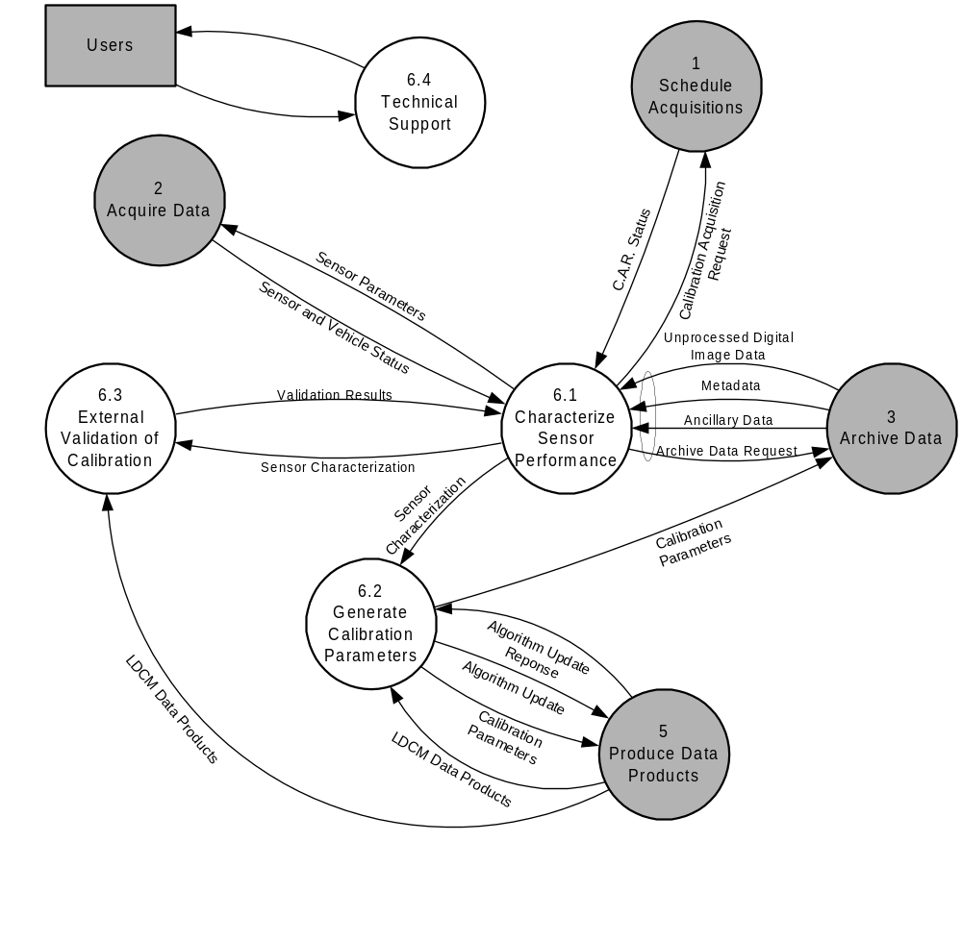

Figure 8 – Data Flow Diagram breakdown for the Calibrate LDCM
Data process.

The Calibrate LDCM Data process maintains the calibration required for LDCM Data Products to meet their requirements, and provides technical support. This includes performing an external validation of calibration, generation of calibration parameters and providing technical support in these areas.

Characterize Sensor Performance

The Characterize Sensor Performance process monitors LDCM Sensor. This can include the analysis of on-board calibration information, analysis of vehicle heath data, analysis of other calibration imagery, and incorporation of results from the Product Validation and External Validation processes. Refinements to the processing algorithms are developed within this process and passed on to the production processes.

This process can include the determination of any possible changes in the instrument configuration (detector gain levels, calibration sequences, modifications to acquisition procedures and so forth). These parameters are passed on to the Acquire Data process for incorporation into future payload command files.

Generate Calibration Parameters

The Generate Calibration Parameters process takes the Sensor Characterization and derives the Calibration Parameters that enable production of LDCM Data Products to meet all the geometric and radiometric requirements specified in 427-SPEC-00001, LDCM Data Specification.

External Validation of Calibration

The External Validation of Calibration process collects and analyzes validation data. LDCM Data are acquired in tandem with other ground-, air- or space-based sensors with comparable spectral and geometric characteristics. These data are analyzed to provide an independent verification of the validity of the LDCM datasets. The Government intends to independently perform this process for the data it procures.

Technical Support

The Technical Support process responds to technical questions regarding the characteristics of the LDCM Data Products. Investigation of product anomalies and resolution of problems are part of this process.

SYSTEM QUALITY MANAGEMENT

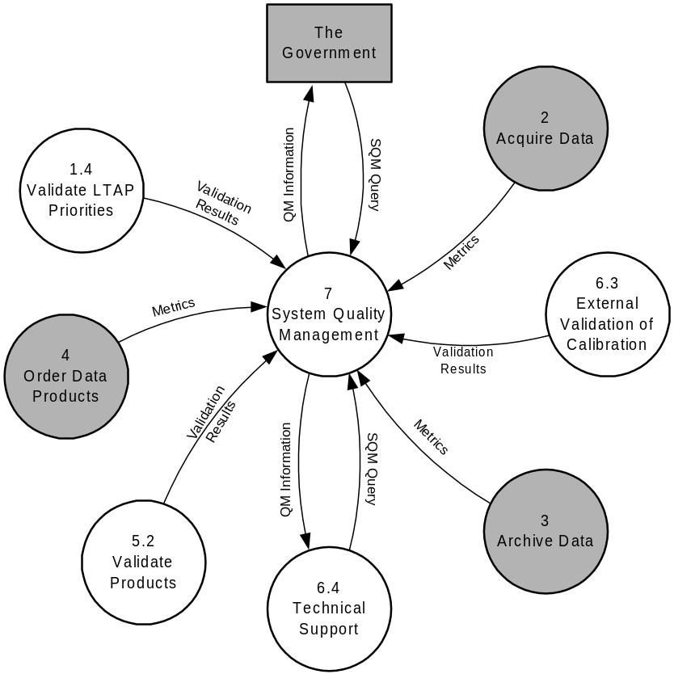

Figure 9 – Data Flow Diagram highlighting the System Quality Management process.

System Quality Management functions are distributed across the six primary processes. These functions are explicitly defined in processes 1.4, 5.2, 6.3 and 6.4. For processes 2, 3 and 4, generic system metrics are collected. Data from all these validation functions are analyzed in the central System Quality Management process. In addition, various performance and operational statistics are collected from all LDCM processes. All of this information is made available and can be retrieved by the Government through a System Quality Management Query.

EXAMPLE OPERATIONS SCENARIOS

Section 3 covers a series of operational scenarios based on the system described in section 2. The reader should keep in mind that the system presented in section 2 is just one possible process breakdown. These scenarios are intended to provide an outline of how the system described in section 2 would operate to enhance reader comprehension of the expected system interactions.

The Landsat 7 operations were used as a model for these scenarios. This is not meant to imply that LDCM operations must be conducted in this manner. The five scenarios included with this document are:

3.1 Acquiring Global LDCM Data
3.2 Order & Distribute an Archived LDCM Data Product
3.3 Special DAR – L.A. Earthquake
3.4 New Data Request From International Cooperator
3.5 Update Sensor & Calibration Parameters

These are intended to highlight the major operational aspects of the envisioned LDCM system presented in section 2. Each scenario includes a brief objective statement, a list of assumptions, a data flow diagram and a corresponding list of operational steps. Steps are indicated on the diagram in red.

ACQUIRING GLOBAL LDCM DATA

Objective

The purpose of this scenario is to highlight the automated global acquisition planning process. The objective is to acquire a global dataset of the Earth’s land surfaces on a seasonal basis that meets the requirements established in 427-SPEC-00001, LDCM Data Specification.

Assumptions

The LDCM system is fully operational. The system successfully imaged every pre-identified land scene at least once during the previous year of operations.

Scenario Description – Acquiring Global LDCM Data

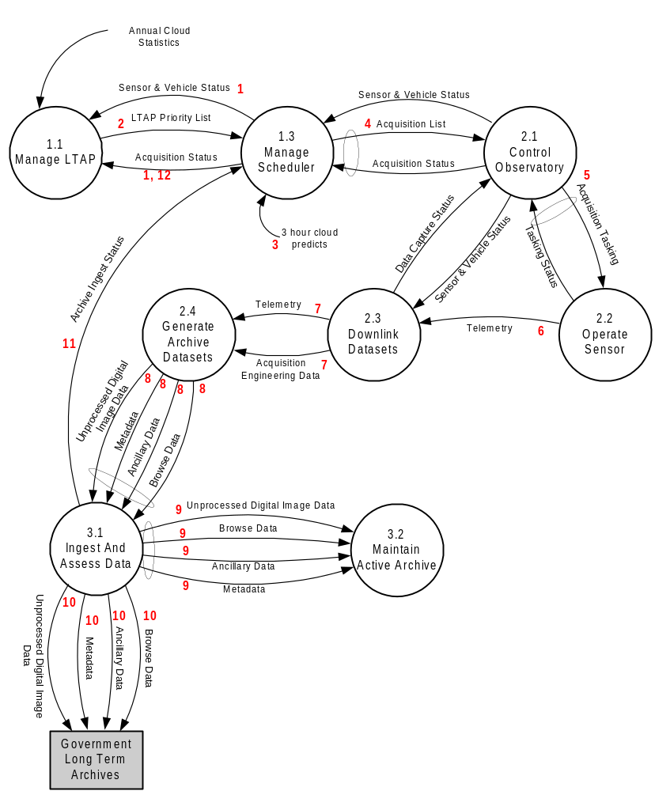

Figure 10 – Data Flow Diagram of the operations concept for the automated acquisition of a global LDCM dataset. The red numbers indicate the sequence of events.

Step | Processes
1 | Data is not acquired continually. Instead, acquisitions are scheduled in advance using a Long Term Acquisition Plan (LTAP) in conjunction with a software scheduler. The WRS-2 system divides the Earth into a grid of 57,784 scenes, with each scene centered on the intersection of a path (groundtrack parallel) and row (latitude parallel). The observatory is operated such that it follows the WRS-2 grid within tight tolerances, overflying the entire global WRS scene grid every 16 days. A database of just over 14,000 scenes containing “land” was compiled for the LTAP (http://ltpwww.gsfc.nasa.gov/IAS/htmls/igs.html), including continental areas, shallow coastal waters, Antarctic sea-ice, and all known islands and reefs. Within any given 24-hour period, approximately 850 of these WRS land scenes (descending paths only) are in view of the ETM+ and are candidates for acquisition. The mission scheduler must select the “best” 250 scenes for acquisition each day within these constraints.
2 | The LTAP priorities are transferred from the Manage LTAP process to the Manage Scheduler process.
3 | The Manage Scheduler process pulls the most recent cloud predict information. The scheduler automatically schedules acquisitions in accordance with the LTAP priorities, basing these decisions on cloud-cover forecasts, urgency of acquisition, and availability of resources to optimize fulfillment of mission goals. The output schedule merges the LTAP priorities with special requests from the Government and any commercial requests on the system. This may involve conflict resolution procedures, some of which are laid out in the LDCM Data Policy, Attachment D to the LDCM Request for Proposal. Scene acquisition priorities are also balanced against SSR capacity, ground station locations, and duty cycle limitations in order to obtain the final acquisition list uploaded to the spacecraft.
4 | The conflict-free acquisition list is passed on to the Control Observatory process. In the current Landsat 7 implementation, this is equivalent to the Mission Operations Center. Functions such as orbital maintenance, building of command loads are executed here. The conclusion is an Acquisition Tasking sent to the Operate Sensor process.
5 | The LDCM sensor is actually operated per the commands in the Acquisition Tasking. The radiance values are captured and encoded in a telemetry system for transmission back to the Earth. The output is a telemetry stream encoded for transmission.
6 | The Telemetry stream is transmitted through the Downlink Datasets process. In the traditional space-based architecture this process maps to one or more receiving ground stations. The output is the telemetry stream in digital form.
7 | The digital Telemetry stream is passed to the Generate Archive Datasets process. This is where communications formatting and artifacts are removed. The output is the Unprocessed Digital Image Data as defined in 427-SPEC-00001, LDCM Data Specification, together with Browse Data, Ancillary Data and Metadata.
8 | The Unprocessed Digital Image Data and preliminary ancillary data are passed to the Ingest and Assess Data process. This is the first step in the Archive Data process. The cloud cover estimates are made at this step.
9 | All of the archive datasets are passed on to the Maintain Active Archive process. This is the process of maintaining the datasets in a logical archive. The Active Archive is the one from which all LDCM data products will be distributed.
10 | All of the archive datasets are also delivered to the Long Term Archive, which is operated by the Government at the EROS Data Center.
11 | The final information on the ingest of data is built and passed back to the Manage Scheduler process. This includes information on exactly what data was actually acquired, what modes the instrument was operating in, cloud cover estimates and so on. The Manage Scheduler process updates the status of the acquisitions in the Acquisition List, and passes this status back to the Manage LTAP process.
12 | The Manage LTAP process updates the history tables for the land scenes in its database to reflect the latest acquisition history information.

ORDER AND DISTRIBUTE AN ARCHIVED LDCM DATA PRODUCT

Objective

The objective of this scenario is to illustrate how a typical LDCM User searches, then orders an LDCM Data Product, through processing and delivery of the order.

Assumptions

The LDCM User is interested only in an LDCM scene that is already stored in the Active Archive.

Scenario Description – Order And Distribute An Archived LDCM Product

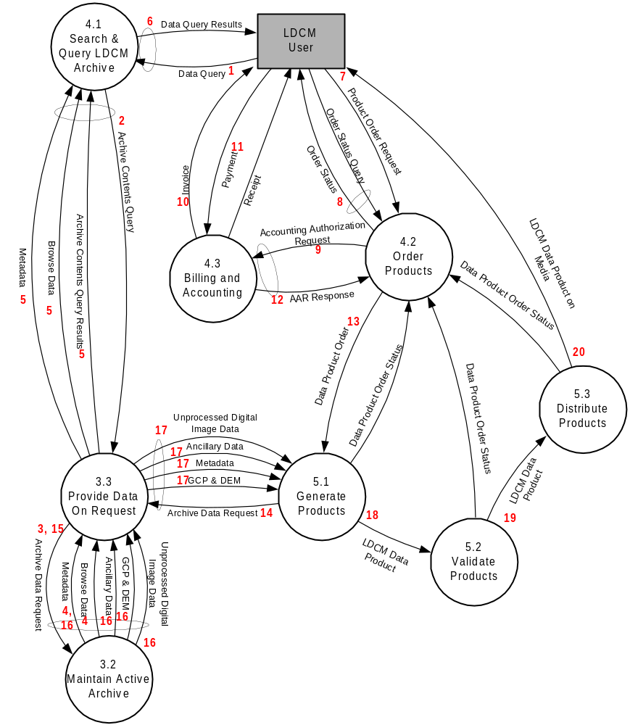

Figure 11 – Data Flow Diagram of the operations concept for the ordering, production and distribution of an LDCM Data Product. The red numbers indicate the sequence of events.

Step | Processes
1 | The User initiates a data search based on their criteria.
2 | The search interface translates this into an internal system query. This is passed off to a database server.
3 | The server performs a search of the active archive to see what data match the criteria.
4 | The Active Archive returns the Browse Data and relevant Metadata for all data meeting the search criteria.
5 | This information is passed back to the search engine, which reformats the information for display to the users.
6 | The user sees the results of their search and selects one or more products for ordering.
7 | By selecting the place order function, the information is passed along to the Order Products function. A new order is established in the system.
8 | The information on the order is passed back to the User, namely an order ID and any other relevant information.
9 | The Order Products process requests an accounting authorization.
10 | An invoice is generated and sent to the user for payment.
11 | The user sends a payment in based on the invoice. This might be in the form of a purchase order or perhaps a credit card number entered through an online order interface.
12 | The Billing and Accounting system passes back confirmation that the order is ready to pass off to production. The Order Products process updates the order status, and generates a Data Product Order.
13 | The Data Product Order is sent to the Generate Products process. This is where all the processing is done to generate the LDCM data products requested in the data product order.
14 | The Generate Products process sends a request for data from the archive to the Provide Data On Request process.
15 | The archive data request is translated into an internal data request and sent to the Manage Active Archive function.
16 | The Maintain Active Archive function returns the archive datasets requested for processing, the Unprocessed Digital Image Data, Ancillary Data and Metadata.
17 | The requested datasets are passed back to the product generation process by the Provide Data On Request process.
18 | The Generate Products process performs the processing necessary to generate the LDCM Data Products requested in the data product order. The data products are passed on to the product validation process.
19 | After the product validation (quality assurance / quality control) process is completed, the data products are passed on to the product distribution process.
20 | The LDCM Data Products are distributed to the users on the requested medium. This includes the process of writing products to media, verifying the media, packaging, shipping or staging of data for electronic distribution as requested.

SPECIAL DAR – LOS ANGELES EARTHQUAKE

Objective

The objective of this scenario is to illustrate how the concept of a Data Acquisition Request (DAR) is applied. This is an example of a specific request to acquire an image of Los Angeles (path 42, row 36) at the first acquisition opportunity.

Assumptions

All LDCM systems are functioning nominally. The Government identifies the need for an acquisition over Los Angeles following an earthquake. The Government decides to submit a DAR for a scene to meet this request.

Scenario Description – Special DAR – Los Angeles Earthquake

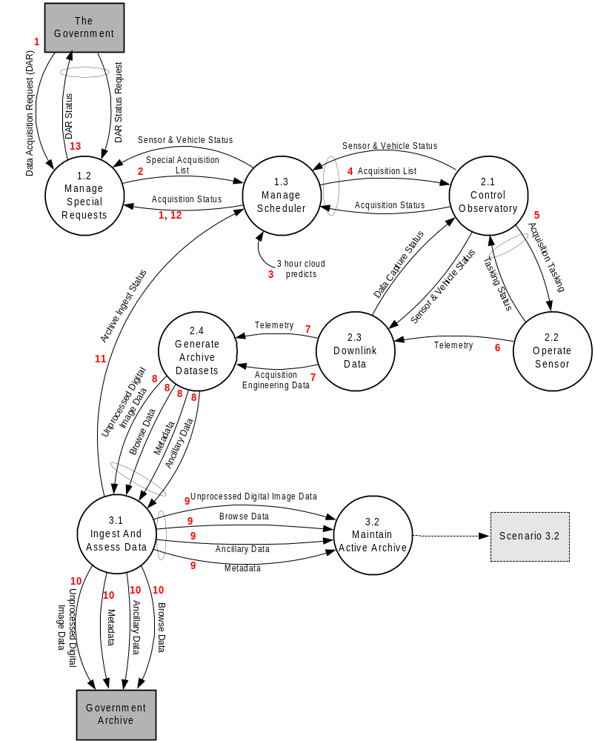

Figure 12 – Data Flow Diagram of the operations concept for a one-time Government Data Acquisition Request (DAR). The red numbers indicate the sequence of events.

Step | Processes
1 | A representative of the Government submits a Data Acquisition Request. This can be in the form of an email, a telephone call, or an input to an online request interface. The special requests manager may need to clarify some details with the requesting party, eventually developing a Special Acquisition List. This is a list of one-time acquisitions to be made to fulfill the request.
2 | The list of special acquisition requests is passed along to the scheduler. The requests have associated priorities and optionally some cloud cover constraints.
3 | The latest 3-hour cloud prediction information is pulled from NOAA to the scheduler process.
4 | The Scheduler builds the Acquisition List, which merges special requests with the LTAP priorities and commercial requests, incorporating relative priority information and the latest cloud predictions. Since this is a natural disaster response request, this acquisition is at a high priority level and will occur for any probability of cloud cover. This acquisition list is passed on to the Control Observatory process
5 | The control observatory process translates the list of acquisition requests into acquisition tasking, a set of commands for the sensor and observatory. These are transmitted up to the observatory.
6 | The sensor is operated as commanded and the data are acquired successfully. The data are encoded in a telemetry stream that is transmitted from the observatory to the ground.
7 | The Downlink Data process receives the telemetry and passes it on for preparation for the archive.
8 | The Generate Archive Datasets process translates the telemetry into Unprocessed Digital Image Data, and develops the preliminary ancillary data. These are passed on to the archive ingest process.
9 | The archive ingest process builds the Browse images, Ancillary Data, Metadata and Uncorrected Digital Image Data. These are passed on to the Active Archive for storage for the life of the mission.
10 | Copies of all the data ingested are also passed on to the Long Term archive maintained by the Government.
11 | The successful archive ingest status is passed back to the scheduler. This includes information on exactly what data were ingested, spatial coverage, date/time information and estimated cloud cover. The scheduler updates it’s acquisition list.
12 | The updated acquisition status is passed on to the special requests manager.
13 | The original requester in the Government is informed of the success of the acquisitions. Refer to the scenario described in section 3.2 for the data product order & delivery scenario.

UPDATE SENSOR AND CALIBRATION PARAMETERS

Objective

The objective of this scenario is to outline some of the basic calibration functions. Specifically, the ways in which this process can effect changes in both the LDCM sensor and the ground processing systems.

Assumptions

The system has been previously calibrated. During routine monitoring, it is determined that a change in the sensor performance has occurred, and a change in the Sensor Parameters and the Calibration Parameters will be required to bring the LDCM Data Products back up to specifications. For the sake of discussion, the change is assumed to be a detector gain change.

Scenario Description – Update Sensor And Calibration Parameters

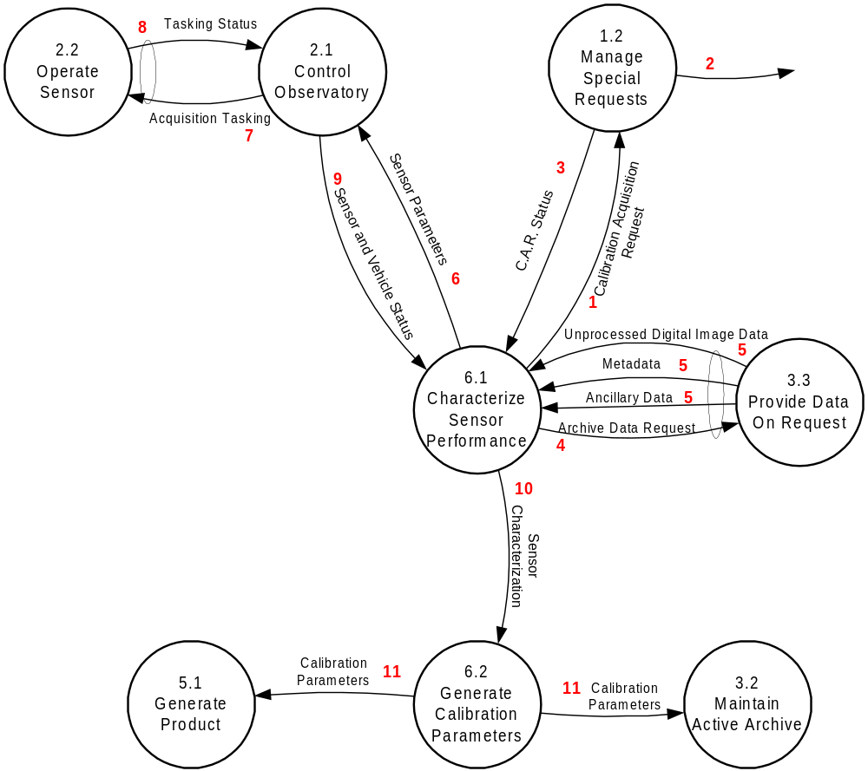

Figure 14 – Data Flow Diagram of the operations concept for the Update Sensor & Calibration Parameters scenario. The red numbers indicate the sequence of events.

Step | Processes
1 | While monitoring the sensor characterization as part of the characterize sensor performance process, it is determined that the performance of a detector has changed, and a new sensor configuration and calibration parameter file will be required. A Calibration Acquisition request is built which asks that a scene be acquired using a special sensor configuration specified in the request (i.e. with the new detector gain value). This request is sent to the Manage Special Requests process.
2 | The Manage Special Requests process deals with this request just like any other special request. Refer to steps 2 through 12 in section 3.3.3 to see how this request flows through the system.
3 | The special acquisition is successfully acquired, and a calibration acquisition request status message is passed back to the sensor characterization process.
4 | A request is sent to the archive to retrieve the data from the special calibration acquisition.
5 | The unprocessed digital image data, metadata and ancillary data are all transferred from the active archive back to the Characterize Sensor Performance process. These data are analyzed to confirm that the gain change worked, and the response from the affected detectors is appropriately scaled.
6 | A permanent change in the sensor parameters is prepared which reflects the new detector gain value. This is provided to the observatory control process.
7 | The observatory control process transmits the new sensor parameters up to the LDCM sensor.
8 | The observatory/sensor report back to the observatory control process that the new sensor parameters have been loaded correctly.
9 | The observatory control process reports back to the sensor characterization process the new sensor and vehicle status, which reflects the change in sensor parameters.
10 | The new sensor characterization is developed and forwarded to the process that generates calibration parameters that are used in the processing of LDCM data products.
11 | The new calibration parameters are computed which account for the detector gain change. The calibration parameters are tagged with a date range corresponding to when the change in sensor parameters was actually implemented. The calibration parameters are passed on to the active archive for storage, and to the product generation process for incorporation into the production process.

DOCUMENT DATA DICTIONARY

Element | Definition
Accounting Authorization Request | A request for the Billing and Accounting process to perform necessary procedures to verify and/or bill users for an invoice.
Accounting Authorization Request Response | The response to an AAR regarding the success or failure of an attempt to verify a payment method or obtain payment.
Acquisition Engineering Data | Engineering data regarding link status, bit error rates, dropped frames, and other quality information.
Acquisition List | The list of all future acquisitions that are intended to be captured.
Acquisition Status | The status of items on the acquisition list (Accepted, Rejected and so on).
Acquisition Status | The acquisition status for items in the Acquisition List, indicating the success or failure of each acquisition, plus ancillary data regarding the acquisitions (where data was downlinked, actual modes, quality information etc.)
Acquisition Tasking | A list of individual acquisition commands sent to the vehicle for execution.
Ancillary Data | Ancillary data as defined in section 1.1.2 of 427-SPEC-00001, LDCM Data Specification.
Annual Cloud Statistics | The cloud climatology for all the land WRS-2 scenes. Refer to the description of the LDCM LTAP in section 2.1.1 and Section 4.
Archive Contents Query | A query to determine the holdings within the LDCM Archive. The query can be for a specific granule, or for granules that meet one or more criteria.
Archive Contents Query Results | A list of granules that meet the criteria given in an Archive Contents Query
Archive Data Request | A request for one or more granules of Level 0 LDCM Archive Data.
Archive Ingest Status | A status message from either the Active Archive or an International Cooperator indicating the success or failure of the ingest of data into an archive, including details on what data were ingested.
Archive Metadata | A complete catalog of all LDCM Data Products contained in the archive.
Calibration Acquisition Request | A Data Acquisition Request from the calibration process area. This is like a normal DAR but includes special engineering parameters which the calibration processes can specify for changing sensor configuration.
Calibration Acquisition Request Status | The acquisition status for an associated Calibration Acquisition Request
Calibration Parameters | A complete set of parameters that can be applied to Level 0 LDCM data during processing to generate calibrated Level 1 products.
Commercial Acquisition Request | If the LDCM system is also being used to acquire commercial data products, it is assumed that commercial sales would result in acquisition requests specifically for these data.
DAR Status Request | Request message asking for status of a particular Data Acquisition Request submitted by the Government.
Data Acquisition Request (DAR) | A special acquisition request from the Government. For one-time or non-recurring data acquisition requests, or for night-imaging or other special conditions not handled by the LDCM LTAP.
Data Acquisition Request (DAR) Status | Data Acquisition Request Status response to the Request DAR Status message. Information on the success or failure of the Government’s special data acquisition requests.
Data Capture Status | Information from the Transfer Sensor Data process on success or failure of the capture & transfer of Raw Sensor Telemetry from the vehicle(s).
Data Product Order | The actual order for one or more LDCM data products.
Data Product Order Status | Status of associated Data Product Orders.
Data Query | A search request from a user including search parameters for data products in the LDCM archive.
Data Query Results | The results of the search based on the Data Query from a user.
International Cooperator Request | An acquisition request for data to be supplied to an International Cooperator, which can be either for recurring acquisitions or one-time acquisitions.
Invoice | A bill for one or more LDCM Data Products, including information on who will be charged.
LDCM Data Product | A L0, L1 or L2 LDCM Data Product for delivery to a user (not the format of data in the archive)
LTAP Change | A change in the algorithms or underlying tables that comprise the LDCM LTAP.
LTAP Priority List | A list of priorities attached to a list of WRS-2 path & row frames, including cloud cover constraints.
Order Status | In response to an Order Status Query, contains the status of the orders referenced.
Order Status Query | A query sent by a user looking for the status of one or more orders identified in the query.
Payment | US currency.
Planned Acquisitions | The list of acquisitions actually scheduled for future acquisition.
Planned Acquisitions Query | A query to search for acquisitions in the Acquisition List.
Planned Acquisitions Results | Response to the Planned Acquisitions Query, indicating which acquisitions are in the tasking list that met the conditions in the query.
Preliminary Ancillary Data | The Ancillary Data record filled in with what information is known prior to generation of the archive data.
Product Generation Package | All information and data required to allow production of an LDCM Data Product specified in an associated Data Product Order.
Product Order Request | An order for one or more LDCM Data Products from a user.
Receipt | Receipt for payment of Money to settle an Invoice.
Sensor & Vehicle Status | The current status of the sensor and the vehicle(s), as well as a list of future planned outages or changes in status.
Sensor Parameters | A set of configurable parameters that adjust the operation of the LDCM sensors.
Tasking Status | The sensor or vehicle status for each of the tasking commands issued.
Telemetry | The data stream transmitted by the LDCM vehicle(s).
Three Hour Cloud Predicts | The most recent cloud cover predictions for the land areas of the world.
Unprocessed Digital Image Data | The LDCM Archive Data procured under the data buy, refer to 427-SPEC-00001, LDCM Data Specification.
Validation Results | A generic name for the results of a validation process.

