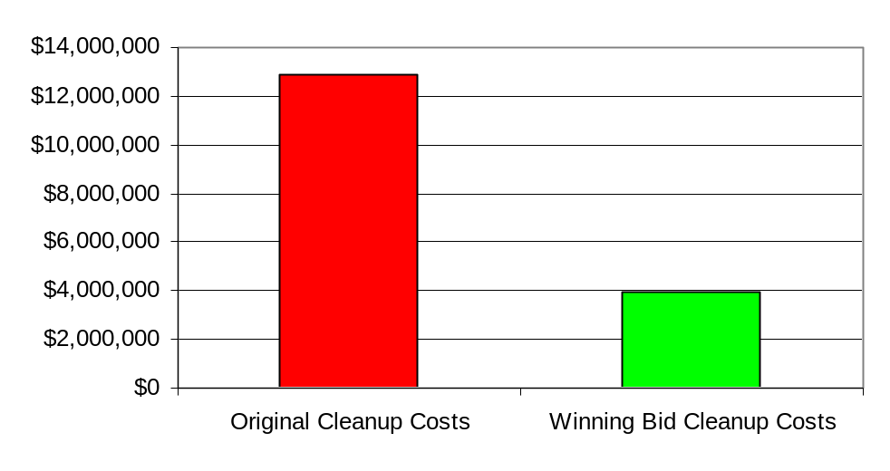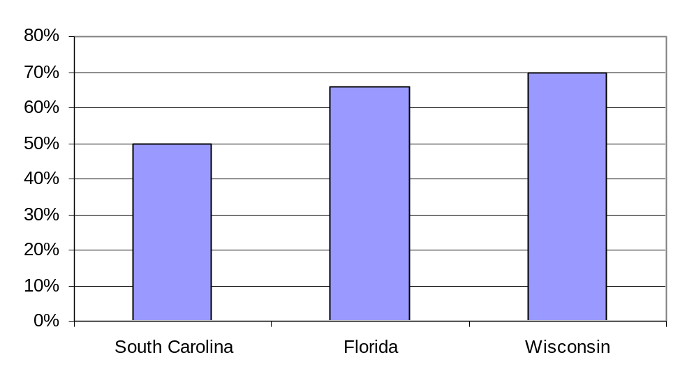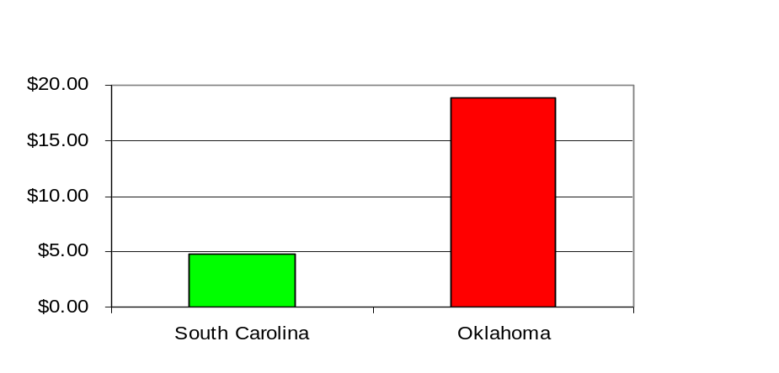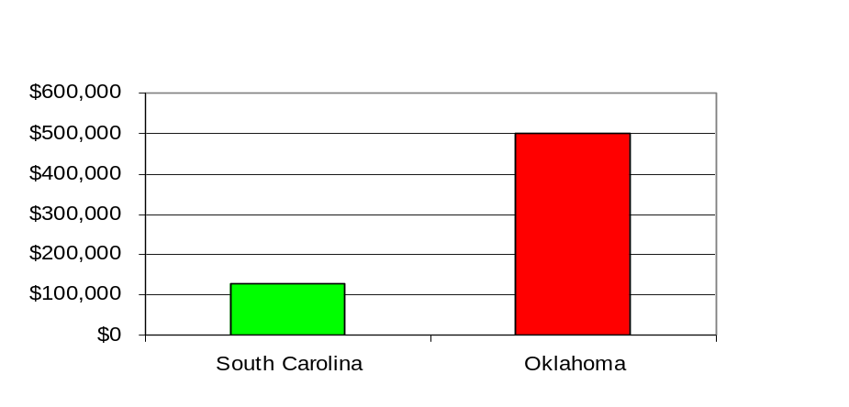WISCONSIN (63 Sites)
REDUCTION IN CLEANUP COSTS BY BIDDING
UNIT COSTS ($/cubic yard) FOR BID vs. NEGOTIATED CLEANUPS
COSTS FOR AVERAGE (26,500 cu. yd) BID vs. NEGOTIATED CLEANUPS
(Bid)
(Negotiated)
(Bid)
(Negotiated)

