USDA Foreign Agricultural Service
GAIN Report

Global Agriculture Information Network
Template Version 2.09

Voluntary Report - public distribution
Date: 5/18/2006
GAIN Report Number: CH6807
CH6807
China, Peoples Republic of
Market Development Reports
Shanghai Market Profile
2006

Approved by:
Ross Kreamer
U.S. Consulate
Prepared by:
Ralph Bean

Report Highlights:
Continued investment in infrastructure, along with rapid economic growth, have turned Shanghai into a regional trade and financial powerhouse. Beyond its own 20 million consumers, Shanghai serves as the gateway to cities throughout the Yangtze River region and deep into the interior.

Includes PSD Changes: No
Includes Trade Matrix: No
Unscheduled Report
Shanghai [CH2]
[CH]
Growing Market, Great Potential

China’s continued economic growth and improved access to imports under the WTO have helped to underscore the importance of this emerging market. At the same time, growth in trade has helped to cement Shanghai’s position as the commercial capital of China. With a growing population, incomes far above the national average and one of the largest container ports in the world, the city of Shanghai is both a major market and a key access point to the industrial centers of East China. It is also a gateway to many of the major cities of China’s interior.

The business climate in Shanghai is more favorable than in most other major cities in China, and local officials are aggressive in promoting business development. This pro-business attitude, along with good infrastructure, explains Shanghai’s continued success in attracting businesses, despite rising costs. In recent years Shanghai has hosted the Global Fortune 500 Forum (1999), the annual APEC summit (2001), and won its bid to host the World Expo in 2010. It may also explain why Shanghai has grown into a key import center for much of East and Central China. Products imported into Shanghai are redistributed up and down the coast, and inland to cities as distant as Chengdu and Kunming.

City on the Sea

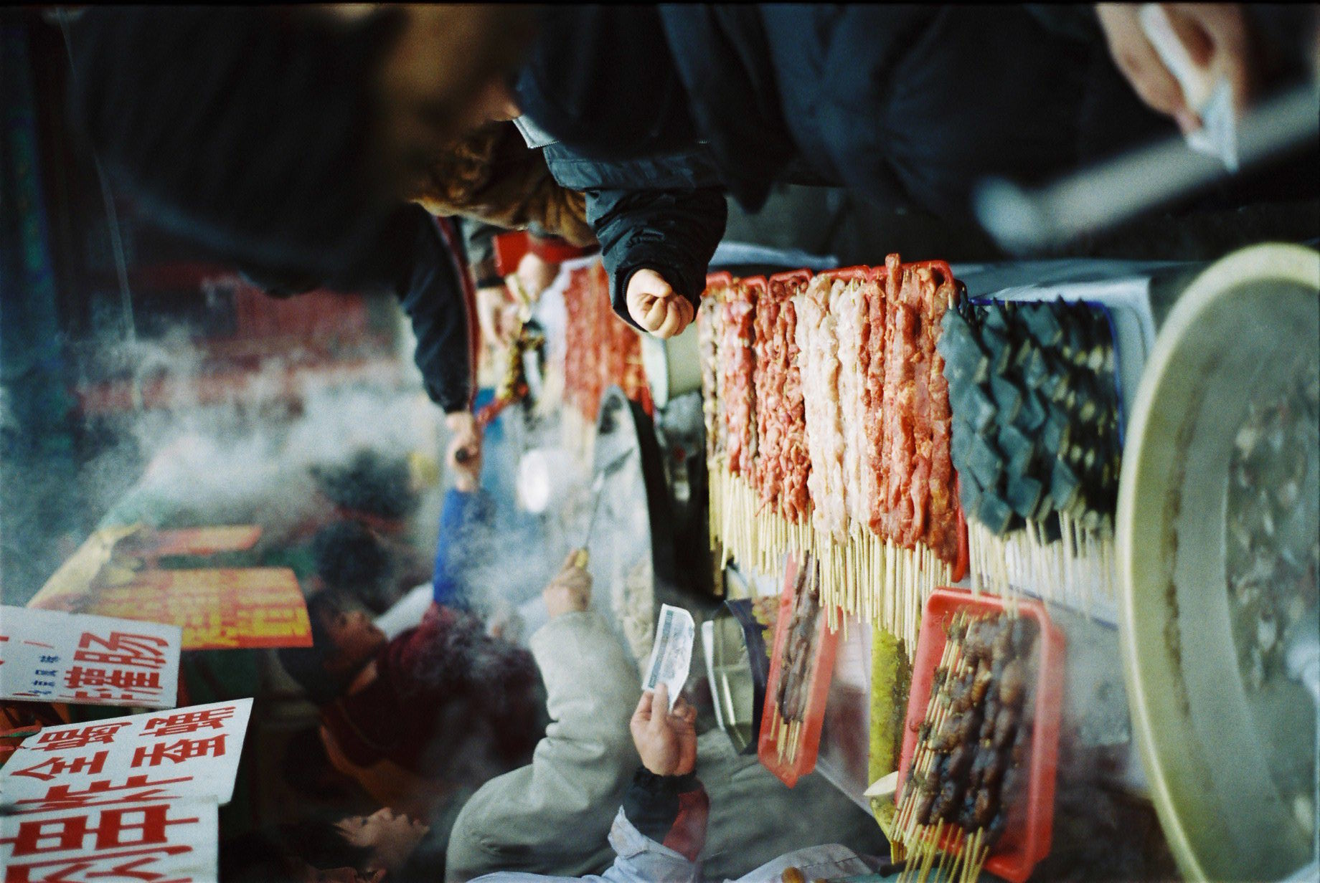
The name Shanghai literally means ‘on the sea.’ The city of Shanghai has made the most of its location between the edge of the Pacific and the mouth of the Yangtze River to become a regional trade powerhouse with access to both international markets and China’s interior. Shanghai’s history is much shorter than that of nearby cities, with origins in the European concession ports of the mid 1800s. The city was quite literally built for international trade, and many of the concession-era buildings still stand at the heart of the city. Although Mandarin is the official language, local residents often use the Shanghai dialect when speaking to each other. In addition to its own dialect, Shanghai has it’s own distinct cuisine and culture. Official sources describe the climate as a ‘subtropical monsoon climate,’ although the average annual temperature is only 17.4°C, with a monthly high of 39°C and a low of –4.6°C. Average annual precipitation is 931.2 millimeters.

Like Beijing, Chongqing and Tianjin, Shanghai is an autonomous municipality, combining governmental features of a city and a small province. Unlike some of the others, the surrounding areas of the Shanghai district are incorporated into the city’s economy, making the distinction between Shanghai District and the City of Shanghai largely academic. In fact, the city’s economic influence extends far beyond the district into neighboring provinces. The Shanghai district’s population is now estimated at 20 million. This is a jump of 3-4 million over previous estimates, although the official population is still estimated at 17.42 million. The difference is composed primarily of migrants from the rural areas of China, who do not hold official resident status in Shanghai. The bulk of unskilled labor and service jobs in the city are held by rural migrants.
Food kiosks at a temple fair.

Table 1. Shanghai At A Glance
Indicator | 2003 | 2004 | 2004 Growth
Land area (sq. kilometers) | 6,341 | -- | --
Population (million)* | 20 | -- | --
GDP ($billion) | 75.58 | 90.09 | 19.1%
Average urban disposable income ($) | 1,797 | 2,017 | 12.2%
Foreign direct investment ($billion) | 5.85 | 6.54 | 11.8%
Total value of imports ($billion)** | 88.9 | 121.3 | 26.7%
Total value of exports ($billion)** | 112.3 | 161.0 | 30.2%
* 20 million is an estimate of actual population made in 2003 by Shanghai’s mayor. Official figures are lower, and no update to the mayor’s estimate is available. **World Trade Atlas. All other figures are from the Shanghai Statistical Yearbook, 2005.

The Economy

Despite concerns about rising prices, Shanghai’s economy continued to churn ahead in 2004, with a GDP growth rate of 19.1%. According to Shanghai government statistics, total GDP for the year was $90.9 billion. Sustained double-digit economic growth has raised the specter of inflation, and the government took action in 2005 to slow the economy. Although prices for premium office space continue to rise, the increases in the cost of housing and food prices have both slowed over the past year. The government continues to be concerned about overheating, and new controls on mortgages were a factor helping to limit price increases in housing by reducing speculative investment, and overall growth is believed to have been significantly slower in 2005, with preliminary estimates set at 11.1%. Even with these problems, Shanghai remains a center for automobile and garment production, and is continuing to develop as an important center for finance, banking and insurance.

With an estimated 1.3% of the nation’s population in 2004, the port of Shanghai accounted for nearly 21% of China’s total imports and nearly 32% of total exports, as well as accounting for roughly 10.7% of foreign direct investment. The growth in trade not only reflects the expansion of markets in East China, but an overall shift toward direct trade, away from gray market channels. This shift toward direct trade is being driven by improved access for imported products and declining tariffs under China’s WTO agreement, which has made direct imports easier and less costly than in the past. Recent government crackdowns on illegal imports have also made it riskier to rely on gray-market channels.

The municipal government has played an important role in developing trade and foreign investment, offering a number of preferential policies and investing heavily in trade infrastructure. The Port of Shanghai tops all other mainland ports in volume, routinely ranking among the top three ports worldwide, and the addition of the Yangshan deepwater facility has helped it to cinch the port’s position as number one worldwide in volume. Air cargo has seen a similar boom, and the air cargo terminal at Pudong is now the world’s busiest. Numerous projects already underway will continue to ensure that Shanghai’s logistics and transportation capabilities remain among the best in China. Shanghai’s free trade zones (FTZs) such as Waigaoqiao also offer a wide range of services to importers. Products can enter the FTZ and not pay duty until it is shipped out. Companies in the FTZs provide a full range of services including inventory tracking, logistics and cold storage. The FTZs also offer special tax and tariff advantages for businesses that add value to imported products prior to shipping them into the Chinese market. Beyond the FTZs, Shanghai also has a growing population of specialized distributors that can handle not only logistics and distribution, but marketing the product as well.

The Consumers

Shanghai is one of the wealthiest cities in China, with average annual incomes nearly equal to the top 10% of China’s urban consumers at RMB 18,502 ($2,312) per capita. The growth in incomes shows no sign of slowing. In 2004, the average income jumped by nearly 20%, as compared to 12.2% in 2003. (Note that these income figures are official numbers, and are considerably lower than most other estimates). Consumption expenditures have also grown, and borrowing has become more commonplace. The increase in borrowing is the combined result of rapid privatization of housing and the growing availability of mortgage loans. As recently as seven years ago, the majority of homes were distributed through the workplace or by the government. Now, the bulk of homes are privately owned.

Shanghai is also home to one of China’s largest foreign communities, with estimates of the total foreign population ranging from 300,000 to 500,000, including 15,000 U.S. citizens. (In an unintentional bit of irony, the Chinese government lists Taiwanese as foreigners). The city’s cosmopolitan character and affluent population provides it with both broad exposure to foreign products and the wherewithal to buy them. As a result, Shanghai’s residents often act as trend-setters for the rest of China. Consumers in Shanghai are very style and brand-conscious, viewing famous brands as both status symbols and guarantees of quality. Consumers in this city are more willing than most people in China to make the tradeoff between price and quality. As a result, high-end shopping districts such as Nanjing Road or Huaihai Road are crowded with top-end fashion boutiques such as Ferragamo, and Christian Dior, doing excellent business despite the availability of low-cost look-alikes and counterfeits just a block or two away.
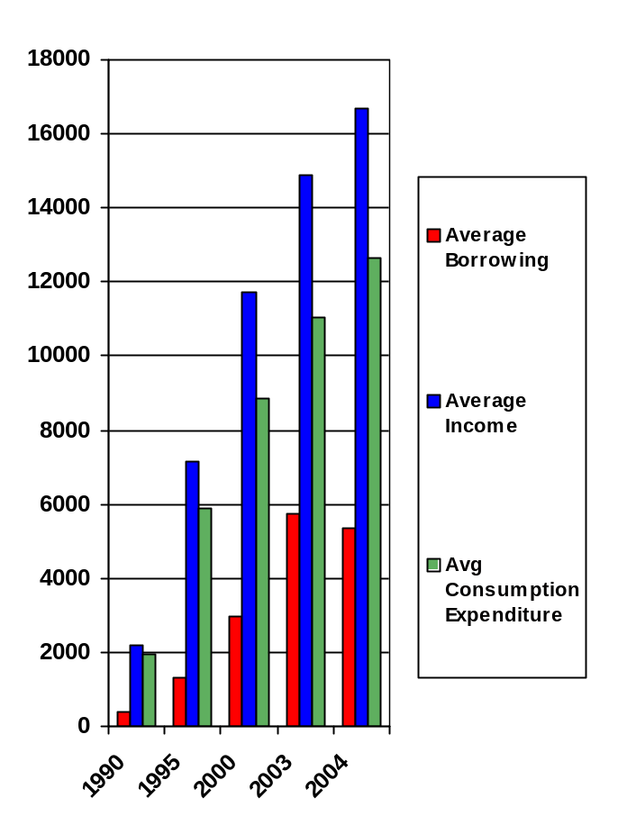
Better Buyers
Key Consumer Indicators for
Shanghai, 1990-2004
(RMB/Capita)
Recent years have seen the emergence of a new consumer demographic throughout China, particularly in Shanghai. These are the up-and-coming generation of people who were raised during the years of prosperity, and are now coming to the fore as independent consumers. Young and affluent, and typically single children, they are more consumption oriented and less thrifty than their parents. Their appearance has helped to spawn the emergence of a ‘mall culture’ in Shanghai that looks to retail venues as sources of entertainment as well as places to shop. They are also more willing to take on debt as a means of financing purchases, which has helped led to a boom in home and car sales. In terms of food sales, this group of consumers is helping to drive the movement toward ready-to-eat and heat-and-eat meals in retail venues. This last trend is likely to become more pronounced as this generation begins having children and finds itself short on time.

The Food Market

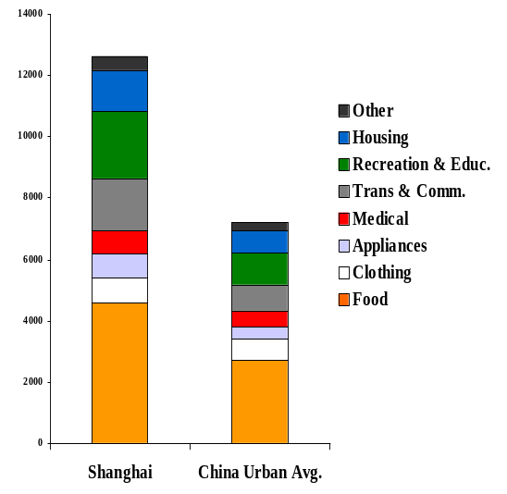
Although incomes in Shanghai are relatively high, Shanghainese still spend a surprisingly high proportion of their earnings on food. Per-capita food spending in Shanghai tops the nation in official statistics. (Guangzhou, famous even in China for its epicures, might actually outspend Shanghai, but does not appear separately in the statistics). Chinese census data also show where the differences lay: Shanghainese spend a remarkably large amount of their income on dining out. A number of factors likely figure into this, including relatively crowded living spaces (not suitable for entertaining guests), busy schedules and a gift-giving culture that emphasizes high-profile entertainment for guests. They also spend more on aquaculture products (nearly three times the national average for urban residents) than any other place in China, except neighboring Zhejiang Province. Anecdotal evidence indicates that much of this, in both Shanghai and Zhejiang, is accounted for by crab and shellfish, which are heavily favored in local cuisine. Shanghainese also spend a relatively large amount on dairy products, with exenditures well over double the national average. The surprisingly large amount of income that Shanghai’s consumers are willing to spend on food, and the cosmopolitan culture of the city, makes Shanghai an outstanding candidate for imported foods.
Average Household Living Expenditures
By Category, 2004 (RMB)

Food retail is big business in Shanghai. According to Shanghai Census figures, wholesale and retail sales of food, beverages and liquor and tobacco amounted to RMB 130 billion ($16.24 billion) in 2004. Food shoppers in Shanghai also have a growing variety of venues for spending their money. Shanghai is a hotbed of retail development, with a wide range of foreign-invested hypermarkets such as Carrefour, Metro, Lotus, Trust-Mart, Auchon, and RT Mart, as well as being home to three of China’s top five domestic supermarket chains, Lianhua, Hualian and Nonggongshang. Shanghai also pioneered the convenience store format in China, and now has nearly half of all the convenience stores in the country. Despite the competition, foreign retailers continue to express interest in Shanghai. Wal-Mart has finally come to Shanghai, establishing its flagship Nanpu store in late 2005, with plans to open two more soon. Other foreign retailers including Korea’s E-Mart and Japan’s Family Mart have also come to Shanghai. The prize is worth the competition. Retail sales revenues amounted to RMB 245 billion ($29.7 billion) in 2004, increasing by 9.5% over the previous year. Tough competition is putting retailers under pressure to innovate, and Shanghai-based chains are becoming increasingly sophisticated in their marketing efforts.

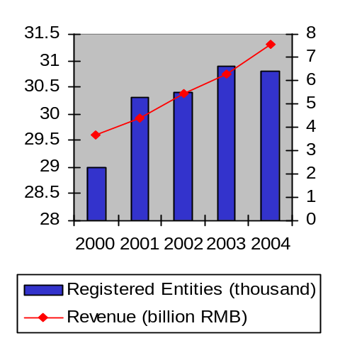
The hotel, restaurant and institutional food sector (HRI) is also extremely well developed. As noted before, Shanghai’s consumers spend a remarkably large portion of their food dollar on dining out. This, combined with high incomes and a cosmopolitan atmosphere puts Shanghai at the cutting edge of China’s culinary landscape. While Chinese and expatriate diners typically have distinct preferences, in Shanghai more than any other place in China, the two groups are merging into a single high-end clientele. This group is interested in novelty, and foreign restaurants and fusion restaurants are more common than elsewhere. There are slightly over 30,000 registered ‘business units’ in Shanghai’s catering industry, and probably at least as many go unregistered. Among this number, there are over 1,000 registered western restaurants. The emergence of high-end restaurant chains has become an important trend, particularly for imported food products, as they demand both high quality and large volumes. The hotel industry however, continues to serve as a key source of demand for high-end imported food products. At the start of 2004, Shanghai was home to 24 five-star hotels. Even so, the city suffers from a chronic shortage of top-notch hotel space, and a number of new hotels are under construction. Catering is very much at the heart of Shanghai’s hotel industry, with catering revenues accounting for nearly 1/3 of all operational revenues and an even larger share of profits. ATO/Shanghai routinely works with hotels to promote high end products including meat, seafood and wine.
Shanghai Catering Industry
2000-2004

Trade Show Central

Shanghai has carved out a niche for itself as a major center for trade shows. The addition of new, state-of-the-art facilities in Pudong district has helped further boost this claim. Major upcoming events include two of China’s largest international food shows, Food and Hospitality China (in November) and SIAL (in May), along with China’s largest wood show, WoodBuild China (in June). There are quite a few other shows that include agricultural or food products. These include: Pet Fair Asia (June 2006), the Modern Landscape Design and Construction Forum (June 2006), the All China Leather Expo (September 2006), the Shanghai Culinary Exposition (November 2006), Food Ingredients Asia/China (February 2006), Food Ingredients China (March 2006), Bakery China (October 2006) and Hortiflorexpo (April 2007). New shows are appearing at record speed, and not all shows are created equal. U.S. companies are advised to contact ATO if they are uncertain about the value of attending one of the lesser-known shows.

Beyond Shanghai

Shanghai is more than just an immense market. It is also a shipping and distribution hub for products that move into markets throughout Eastern, Central and even West China. In addition to excellent logistics infrastructure, Shanghai boasts a cohort of distributors whose reach now extends to the furthest corners of the country. Experienced in working with customs clearance, quarantine and currency exchange procedures, a growing number of these distributors offer a full range of services to exporters, taking much of the paperwork and hassle out of exporting to China.

The Window to a Developed China

Shanghai’s rapid growth has been a boon to cities in the neighboring provinces of Jiangsu and Zhejiang. Many of these cities are now emerging as major markets in their own right, with populations in the millions and per capita incomes far above the national average. As with costs in Shanghai continue to rise, many industrires have moved to these nearby cities. In 2003, the city of Suzhou actually overtook Shanghai as a destination for foreign direct investment. In 2004, Hangzhou was named by Forbes Magazine as the best place to do business in China, followed by Wuxi. A brief rundown of the most prominent of these little-known but important cities is laid out in the following table. For more information, please see ATO’s Emerging City Market reports on the FAS website.
Table 2. Major Cities in Greater Shanghai (2004)
City | Province | Population (1,000) | GDP  ($million) | Per Capita Income ($)
Hangzhou | Zhejiang | 6,516 | 31,348 | 1,821
Ningbo | Zhejiang | 5,527 | 26,606 | 1,985
Nanjing | Jiangsu | 5,013 | 21,966 | 1,450
Wenzhou | Zhejiang | 7,462 | 17,532 | 2,216
Wuxi | Jiangsu | 2,235 | 16,355 | 1,699
Shaoxing | Zhejiang | 4,347 | 16,717 | 1,955
Taizhou | Zhejiang | 5,559 | 14,672 | 2,014
Suzhou | Jiangsu | 2,208 | 16,500 | 1,806
Jiaxing | Zhejiang | 3,339 | 13,132 | 1,837
Jinhua | Zhejiang | 4,517 | 12,230 | 1,739
Changzhou | Jiangsu | 2,171 | 10,388 | 1,609
Huzhou | Zhejiang | 2,568 | 6,134 | 1,576
Source: Zhejiang and Jiangsu Statistical Yearbooks, 2005. Note that population statistics are widely variable, depending on inclusion of immigrant workers, satellite cities and development zones.
Shanghai
Jiangsu Province
Zhejiang
Province
Nanjing
Hangzhou
Zhenjiang
Shaoxing
Ningbo
Taizhou
Jinhua
Wenzhou
Yancheng
Xuzhou
Jiaxing
Huzhou
Wuxi
Changzhou
Suzhou
Yangzhou
Nantong
The Greater Shanghai Area
(Shanghai, Jiangsu and Zhejiang)

Gateway to Western China

Shanghai’s influence extends far beyond its neighbors in the Yangtze delta. Cargoes that pass through Shanghai are often destined for major cities deep in China’s interior.
Although incomes in these areas are often lower than in the coastal cities, the sheer size of many of these markets makes them tempting. Many boast a small but fast-growing middle-class with a taste for novel products and the money to buy them. Tastes in these cities vary widely and which products will be successful is difficult to anticipate. For example, at a recent food promotion in Wuhan, (the capital of Hubei Province) the fastest moving items turned out to be Mexican foods. The level of development in retail and HRI, not to mention logistics, is also variable. Kunming, deep in the interior, has an extremely sophisticated retail sector with investment from Wal-Mart, Carrefour, Metro, Parkson and numerous other foreign retailers. This is considerably more development than in Nanjing, despite the fact that Nanjing has a larger population, higher incomes and is closer to Shanghai. The regional differences go far beyond incomes and infrastructure to include local dialects and food culture. Foods that do well in Shanghai, where the cuisine is typically sweet and mild, may not do so well in Chongqing, which is famous for plate (and palate) meltingly hot food. Exporters that are interested in going further afield are advised to research these markets carefully prior to entering them.
Table 3. Selected Cities of the Interior (2004)
City | Province | Population  (1,000) | GDP  ($mill) | GDP/Capita ($/yr)
Chengdu | Sichuan | 10,600 | 27,321 | 2,577
Chongqing | Chongqing | *31,440 | 33,317 | 1,059
Hefei | Anhui | 4,450 | 7,371 | 1,656
Kunming | Yunnan | 5,030 | 5,545 | 1,102
Wuhan | Hubei | 7,860 | 24,450 | 3,111
Note: population estimates are notoriously variable as cities appear to report nonresident and/or nearby farm populations in different ways. *This appears to include the entire Chongqing district, which includes a large rural population, inflating population numbers while reducing GDP/capita. (Source: China Census).

Contact Information:
Shanghai
Jiangsu
Zhejiang
Anhui
Jiangxi
Hubei
Sichuan
Chongqing
Yunnan
Hefei
Wuhan
Chongqing
Chengdu
Kunming
Key Cities of the Yangtze

U.S. Agricultural Trade Office, Shanghai
Suite 331, Shanghai Center
1376 Nanjing West Road
Shanghai 200040
Tel: (86-21) 6279-8622
Fax: (86-21) 6279-8336
Email: ATOShanghai@usda.gov

