Tina and Jewel:
Caught in the web of circus industry neglect and abuse
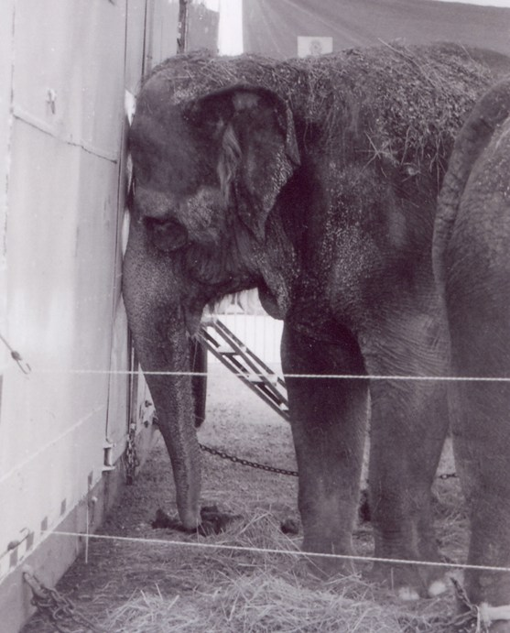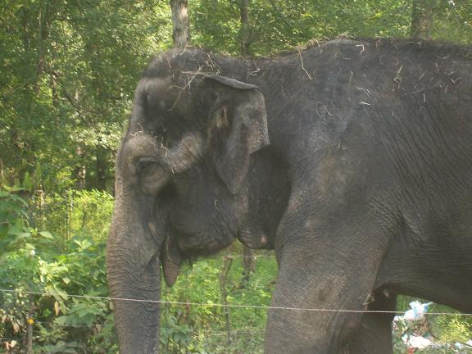

Tina and Jewel are two Asian elephants in their early forties who have lived most of their lives in the circus. For decades, they have been “owned” and by the Cole Brothers Circus and trucked around the country to perform in shows and give elephant rides. In 2006, amidst amassing Animal Welfare Act (AWA) violations and after seven of its elephants died or became too disabled to work, Cole Brothers leased Tina and Jewel to Gigi’s Exotics and its proprietress Gigi Davenport.

Both Cole Brothers Circus and the Davenport family have an egregious history of elephant abuse and neglect, as the chronology below documents.

USDA inspection reports on both Tina and Jewel document the abusive and negligent treatment to which these elephants have been subjected over the past decade and a half. The reports document repeated beatings of both elephants and abusive use of the bullhook on them, producing wounds to their bodies; chronic lack of adequate veterinary care, foot and skin care resulting in severe weight loss, overgrown feet, scaling dead skin and urine scalds on legs; lack of legally-required testing for tuberculosis, endangering both the health of the elephants

Life under these abusive conditions has taken its toll on these elephants. In fall 2006, while traveling with Cole Brothers circus, both elephants appeared gaunt, sick and broken. In Spring 2007, they reappeared in LE Barnes and Bailey Circus looking even worse. In March 2007, USDA ordered that Jewel be taken off the road, noting that she had lost an appalling 2,000 pounds. A veterinary expert confirmed that both elephants had suffered “alarming weight loss.”

Jewel and Tina disappeared from public view. In July 2006, In Defense of animals located them in rural Texas at an unapproved Davenport facility in Leggett. They had spent several months confined there to a 20 X 20 slab of concrete, surrounded by circus refuse, or locked inside an unventilated tin barn.

In August, the elephants were reportedly given access to a larger outdoor yard, in a space that is still well under an acre in size. They remain at the unapproved Leggett, TX, and continue to be at the mercy of circus interests with a long history of abusing elephants and violating federal animal welfare law.

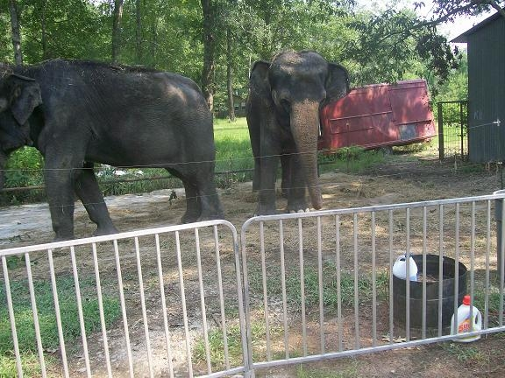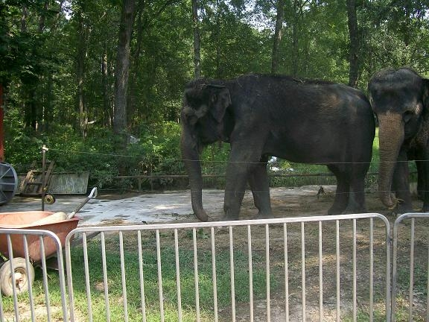
Tina and Jewel confined by hotwire to a 20 x 20 concrete slab in Leggett

Chronology of Elephant Abuse and Neglect
History of the Cole Brothers Circus and the Davenport Circus Interests

1994-1997: King Royal Circus cited repeatedly for Animal Welfare Act (AWA) violations for failing to provide adequate veterinary care, failing to provide adequate space, and failing to handle animals humanely. (For details, see http://www.circuses.com/fact-king.asp)

August 12, 1996: King Royal formally charged with Animal Welfare Act violations and assessed an $8,000 fine in conjunction with the public beating of a young bull elephant named Mickey. King Royal trainer/exhibitor Bela Tabek’s USDA license is revoked.

March, 1997: An Cole Brothers Circus elephant named Ola died under suspicious circumstances at age 40. Cole received a warning from the USDA as result of this death. The circus tranquilized Ola to trim her feet (not standard procedure), and for 28 – 29 hours leading up to her death, Ola was unable to stand. The other Clyde Beatty-Cole Bros elephants were only 30 miles away and could have been brought to the facility to help lift her to a standing position.

A circus employee claimed that because Ola was no longer a performing elephant due to hip problems, she was of no use to the circus anymore.

July, 1997: USDA launches investigation of Clyde Beatty-Cole Brothers for alleged violations of the AWA and regulations.

August 6, 1997: King Royal Circus crammed three elephants and eight llamas into a poorly ventilated trailer in Albuquerque, NM which resulted in the death of one baby elephant named Heather. Police estimated the temperature inside the trailer to be approximately 120 degrees. State and local officials confiscated the remaining animals and charged King Royal employees with violating local animal cruelty laws

August 27, 1997: King Royal proprietor John (“Gopher”) Davenport is formally charged with Animal Welfare Act violations relating to the death of Heather. Among the violations: failing to provide adequate vet care and failing to provide “urgently-needed” veterinary care to animals in need; handling animals in an inhumane and stressful manner; transporting animals in a cargo space that not properly ventilated or safely constructed; transporting animals in obvious physical distress; failing to provide elephants with food appropriate for that species.

Of the charges, Michael V. Dunn, USDA assistant secretary said, “It appears that the death of Davenport's elephant Heather is a direct result of gross neglect . . . Treating animals in a manner that ultimately threatens their safety will not be tolerated."

January 1998: Federal administrative court upholds the charges against John Davenport. His USDA exhibitor license is revoked, he is permanently barred from the exotic animal business and he is assessed a $200,000 fine, one of the largest ever assessed in the history of the Animal Welfare Act. Davenport has allegedly continued to operate, however, under USDA exhibitor licenses held by his wife Gigi (Gigi’s Exotics), son Juan Davenport, niece Billie Davenport, and another Davenport interest “Maximus Tons of Fun.”

Feb. 2, 1998: The USDA cited Clyde Beatty-Cole Brothers: “All elephants are in need of foot care. Elephants have cracked nails, overgrown soles and cuticles.” Also cited for failure to maintain records of foot care procedures, of the cause and treatment for several observed abrasions/lesions, and of the administration
of medication.

June 3, 1998: The USDA cited Clyde Beatty- Cole Brothers for noncompliance with the AWA. “Two of the six elephants had obvious hook mark wounds on their rear legs. Some hook marks were also observed under the jaw of one elephant.” Further, it was noted that the circus had failed to provide shade for the elephants.

June 12, 1998: Cited by the USDA for failing to provide shelter for the elephants, and for the primary enclosure needing repairs. Cited again for inappropriate handling; “On a previous inspection, two of the six elephants had obvious hook marks present. During the inspection today, four of the six elephants were observed with what appears to be hook marks.”

Aug. 14, 1998: In an article in the newspaper The Tennessean, the circus admitted to puncturing an elephant’s skin and stated, “We had a guy who put a couple of boils on an elephant, where you hook them too hard and puncture the skin.”

Sept. 10 and 11, 1998: The USDA cited Clyde Beatty-Cole Brothers for failure to have an attending veterinarian or a program of adequate veterinary care. The inspector noted that three of the elephants (Conti, Helen and Pete) are “intermittently demonstrating some abnormalities in gait and other movement that might be age related. Helen may also be exhibiting some of these partially due to previous injuries,” and ordered that “Performance behaviors and requirements and other circumstances that might cause pain, distress or strain on the individual animals should be addressed.”

Nov. 17 and 18, 1998: The USDA cited Clyde Beatty-Cole Brothers for failure to allow access to and inspection of the records. The circus would not provide the inspector with a report concerning the health of the elephants. The inspector also noted scabs on the backs and behind the ears of the elephants. Medical records indicated that these injuries were not examined or treated by a veterinarian. The circus was also cited for storage of food and bedding in a manner which would not prevent contamination: “The back of truck #61 which stores the grain is dirty. There are cups, an empty cigarette pack, a gas powered weed eater, and spilled grain on the floor…This area also serves as storage for a can of paint as well.”

April, 1999: The USDA charged Clyde Beatty- Cole Brothers circus with Animal Welfare Act (AWA) violations. According to a statement by Michael Dunn, Undersecretary for the USDA’s marketing and regulatory programs, “We believe that on numerous occasions employees of the Clyde Beatty-Cole Brothers Circus abusively used an elephant hook on several animals. Charges of abuse are always among the most serious. And, it both angers and saddens me when I hear allegations such as these.”

August, 1999 Petunia (Pete) and Conti died suddenly, within a two-week, period, after the circus took them off-tour after numerous complaints from the public about their health.
A necropsy report on Pete indicates that she collapsed in a field and lay on the ground for 2 ½ days until they brought in a crane to help her up. “She stood for several minutes, ate hay, drank water, sprayed herself down and then urinated multiple liters of dark red/brown urine. She then laid down and died.” The report further indicates hemorrhaging throughout her body. She also had significant degenerative joint disease and arthritis. The USDA had no medical record that Pete had ever been diagnosed or treated for this condition.
Conti died under similar circumstances only two weeks later. There has been no published necropsy report on Conti.

August 27, 1999: The Monmouth County SPCA in New Jersey filed animal cruelty charges against Clyde Beatty-Cole Brother Circus for overworking and overloading an elephant named Helen who appeared to suffer from a crippling knee injury. The charges were filed after observing the animal during an exhibit at the Freehold Raceway Mall on August 18-20; criminal and civil charges are pending in the Freehold (NJ) Township Municipal Court.

January 24, 2000: USDA and Clyde Beatty-Cole Brothers Circus settle the charges filed in April that they abusively bullhooked several elephants on more than one occasion. Cole agrees to hire a consultant approved by the USDA, and implement recommendations made to improve elephant handling and care. There was also a civil penalty of $10,000, suspended provided that the circus spends this amount to retain the consultant and implement the recommendations. “The training outlined in this agreement should ensure that, in the future, Cole Bros. will properly train and handle their elephants” according to Michael Dunn, USDA Undersecretary for marketing and regulatory programs.

February 2 and 3, 2000: The USDA cited Clyde Beatty-Cole Brothers with failure to handle the elephants “in a manner that prevents trauma of physical harm” when the inspector discovered several bullhook scars on both Helen and Bessie..

They were cited as well for failure to “provide adequate veterinary care”. Helen and Bessie had not received foot care in 3 months. Bessie was bleeding after and/or during urination and had not been diagnosed or treated for that condition. The circus was ordered to keep Bessie at winter quarters until she was diagnosed, treated, and cleared for travel by a veterinarian. Helen had fecal material protruding from under the base of her tail. According to her trainer, her tail was paralyzed by a truck accident. She had not been examined by a veterinarian for this condition.

The attending veterinarian was not experienced in the care of elephants. Cole was ordered to employ a veterinarian with substantial prior experience with this species.

There were no records to document the TB status of the elephant handlers that had direct contact with the elephants in the past year.

The circus was cited for failure to properly construct and design the transport truck to ensure the safety and comfort of the elephants after Helen was slammed into a wall and injured during sudden braking.

The circus was again cited for failure to properly store food.

March 9, 2000: Three veterinarians testified under oath as to videotape that they reviewed of Cole’s elephant Helen being forced to give rides and pull a caravan of heavy tiger cages. All three described Helen’s disability as a chronic, degenerative condition causing pain-related lameness and instability. They testified that this would be aggravated by the work they observed her doing, and recommended that she be removed from service. (Helen continued to tour with the circus for at least 6 months following this.)

June 13, 2000: Former Clyde Beatty-Cole Brothers circus elephant trainer Tom Rider testifies before the US Congress: that “in White Plains, NY, when Pete did not perform her act properly, she was taken to the tent and laid down, and five trainers beat her with bullhooks. Pete is now dead.”

September 20, 2000: In a letter to the USDA, PETA wrote, “PETA has written several times with concerns about Helen, an elephant with a serious knee disability. Helen’s crippling condition has deteriorated, and she should be immediately taken off the road. …Helen’s persistent use has apparently caused her injuries to worsen.”

October 18, 2000: In response to a letter from PETA, the USDA stated, “With regard to your additional concerns about Helen’s knee condition, it does appear that this condition may be worsening. …Helen is now retired at a private facility in Missouri.”

Helen was forced to work for more than two years after her disability was first documented. When the circus could no longer use her they gave her to a poorly- funded facility owned by Murray Hill, father of Cole trainer Adam Hill. Murray Hill is known in the elephant community for, among other things, publicly threatening to euthanize his elephants if he does not obtain sufficient donations for their upkeep.

Feb. 12, 2001: The USDA reports a complaint about “inadequate control…and use of physical force” of Tina. Report indicates that the “matter is still under investigation.”

April, 2001: Circus officials confirmed that Helen – sent to a private facility in Missouri in Sept. 2000 – had been euthanized. Helen had been touring with the circus for two years despite documentation of a painful and dangerous disability. She was only 42 when she died.

June 14, 2001: USDA inspection report on Clyde Beatty-Cole Brothers circus notes multiple complaints involving Bessie, “regarding excessive vocalizations during performances, when on or off loading from her trailer and an inability to walk.” The report notes that she has been diagnosed with arthritis and that she is notably short-strided in both legs.

July 22, 2002: Knoxville Zoo veterinarian Ed Ramsay reviewed videotape of Bessie and commented, “The video segments clearly show this elephant to have restricted range of movement of the front left leg. …(I)n my professional opinion there is little to no question this animal suffers from arthritis. …(T)his condition is painful….Extended periods of exercise and forced performance of unusual leg motions may very well cause this animal to suffer.”

Nov. 18, 2002: After repeated complaints from concerned citizens and animal activists and a statement from a prominent elephant veterinarian, the Clyde Beatty-Cole Brothers circus has retired Bessie the elephant to the Wild Adventures Theme Park in Valdosta, Georgia. She had been forced to work for at least a year and a half since her arthritis and difficulty walking was first documented.

Sept. 16, 2003: Spartanburg County Environmental Enforcement Department (South Carolina) received complaint from a man who saw two elephants, Tina and Jewel, being beaten. According to his sworn statement, the witness saw “ a guy come out of a motor home with a feeding bucket and a black pool stick with a silver point on it and with 2 hands like holding a baseball bat, proceeded to beat 2 elephants …about the backs, sides, head, trunks. The guy had no reason!” The night watchman acknowledged hitting the elephants with the bullhook “ to make them be quiet.” The officer taking the complaint ordered trainer Adam Hill to remove the night watchman from any contact with the elephants.

December, 2003: The USDA cited and fined Clyde Beatty-Cole Brothers circus $2,750 for “improper handling of an elephant” after receiving a videotape taken March 27, 2003 of a handler hitting an elephant with a broom. The handler was fired.

May 6, 2004: Clyde Beatty-Cole Brothers circus announced that they have changed their name to the New Cole Brothers Circus and decided to discontinue using elephants in their shows. However, they would continue to rent out their two remaining elephants, Tina and Jewel, for television commercials and other performances, including Republican Party events.

In fact, Tina and Jewel and their trainer were almost immediately sent on tour with the Walker Brothers Circus. Just over a month prior, Walker Brothers’ owner John Caudill, Jr. and elephant trainer John Caudill III pleaded guilty in a federal administrative court to 18 violations of the minimal standards of care in the federal AWA. The Caudills were ordered to pay a $25,000 fine, and their circus exhibitor’s license was suspended for five years. The USDA had charged Walker Bros. and its employees with causing physical harm and discomfort, with failing to provide veterinary care to an emaciated elephant, an elephant suffering from severe chemical burns and a bacterial infection, and several elephants with potentially deadly foot problems, with unsafe public contact and with operating without a USDA exhibitor’s license.

June 23, 2004: The USDA cited Cole (in an inspection of its animals on tour with Walker Brothers Circus) for failing to handle animals “in a manner that does not cause trauma, overheating, excessive cooling, behavioral stress, physical harm, or unnecessary discomfort” and for violating the regulation which states that “Physical abuse shall not be used to train, work or otherwise handle animals.” The Massachusetts Environmental Police had received a report that 3 witnesses had observed a circus employee hitting an elephant about the head and face. The elephant gave a grunt and then a high pitched sound. The USDA sent three inspector-veterinarians to investigate this complaint. An elephant handler, questioned by USDA, admitted that he had hit Jewel several times with a piece of 1” plastic pipe.
“He said that he did not hit the elephant hard enough to hurt it because the plastic/PVC pipe did not break.”
The inspectors noted an area of abnormal looking skin over the bony areas of Jewel’s forehead and an area of red tissue over her left eye.

Cole was also cited for failing to employ an attending veterinarian, for not having a signed Program of Veterinary Care, for not adequately describing its method of euthanasia, and for the absence of TB tests on two new employees who worked around the elephants.

Cole was also criticized for not promptly notifying the regional USDA office of its name change. According to the USDA report, Cole is now known as the American Circus.

July 30, 2004: Gigi’s Exotics pays $1100 fine in settlement agreement with USDA for violations of the Animal Welfare Act in 2002, 2003 and 2004, at least some of which related to the care of the elephant named “Boo.” Violations included “failure to provide adequate veterinary care, failure to maintain proper records on animals, “failure to handle animals in a manner that does not cause trauma, overheating, excessive cooling, behavior stress, physical harm or unnecessary discomfort;” “failure to provide appropriate methods to prevent, control, diagnose and treat diseases and injuries for the elephant named Boo;” and “failure to maintain transport enclosure free from any protrusions that could be injurious to the animals.”

March 2005: USDA inspected Carson and Barnes winter quarters in Hugo, OK where “Boo” was being kept for the winter. “No one from Gigi’s Exotics present.”

April 1, 2005: Springfield ( IL) Journal-Register reports on consumer complaints against Bailey Brothers Circus, which also has appeared as Great Circus of China, in Alaska and Illinois. Paperwork in Alaska was filed for Bailey Brothers Circus under the name “Juan Davenport,” and in Illinois, paperwork for Great Circus of China was filed under the name “Charles Davenport.” Both circuses included the Davenport elephant, “Queenie” in their act.

August 27, 2005: Tina and Jewel, still owned by Cole (American) were touring the country with Florida-based Wambold’s Circus Menagerie. While in Mt. Pleasant Township, PA, available for petting and feeding by the public, Jewel grabbed a woman’s wrist and sprained it badly.

Jan. 13, 2006: USDA cites Gigi’s Exotics for AWA violation related to structural soundness of trailer that is used to transport “Boo” and also a horse (in a separate compartment).

Jan 17, 2006: Gigi’s Exotics signed a five-year lease for Tina and Jewel, stating, “We plan to incorporate the elephants into our breeding program, performance and rides. Gigi’s Exotics accepts responsibility for the health, welfare and mortality of said elephants.”

Jan. 27, 2006: Texas Attorney General files consumer fraud/deceptive business practices charges against Juan Davenport, Bailey Brothers Circus and several other defendants who “collectively operate a circus show under the names of “Kings Royal Circus,” “The Great Circus of China,” “Bailey/ Wallace and Bros. Circus, Inc.,” “Barnes and Bailey Bros. Circus, Inc.,” “Bailey Bros. Circus,” “Barnes & Bailey Circus,” and “Barnes and Bailey Bros. Circus.” .

Feb. 2006: Gigi’s Exotics aka American All-Star Circus under investigation for consumer fraud as well as AWA violations, according to memo from Sgt. Keith Bond, Jackson, Co., Miss.

Feb. 22, 2006 Gigi’s Exotics on the road with Boo, Tina, Jewel and 2 camels.

Summer, 2006: Tina and Jewel traveled with Cole Brothers Circus, accompanied by trainer Will Jacobs Davenport.

The following review appeared on the blog of circus fan Crash Moreau:http://www.circusrevue.com/2006circusvisits.htm
COLE BROTHERS CIRCUS W. Hartford, NY June 11
This is a nice looking show with a large red and yellow tent and painted trucks. This year the show had a much better line up of acts compared to the past few years. This year at selected performances the elephants has returned now owned by Gopher Davenport and handled by his son. The only thing I can say is young Davenport needs to put away the bull-hook on these two elephants as Adam Hill never used the hook on these two in previous years. All the animal rights people need is to see how he is handling these two elephants, Tina and Jewel and there will be a lot more flax (sic) about not having animals in circuses.

Oct. 24, 2006: USDA inspects Gigi’s Exotics and cites for inadequate veterinary care: “I observed two Asian elephants, Tina (40 yrs.) and Jewell (42 yrs.). Jewel appears to be underweight. The muscling along both sides of her spine appears sunken or hollowed out. Her spine is very prominent. The handler stated that he has not noted any weight loss and that she had an injury several years ago. In addition, there appears to be very little muscling over the eyes. Although the handler stated that this is her “normal” conformation there are no records other than the health certificate and TB results available for me to review documenting her past or current health status.”

Winter, 2007: Tina and Jewel traveled with the LE Barnes and Bailey circus; their names are given to the public and the media as Margaret and Lilley. LE Barnes and Bailey circus performs 640 shows per year.

Feb. 16, 2007: USDA inspects Gigi’s Exotics at Heritage Park in Watkinsville, GA in conjunction with LE Barnes and Bailey Circus. Tina, Jewel and Boo are present.

Numerous violations noted, including:

- Inadequate veterinary care Jewell is “noticeably thin.” Comparison of photographs taken by USDA between Oct. 2006 and Feb. 2007 indicate that animal is “chronically thin.” Although handler was instructed in Nov. 2006 by USDA to weigh Jewel, no weight is available until Feb. 07. “The animal’s weight most be monitored at least monthly to assess her progress”

TB records outdated. (most recent trunk wash results dated Nov, 29, 05). “Because TB can be a cause of chronic weight loss, it is imperative that the elephants are tested in timely manner.”

Failure to handle animals properly to insure minimal risk of harm to animals and people. Boo placed in a corral and public allowed to walk up to corral and toss in carrots. Small children noted in open area of corral while handler was distracted.

March 2, 2007: Gigi’s Exotics objects to Feb. 16 USDA inspection report. In letter, claims that Jewel was examined by Dr. Ted Eudy (flown in from OK) and examined and tested. Claims health report including trunk wash results were given to USDA. Cites inspection from November, 2006 that found no non-compliance.

March 14, 2007: USDA upholds findings of Feb. 16 inspection, noting the trunk wash samples for TB testing were unacceptable and still the only TB test results are from 2005. Letter also states, “considering Jewel’s unthrifty condition and chronic weight loss, the failure to obtain a weight in a timely manner jeopardized her health and indicated a clear failure to provide adequate veterinary care and monitoring of her condition.”

March 17, 2007: USDA inspection notes Gigi’s Exotics continued violation for inadequate veterinary care. Jewel remains “noticeably thin.” Her weight was taken only twice (elephant weighs between 6600 and 6800 pounds.) Weight loss remains undiagnosed. Current TB trunk wash results still unavailable. “Travel restrictions and prohibiting public contact with these elephants is necessary to ensure the health of both the elephants and the public by minimizing the potential spread of tuberculosis. In the absence of a clear diagnosis of Jewel’s weight loss, and the potential for tuberculosis or some other unknown disease being present, it would be inappropriate for her to travel.”

March 30, 2007: Damning USDA inspection of Gigi’s Exotics in Pueblo, CO. Numerous violations noted, including inadequate veterinary care (including no program for appropriate skin and foot care); inadequate training of elephant handler; failure to handle elephant in manner that does not cause excessive trauma, stress, physical harm, unnecessary discomfort); inadequate record keeping; failure to maintain appropriate primary enclosures for transport The elephant described in this report is not identified.

Finds elephant with “excessive dead skin over most of her body and doesn’t show evidence of proper bathing for quite some time. She has urine staining and what appears to be urine scalds on her back legs. The pads n this elephant had excessive growth and there were numerous flaps of skin that had trapped debris in them. The cuticles were also excessively long.”

Elephant also has “ multiple wounds draining yellowish exudates inside the left ear” that handlers had not noticed. Wounds would be “consistent with the improper use of an ankus in the ear.”

Handler found to be “not properly trained or experienced.” Trained in Nov/Dec. 2006 by a handler who had “worked with horses a little but had no animal handling, husbandry experience or training. Back up handler had no elephant experience. Previously did construction work. He feeds, waters, handles the elephants and is the loader for rides. “

Handler “had trouble getting [the elephant] to consistently do basic things like pick her feet up for exam. He had to prod her excessively with the ankus (bullhook) to get the desired behavior and sometimes could not get the behavior completed. The handler was not able to demonstrate adequate control of elephant.”

USDA documents physical abuse. “The handler had to continuously rely on excessive and inappropriate use of the ankus to get the elephant to perform the behaviors he was asking for during the rides and performances. . . during the rides and performances, the handler was observed repeatedly jabbing and hitting the elephant with the ankus. Several times during the elephant ride, the handler used the ankus to hit the elephant and she reacted by throwing her head and changing her gait demonstrating irritation at the action of the handler. . . This is inappropriate and abusive use of the ankus and such use is likely to cause trauma, behavioral stress, physical harm or unnecessary discomfort . . . This type of inappropriate use can cause the elephants to become more aggressive behavior.

Also reports public endangerment, through abusive bullhook use, lack of control of elephant and for allowing children to sit on the floor in front of elephant who was confined behind an inadequate barrier with a handler who was distracted. At one point a child was actually let into the elephant’s enclosure to retrieve a balloon. No handler was present at that time.

Other transgressions include: no one could tell USDA where the licensee (Gigi Davenport) was at time of inspection; no health records on hand; immobilization drugs for emergency restraint for elephants were labeled for “yellow cats” and handler had no idea how to use the dart gun to administer the drugs.
April 10, 2007: USDA inspected at New Bern, NC and again cites Gigi’s Exotics for inadequate veterinary care .Jewel is still thin, weighing 220 lbs less on April 8 than when her last weight was taken on March 11. “ TB cultures were taken and were negative. Jewel is not gaining weight despite an apparently adequate diet. The cause of her being underweight is still undiagnosed. She was last seen by the attending vet at the end of Jan. 2007 . .. Because of the stress of traveling, a second opinion from anther veterinarian who specialized in elephants is needed at this time. . .”

April 12, 2007: USDA orders Jewel off the road, warning, “continued travel by Jewel for exhibition, including travel with the circus, even if not performing, would constitute a violation of Sec. 2.40 until such time as her condition has been adequately evaluated and/or there is measurable improvement in her weigh and overall health. Travel to a facility appropriate for long-term holding, or to a facility suited to evaluation and diagnosis of her health issues would be appropriate.”

April 16, 2007: USDA inspects Gigi’s Exotics at New Ulm, MN. One elephant (“Boo”) and 2 camels present. Cited again for failure to handle animals in a manner that minimizes harm to animals and to public. No elephant handler “with appropriate training and experience traveling with this group. . . Safe public exhibition and handling cannot take place without a knowledgeable individual or individuals present.”

May 15, 2007: USDA again cites Gigi’s for inadequate veterinary care). Reports findings of specialist in elephant health called in by Cole Brothers to examine Tina and Jewel in Greenville, NC on April 23, 2007. “The expert determined that both elephants showed an alarming amount of weight loss and that Jewel was not fit to continue traveling with the circus. The expert felt that both elephants should be kept together and should be moved to the winter quarters for Cole Brothers in Deland, FL where they could be closely monitored and have access to veterinarians experienced in elephant health Expert recommended switch in diet to gain weight and advised that feeding amounts provided and eaten should be recorded.

In early May the elephants were moved to Leggett, TX instead of Florida “Not an approved site location.” Inspection of Leggett site found: no daily logs of feed were being maintained. Health of elephants further jeopardized because the facility does not meet minimum standards for long-term housing due to its incompletion of the primary enclosure and shelter. Animals must be housed in a trailer during inclement weather. Moving to Texas instead of Florida “added additional stress due to the longer transit time.” Weights taken on May 14: Jewel 6880 and Tina 7620. Slight weight gain but too early to tell if significant. Management claimed that attending veterinarian had visited, but no records were available to document this claim. Immobilization drugs stored in a lock box filled with water from a leak. “At this time there is no valid home site for this license.”

June 5, 2007: USDA again cites Gigi’s for inadequate veterinary care and facilities violations. “the lack of a permanent long term housing facility that provides adequate shelter and enclosures jeopardizes the health of the animals and hinders their ability to gain weight. Lack of sufficient ventilation in the barn housing the elephants can contribute to heat related stress that would also adversely affect their health. “

Elephants are restrained through hotwires and chaining. Facility lacks “adequate permanent enclosures for elephants.” It also lacks adequate shade and barn lacks sufficient ventilation.

Gigi’s Exotics is given until July 5, 2007 to correct violations.

July 17, 2007: Gigi Davenport sends email to circus list entitled, “My Wonderfull (sic) Son "Will" He is an amazing person, his love for these animals is nothing less than a gift from God. He has suffered from people making ugly judgments to his qualifications. Being born and raised in the circus and around animals all his life. Common sense, book smart and animal sense, he has it all. God Bless him. He is an amazing young man and hasn't done anything wrong. I pray everyday that God will let the USDA see the truth and tell us (what it is) and take that ugly cloud off my son's head and just let him do what comes so very natural to him, taking care and loving these incredible animals.”
July 25, 2007: IDA obtains photographic evidence of elephants living in squalid conditions at the Davenport facility in Leggett, TX. There is no indication that the violations cited by USDA have been corrected, despite the fact that the corrections deadline has passed 20 days before. The eyewitness report provided to IDA states,

“We located Jewel and Tina at a circus approved 'holding area'...and they were far worse than we'd anticipated.. . . Tina and Jewel are living every day on a concrete slab surrounded by building debris and half-burned garbage. Their hard slab-estimated at a mere 12' x 24' is surrounded by electrified wire--and they know this, evident by their fear of standing anywhere close to the perimeter. The cramped girls seemed to huddle together as not to accidentally hit the hot-wire, staying at least 3' from the shock. . . Their condition? Emaciated. The photographic images reveal Tina and Jewel's sunken faces and sad eyes. Facts:
- Both elephants are underweight.
- There was no access to water.
- There was no evidence of other food-types such as fresh browse or produce, only a bit of hay.
- Their 'walking'/living area is approximately 12' X 24' which upon observation is reduced to approximately 9' X 21' given the 3' 'fear-zone' of the electrified wire.
- There was no structural shade from the sun with the exception of some trees.
- They both exhibited stereotypical neurotic behavior of rocking, and one of the girls' back left foot is being treated for thrush--she was lifting it and looking at her foot.
- If there was a structure provided for night-housing or protection from harsh weather, it may have been the old shed located next to the hot-wire corral. This shed is dilapidated and very small with no evidence of proper ventilation.
- As one drives from the county road onto the driveway, Tina and Jewel are immediately to the left, approximately 20 yards from the public's access. Left entirely unprotected and electrically penned like fish in a barrel, they are no measures to insure their safety--or that of the public's.”

August 2007: Tina and Jewel still at the Leggett facility. They have reportedly been given access to a larger outdoor area, still well under an acre in size, and windows for ventilation have been cut into the tiny tin barn, in which they are frequently confined. USDA continues to allow Tina and Jewel’s care to be directed by the same individuals who, as the agency has repeatedly documented, have failed to provide these ailing elephants with necessary veterinary care; have handled the elephants in an unsafe and inhumane manner, and left them in the care of an inexperienced and unskilled trainer. In addition, USDA is reportedly in possession of evidence documenting the illegal involvement of John Davenport, who lost his USDA exhibitor license in 1998, in the circus business, including with Tina, Jewel and the third elephant, Queenie. The agency continues to do nothing to stop this alleged illegal activity.

