VA Patient Falls Clinic

Functional
Balance
Class
FUNCTIONAL BALANCE CLASS
PROGRAM ORIENTATION

- Introduction:

This manual was devised to disseminate a successfully proven balance intervention strategy which was developed by the VISN 8 Patient Safety Center Falls Clinical Division. This treatment intervention consists of an 8 week Functional Balance Class with accompanying home exercise program. The class is lead by a therapist (PT or KT). Class convenes 1x/week. This intervention is targeted towards community dwelling patients with balance and gait difficulties who complain of falls or episodes of near falls.

- Class Outline:

Class goals and exercise content over the 8 week period are as follow

CLASS # | CLASS CONTENT
1 | Stance Stability
2 | Initiation of Weight Shift
3 | Weight Shifting Over Various Bases
4 | Introduction to Stepping
5 | Dynamic Base of Support
6 | Vestibular/Inner Ear Training
7 | Turning and Backwards Motion
8 | High Level Coordination/Multi-Tasking

- Using this Manual:

Included in this manual the reader will find the following information and handouts to facilitate program deployment:

- Pre-class patient handouts which include: orientation/welcome handout, exercise log and fall log.
- Class by class therapist instruction sheet with detailed description of exercises to be performed during each session.
- Accompanying class by class patient handout which will serve as the client’s assigned home exercise program for that session.

- Patient Indications for participation:

This class has been developed for community dwelling, ambulatory patients with minor to moderate balance impairments. Use of this program on a different patient population would require substantial program modification.

Suggested indications for class participation include but are not limited to:

-The ability to stand unsupported for a minimum of 5 to 10 minutes
-The ability to follow multiple step commands
-Fair to good rehab potential
-The willingness to participate and attempt to attend all 8 class sessions
-Medical clearance for moderate levels of exercise

- Testing Procedures:

Pre-class and post class functional testing is performed on all participants in order to monitor progress over time and to allow the therapist to personalize the exercise protocol as necessary for each client. Generally, it is recommended that clients be scheduled for pre-class testing the week prior to the commencement of class. Post class assessment may be performed on the day of Class #8 (schedule patients to arrive at class early or stay late).

Pre and post-class testing consists of the following battery of Functional Tests:

-Berg Balance Score
-8 foot Up and Go Test
-Gait Speed (habitual speed measured over 15feet)
-Sensory Integration Testing: mCTSIB (tested with either clinical version or NeuroCom Balance Master if available)
-Limits of Stability: Tested with either the Multi-Directional Reach Test or Limits of Stability test on the NeuroCom Balance Master if available.
-Falls Self-Efficacy: Modified Fear Efficacy Scale
-Assistive device use recorded

All pre-class handouts (welcome sheet, fall and exercise logs) are given out to patients at the time of the pre-class evaluation in a tri-fold folder. Participants are encouraged to bring this folder with them every week as they will receive a weekly home exercise handout which will need to be placed in this folder.

- Class Format:

Classes are scheduled to be 1 hour in length. All class sessions begin with the same warm-up exercises facilitated by the therapist. Classes are conducted as per the instruction sheet. The weekly exercise sheet is given out to clients at the end of each class. The therapist will demonstrate the home exercise and answer any questions at that time. Clients are encouraged to place their weekly exercise sheet in the folder given to them during the pre-class assessment. This folder will serve as a “book” of balance exercises which patients will be encouraged to continue following the completion of this program.

The therapist and class facilitators may use verbal and tactile cues to ensure proper patient technique. Instructors are also encouraged to provide participants with positive feedback frequently during the class and foster an atmosphere of patient camaraderie.

- Exercise Progression:

It is strongly encouraged for the therapist to tailor each exercise to the level of each class and each individual participant. Exercises should always be challenging yet geared to a level to allow for successful completion. This may be achieved by varying sensory conditions which stimulate postural control. The progression of exercises by altering visual inputs (closing eyes or wearing sunglasses), stimulating the vestibular apparatus or disadvantaging the somatosensory system (narrowing base of support or placing client on foam surface) is frequently listed within this manual. This allows participants to realize that their balance and walking abilities are challenged/changed when there is diminished lighting, lack of contrast/depth perception cues, busy visual environments or irregular surface conditions. Therapists are encouraged to progress exercises as listed in the teacher handouts and use clinical judgment to alter/advance the exercises as appropriate in order to challenge each participant and promote functional sensory reorganization. Additionally, a specific number of sets and repetitions have not been included on either the therapist instruction sheet or the patient handouts. Instructors are encouraged to use clinical judgment to set these parameters based on patient presentation and functional ability.

- Environmental Set-Up and Equipment:

This exercise class should be convened in an open space large enough for participants to move around without “bumping into” each other. The space should be able to accommodate a large set of parallel bars and multiple chairs. Warm-up exercises are performed in a seated position with the participants’ chairs being set-up in a “U” shape around the instructor and facilitators. The majority of the standing exercises are then performed with the clients’ facing the parallel bars. Each participant should have ample room to stand and move without touching each other. Chairs are positioned behind each patient to allow them to sit and rest immediately if necessary.

Equipment required for each class is listed on each handout. Typically, this equipment consists of devices which are readily available in a therapy department.

- Safety:

Patient safety is of the highest concern in this class. Because participants are requested to perform challenging balance exercises, they are positioned next to parallel bars for security. Additionally, a 2:1 ratio of participants to therapist/facilitator is strongly recommended. Thus, additional staff members are required to achieve this safety ratio. Facilitators may be therapy aids, nurses or any direct care healthcare professional who has been appropriately trained in patient handling techniques. This allows a class facilitator to be positioned between 2 clients while the exercises are being performed. Therapists may choose to place gait belts on patients for added security.

Patients are frequently advised to exercise at their “own level” and “listen to their body”. They are encouraged to sit (chair located behind them) at any time during the class to rest if necessary. Additionally, they are advised to inform a staff member immediately if they experience any form of distress.
CLASS #1: Stance Stability

LESSON: The goal of this class is for participants to get comfortable standing unsupported as well as being strong and confident enough to overcome external perturbations placed on them in this position.

WARM-UP (Participants in seated position):

-Neck circles with avoidance of cervical extension
-Shoulder circles: forward and backwards direction
-Wrist circles: both directions
-Trunk elongation (reaching to ceiling L than R side)
-Alternating toe raises and heel raises (performed bilaterally)
-Seated soleous stretch (performed on R than L leg)
-Seated hamstring stretch (performed on R than L leg)

**This warm-up routine should take approximately 5 minutes to perform.

EXERCISES:

- Sit to Stand:

Start with participants in sitting. Demonstrate task showing participants proper technique. Emphasize that forward trunk lean (which some are frightened to do) is the key to performing transfer efficiently and with ease. Have patients perform task repeatedly while focusing on anterior displacement of center of gravity thru forward trunk lean. Cue pts to use hands as little as possible; it is preferable that they perform the task with their arms crossed over their chests. Additionally, emphasize a slow and controlled decent. Facilitate proper technique with appropriate tactile cues as required.

- “Mini” Squats (1/4-1/2range):

Participants perform “mini squats” while positioned in front of parallel bars. Have participants “hover” hands over bars; encourage them not to physically hold onto bars for support during exercise. Progress exercise by having participants close their eyes and/or stand on foam if indicated.

- Resisted Leg Rotation:

Participants stand with wide base with theraband tied around their knees. Have participants separate their knees apart against the resistance of the elastic. Ask patients to bring their awareness to the lateral weight transfer which is occurring at their feet. Encourage them not to physically hold onto bars for support during exercise.

Exercises 4-6 are performed with patients paired up in 2s. Progress each exercise as indicated (personalize exercise difficulty as indicated to each patient) by having participants close their eyes, wear sun glasses, narrow their base or stand on foam if possible.

- Resisted Scapular Retraction:

Standing face to face- One participant performs theraband resisted rhomboids motion while other person holds the theraband immobile against their abdomen.

- Resisted Shoulder Abduction:

Standing side by side- One participant performs theraband resisted arm abduction (slowly) with emphasis on balance and maintenance of weight support evenly on legs. Other person holds the theraband immobile with their arm by their side.

- Resisted Trunk Rotation:

Standing face to face- One participant performs theraband resisted trunk rotation (holds band by side against hip and rotates it in conjunction with trunk) with emphasis on balance and maintenance of weight support evenly on legs. Other person holds the theraband immobile with their arm by their side.

- Therapeutic Ball Toss:

Position patients in a large circle. Have participants bounce a large therapy ball to each other. Instruct patients to say the name of the person they are throwing the ball to (to promote socialization).

HOME EXERCISE REVIEW:

Handout Class #1 home exercise sheet to participants. Demonstrate all exercises and their potential variations/progressions. Answer question as appropriate to ensure good patient understanding.

EQUIPMENT NEEDS:

-Large therapy ball
-Long pieces of theraband
-Therapeutic foam
-Sun glasses
CLASS #2: Initiation of Weight Shift.

LESSON: The goal of this class is for participants to become familiar and comfortable with weight shifting activities as well as to gain an awareness of their personal limits of stability. Correct, controlled weight shift will be emphasized.

WARM-UP: As per class #1

EXERCISES:

- Seated Weight Shift:

Sit participants on a large therapy mat with adequate room between them. Instruct patients to rock side to side on mat. Ensure full weight shift from right to left buttock (ensure opposite side if fully unweighted when shifted). Cue patients to bring their awareness to their weight shift and truly feel the shift from side to side.

- Standing Weight Shift:

Position 2 chairs on either side of each patient (chair backs facing patient). Position clients sideways between chairs. Participants are requested to weight shift from side to side. Ensure opposite side is fully unweighted when shifted. Chairs function as tactile and visual cues to ensure adequate weight shift. Patient is advised to shift weight so as their outer hip lightly brushes the chair back. Repeat in anterior/posterior direction by having patients rotate 90 degrees so as 1 chair is in front of them and 1 is behind them. Gradually increase distance between chairs throughout the exercise as participant becomes more proficient and confident with weight shifting.

- Cone Stacking:

Again position 2 chairs on either side of each patient (seating surface facing patient). Position client sideways between chairs. Place 1 stack of cones on 1 chair seat. Participant is asked to transfer cones, one at a time, from one chair to the other. Feet remain immobile during task with patient cued to focus on lateral weight shift. Gradually increase reaching distance as tolerated throughout exercise (move chairs further apart or reposition cones on chair to ensure greater reaching). Progress to foam surface if capable.

- Heel/Toe rise:

Position participants next to parallel bars. Have patients “hover” hands over bars; encourage them not to physically hold onto bars for support during exercise. Ask patients to alternate between bilateral toe raises (posterior weight shift) and bilateral heel raises (anterior weight shift). If unable to raise toes and heels off floor, ensure that client is performing some form of anterior/posterior weight shift. Progress to eyes closed or sun glasses for those patients who are able.

- Shoulder twist:

With patients positioned next to parallel bars as per previous exercise; instruct them to twist their body in order to look over their shoulder. Cue patients to not move their feet and to bring their awareness to their weight shift and truly feel the shift from side to side. Encourage them not to physically hold onto bars for support during exercise. Progress to eyes closed and foam surface if indicated.

- “Buddy” ball pass:

Pair participants up (attempt to pair patients by similar height). Position patients with their back to each other approximately 1 foot apart. Provide each pair with a medium-sized ball. Instruct patients to twist and pass the ball laterally to their partner. Progress to foam surface if indicated.

- Class Pass:

Have patients form a large circle (approx 2 –3 foot distance between them). Participants are requested to pass a ball around the circle from one to another. Therapist progresses exercise by incorporating direction changes and alternating between high/low pass (pass ball above shoulder height or at knee level). Individualize exercise to each patient by varying their support surface if indicated. Exercise can be further progressed by adding additional balls in the circle. Light weighted balls can also be utilized to provide an element of uncertainty requiring participants to rapidly adapt to the unexpected weight.

HOME EXERCISE REVIEW:

Handout Class #2 home exercise sheet to participants. Demonstrate all exercises and their potential variations/progressions. Answer question as appropriate to ensure good patient understanding.

Equipment Needs:

-Weighted balls
-Regular balls
-Stacking cones
-Therapeutic foam
-Sun glasses
CLASS #3: Weight Shifting Over Various Bases

LESSON: The goal of this class is for participants to become familiar and comfortable with weight shifting activities while standing with various bases of support. Correct, controlled weight shift and awareness of limits of stability will continue to be emphasized.

WARM-UP: As per class #1

EXERCISES:

- Narrow Base “Mini” Squats (1/4-1/2range):

Participants perform “mini squats” with their feet in a narrow base (preferably touching each other) while positioned in front of parallel bars. Have participants “hover” hands over bars; encourage them not to physically hold onto bars for support during exercise. Progress exercise by having participants close their eyes if indicated.

- Narrow Base Shoulder Twist:

With patients positioned next to parallel bars as per previous exercise; instruct them to position their feet with a narrowed base of support while twisting their body in order to look over their shoulder. Cue patients to not move their feet. Encourage them not to physically hold onto bars for support during exercise. Progress to eyes closed, sun glasses and/or foam surface if indicated.

- Narrow Base “Buddy” Ball Pass:

Pair participants up (attempt to pair patients by similar height). Position patients with their back to each other approximately 1 foot apart. Participants should be standing with a narrow base of support. Provide each pair with a medium-sized ball. Instruct patients to twist and pass the ball laterally to their partner. Progress to foam surface if indicated. Exercise may also be progressed as indicated by having patients alternately pass the ball at head height followed by immediately passing the ball at knee level.

- Forward Weight Shift in Step Stance:

With patients positioned next to parallel bars, instruct them to position their feet in a step stance format. Instruct participants to shift their weight forward onto their front foot followed by a posterior weight shift on their rear foot while their hand “hovers” over the parallel bars. Cue patients to bring their awareness to their weight shift and truly feel the shift from one foot to another. Progress to eyes closed, sun glasses and/or foam surface if indicated.

- Shoulder Twist in Step Stance:

With patients positioned next to parallel bars; instruct them to position their feet in step stance while twisting their body in order to look over their shoulder. Cue patients to not move their feet. Encourage them not to physically hold onto bars for support during exercise. Progress to eyes closed, sun glasses and/or foam surface if indicated.

- “Buddy” Theraband Pull:

Pair participants up with one long piece of theraband between them. Position participants standing face to face while located next to the parallel bars. Instruct participants to wrap theraband around one hand and place that hand firmly by their side. Theraband should be taught. Instruct patients not to move hand throughout the exercise. Advise one patient to stand still (may have eyes closed or stand with altered base of support if indicated) while the other, who is standing in step stance, shifts their weight forward onto their front foot followed by a posterior weight shift on their rear foot. This participant may progress exercise by closing eyes or standing on foam as indicated. Reverse roles once 1 participant has completed the exercise.

- Step Stance Stack:

Position one chair and one shin height stool or block on either side of each patient (seating surface facing patient). Position client sideways between chair and stool/block with their feet in a step stance position. Place 1 stack of cones on the chair seat. Participant is asked to transfer cones one at a time from chair to the lower, shin height stool/block. Patient is cued to focus on lateral weight shift during task. Gradually increase reaching distance as tolerated throughout exercise (move chair/block further apart or reposition cones on chair to ensure greater reaching.. Progress to foam if capable.

- Narrow Based Wall Touch:

Locate “free” wall space in the room. Position patients with their backs approximately 6-8 inches from the wall. Participants are instructed to assume a narrowed base of support. Instruct participants to shift their weight posteriorly onto their heels until their buttocks lightly “brush” the wall. Advise patients not to “fall back” into the wall but rather weight shift in a controlled manner posteriorly. Position client closer to the wall if they are unable to perform exercise in a controlled manner. Instructor notes the presence of ankle strategies to promote controlled posterior weight shift.

HOME EXERCISE REVIEW:

Handout Class #3 home exercise sheet to participants. Demonstrate all exercises and their potential variations/progressions. Answer question as appropriate to ensure good patient understanding.

Equipment Needs:

-Stacking cones
-Therapeutic foam
-Long pieces of theraband
-Multiple step stools or low-leveled blocks
-Sun glasses

CLASS #4: Introduction to Stepping

LESSON: The goal of this class is to introduce participants to controlled stepping without the use of their hands for support.

WARM-UP: As per class #1

EXERCISES:

- Pool Noodle Foot Roll:

Begin this exercise with the patients in a seated position. Provide each participant with a 2 foot piece of pool noodle (approx 3 inches in diameter) or firm therapy roll. Instruct participants to place noodle under right foot and roll it back and forth from their toe to their heel. Encourage full ankle dorsiflexion when rolling noodle towards their heel. Repeat with left foot. Once participants master this task in sitting repeat exercise in standing with patients next to parallel bars (encourage them to “hover” hands over bars but not to hold on unless necessary).

- Target Touch:

Position participants next to parallel bars. Place a playing card on the floor approximately 10-12 inches in front of each foot. Instruct patients to alternately step to the card in front of each foot. Ensure participants are performing adequate forward weight shift once their foot is placed on the card. Use appropriate manual contact and verbal cues to encourage weight shift in clients who are having difficulty. Task may be progressed by placing cards further away from feet (elongating steps). If participant is performing very well, progress task by asking them to step to card placed directly in front of their foot and then to immediately cross over to card located in front of other foot (places them in tandem stance) and then to return to the starting position.

- Line Step:

Position participants next to parallel bars. Delineate 2 lines on the floor approximately 1.5-2 feet apart using either theraband, gait belts or cuff weights (laid flat). Position each patient between a set of lines. Instruct participants to side step with their right foot over the right line and then return to their midline position. Repeat with left foot. Encourage client to fully weight shift over following their sidestep and to weight shift back once midline position is achieved. This exercise can be progressed by placing foam pads on the opposite sides of the lines so clients sidestep onto an uneven surface.

- Forward Lunges:

Position patients next to parallel bars. Instruct participants to perform a controlled forward lunge (ensuring adequate weight shift) and then return to starting position. Repeat with other foot. Progress exercise by having participants make bigger lunges, close their eyes, wear sun glasses or lunge onto an uneven surface (i.e.-foam or dyna disc). Instruct clients to only lunge as far forward as they can ensuring good control without the use of their hands for support.

- Tap-ups:

Position patients next to parallel bars. Provide each patient with a 3-5 inch therapy block or stool. Instruct participants to alternatingly tap foot up onto block and then return foot to starting position. Encourage slow, controlled motion when tapping up onto block.

- Resisted Stepping:

Pair participants up in 2s with one long piece of theraband between them. Position participants one behind the other with approximately 2 feet between them . With the rear patient holding either end of the theraband, the front participants “loops himself in the elastic”, running the theraband over his ASISs. Theraband should be taught (adjust tension by positioning clients further apart or closer together). Advise rear patient to stand still and maintain their arms by their sides (may have eyes closed or stand with altered base of support if indicated) while the other takes a large, controlled forward step against the resistance of the theraband. Ensure adequate weight shift to the forward foot once the step has been performed. Return to starting position and repeat with opposite foot. This participant may progress exercise by closing eyes or stepping onto foam pad or dynadisk as indicated. Reverse roles once 1 participant has completed the exercise.

- Group Bounce Pass:

Have patients form a large circle (approx 4-5 foot distance between them). Participants are requested to pass a large therapy ball to each other. Specify that clients have to have the ball bounce on the ground on its way to the intended recipient. Instruct patients to perform a rapid, forward step (similar to a bounce pass in basketball) when throwing and releasing the ball.

HOME EXERCISE REVIEW:

Handout Class #4 home exercise sheet to participants. Demonstrate all exercises and their potential variations/progressions. Answer question as appropriate to ensure good patient understanding.

Equipment Needs:

-Deck of playing cards
-Pool noodles (cut into 2 foot long sections) or therapy rolls (approx 3 inches in diameter)
-Therapeutic foam and/or dyna disks
-Long pieces of theraband
-Multiple step stools or low-leveled blocks
-Gait belts or cuff weights
-Sun glasses

CLASS #5: Dynamic Base of Support

LESSON: The goal of this class is to built upon concepts introduced during last class and further expose participants to various stepping tasks without the use of their hands for support.

WARM-UP: As per class #1

EXERCISES:

- Standing Leg Swing “A”:

Position participants next to parallel bars with hands “hovering over” bars for support if necessary. Instruct patients fully weight shift onto left leg therefore allowing them to gently swing right leg in an anterior/posterior motion. If clients are unable to perform task (requires them to be able to unilateral stand for several seconds) advise them to gently toe touch at the extremes of the movement (furthest point anterior and posterior) to provide additional support. Repeat with other side. Clients encouraged to remove toe touch at extremes of range when able. Progress to eyes closed or sun glasses if indicated.

- Standing Leg Swing “B”:

Same as above yet participants are instructed to swing leg out laterally (abduct hip). Again patients may again gently toe touch at the extremes of the movement (furthest point laterally and at midline) to provide additional support. Repeat with other side. Clients encouraged to remove toe touch at extremes of range when able. Progress to eyes closed or sun glasses if indicated.

- Resisted Diagonal Stepping:

Pair participants up with one long piece of theraband between them. Position participants one behind the other with approximately 2 feet between them . With the rear patient holding either end of the theraband, the front participants “loops himself in the elastic”, running the theraband over his ASISs. Theraband should be taut (adjust tension by positioning clients further apart or closer together). Advise rear patient to stand still and maintain their arms by their sides (may have eyes closed or stand with altered base of support if indicated) while the other takes a large, controlled diagonal step against the resistance of the theraband. Ensure adequate weight shift to the forward foot once the step has been performed. Return to starting position and repeat with opposite foot. This participant may progress exercise by closing eyes or stepping onto foam pad or dynadisk as indicated. Reverse roles once 1 participant has completed the exercise.

- Sidestep Shuffle:

Place one stack of cones on the ground 6 feet way from a chair. Position participant midway between the cones and the chair. Instruct client to bend down and retrieve 1 cone off the ground, then sidestep over to their respective chair and place the cone on its sitting surface. Client repeats this task until all cones have been transferred to the chair. Following a brief rest period, if necessary, instruct patients to return the cones to their initial position on the floor by sidestepping. To increase the difficulty of this exercise playing cards may be exchanged for the cones (increased bending). Additionally, small obstacles can be placed on the ground in the patient’s gait path necessitating them to step over these objects. Additionally, a therapy mat may be placed on the ground necessitating pt to perform the task on a pliable surface.

- Quadrant Exercise:

Delineate a cross on the floor with colored tape (if unable to stick tape on the floor use gait belts, theraband and cuff weights to do so. Position a patient at each cross (may want to have half of the patients sit and watch while other half perform exercise for safety-suggest 1:1 guarding). Instruct patients to step around each quadrant in a clockwise direction without stepping on the lines. Repeat in a counter clockwise direction. Exercise may be progressed by stepping diagonally into quadrants making an hourglass shape (diagonally forward to left, lateral step to right, diagonally backwards to left, lateral step to right). Exercise may be further progressed by delineating cross on a large therapy mat and having participants perform this exercise on an compliant surface.

- Grapevine:

Instruct clients to “grapevine”(cross over steps sideways) across room.

- Education Session: Rising from Floor

Discuss and problem solve various techniques for rising from the floor in the event of a fall. Also discuss need to have a call alert system or phone which they can reach from the floor.

HOME EXERCISE REVIEW:

Handout Class #5 home exercise sheet to participants. Demonstrate all exercises and their potential variations/progressions. Answer question as appropriate to ensure good patient understanding.

Equipment Needs:
-Therapeutic foam and/or dyna disks - Long pieces of theraband
-Large therapy mat - Sun glasses
-Tape or theraband/gait belts
CLASS #6: Vestibular/Inner Ear Training

LESSON: The goal of this class is expose the participants to various different maneuvers which stimulate the vestibular system. Typically some clients find this class easy while others (generally those with functional vestibular deficits) find it challenging.

WARM-UP: As per class #1

EXERCISES:

- Standing Smooth Pursuit:

Position participants next to parallel bars with hands “hovering over” bars for support if necessary. Have patients perform “smooth pursuit” exercise with a playing card (Card is held at arms length. Head remains immobile. Client visually follows card which they are moving horizontally from side to side). Repeat exercise moving the card vertically. Exercise may be progressed by narrowing base of support or having clients stand on foam pad.

- Standing VOR x 1:
(VOR=vestibular ocular reflex)

Position participants next to parallel bars with hands “hovering over” bars for support if necessary. Have patients perform “VOR x 1” exercise with a playing card (Card is held at arms length. Client holds card immobile at eye level and gently rotates head from side to side while maintaining a fixed gaze on the card). Repeat exercise while maintaining gaze fixed on card and gently nodding head up and down. Exercise may be progressed by narrowing base of support or having clients stand on foam pad.

- Standing VOR x 2:

Position participants next to parallel bars with hands “hovering over” bars for support if necessary. Have patients perform “VOR x 2” exercise with a playing card (Card is held at arms length. Client maintains a fixed gaze on the card while moving both the card and their head from side to side. Head and card motion should oppose one another-i.e. card goes left while head rotates right). Repeat exercise in vertical direction while maintaining gaze fixed on card. Exercise may be progressed by narrowing base of support or having clients stand on foam pad.

- Foam Gaze:

Position participants next to parallel bars with hands “hovering over” bars for support if necessary. Clients are requested to perform the following exercise while standing on a foam pad. Position playing cards on the floor in a triangular pattern. Place foam pad in the middle of this triangle and position participant on pad. Instruct participant to rapidly and rhythmically switch gaze from one card to another.

- Head Turn Step:

Participants are requested to rapidly turn head to the right following which they are instructed to perform a large sidestep to the right. Repeat exercise to left. Exercise may be progressed by having patient perform this exercise on a large therapy mat.

- Walking Head Rotation:

Clients are instructed to walk across room at a fair pace while rotating head from side to side. Exercise repeated with patients looking up and down. Suggest having half of the patients sit and watch while other half perform exercise for safety-suggest 1:1 guarding during this activity.

- Monkey in the Middle:

Place 2 patients, each with a ball, approximately 20 feet apart. Position a third participant in between the 2 patients previously mentioned. One patient throws their ball to the participant positioned in the middle who in turn immediately throws the ball back to them. After returning the ball, the middle patient rapid turns 180 degrees at which time the other patient throws his ball to them. The middle patient again immediately throws the ball back and returns back to facing his original direction at which time the above mentioned steps are repeated. Encourage participants to perform this exercise rapidly which thus forces the middle patient to turn quickly.

- Balloon Toss:

1:1 guarding is suggested during this activity for safety. Provide each participant with a balloon. Instruct participant to toss the balloon up in the air. Patient is asked to attempt to turn 90 degrees (while looking up) prior to catching the balloon on its descent.

HOME EXERCISE REVIEW:

Handout Class #6 home exercise sheet to participants. Demonstrate all exercises and their potential variations/progressions. Answer question as appropriate to ensure good patient understanding.

Equipment Needs:

-Therapeutic foam
-Large therapy mat
-Deck of playing cards
-Balloons
-Balls
CLASS #7: Turning and Backwards Motion

LESSON: The goal of this class is train participants to safely perform turns and backwards walking/motions; activities which are generally high-risk for many patients.

WARM-UP: As per class #1

EXERCISES:

- Foam Roller Mini Squat:

Position participants next to parallel bars with hands “hovering over” bars for support if necessary. Instruct patients to perform “mini squats” while standing on a half foam roller. Have participants “hover” hands over bars; encourage them not to physically hold onto bars for support during exercise. Progress exercise by having participants close their eyes ro wear sun glasses. If patients are unable to balance while performing a squat on the roller simply have them try to maintain stability while standing on the roller.

- High March:

Position participants facing parallel bars with hands “hovering over” bars for support if necessary. Instruct patients to perform slow, high marches in place. Exercise may be progressed by having clients close their eyes, wear sun glasses or perform activity on a therapy mat.

- 360 Degree Chair Turn:

Position participants in front of a chair (patient is facing the seating surface of the chair). Place 2 small piles of playing cards or cones on the chair. Instruct participant to pick up 1 card from 1 pile, turn 360 degrees and place the card on the other pile. Have clients alternate between turning 360 degrees to the right and turning 360 degrees to the left. Exercise may be progressed by placing patient on a therapy mat if indicated.

- Backwards Line Stepping:

Position participants next to parallel bars with hands “hovering over” bars for support if necessary. Delineate a line with either theraband, a gait belt or a cuff weight on the floor directly behind each patient. Instruct participants to step backwards over the line with their right foot, fully weight shift onto that rear foot and then return this foot to the starting position. Repeat with left foot. Continue alternating feet ensuring that clients do not step on the line while performing task (many will simply “drag” foot back as opposed to “lifting”). Exercise may be progressed by having patient step back onto a foam pad or a dynadisc.

- Resisted Backwards Stepping:

Pair participants up in 2s with one long piece of theraband between them. Position participants facing each other with approximately 2 feet between them . Identify 1 patient as the “holder” and one as the “stepper”. Advise the “holder” to stand still and maintain their arms by their sides while holding either end of the theraband in their hands (may have eyes closed or stand with altered base of support if indicated). At this time the “stepper” “loops himself in the elastic”, running the theraband behind his back over his PSISs. Instruct the “stepper” to take a large, controlled backwards step against the resistance of the theraband. Ensure adequate weight shift to the rear foot once the step has been performed. Return to starting position and repeat with opposite foot. This participant may progress exercise by closing eyes or stepping onto foam pad or dynadisk as indicated. Reverse roles once 1 participant has completed the exercise.

- Red Light/Green Light:

Have patients form a line (standing side by side) at one end of the room. Instruct clients to begin walking backwards at a comfortable pace when they hear the words “green light”. Therapist says the words “green light’ and participants begin waking backwards towards the other side of the room. At any time during this activity therapist may say the words “red light” at which time participants stop walking immediately and only resume backwards walking once the therapist says the words “green light”. Repeat this activity having participants walk from one side of the room to another backwards while stopping sporadically and unexpectedly when instructed by therapist. According to the class’ proficiency at this task, the therapist may want to have half the class sit and wait while the other half performs this activity to ensure adequate hands on supervision by facilitators during task. Exercise may be progressed by requesting patients to walk backwards at a fast pace if indicated.

- Backwards Walk-Overs:

Delineate several lines (approx 7-8) on the floor approx 2 feet apart from one another (as prior may use tape, theraband, gait belts or cuff weights to do so). Have patients one by one walk backwards over this obstacle course of lines. Task may be progressed by having patients hold a medium sized rubber laundry basket while performing task.

HOME EXERCISE REVIEW:

Handout Class #7 home exercise sheet to participants. Demonstrate all exercises and their potential variations/progressions. Answer question as appropriate to ensure good patient understanding.

Equipment Needs:

-Deck of playing cards
-Half foam rollers
-Therapeutic foam and/or dyna disks
-Long pieces of theraband
-Gait belts or cuff weights
-Medium sized rubber laundry basket
-Sun glasses
CLASS #8: High Level Coordination/Multi-Tasking

LESSON: The goal of this class is train and familiarize patients with high-level coordination and multi-tasking activities. Participants will realize that frequently their balance and walking abilities deteriorate when they are attempting to dual or multi-task this activity. Clients should be educated about this and advised to try to minimize multi-tasking whenever possible during balance/gait activities (if problems noted during class) in order to solely focus on the balance/gait task.

WARM-UP: As per class #1

EXERCISES:

- Alternating Set-ups:

Position participants next to parallel bars with hands “hovering over” bars for support if necessary. Provide each patient with a 3-5 inch therapy block or stool. Instruct participants to alternatingly step up onto block, thus coming to a standing position on top of the block and then step down therefore returning to the starting position. Repeat with other foot. Encourage slow, controlled motion when stepping up onto block.

- Clap Walk:

Position participants in a line, one behind another, at one end of the room. Instruct participants to walk one by one to other end of the room while clapping their hands from side to side (i.e.-clap to the right, then clap to the left). Attempt to have patients alternate clapping with their stride (i.e.-clap to the right while taking a left step) to encourage trunk counter rotation.

- Base Change Walk:

Instruct participants to walk to other end of the room while altering their base of support from narrow to wide with each stride.

- Speed Change Walk:

Instruct participants to walk to other end of the room. Therapist advises clients to walk as fast as they can when they hear the word “fast” and as slow as they can when they hear the word “slow”. Participants speed up and slow down sporadically and unexpectedly during task as instructed by therapist.

- Ball Kick:

Position participants in a line, one behind another, at one end of the room. Therapist stands at other end of the room with a ball. Therapist gently kicks the ball to the first patient in line (being guarded by a class facilitator) who stops the ball with their feet and kicks it back. Repeat with next client. Instruct participants not to wait for the ball to come to them but rather move towards the rolling ball and meet it.

- Balloon Volleyball:

Section the therapy room in 2 using a long piece of string. This string will serve a volleyball net (approximately 4 foot high however, height is not critical). Separate the patient into 2 equal groups and place each group on either side of the net (ensure that class facilitators are also on either side of the net standing next to patients for safety). A balloon will serve as a ball and commence a game where the balloon is hit back and forth over the net.

- Obstacle Course:

Set-up an obstacle course around the room with various different elements including blocks to step onto and over, tilt boards to walk across, objects to pick up, foam pads, dyna disks and or therapy mats to walk across, baskets to carry etc… Vary tasks according to class ability yet ensure all elements are challenging yet accomplishable. Have each patient complete the obstacle course twice.

HOME EXERCISE REVIEW:

Handout Class #8 home exercise sheet to participants. Demonstrate all exercises and their potential variations/progressions. Answer question as appropriate to ensure good patient understanding.

Equipment Needs:

-Ball
-Balloons
-Long piece of string to serve as volleyball net
-Multiple step stools or large, low-leveled blocks
-Equipment for obstacle course (therapeutic foam, dyna disks, cones, baskets, tilt boards etc..)

VA MEDICAL CENTER

BALANCE CLASSES

- You have been chosen to participate in balance class because you were found to be “at risk” for falling. The class will consist of an 8 week program which will guide you through various levels of very specific balance exercises. These exercises will to give you strategies and skills that will help minimize your risk for falls. Your safety is our concern. These classes are an efficient and fun way to improve your safety.

- Class meets once a week on _________ at ________. If you are unable to attend PLEASE call (XXX) XXX-XXXX to inform us of your absence; otherwise we will worry about you!

- You will be given a handout each class which shows exercises to do at home to practice the skills learned in class that week. Keep these handouts so they can become your daily exercise routine to use once class is over. Practice is the only way to improve your skills.

- Use these tips when in class or doing your exercises at home.

  - Use a solid chair with arms for seated exercises.
  - Stand next to a solid counter or table for the standing exercises. Place a chair nearby in case you need to rest while doing the exercises. Have someone help you move the chair if you are unsteady. It is also safest to perform the home exercises, whenever possible, with your back to an empty corner of the room (about 1 foot away).
  - Wear solid, supportive shoes such as sneakers– no slippers, sling backs or high-heeled shoes.
  - Exercise in a well-lit place, with enough room to move while exercising.
  - Take short rests as needed during each exercise, and longer rests when changing exercises.
  - Breath normally as you exercise. DON’T HOLD YOUR BREATH! Holding your breath will raise your blood pressure and your muscles need the oxygen for exercise.

REMEMBER: Sit quietly for 2-3 minutes after each exercise session.

To better understand your specific balance problem and help you, we are asking you to keep some records in the notebook provided. We need to know:

- Falls-If you fall, please write down the date, time of day and what happened on the sheet provided.
- Exercise time-Please record when you exercise (both the class exercises and any other type you do). List the date, time of day, and length of time spent exercising on the sheet provided.

We are hoping this class will make you steadier, safer and more confident to go about your daily routine-HAVE FUN AND ENJOY IT!

EXERCISE LOG

Please record when you exercise in the table below. Write down the date, time of day, length of time you exercise and the type of exercise you do. It is easier to remember if you record your activities as you do them. Sit down at least once a day and record what you remember.

DATE | TIME OF  DAY | LENGTH OF  EXERCISE | TYPE OF  EXERCISE
10/4/00 | 11AM | 10 MINS | Ex: WALKING OUTSIDE

FALL DIARY

Falling down is not a normal part of life. Falls often have multiple causes, many of which can be treated. In order to prevent you from falling, we need to know as much as possible about all of your falls. To do this we have made this fall diary for you to fill out.

We suggest you complete your diary immediately after any fall. Each time you experience a fall please fill in the date, time of day, where the fall occurred (location), what you were doing at the time (activity), what you felt at the time (symptoms) and if you were hurt (trauma). To make this easier for you we have given you 2 examples.

Fall Definition: A fall is considered a loss of upright position that results in landing on the floor, ground, an object or furniture:

Diary:

DATE |  | TIME |  | LOCATION |  | ACTIVITY | SYMPTOMS | TRAUMA
10/2/00 | 8AM |  | BATHROOM |  | Bending |  | Dizzy | Bruise on knee
10/4/00 | 3PM |  | OUTDOORS |  | Walking |  | Lost balance | Pain in wrist

CLASS #1: Stance Stability

LESSON: The goal of this class is for you to get confident, strong and steady while standing on your two feet without using your hands for support.

- Calf Stretch:

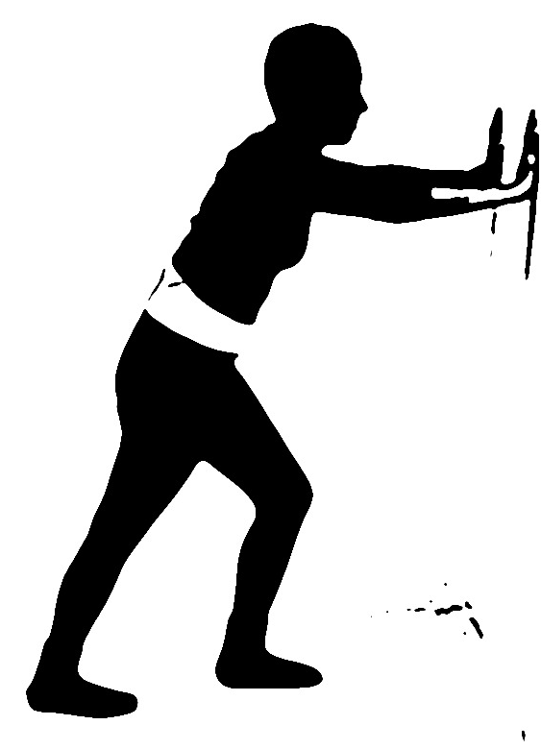
- Face the wall and hold onto it for support.
- Place right leg forward with a slightly bend knee.
- Place left leg back with a straight knee.
- Lean into the wall while keeping your back heel flat on the floor.
- Stretch should be felt in the calf.
- Hold 10 seconds.
- Repeat with other side.

- Resisted Standing Balance:

- Tie mid-point of elastic to an immoveable object (sturdy table leg or towel rack etc…).
- Hold one end of the elastic in each hand.
- Pull your arms back against the elastic’s resistance as if you were rowing a boat. Exercise can be made harder by closing eyes or varying foot positions (feet together or staggered).

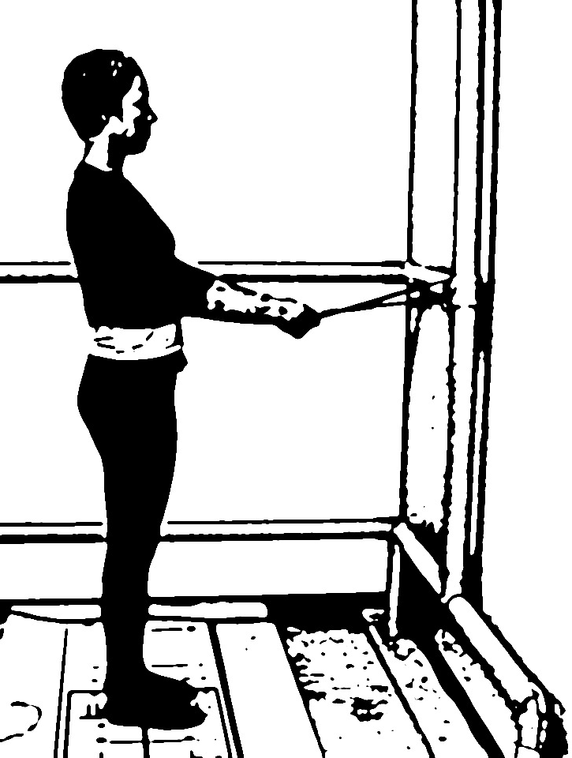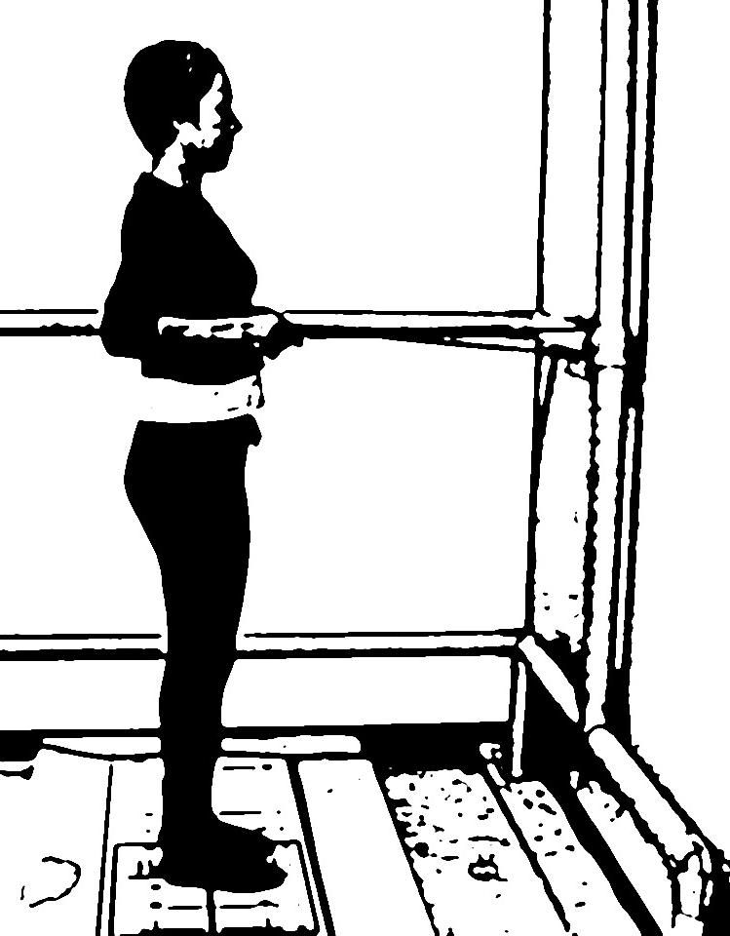

CLASS #2: Initiation of Weight Shift

LESSON: Now that we worked on making you more stable when standing still, it is time to begin getting use to shifting your body weight over your feet. The goal of this class is to become more confident moving your upper body over your feet.

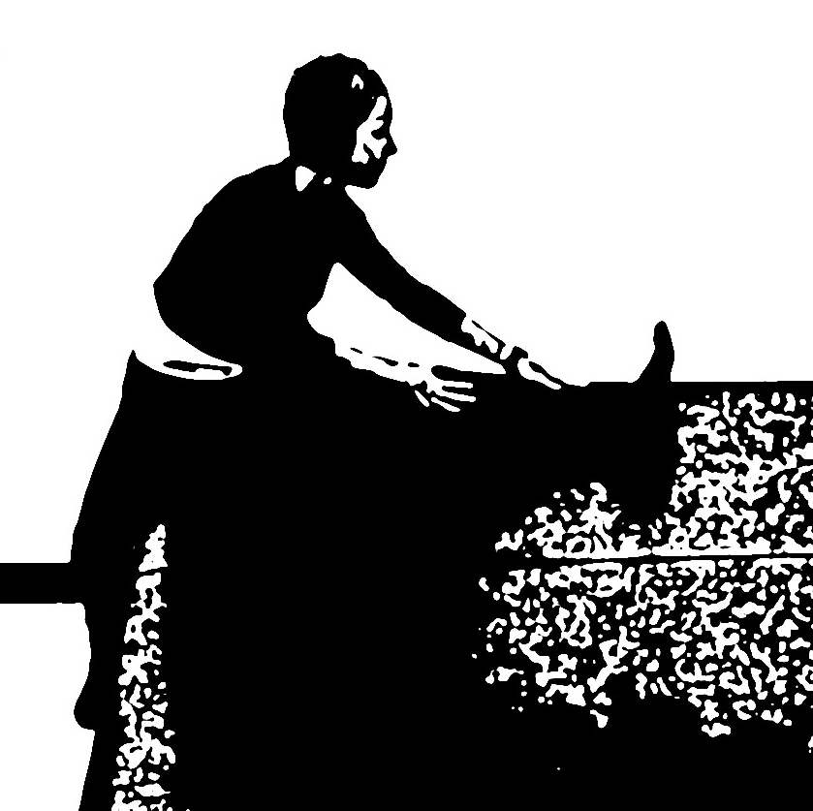
- Hamstring Stretch:

- Sit on a bed or sofa
- Place left leg up on surface. Make sure knee is as straight as possible.
- Place right foot on the floor.
- Lean forward and reach for left foot while keeping back and left knee straight.
- Stretch should be felt in the back of the thigh.
- Hold 10 seconds.
- Repeat with other side.

- Standing Foot Rocks:

- Stand with your back to corner and a chair in front of you for intermittent support if necessary.
- Place your feet shoulder width apart.
- Rise up on toes-hold 3 seconds
- Roll back on heels-hold 3 seconds

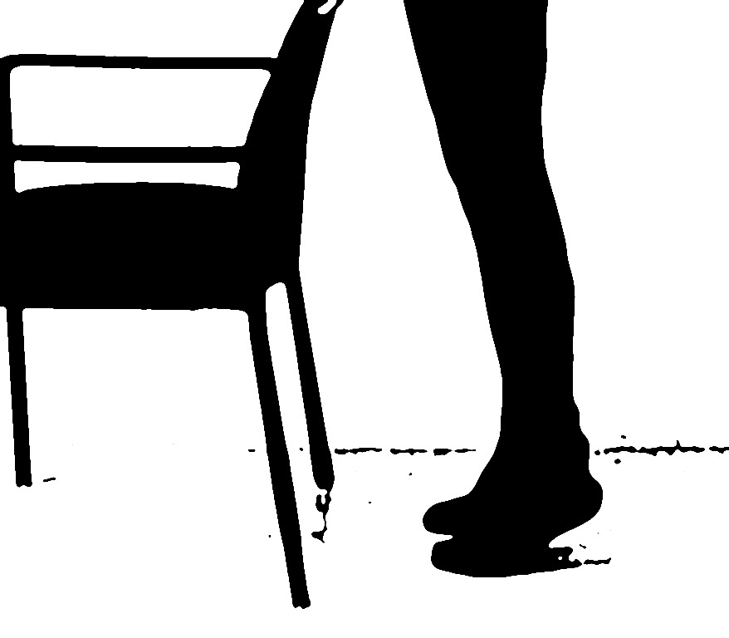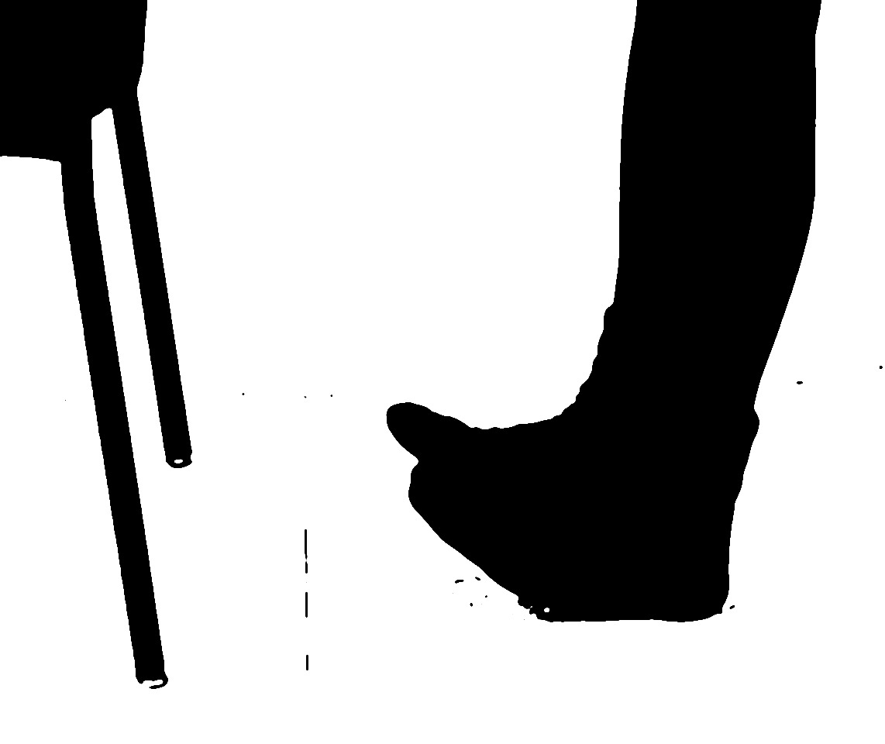

CLASS #3: Weight Shifting Over Various Bases.

LESSON: Last week we learned to shift weight. The goal of this class is to get comfortable with shifting weight over different foot positions.

- Shoulder Rotation:

- Stand with your back to a corner and chair in front of you for support if necessary.
- Place feet shoulder width apart.
- Twist head and shoulders in order to look behind you as much as possible.
- Repeat to other side.
- Exercise can be made harder by closing your eyes or varying foot positions (feet together or staggered).

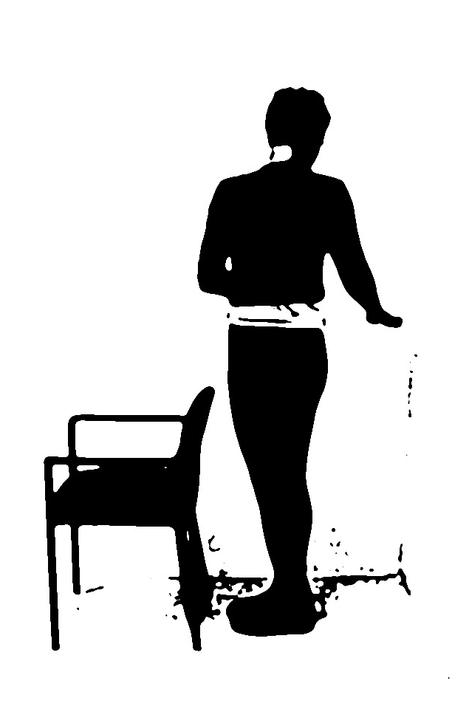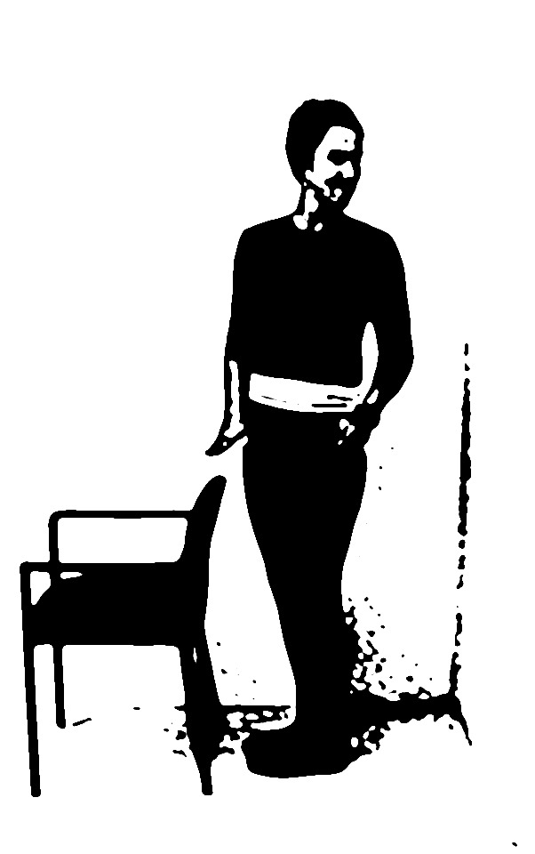

CLASS #4: Introduction to Stepping

LESSON: Being comfortable and confident with weight shifting with your feet in one place has been the goal of your first 3 classes. Unfortunately, life continually forces us to perform a balancing act while shifting weight over our moving feet. With this class, we will now enter this new phase.

- Standing Side Kicks:

- Stand with your back to a corner and chair in front of you for intermittent support if necessary.
- Lift right leg out to the side and then return it to starting position while keeping torso straight.
- Repeat with left leg.
- If unable to perform the exercise as described, lightly touch toe on ground for support at either end of the movement.
- Exercise can be made harder by closing your eyes

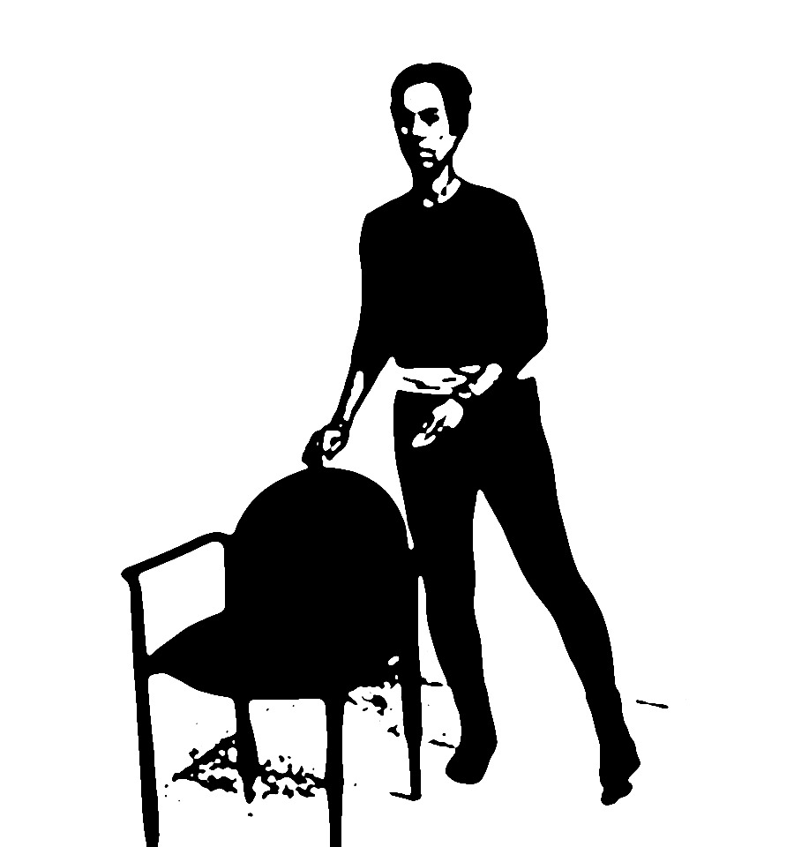

CLASS #5: Dynamic Base of Support

LESSON: The goal of this class is to built upon the stepping concepts introduced during last class. Being able to confidently step is the essence of most movements you perform daily.

- Standing Front Kick:

- Stand with your back to a corner and a chair in front of you for intermittent support if necessary.
- Move your right leg forwards and backwards as if kicking a ball.
- Repeat with left leg.
- If unable to perform the exercise as described lightly touch toe on ground for support at either end of the movement.
- Exercise can be made harder by closing your eyes

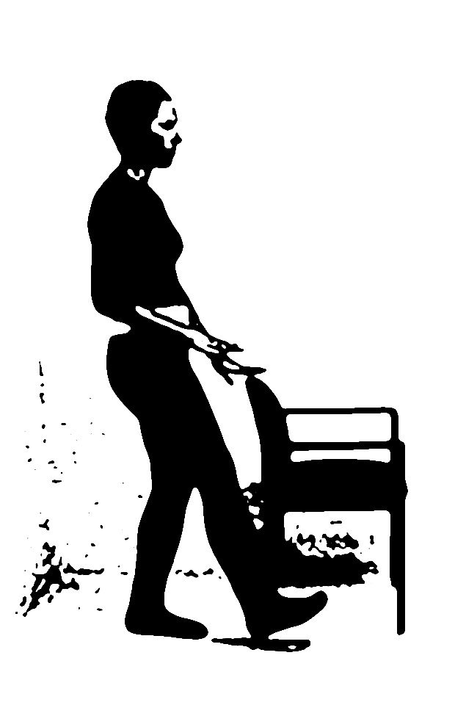

CLASS #6: Vestibular/Inner Ear Training

LESSON: One aspect of balance which we have not addressed with any exercises yet is the inner ear. It plays an important role in balance and gives the brain information about where your head is located in space and what direction you are moving in. Problems with your inner ears can make you feel “woozy” and “dizzy”. They can also make you loose your balance anytime you move your head. The goal of this class is to stimulate your inner ears and force you to use them when you are performing a balance task.

- Standing Eye Exercises:

- Stand with your back to a corner and a chair in front of you for intermittent support if necessary.
- Your feet should be shoulder width apart.
- Hold a playing card (may use any small object, such as a pen or pencil, that you can focus your vision on) in your right arm at eye level and arm’s distance away.
- Stare at card while gently moving head from side to side as if shaking your head “no”.
- Card should NOT MOVE during exercise.
- Repeat exercise while gently shaking your head up and down as if nodding “yes”.
- Exercise can be made harder by varying foot positions (feet together or staggered).

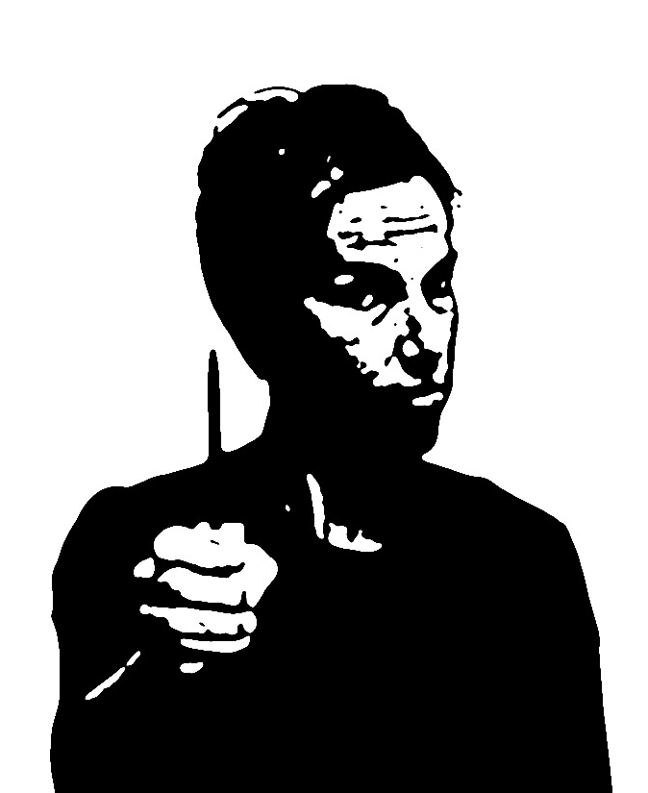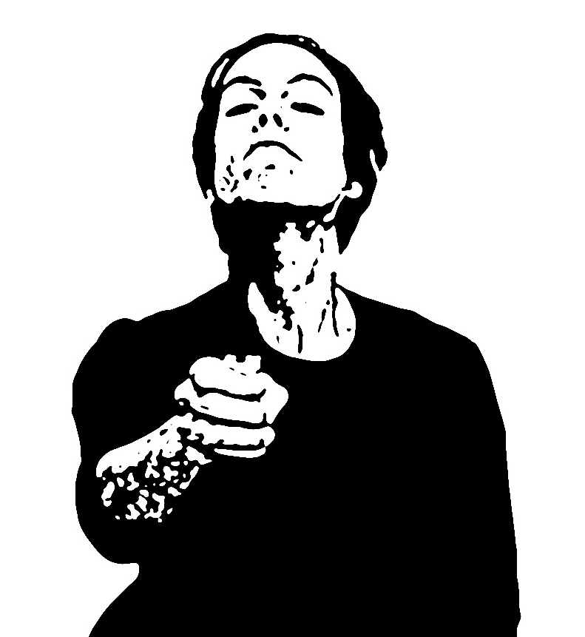

CLASS #7: Turning and Backwards Motion

LESSON: As we near the end of our 8 week balance session it is time to start pulling everything together in a way that will help you beyond these 4 walls. Class #7 emphasizes high risk activities which you perform daily.

- Backwards Stepping:

- Stand with your back to corner and chair in front of you for intermittent support if necessary.
- Take a big step backwards with your right leg. Return leg to starting position.
- Take a big step backwards with your left leg. Return leg to starting position.
- Repeat above alternating your right and left leg.
- Exercise can be made harder by closing your eyes.

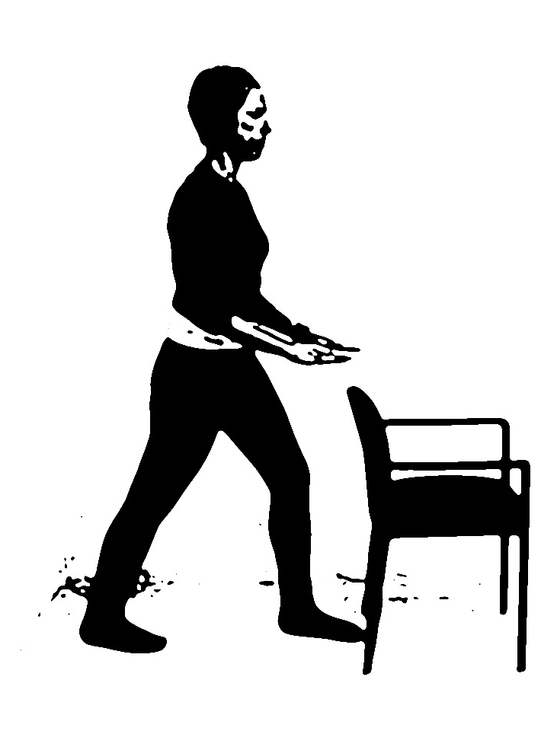

CLASS #8: High-Level Coordination/Multi-Tasking

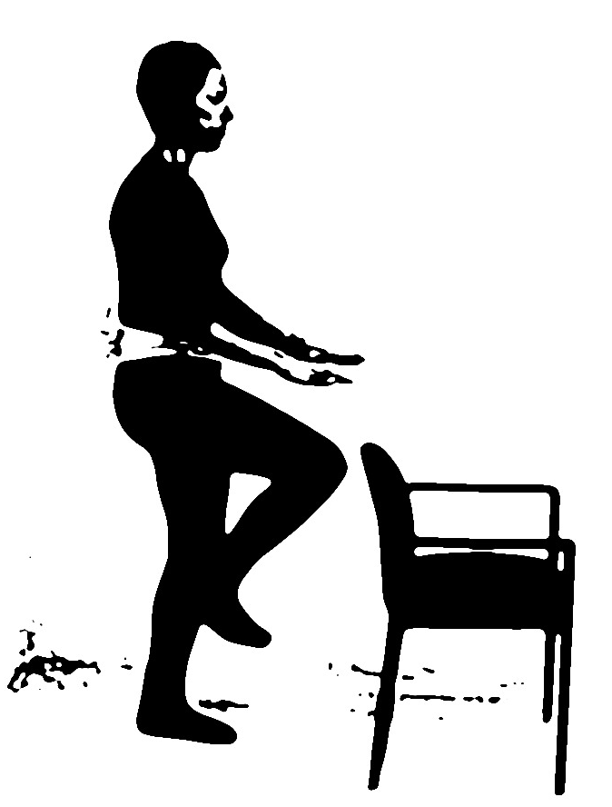
LESSON: For our last class we will put all the skills that we have learned together. Today we will focus on coordination and work on your ability to do 2 and 3 things at once.

- High March:

- Stand with your back to a corner and chair in front of you for intermittent support if necessary.
- March on the spot lifting knees your as high as possible.
- Try to perform the exercises slowly and in a controlled fashion.
- Exercise can be made harder by closing your eyes.

- Ball Work:

  - Stand with your back to a corner and a chair to the side of you for intermittent support if necessary.
  - Place your feet shoulder width apart and hold a ball with both hands.
  - Maintain your balance while bouncing the ball on the floor and/or throwing ball up in the air.
  - Exercise can be made harder by closing your eyes or by varying your foot positions (feet together or staggered).

