The EIA Short-Term Regional Electricity Model: Capabilities and Data Requirements
Phillip Tseng, SMG, and Dave Costello, EMEU, EIA
October 2004

Abstract

The United States Energy Information Administration (EIA) is developing a thirteen-region electricity demand and supply model in response to questions on regional energy issues from high-level decision makers. One of the important features of the new modeling system is transparency; it must provide tractable results and insights that stakeholders can easily understand. The electricity module of the Regional Short Term Energy Model serves that function and provides a vital link to the new integrated regional energy system in answering several key region-specific questions on:

- Winter heating fuel market
- Natural gas market
- Summer gasoline market
- Summer electricity market

The objective of this paper is to document the structure of the regional electricity model, identify data requirements, and demonstrate the model’s capability in providing users an understanding of issues facing the current electricity market. The model will be used for generating routine short-term forecasts. However, the model can also be used as an analytical tool to provide useful insights into the electric power market itself and into the principal interactions between electricity supply and fossil fuel markets. The interactions and linkages between the electricity market, the natural gas market, and heating fuel market will be described explicitly. In addition, an illustration of the potential modeling applications will be presented. The demonstration will show how the model can help policy makers in their decisions on deployment of technologies that may be cost effective socially but not privately.

1. Introduction

This paper documents the new regional electricity model for the Regional Short Term Energy Model (RSTEM). A regional modeling approach to addressing regional energy issues is more appropriate than a strictly national-level approach even though it is a very challenging task to compile a regional demand and supply database. This new modeling framework can provide more specific outputs that reflect changes in demand, electricity generating capacity, and fuel markets.

This paper is as an interim report that will be presented at the October Energy Committee meeting of the American Statistical Association. The goal is to receive comments and constructive inputs from the committee before the model is finalized and calibrated for use in actual production of the Short Term Energy Outlook.

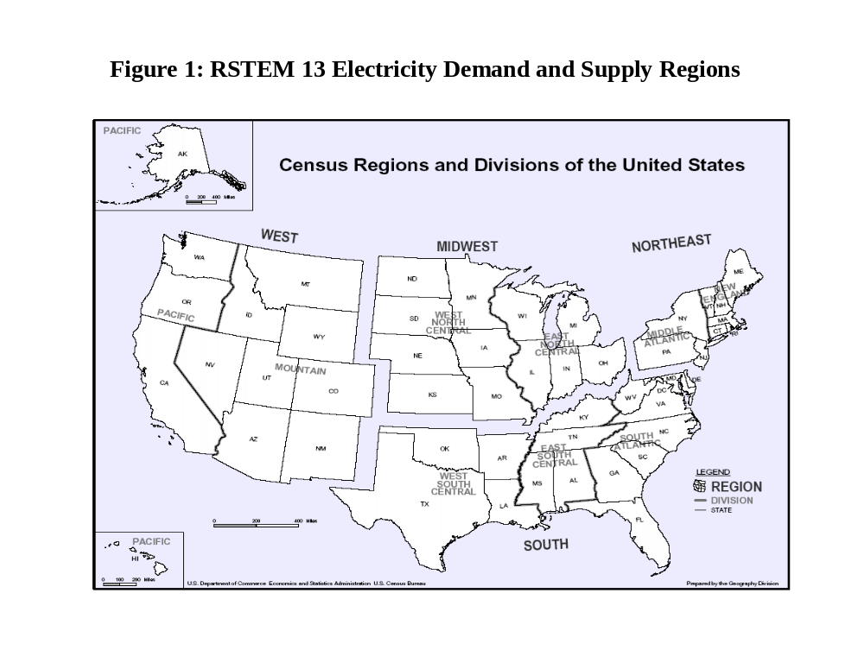
Section 2 of this paper describes the model structure. Section 3 reports the data requirements. Section 4 presents a few examples to illustrate the capability of the model. Data on power supply will probably be used for the projection of the new outlook. Data on the demand curve and the hourly load curves are still being developed. Simulation results are for illustrative purpose only.

2. The Regional Electricity Model

The regional electricity model is a partial equilibrium model of the U.S. electricity market. The model includes nine Census regions and breaks out four important states as special cases. It includes demand from four end-use sectors and supply of electric power from about 10,000 power generators. The model is solved monthly to provide an outlook of the electricity market over the 24 to 36 months subsequent to the RSTEO publication date, and it tracks exogenously changes in electricity generating capacity over the forecasting period.

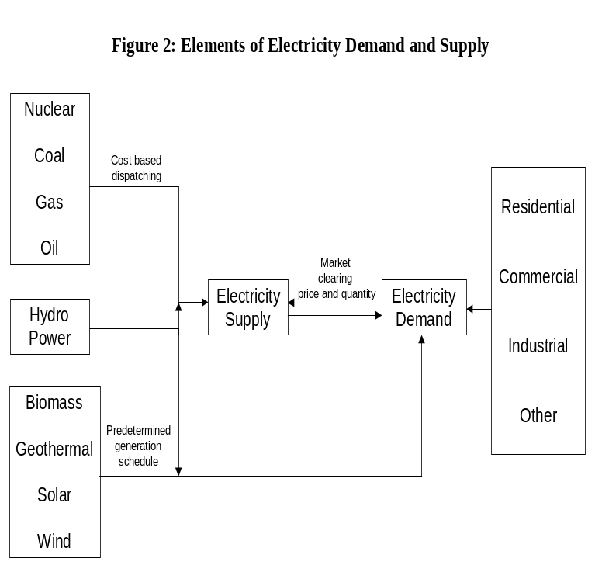Figure 1 shows the 13 regions included in the model:

New England,

Mid Atlantic less New York,

E. North Central,

W. North Central,

South Atlantic less Florida,

E. South Central,

West South Central less Texas,

Mountain,

Pacific less California,

California,

Florida,

New York,

Texas.

These thirteen regions are grouped into three blocks: The Eastern Connections, which includes regions 1 through 7, and regions 11 and 12, the Western Interconnection, which includes regions 8, 9, and 10, and Texas.

Figure 2 shows the elements of electricity demand and supply in a single region without trade. The demand side of the electricity model includes four end-use sectors: residential, commercial, industrial, and other. The supply side includes power generators for oil, gas, coal, nuclear, hydro, biomass, geothermal, wind, and solar.

Projected monthly demand for electricity in each end-use sector is determined by heating degree days (HDD), cooling degree days (CDD), gross regional product, and electricity prices for each sector. Monthly demand projections are converted to 16 daily time slices to capture the variations in daily demand patterns. These time slices provide more detailed load information than the NEMS because the short-term model puts more emphasis on the peak load demand and its impacts on fuel use.
There are 8 three-hour load periods considered for weekdays and 8 three-hour load periods for weekend (and holiday) days. The conversion of monthly demand derived from regional demand forecasts to 16 three-hour load periods is based on historical hourly load data, hourly temperature, average daily temperature, and the historical relationship between HDD, CDD, and average daily temperature. Appendix A describes more of the conversion process.

On the supply side, the EIA plant file from EIA’s Office of Integrated Analysis and Forecasting (OIAF) has data on power generators by state, by technology, and by fuel. The database also includes information on heat rates, fixed and variable O&M costs, capacity factors, identifiers for dual fired generators, and NOx and SO2 emission coefficients. For each generator, variable cost is computed using the heat rate, capacity factor, O&M cost, and fuel cost, which are derived from the Form EIA-423. For dual-fired units, such as oil and gas, a generator is treated as an oil-fired unit for the month if the price of residual fuel or diesel fuel is lower than natural gas and vice versa. One exception in the computation of variable costs is for power plants identified as “must-runs”. For these plants, the variable costs include only the O&M costs to ensure that these power plants are cost effective and will always be used in a cost-based dispatching algorithm. For each generator, generation is computed based on capacity and a capacity factor. The supply curve is constructed in two steps. First the plants are sorted in terms of variable costs (and “must-runs”) from lowest to highest. Cumulative generation is calculated summing the plant capacity with its associated plant factor along the cost curve. To derive a supply curve, variable costs are sorted in ascending order and the model computes cumulative generation starting from the one with the lowest variable cost.

Hydropower and solar power are two exceptions. For hydro, there are multipurpose dams designed to meet requirements for irrigation, navigation, generation, and flood control. Dispatching from those plants will be treated as base load and will be subtracted from the load curve. For solar power, dispatching and generation are based on capacity and the average number of daylight hours. The capacity factor serves as a proxy for the number of hours that a solar plant can produce power. Estimated generation from solar power will be subtracted from the load curve during the daylight hours between 10:00 AM and 6:00 PM.

Single region dispatching and fuel use by type. Figure 3 shows how hourly load determines the supply and marginal cost of electricity. The vertical lines represent the hourly load of a hypothetical day and the supply of power. The horizontal axis shows marginal costs of power supply. The line chart depicts the relationship between cumulative generation and the variable costs. For demand level D1, the corresponding supply is P1, and the marginal cost is determined by the intersection of the line D1-P1 and the supply curve. Given the dispatching level and variable costs, dispatching by technology and by fuel type can be identified. The model accumulates fuel consumption for each time slice to get projected average daily fuel use and power generation.
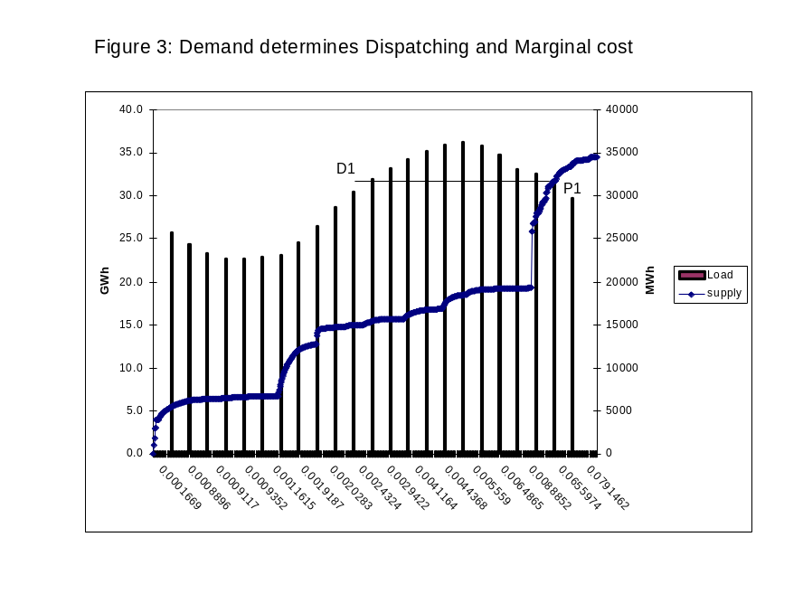Note that in this model electricity price plays a role in determining the monthly demand for electricity. However, the hourly load curves are treated as exogenous in the dispatching module and are used to determine dispatching only. They are conditional upon the weather conditions and temperature elasticities. The outputs of the dispatching module include generation by technology and fuel use. The fuel use data will be passed to the fuel demand module to solve for market prices of natural gas, coal, and petroleum products.

Regional Trade. The electricity model includes several modules to assess the effects of regional trade on regional dispatching, net trade flows, regional equilibrium price at the generator gate, and regional fuel use by type. The solution algorithm for a multi-region market is similar to a single region approach. For example, a 3-region trade module will have an hourly load curve, which is the sum of three load curves and the 3-region supply curve includes all the generators in these three regions. The 3-region demand and supply will determine dispatching required in meeting the demand. The model uses region codes to identify dispatching by technology and fuel use by type for each region. The final version of the model would most likely include two major trading blocks. The West and the East. Texas will be treated as a stand along region without trade. This arrangement reflects the three separate transmission interconnections.

Transmission capacity constraints between regions within a trading block will be imposed to reflect physical constraints on the flow of power between regions. The data will be from the NERC report. Specific data source will be provided later.

It is worth noting that the components of the electricity model of the RSTEM is modular and can easily be expanded to include more disaggregated representations to address state level questions for possible demand, supply, and power flow analysis.

3. Data requirements and assumptions

The Short-Term Energy Outlook relies heavily on short-term historical data and near-term economic forecasts. This section lists the data sources that will be used for the electricity model. The model runs on Eviews. Preliminary runs show that run time for a 13-region model with trade and transmission constraints solves in about 20 seconds for each time period (24 hours). Total run time is estimated to be about 8 to 10 minutes.

Demand data and economic variables:

- Monthly data on electricity sales/demand by state aggregated to regional demand
- Monthly electricity retail prices
- Quarterly state/regional income and retail sales
- Heating degree-days
- Cooling degree-days
- Projected state/regional income and retail sales from Global Insight
- Households
- Employment

Hourly load curves:

- State/regional average and hourly temperature
- State/regional hourly electricity load

Note that load and temperature data are not homogenous within the same state or independent system operator (ISO). A proper approach to map the monthly demand to hourly load curves will benefit greatly from the ASA committee. We would like to conduct more future research on the subject and make future improvement in the RSTEM.

Electricity supply:

- Electricity generator by technology, and by fuel type.
  - Oil, gas, coal, nuclear, hydro, biomass, wind, solar
- Heat rate
- Fuel prices by region
- Operating and Maintenance costs (fixed and variable)
- Primary and secondary fuel for dual fuel generators
- Transmission interconnection constraints (future research)
- Imports (future research)

4. Applications of the model in Forecasting and Analysis

At the spring, 2004, ASA Energy Committee meeting questions arose regarding the objectives of the regional modeling framework. In this section, a few examples will be discussed in great detail to highlight the capability of the new model as a forecasting and analytical tool. One advantage of the new modeling framework is its capability in tracing the links between the electricity market and other fuel markets. One advantage of the new modeling framework is the capability to show the relationship between electricity consumption and utility fuel use according to a dispatch algorithm and the subsequent link to the fuel markets and renewable supply resources.

Understand the fuel use pattern in the power generation sector.

Regional demand for electricity and the hourly load curve for a typical day determine regional dispatching requirements. In the near term, power generation will come from existing power plants. Therefore, plants with lower variable costs would most likely be deployed first. Exceptions to this rule include combined heat and power (CHP) and units in areas where transmission line capacity is a limiting factor for least-cost considerations. The marginal cost based dispatching algorithm for the RSTEM provides a good accounting of generation by technologies and by fuel types. A list of technologies and fossil fuels is shown in figure 2.

In recent years prices of crude oil and natural gas have reached new highs (in nominal dollars). Increased demand for power and the addition of new gas combined-cycle power plants play a significant role in the use of natural gas. Dispatching patterns of gas-fired units (base load and peak load) can have profound impacts on natural gas consumption, storage, and prices. Prices of crude oil and natural gas can change dispatching decisions for many dual-fuel units. To a smaller extent, the dispatching of oil-fired and gas-fired units could change with fuel prices as well.

The effects of fuel switching on fuel use depend on the shape of hourly load curves for each region. In regions where peak load demand is high and there are many dual-fired units, the potential for switching will also be high. This is demonstrated by simulating the dispatch model (note: it is still in testing mode). Table 1 illustrates the changes in natural gas consumption in July when the price of natural gas is raised above the price of diesel fuel. In the reference case, diesel fuel prices are higher than the natural gas price. As a result, duel-fired units select gas to power generators. Given the load curve used for July in the model, use of oil could increase by about 180 trillion Btu and gas will decrease by about the same amount if the relative price of diesel fuel becomes more favorable.

Note that the simulation results reported in Table 1 assume no regional trade and are for demonstration only. For regions with high peak load demand, the results will overstate the use of peak load generators relative to the results expected when regional trade is incorporated in the sensitivity run.

Table 1: Hypothetical Fuel Switching in July:
Response to An Increase in the Relative Price of Natural Gas
Region | oil consumption/trillion btu |  | gas consumption/trillion btu
 | Reference Case | Higher Gas Price Case | Reference Case | Higher Gas Price Case | Percent Change in Oil Consumption from Reference Case ((col 3/col 2)-1)
1 | 12 | 26 | 28 | 13 | 116.67%
2 | 10 | 26 | 51 | 35 | 160.00%
3 | 4 | 13 | 48 | 39 | 225.00%
4 | 14 | 26 | 27 | 15 | 85.71%
5 | 22 | 37 | 84 | 68 | 68.18%
6 | 1 | 2 | 42 | 41 | 100.00%
7 | 0 | 3 | 56 | 53 | cc
8 | 1 | 6 | 29 | 24 | 500.00%
9 | 0 | 2 | 5 | 3 | cc
10 | 3 | 10 | 115 | 108 | 233.33%
11 | 36 | 70 | 77 | 43 | 94.44%
12 | 24 | 69 | 67 | 22 | 187.50%
13 | 2 | 20 | 198 | 180 | 900.00%
Total | 129 | 310 | 827 | 644 | 140.31%

Effects of summer fuel use on winter heating fuel prices

Natural gas plays a major role in meeting space heating needs. Table 2 shows residential energy use for space heating in 2001 as reported in the Residential Energy Consumption Survey. In the Northeast, natural gas consumption was 0.71 quadrillion Btu (quads) and fuel oil consumption was 0.58 quads. Natural gas dominates in the Midwest, South and West where consumption was 1.39, 0.70, and 0.52 quads, respectively.

Table 2: Residential Sector Energy Use for Space Heating in 2001
Fuel use (quads) | Total U.S. | Census Region
Fuel use (quads) | Total U.S. | Northeast | Midwest | South | West
Natural Gas | 3.32 | 0.71 | 1.39 | 0.70 | 0.52
Fuel Oil | 0.58 | 0.45 | 0.06 | 0.05 | 0.01
Electricity | 0.39 | 0.05 | 0.06 | 0.20 | 0.08
LPG | 0.28 | 0.03 | 0.12 | 0.10 | 0.04
Kerosene | 0.04 | 0.02 | * | 0.02 | 0.01
Source: RECS 2001
Higher demand for natural gas in the summer can reduce gas destined for injection into underground storage. This could reduce availability and raise natural gas prices in the winter. There are many dual-fired power generators in the electric power sector. They are responsive to changes in fuel prices and the demand for electricity. The electricity module of the RSTEM tracks the use of natural gas and fuel oil. It provides a useful accounting framework and tool to evaluate and analyze the overall natural gas market, gas storage, and prices over a period of 24 months.

Figure 4 shows the effects of a 5% reduction in electricity demand in July on natural gas use for power generation in region 2 East North Central, 3 Middle Atlantic, and 12 New York In a three-region trade analysis, there is almost no change in the use of natural gas in the first 10 hours of a hypothetical July day. The biggest impacts are between 11th and 20th hour. The reduction in natural gas use for the month in these three regions would be about 17 trillion Btu or 0.017 quads. Given the level of supply, changes in demand can be easily converted to additions to storage.

Summer demand for gasoline has similar effects on the production, and storage of heating fuel. Petroleum refiners maximize gasoline production in the summer. After the summer
driving season, refiners change operations to maximize production of diesel fuel. Summer demand for diesel fuel for power generation would lower availability of heating fuel in the winter in the northeast.

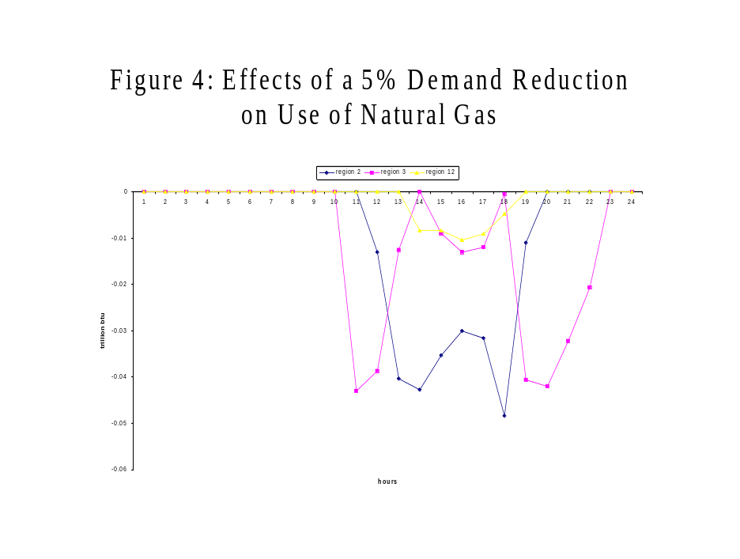

Electricity demand, supply, and regional trade

The electricity model has one supply and demand representation for each of the 13 regions. Differences in regional demands, the general shapes of hourly load curves, time zones, and costs of generation, create opportunities for trade. To facilitate trade analysis, load curves for all time zones are converted to an Eastern time-zone basis so that analysis of electricity trade between different time zones with different peak load demand can be conducted. As an example, Figure 5 shows the results of a three-region trade for East-North Central(region 3) , Mid- Atlantic excluding New York (region 2), and New York (region 12).

Model results show that Region 12 will import electricity from other regions because its own generating capacity cannot meet demand. Under normal conditions, Region 12 will not use all of its generating capacity because of high generating costs for peak load units. Region 3 has excess generating capacity and will be an exporter of power. It is worth noting in this sensitivity run that Region 12 exports electricity from mid-night to about 6 AM, while the major exporter Region 3 imports small amounts of power during these hours. The example demonstrates that the model is flexible enough to capture the power flow on the basis of marginal cost of generation and the shape of load curve.

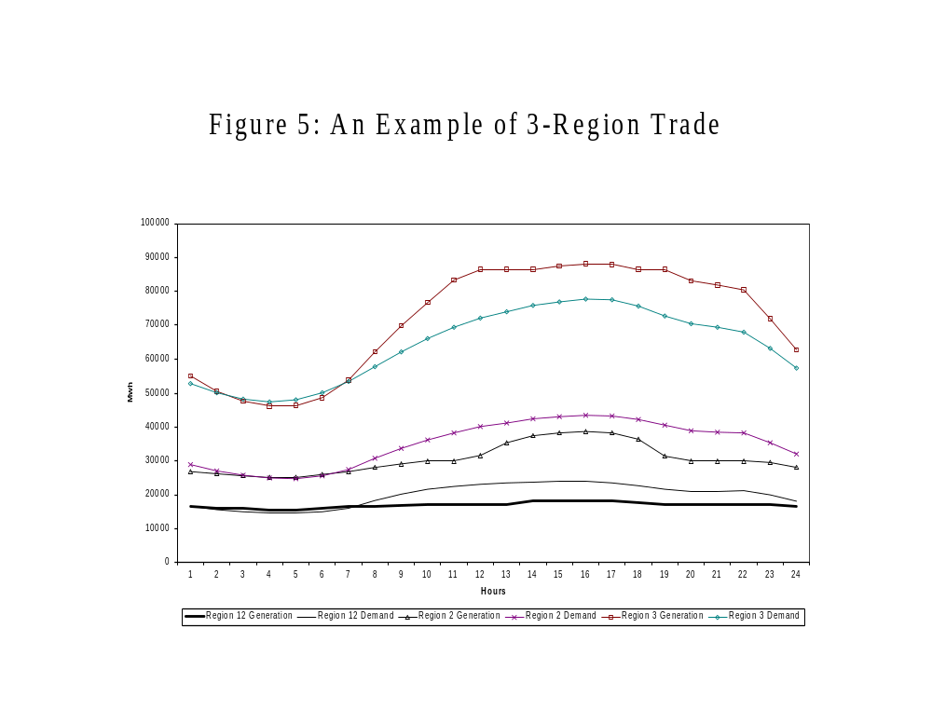

This test run does not consider imports from Canada to New York. Electricity imports will be handled exogenously in the current version of RSTEM.

For each region, the monthly model solution includes net trade flow, regional generation, and regional equilibrium prices, and utility fuel consumption by type. Note that the trade is based on hourly load curves and region specific supply curves. Therefore, it is possible to identify potential transmission bottlenecks with the NERC interregional transmission report.

Analysis of the role of energy technologies and dispatching decisions

The model structure can be used to simulate the effects of technologies such as distributed generation for CHP and PV on dispatching and fuel consumption. For example, if a market experiences transmission constraints and cannot import enough power to meet demand economically, deployment policies such as installing distributed generation technologies (DG) or photovoltaic (PV) may reduce peak load demand and fuel use. In the case of PV, if it reduces peak load demand in the summer and backs out enough demand for natural gas, the price of gas may decline in the heating season. (Numerically, PV costs will have to come down significantly to make this option feasible).

The modeling framework can also be used to assess the effects of dispatching decisions for hydropower on the regional energy system. If dispatching decisions can be made that shave the demand for natural gas, it may be possible to change regional demand and underground storage patterns, which in turn may have impacts on winter fuel prices.

Future Work

In the next few month analysts at EIA will work on model calibration. This process will be designed to check for data consistency. For each region/state, historical data will be used to compare model results in generation by fuel type and fuel use. Insights from this process will be documented to help enhancement of future modeling and data collection efforts.

Questions for the Committee

The methodology used to map HDD, CDD, to the hourly temperature, which in turn are used to estimate the hourly load, is critical to the dispatching algorithm in solving for generation by technology and the use of fossil fuel. Please provide comments on the appropriate statistical methods for the estimation of the load curves.

