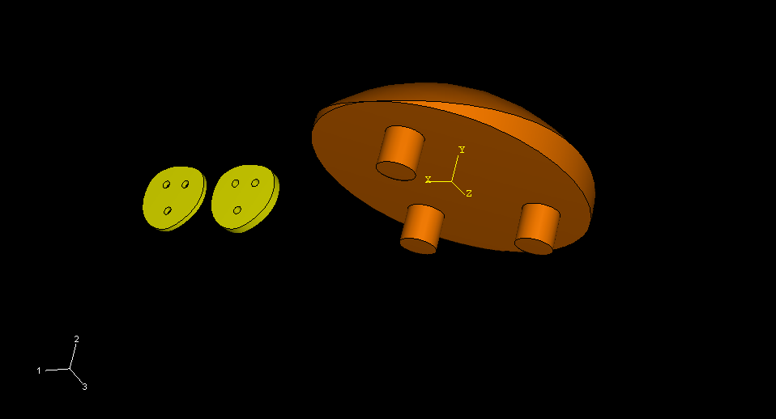

- The patella is the orange model which is a one inch radius, dome shaped with a depth of 0.38 inches designed with polyethlyne.

- Far left is the bone cement which is placed between the plastic patella and the bone for stability (0.03 inches).

- In the middle is the bone/knee cap which is flipped over and shaved down with three holes drilled in it to give the plastic patella a perfect fit (0.05 inches).

