Bending/ low-level work:
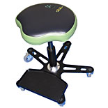
SF130
IMPACTO ergonomic support for sitting work. 360° rotating swivel seat, 5 industrial caster wheels adapt well to all surfaces. Utility tray included. Also available with fire retardant cover. Helps reduce pressure in the knees and ankles. Adjustable seat height (16.5" to 22")

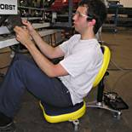
FLEX
IMPACTO ergonomic support for sitting positions over prolonged periods. Used in two positions: sitting with back straight between 3 and 5 feet and sitting low to the ground for tasks between 1 and 4 feet. 360° seat rotation, 90° seat tilting, 5 industrial caster wheels, heavy duty upholstery with thick padding for comfort. Utility tray available as accessory.
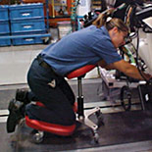
STAG4
IMPACTO ergonomic support for kneel-down work over prolonged periods. Used in three positions: sitting with back straight, kneeling with back straight and kneeling bending with chest supported. Seat rotates 360°, tilts 20°, 5 industrial caster wheels. Utility trays available as accessories. Also available with fire retardant cover.
- Helps reduce pressure on the knees and low back
- Versatile – can be configured to various positions
http://www.2protect.com/home.htm
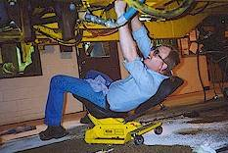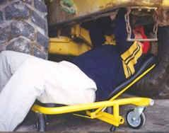

Eidos http://www.eidosergonomics.com/inuse.htm makes a wide range of industrial chairs and creepers
Kneeling:

Knee pads should be considered to reduce pressure on the knees. Many knee pads ‘bind’ uncomfortably behind the legs, and slip off the knees and down the legs.

- SoftKnees Knee pads (Product #1010) are designed to protect knees from hard, rough, wet, or cold surfaces, and area easily installed in double knee workwear. They eliminate the problem of being unprepared for kneeling when on site, away from any source of knee protection. SoftKnees can remain in work clothes when they are washed, but are easy to remove and replace so that the garment dries faster. Some people make ‘home-made’ knee pads by cutting Army surplus sleeping pads into small squares, which can fit into double knee workwear.

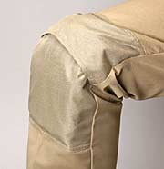
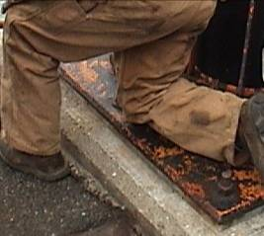
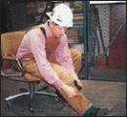
SoftKnees inserted into knee pockets
http://softknees.com/softknees.html.

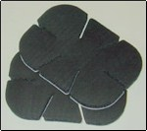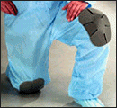
SoftKnees Disposable Universal Peel & Stick Pads
(Product #1012) (Product #1012R)
SoftKnees disposable pads may work better in some situations. The self-stick adhesive and the ability to trim them with scissors or a utility knife allows these pads to be placed where needed, on knees, elbows, shoulders, and other areas needing temporary padding.

- Hard shell kneepads are better for situations where there are hard or sharp protrusions that might impact the kneecap area.

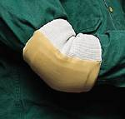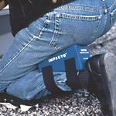
Hard shell knee pads IMPACTO Elbow Pad 806-20 IMPACTO Knee Saver

For indoor tasks, pads such as the IMPACTO Knee Saver and the Personal Comfort Mat may be useful for prolonged kneeling.
