Unit I
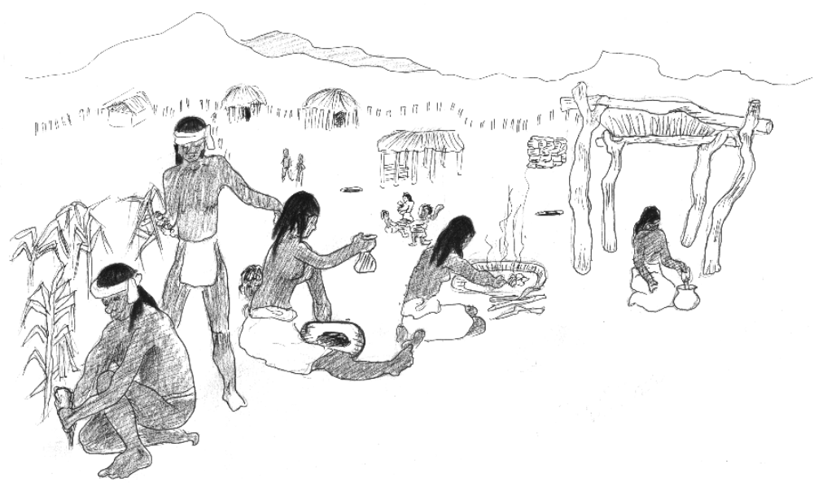The O’odham

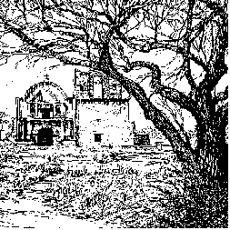
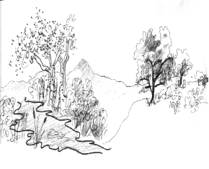
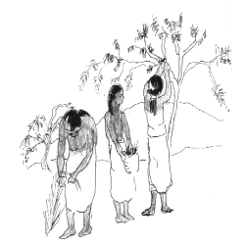

O’odham Village Life. . . . . . . . . . . . . . . .page I - 1
OVERVIEW: Students will explore the O’odham culture by participating in a variety of experiential activities, including an O’odham language lesson and role playing daily tasks such as food preparation, tattooing, games, mat making and pot making.

Why the Santa Cruz?. . . . . . . . . . . . . . .page I - 13
OVERVIEW: Through a two-part exercise of studying maps and graphing rainfall and temperature patterns, students will learn how environmental conditions affected human settlement patterns in the Pimeria Alta.

Create an O’odham Village . . . . . . . . . .page I - 19
OVERVIEW: Students will use their knowledge of cultural needs and climate restrictions to place a fictional village in the prehistoric Santa Cruz valley. They will describe the advantages of their site, and draw a sketch of the village.

