Comparing the FCC’s Combinatorial and Non-Combinatorial
Simultaneous Multiple Round Auctions:
Experimental Design Report

Prepared for the Federal Communications Commission

Jacob K. Goeree, Caltech

Charles A. Holt, University of Virginia

This Version: April 27, 2005

The authors wish to acknowledge FCC staff Mark Bykowsky, William Sharkey, and Martha Stancill for input and helpful comments. Any views expressed in this paper are those of the authors and are not purported to reflect those of Caltech, the University of Virginia, the Federal Communications Commission, Wireless Telecommunications Bureau, or other members of the Commission’s staff.
I. Introduction

The Federal Communications Commission (FCC) has decided to use laboratory experiments to compare the performance properties of its simultaneous multiple round (SMR) auction design with its newly developed simultaneous multiple round auction that permits combinatorial, or package, bidding (SMRPB). The purpose of this comparison is to shed light on the conditions under which the FCC should employ one auction form rather than the other for the assignment of spectrum licenses.

Experiments are a natural way to compare the different auction formats, since many aspects of package bidding have proven to be extremely difficult to analyze using economic theory. Experiments may also be able to capture behavioral elements (risk aversion, winner’s curse effects, bounded rationality) that are hard to incorporate in standard theoretical models. These behavioral elements may have important effects on auction performance, and these effects may be mitigated or exacerbated by the auction form used. Furthermore, controlled laboratory experiments allow the researcher to examine the extent to which the tested auction design assigns licenses to the bidders which value them most highly. Because the researcher assigns bidders’ values for licenses and packages, at the close of the auction it is possible to evaluate the economic efficiency of the allocation. In contrast, field data obtained from actual auctions do not permit one to make a direct inference about the efficiency of the final allocation since real bidders’ values are unknown. Finally, experimentation offers the opportunity to run numerous auctions under controlled conditions while changing a single design feature. This replication and control allows the researcher to spot systematic differences across auction formats that are not due to random variations from one auction to another.

The FCC has only limited experience with package bidding. Therefore, the experiments may help the Commission to avoid any procedural problems and unintended side effects that become apparent, and will facilitate the effective use of package bidding.

An important first step in this process is the development of an “experimental design,” which specifies the economic environment, the experimental procedures, and the criteria used to measure performance. The purpose of this paper is to propose an experimental design. In addition to permitting a comparison between the SMR and SMRPB auctions, the experimental design can also be used as a benchmark for possible future evaluations of the performance properties of other auctions (e.g., price-driven “clock” auctions).

While the FCC has sponsored an earlier experimental study of auctions that allow for package bidding, the currently proposed SMRPB design has not yet been evaluated in the laboratory. Furthermore, the proposed experimental design includes several new features that supply additional realism (e.g., bidders may face budget constraints and their valuations consist of both private and common-value components). Finally, besides revenue and efficiency, the performance measures used to evaluate the different designs now include other factors, such as the effects on small bidders, and the extent to which collusion is suppressed.

Section II of this report discusses a method for generating bidder valuations for licenses based on common and private-value elements, population covered by the licenses, and economies of scale. Several treatment conditions are outlined in Section III based upon structural conditions that might make one auction form more attractive than another. Section IV describes experimental procedures such as the number of experimental sessions, and the number and experience level of subjects. Section V details the performance measures by which the auction formats are evaluated and compared. Appendix A reviews the definitions of competitive equilibrium and the core. Appendix B suggests some specific parameter values for different treatments. The auction rules are specified in detail in Appendices C and D.

II. Modeling Bidder Valuations

- Private and Common Values

Auction models typically fall into one of two categories. In private value auctions, bidders know their own value for the object but are unsure about others' valuations, as in the purchase of a painting for personal enjoyment. Common value auctions pertain to situations where the object is worth the same to everyone but bidders have different information about its true value, as in the auctioning of oil drilling rights. While this dichotomy is useful from a theoretical viewpoint, real world auctions, including spectrum auctions, are likely to exhibit both characteristics. For instance, when a painting is auctioned, it may be resold in the future and the resale price will be the same for all bidders, which adds a common value element. And in the oil drilling example, private value differences may arise because of differences in production technologies.

One way to capture both private and common value elements is provided by Milgrom and Weber’s (1982) “affiliated-values” approach. Roughly speaking, bidders’ assessments of their values, or “signals”, are affiliated when one bidder’s high (low) signal makes it more likely that others’ signals are high (low) as well. This approach is able to reproduce the independent private values model and the pure common-value model as limit cases. However, in this setup, each bidder receives a single signal (and in equilibrium, the bidder with the highest signal wins), which precludes an analysis of the possible inefficiencies that arise when separate private and common values are present.

To illustrate, consider the case of spectrum licenses where bidders’ valuations involve private value elements (e.g., geographic preferences) and common value elements (e.g., future consumer demand for wireless services). Here, an inefficient allocation results when a bidder with a relatively high private value for a particular license but who is relatively pessimistic about future demand is outbid by an overly optimistic bidder with a relatively low private value. This inefficiency can be modeled only by letting each bidder receive a private value signal and a separate independent common value signal.

For purposes of the experiments, we propose that the common and private value elements enter a bidder’s valuation in a simple multiplicative manner. For example, consider the value of bidder i for a single license j that pertains to a particular geographic area with a population of q_{j}. Bidder i’s valuation for license j is modeled as the product of a “per pop” valuation and the total population covered by the license. The “per pop” valuation, in turn, is the product of the private value component for license j (i.e. U_{ij}) and the common value component (i.e. CV_{j}). That is:

(1.1) 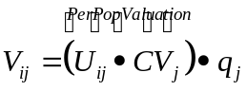

The private value component of the “per pop” valuation, U_{ij}, reflects bidder i’s per capita profit in region j in the “baseline” state of the market characterized by no consumer demand uncertainty (i.e., CV_{j} = 1). Bidder i may believe that future consumer demand in region j may be higher than expected (i.e., CV_{j} > 1) or lower than expected (i.e., CV_{j} < 1) due, for example, to differences in expected population growth. Bidders do not know the common value component CV_{j} at the time of bidding but, instead, receive prior to bidding an unbiased signal about its value: s_{ij} = CV_{j} ∙ e_{ij}, where the “error” e_{ij} has a mean of one (1) and is independent across bidders. In the presence of this type of common value uncertainty, bidders face an inference problem in the sense that an optimistic common value signal may be due to favorable market circumstances (high common value CV_{j} ) or due to overly optimistic expectations (high error e_{ij}).

However, this formulation may provide subjects with too much information: for each license they receive a private value and a common value signal. A simplification that we recommend involves giving each bidder receives a single common value signal, s_{i}, that applies to all the licenses of interest. Equation (1.1) then becomes:

(1.2) 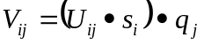

The introduction of a single common value for each bidder may change the extent to which bidders are affected by the “winner’s curse,” which is caused by the tendency for the bidder with the highest bid to be one with the most optimistic value estimate. Separate license-specific common value elements would tend to mitigate the winner’s curse effect since the effects of the error terms would tend to “average out” when bidders acquire packages of multiple licenses. In contrast, a single common value for each bidder may exacerbate winner’s curse effects since a bidder’s high estimate for one license would imply high estimates for all other licenses. For example, with a single common value, a bidder who is optimistic about the demand for wireless services in one geographic area is equally optimistic about the demand in all areas.

- Packages: Substitutes and Complements

The value a bidder places on a package of licenses need not be equal to the sum of the values for the individual licenses. For instance, if licenses A and B are considered substitutes, the value of the package AB may be less than the values of A and B added together. Alternatively, if licenses A and B are considered complements, the value of the package AB may exceed the values of A and B added together.

The degree of complementarity or substitutability for licenses or packages can be generated from assumptions about the distributions of the private and common values within the bidder population. As an example, consider the case of pure private values (i.e. CV = 1) and suppose bidders’ values for licenses A and B are uniformly distributed on [100, 200]. The relationship between license values may indicate either substitutes or complements if the AB package value is distributed on [200, 500]. When the value draw for the AB package is towards the lower end (close to 200) the package value will generally be less than the sum of the license values (although higher than each of the license values individually). Conversely, when the value draw for the AB package is towards the upper end (close to 500), the package value exceeds the sum of the individual license values, indicating synergies between the two licenses.

Through the use of such distributional assumptions, together with assumptions regarding license preference overlap, a wide variety of efficient license assignments can be created. For example, assume there are two bidders with strong local preferences, one for A and the other for B. Each bidder’s value for its “own” location is drawn from [100, 200], with no value for the other location. Assume, further, that there is a single national bidder whose single item values for licenses A and B are drawn from [100, 200], and whose value for the AB package is drawn from [200, 500]. Depending on the draws, the efficient allocation may involve assigning both licenses to one bidder while, in other instances, it would involve assigning each license to different bidders.

- A Parametric Approach to Defining Valuations

Another consideration is how to scale up the experiment (in terms of the number of bidders and packages) without overloading subjects with information about distributional assumptions on private values (for each license and package), the common value, and common-value signals. One approach is to take a setup like the one above for two licenses and a single package and replicate it – increasing the numbers of licenses and bidders, with values drawn from the same distributions as before.

We prefer instead to use a formula-based approach that includes parametric terms to capture market size, geographic location, and complementarities. In this manner, the experimenter specifies a large array of combinatorial valuations with particular properties by specifying values for a small number of parameters. More importantly, this formula-based approach may be presented to subjects in a way that makes it easier for them to understand the nature of value complementarities on an intuitive level.

For example, consider the value for bidder i of a package X consisting of several licenses, where each license jX pertains to a particular geographic area with a market size of q_{j}. The package value is the sum of the individual valuations, modeled as the product of the market size and a valuation “per pop” that is now the product of three elements: a bidder-specific private value U_{ij} times the common value s_{j}, and a scale component, f_{i}(n_{i}) that is a function of the number of licenses bidder i acquires, which affects the profitability of the overall operation.

(1.3) 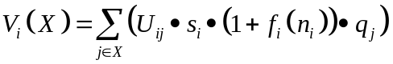

Comparing (1.1) and (1.3) shows that a package consisting of only a single license has a scale component f_{i}(1) = 0. There are complementarities when f_{i}(n_{i}) is positive. This kind of function could be specified parametrically, e.g. a quadratic form where convexity for some bidders would provide strong incentives for those bidders to bid on packages, budget constraints permitting. In any case, the function should be presented to subjects in tabular form for integer values of n_{i}, which would enable subjects to obtain a quick intuitive understanding of the incentives for package bidding, an understanding that would be supplemented by providing package value calculations for specific packages on request. These calculations, however, are contingent on the uncertainty over common values, so a table show would be especially useful.

The approach where n_{i} corresponds to the total number of licenses acquired by bidder i (corresponding roughly to the total area served) is probably simplest to explain to subjects in an experiment. Alternatively, one could introduce “region-dependent” synergies by having a scale component f_{i}(n_{ij}), where n_{ij} is the number of licenses bidder i wins that are located “close” to the area for license j, according to some distance metric (e.g. those adjacent or within a specified distance). The complementarities being modeled here might correspond to increased value to subscribers of being able to obtain service in adjacent areas without paying roaming fees, or to reductions in average costs due to economies of providing service to adjacent areas (marketing, inventory, repair, etc.). These cost economy and roaming factors, of course, could be modeled separately, but the goal here is to provide for a flexible form of complementarities without introducing too much complexity into the setup from the subjects’ point of view.

- Budget Constraints

Along with a set of valuations for individual licenses and packages of such licenses, each bidder will be assigned prior to bidding a budget that limits the total payment the bidder can make at the close of the auction for the licenses it has won. The bidder’s objective is to maximize its net profit (i.e., license or package valuation minus payment) subject to this budget constraint.

The experiments should, at a minimum, include some situations in which budget constraints are binding for winning bidders. However, budget constraints should not be so tight as to eliminate opportunities to observe bidding behavior related to the financial exposure issue. For example, we are interested in whether bidders will risk exposure by bidding above the stand-alone values for a group of licenses with superadditive values in the SMR auction, but they will not take the risk if their budget is inadequate.

If bidders default (i.e. when their winning bids total more than their allotted budgets), they must default on all winning bids, forfeiting the licenses and incurring the penalties specified in the auction rules. In the actual FCC auctions, a bidder who defaults is required to pay the difference between the withdrawn winning bids and the amount that the licenses sell for subsequently as well as an additional amount based on a percentage of the winning bids. This percentage is higher if the default occurs after a package bidding auction. In the experiment, this process can be mimicked by having the subsequent sale prices be determined as a random draw from a known distribution.

- Additional Considerations

An important question is whether aids should be provided to experimental subjects to help them make thoughtful decisions in complex environments. This issue typically gets clarified after some pilot experiments. At present, we envision providing subjects with an interface that contains a “Package information” table, a “Bidding basket,” and “Bidding History” plus a separate “Auction Result” page, see Figure 1. In addition, it would be useful to incorporate a message area, which the experimenter can use to send general messages (e.g. “the experiment will start in a few seconds”). In the subject’s “Package Information” table there would be a row for each license/package for which the subject has positive values. For example, in Figure 1, bidder 1 has positive values for packages A, B, C, AB, AC, BC, and ABC. The columns of the “Package information” table would identify the license or package, the current price, the private value component, and the common value signal. Subjects can place bids on licenses/packages they are interested in by moving them into the “Bidding basket,” which they can submit after all relevant licenses/packages have been entered.

In each round, bidders are informed if they are the provisional winner on a license or package through the use of colors: in Figure 1, for instance, the grey cells indicate that bidder 1 is the provisional winner on package BC. When licenses/packages are added to the bidding basket, bidders will see the minimum bids that need to be submitted in the next round: for non-provisional winners, it is the current price plus a pre-specified increment. In the right bottom panel, the “Bidding history” shows the bidding activity during the period on the packages relevant to the subject. The experimenter should be able to choose different information feedback conditions, e.g. show all bids and identities, show all bids (but not identities), or show only own bids. Finally, by clicking on the “Auction Result” tab on the top-left panel, subjects can view previous auction results. The corresponding screen will appear automatically after an auction has ended, and subjects will get some time to interpret the results before a new auction starts and the screen changes back to the one shown in Figure 1. Of course, other experimenters are likely to have different ideas about how to best represent all the information to subjects, so the interface presented in Figure 1 should be seen as a suggestion not a requirement.

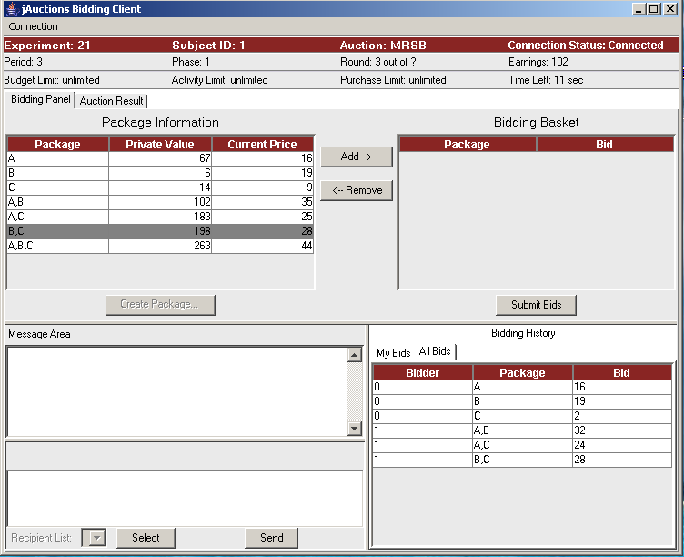

Figure 1. Example of Proposed Client Interface

In any case, the experiment software would have to be extremely simple from the subject’s point of view, without many of the extra details required in the actual FCC auctions. In contrast, the software must provide the experimenter with all of the options needed for the treatments discussed below. In particular, the setup pages should allow the experimenter to specify the auction format, the protocol for matching subjects in auction groups (random or fixed), the common and/or private value distributions, the information feedback conditions, the enforcement of bidding budget and activity rule constraints, etc. Moreover, the software must provide for instructions and easy to understand earnings calculations at the end of each auction period.

III. Proposed Treatments

Before we discuss the treatments that are most relevant to test the SMR auction vis-à-vis the SMRPB auction, we first review the attributes of package bidding. We also discuss elements likely to affect both institutions.

- Attributes of Package Bidding

The principal reason to consider the SMRPB auction is to allow bidders to express their preference for a combination of licenses without risking financial exposure. The “exposure problem” arises when a bidder obtains part, but not all, of the preferred package but spends more for the obtained pieces than they are worth to him. For example, suppose a bidder values the package AB at 10 but has no value for either A or B separately. In an SMR auction with no package bidding, a bidder who attempts to acquire both licenses but is outbid for one will incur a financial loss. To avoid the loss, the bidder may decide not to bid aggressively on either item, resulting in an inefficient allocation when the total value of licenses A and B to others is less than 10. In contrast, in the SMRPB auction the bidder would be willing to bid up to 10 on the AB package, and this bidder will efficiently be assigned the package if the total value of licenses A and B to others is less than 10. Intuitively, the exposure problem of the SMR auction will become more severe as the degree of complementarity between the licenses rises and bidder license preference overlap increases.

The ability to express preferences for packages may thus enhance efficiency and revenues. However, the SMRPB auction may create problems for “small bidders,” which we define here to be those bidders interested only in small packages or even a single license. This is known as the “threshold problem.” Suppose in the above example that there are two other small bidders who have values of 8 for license A or license B, but no value for the package AB. Furthermore, suppose the current prices in the SMRPB auction are 2 for A, 2 for B, and the package bidder is the provisional winner by bidding 9 for AB. The small bidders could overthrow the package bid by both increasing their bids to 5, but both would prefer a smaller increase in their own bid hoping the other will make up for the difference. In other words, the positive effect of an increase in one small bidder’s bid for other small bidders creates incentives for small bidders to “free ride,” i.e. to let others bear the cost of outbidding the package bidder. Moreover, small bidders face a coordination problem in that their combined total bid needs to rise to overthrow the package bid, but an increase that overshoots the minimum required amount is wasteful from their point of view. (The situation the small bidders face is therefore akin to a step-level public goods game.) Intuitively, this coordination problem may get worse as more small bidders are needed to overthrow the package bid. Note that the threshold problem is a problem in the sense that free riding and/or failure to coordinate bid increases may result in an inefficient allocation (i.e., the licenses included in the package are worth more to two or more non-winning bidders than to the winning bidder).

In addition to the exposure and threshold issues which are likely to vary according to whether a package or non-package format is used, the winner’s curse and tacit collusion may also affect the outcomes of the alternative auction designs differentially. The winner’s curse effect is due to a failure of a bidder to recognize that winning is more likely when one’s common value signal is relatively high. In other words, even though the value signal is unbiased ex ante, there is an upward bias conditional on winning. The failure to realize that winning is an informative event may cause bidders to submit bids that are too high for given signals, and as a consequence, the winner may end up paying more than the license turns out to be worth to him. When there is a single common value that applies to all licenses, winner’s curse effects may be stronger for larger packages since the adjacency factor in equation (1.2) exaggerates any misjudgments that bidders may make regarding the level of the common value. Experimentation provides an ideal vehicle to test how these winner’s curse effects interact with the auction format.

Tacitly collusive outcomes may result from coordinated attempts to divide the market at low prices. By tacit collusion, we mean mutual pricing restraint that is a result of a “meeting of the minds” without any explicit communication or bid agreements, which would have to be reported under current FCC rules. Intuitively, tacit collusion is more likely to be observed if each bidder has a local advantage for one license or, more generally, when bidders’ preferred packages show little overlap, and if complementarities are low. The lower the complementarities, the smaller the economic value a cooperative bidder surrenders when agreeing to a collusive strategy that splits the market. In addition to the valuation environment, auction rules may have an important effect on the ability of bidders to identify a collusive outcome. For example, in order to divide up the market, bidders must signal to other bidders their desired collection of licenses. This is facilitated if bidders have information regarding the identities of the submitters of the provisionally winning and non-winning bids. Moreover, such information is needed in order for cooperative bidders to impose, in the form of a retaliatory bid, a cost upon bidders that behave non-cooperatively. Finally, the ability to make publicly announced bids on packages may facilitate bidders’ abilities to lay claims on non-overlapping segments of the market. An important auction design question is whether bidders can successfully divide up a market and whether changing the information environment and allowing for package bids would enhance their ability to do so. The suggested treatment structure in Appendix B is designed to focus on the effects of auction rules on tacit collusion, in environments where collusive outcomes are more likely to appear.

Finally, both the SMR auction and the SMRPB auction described in Appendices C and D provide price feedback on individual licenses that may help bidders decide where and how to adjust their bids in the course of an auction. When the auction closes and no bidder wishes to further raise their bids at the current prices, the resulting set of final prices essentially corresponds to a competitive equilibrium in which all licenses are allocated. This process may be unstable when complementarities in valuations preclude the existence of a set of individual-license prices that clear the market. Experiments can show if in these circumstances the extra pricing flexibility provided by package bidding results in improved performance of the auction. Therefore, it is essential that the experimental environment include some cases where no competitive equilibrium exists. See Appendix A for a detailed discussion of the non-existence of a set of competitive equilibrium prices in the presence of license value complementarities (i.e., non-convexities) and the related concept of the core.

- Experimental Treatments

To evaluate all four effects (i.e., financial exposure, threshold problem, winner’s curse, and tacit collusion) we propose to allow for both common and private value elements, and for bidders of different sizes and license preferences (i.e., small bidders interested in a single license and large bidders interested in sets of licenses). Within this framework, we need to define the variables under experimental control. These are:

- The degree of complementarities among licenses.
- The amount of overlap in bidders’ preferences.
- The “strength” of small bidders vis-à-vis large bidders (i.e., the difference between the sum of the valuations small bidders place on a set of licenses and the value the highest value large bidder places on those same licenses as a package).
- The amount of information bidders receive during the course of the auction regarding the identities of the provisionally winning and non-winning bids.

We propose to include two cases for each variable: low/high degree of complementarity, low/high overlap in bidder preferences, “weak/strong” small bidders, and full/incomplete bidder information disclosure. The combinations of variables, or “treatments,” are categorized in the table below. Each would be tested in both the SMR and SMRPB formats. If desired, additional treatments, including, for example, varying degrees of common-value uncertainty, could be considered. Also, depending upon results, it may be unnecessary to include all of the treatments listed.

Treatments | Degree of  Complementarity |  | Preference  Overlap |  | Small Bidder  Strength |  | Information Disclosure
 | Low | High | Low | High | Weak | Strong | Full | Partial
LC,OL,SW,IF | X |  | X |  | X |  | X
LC,OL,SS, IF | X |  | X |  |  | X | X
LC,OH,SW, IF | X |  |  | X | X |  | X
LC,OH,SS, IF | X |  |  | X |  | X
HC,OH,SS, IF |  | X |  | X |  | X
HC,OH,SW, IF |  | X |  | X | X
HC,OL,SS, IF |  | X | X |  |  | X
HC,OL,SW, IF |  | X | X |  | X
LC,OL,SW,IP | X |  | X |  | X |  |  | X
LC,OL,SS, IP | X |  | X |  |  | X |  | X
LC,OH,SW, IP | X |  |  | X | X |  |  | X

Each of the eleven treatments will require six groups (six independent data points) for a total of 66 groups for the 2 basic auction formats, which results in a grand total of 2*11*6=132 groups. Appendix B gives a specific proposal for the parameterizations of these sessions.

IV. Experimental Procedures

It is anticipated that adequate data collection will involve about 6-12 subjects for each of the 132 groups, and another 150 subjects for debugging and pilot studies, for a total between 942 and 1,734 subjects. These numbers are only an approximation, and may be negotiated with FCC staff as the project proceeds. The sessions will probably be somewhat long, perhaps 2 hours or more, due to the need to explain complex procedures and obtain enough replications. Financial motivation should be high enough to merit serious attention, and therefore, it is anticipated that earnings will be about $50 per person, including show-up fee.

The auction rules should be based closely on the description of the two alternative auctions, contained in Appendix C, which was provided by FCC staff. The actual FCC auction framework will be done on-line, and therefore, the experiments will also be computerized. The FCC will provide the needed pricing and assignment algorithms (see Appendix D), but it is the responsibility of the experimenter to develop the software that would be used for the experiments (not for the actual FCC auction). The software developed by the FCC for the actual auction may be of limited use to run the experiments, although it may be useful to do some comparability testing to assure that the experimental and FCC interfaces induce similar results. In particular, it is necessary to provide the experimenter with the flexibility to run alternative treatments, induce a desired array of private and common values, enforce budget and activity constraints, and allow for a variety of information feedback conditions. Furthermore, the software should provide subjects with an easy-to-understand interface for instructions, valuations and signals, bidding decisions and earnings.

Of course, all information collected in the experiment (current and past bids, values, signals, earnings, etc.) should be recorded and reported to the FCC. In addition, it is desirable to report and control any prior experience that particular bidders have had in prior auction experiments, along with some demographic information. This information can be collected with a questionnaire that should be done ex post. The structure of the survey is up to the experimenter.

V. Performance Measures

Economic efficiency, the degree to which the auction assigns the licenses to the bidders with the highest valuations, is the most commonly used performance measure in economic experiments. Efficiency is measured as a ratio of the sum of the valuations winning bidders place on the obtained items to the maximum valuation placed by bidders under the efficient allocation of items, and is independent of prices paid. For example, suppose two bidders compete for a single license; one of them values the license at 10 while the other bidder values it at 6. Awarding the license to the lower-valuing bidder would result in an efficiency level of 6/10, or 60%. One of the main benefits of laboratory experiments is that bidders’ valuations are induced and known to the researcher, which makes it possible to examine efficiency and to compare average efficiency levels across different auction formats.

The FCC may be interested in other measures as well. The experimental data should also include sales revenue comparisons between auctions run with and without package bidding. The reports should distinguish between revenue resulting from sales which were profitable to bidders, and revenue from sales in which bidders “overbid” due to exposure problems or a “winner’s curse.”

Since the length of FCC auctions is important to actual FCC bidders, the experiments should report the number of rounds for each auction, and compare treatments. In addition, there should be some measure of the extent to which the time patterns of bidding activity vary. One simplistic measure would be in terms of cumulative numbers of bid changes, by round, which would give a picture of the extent to which bidding is concentrated towards the beginning or end of the auction. A more economically relevant measure would take bid amounts into account and would attempt to ascertain the extent to which bids begin to reveal final valuations during the auction process. To this end, the provisional winning bids in each round would be calculated, summed, and expressed as a fraction of the maximum-value allocation or as a fraction of the final sales revenue.

It may also be useful to try to evaluate the extent to which the various auction formats and treatments produce stable prices and outcomes. Loosely speaking, final auction prices can be thought of as market-clearing prices, since no new bids are being made. However, the final prices and allocation may not comprise a competitive equilibrium; indeed, a competitive equilibrium may not exist in some of the more complex fitting environments that these experiments are designed to test. In this context, it is important to consider whether or not such equilibria are possible, and if so, whether the final experimental allocations and prices correspond to competitive equilibrium outcomes. Given that in theory there are situations in which competitive equilibria do not exist in non-package bidding auctions but are possible in package bidding auctions, we are interested in the extent to which the auction format contributes to the potential for attaining a competitive equilibrium outcome. The researcher should note whether competitive equilibria exist, and whether the experimental outcomes correspond to those equilibria.

A weaker measure of the stability and desirability of an outcome is to examine whether an experimental auction results in prices and allocations which are in the “core.” The researcher should report the percentage of times that the final allocations are in the core. Of course, as with competitive equilibria, noise and other variations in bidding behavior are likely to result in inefficiencies which may preclude core outcomes, even if such outcomes are predicted in theory. However, differences which vary systematically by auction format are of interest.

Finally, the FCC may be interested in assessing whether the success of small bidders in winning licenses, relative to the success of large bidders, varies according to auction format, taking into account valuations and budgets. One way to examine this effect is to consider the efficient allocation of licenses (with some provision for ties), and to calculate the sum of the license valuations that all small bidders obtain in the efficient allocation, V*. Then let V represent the sum of all prize valuations obtained by small bidders in the actual allocation that results from the auction. These valuations would include the complementary effects but would not include prices paid. Then the ratio, V/V*, provides a license-based measure of bidding success, which can be compared across auction formats. This ratio, however, does not incorporate profit information based on prices paid. An alternative is to compare ratios of small bidders’ earnings to large bidders’ earnings across auction formats. These and possibly other measures may be used to help the FCC assess performance in this dimension.

Appendix A: Competitive Equilibrium and the “Core”

The draws from the various distributions determine whether there exists a set of prices that supports the efficient assignment of licenses. Recall that a feasible allocation is an assignment of licenses such that no license is assigned to more than one bidder. A competitive equilibrium is a feasible allocation and a set of prices, one for each license, such that: 1) all licenses are assigned to a bidder (market clearing), and; 2) no bidder can earn a higher profit by adding licenses or deleting licenses from the assigned allocation, and altering the payment based on the prices for those licenses (profit maximization given prices). More formally:

Definition: A competitive equilibrium is a set of prices 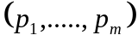 and allocations 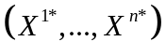 where the X ^{k *} span the entire set of licenses X, 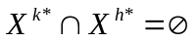 for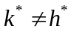, and for all k, 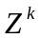.

We are interested in considering competitive equilibria since their existence or non-existence may affect the stability of auction outcomes, even though an alternative equilibrium concept, the Bayesian-Nash equilibrium, is more typically used to analyze auctions. In determining experimental parameters, we recognize that value complementarities will tend to introduce precisely the kinds of non-convexities that may preclude the existence of a competitive equilibrium, even in setups that may seem reasonable in terms of their economic structure. Consequently, in evaluating whether an auction results in a competitive equilibrium outcome, we will need to consider whether such a result is possible.

Consider the following example, with three licenses (A, B, and C) and three bidders (S1, S2, and L1). Table 1A below presents the set of valuations for individual licenses and combinations of such licenses for each bidder. Each bidder has a positive value of 10 for two of the licenses. For the small bidders, S1 and S2, the value of the package consisting of those two licenses is double the sum of the individual values. For the large bidder, L1, the value of the AB package is 2.5 times the sum of the individual values for A and B.

Table A1: License and Package Valuations

Bidders | A | B | C | AB | AC | BC | ABC
S₁ | 10 | 0 | 10 | 10 | 40 | 10 | 40
S₂ | 0 | 10 | 10 | 10 | 10 | 40 | 40
L₁ | 10 | 10 | 0 | 50 | 10 | 10 | 50

The efficient allocation is to assign the package AB to bidder L1 and assign license C to either of the small bidders. The set of competitive equilibrium prices is determined by the requirement that the “market clears,” i.e. demand equals supply. If the price of license C, p_{C}, is less than 10 both small bidders would want to buy license C and there would be excess demand. In contrast, if p_{C} exceeds 10 then neither small bidder would be interested in license C and there would be excess supply. Hence, p_{C}=10 in equilibrium. Next, p_{A}+ p_{B} ≤ 50 since otherwise bidder L1 would not be willing to buy the package AB. Finally, there are two conditions that keep the small bidders from demanding packages AC and BC: p_{A}+ p_{C} ≥ 40 and p_{B}+ p_{C} ≥ 40. Together with the constraint that p_{C}=10 this yields p_{A} ≥ 30 and p_{B} ≥ 30, which contradicts the condition p_{A}+ p_{B} ≤ 50. Therefore, for the example in Table 1A no competitive equilibrium prices exist. Note that equilibrium prices would exist if the large bidder’s value for the AB Package were raised to 60. Appendix B describes how the example in Table 1A can be generalized to accommodate the treatments discussed in section 3 while maintaining the flexibility of parameterizing auctions with and without competitive equilibrium prices.

As a relaxation of the competitive equilibrium notion we next consider the set of core payoffs. Let N denote the set of players including the seller, N = {0, 1, …, n} where the 0-label corresponds to the seller, and let v_{k} (x_{k}) denote bidder k’s value for package x_{k} (with v₀ (x_{k}) = 0 for all possible packages x_{k}). Define the coalitional value function, w(S), for S  N as:
w(S) = max _{x  X} { _{k  S} v_{k} (x_{k} )},

if 0  S, and w(S) = 0 otherwise (since the bidders have nothing to trade among themselves). Let π_{k} = v_{k} (x_{k}) – p_{k} denote bidder k’s profit when obtaining package x_{k} at price p_{k} and let π₀ = ^{n} _{k=1} p_{k} denote the seller’s revenue. The set of core payoffs is defined as:

Core = {π |  _{k  N} π_{k} = w(N) and w(S)   _{k  S} π_{k} for all S  N}.

Note that for payoffs to be in the core, the corresponding allocation has to be efficient. In the example, this implies that the large bidder obtains the AB package and one of the small bidders obtains license C. Each of the inequalities w(S)   _{k  S} π_{k} for all S  N requires that the sum of the payoffs for the members of coalition S be no less than the total surplus generated by the coalition S in isolation of the rest. In other words, if one of the inequalities was not satisfied then the coalition S could form a “blocking coalition” that provides its members with a higher payoff than they would receive otherwise. For the example above, some of the relevant inequalities are:

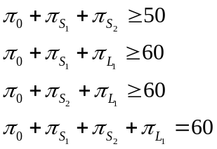

By adding the first three inequalities and using the final equality, we get π₀ ≥ 50. Moreover, by subtracting the second or third inequality from the final equality yields 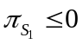and 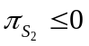. So the profits of the small bidders are zero while the large bidder’s profit can be anything between 0 and 10 and the seller’s revenue is anything between 50 and 60. These payoffs correspond to a price equal to 10 for license C and a price between 40 and 50 for the AB package.

The notion of core payoffs is less restrictive than the notion of a competitive equilibrium in the sense that it will always exist in the framework being considered and it does not require the calculation of prices for individual licenses. In the presence of complementarities, individual-license prices that clear the market often do not exist and the notion of the core thus seems the relevant generalization to deal with such situations. It will be easy to verify whether the final outcomes of the auction are in the core, since the experimenter has complete knowledge of the bidders’ valuations, their payoffs and the seller’s revenue.
Appendix B: Parameter Choices for the Different Treatments

As an illustration of the proposed parametric approach to defining valuations, below we take the “three-bidder ABC design” of the previous appendix and scale it up by having two A licenses (A1 and A2), two B licenses, and two C licenses. With these labels, the valuation structure matches that of Table A1 with the deterministic, commonly known values replaced by privately known, uniformly distributed random variables. In Table B1, each V_{i} is a realization of a uniformly distributed variable (e.g. between 0 and 100). Therefore, each bidder obtains a single private value that pertains to each of the licenses in which it is interested. This example assumes a pure private value structure, so that CV_{i} = 1 for each bidder i in equation (1.3). Table B1 displays the values corresponding to U_{ij} for each bidder i and individual license j. Values for packages of two or more items are represented using Tables B2 and B3 as explained below.

To capture synergies between licenses in a simple manner (see section 3), we assume that a small bidder’s value for a package consisting of N licenses is simply the sum of values of the individual licenses multiplied by a scale factor 1+ (N-1)α (see Table B2). For instance, if V₁ = 10 and α=1, bidder 1’s value for the package A₁C₁ is (10+10)*(1+1) = 40, as in the example of Appendix A. (Note that our setup also allows for substitutes by letting α be less than 0.) Likewise, for a large bidder the value of a package that consists of N licenses is the sum of values of the individual licenses in the package multiplied by a scale factor 1+ (N-1)β, see Table B3. For example, if V₅ = 10 and β =1.5, the value of the package A₁B₁ to bidder 5 is (10+10)*(1+1.5) = 50, as in the example of Appendix A.

Because we want to study the effects of overlapping preferences among bidders, we replicate the basic market by introducing two additional small bidders, one additional large bidder, and additional licenses D₁ and D₂, E₁ and E₂, and F₁ and F₂. This second market is completely separate if the “cross-over” values labeled by W₅ and W₆ are constrained to be zero. In contrast, there is full overlap if W₅ = V₅ and W₆ = V₆.

Table B1: Private Value Structure

Bidders | A₁ | A₂ | B₁ | B₂ | D₁ | D₂ | E₁ | E₂ | C₁ | C₂ | F₁ | F₂
Small Bidder 1 | V₁ | V₁ |  |  |  |  |  |  | V₁ | V₁
Small Bidder 2 |  |  | V₂ | V₂ |  |  |  |  | V₂ | V₂
Small Bidder 3 |  |  |  |  | V₃ | V₃ |  |  |  |  | V₃ | V₃
Small Bidder 4 |  |  |  |  |  |  | V₄ | V₄ |  |  | V₄ | V₄
Large Bidder 5 | V₅ | V₅ | V₅ | V₅ | W₅ | W₅ | W₅ | W₅
Large Bidder 6 | W₆ | W₆ | W₆ | W₆ | V₆ | V₆ | V₆ | V₆

Table B2. Scale Factors for Small Bidders
(α > 0 for complements, and α < 0 for substitutes)
Number of Licenses  Won by Small Bidder | N=1 | N=2 | N=3 | N=4
Scale Factor | 1 | 1+α | 1+2α | 1+3α

Table B3. Scale Values for Large Bidders
(The magnitude of β determines the strength of complementarities, with β > 0)

Number of Licenses  Won by Large Bidder | N=1 | N=2 | N=3 | N=4 | N=5 | N=6 | N=7 | N=8
Scale Factor | 1 | 1+β | 1+2β | 1+3β | 1+4β | 1+5β | 1+6β | 1+7β

There are two main advantages to the value structure in Table 1B. First, the possible non-existence of competitive equilibrium prices for the example in Appendix A carries over directly to the present setup when the markets do not overlap. Depending on the actual realizations of the V_{i}, a competitive equilibrium may or may not exist for certain values of α and β. The second advantage is that the licenses of exclusive interest to the small bidders (C1, C2 and F1, F2) provide them with an opportunity to compete actively and make some earnings even when the large bidders have a scale advantage.

Using this setup, we can address the treatment variations called for in Section III. For example, by choosing high or low values of α and β, we can vary the degree of complementarity between licenses. Likewise, by restricting the realizations of W_{i} to be zero, the degree of overlap is small while high overlap occurs for W_{i} = V_{i}. The strength of large vis-à-vis small bidders is determined by the scale factor α and β and the extent to which the large bidders’ random values are drawn from a higher or lower range of values. The remaining treatment change is implemented by altering the amount of information bidders receive concerning the identities of bids submitted by others. Other variations that might be of interest to the FCC include (i) changing the degree of common-value uncertainty, (ii) allowing bidders to submit bids in separate OR-groups thereby allowing the possibility that a bidder could have multiple winning bids, with at most one in each OR-group, (iii) changing the activity and stopping rules, (iv) varying the pricing rules, and finally (v) allowing for alternative auction designs (e.g. clock auctions or clock-proxy auctions).

Appendix C: Auction Rules

The following describes the rules of the SMR and SMRPB auctions.

1. SMR Auction
- Simultaneity and Bid Structure
All licenses are put up for bid simultaneously. Participants have the opportunity to submit bids on individual licenses, for as many licenses as they wish.

- Iterative
The auction consists of discrete, successive rounds in which buyers have the opportunity to place bids on their desired licenses. Following each round, the high bid for each license is posted. These high bids then become the standing bids for the next round of bidding.

- Minimum Opening Bid
The minimum opening bid is defined as the minimum price the Commission demands in exchange for selling the license.

- Minimum Acceptable Bid
In the first round and until a bid has been placed on a license, an acceptable bid must be equal to or exceed the minimum opening bid. Subsequently, in order to be acceptable, a bid must exceed, by a specified percentage, the provisionally winning bid for the license. In order to move the auction along more quickly, the increment percentage can be calculated on a per-license basis, as an increasing function of the number of bids placed on the license in previous rounds. If speed of the auction is a concern in these experiments, we may want to use this feature – known as the exponential smoothing formula.

- Bid Increments
Bidders are given the choice of making the minimum acceptable bid, or of making one of eight incrementally higher bids.

- Bid Withdrawal
In a limited number of rounds (usually two), participants are permitted to withdraw any of their provisionally winning bids. After the withdrawal, the Commission becomes the provisionally winning bidder for the withdrawn license and the minimum acceptable bid in the following round equals the second highest bid received on the license (which may be less than or equal to, in the case of tied bids, the amount of the withdrawn bid). A withdrawing bidder pays a penalty equal to the maximum of zero or the difference between the price at which the bidder withdrew its bid and the final sale price in the current auction or in a subsequent auction in which the license is sold. If the license remains unsold in the current auction, the withdrawing bidder pays an interim payment of 3% of its withdrawn bid.

- Bidding Eligibility and Activity
Each license is assigned bidding units typically based on its bandwidth and the size of the population “covered” by the geographic area of the license. A bidder’s upfront payment determines the total number of bidding units a bidder can “bid on” at any one time. The total number of bidding units available to the bidder establishes the bidder’s maximum “eligibility” to bid in the auction. To encourage active bidding, the auction has rules that impose a cost upon bidders if they fail to display a minimum amount of bidding activity. In each round, bidders must be active on at least a fixed percentage of the total bidding units available to the bidder. High standing bids for licenses from the previous round and new bids in the current round are considered “active” bids for purposes of measuring bidding activity. The failure of a bidder to satisfy the activity rule leads to a reduction in his bidding eligibility sufficient to bring him into compliance with the rule (unless the bidder uses an activity rule waiver, as described below). Therefore, in subsequent rounds, the maximum number of bidding units on which the bidder may be active is below the original number. The bidder may also actively reduce his eligibility, if he does not wish to maintain the minimum bidding activity required by the activity rule. While a bidder’s eligibility determines the maximum number of bidding units on which a bidder can bid on and the activity rule defines the minimum level of bidding activity the bidder must exhibit in order to maintain its current bidding eligibility, the activity and eligibility rules do not restrict the amount of the bids.

- Activity Rule Waiver
Each bidder is granted a limited number of opportunities (usually 3-5) to avoid being subject to the activity rule. If the bidder does not meet his minimum activity requirement for a round, the system will automatically apply a waiver, if the bidder has one remaining, or the bidder may actively submit a waiver. An activity rule waiver applies to an entire round, not to particular licenses (i.e., by using an activity rule waiver, a bidder is essentially taking a “time out” for the round).

- Closing Rule
The auction closes after the first round in which no new bids were placed, no bids were withdrawn, and no waivers were actively submitted.

- Information Environment
Prior to entering the auction, bidders have information showing the number of bidding units associated with each license and the number of bidding units each bidder is able to “bid on.” Following the end of each round, participants receive information on provisionally winning bids, the identity of each high bidder, the name of each non-winning bidder and their bids, the identity of any bidders using activity waivers, the eligibility requirement for each bidder in the subsequent round, and the minimum acceptable bid for each license for the subsequent round. After each round, bidders also know the identity of the bidders that have withdrawn bids and the license(s) on which they have withdrawn bids.

- Payment Default Rule
If a winning bidder defaults on payment for the licenses he won, he is liable for a deficiency payment, equal to the difference between the amount of the bidder’s bid and the amount of the winning bid the next time the licenses are won in an auction, plus an additional payment equal to a percentage of the defaulter’s bid or of the subsequent winning bid, whichever is less. In instances in which the amount of a default payment cannot yet be determined, the Commission assesses an initial default deposit of a percentage of the defaulted bid amount. (If a bidder defaults, he must default on all of his winning bids.)

    - SMRPB Auction

- Simultaneity and Bid Structure
All licenses are put up for bid simultaneously. Participants have the opportunity to submit sets of bids, each of which may be for one or more licenses. Multiple bids submitted by each bidder will have an “exclusive OR” (i.e., “XOR”) relationship. For example, bids of the form “AB XOR C” would be interpreted as the bidder’s desire to acquire A and B or C, but not A or B separately or the set A, B, and C. Implementing this structure requires that only one of a bidder’s bids can be included in the provisionally winning set of bids.

- Iterative
The auction consists of discrete, successive rounds in which buyers have the opportunity to place bids on their desired licenses. Following the submission of bids, an algorithm identifies the provisionally winning assignment of licenses through revenue maximization of gross bids. In addition, an algorithm estimates a set of individual item prices (i.e., “current price estimates” (“CPEs”)) that is consistent with this assignment. The CPEs then become the basis for establishing minimum bids for the next round of bidding.

- Minimum Opening Bid
The minimum opening bid is defined as the minimum price the Commission demands in exchange for selling the license. It serves as the minimum acceptable bid on a license in the first round and in subsequent rounds if no bids have been placed covering that license. For a package, the minimum opening bid is the sum of the minimum opening bids for its component licenses.

- Minimum Acceptable Bid
In all rounds subsequent to the first round in which a bid is placed on a license or on a package containing the license, the minimum acceptable bid for a license must exceed the CPE by a specified percentage. This percentage is either a flat rate or a license-by-license percentage based on bidding activity. The minimum acceptable bid for a package of licenses is the sum of the minimum acceptable bids for its component licenses.

- Bid Increment
Bids can also be made in one of eight incrementally higher bid amounts. The increment is based on a fixed percentage of the minimum acceptable bid amount for the license or package.

- Bidding Activity
Each license is assigned bidding units typically based on its bandwidth and the size of the population “covered” by the geographic area of the license. A bidder’s upfront payment determines the total number of bidding units a bidder can “bid on” at any one time. The total number of bidding units available to the bidder establishes the bidder’s maximum “eligibility” to bid in the auction. To encourage active bidding, the auction has rules that impose a cost upon bidders if they fail to display a minimum amount of bidding activity. In each round, bidders must be active on at least a fixed percentage of the total bidding units available to the bidder. A bidder's activity in a round is equal to the number of bidding units in the bidder’s largest (in terms of bidding units) active bid. Active bids include current provisionally winning bids, new bids and any bids from previous rounds which are at or above the current minimum acceptable bid. While a bidder’s eligibility determines the maximum number of bidding units on which a bidder can be active and the activity rule requires a minimum level of activity, the activity and eligibility rules do not restrict which licenses the bidder can bid on or the amounts of the bids. The failure of a bidder to satisfy the activity rule leads to a reduction in his bidding eligibility sufficient to bring him into compliance with the rule (unless the bidder uses an activity rule waiver, as described below). Therefore, in subsequent rounds, the maximum number of bidding units on which he may be active is below the original number corresponding to his upfront payment. He may also actively reduce his eligibility, if he does not wish to maintain the minimum bidding activity required by the activity rule.

- Activity Rule Waiver
Each bidder is granted a limited number of opportunities (usually 3-5) to avoid being subject to the activity rule. If the bidder does not meet his minimum activity requirement for a round, the system will automatically apply a waiver, if the bidder has one remaining, or the bidder may actively submit a waiver.

- Closing Rule
The auction closes when no new bids have been submitted and no proactive waivers applied in one or two consecutive rounds. Whether the auction closes after one round or two consecutive rounds with no new bids and no proactive waivers will be established prior to the auction.

- Information Environment
Prior to entering the auction, bidders have information showing the number of bidding units associated with each license and the number of bidding units each bidder has available to assign. Following the end of each round, participants receive information on the provisionally winning set of bids, the identity of each provisionally winning bidder, the name of each non-winning bidder and their bids, the identity of any bidders using activity waivers, the eligibility requirement for each bidder, and the minimum acceptable bid for the next round for each license and for each package that has already received a bid. In addition, bidders are given the per-license CPEs.

- Payment Default Rule
If a bidder defaults on payment for a winning bid, he is liable for a deficiency payment, equal to the difference between the amount of the bidder’s bid and the amount of the winning bid the next time licenses covering the same spectrum are won in an auction, plus an additional payment equal to 25 percent of the defaulter’s bid or of the subsequent winning bid, whichever is less. In instances in which the amount of a default payment cannot yet be determined, the Commission assesses an initial default deposit of between 3 percent and 20 percent of the defaulted bid amount.
Appendix D: Pricing Rules

This appendix describes the method by which bid information on packages and licenses is used to approximate a “price” associated with each license at the close of every round. These “current prices,” as they are called, are then used in the next round when calculating minimum acceptable bid amounts. Specifically, for a license, this value is the current price of the license plus a percentage. For a package, the minimum acceptable bid amount is the sum of the minimum acceptable bid amounts of its component licenses.

The current item prices of the licenses are based on the concept that every linear optimization problem has a dual problem that provides pricing information. We begin by discussing a simplified representation of the FCC winner determination problem and then discuss its linear programming relaxation before explaining the dual problem of interest. The winner determination problem is shown in (P1):

(P1): 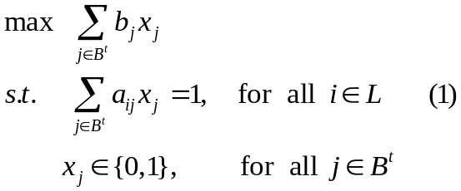

where B^{t} is the set of considered bids in round t,
b_{j} is the bid amount of bid j,
L is the set of licenses being auctioned,
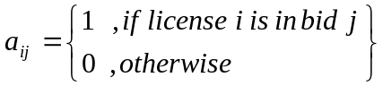 and,
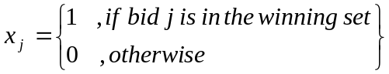

In this formulation, x_{j} is an indicator variable that equals one if bid j is in the provisionally winning set and zero otherwise. Thus, the sum of the bid amounts of all provisionally winning bids produces the maximum obtainable revenue for round t. Constraints (1) ensure that each license is awarded exactly once. The constraints that ensure that a bidder’s bids between rounds are mutually exclusive are not represented in (P1) since they will be ignored in the linear representation of the problem.
The linear program of (P1) relaxes the restriction on the variables x_{j}, for all j∈B^{t}, allowing these variables to take on any value between zero and one. The linear programming representation of (P1) is shown in (P2):

(P2): 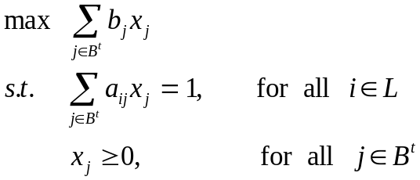

The dual formulation of (P2) can be used to identify a price, π_{i}, for each license i, and is shown in the following linear program (P3):

(P3): 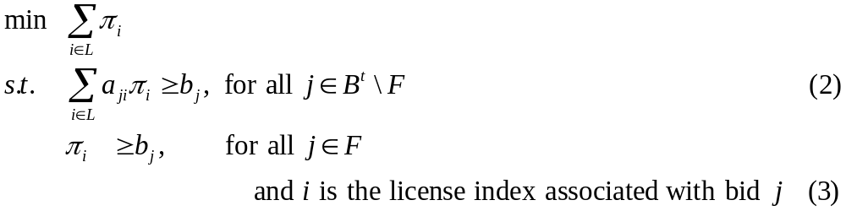

where F⊂ B^{t} is the set of FCC bids on each license and,
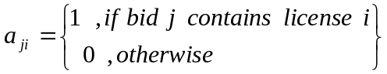.

The optimal value of each variable, π_{i}, in (P3) corresponds to a dual price – often called a “shadow price” – for each constraint, i.e., each license, in (P2). The dual price of each license measures the monetary cost of not awarding the license to whom it has been provisionally assigned under the solution to (P2). Thus, this monetary cost has a clear and natural use in estimating the current price of a license given the bids considered in the current round.

Constraints (2) in (P3) ensure that the dual price of a license must be at least as large as the greatest bid made on that license. For a package, these constraints ensure that the sum of the dual prices of the licenses that make up a particular package must be at least as large as the greatest bid made on that package. Constraints (3) in (P3) ensure that if a license has not been bid on, the dual price of that license is at least as large as the FCC bid amount.

Ideally, the solution to (P2) is identical to the solution of (P1). When this occurs, the sum of the dual prices of the licenses comprising any provisionally winning bid equals the winning bid amount. However, (P2) is only an approximation to the integer problem and often overestimates the maximum revenue of (P1). When this occurs, the sum of the dual prices of the licenses in at least one provisionally winning bid will be greater than the respective bid amount. Thus, using the dual prices of (P3) can result in minimum acceptable bid amounts that are too high.

We propose to resolve this issue by using pseudo-dual prices, rather than the dual prices of (P3). These pseudo-dual prices are obtained by forcing the sum of the dual prices of the licenses comprising a provisionally winning bid to equal its respective bid amount. For example, suppose there are two bids in the provisionally winning set in round t: a bid on license A for $10 and a bid on package BC for $25. The pseudo-dual price of A would exactly equal $10 and the sum of the pseudo-dual prices of B and C would exactly equal $25. These restrictions ensure that the sum of the pseudo-dual prices equals the maximum revenue for the round (e.g. $35) and that minimum acceptable bid amounts reflect the bid amounts of bids in the provisionally winning set.

Pseudo-dual prices for each license i, denoted π_{i}, satisfy the following constraints:

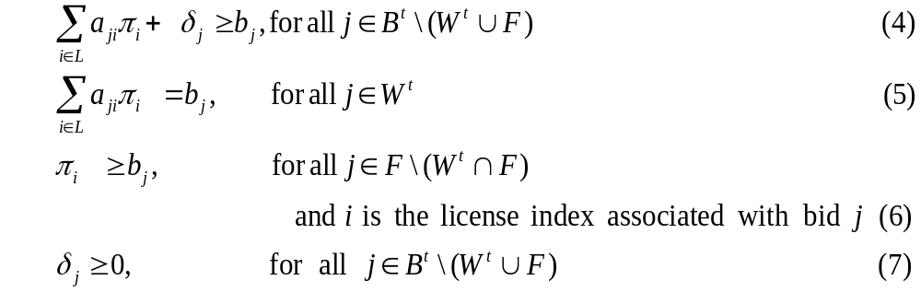

where W^{t}⊂ B^{t} is the provisionally winning bid set in round t and,
δ_{j} is a slack variable that represents the difference between the bid amounts of
non-winning bid j and the sum of pseudo-dual prices of the licenses contained
in non-winning bid j

Constraints (5) ensure that for each provisionally winning bid, the sum of the dual prices of the licenses comprising that bid equal its respective bid amount. This new restriction requires that we ease restriction (2) in (P3) for non-winning bids in order to ensure that a feasible solution exists. Constraints (4) provide this needed slack. Constraints (6) are equivalent to constraints (3) in (P3) and constraints (7) force the slack variables to be non-negative.

Satisfying constraints (5) implies that the sum of the pseudo-dual prices always yields the maximum revenue for the round. There are likely to be many sets of pseudo-dual prices that satisfy this constraint set. For instance, in the example provided earlier, the pseudo-dual prices of B and C might be any two numbers that together sum to $25.

By keeping constraints (4)-(7), we have the flexibility to choose an objective function that will help in selecting among multiple solutions while still ensuring that the sum of the pseudo-dual prices yields the maximum revenue of the round. We would like an objective function that minimizes the values of the slack variables δ_{j}, for all j∈ B^{t} \ (W^{t} ∪ F) in order to obtain pseudo-dual prices that are close to the dual prices of (P3). We have tested a number of alternative objective functions:

- Minimization of the maximum δ_{j} for all j∈B^{t} \ (W^{t} ∪ F) followed by maximization of the minimum π_{i} for all i in license set L, in an iterative manner. (DeMartini, Kwasnica, Ledyard and Porter, 1999)
- Minimization of the sum of the squares of δ_{j} for all j∈B^{t} \ (W^{t} ∪ F). (also DeMartini, Kwasnica, Ledyard and Porter, 1999)
- Minimization of the sum of the δ_{j} for all j∈B^{t} \ (W^{t} ∪ F) using a “centering” algorithm to solve, essentially finding an average among all sets of optimal pseudo-dual prices.

In testing the above alternatives, we frequently observed instances where the pseudo-dual price of a license significantly changed from round to round. We acknowledge that prices of licenses should be allowed to reflect real changes, both increases and decreases, in the way bidders value the licenses over time. However, we believe that large oscillations in minimum acceptable bid amounts for the same bid that are due to irrelevant factors such as multiple optimal solutions, can be confusing to bidders. We have therefore chosen a method that attempts to balance minimizing the slack variables and reducing the fluctuations in pseudo-dual prices from round to round. This method requires solving two optimization problems, the first of which is alternative 3 above, which we present as (P4):

(P4): 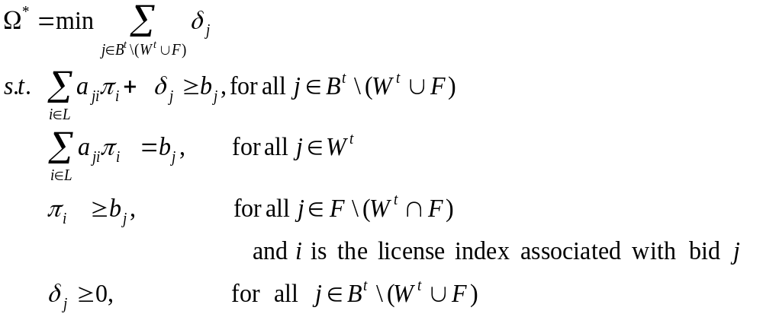

Since multiple optimal solutions can exist to (P4) we solve a second optimization problem that chooses a solution in a way that reduces the magnitude of price fluctuations between rounds. Specifically, we use an objective function that applies the concepts of exponential smoothing to choose among alternative pseudo-dual prices with the additional constraint on the problem that the sum of the slack variables equals Ω* (the optimal value of (P4)). This objective function minimizes the sum of the squared deviations of the resulting pseudo-dual prices in round t, from their respective smoothed prices in round t-1. At the start of the auction, we use the minimum opening bid prices as the prior smoothed prices. Since these opening prices are based on bandwidth and population, the pricing algorithm begins with a priori information about the differences among licenses.

Let 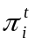 be the pseudo-dual price of license i in round t. The smoothed price for license i in round t is calculated using the following exponential smoothing formula:

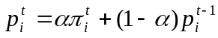

where 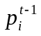is the smoothed price in round t-1,
0 ≤ α ≤ 1, and
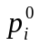 = the minimum opening bid amount for license i.

Consistent with prior practice of the Commission, a weighting factor of 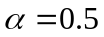 has been chosen but can change, as the Commission requires.

The following quadratic program (QP) will find the pseudo-dual price, , for each license i in round t that minimizes the sum of the squared deviations from the respective smoothed prices in round t-1 while ensuring that the pseudo-dual prices sum up to the provisionally winning bid amounts and that the sum of the slack variables is minimized.

(QP): 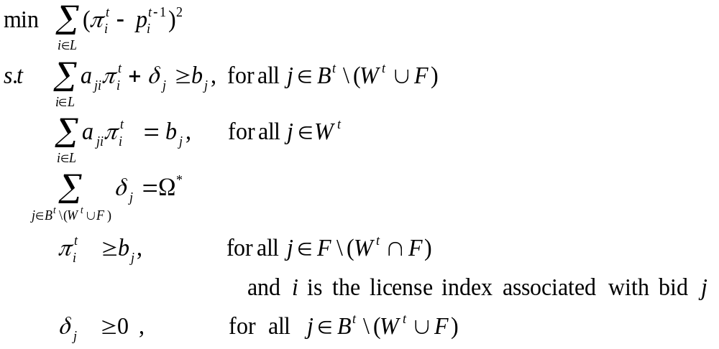

where 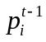 is known and treated as a constant within the optimization.

Among alternative prices that satisfy all constraints, the objective function of this optimization problem chooses one that forces the pseudo-dual prices to be as close as possible to the previous round’s smoothed price. Thus, we call this the Smoothed Anchoring Method since we “anchor” on the smoothed prices when solving for the pseudo-dual prices. We define the “current price” for license i in round t as the pseudo-dual price,, obtained by solving (QP).

The minimum acceptable bid amount for a license in round t+1 will be the current price of the license, as calculated above, plus a percentage. For a package, the minimum acceptable bid amount will be the sum of the minimum acceptable bid amounts of the licenses that make up the package.

Among previous studies, the most relevant is Cybernomics (2000), “An Experimental Comparison of the Simultaneous Multi-Round Auction and the CRA Combinatorial Auction.” Available at http://wireless.fcc.gov/auctions/conferences/combin2000/releases/98540191.pdf.
Milgrom and Weber (1982) “A Theory of Auctions and Competitive Bidding,” Econometrica, 50, 1089-1122.
There may be other sources of uncertainty. For example, per capita costs may be lower or higher than expected.
Bidders’ private values, U_{ij}, the common values, CV_{j}, and bidders’ common value signals, e_{ij}, are draws from pre-specified distributions, assumed to be common knowledge among the bidders.
In the oil drilling rights case, for example, this could correspond to uncertainty about the future price of oil, an effect that is independent of tract-specific considerations.
Here, n_{i} includes only the licenses of interest to bidder i, i.e. for which U_{ij} > 0 (since otherwise bidders could increase the value of a package by buying unrelated licenses that have no value to them).
An alternative way to define the notion of geographic closeness is to locate licenses on a circle, as in the Cybernomics (2000) experiments, in which case n_{j} would take on the values of 0, 1, or 2. Another approach is to locate licenses on a rectangular grid, where adjacency is determined by shared boundaries. In this case, each location in the interior of the grid would have 8 neighbors, so n_{j} would take on integer values from 0 to 8. Our approach (see also Appendix B) is even simpler, i.e. to have scale effects be a function of the total number of licenses acquired by a bidder.
Figure 1 does not show a column for the common value signal.
Alternatively the “Current Price” column could be shown in the “Bidding Basket” table next to the “Bid” column.
The experimenter should also be able to set budget constraints and activity rules if desired. In the example given in Figure 1 no such constraints were imposed (see the top panel).
See, for instance, Isaac, R.M., D. Schmidt, and J. Walker (1989) “The Assurance Problem in a Laboratory Market,” Public Choice, 62(3), 216-236; Ledyard, J. O. (1995): "Public Goods: A Survey of Experimental Research," in A Handbook of Experimental Economics, ed. by A. Roth, and J. Kagel. Princeton: Princeton University Press, 111-194.
There is some evidence that in an ascending auction without package bidding, collusive outcomes are less likely when there are strong complementarities between licenses. See Anthony Kwasnica and Katerina Sherstyuk, “Collusion and equilibrium selection in auctions”. Presented at the FCC, September 2004.
Of course, revealing information about all bids and bidder identities may have benefits, as well, such as making the auction more “transparent” and informing bidders about demand for the licenses on which they are bidding.
Larger groups can result from scaling up the basic six-bidder design in Appendix B or from randomly reconfiguring a group of twelve subjects among two smaller groups of six.
See Appendix A.
See, for example, Bykowsky, Cull and Ledyard. “Mutually Destructive Bidding: The FCC Auction Design Problem,” Journal of Regulatory Economics, 17(3), May 2000.
The FCC will provide an algorithm to determine whether or not a final allocation is in the Core.
In the remainder of this section we assume a pure private values environment.
Bykowsky, Cull, and Ledyard (2000) note that bidders in the SMR auction are likely to lose money when a set of prices consistent with a competitive equilibrium fails to exist.
One way to determine whether a competitive equilibrium exists is to apply the RAD algorithm (DeMartini, Kwasnica, Ledyard and Porter, 1999) described in Appendix D and verify whether the slack variables δ_{j} are zero for all j.
The current FCC SMRPB auction format specifies an XOR bidding language in which each bidder can have at most one winning bid. This makes it easier for bidders to avoid spending more than their budgets but may require a large number of bids to be specified.
Broadly speaking, the price estimate of a license corresponds to the monetary cost of not awarding that license to the bidder to whom it is provisionally assigned. Appendix B contains a detailed description of the pricing algorithm.
This Appendix was written by contractors to the FCC from Decisive Analytics Corporation, under contract to Computech, Inc.
The “current prices” referred to in this Appendix are called “current price estimates” or “CPEs” by the FCC, and are referred to as such in the rest of this document.
These constraints will be ignored in the linear program representation since they are rarely binding in the relaxation of the integer-programming problem and because adding such constraints to the dual problem creates “degeneracy” in the solution thereby causing multiple alternative solutions.
The bid amount for a FCC bid is some small amount less than the minimum-opening bid for that license. See Auction Of Licenses in the 747-762 and 777-792 MHz Bands Scheduled for March 6, 2001; Modifications to the Calculation for Determining Minimum Acceptable Bids and the Provisions Concerning “Last and Best Bids” and Other Procedural Issues, DA 01-12, Public Notice, 16 FCC Rcd 217 (2001)(Section III discusses the reasons for this approach).
We note that for non-linear problems, these dual prices are also known as Lagrange multipliers.
When the problem is a convex optimization problem, the primal and dual problems yield the same objective function values. This is called strong-duality. These conditions do not hold for integer programming problems, often resulting in a gap between the linear programming and integer programming solution values.
In our research we found this term first applied to auction pricing in the paper by Rassenti, Smith and Bulfin (1982), “A combinatorial auction mechanism for airport slot allocation,” Bell Journal of Economics, vol. 13, pp. 402-417.
The centering algorithm used in this testing was the barrier method available in CPLEX, a commercial optimization package.
Exponential smoothing often is used in determining minimum acceptable bids in FCC auctions. See, e.g., Auction of Licenses in the 747-762 and 777-792 MHz Bands; Auction Notice and Filing Requirements for 12 Licenses in the 700 MHz Bands Auction Scheduled for May 10, 2000; Minimum Opening Bids and Other Procedural Issues, DA 00-292, Public Notice, 15 FCC Rcd 2921, Attachment G (2000).
This objective function is a convex, quadratic function. This quadratic optimization problem is solved using the barrier method.
Once the pseudo-dual prices, , have been determined, the smoothed prices, 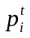, can be calculated and used for solving (QP) in round t+1.

