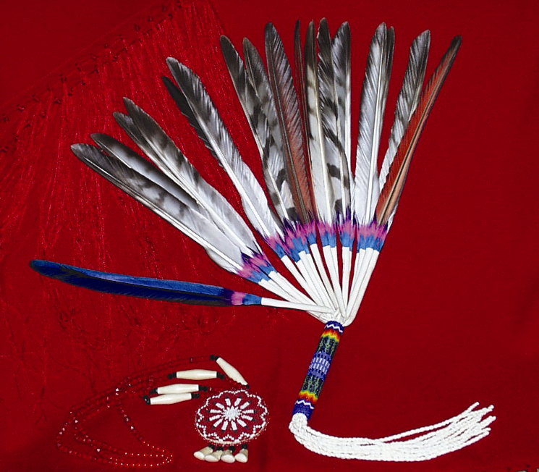

12-Area
Indian Health Service
Government Performance Results Act Report

2004

February 25, 2005

Table of Contents

Explanation of Report 1

Proportion of User Population Represented by Area 2

Twelve-Area Comparative Charts

Documented HbA1c 3
Poor Glycemic Control with Diabetic Patients 4
Good Glycemic Control with Diabetic Patients 5

Blood Pressure Control with Diabetic Patients 6
Dyslipidemia (Cholesterol) Screening with Diabetic Patients 7
Kidney Disease Screening with Diabetic Patients 8
Retinal Examinations with Diabetic Patients 9
Annual Dental visit for Diabetic Patients 10

Influenza Vaccine 11

Pneumococcal Vaccine 12

Cervical Cancer Screening 13
Breast Cancer Screening 14
Access to Dental Care 15
Fetal Alcohol Syndrome Prevention 16

Domestic Violence/Intimate Partner Violence Screening 17

Body Mass Index Measured 18

Tobacco Assessment 19

Area Success Story Summaries and Contact Information 20

Indian Health Service 12-Area Summary Report

This report is a companion document to the 2004 GPRA Executive Summary and is designed to provide Indian Health Service executives and staff with comparative information about Area level performance. It contains data about selected clinical indicators that was collected at the individual health facility level, using GPRA+ software. Information about the population that the data represents, a brief summary of Area best practices to improve GPRA participation, improving GPRA data quality, and performance on specific indicators are also included.

The graphs for the clinical indicators display results by Area for GPRA Baseline Year (GY) 2000, GY2003, and GY 2004. (The GPRA year begins July 1 and ends June 30.) Each graph also shows the IHS average for GY 2004 and either the Healthy People 2010 or IHS 2010 goal for the indicator. Areas can use the graphs to review the change in their performance from GY 2003 to GY 2004, to compare their performance to that of other Areas or to the national average, and to assess their progress towards achieving long-term goals.

The information for all three years was extracted from the RPMS databases of sites participating in the GPRA review in the summer of 2004. For that reason, the 2003 results in this document may differ from the 2003 data that was reported in the 12-Area Summary Report last year. Any differences may be attributed to one or more of the following reasons:

- The Area had different facilities reporting in 2003 and 2004.
- The 2004 data collection picked up 2003 information that got entered after the deadline for the 2003 GPRA review.
- The performance measures for some indicators were adjusted.

The map that appears on the following page displays the approximate percent of the active population that the collected data for each indicator represents. The 2004 percent was calculated by dividing the total GPRA user population represented in the 2004 GPRA review (the denominator for the Access to Dental Care indicator) by the total 2003 Area active user population (from the IHS Official Active User by Area 2003 Report). In addition, population numbers for four Urban clinics that use RPMS-provided data for the 2004 GPRA review are included in the GPRA user population for the Areas where they are located. Since the IHS Official Active Indian User count does not include Urban users, the percent of participating population may be somewhat higher than if this population were not included; an asterisk identifies those Areas. The total percentage of population represented in the 2004 GPRA review is 86%, which is significantly higher than the percentage from last year.

The long-term objective of this report is to provide Areas with comparable and consistent performance data that can be used to identify opportunities for improvement. Each Area has the capability to develop a similar report for each clinical site within their Area. The ability to access performance data at the local level will allow the Areas to identify those programs that are performing at a high level as well as those that need to improve. These distinctions will be more important as IHS moves toward performance-based budgeting at all levels.
IHS Area | GPRA Population  Includes Urban Clinics Reporting | NPIRS Population  Excludes Urban Population | 2004 Percent Reporting | 2003 Percent Reporting
Aberdeen | 114,558 | 115,335 | 99% | 94%
Alaska | 116,093 | 120,465 | 96% | 61%
Albuquerque | 88,014 | 85,481 | 100% | 100%
Bemidji | 62,974 | 85,971 | 73% | 68%
Billings | 55,685 | 68,743 | 81% | 87%
California* | 68,246 | 69,238 | 99% | 96%
Nashville | 36,100 | 37,992 | 95% | 72%
Navajo | 226,257 | 225,534 | 100% | 99%
Oklahoma* | 171,745 | 290,832 | 59% | 61%
Phoenix | 140,730 | 142,156 | 99% | 99%
Portland | 69,591 | 94,040 | 74% | 37%
Tucson^ | 18,318 | 24,016 | 76% | 76%

National Average of Sites Reporting: 86%
1,168,311 Patients

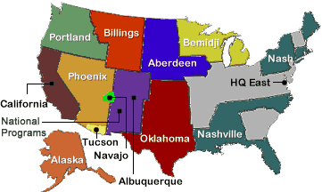

- The numerator is the GPRA population. The Denominator is the Active Indian Registrants from NPRS 2003 data.

- *Areas including RPMS Urban programs in their denominator counts.

- ^Data error in 2003. Pascua-Yaqui Tribe not reported (<98%)

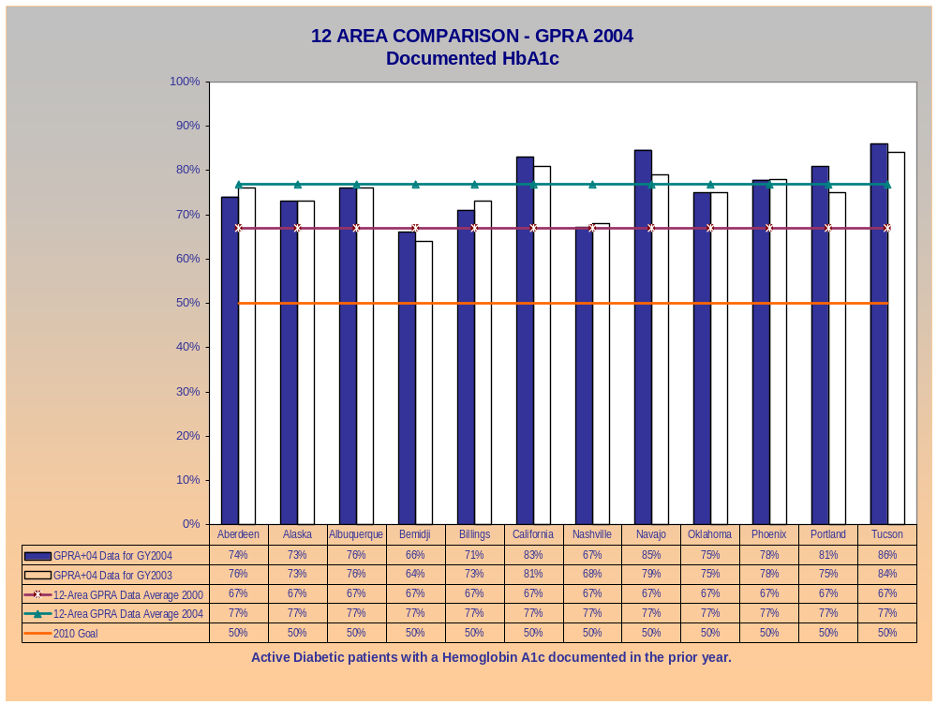
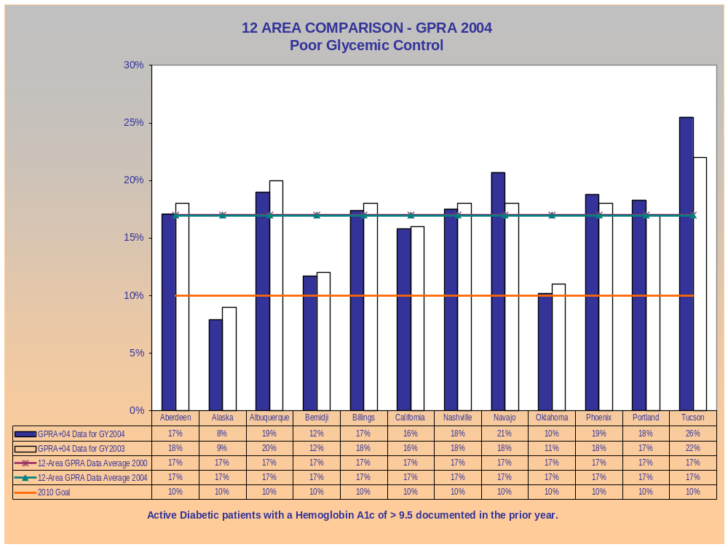
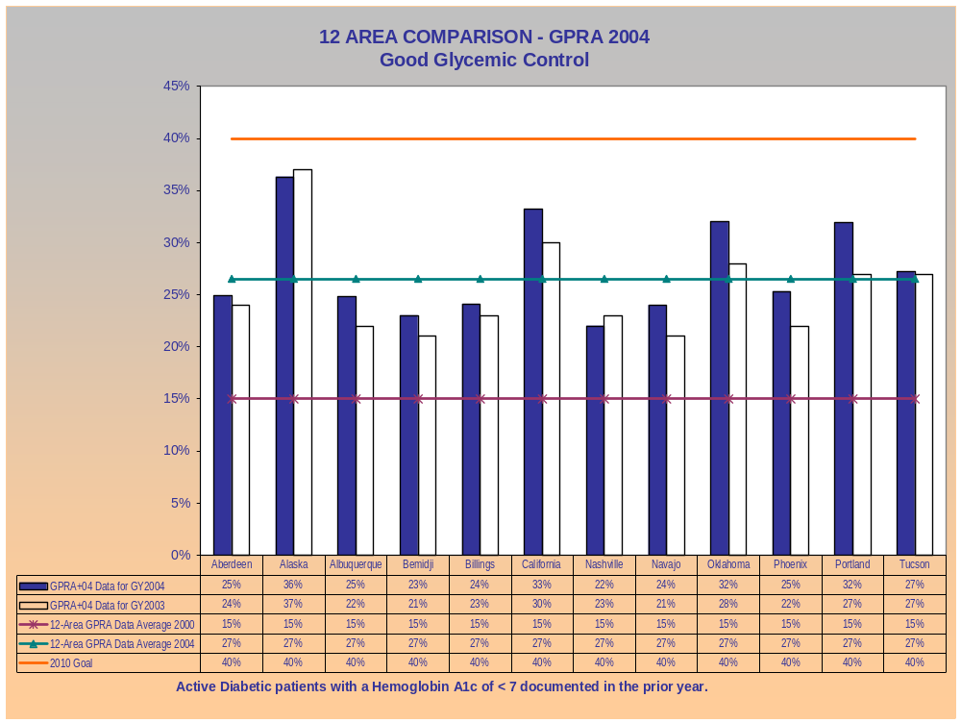
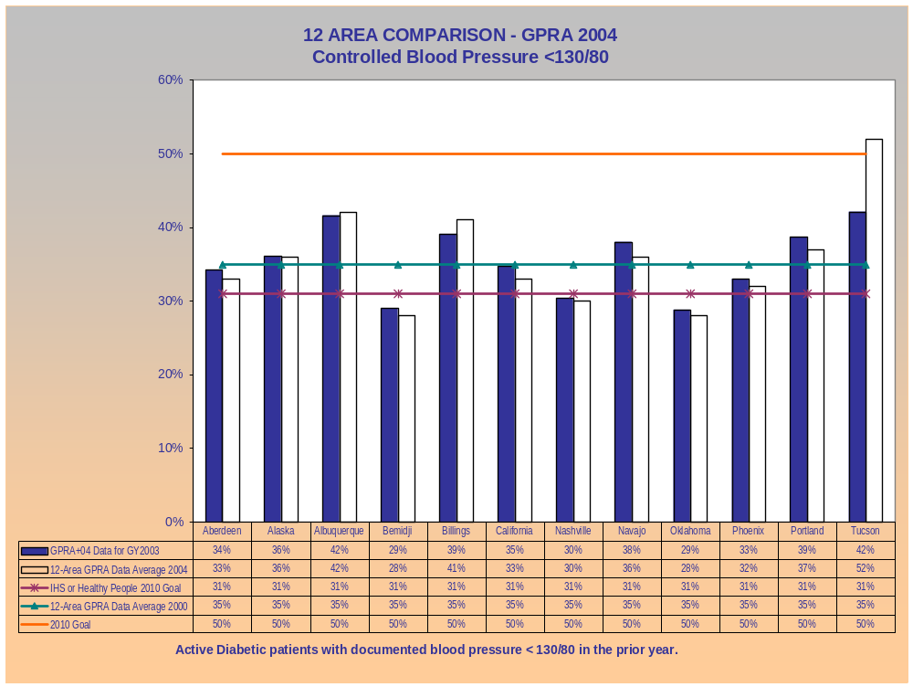
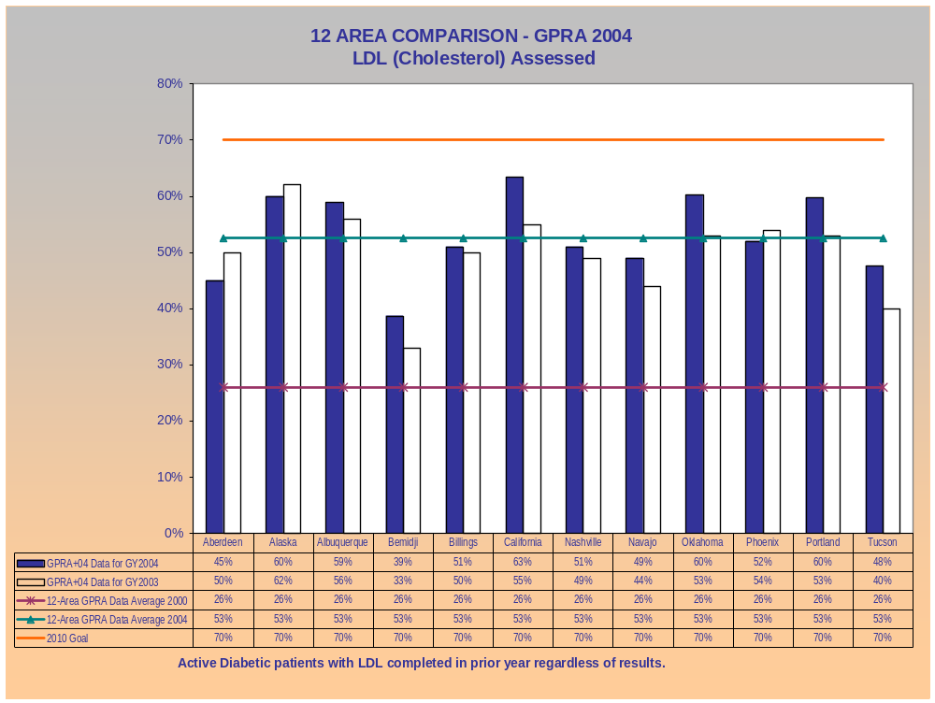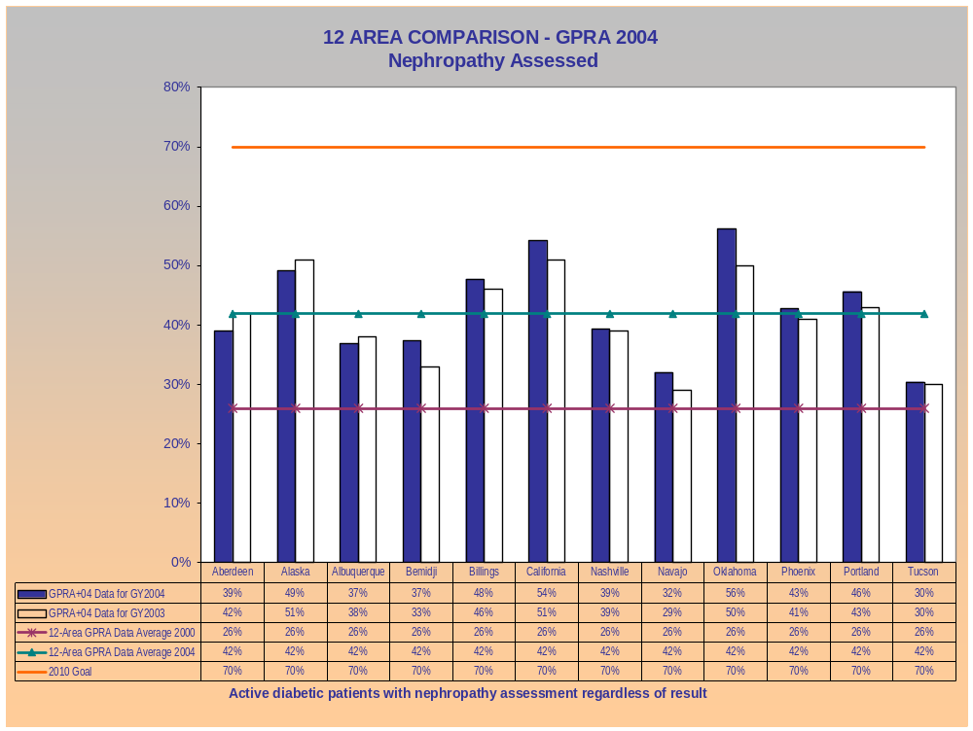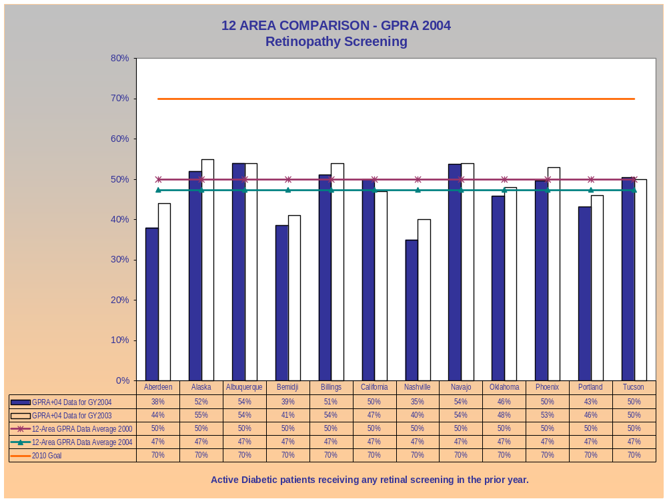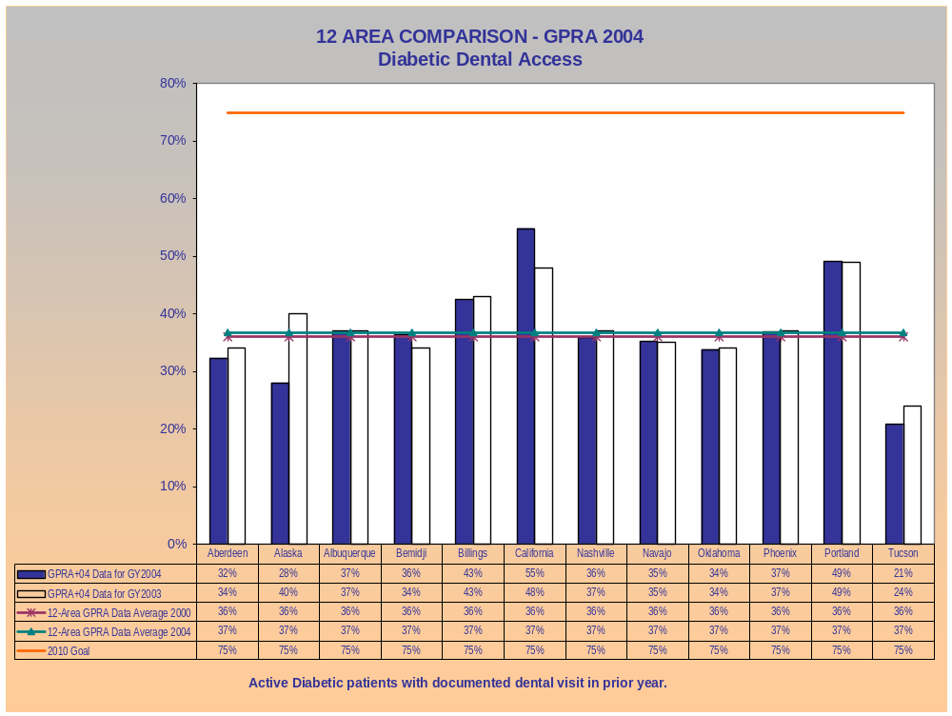
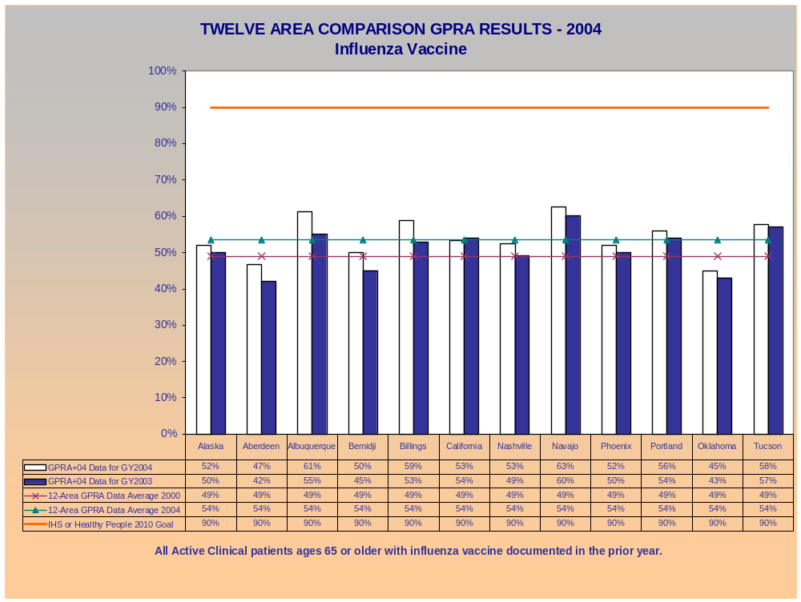
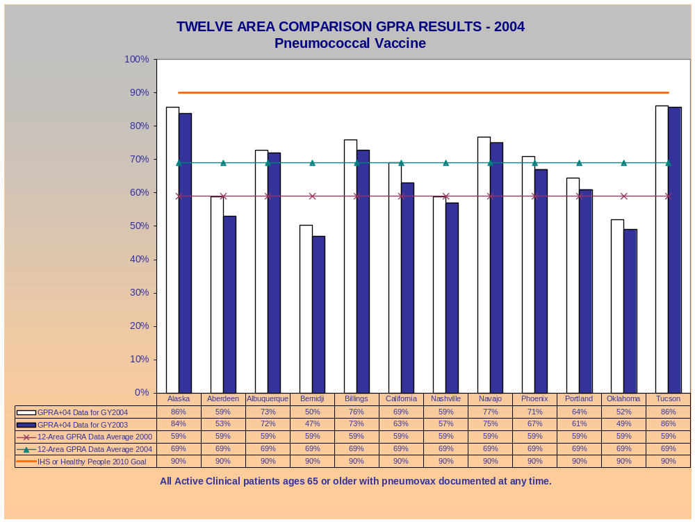
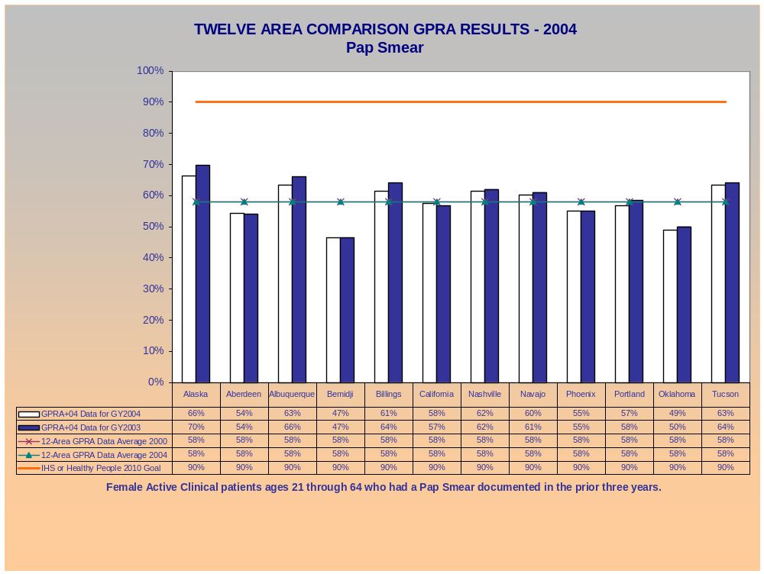
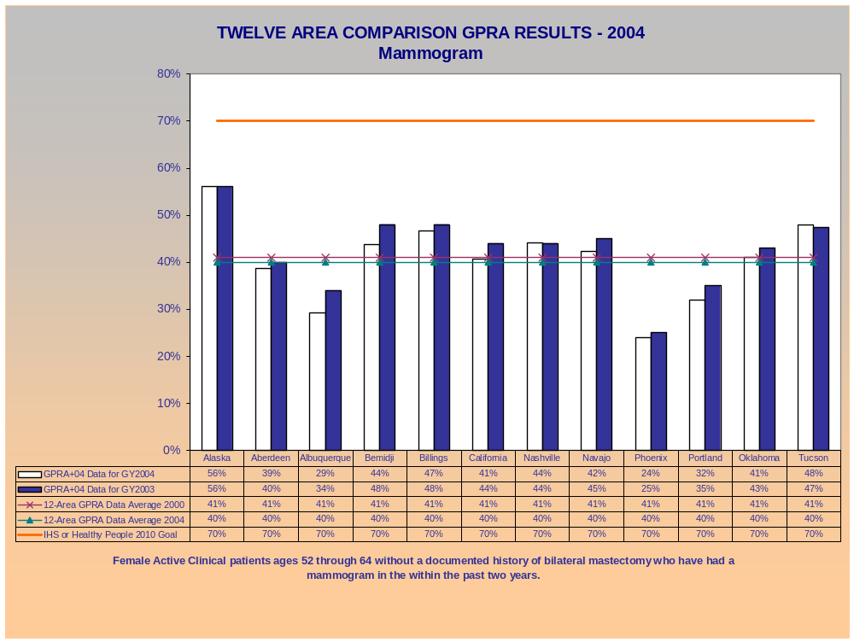
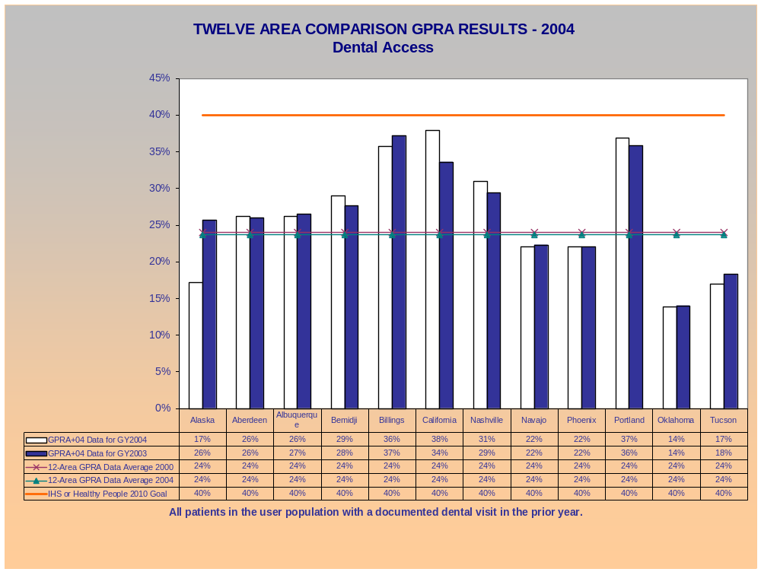
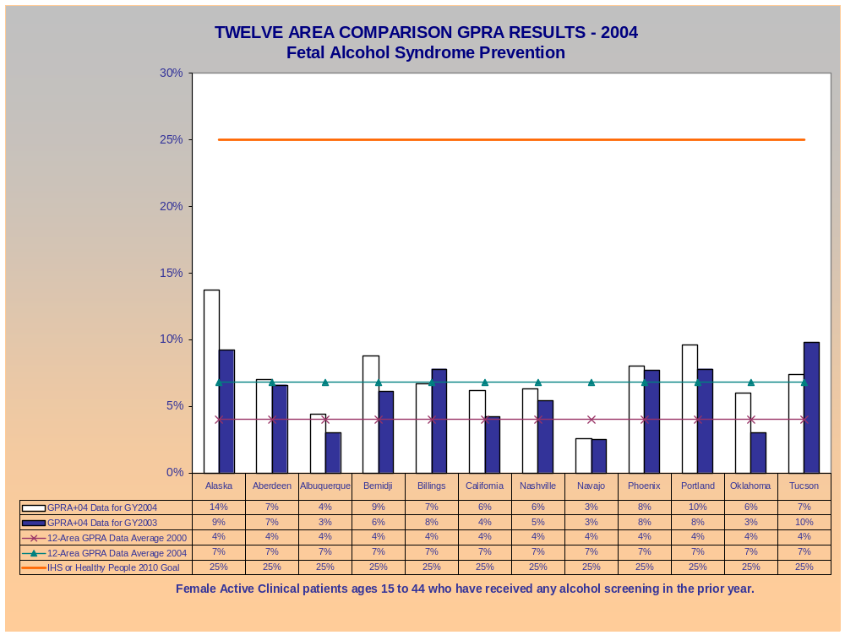
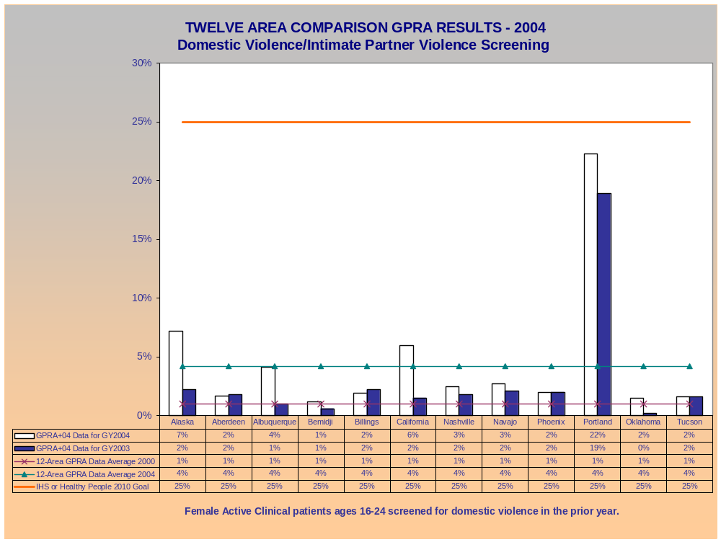
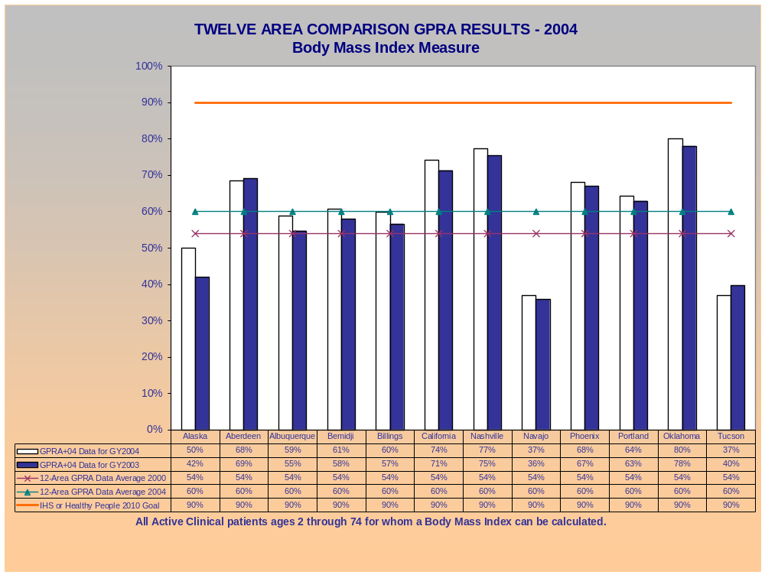
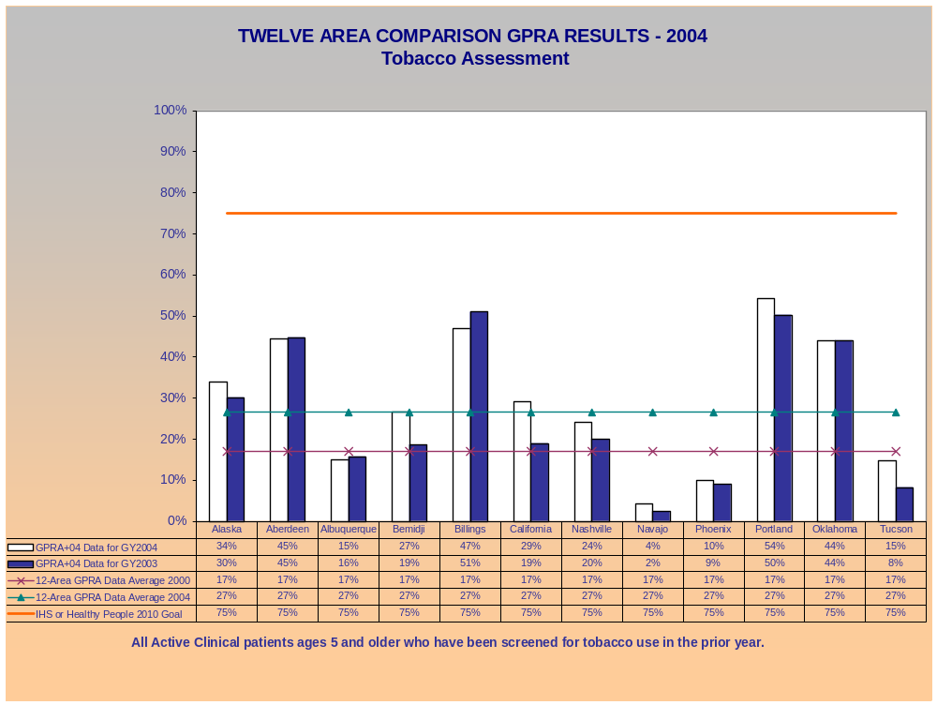

Area GPRA Success Stories

At the National GPRA Coordinators October 2004 conference, GPRA coordinators shared information about 2004 activities aimed at improving GPRA participation, data quality, and performance on specific indicators. The following paragraphs are brief summaries of information that coordinators shared and provide a sample of these activities; hopefully, these will provide ideas for other Areas and sites.

Increasing Participation

In the Portland Area continual emphasis on GPRA, as well as efforts to recognize GPRA performance with awards, improved GPRA participation dramatically in 2004. The Area added GPRA as a topic of discussion in orientations, at health board meetings and clinical directors’ meetings, and scheduled GPRA Area trainings throughout the year. In addition, the Northwest Portland Indian Health Board began a recognition program for GPRA achievements, awarding certificates to programs that improved performance or achieved the highest scores on particular indicators. These actions have generated Tribal program interest and have resulted in the additional 12 Tribal programs providing GPRA data in 2004; these twelve as well as additional Tribal programs have also agreed to participate in 2005. For more information, contact Cheryl.Bittle@ihs.gov.

Improving Data quality

Many of the success stories reported at the conference centered on ways to improve data quality and collection. Strategies included training, data assessment, conferences, committees, and working groups.

In Alaska, two new tribes joined in the Alaska GPRA Pilot Project, bringing the participation rate to 96%. The Alaska GPRA Pilot Project has undertaken several data quality initiatives. It sponsored “train the trainer” workshops on data quality, where attendees learned to compare data from patient charts to the corresponding RPMS and NPIRS records. It also created a data quality ‘swat’ team to visit remote sites and assess data.

One Alaska tribe performed a data quality assessment for the pneumovax indicator. The assessment reviewed the records of 543 elders.. Among the findings: 180 of the elders were deceased, had moved, or didn’t receive primary care; 58 immunizations were documented in the chart but not recorded in RPMS; 95% of the missing documentation occurred prior to a change to point-of-service RPMS data entry. The assessment concluded that the GPRA+ data is reliable and that point-of-service RPMS data entry is an effective method of assuring electronic patient records are updated. For more information, contact BBoedeke@akanmc.alaska.ihs.gov.

The Nimkee Memorial Wellness Center is the pilot site for implementation of GPRA in the Bemidji Area. In 2004 this tribal program provided GPRA training and mentoring to five other tribal sites as well as one urban program that is preparing to implement RPMS. Training includes: discussing indicators, data entry, and documentation; analyzing the reports to identify areas for improvement; and providing hands-on training on different RPMS functions. Beyond these basics, the training covers ways to improve documentation (requesting records from outside providers) and ways to increase patient cooperation through traditional methods (sending letters and making follow-up telephone calls) as well as some innovative approaches (one tribe entered men returning their occult stool cards into a drawing for a canoe; women coming in for annual gynecological exams were entered into a drawing for a spa package). The Tribes also learn how the benefits of GPRA extend to other areas, and are using the data for grant writing, budget justification, and requests for staff increases. For more information, contact Mary.Fairbanks@ihs.gov.

During FY 2004 the Nashville Area, in collaboration with the United South & Eastern Tribal Organization (USET), implemented an Area Data Quality Committee which focuses on data collection and data integrity. The Nashville Area also has planned a Medical Providers Best Practice conference to educate providers about clinical best practices and data and quality improvement. This Continuing Medical Education (CME) conference will focus on improving patient care through GPRA/CRS tracking and implementing best practices. The conference will feature presenters (including senior clinicians and academics) on every category of GPRA indicators. To insure good attendance, the Area has made the training mandatory for clinic directors and has funded each tribal site to send providers, including Contract Health Service (CHS) only programs, which can invite their CHS providers. After the conference, the Area plans to continue provider documentation training and best practices tracking, using senior clinicians, with the USET Epi-Center to provide updates on disease in the AI/AN community. For more information, contact Byron.Jasper@ihs.gov.

The Albuquerque Area established a Documentation Improvement Committee that brings together representatives of each facility. Its goal is to help improve the documentation process in order to improve patient care, data, GPRA results, and all other workload outputs. The committee, which includes providers and staff from the medical records, billing, and coding functions, meets once each month. If the primary member is not able to attend, an alternate must be designated to attend in person or via conference call. At meetings, members share best practices, standards, policies, and procedures. As a group, they have been able to identify problems, such as a lack of GPRA training for providers, and develop responses to these issues on the spot. For more information, contact Regina.Robertson@ihs.gov.

In the Navajo Area, where 100% of sites reported GPRA data, every service unit has a GPRA coordinator, and there are individual GPRA indicator leads to increase the understanding of the facility’s RPMS data process and the need for improvement at the facility level. There is also a “Strategic Planning for Data Quality Group,” consisting of a mix of physicians, nurses, business office staff, and data entry personnel that report to the Area’s Service Unit Management Council. The group’s one-day meetings focus on workflow monitoring, data flow, and integrated GPRA problem solving by sharing success stories. The group identified and is addressing a need to improve provider documentation and awareness of performance measures. In 2005, their focus will be improving documentation of domestic violence screening and diabetic indicators. For more information, contact Genevieve.Notah@ihs.gov.

The Oklahoma Area created I/T/U Work Groups to focus on improving GPRA data quality, in terms of collection, data entry, extraction, and analysis of results. One project undertaken was a “Who uses What” survey to identify which RPMS packages each employee was using. The Area used the information to plan training. In addition, the Area designated a super user for each package in use. The super-users will be a resource for all other users who may have data entry questions or difficulty using a package. More standardized data entry is one outcome the Area expects to result from these actions. For more information, contact Marjorie.Rogers@ihs.gov.

Improving Results on Targeted Indicators

Diabetic Retinal Screening Indicator
Seven Tribal clinics in California have been able to obtain retinal cameras for tele-opthalmology, using a California Endowment grant obtained by the California Rural Indian Health Board. The clinics have implemented this tele-ophthalmology initiative using a community-based model. Lay technicians have been trained to operate the cameras, conduct non-dilated exams and transmit the retinal photos electronically to an ophthalmologist for examination. If the findings are positive, the patient is referred for laser treatment.

The clinics use various methods to maximize screening rates. At one site, the tele-ophthalmology coordinator takes pictures once monthly or every other month, after a community health representative has contacted eligible patients and arranged to transport them to the clinic; at this site the screening rate went to 70%. At another site, two lay people were trained to do eye exams, and the exams are done whenever anyone needing one walked through the door. The clinic staff pages overhead that retinal pictures are needed and the patient is assessed at that same visit. For more information, contact Dawn.Phillips@ihs.gov.

Influenza Immunization Indicator
In the Billings Area, at the Blackfeet Service Unit, a “Beat the Bug” campaign increased influenza immunization rates. Special “love bug” letters, sent to high risk patients, provided patient education and instructions for obtaining an immunization. In addition, the facility established standing orders to allow vaccination without a provider examination, created laminated cards with immunization eligibility requirements for the nursing staff, and prepared customized Patient Care Component (PCC) forms with pre-printed codes to properly document administration of the vaccine. The laminated cards and customized PCC forms allowed for standardization of documentation, so that data entry staffs were able to quickly find accurately coded immunization information. For more information, contact Diane.Jeanotte@ihs.gov.

Diabetic Indicators
The Phoenix Area has established a quality council to provide guidance to facilities in the Area and share information, including success stories. Working with the Council, the Colorado River Service Unit established a diabetes process team to design a comprehensive diabetes team to improve care. The team developed and implemented weekly diabetic clinics with laboratory tests, dental and optometry screenings, medical assessment, and patient & family education. The team also participated in numerous community prevention activities. GPRA 2004 results for Parker Indian Health Center show the positive impact of these efforts with increases in good glycemic control, nephropathy, and diabetic dental access between 2003 and 2004. For more information, contact Steven.Tetrev@ihs.gov.

BMI Indicator
At the Saginaw tribe’s Nimkee Memorial Wellness Center in the Bemidji Area, the diabetes coordinator has been focusing on the BMI indicator for a childhood obesity initiative. Staff collected data on tribal elementary and middle school students and worked with the schools’ administration. They presented the data to the tribal council, and the council was convinced to approve and hire a school fitness director. For more information, contact Mary.Fairbanks@ihs.gov.

Mammogram Indicator
The Tucson Area Sells Service Unit is using a mobile van to provide mammogram screening at its Sells, Santa Rosa, and San Xavier sites, and this program is improving mammogram rates. When the contract for this program began in September 2002, the mammogram rate for that year at those sites was 42% as measured by GPRA+. In 2003 the rate rose to 47%, and in 2004 the rate was 48%. For additional information, contact Karen.Higgins@ihs.gov.

