

Improving the Quality of Health Care 2004

Measuring Successes and Challenges

Acknowledgements

Dr. Stephen Jay Mader (1951-2004)

Data collected by:

IHS and Tribal Health Program staff
IHS Area GPRA Coordinators
IHS Headquarters GPRA leads

Area GPRA Coordinators:

Aberdeen | Mary Lynne Eaglestaff | (605) 226-7306 | Mary.Eaglestaff@ihs.gov
Alaska | Bonnie Boedeker | (907) 729-3665 | BBoedeke@akanmc.alaska.ihs.gov
Albuquerque | Regina Robertson | (505) 248-4773 | Regina.Robertson@ihs.gov
Bemidji | Mary Fairbanks | (218) 444-0487 | Mary.Fairbanks@ihs.gov
Billings | Diane Jeanotte | (406) 247-7125 | Diane.Jeanotte@ihs.gov
California | Carol Goodin | (916) 930-3927 | Carol.Goodin@ihs.gov
Nashville | Byron Jasper | (615) 467-1507 | Byron.Jasper@ihs.gov
Navajo | Jenny Notah | (928) 871-5836 | Genevieve.Notah@ihs.gov
Oklahoma | Marjorie Rogers | (405) 951-6020 | Marjorie.Rogers@ihs.gov
Phoenix | Steve Tetrev | (602) 364-5190 | Steven.Tetrev@ihs.gov
Portland | Cheryl Bittle | (503) 326-3288 | Cheryl.Bittle@ihs.gov
Tucson | John Kittredge | (520) 295-2406 | John.Kittredge@ihs.gov

Special thanks for data analysis, data format presentation, and report preparation to:
Elaine Brinn, Theresa Cullen, Carol Goodin, and Amy Patterson

IHS Contacts:
Theresa Cullen, MD, Timothy Taylor, PhD
Phone: (520) 670-4803 Phone: (301) 443-1549
Theresa.Cullen@ihs.gov Timothy.Taylor@ihs.gov

Table of Contents

Executive Summary 1
Detail of Selected Clinical Indicators 4
Poor Glycemic Control 5
Ideal Glycemic Control 6
Blood Pressure Control 7
Dyslipidemia Assessment 8
Nephropathy Assessment 9
Diabetic Retinopathy 10
Pap Screening 11
Mammography Screening 12
Alcohol Screening (Fetal Alcohol Syndrome Prevention) 13
Dental Access 14
Dental Sealants 15
Diabetic Dental Access 16
Public Health Nursing 17
Intimate Partner Violence………………………………………………………………….18
Childhood Immunizations 19
Influenza Immunizations 20
Pneumococcal Immunizations 21
Summary of Other Indicators Met or Not Met 22
Graphics Credits & References 24

Executive Summary

The Indian Health Service (IHS) is the agency within the Department of Health and Human Services that carries out the federal government’s trust responsibility to provide health care services to eligible American Indian and Alaska Native (AI/AN) people. IHS provides these health services through a network of hospitals, emergency clinics, health stations, school-based clinics, and numerous Alaskan village clinics.

These facilities provide direct health care services to over 1.9 million AI/AN people. Currently, over half of the Indian health system is operated directly by tribal governments through contracts or compacts. In addition to these tribally operated programs, IHS contracts with urban Indian organizations to provide services to eligible AI/AN people who reside in large metropolitan areas. Together, these sources of care are known as the IHS/Tribal/Urban (I/T/U) network. When the capability to provide a particular service is not available through this network, the IHS Contract Health Services (CHS) appropriation covers the cost of referring patients to hospitals and specialists. However, most health programs deplete their funds prior to the end of the year.

Historically, the Indian Health Service has succeeded in substantially improving the health status of the AI/AN population, primarily by focusing on preventive and primary care services and developing a community-based public health system. Examples can be seen in the dramatic decreases in mortality rates for certain health problems between 1972-1974 and 1997-1999:

- Maternal mortality reduced 79% (31.6 to 6.7 per 100,000);
- Tuberculosis mortality reduced 86% (10.7 to 1.5 per 100,000);
- Gastrointestinal disease mortality reduced 72% (6.7 to 1.9 per 100,000);
- Infant mortality reduced 65% (25.0 to 8.8 per 100,000);
- Unintentional injuries mortality reduced 54% (206.7 to 95.1 per 100,000).

The average death rate from all causes for the AI/AN population dropped a significant 21% between 1972-1974 and 1996-1998.

However, population growth and economic factors are creating pressure on AI/AN communities and the IHS system. From 1990 to 2000, the AI/AN population grew at a rate of 26%, while the total U.S. population grew by only 13%. The Census Bureau projects a 40% increase in the AI/AN population from 2000 to 2025. In addition, the 1999 unemployment rate for the AI/AN population was 2.5 times higher than the rate for the rest of the population;

the percent of the AI/AN population living in poverty was more than three times that of the non-Hispanic white population in 1999 (25.7% compared to 8.1%). Educational levels, which influence economic prospects, also reflect significant differences. The 2000 census reported that among people aged 25 and older who identified their race as AI/AN only, 11% had a bachelor’s degree or higher compared with 26.7% of all people aged 25 and older; only 71% of AI/ANs had at least a high school diploma compared to 84.1 % of all people in the 25 and older age range.

The AI/AN population suffers disproportionately from a number of health problems. For example:

- The 1999-2001 death rate from alcohol abuse was more than 6 times higher among AI/ANs than the rate for all races in 2000;
- In 2001, AI/ANs were 2.6 times more likely to have diagnosed diabetes than non-Hispanic whites and the death rate from diabetes was 2.9 times higher among AI/ANs than non-Hispanic whites;
- The death rate from diabetes in the AI/AN community has increased by 79.9% between 1972-1974 and 1999-2001.

The growth in AI/AN population and chronic disease rates, as well as socioeconomic constraints, are increasing the challenge of effectively improving the health status of this population. While the death rates for both the AI/AN and the U.S. All Races populations dropped according to the most recent statistics published in January 2005, the rate of decline among U.S. All Races from 1997 to 2000 was almost twice the rate of decline among AI/ANs from 1996-1998 to 1999-2001. The 1999-2001 mortality rates for the AI/AN population (adjusted to compensate for misreporting of AI/AN race on state death certificates) are 21% higher than the 2000 mortality rate for U.S. All Races. In 2004, the agency GPRA results reflect the difficulty of maintaining services in light of increasing demand, as the number of annual GPRA targets that were met dropped below 70%.

At the same time, it is important to note that the number of patients actually receiving care has risen. The agency has made significant progress on some important indicators. For example, in 2004, the screening rate for diabetic nephropathy rose from 38% last year to 42%. End stage renal disease or diabetic kidney disease, is a significant and growing problem in Indian communities. Early identification of patients at risk for end stage renal disease may help to prevent or delay the need for costly care such as dialysis or renal transplant.

This year, IHS also made progress in increasing the pneumococcal vaccination rate for adults over 65 years of age from 65% in 2003 to 69% in 2004. The improvement in pneumococcal vaccination rates is important because studies have shown that AI/AN people are at high risk for this disease; the 1999-2001 AI/AN death rate from pneumonia and influenza was 42% greater than the 2000 U.S. All Races death rate. Vaccination of the elderly against this disease is one of the few medical interventions that has been shown to improve health status and save on medical costs.

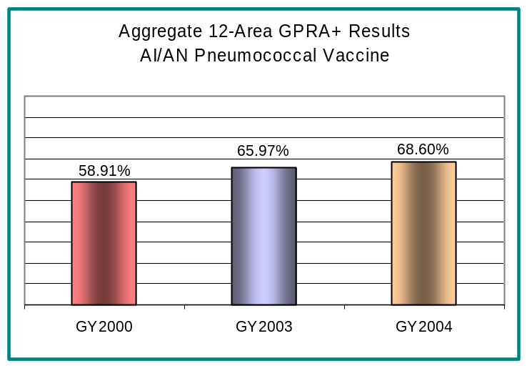

Clearly, the I/T/U programs have demonstrated the ability to improve AI/AN health over time. In 2004, IHS continued to maximize health outcomes. Accountability for GPRA Government Performance Results Act (GPRA) results is now part of the performance appraisal criteria at all levels. Clinical Results System software, which provides the capability for local programs to identify non-compliant patients for follow-up, has been deployed nationally to interested local facilities. Training for program staffs is presented in every IHS Area. Area GPRA coordinators have been actively networking to share information and material on successful programs, as well as technical assistance to programs to identify ways of improving clinic operations.

The annual GPRA evaluation is one of a number of measures that assesses IHS performance. One other important measure is the Performance Assessment Rating Tool (PART) used by OMB (Office of Management and Budget). The single IHS program assessed by the PART for this budget cycle was the Health Care Facilities Construction Program, which received an overall score of 92%. One of the strengths of this program is its clear linkage to annual GPRA indicators and ultimately to the long-term goal of reducing the Years of Potential Life Lost (YPLL). In essence, this program documents how the construction of health care facilities contributes to expanding access to critical services as identified by clinical performance measures documented in the IHS GPRA plan at specific sites once they are completed and staffed.

This increase in access to critical services over time results in the reduction of premature deaths as measured by YPLL. The Health Care Facilities Construction Program’s PART assessment required no new performance measures beyond the existing GPRA indicators (including the efficient construction of facilities) and the long-term measure of YPLL from the IHS Strategic Plan. Finally, the contribution of this program to HHS objectives 3.4 Eliminate racial and ethnic health disparities and 3.6 Increase access to health services for AI/ANs is exceptionally clear.

Detail of Selected Clinical Indicators
Government Performance Results Act
2004



Poor Glycemic Control

Indicator: Assure that the proportion of patients with diagnosed diabetes that have poor glycemic control does not increase.

Importance: Reducing the number of patients with poor blood sugar control will reduce the prevalence of diabetes complications. Some clinical studies have shown that a 1% decrease in the absolute A1c level translates into: 14% decrease in total mortality, 21% decrease in diabetes-related deaths, 14% decrease in myocardial infarction, 40% decrease in eye disease, 12% decrease in strokes, 43% decrease in amputations, and a 24% decrease in kidney failure. Reducing A1c levels can also save $800 per person in annual health care costs.

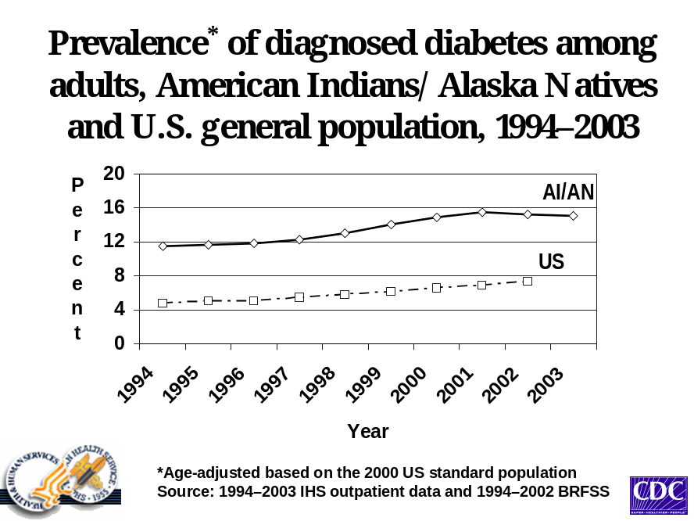2004 Target: Establish the baseline of patients with diagnosed diabetes that have poor glycemic control.

Data source: GPRA+ electronic examination of 74,408 patient records
IHS diabetic Care and Outcomes Audit

Results: IHS met this indicator by setting a baseline.

Discussion and analysis: According to GPRA+ results, in 2004, 17% of diabetic patients had poor glycemic control (>9.5), as measured by the Hemoglobin A1c test that measures average blood sugar over the last 1-2 months.

Ideal Glycemic Control

Indicator: Address the proportion of patients with diagnosed diabetes that have demonstrated ideal glycemic control.

Importance: Keeping Hemoglobin A1c levels below 7 can slow or prevent the onset and progression of eye, kidney, and nerve disease caused by diabetes. Good blood sugar control also lowers the risk of heart attack and stroke.

2004 Target: Increase the proportion of I/T/U clients who have demonstrated ideal glycemic control by 1%.

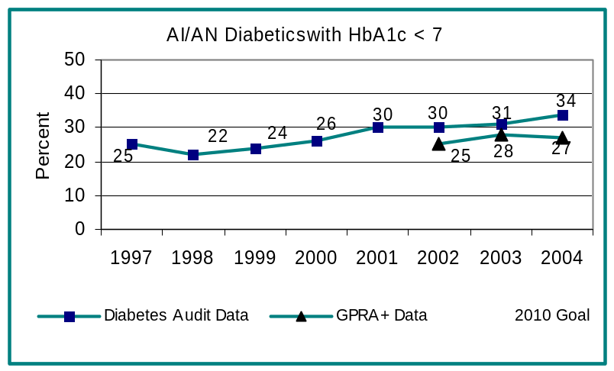

Data source: GPRA+ electronic examination of 74,408 patient records
IHS Diabetic Care and Outcomes Audit

Results: IHS met this indicator based on diabetic audit data.

Discussion and analysis: The FY 2004 diabetic audit data showed a 3% increase in the proportion of I/T/U clients with diagnosed diabetes that have demonstrated ideal glycemic control. These results reflect meaningful agency accomplishment considering:

- The prevalence of diabetics in the communities represented in the GPRA+ review has increased from 8% in 2000 to 10% in 2004.
- The number of patients being treated for diabetes in these same communities is 7% higher than the number treated in 2003 and 34% higher that in 2000.
- 77% of diabetic patients were screened for HbA1c, compared to 67% in 2000, substantially exceeding the Healthy People 2010 goal of 50%.
- The number of patients in good control increased from 18,998 in 2003 to 19,743 in 2004.

Blood Pressure Control

Indicator: Address the proportion of patients with diagnosed diabetes that have achieved blood pressure control.

Importance: This indicator is directed at reducing complications of diabetes. A National Heart, Lung, and Blood Institute report indicates that the risk of heart disease and stroke doubles for every increase of 20 mm in systolic or 10 mm in diastolic pressure. Lower blood pressure levels in people with diabetes reduce the risk of heart disease and stroke by 33-50%. Blood pressure control also reduces the risk of eye, kidney, and nerve disease by one third.

2004 Target: Increase the proportion of I/T/U patients with diagnosed diabetes that have achieved blood pressure control (<130/80) by 1% over the FY 2003 level.

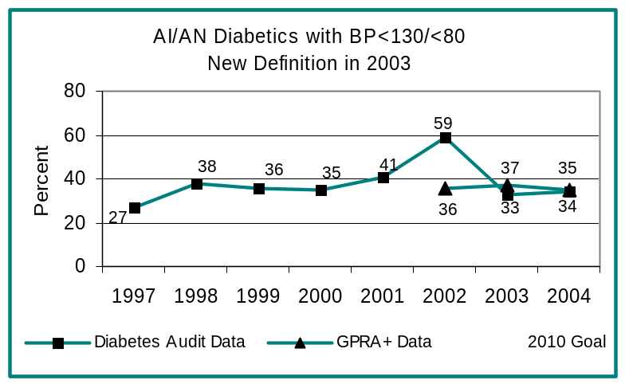

Data source: GPRA+ electronic examination of 74,408 patient records
IHS Diabetic Care and Outcomes Audit

Results: IHS met this indicator based on diabetic audit data.

Discussion and analysis: The FY 2004 diabetic audit data showed that the proportion of patients in good control increased from 33% to 34%. GPRA+ data showed a drop in the percentage of patients who achieved good control from 37% in 2003 to 35% this year. This drop may be attributable to tightening the definition of good blood pressure control in GPRA+ software from 2003 to 2004. As a result, some patients who were considered to be in good control last year are no longer in that category.

Dyslipidemia Assessment

Indicator: Address the proportion of patients with diagnosed diabetes assessed for dyslipidemia.

Importance: Low cholesterol levels help to protect diabetic patients from developing heart disease. Improved control of cholesterol levels reduces the risk of cardiovascular complications by 20-50%. National standards recommend that people with diabetes keep their cholesterol levels below 200 mg/dl, and their LDL cholesterol levels below 130 mg/dl and ideally below 100 mg/dl. Diabetic patients are especially prone to develop heart disease and therefore identification and treatment of elevated lipids in diabetic patients is extremely important. In addition, because persons with diabetes who experience a heart attack have an unusually high death rate either immediately or in the long term, a more intensive prevention strategy is warranted.

2004 Target: Increase the proportion of patients with diagnosed diabetes assessed for dyslipidemia by 1% over the FY 2003 level.

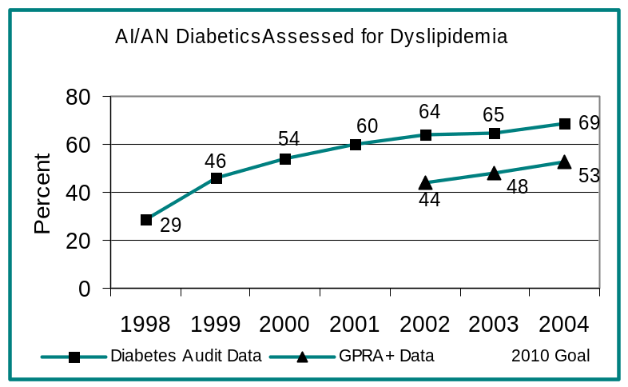

Data source: GPRA+ electronic examination of 74,408 patient records
IHS Diabetic Care and Outcomes Audit

Results: IHS met this indicator in 2004.

Discussion and analysis: The target of increasing the number of patients assessed for dyslipidemia was met and substantially exceeded according to both the diabetic audit data and GPRA+ data.

Nephropathy Assessment
Indicator: Address the proportion of patients with diagnosed diabetes assessed for nephropathy.

Importance: Diabetes can cause kidney disease by damaging the parts of the kidneys that filter out wastes. Diabetes is the leading cause of end stage renal disease (ESRD) and kidney failure, a growing problem in Indian communities. Early identification of at risk patients may help prevent or delay the need for costly care such as dialysis or kidney transplant.

Microalbumin (small amounts of protein) in the urine is an early sign of diabetic kidney disease. Proteinuria (any protein in the urine) is also an independent predictor of cardiovascular disease, which is the number one killer of American Indian and Alaska Native adults.

2004 Target: Increase the proportion of patients with diagnosed diabetes assessed for nephropathy by 1% over the FY 2003 level.

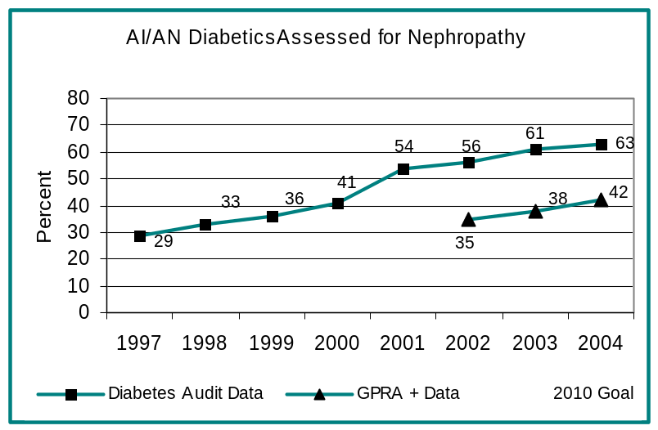

Data source: GPRA+ electronic examination of 74,408 patient records
IHS Diabetic Care and Outcomes Audit

Results: IHS met this indicator.

Discussion and analysis: The target of increasing the number of patients assessed for nephropathy was met and substantially exceeded, with a 4% increase in the number of patients assessed based on GPRA+ data and a 2% increase according to the diabetic audit data.

Diabetic Retinopathy

Indicator: Address the proportion of patients with diagnosed diabetes who receive an annual diabetic retinal examination at designated sites.

Importance: Diabetes can affect sight by damaging the blood vessels inside the eye, a condition known as “diabetic retinopathy.” Diabetic eye disease is a leading cause of blindness in the United States. Early detection of diabetic retinopathy (DR) is a fundamental part of the effort to reduce visual disability in diabetic patients. Clinical trials demonstrated that effective laser photocoagulation treatment of DR could reduce vision loss by 90%. These studies also underscore the need for early identification of DR at a time when laser photocoagulation is most effective

2004 Target: During FY 2004, increase the proportion of I/T/U patients with diagnosed diabetes who receive an annual diabetic retinal examination at designated sites by 3% over the FY 2003 rate.
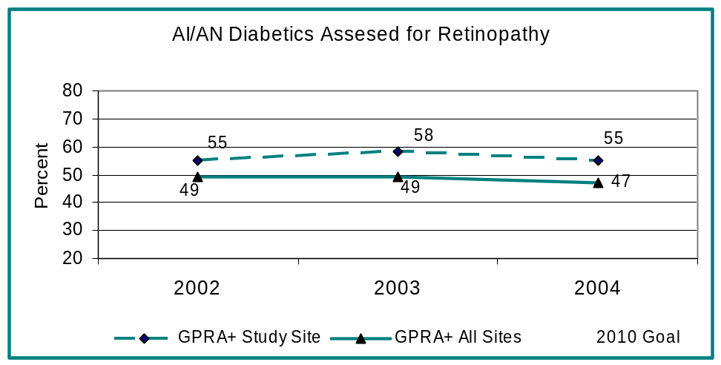

Data source: GPRA+ data from RPMS databases at selected pilot sites as well as all other facilities.

Results: IHS did not meet this indicator.

Discussion and analysis: In FY 2003, the examination rate for pilot sites was 58%; in FY 2004, the rate dropped to 55%. Reasons for this drop include an increase in the size of the diabetic population as well as eye department staff decreases, or lack of staff increases. Adjusting for these variables, increases can be shown at all pilot sites except one, where the “Tmed-DR” telemedicine program was minimally operational in 2004 due to staffing issues. Compared with the results of all sites providing GPRA+ data in FY 2004, the results at pilot sites are impressive. The rates for all sites dropped from 49% in FY 2003 to 47% in FY 2004.

Pap Screening

Indicator: Address the proportion of eligible women patients (ages 18 through 64) who have had a Pap screen within the previous three years.

Importance: American Indian women have a cervical cancer mortality rate of 3.8 (1999-2001) exceeding the 2000 rate of 2.8 for U.S. All Races. More than any other racial or ethnic group, American Indian women report having never had a Pap screen. Regular screening with a Pap screen lowers the risk of invasive cervical cancer. If cervical cancer is detected early, the survival rate is almost 100 percent with appropriate treatment and follow- up.
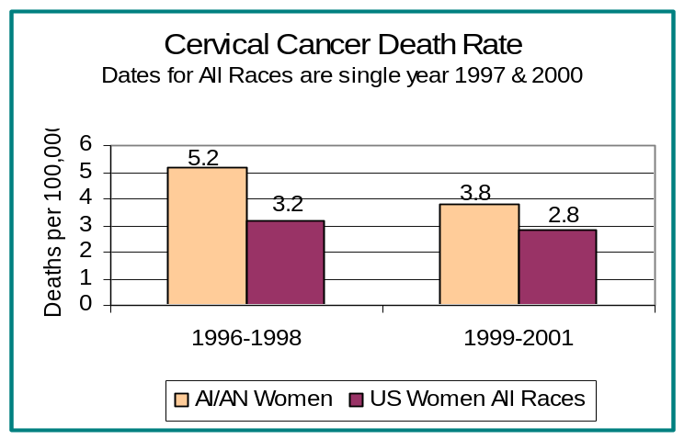
2004 Target: Maintain the proportion of eligible women patients who have had a Pap screen within the previous three years at the FY 2003 levels.
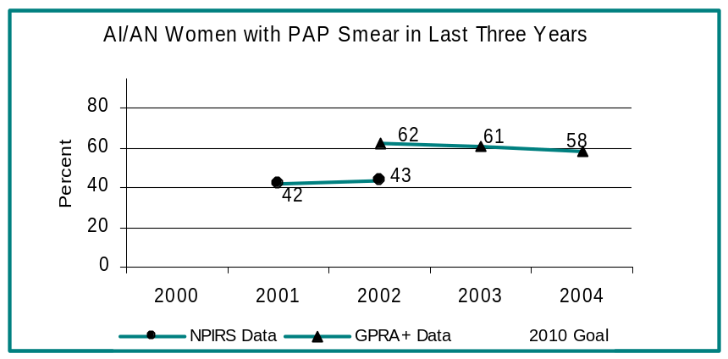

Data source: GPRA+ electronic examination of 227,904 patient records

Results: IHS did not meet this indicator, partly because gynecological examinations are no longer counted unless the patient record explicitly states a Pap screen has been done.

Discussion and analysis: In 2004 the Pap screen rate was 58%, a drop of 3% from the 61% rate reported in 2003.

Mammography Screening

Indicator: Address the proportion of eligible women (ages 50 through 64) who have had mammography screening within the last 2 years.

Importance: Screening women every two years between the ages of 50 and 69 has been shown to be a cost effective way to decrease the breast cancer mortality rate. Breast cancer is the second leading cause of cancer death among U.S. women (lung cancer is first). Regular mammography screening can reduce breast cancer mortality by 20-30%. AI/AN women diagnosed with breast cancer have lower 5-year survival rates in comparison to whites, mainly because their cancers are less likely to be found in earlier stages.

2004 Target: During FY 2004, maintain the proportion of eligible women patients who have had mammography screening within the last 2 years at the FY 2003 level.

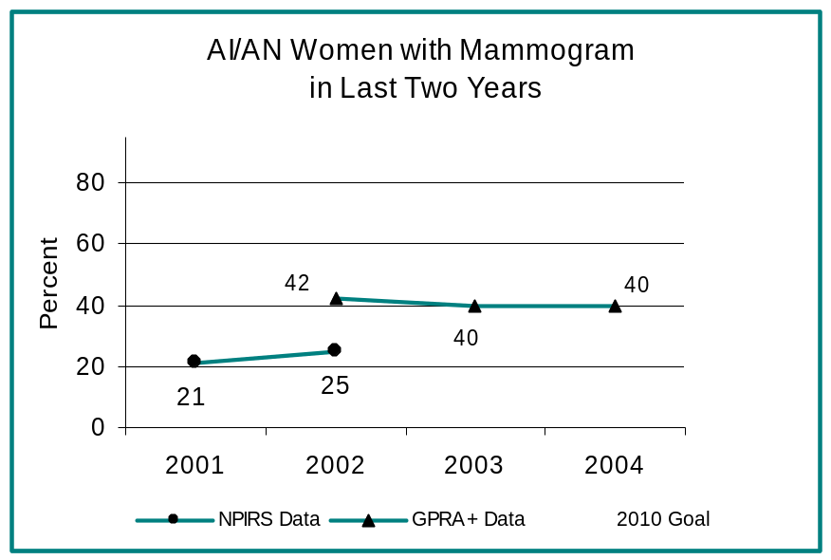

Data source: GPRA+ electronic examination of 39,780 patient records.

Results: IHS met this indicator

Discussion and analysis: The 2004 mammogram rate remained unchanged from the 2003 rate of 40%. Experience with mobile mammography demonstrates that lack of equipment to perform screenings on site is one reason this rate is difficult to increase. For example, one site offering mobile mammogram service had a 56% screening rate in 2003; the rate dropped to 47% in 2004 when the service was not available. Similarly, another site with a 48% screening rate in 2003 dropped to a 20% rate in 2004 when its grant for mobile mammography ended. A second factor is that Contract Health Service funding, used to purchase care not available at the local operating unit, is often spent on emergency care.

Alcohol Screening (Fetal Alcohol Syndrome Prevention)

Indicator: Address screening for alcohol use in appropriate female patients.

Importance: Heavy drinking during pregnancy can cause significant birth defects, including Fetal Alcohol Syndrome (FAS). FAS is the leading known, and preventable, cause of mental retardation. Rates of FAS are higher among AA/ANs than the general population. The US Preventative Services Task Force recommends screening and behavioral counseling interventions to reduce alcohol misuse by adults, including pregnant women, in primary care settings. Screening with intervention has been shown to be effective in reducing alcohol misuse in pregnancy and to reduce the incidence of FAS.

2004 Target: During FY 2004, establish a baseline screening rate for alcohol use in women of childbearing age.

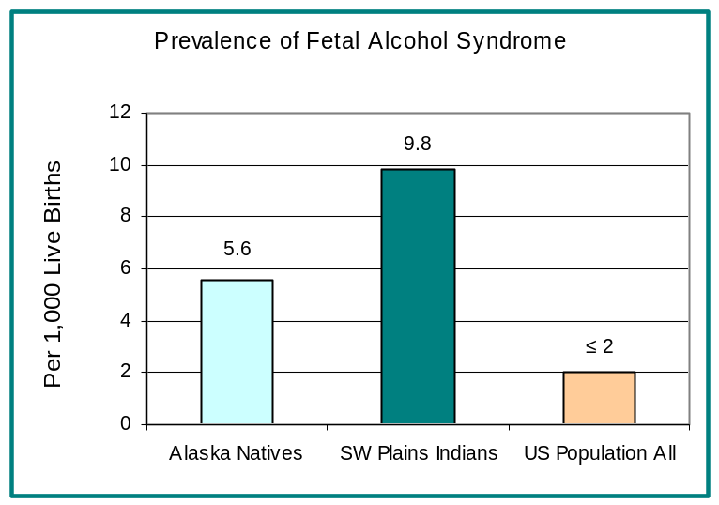

Data source: GPRA+ electronic examination of 217,255 patient records

Results: IHS met this indicator and established a baseline screening rate of seven percent.

Discussion and analysis: The intermediate goal of this indicator is to increase the screening rate for women of childbearing age. The long term goal is a reduction in the incidence of Fetal Alcohol Syndrome.

Dental Access

Indicator: Address the proportion of AI/AN patients who obtain access to dental services.

Importance: This indicator is directed at improving the oral health status of the American Indian and Alaska Native population. Untreated tooth decay can cause abscesses and infections, pain, dysfunction and weight loss. Dental problems result in the loss of almost 2.5 million workdays each year. Access to dental care improves oral health as well as the overall health of AI/AN people.

2004 Target: Maintain the proportion of patients that obtain access to dental services at the 2003 level.

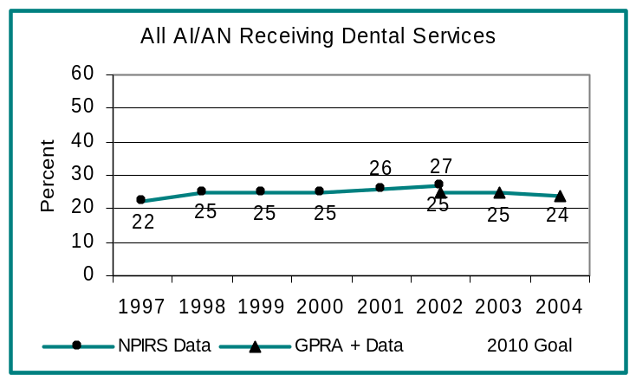

Data source: GPRA+ electronic extraction of 1,168,311 patient records

Results: IHS did not meet this indicator.

Discussion and analysis: The target of increasing the percent of patients who accessed dental services in 2004 was not met, as the percentage of patients obtaining access dropped by 1% to 24%. The key national factor contributing to this drop is the continued high vacancy rate in the dental program, which remains around 23%. Access to care, over recent years, seems closely tied to vacancy rates. A second factor is a substantial drop (9%) in the percentage of patients reported as accessing dental service in one Area. In all other reporting areas, the percentage of patients reported as accessing dental services remained static or varied by either one percent higher or lower. An investigation into this discrepancy showed that two reporting facilities had substantial data entry problems. These two facilities did have manual tallies available. If we take these into account, the indicator is met.

Dental Sealants

Indicator: Address the number of sealants placed in AI/AN patients per year.

Importance: Surveys of American Indian and Alaska Native children have consistently identified them as having significantly higher dental decay rates than the general U.S. population. Dental sealants, a recognized standard in preventive dental care, are an effective measure for reducing dental decay rates and can be effectively applied by dental auxiliaries at relatively low cost. Sealants reduce both the ravages and costs of treating dental decay.

2004 Target: During FY 2004, maintain the number of dental sealants placed per year in American Indian and Alaska Native patients at the FY 2003 level.

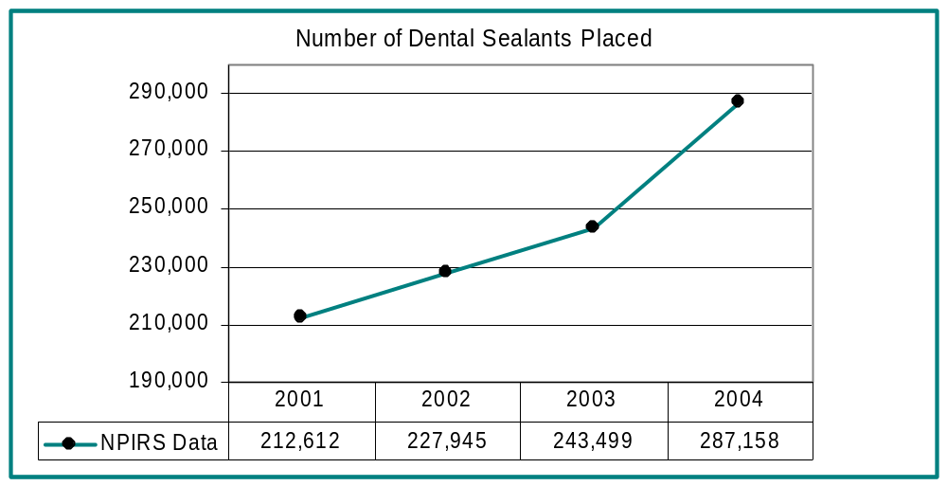

Data source: The National Patient Data Information Reporting System (NPIRS). In 2005, sealant data will be reported based on data collected at local facilities using CRS software.

Results: IHS met this indicator.

Discussion and analysis: The intent of this indicator is to reduce dental decay by increasing both the number of patients with dental sealants and the number of sealants per patient, and the 2004 target was met. As measured by NPIRS, the total number of sealants increased from 243,499 in 2003 to 287,158 in 2004.

Diabetic Dental Access

Indicator: Address that the proportion of patients diagnosed with diabetes who obtain access to dental services.

Importance: The purpose of this indicator is to improve both oral health status and diabetic control for American Indian and Alaska Native diabetics. All diabetic patients should receive a complete dental exam on an annual basis. Diabetics are at increased risk for destructive periodontal disease and subsequent tooth loss.

In addition, untreated periodontitis (inflammation of the gums) in diabetics may complicate glycemic control. Access to both primary and secondary treatment and preventive services for diabetics can lessen periodontal disease progression and the subsequent effects on diabetes and overall health. Regular visits provide opportunities for prevention, early detection, and treatment.

2004 Target: Increase the proportion of patients with diagnosed diabetes who obtain access to dental services by 1% over the 2003 level.

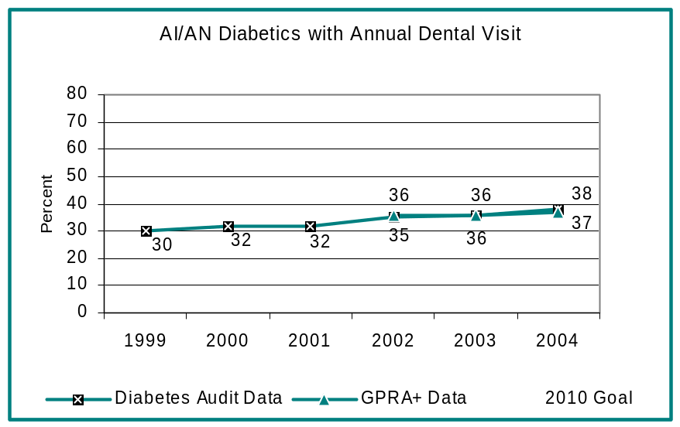

Data source: GPRA+ examination of 74,408 patient records
IHS Diabetes Care and Outcomes Audit

Results: IHS met this indicator.

Discussion and analysis: The percentage of patients diagnosed with diabetes that accessed dental care increased by 1% over the previous year. The diabetic audit data showed a 2% increase.

Public Health Nursing

Indicator: Address the number of public health nursing services provided by public health nurses.

Importance: Public health nursing is a method of delivering services to patients outside of the clinic or hospital setting. Public health nurses usually treat very young children, pregnant women, patients with chronic or acute diseases, the elderly, and the medically under-served. Public health nurses provide health assessment, health promotion, disease prevention, and infectious disease management. The public health nurse has intimate knowledge of the local community and family structures; this knowledge is essential in improving health status. Public health nursing in the community and homes helps reduce health care cost through early detection and prevention of health problems and reaches patients who might not receive care if they were required to travel to a doctor’s office.

2004 Target: Maintain the total number of public health nursing services provided to individuals in all settings and the total number of home visits at the 2003 workload levels.

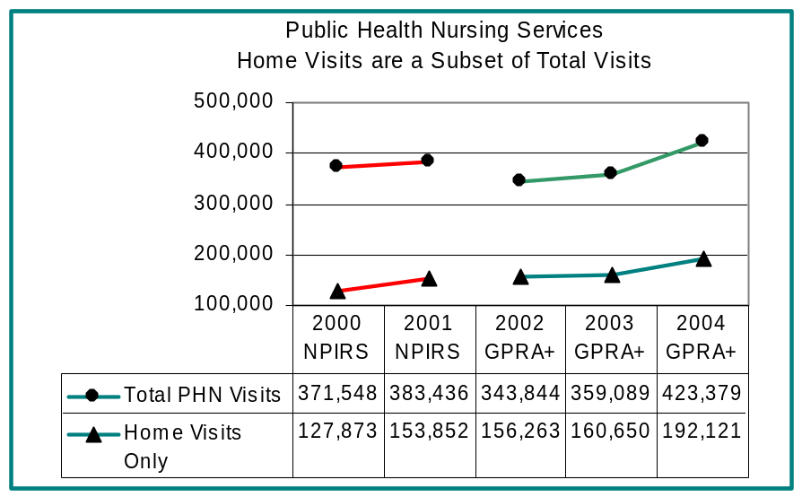

Data source: GPRA+ electronic examination of 1,168,311 patient records

Results: IHS met this indicator.

Discussion and analysis: The total number of home visits reported in 2004 was 192,121 compared to 160,650 visits reported in 2003. The total number of visits in all settings was 423,379 in 2004, compared to 359,089 visits reported in 2003. It is important to note that the number of facilities reporting in 2004 increased significantly.
Domestic Violence - Intimate Partner Violence

Indicator: Address the proportion of women who are screened for domestic violence at health care facilities.

Importance: This indicator is designed to ascertain, evaluate and reduce the prevalence of family violence, abuse and neglect in American Indian and Alaska Native communities. Rates of intimate partner violence are double for American Indian and Alaska Native people compared to whites, and 1½ times greater than U.S. all races. The health consequences of intimate partner violence are numerous. Women who experience domestic violence are more often victims of nonconsensual sex, have higher levels of smoking, chronic pain syndromes, depression, generalized anxiety, substance abuse, and Post-Traumatic Stress Disorder. Screening and appropriate referrals should help decrease the morbidity and mortality associated with intimate partner violence.

2004 Target: During FY 2004, the IHS will screen at least 15% of female patients ages 16-24 for domestic violence at health care facilities.
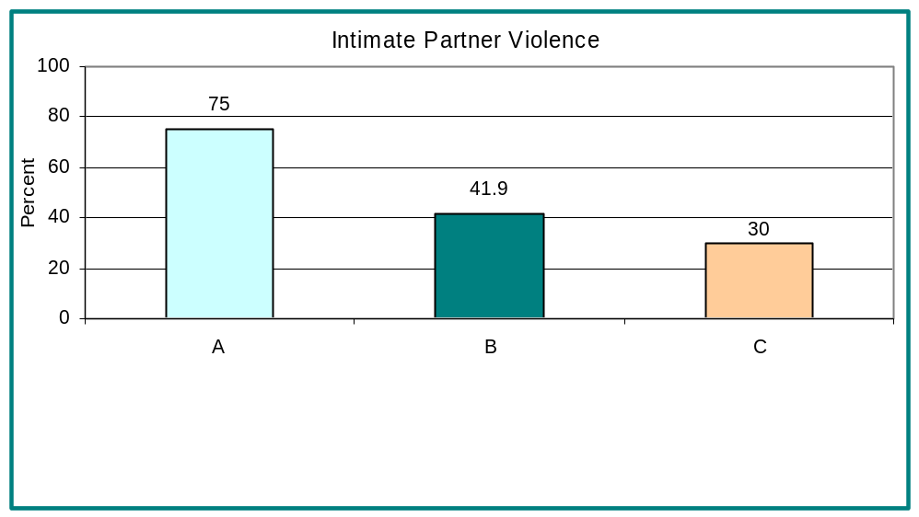

Data source: GPRA+ electronic examination of 78,917 patient records.

Results: IHS did not meet this indicator with only 4% of eligible patients screened.

Discussion and analysis: IHS is working with the Family Violence Prevention Fund and Administration for Children and Families to fund domestic violence prevention projects in over 10 communities during FY 2005.
Childhood Immunizations

Indicator: Address rates for recommended immunizations for AI/AN children patients 19-35 months.

Importance Routine immunizations (vaccines) represent a cost-effective public health measure that significantly improves the health of children. Among all US children aged 19-35 months, vaccine coverage in 2003 reached an all-time high. National coverage levels are now over 90 percent for each vaccine recommended through age 35 months, except the Varicella and Pneumococcal vaccines, and the fourth dose of DTaP. National Immunization Survey statistics show that AI/AN children have vaccination rates that are below the national averages. The Healthy People 2010 goal is 90% coverage for all routine immunizations for children aged 19-35 months.

2004 Target: During FY 2004, establish baseline rates for recommended immunizations for American Indian and Alaska Native children 19-35 months and increase 3-27 month rates by 2% over FY 2003.

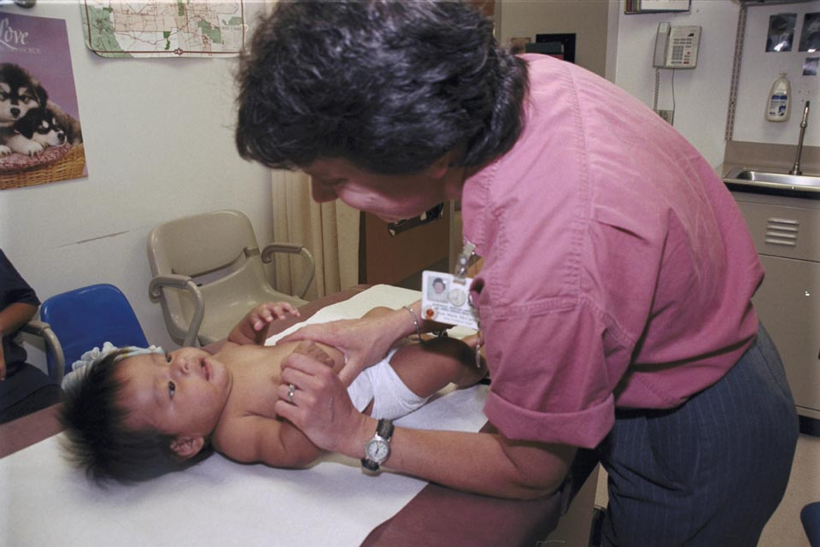

Data source: Quarterly immunization reports on children 3-27 months old and an annual 2- year old immunization report based on IHS patient care records and public health nursing records of children who receive immunizations at an IHS facility. GPRA+ data will be used in future years.

Results: IHS did not meet this indicator.

Discussion and analysis: Although a baseline rate was established for children 19-35 months, the coverage rate for 3-27 month old children was raised only by 1%, from 80% to 81%. After 2004, the IHS will track immunization rates for children ages 19-35 months only.

Influenza Immunizations

Indicator: Address influenza rates among adult patients aged 65 years and older.

Importance: Influenza (flu) is a highly contagious respiratory disease that can cause potentially life-threatening secondary infections. Elders who get influenza are also at increased risk of hospitalization and death from heart disease and stroke, and vaccination reduces that risk. In one study comparing vaccinated to non-vaccinated persons aged 65 and older over two influenza seasons, researchers found a 20% reduction in hospitalization for cardiovascular and cerebrovascular events in addition to a 30% reduction in hospitalization for influenza and a 50% reduction in death from all causes.

2004 Target: In FY 2004, maintain FY 2003 rate for influenza vaccination levels among adult patients aged 65 years and older.

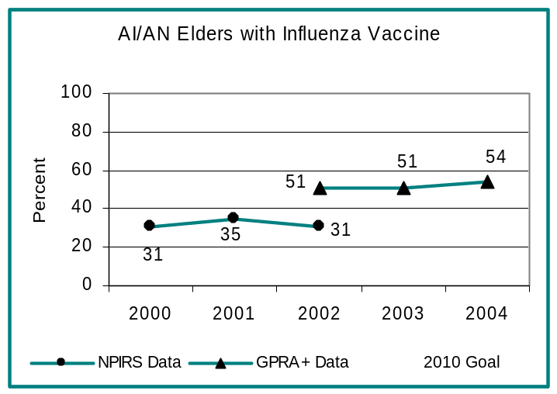

Data source: GPRA+ electronic examination of 46,647 patient records

Results: IHS met this indicator.

Discussion and analysis: The target of maintaining the influenza vaccination rate was met and exceeded, with the percentage of eligible patients receiving influenza vaccine at 54%. This rate is 3% higher than the percentage reported last year and more than 20% higher than the percentage reported in 2000. Continued efforts must be made in order to reach the Healthy People 2010 goal of a 90% immunization rate. Studies show that system interventions such as standing orders to administer vaccine increased rates by 39%, more than any other type of intervention.

Pneumococcal Immunizations

Indicator: Address Pneumococcal vaccination rates among adult patients aged 65 years and older.

Importance: The purpose of this indicator is to reduce illnesses and deaths due to pneumococcal disease among older adults. Elder health is an increasingly important issue as more and more of the population survives beyond the age of 65. Pneumococcal disease includes pneumonia, bacteremia, and meningitis. Pneumococcal disease has the highest death toll from a vaccine-preventable bacterial disease and patients over the age of 65 account for more than 51% of the deaths. Vaccination of the elderly against pneumococcal disease is one of the few medical interventions that has been found to improve health and save on medical costs.

2004 Target: In FY 2004, maintain the FY 2003 rate for pneumococcal vaccination levels among adult patients age 65 years and older.

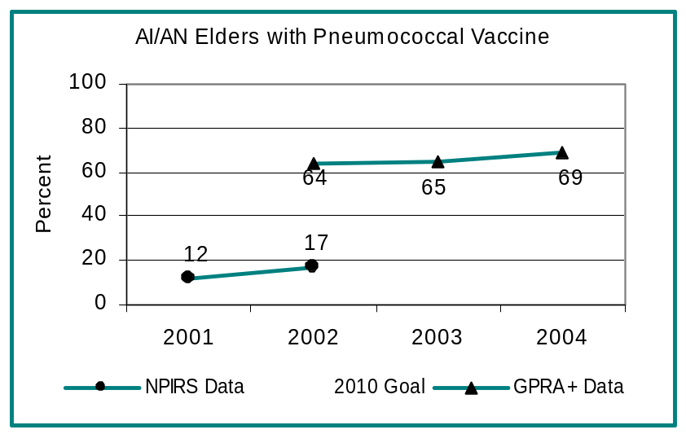

Data source: GPRA+ electronic examination of 46,647 patient records

Results: IHS met this indicator.

Discussion and analysis: The target of maintaining the 2003 rate for pneumococcal vaccination was met and exceeded. In 2004 the percentage of patients receiving pneumococcal vaccinations rose 4% compared to the percentage reported in 2003.

Summary of Other Indicators Met or Not Met
Government Performance Results Act
2004 Results



The following page shows results for those 2004 GPRA indicators not highlighted on the previous pages. A comprehensive GPRA indicator list for FY04-FY06, including complete definitions, is located at www.ihs.gov/cio/crs

2004 GPRA Indicator |  | Met/Not Met/Data Pending
Youth Regional Treatment Centers |  | Met
Fluoridated water |  | Not met
Data quality improvement |  | Met
Behavioral health |  | Not met
Urban improvement |  | Met
IHS hospital and clinic accreditation |  | Met
Medication error reporting |  | Met
Customer satisfaction |  | Not met
Injury prevention |  | Met
Injury deaths |  | Data available 2005
Suicide prevention surveillance |  | Met
Cardiovascular disease prevention (pilot sites) |  | Met
Obesity assessment |  | Met
Tobacco use assessment |  | Met
HIV risk reduction counseling |  | Not met
Environmental health web-based system |  | Met
Sanitation facilities to Indian homes |  | Met
Construction of new health facilities |  | Met
I/T/U satisfaction with consultation |  | Not met
CHS procurements by contracts and rate quotes |  | Not met
Assessment of public health infrastructure |  | Met
Placement of scholarship recipients |  | Met

Graphics Credits & References

GRAPHICS CREDITS

© Poison's Icons (http://members.aol.com/poison64/nagifs/gifs.html)
© THE GREASY GRASS 2000-2004 (http://www.thegreasygrass.com/ggtrail.html)
Cover Photo Courtesy of Nora Cata

REFERENCES
Bernard, V. B., N.C. Lee, M. Piper, L. Richardson. 2001. Race-specific results of Papanicolaou testing and the rate of cervical neoplasia in the National Breast and Cervical Cancer Early Detection Program, 1991-1998 (United States). Cancer Causes and Control, 12: 61-68.
Centers for Disease Control and Prevention. 2003. National Diabetes Fact Sheet: National estimates and general information on diabetes in the United States. Atlanta, GA. http://www.cdc.gov/diabetes/pubs/estimates.htm
Centers for Disease Control and Prevention. 2003. The National Breast and Cervical Cancer Early Detection Program. http://www.cdc.gov/cancer.
Centers for Disease Control and Prevention. 2004. CDC Fact Sheet: HIV/AIDS Among US Women: Minority and Young Women at Continuing Risk. http://www.cdc.gov/hiv/pubs/facts/women.htm
Early Treatment Diabetic Retinopathy Study Research Group. Early photocoagulation for Diabetic Retinopathy. ETDRS Report 9. Ophthalmology. 1991;98:766-785. Abstract
Espey, D., R.E. Paisano, and N. Cobb. 2003. Cervical Cancer Mortality Data for AI/AN Females, 1994-98. http://www.ihs.gov/MedicalPrograms/MCH/W/WHcancer.asp
Fairchild D, Fairchild M, Stoner S. Prevalence of adult domestic violence among women seeking routine care in a Native American health care facility. American Journal of Public Health. 1998;88:1515-7.
Fetal alcohol syndrome: Alaska, Arizona, Colorado, and New York, 1995-1997: MMWR. Morbidity and Mortality Weekly Report. 2002 May 24;51(20) 433-5.
Flanders, S. 2003. Pneumococcal vaccination prior to hospital discharge. Making Health Care Safer. 12 pp. http://www.ahrq.gov/clinic/ptsafety/chap36.htm.
Flegal KM, Carroll MD, Ogden CL, Johnson CL. Prevalence and trends in obesity among US adults, 1999-2000. Journal of the American Medical Association. 2002 Oct 9;288(14):1723-7.
Ganley A, Warshaw C, eds. Improving the Health Care Response to Domestic Violence: A resource manual for health care providers. Family Violence Prevention Fund. 1995.
Hamby S, Skupien M. Domestic violence on the San Carlos Apache reservation: Rates, associated psychological symptoms, and current beliefs. IHS Provider 1998, August.
Hankin, JR. Fetal Alcohol Syndrome Prevention Research. Alcohol research & health : the journal of the National Institute on Alcohol Abuse and Alcoholism. 2002;26(1):58-65
May PA, Hymbaugh KJ, Aase JM, Samet JM Epidemiology of fetal alcohol syndrome among American Indians of the Southwest. Social Biology. 1983 Winter;30(4):374-87.
McFarlane J, Gondolf E. Preventing abuse during pregnancy: a clinical protocol. MCN American Journal of Maternal Child Nursing 1998 Jan-Feb;23(1):22-6.
National Immunization Survey 2003 tables.
National Institute of Diabetes and Digestive and Kidney Diseases. 1995. The Pima Indians: Pathfinders for Health. NIH Publication No. 95-3821. Washington, DC: U.S. Government Printing Office.
National Institutes of Health. 2003. Seventh Report of the Joint National Committee on Prevention, Detection, Evaluation, and Treatment of High Blood Pressure, NIH Pub. No. 03-5233.
National, State, and Urban Area Vaccination Coverage Among Children Aged 19-35 Months—United States, 2003. MMWR: Morbidity and Mortality Weekly Report 2004;July 30;53(29):658-661.
Photocoagulation treatment of proliferative diabetic retinopathy: The Second Report of Diabetic Retinopathy Study Findings. Ophthalmology. 1978; 85: 82-106. Abstract
Prevalence and characteristics of alcohol consumption and fetal alcohol syndrome awareness--Alaska, 1991 and 1993. MMWR. Morbidity and Mortality Weekly Report. 1994 Jan 14;43(1):3-6.
Saslow, D., C.D. Runowicz, D. Solomon, A. Moscicki, R. A. Smith, H. J. Eyre, C. Cohen. 2002. American Cancer Society Guideline for the early detection of cervical neoplasia and cancer. CA, A Cancer Journal for Clinicians, 52: 342-362.
Sisk, J. E. 2000. The best and worst of times: Use of adult immunizations. American Journal of Preventive Medicine, 19: 26-27.
Smith RA, Saslow D, Sawyer KA, Burke W, Costanza ME, Evans WP, Foster RS, Hendrik E, Eyre HJ, and Sener S. 2003 American Cancer Society Guidelines for breast cancer screening: Update 2004. CA, A Cancer Journal for Clinicians, 53:131-169.
Story M, Evans M, Fabsitz RR, Clay TE, Holy Rock B, Broussard B. The epidemic of obesity in American Indian communities and the need for childhood obesity-prevention programs. American Journal of Clinical Nutrition. 1999 Apr;69(4 Suppl):747S-754S.
U.S. Department of Health and Human Services. 1998. Tobacco Use Among U.S. Racial/Ethnic Minority Groups —African Americans, American Indians and Alaska Natives, Asian Americans and Pacific Islanders, and Hispanics: A Report of the Surgeon General. Atlanta: U.S. Department of Health and Human Services, Centers for Disease Control and Prevention.
US Public Health Service recommendations for human immunodeficiency virus counseling and voluntary testing for pregnant women. MMWR: Recommendations and Reports. 1995 Jul 7;44(RR-7):1-15.
Wagner, E. H., C. Davis, C. Homer, S. Hagedorn, B. Austin, A. Kaplan. 2002. Curing the system: Stories of change in chronic illness care. Accelerating Change Today: 9. http://www.qualityhealthcare.org/QHC/Topics/ChronicConditions/Diabetes/Literature/CuringthesystemStoriesofchangeinchronicillnesscare.htm
Wilt S, Olson S. Prevalence of domestic violence in the United States. Journal of the American Medical Women’s Association 1996; 51(3):77-82.



