New Resource for Educating Patients About
Diabetic Eye Disease

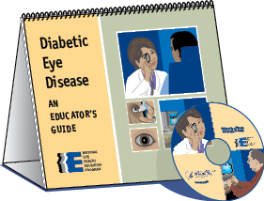
Diabetes is the leading cause of new cases of blindness among adults aged 20 to 74. Since there are often no symptoms in the early stages of diabetic eye disease, people with diabetes should get a comprehensive dilated eye exam at least once a year.

The National Eye Institute (NEI), part of the National Institutes of Health, has developed this award-winning educational tool, Diabetic Eye Disease: An Educator’s Guide. This colorful, easy-to-read, flip chart is designed to help health professionals educate their patients about the important steps they can take to protect their vision. The Educator’s Guide is available in English and Spanish, and includes a CD−ROM with self-guided modules, a PowerPoint presentation, and PDF files of the presentation. For more information about diabetic eye disease, or to order your free copy of the Educator’s Guide, visit www.nei.nih.gov/diabeteseducation.

Join us in making vision a health priority! For more information about eye health, visit www.nei.nih.gov.

