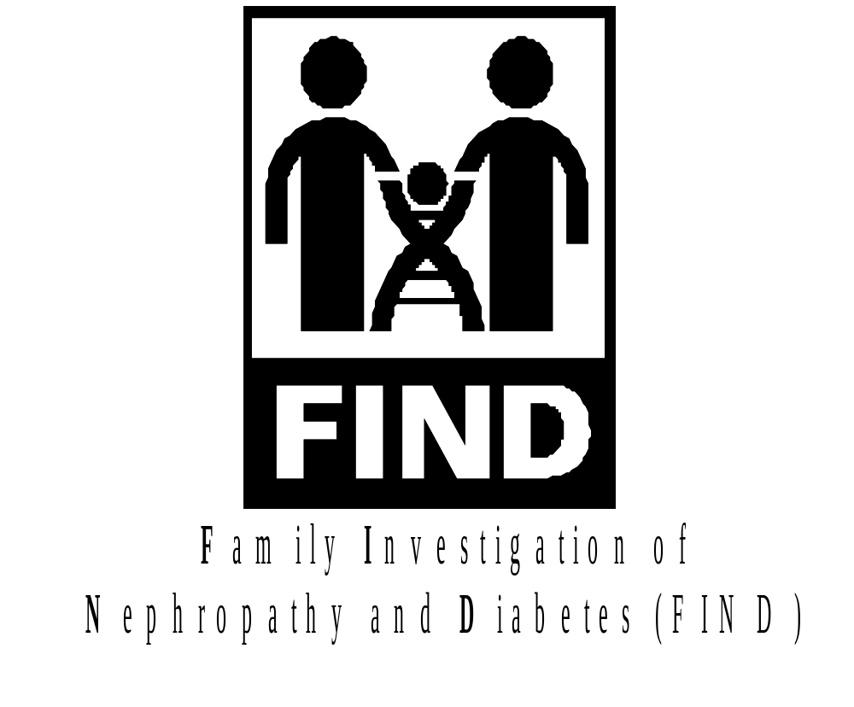
August 31, 2001
List of Acronyms
AA | African American
ACD | Acid Citrate Dextrose
ACE | Angiotensin Converting Enzyme
ARP | Affected Relative Pair
AT1RA | Angiotensin 1 Receptor Antagonist (or blocker)
ASP | Affected Sibling Pair
BPBL | Peripheral Blood Monocytes from Fresh Blood
BUN | Blood Urea Nitrogen
CoIs | Co investigators
CORBA | Common Object Request Broker Architecture
CWRU | Case Western Reserve University
DHHS | Department of Health and Human Services
DLT | Digital Linear Tape
DM | Diabetes Mellitus
DMSO | Dimethylsulfoxoide
DN | Diabetic Nephropathy
DRP | Discordant Relative Pair
DSP | Discordant Sib Pair
EA | European American
EAC | External Advisory Committee
EBV | Epstein-Barr Virus
ECDSA | Elliptic Curve Digital Signature Algorithm
EDTA | Ethylenediaminetetriactetic Acid
ESRD | End Stage Renal Disease
FBS | Fasting Blood Sugar
FIND | Family Investigation of Nephropathy and Diabetes
FPG | Fasting Plasma Glucose
FSG | Fasting Sugar Glucose
FSP | Fasting Plasma Glucose
GADCC | Genetic Analysis and Data Coordinating Center
GB | Gigabyte
H-E | Haseman and Elston
HGAL | Human Genetic Analysis Lab
IBD | Identity By Descent
ID | Identification
IRB | Institutional Review Board
IS | Information Services
JHU | Johns Hopkins University
MA | Mexican American
MALD | Mapping Admixture Linkage Disequilibrium
MLS | Maximum Lod Score
MOO | Manual of Operations
MRC | Resource Center
NCI | National Cancer Institute
NIDDK | National Institute of Diabetes& Digestive & Kidney Diseases
NIH | National Institutes of Health
NIMH | National Institute of Mental Health
OGTT | Oral Glucose Tolerance Test
PBL | Peripheral Blood Lymphocytes
PBMC | Peripheral Blood Monocytes
PI | Principal Investigator
PIC | Participating Investigator Center
PID | Patient Identifier Number
QC | Quality Control
QTL | Quantitative Trait Locus
RBC | Red Blood Cells
RR | Relative Risk
S.A.G.E. | Statistical Analysis for Genetic Epidemiology
S/MIME | Secure Multipurpose Internet Mail Extensions
SSL | Secure Socket Layer
TAC | Total Allele Content
TDT | Transmission/Disequilibrium Test
UCI | University of California at Irvine
UNM | University of New Mexico
URN | Urine
UTHSCSA | University of Texas Health Sciences Center San Antonio

INTRODUCTION

Overview of the Manual of Operations

The Manual of Operations (MOO) provides detailed instruction of study procedures, details of each subcommittee, and instructions regarding all aspects of the study operations, inclusive of human specimen sample shipping and handling.

Study Overview

The Family Investigation of Nephropathy and Diabetes (FIND) study will have prospective subject entry. The National Institute of Diabetes and Digestive and Kidney Diseases at the National Institutes of Health (NIDDK/NIH) funds FIND.

FIND is a multi-center consortium, comprising eight (8) Participating Investigator Centers (PICs) and a Genetic Analysis and Data Coordinating Center (GADCC), established to study the genetics of Diabetic Nephropathy. The charge of the consortium is to acquire sets of families with well-characterized diabetic nephropathy, establish a secure master FIND database, and perform a genome scan to identify chromosomal regions linked with diabetic nephropathy. Analytic methods will include a) affected sibling pair (ASP), discordant sib pair (DSP), affected relative pair (ARP), and discordant relative pair (DRP) linkage analyses and b) Mapping by Admixture Linkage Disequilibrium (MALD) analyses. To expedite the mapping, and eventual cloning, of nephropathy genes, markers at candidate genes or human chromosomal regions containing putative renal failure susceptibility genes identified in previous genome scans, or syntenic to regions of renal susceptibility in model organisms, will also be examined. For candidate gene analysis both linkage and association (Transmission Disequilibrium Test (TDT)) methodologies will be used.

There are eight (8) Participating Investigator Centers (PICs). The GADCC and PICs, inclusive of each personnel directory, together with the NIDDK/NIH support staff and the External Advisory Committee, are given in APPENDIX A. This list, updated monthly, can be found on the FIND website (http://darwin.cwru.edu/find).

Study Objectives

The primary aim of the FIND is to identify genes responsible for diabetic nephropathy and their linkage relationships, if any, to nephropathy.

Specific aims are to:

- Organize a multi-centered consortium to undertake the recruitment of participants of several ethnicities.

- Use Affected Relative Pair (ARP), Discordant Relative Pair (DRP), and Mapping by Admixture Linkage Disequilibrium (MALD) linkage analyses to scan the genome for linked chromosomal regions, and the transmission disequilibrium test (TDT) to evaluate candidate genes in those regions with evidence for linkage.

- Use environmental data as a guide for possible risk factor effects on genetic susceptibility.

This is a clinical research cross-sectional study and longitudinal studies will not be addressed at this time, although may be at some later date.

Committee Structure

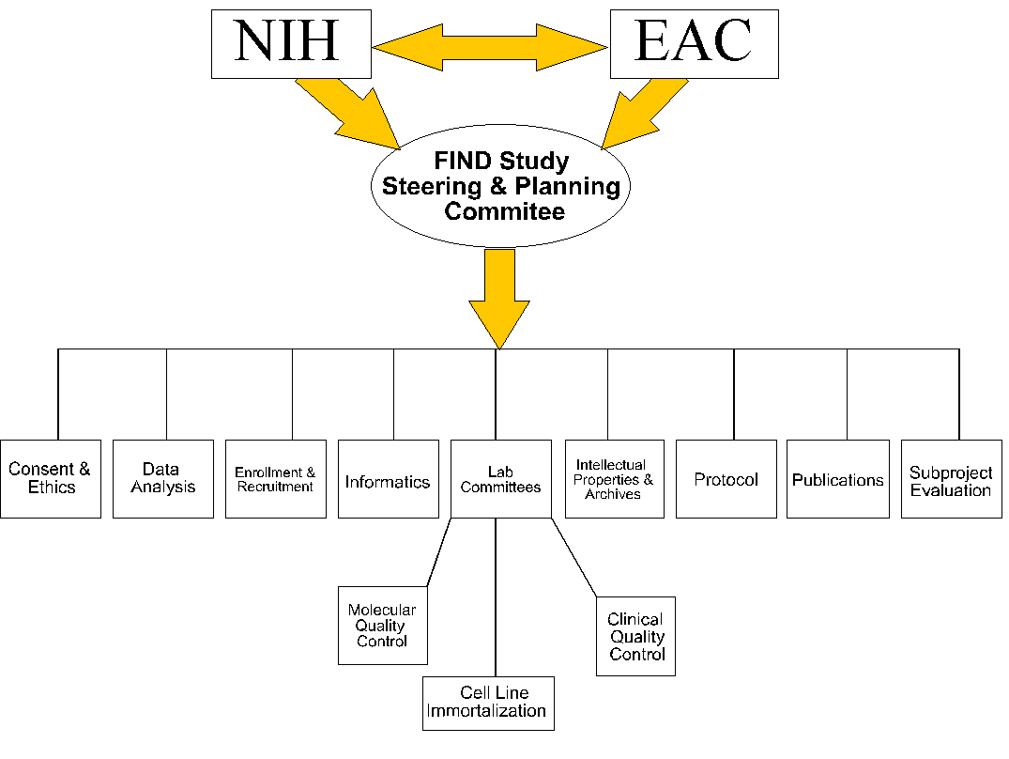

Constitutional Policy

The Steering committee is the governing body that has the authority to approve and amend the protocol, subcommittee membership, and manual of operations with a six out of ten majority vote. The Steering Committee is made up of the PI’s of each center (the eight PICs and the GADCC), and the NIDDK representative (Appendix G). It will meet at least twice a year to establish any changes to the manual of operations, including subcommittee memberships.

intellectual Property and Archive Policies

Function and purpose

The Intellectual Property and Archive Subcommittee will develop and propose policies relating to ownership and storage for data and biological specimens generated by the F.I.N.D.

Duties of the Intellectual Property and Archive Subcommittee

Develop policies relating to ownership and storage for data and biological specimens generated by the F.I.N.D., and to the distribution of these to non-F.I.N.D. investigators (in the latter regard, the duties may overlap with the Subproject Evaluation Subcommittee). These policies will require approval by the Steering Committee.

Evaluate and make recommendations for use of data or biologicals by specific outside (i.e. non-F.I.N.D.) investigators. (This duty may overlap with the Subproject/Ancillary Studies Subcommittee.)

Serve as the initial forum for decision and appeal of intellectual property issues. Decisions in this regard are to be recommended to the Steering Committee for final decision.

All policies and recommendations need to be in accordance with the arrangements made with the specific population involved (e.g. Native American groups), and in accordance with NIH and federal guidelines, and when possible in accordance with individual institutional guidelines. Policies and recommendations [internal and external] will be dictated by the nature of the informed consents signed by the subjects.

Categories of Materials

There are several categories of data, as follows:

Category 1:
Data are project wide, e.g., phenotypes being recorded on all participants, genotyping data for genome scans. In general these are data specified in the MOO (Manual of Operations).

Category 2:
Data that are part of the designed study, but generated by a limited number of centers (e.g. 2 PIC’s, or 1 PIC and the GADCC).

Category 3:
Data that are the results of an approved subproject (ancillary) study that is funded by the NIDDK as a supplement to the F.I.N.D. or formally in collaboration with the F.I.N.D. (e.g. the NEI retinopathy study).

Category 4:
Data that are the result of an approved subproject (ancillary study) not funded by the NIDDK.

Category 5:
Data that are generated independently from F.I.N.D., but utilizes in part F.I.N.D. subjects, whether conducted by F.I.N.D. investigators or non-F.I.N.D. investigators.

Biological Specimens

There are two basic categories:

Category 1: Material in finite supply.
a. DNA
b. Serum/plasma
c. Urine

Category 2: Material of unlimited supply.
This can include but is not limited to:
a. Immortalized cell lines
b. DNA from immortalized cell lines

Ownership

The basic concept here is that ownership of material is vested in the participating investigators (and their institutions), limited by agreements with, and the rights of, participating populations, NIH and federal polices, and policies of the individual funding agencies. Confidentiality of individual participants will be maintained with all data shared between centers and with all releases of data. Furthermore, it is deemed advisable that, after some period of time, certain categories of data and possibly biologic materials be made available to non-FIND investigative teams.

Category 1
These data will be owned jointly by the individual PIC’s and the GADCC. They will be kept at the GADCC, and at each PIC that desires them. While each group is free to examine and evaluate the data for informal/internal purposes, the formal use of these data will be dictated by the Steering Committee via the Analysis, Protocol, and the Publication Subcommittees. The GADCC and PIC’s will not disclose the data to other parties except as specified by the above committees and the Manual of Operations.

After each F.I.N.D. publication that involves major data, the GADCC will make the data used in that publication available to the public (the exact method to be proposed by the GADCC) as soon as is reasonably possible, but no later than within one year. These data will be anonymized, i.e. identifiers (e.g. birthdates) will be removed, and ethnic group identified by only one of 4 categories (Caucasian, African-American, Hispanic, Native American). This anonymization must be done before any data are released to the public.
When the GADCC (or equivalent successor) ceases to function as the data coordinator and analytic resource to the F.I.N.D., it will release a fully documented copy of all F.I.N.D. data to each PIC (limiting identifiers to the PIC from which the data were derived), and an anonymized data set to the NIDDK. One to Two years after the termination of the F.I.N.D. and/or this release (whichever comes first), the anonymized data set will be made public (this will probably require an archiving mechanism, to be discussed). Decisions regarding any other disclosure of data to other parties will be brought to the Intellectual Property Subcommittee, which will make recommendations for decision by the Steering Committee.

Note: The responsibilities of any users (e.g. the GADCC) to return these data to the central database will continue, the data being sent to the archives/repository mechanism established after the GADCC ceases to function.

Category 2
For the most part these are to be treated in the same way as category 1 data, but ownership of the data is to be vested in the individual participating centers (e.g. the GADCC and a PIC or 2 PICs). The location of the data should be in the GADCC and participating centers.

Category 3
These are to be treated as category 1 or category 2 data, depending on the number of Centers involved.

Category 4
These data are to be owned by the responsible investigators. Data analysis is the responsibility of those investigators, with whatever involvement of the GADCC the Subproject and Steering Committee will have designated. Since this is an approved project of the F.I.N.D., even if the GADCC is not involved in analysis, the data (e.g. the primary molecular genotyping data) should be immediately available to the GADCC and the Steering Committee upon publication. However any public release of these data will be at the discretion of the responsible investigators, but will be included in the full public data release.

Category 5
The responsible investigators own these data, and their analysis. After publication, the data are to be made available to the GADCC central database (and/or successor) within 3 months. Public distribution of these data is at the discretion of those investigators but will be included in the full public data release.

Biological materials

The basic principal here is that the first priority is the desire of populations, second the needs of the study, third that of the investigators, and fourth posterity.

Finite Supply

PIC's will have the option of receiving a sample of DNA (quantity to be determined) from all FIND participants recruited at that site during the initial 5 year enrollment period. Within one to two years of the conclusion of the study, any remaining biological materials in this category (e.g. DNA, serum) residing at the GADDCC or other central laboratory (e.g. assay laboratory) will be treated as follows:

- If a given population has requested return of samples, that request will be honored.
- Of the remaining material at the GADCC (or other central core), half will be returned to the individual PIC, and half will be archived for the NIDDK (mechanism to be determined).
- The ownership of these samples will reside with the possessors (e.g. the NIDDK and the individual PICs, respectively).

Note, excess materials that have been accumulated at a given PIC will be owned by that PIC, subject to restriction (a) above.

Infinite Supply

First, as cell lines are created from any samples from one or more PICs, the individual PICs will be given the opportunity to receive viable aliquots of those lines as soon as feasible by the central laboratory, but no later than 3 months after establishment of the lines.

Within one to two years of the conclusion of the study, any biological materials in this category residing at the GADDCC or other central core laboratory will be treated as follows:

If a given population has requested return of the samples, that request will be honored. A viable aliquot of the material will be provided to each individual PIC that generated it. A viable aliquot will be archived for the NIDDK (mechanism to be determined). Ownership of the samples will reside with the possessors (e.g. the NIDDK and the individual PICs, respectively).

It is currently the intention of the NIDDK to establish a repository of cell lines with accompanying data to be available to outside, i.e. non-F.I.N.D., investigators. The full sample repository (final phase repository) will be established within 1 to 2 years, after the termination of the F.I.N.D. These samples must be anonymized, i.e. all identifiers removed. Ethnic groups will be identified by only one of 4 categories: Caucasian, African-American, Hispanic, Native American.

There may be a desire to establish an early phase repository based on relevant publications (e.g. the initial genome scan). Such an early phase repository would include the relevant publication data and samples available at that time. They would be anonymized. The desire/need for such a repository will be assessed by a to-be-established committee (such could include representatives from the F.I.N.D. Steering Committee, EAC, NIDDK, and non-F.I.N.D. representatives).

Access to the sample repository(ies) would be decided by a to-be-established committee, likely to consist of F.I.N.D. Steering Committee members, EAC members, NIDDK, and possibly outside (non-F.I.N.D.) representatives. This will require an application process, and formal commitments by the requested investigators (whether in academia or industry) to commit to utilize the samples only for the F.I.N.D. purposes (i.e. to find the genes for kidney disease, diabetes, and associated diseases, e.g. retinopathy and atherosclerosis), and to deliver to the central database the primary data of any publication within 3 months after publication. Provision of these samples and accompanying data will require a funding mechanism to be developed, ranging from peer reviewed funding to a fee-per-sample mechanism.

Funding

All activities that are mandated by these policies will receive appropriate funding for the responsible parties to carry them out, otherwise these parties will not be held responsible for the tasks (i.e. there are to be no unfunded mandates).

PUBLICATIONS

Overview and Objectives of the Publications Subcommittee

The Publications Subcommittee will coordinate, monitor, review, and assume responsibility for, arranging the preparation of all study-wide press releases, interviews, presentations, and publications relating to the scientific aspects of FIND. During the planning, conduct, and analysis of FIND, there will be no communications of study plans or results that have not been reviewed and approved following the procedures as described below.

Duties of the Publications Subcommittee

Recommend policy and procedures for review and approval of all scientific communications regarding FIND to outside groups.

Identify publications to be written and presentations to be made during the course of the study, with target dates for each. The Publications Subcommittee will also review proposals for FIND-related publications or presentations. These will include publications related to the main study and those resulting from projects previously approved by the Subprojects Evaluation Subcommittee.

Propose policy guidelines for authorship of FIND publications and appoint writing groups.

Monitor the writing of each paper to ensure publication in a timely fashion.

Suggest appropriate journals for FIND publications and monitor the process of publication.

Perform other writing, reviewing, or editing tasks assigned by the Steering Committee.

Assist writing groups in publishing papers of the highest quality and clarity. Review and edit all FIND publications and presentations prior to submission (see section 13.4), enlisting the special assistance of other members of FIND Research Group and subcommittees whenever appropriate. The activities of the Publications Subcommittee will be conducted pursuant to the following policy regarding publications and presentations from FIND:

- ensure accurate, uniform, timely, and high quality reporting of FIND activities and results;

- preserve the scientific integrity of the study;

- safeguard the rights and confidentiality of participants;

- ensure that the timing of publications and presentations serves the right of the public to know the results of the study without jeopardizing the privacy of the participants.

In all of these matters, the Publications Subcommittee will, by majority vote, make recommendations to the Steering Committee. Final decisions will be by majority vote of the Steering Committee.

Categories of Papers

Definitions

Paper: a paper written for publication in a journal, monograph, or book, whether initiated by the group or invited.

Writing group: the individuals directly responsible for writing a paper, even though many others in the research group may be involved in review and approval before the paper is submitted. A writing group will usually be composed of three to seven people and include representatives from all the disciplines involved in the paper (e.g., clinicians, molecular geneticists, genetic epidemiologists, or statisticians).

Research Group: all investigators at the PICs, GADCC, NIDDK project office, and any subcontracting units, such as central laboratories. Investigators are considered those working at professional levels (and usually trained at the doctoral level), regardless of professional discipline (e.g., clinicians, molecular geneticists, genetic epidemiologists, or statisticians). The program coordinator at each PIC might be included regardless of degree or professional credentials.

Each paper will be categorized before the analysis and writing are undertaken. Categories are determined by the scope and content of each paper, rather than by the particular protocol or protocol(s) under which the data were obtained. Results obtained under the full protocol followed by all centers will probably be designated as category A (defined below), whereas results obtained in ancillary or sub-studies may be of any category, depending on their scope and content.

A. Full group papers

These papers represent the work of the entire consortium, including the PICs, GADCC, NIDDK project office, and any subcontracting units, such as central laboratories. Examples of topics are: overall study design and methods, descriptions of recruited populations, and findings representing all study subjects and PICs.

Authorship will be by the FIND Research Group. Group members will be listed in a footnote or appendix (depending on editorial policy of the journal). The list may designate certain roles of individuals, such as PIs, chairs of the Steering Committee and subcommittees, and members of the writing group. The corresponding author will be the GADCC, with no individual named, unless required by the journal, in which case the PI of the GADCC will be named. The appendix may also acknowledge by name or by group the nonprofessional staff, external advisors and consultants, and others as appropriate.

B. Subgroup papers

These papers represent the work of part of the consortium, consisting of at least one center, which may include the PICs, GADCC, NIDDK project office, and any subcontracting units, such as central laboratories. Examples of topics are: study design, methods, subjects, and findings pertaining to a subset of PICs or a single PIC; or methods (but not study results) used by the GADCC alone.

The involved centers may be a single PIC (including affiliated laboratories or consultants) if the services of the GADCC were not used in the substudy, the single center plus the GADCC, or more than one (but not all) PICs, with or without the GADCC. Depending on the roles of the GADCC in the substudy (i.e. statistical analysis or genotyping), the authorship list may include only some members of the GADCC.

Authorship will be the investigators of the centers involved. A subtitle, footnote, acknowledgment, or appendix will indicate that this represents a subgroup of FIND, and if possible, a FIND paper (category A) will be referenced.

C. Miscellaneous papers

These papers represent work funded by FIND but not central to the FIND consortium. Examples are: development of statistical or genotyping methods not illustrated by FIND results (even if subsequently used in FIND), descriptions of aspects of the study populations not directly related to FIND analyses (such as correlations among study variables). These papers may emanate from a single center (PIC or GADCC) or from a combination of one or more PICs, with or without the GADCC.

Authorship will be by the investigators of the centers involved. A subtitle, footnote, acknowledgment, or appendix will indicate how this paper is related to FIND, and if possible, a FIND paper (category A) will be referenced.

Abstracts and meeting presentations will be classified and approved as above. When required by the organization sponsoring the meeting, a corresponding author can be named, e.g. in a footnote or in the authors line, such as A. B. Member, for the FIND Research Group. If any member of the FIND Research Group receives an invitation to make a FIND presentation, the invitation should be forwarded to the Publications Subcommittee. The Publications Subcommittee will recommend whether the invitation should be accepted, and may suggest that the presentation be given by a member of the Research Group other than the person originally invited (to spread the workload of presentations and facilitate public recognition of members who may not be frequently invited).

Implementation of Policy and the Review Process

Topics for papers and members of writing groups may be proposed by the Publications Subcommittee or any member of the Research Group. The Publications Subcommittee will either reject the proposal or assign each proposal a category and writing group. A log of such decisions will be maintained on the FIND website accessible to all members of the Research Group. Any members disagreeing with a Publications Subcommittee decision on categorization of a paper, membership in the writing group, or approval of a paper should express their concerns to the Chair of the Publications Subcommittee, who will relay them to the full Publications Subcommittee, if necessary, for resolution. Unresolved disagreements within the Publications Subcommittee will be referred to the Steering Committee for resolution. A decision of the majority of the Steering Committee will be binding.

The Publications Subcommittee will review a completed paper of any category. The review will include attention to scientific accuracy, clarity, and style. If a majority does not approve it, suggestions for revision will be given to the writing group for revision, after which the Publications Subcommittee again reviews the paper. When the majority of the Publications Subcommittee approves a paper, it will be forwarded to the Steering Committee for further suggested revisions or final approval by majority vote.

Use of Data

For purposes of publication and presentation policies, study data are defined as all data specified in the MOO pertaining to enrolled participants. Subjects evaluated for eligibility but not enrolled (for whatever reason) can be used by the individual PICs for other studies.

Study data will be owned jointly by the individual PICs and the GADCC, but will be kept at the GADCC. The GADCC and PICs will make no use of study data nor disclose them to any other parties except as specified in the Protocol or MOO, unless such use or disclosure is approved by a majority of the Steering Committee.

Final disposition of the data is covered by the policies developed by the Intellectual Property and Archives Subcommittee.

Presentations to Volunteer Participants

Presentation of results with clinical significance determined by the steering committee will be offered to the volunteer participants in an appropriate manner before they are presented to the public or the professional communities.

Subprojects and Ancillary Studies

Objectives of the Subprojects and Ancillary Studies Subcommittee

Subprojects and ancillary studies will be evaluated with regard to scientific merit and the potential impact on the objectives of FIND. Projects that complement the objectives of FIND will enhance the value of the study and, therefore, are encouraged. The Subproject Evaluation Subcommittee will evaluate each proposal and make a recommendation to the Steering Committee. The Steering Committee’s final approval is necessary before the sub-study can begin. In addition, the customary approval of the relevant Institutional Review Board(s) must be obtained.

Definition

Subprojects and ancillary studies are defined as investigations that are not set forth in the primary FIND protocol, but which require resources that are shared by all of the PICs (including analytic resources and genotypic data), or which relate to the molecular genetics of nephropathy. These include the following types of proposals:

- Proposals that the GADCC conduct analyses of data collected by one or more individual PICs which are not part of the analyses proposed by the overall FIND protocol.

- Proposals that the GADCC type candidate genes, which are not proposed in the FIND protocol, in samples collected by one or more individual PICs.

- Proposals that individual PICs, or other collaborators, type candidate genes in samples obtained from more than one PIC, which are collected for the primary FIND protocol.

- Analyses conducted by individual PICs or other collaborators, which employ genotypic data generated by the main FIND.

- Proposals that all PICs collect data that is not specified in the primary protocol.

- Proposals that an individual PIC investigate the molecular genetics of nephropathy (e.g., by association or linkage studies utilizing candidate genes or genomic segments), in data collected by the individual PIC under the FIND protocol.

Analyses, conducted by an individual PIC, of clinical phenotypic data collected by that PIC or of molecular genetic data that are unrelated to nephropathy, do not require evaluation by the Subproject Evaluation Subcommittee. (Note that any such studies using data in FIND subjects are limited by the participants’ consent.)

Subprojects are defined as proposals, meeting the above definition, that are to be conducted using FIND resources. Ancillary studies are studies that require supplemental funding or resources in addition to FIND resources. (For example, ancillary studies may be conducted with funding obtained from an RO1 grant from NIH. Since approval from FIND will be necessary before proceeding with such studies, it will generally be to the investigators’ advantage to obtain approval for such studies from FIND prior to applying for supplemental funding.)

Criteria

The Subproject Evaluation Committee will evaluate proposals with regard to the following:

- Impact on the objectives of FIND (no subproject should compromise the scientific integrity of FIND, adversely effect its public image, or cause a significant diversion of Find’s resources. In addition, subprojects should not compete with or duplicate the main results of FIND).

- Scientific merit (proposals should test an important hypothesis and the design and power of the proposal should be adequate to ensure a reasonable test of this hypothesis).

- Feasibility (both from a practical and ethical standpoint- the input of the Consent and Ethics Subcommittee will be sought when necessary to ensure that the proposed project is within the scope of participants’ consent).

Procedures

The Subproject Evaluation Subcommittee will meet at each FIND Investigators’ meeting. Proposals for subprojects or ancillary studies should be submitted at least one month prior to each meeting to ensure that sufficient time is available for review.

A written request for approval of a proposed subproject or ancillary study should be submitted to the Chair of the Subproject Evaluation Subcommittee. The request should be brief (no more than 5 pages), but should contain sufficient detail so that scientific merit can be assessed. It should contain the following elements in order:

- description of the hypothesis(es) to be evaluated.
- background and significance of the study.
- the proposed methods.
- analysis strategy.
- plans for publication.
- source of funding.

If funds are being sought from outside FIND, the proposed source of such funds should be clearly identified. If additional data from subjects are to be collected (e.g., by collection of additional samples or by clinical examination), full details need to be provided. It should also be specified whether molecular or statistical analyses are to be conducted by the GADCC.

Proposals may be assigned to have a detailed or abbreviated review. Any proposals that utilize genotypic data, clinical data or analytic resources common to more than one PIC (study types 1-5 above) will receive a detailed review; proposals that relate to the molecular genetics of diabetic nephropathy, but in which all of the work, including genotyping and data analysis, will be done by a single PIC (study type 6) will receive an abbreviated review. If a detailed review is necessary, the Chair of the Subproject Evaluation Subcommittee will assign a primary and secondary reviewer from among the committee members for each proposal. The opinions of outside experts will be sought at the discretion of the committee. A statistical review by the GADCC will also be conducted. The Subproject Evaluation Subcommittee will vote on approval or disapproval; approval is based on a simple majority of committee members. The Chair will then prepare a written summary of the committee’s decision and forward this to the investigator(s). Copies of proposals designated for an abbreviated review will be forwarded by the Chair to the Subcommittee, which will vote on whether the proposal is consistent with the objectives of FIND. Since such proposals will not utilize the shared molecular or analytical resources of FIND, they will not require a detailed review by primary, secondary and statistical reviewers.

If the Subproject Evaluation Subcommittee approves the proposal, the proposal will be forwarded to the Steering Committee, along with the summary and recommendation of the Subproject Evaluation Subcommittee. Final approval of the proposal will be based on a majority vote of the Steering Committee. If the Steering Committee approves a subproject, it will proceed. If the proposal is an ancillary study, it may proceed with Steering Committee approval once funding is obtained.

The Subproject Evaluation Subcommittee may not initially approve the proposal, but may request further information from the investigators before rendering a final decision. In such cases, the investigators will be invited to submit a revised proposal.

If the Subproject Evaluation Subcommittee disapproves the proposal, the investigators may appeal to the Steering Committee, which may override the decision of the Subcommittee. If the Steering Committee also disapproves the subproject, it will not be conducted.

Publication

Publication of data from all subprojects and ancillary studies must comply with the policies of the FIND Publications Subcommittee.

