PUBLIC NOTICE
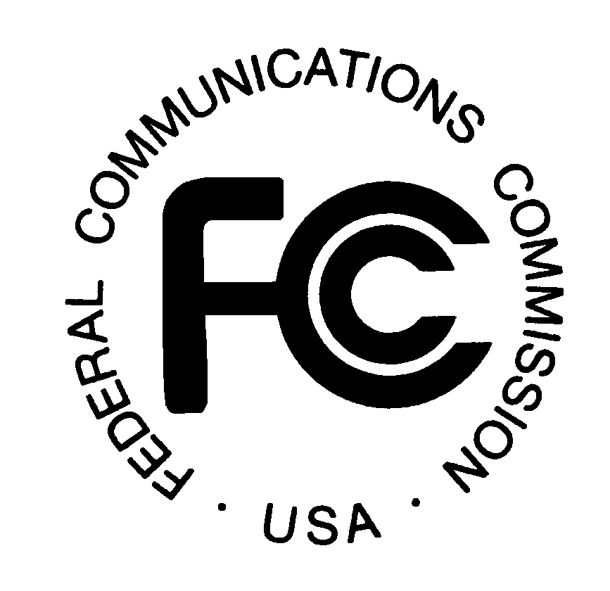

FEDERAL COMMUNICATIONS COMMISSION

445 12th Street, SW

WASHINGTON, DC 20554

News Media Information (202) 418-0500 Fax-On-Demand 202/418-2830 Internet http://www.fcc.gov TTY: 202/418-2555

DA 99-2400
Released: November 2, 1999

Petitions For Declaratory Ruling Filed by Beehive Telephone Company and Database Services Management, Inc.

CC Docket No. 95-155, Toll Free Access Codes

NSD -L-99-88, Beehive Telephone Company’s Petition For Declaratory Ruling

NSD -L-99-87, Petition of Database Service Management, Inc. For Expedited

Declaratory Ruling and Response to Petition of Beehive Telephone Company, Inc.

On January 29, 1999, Beehive Telephone Company, Inc. (Beehive) filed a petition for a declaratory ruling, to resolve seven specified counts that it had raised in a court proceeding involving Database Service Management, Inc. (DSMI). On February 17, 1999, DSMI also filed a petition for a declaratory ruling, to resolve the same seven counts and to respond to Beehive’s petition. The Commission seeks comments on the seven counts and any related issues raised in the petitions. On March 1, 1999, Beehive filed a motion to strike and response to DSMI’s petition.

DSMI manages the SMS/800 system, providing toll free numbers in North America. DSMI had earlier discontinued providing toll free numbers to Beehive, for non-payment of charges for access to the SMS/800 system, and it sued Beehive in the United States District Court for the District of Utah to collect the sought charges. Beehive responded in court by filing a counterclaim against DSMI, in which it specified the seven counts at issue. The court referred Beehive’s counterclaim to the Commission. The seven counts concern the following issues:

1. Whether the SMS/800 system may be provided under tariff, as it is currently, or must be provided under intercarrier agreements pursuant to sections 251 and 252 of the Act, 47 U.S.C. §§251 and 252.

2. Whether DSMI is an impartial administrator of the SMS system, under section 251(e).

3. Whether the SMS/800 system complies with section 251(e)(2), which requires the costs of number administration arrangements and number portablity to be borne by all carriers on a competitively neutral basis.

4. Whether DSMI may legally discontinue providing SMS/800 service.

5. Whether DSMI may administer the SMS/800 system under tariff even though it is not a common carrier.

6. Whether DSMI gave proper notice before discontinuing service to Beehive.

7. Whether Beehive held a constitutionally protected property interest in toll free numbers that DSMI violated by discontinuing service to Beehive.

Comments may be filed with the Commission by December 2, 1999. Replies to comments may be filed by December 16, 1999. All comments and replies must refer to CC Docket No. 95-155 and also to NSD File Numbers 99-87 and 99-88. To file comments and replies, send them to the Office of the Secretary, Federal Communications Commission, 445 12th Street, SW, Room TW-A325, Washington, DC 20554. Two copies of the comments should also be sent to the Network Services Division, 445 12th Street, SW, Room 6-A207, Washington, DC 20554. All comments and replies will be available for review and copying during regular business hours at the FCC Reference Center, Portals II, 445 12th Street, SW, Room CY-A257, Washington, DC 20554, (202) 418-0270.

Comments may be filed using the Commission's Electronic Comment Filing System (ECFS) or by filing paper copies. Comments filed through the ECFS can be sent as an electronic file via the Internet to <http://www.fcc.gov/e-file/ecfs.html>. If using this method, please reference CC Docket No. 95-155 in the Proceeding Block. Generally, only one copy of an electronic submission must be filed. In completing the transmittal screen, commenters should include their full name, Postal Service mailing address, and the applicable docket or rulemaking number. Parties may also submit an electronic comment by Interne e-mail. To get filing instructions for e-mail comments, commenters should send an e-mail to ecfs@fcc.gov, including "get form <your e-mail address>" in the body of the message. A sample form and directions will be sent in reply. Comments may be filed using the Commission's Electronic Comment Filing System (ECFS) or by filing paper copies. After filing your comments electronically, please email Al McCloud, amccloud@fcc.gov, that comments have been filed.

This is a "permit but disclose" proceeding for purposes of the Commission's ex parte rules. See generally 47 C.F.R. §§ 1.1200-1.1216. As a "permit but disclose" proceeding, ex parte presentations will be governed by the procedures set forth in Section 1.1206 of the Commission's rules applicable to non-restricted proceedings. 47 C.F.R. § 1.1206. Parties making oral ex parte presentations are reminded that memoranda summarizing the presentation must contain a summary of the substance of the presentation and not merely a listing of the subjects discussed. More than a one or two sentence description of the views and arguments presented is generally required. See 47 C.F.R. § 1.1206(b)(2). Other rules pertaining to oral and written presentations are set forth in Section 1.1206(b) as well.

For further information, contact Al McCloud, (202) 418-2499 (voice), amccloud@fcc.gov, or Marty Schwimmer, (202) 418-2320 (voice), mschwimm@fcc.gov, at the Network Services Division, Common Carrier Bureau. The TTY number is (202) 418-0484.

-FEDERAL COMMUNICATIONS COMMISSION –

