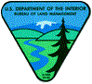



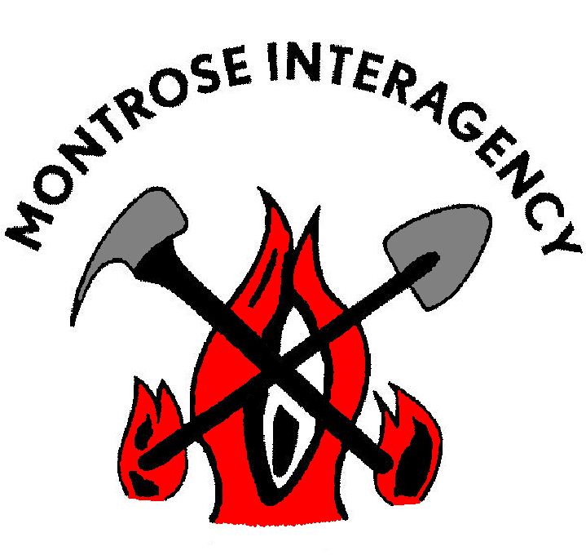
2008
Fire Suppression * Prescribed Treatments * Wildland Fire Use
Education * Dispatch * Contracts * Community Relations

2465 S. Townsend Ave. Montrose, Co 81401
Phone: 970.249.1010
Fax: 970.240.5369
www.gacc.nifc.gov/rmcc/dispatch_centers/r2mtc/
FIRE MANAGEMENT UNIT

Montrose Interagency Dispatch Center

2008 Year End Report

The Montrose Interagency Fire Management Unit (MIFMU) experienced a below average fire season during 2008. For the third year in a row, fire occurrence and numbers of acres burned were well below annual averages for the unit.

Record winter snowfall in most of the Colorado mountain ranges resulted in a snowpack that lingered well into late summer in the higher elevations. Summer temperatures were warm and the region received less than average rainfall due to a weak monsoon pattern, yet fuel conditions remained near average across most of the unit. The diminished thunderstorm activity resulted in significantly less lightning-caused fires across the entire state.

The unit had the opportunity to manage four lightning-caused fires utilizing the Wildland Fire Use (WFU) strategy during this fire season, all within the Norwood Zone. The Rock Flats, Beehive, and Wickson fires which occurred on BLM lands in the Nucla area were identified as appropriate candidate fires for WFU implementation, but weather conditions limited spread and these fires remained fairly small.

The Albin Draw WFU fire on the Grand Mesa, Uncompahgre, and Gunnision National Forest near Norwood was ignited by lightning in an area that had previously been mechanically treated by roller chopping equipment. This area was identified for secondary treatment as a future prescribed burn, and fuel and weather conditions were conducive for spread through the roller chopped unit. Over the period of a week, multiple fire runs of varying intensity resulted in 424 acres burned at a relatively low cost, before the fire was extinguished by monsoon rains.

In the Gunnison Zone, the West Elk fire was monitored remotely under a confine/containment management strategy due to concerns for firefighter safety. This lightning-caused fire was reported on July 4th in a rugged and inaccessible area of the West Elk Wilderness, and continued to burn in decadent fuels for well over four months. The West Elk fire grew to over 1,500 acres, exhibiting many types of fire behavior, from lying dormant for weeks to significant runs when the weather was favorable for fire growth. Fire managers and line officers were challenged with a prolonged incident that included updating public information, signing of a major U.S. highway, and implementing an area closure during the popular muzzle-loading hunting season.

The Ouray Zone experienced several suppression fires on BLM lands that required a heavier commitment of resources due to higher complexity and burning conditions. The Dominguez fire burned 95 acres of desert area northwest of Delta, fueled by cured grasses and driven by nighttime winds. The Oak Mesa and Jay fires burned 45 and 115 acres respectively, in an area north of Hotchkiss that comprises a thermal belt with a southwest aspect on the southern flanks of the Grand Mesa. Pinyon/Juniper, oak, and cheat grass fuels in this area are susceptible to rapid fire growth, and impact the wildland urban interface. In late September, MIFMU resources assisted the Cedaredge and Hotchkiss Fire Departments on the Redlands Mesa fire, which was located on private lands just west of this area and burned 152 acres and five structures. The unit continues to work with cooperating agencies on fire planning and mitigation efforts in these communities.

And finally, one of the most significant events MIFMU experienced this summer was when Unit FMO Steve Ellis abruptly announced his retirement in September. Steve spent his entire career with the BLM in Montrose, and it was under his leadership that the current MIFMU organization has developed and flourished. Steve has been recognized nationally for his tireless contributions to the interagency fire community, and we wish him success in his new position with the Colorado State Forest Service, as FMO for the Montrose and Durango area.

Montrose Interagency Fire Management Unit

2008 Community Assistance/Mitigation and Education Program

Community Assistance: This year the MIFMU distributed a combined total of $115,790.36 in Community Assistance (CA) and Rural Fire Assistance (RFA) grants. (Administered 20 assistance agreements)

Community Assistance (CA): Total = $56K
- West Region Fire Council $6K (covers both field offices)
  - $6K = grant writer for $$ for DOLA/infrastructure grant and FEMA/risk assessment and mitigation treatment grants
- Uncompahgre Field Office ($30K)
  - $10K = San Miguel County - county-wide CWPP
  - $10K = Ouray County - GPS unit - CWPPs
  - $10K = Montrose County - Risk Assessments
- Gunnison Field Office ($20)
  - $10K = Gunnison County – Ohio City/Gunnison Highlands/Wilderness Streams CWPPs
  - $10K = Gunnison County – Marble Fire Protection District CWPP

Rural Fire Assistance (RFA): Total = $59,790.53
- Uncompahgre Field Office ($47,580.53)
- Gunnison Field Office ($12,210)

CWPPs Completed: Delta County/Hotchkiss Fire District CWPP; Ouray County/ Four Communities CWPP in Ouray County (Lake Lenore, Whispering Pines, Panoramic Heights and Dexter/Cutler). CWPPs Near Completion: Horsefly Fire Protection Association/Cornerstone Association CWPP; San Miguel County county-wide CWPP; GPS/Structure Risk Assessment: Delta County completed the GPS and structure evaluations in the Cedaredge area and working to complete Paonia; Montrose County started their GPS and structure evaluations; Telluride Fire Protection District is installing 11 dry hydrants in outlying areas surrounding Telluride. West Region Fire Council: Continued to support the council in developing CWPP standards and risk assessment/survey standards for the counties.

Collaboration: Developed the process and facilitated the North Rim Landscape Strategy Group.

Planning: Began updating the UFO FMP. Developed operational fire plan and developed the outline for a unit-wide Fire Prevention, Mitigation, and Education Plan.

Region2 Fire Prevention Team Coodinator: Compiled a list of available prevention resources and made them available for national-level assignments.

Education/Outreach: Complete three “Why the Smoke” prescribed fire brochures and one “Take Aim Against Wildfire” prevention brochure for Gunnison Zone.
Montrose Interagency Fire Management Unit

2008 Training Summary

For 2008 the Montrose Interagency Fire Management Unit (MIFMU) issued a total of 207 Incident Qualification Cards (red cards). Approximately 50 new position taskbooks were initiated in 2008 covering all facets of the Incident Command System (ICS). A total of 26 taskbooks were completed this season.

The following is a breakdown of taskbook totals by unit:

 | Active Taskbooks | Certified Taskbooks
BLM | 31 | 10
USFS | 47 | 14
NPS | 18 | 2
Totals | 96 | 26

MIFMU has a very active training program; including on-the-job and local, state, regional and national classroom settings. MIFMU sponsors, coordinates and instructs numerous courses throughout the Rocky Mountain Region each year.

The Interagency Qualifications Review Committee met to review taskbooks of Single Resource Bosses, Unit Leaders and above to determine personnel qualifications and taskbook completions. The committee reviews the Incident Qualifications Card System (IQCS) cards each year for validity. After this review, unit shortage categories are determined and positions within these categories are focused on for training and further qualification.

Montrose Interagency Fire Management

Fuels Management Accomplishments

Over 9,000 acres of fuels were treated with Wildland Urban Interface and Hazardous Fuels funding in the Montrose Unit. Both prescribed fire (~5,500 acres) and mechanical treatment (~3,700 acres) were used across the unit by USFS and BLM. Mechanical treatments ranged from chainsaw/hand piling to fecan flail, hydroaxe and roller chop treatments. Prescribed burning occurred in fuel types as diverse as grass/sage, sage/pinyon-juniper, oakbrush, slash (roller chops), ponderosa pine understory, and piles.

Office Totals | Prescribed | Mechanical | Total Acres
Gunnison Ranger District | 3700 | 1260 | 4960
Norwood Ranger District | 529 | 0 | 529
Paonia Ranger District | 165.25 | 215 | 380.25
Ouray Ranger District | 443 | 0 | 443
Uncompahgre Field Office | 391 | 1093 | 1484
Gunnison Field Office | 254 | 1107 | 1361
Unit Totals: | 5482.25 | 3675 | 9157.25
Agency Totals
US Forest Service | 4837.25 | 1475 | 6312.25
Bureau of Land Management | 645 | 2200 | 2845
Unit Totals: | 5482.25 | 3675 | 9157.25

Within the Unit 2 Burn Bosses trainees got significant experience and one was signed off on as a Burn Boss. Additionally, 2-3 new Firing Bosses were qualified through the taskbook process, maintaining the total number of Firing Bosses at approximately 15. 3-4 personnel became single resource qualified and will now be able to serve as Holding Specialists and Firing Boss Trainees in FY09.

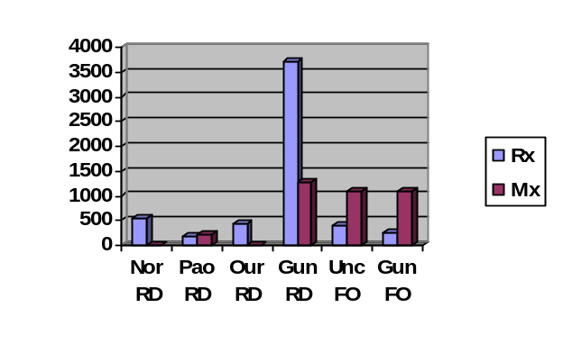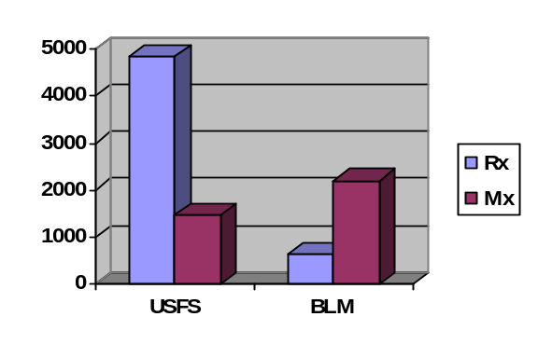

 |  | FIRES BY AGENCY
 |  | Agency | HUMAN |  |  |  | LIGHTNING |  |  |  | WFU |  |  |  | TOTAL
 |  |  | Fires |  | Acres |  | Fires |  | Acres |  | Fires |  | Acres |  | Fires |  | Acres
 |  | GMF | 2 |  | 0.2 |  | 14 |  | 1561.2 |  | 1 |  | 424 |  | 17 |  | 1985.4
 |  | GVF | 0 |  | 0 |  | 2 |  | 0.35 |  | 1 |  | 1485 |  | 3 |  | 1485.35
 |  | GND | 1 |  | 0.88 |  | 3 |  | 0.55 |  | 0 |  | 0 |  | 4 |  | 1.43
 |  | UPD | 3 |  | 0.7 |  | 31 |  | 203.05 |  | 3 |  | 38 |  | 37 |  | 241.75
 |  | SJD | 0 |  | 0 |  | 5 |  | 0.9 |  | 0 |  | 0 |  | 5 |  | 0.9
 |  | BCP | 0 |  | 0 |  | 0 |  | 0 |  | 0 |  | 0 |  | 0 |  | 0
 |  | CCP | 1 |  | 1 |  | 1 |  | 1.5 |  | 0 |  | 0 |  | 2 |  | 2.5
 |  | TOTAL | 7 |  | 2.78 |  | 56 |  | 1767.55 |  | 5 |  | 1947 |  | 68 |  | 3717.33
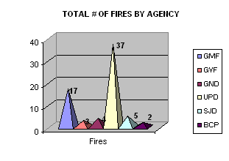 |  |  |  |  |  |  | 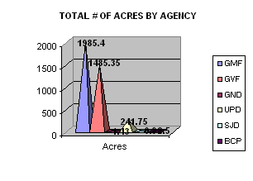
 |  | MIFMU FIRES BY ZONE
 |  | Agency | Gunnison Zone |  |  |  | Norwood Zone |  |  |  | Ouray Zone |  |  |  | TOTAL
 |  |  | Fires |  | Acres |  | Fires |  | Acres |  | Fires |  | Acres |  | Fires |  | Acres
 |  | FS | 6 |  | 1550.5 |  | 5 |  | 430.7 |  | 6 |  | 4.2 |  | 17 |  | 1985.4
 |  | BLM | 4 |  | 1.43 |  | 31 |  | 42.05 |  | 11 |  | 200.6 |  | 46 |  | 244.08
 |  | NPS | 2 |  | 2.5 |  | 0 |  | 0 |  | 0 |  | 0 |  | 2 |  | 2.5
 |  | TOTAL | 12 |  | 1554.43 |  | 36 |  | 472.75 |  | 17 |  | 204.8 |  | 65 |  | 2231.98
 |  | *Fires from top chart not included in Zones (GVF): |  |  |  |  |  |  |  |  |  |  |  |  | 3 |  | 1485.35
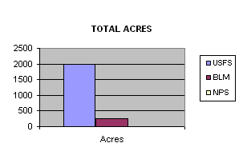
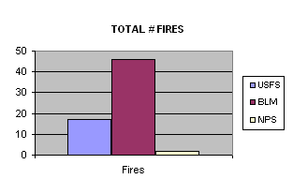
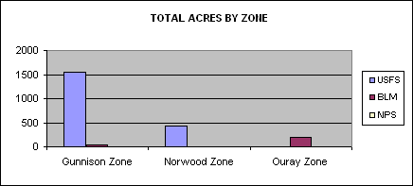
 | FIRES BY COUNTY
 |  |  |  |  |  |  |  | HUMAN |  |  |  | LIGHTNING |  |  | TOTAL
 | County |  |  | DEPARTMENT |  |  |  | Fires |  | Acres |  | Fires |  | Acres | Fires | Acres
 | DTX |  |  | Cedaredge FPD |  |  |  | 5 |  | 164 |  | 3 |  | 8.5 | 8 | 172.5
 |  |  |  | Crawford FPD |  |  |  | 0 |  | 0 |  | 0 |  | 0 | 0 | 0
 |  |  |  | Delta FPD |  |  |  | 6 |  | 116.2 |  | 0 |  | 0 | 6 | 116.2
 |  |  |  | Hotchkiss FPD |  |  |  | 5 |  | 2.9 |  | 0 |  | 0 | 5 | 2.9
 |  |  |  | Paonia FPD |  |  |  | 3 |  | 11 |  | 0 |  | 0 | 3 | 11
 |  |  |  |  |  | TOTAL |  | 19 |  | 294.1 |  | 3 |  | 8.5 | 22 | 302.6
 | MRX |  |  | Montrose FPD |  |  |  | 36 |  | 100.75 |  | 1 |  | 0.1 | 37 | 100.85
 |  |  |  | Olathe FPD |  |  |  | 0 |  | 0 |  | 0 |  | 0 | 0 | 0
 |  |  |  | Nucla/Naturita VFD |  |  |  | 0 |  | 0 |  | 0 |  | 0 | 0 | 0
 |  |  |  | Paradox VFD |  |  |  | 1 |  | 3.6 |  | 1 |  | 0.25 | 2 | 3.85
 |  |  |  | Sheriff/Posse |  |  |  | 0 |  | 0 |  | 0 |  | 0 | 0 | 0
 |  |  |  |  |  | TOTAL |  | 37 |  | 104.35 |  | 2 |  | 0.35 | 39 | 104.7
 | OUX |  |  | Horsefly FA |  |  |  | 0 |  | 0 |  | 0 |  | 0 | 0 | 0
 |  |  |  | Log Hill Mesa FPD |  |  |  | 0 |  | 0 |  | 0 |  | 0 | 0 | 0
 |  |  |  | Ouray VFD |  |  |  | 0 |  | 0 |  | 0 |  | 0 | 0 | 0
 |  |  |  | Ridgway FPD |  |  |  | 0 |  | 0 |  | 0 |  | 0 | 0 | 0
 |  |  |  |  |  | TOTAL |  | 0 |  | 0 |  | 0 |  | 0 | 0 | 0
 | GUX |  |  | Arrowhead |  |  |  | 0 |  | 0 |  | 0 |  | 0 | 0 | 0
 |  |  |  | Crested Butte FPD |  |  |  | 0 |  | 0 |  | 0 |  | 0 | 0 | 0
 |  |  |  | Gunnison FPD |  |  |  | 2 |  | 25.1 |  | 1 |  | 0.1 | 3 | 25.2
 |  |  |  | Pitkin VFD |  |  |  | 0 |  | 0 |  | 0 |  | 0 | 0 | 0
 |  |  |  |  |  | TOTAL |  | 2 |  | 25.1 |  | 1 |  | 0.1 | 3 | 25.2
 | HIX |  |  | Lake City FPD |  |  |  | 0 |  | 0 |  | 1 |  | 0.1 | 1 | 0.1
 | SLX |  |  | Egnar/Slickrock |  |  |  | 0 |  | 0 |  | 2 |  | 3.1 | 2 | 3.1
 |  |  |  | Norwood VFD |  |  |  | 9 |  | 39.8 |  | 1 |  | 0.1 | 10 | 39.9
 |  |  |  | Telluride FPD |  |  |  | 0 |  | 0 |  | 2 |  | 0.2 | 2 | 0.2
 |  |  |  | Sheriff |  |  |  | 0 |  | 0 |  | 0 |  | 0 | 0 | 0
 |  |  |  |  |  | TOTAL |  | 9 |  | 39.8 |  | 10 |  | 3.4 | 14 | 43.2
 | GRAND TOTALS |  |  |  |  |  |  | 67 |  | 463.35 |  | 17 |  | 12.45 | 79 | 475.8
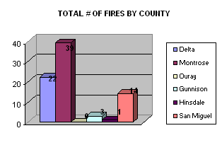
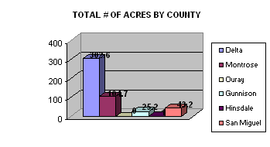

 | RESOURCE ORDERS
 | RESOURCE TYPE |  | # Incidents |  | # Requests
 | Overhead |  | 78 |  | 185
 | Crews |  | 4 |  | 5
 | Equipment |  | 18 |  | 78
 | Aircraft |  | 9 |  | 11
 | TOTAL |  | 100 |  | 252
 |  |  |  | AIRCRAFT ORDERS
 |  | 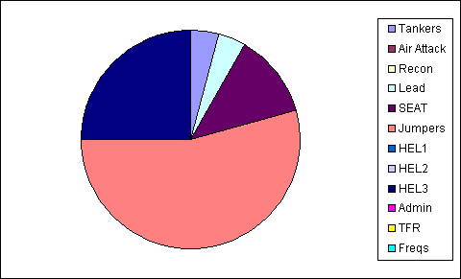
Tankers | 1
Air Attack | 0
Recon | 0
Lead | 1
SEAT | 3
Jumpers | 13
HEL1 | 0
HEL2 | 0
HEL3 | 6
Admin | 0
TFR | 0
Freqs | 0
GUNNISON RIVER CREW MOBILIZATION
 |  | DATE | INCIDENT NAME |  | STATE | UNIT ID
 |  | 7/27/2008 | Gunnbarrel |  | WY | SHF
 |  | 7/28/2008 | Cascade |  | MT | CNF
MIFMU FIVE YEAR AVERAGE - FIRES
 | 2004 | 2005 | 2006 | 2007 | 2008 | Average | +/- AVG
# Fires | 161 | 98 | 110 | 72 | 65 | 101.2 | -36.2
# Acres | 6,008 | 1,783 | 628 | 497 | 2,232 | 2,230 | 2
MTC FIVE YEAR AVERAGE - RESOURCE ORDERS
 | 2004 | 2005 | 2006 | 2007 | 2008 | Average | +/- AVG
Overhead | 554 | 254 | 168 | 165 | 185 | 265.2 | -80.2
Crew | 30 | 12 | 8 | 7 | 5 | 12.4 | -7.4
Equipment | 443 | 121 | 16 | 20 | 78 | 135.6 | -57.6
Aircraft | 150 | 78 | 22 | 12 | 11 | 54.6 | -43.6

